BIPOLAR JUNCTION TRANSISTOR (BJT)

This is a very popular form of transistor but by no means the only type.
In comes in two forms a) the npn b) the pnp type. Basic structure and symbols are shown below:
npn transistor pnp transistor

C C B n. B p
p n
n p
E E
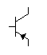
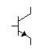

B = Base, C = Collector and E = Emitter
Note: the arrow on the transistor indicates the emitter terminal.

A selection of real transistors is shown below:
All of these transistors are or have been in common usage. The BC10,8,9 are very common general purpose low power transistors and the 3055 type is a common industrial standard general purpose high power amplifier.
TRANSISTOR CHARACTERISTICS

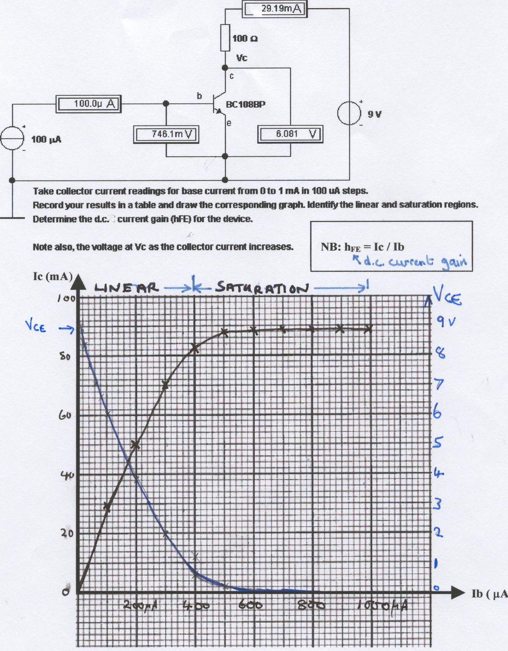
I_{B} (µA)
V_{CE =}

2V
I_{B}=100µA
I_{C}

= 20mA
70mA
30mA

If we bias the base current into the middle of the linear region we can get amplifiacation.

If we switch the base current from one end of the linear region to the other end we get a switching action from the transistor.

It is the position of the bias point that determines whether the transistor will act as a switch or an amplifier.

E.g. If we set up Ib to be 200μA and cause it to vary slightly either side of that by adding to it a small a.c. current due to an input signal then we can get the collector current to swing, but over a much greater range.

This current swing causes a collector voltage swing which is very much bigger than the input voltage swing that caused the base current swing.

Hence we get small signal amplification.

If, however, we cause the base current to switch from 0 to 400 μA, say, then the collector current switches between 0 and 80 mA.

This collector current swing causes the collector voltage to switch between approximately 9v and 0v.

Hence we have the transistor acting as a switch.

TRANSISTOR AS AN AMPLIFIER

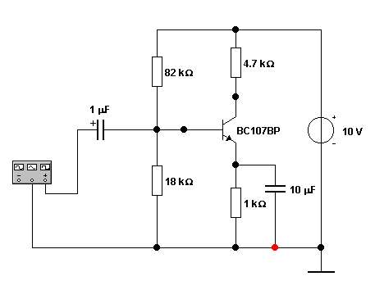

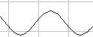

Enlarged, inverted output sitting on a d.c. bias level

Input signal, sitting on d.c. base bias.

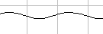

The circuit above shows a typical transistor amplifier circuit.

Such a circuit may be used to amplify any small a.c. signal such as that from a microphone etc.

The 18k and 82 k resistors form a potential divider to set up a d.c. BASE BIAS VOLTAGE.

This voltage drives a d.c. base current into the transistor to
set the nominal resistance of the transistor (between collector and emitter).

This causes a collector current to flow and set-up a d.c. collector voltage.
Just as the collector current is magnified by h_{FE} we also find that if we place a small a.c. voltage on to the d.c. bias voltage we can cause a magnified a.c. voltage to sit on top of the collector d.c. voltage, as shown above.

This circuit forms the basis of a small signal amplifier.

