Effective Teamworking
and
Communications

Tassadaq Hussain
Student number :1905290
Module Code: BMSW4002
Lecturer: Eric Osei

Contents Page

Page 1 - Introduction
Page 2 – Developing an effective team.
Page 3/4 – The impact effective teamworking can have for a team success.
Page 4 – Barriers to effective teamwork.
Page 5 – Roles needed to create a cohesive and effective team.
Page 6 – Conclusion
Page 7 - References

Introduction

This report will talk about how students can develop an effective team, how this impacts effective teamworking can have for team success and the Barriers to effective teamwork. Also looking at the types of roles that are needed to create a cohesive and effective team. Teamwork is a process of working collaboratively with a group of people in order to achieve a goal. It is very important for all individuals to be a team player this impacts on the groups efforts to complete the task. Every individual has strengths and weaknesses and working together as a group can form an effective group as they can support each other. This report is going to address the communication challenges, team management issues and barriers to effective teamwork within the team.

Page 1

Developing an effective team
Teamwork is the strategy of working successfully with a set of people in order succeed and reach their goal. It also a process when a group of people join forces to work , using their personal skills and delivering positive feedback, whether is any personal clash amongst the people taking part. (What is Teamwork Actually? · Activecollab Blog, 2021). When working in a team it is important need to put their differences aside and work together to complete tasks have been set. It has been said working in a group is usually agreed as the commitment of a set of people in a group to commit to task and complete them. This shows when someone has the best interest of their team players at heart. Being a good team player is vital whether it is in a profession or personal life. (What is Teamwork Actually? · Activecollab Blog, 2021)
All members have to give their best in all circumstances. Another key thing in team work is having good leadership skills and being able to take the right decisions for the group.
Leadership is vital when it comes to teamwork. The person leading the group takes the responsibility to make sure the others members work as a group to accomplish their targets and must take all steps needed to complete the tasks successfully with their group. The leader must also make sure that the team has the resources and data that is needed complete its task. (2021)
There are many ways of having a dynamic and effective team.
Step 1: Establish leadership.
If the members in your team have faith in the decisions you make, you will find they will work successfully even when you're not around. Prior to when you can begin to work on team building, you need to have the correct leadership skills. This means even when you are not around because of your good leadership your group will still work effectively.
Step 2: Establish relationships with each other.
It is important to get to know your members in the team .Everyone is unique in their own ways and it is important to get to know the team members Try to learn more about each member of your team, their skill sets, how they are motivated and their likes and dislikes.
Step 3: Build relationships .
Working in at team and building good relationships with your team members is key. The better the relationship you have the more effective the work will be. If there are any conflicts they can be resolved if the good relationships are built amongst themselves. Giving everyone respect and listening to each other is key.
Step 4: Set ground rules for the team.
Finally, you can begin officially establishing your team through creating team values and goals, as well as evaluating team performance alongside individual performance. Be sure to include your team in this process, so they know what's required and agree with it.
Team building is one of the most important responsibilities a manager has. It isn't something that can be achieved in a short time and then forgotten. It is an ongoing organic process that you a will have to facilitate and guide. As this process unfolds, however, your team members will begin to trust and support
one another and share their skill sets and effort in order to more effectively complete your organisation's goals.

The impact effective teamworking can have for a team success

There are many things that effect teamworking such as:
1 – Great ideas don’t come from lone geniuses
2 – Diverse perspectives help you come up with winning innovations
3 - Teamwork can make you happier
4 – when you wok in a team, you grow as an individual
5- Sharing the workload eases burnout
6 – Dividing the work lets you grow your skills
7- Recognition from other team members can improve your productivity
8- Working in a team helps you take risks that pay off
9- when you work in a team ,you’ll feel less stressed
10 – Good communication boosts your creativity
(The importance of teamwork (as proven by science) - Work Life by Atlassian, 2021)

When you are working as a team the tasks or workload are shared amongst the group. As each person is skilled and the work is divided to match their skills and strengths. when the group have a good support network it gives the group the opportunity to build a strong connection to work together. This is because each person has an important role to play and they need to work together to reach their goal. When there is more than one in a group each person can share their creative ideas and come resolve any matters if the one person cannot resolve . When you are working in a group and the workload is distributed amongst the team members . Its gives the group to work together to complete the task and feel like they are part of a group. when you are working with a group of people it gives everyone the opportunity to build a strong relationship with each other . This can open to many opportunities to develop professionally and form good relationships. Also working as a team to successfully to complete task. One more thing that benefits from having strong a relationships is that everyone can support each other and work together to their best abilities to complete the task .This is vital in any form of working together to be successful.(Leitch, 2021).

Page 3
Barriers to effective teamwork

There are many barriers to effective teamwork such as:

1. Self-esteem and not feeling like they add any value to the team.
2. Non-verbal skills are not right for the situation.
3. Stereotyping or using only experience/perspective to communicate.
4. Cultural or Language barriers.
5. Not actively listening.
6. Unclear goals and misunderstandings.
.7. Physical separation among team members.
8. A lack of trust.
9. Distractions.
10. Lack of accountability.
(Practical, 2021)
When you are working in group it is important to treat everyone equally and give the same respect as you would give everyone. Some members will not be as confident as other and it is important to support them and make them feel valued in your group. A person’s body language gives a lot away so it is very important to give everyone the chance to express themselves and not disrespect anyone in the group. Where there is a group and some from the group have speak a different language you need to put the differences aside and find ways of communicating to successfully complete tasks. Listening is very important and respecting everyone when they are talking . When you are put in a group you gave to put all your differences aside and work together to complete the task. Every individual has their own part to play and teamwork is extremely important to complete any task.

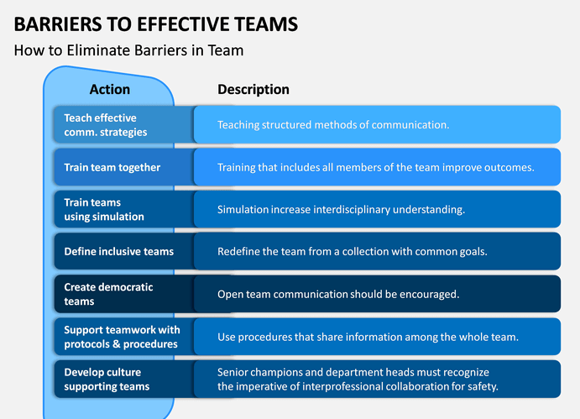

(Bing, 2021)
Page 4
Roles needed to create a cohesive and effective team
There are many different ways of creating a effective team such as :
- Better communication among team members
- A heightened ability to achieve company objectives and goals
- A decreased need to micromanage a team, freeing up time for managers
- A positive work environment
- A decreased use of resources due to a team's effectiveness and efficiency
- Increased job satisfaction among employees who are part of a cohesive team
In addition to a cohesive a team is, the more effort you put in the team the more you get back. When you have a good management and good leadership they are then able to work well alongside the team members and guide them when needed.
One of the theorist that talk about teamwork is Belbin. He recommends that being aware of the team role can improve the strengths and work towards the weaknesses to develop a better relationship within the group. Many teams use the Belbin method to support and form a better group.
If team members are similar strengths and weakness this will create an unbalanced group and will cause issues when it comes to teamwork.
Belbin had recognised nine team roles that are:

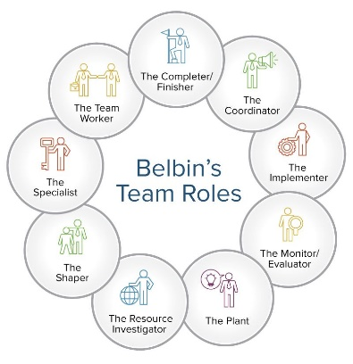

There are many different ways work on to build a better cohesiveness in the environment. Its is very important to communicate and encourage it with each other. Also activities need to be set for team building to get to no one another. Everything needs to be set clearly so all team members are aware what needs to be done and how they will achieve to complete the task. All members need to understand their task so everyone in the group is aware what needs to be done. Everyone in the group needs to trust each and complete their part effectively. Everyone in the to build trust amongst themselves to achieve the best outcome in any task. (2021)
Conclusion

Overall it is very important to have work alongside with your team members no matter what the differences are or if there is a language barrier. Each individual has their own strengths and weaknesses and working in a team can bring out the best in each person. There are many techniques and different forms of support you can get when working in a group. Everyone in the group and management need to put their differences aside and work together to complete tasks. Everyone needs to work in a professional manner to be successful. Every person has its own strengths and weaknesses and everyone needs to support each other to get the best outcome.

Page 6

References

Constructingexcellence.org.uk. 2021. [online] Available at: <https://constructingexcellence.org.uk/wp-content/uploads/2015/03/Teamwork_Guide.pdf> [Accessed 24 October 2021].

Indeed.com. 2021. [online] Available at: <https://www.indeed.com/career-advice/career-development/teamcohesiveness#:~:text=How%20to%20improve%20team%20cohesiveness%20at%20work%201,successes%20as%20a%20team.%20...%20More%20items...%20> [Accessed 26 October 2021].

Bing.com. 2021. Bing. [online] Available at: <https://www.bing.com/images/search?view=detailV2&ccid=8XaXawef&id=38E15D8B2A6D892FFAC219781571BEA8933EC2C7&thid> [Accessed 25 October 2021].

The Happy Manager. 2021. Define Teamwork | a teamwork definition that works! - The Happy Manager. [online] Available at: <https://the-happy-manager.com/article/define-teamwork> [Accessed 24 October 2021].

Practical, O., 2021. 10 Barriers To Teams And How To Overcome Them. [online] Businessonlypractical.com. Available at: <https://businessonlypractical.com/2015/10/17/10-barriers-to-teams-and-how-to-overcome-them/> [Accessed 26 October 2021].

Leitch, C., 2021. 10 Powerful Benefits of Teamwork in the Workplace. [online] Careeraddict.com. Available at: <https://www.careeraddict.com/5-benefits-of-teamwork-in-the-workplace#:~:text=%2010%20Powerful%20Benefits%20of%20Teamw> [Accessed 25 October 2021].

Steve Nguyen, P., 2021. Characteristics of a Team and Barriers to Effective Team Functioning. [online] Workplace Psychology. Available at: <https://workplacepsychology.net/2016/12/03/characteristics-of-a-team-and-barriers-to-effective-team-functioning/> [Accessed 25 October 2021].

Work Life by Atlassian. 2021. The importance of teamwork (as proven by science) - Work Life by Atlassian. [online] Available at: <https://www.atlassian.com/blog/teamwork/the-importance-of-teamwork#:~:text=10%20benefits%20of%20teamwork.%201%201.%20Great> [Accessed 26 October 2021].

ActiveCollab. 2021. What is Teamwork Actually? · Activecollab Blog. [online] Available at: <https://activecollab.com/blog/collaboration/what-is-teamwork-actually> [Accessed 24 October 2021].

Page 7

