  SHAPE UP GYM DATABASE | Kristian Cole (1810705)  Database Management Systems

Contents
1.0 Performance Tuning 2
2.0 Database Distributed Solution 3
2.1. Horizontal fragmentation 3
2.2 Vertical Fragmentation 5
2.3 Mixed Fragmentation 6
2.4 Derived Fragmentation 7
Works Cited 7

Performance Tuning

A single database containing multiple tables and data will have queries run against the tables and data to produce information relevant to the query. An example from the Shape Up Gym Database (Select * from Customer), firstly the * indicates a request for all records in the Customer table. The query will run slow because all records have been requested. There may be millions of records to return from the query. What makes it slower is there is only one Index on the table. The GymID column is allocated a type of ‘UniqueIdentifier’, which means an alphanumeric GUID 36 characters in length is generated, uniquely [1]. This is commonly referred to as a clustered Index. A Clustered Index is automatically set when a Primary Key is defined in the table. [2]
The first Index chosen for Shape Up Gyms database is to be set on the Customer Table:
CREATE INDEX idx_Customer_GymID ON Customer (Surname asc and Homeaddress asc);
The Customers clustered index is assigned to the CustomerID primary key. The primary key being a clustered index by default upon creation of entity record type. The secondary index assigned to the Customer entity is to the Varchar fields, the Surname and HomeAddress column. The reason for the two varchar fields as a secondary index is that the Customer entity is set to grow exponentially due to the influx of Gym users in real life. As the Customer entity grows so will the need for queries against the entity itself to check for duplicated rows.
Select * from Customer Where Firstname = ‘Kristian’ and Surname = ‘Cole’ and Homeaddress = ’1 The Street’
The above select statement selects ALL records with the firstname, surname and homesaddress as requested. The surname and homeaddress, indexed in ascending alphabetical order, perform less of an overhead of the database when searching across hundreds of thousands of records. In this case it would be beneficial to alphabetize the surname and homeaddress varchar fields because the primary key is a uniqueidentifier and too large to search on. Whereas surname and homeaddress varchar fields provide a more meaningful search for front end users. Most queries will take place on the gym users firstname, surname and homeaddress. As the order of index is assigned as name alphabetized then home address it increases query speed.
The second index will be allocated to the GymMembershipPrice entity. This entity has composite keys of two unique identifier GUID’s, which are too complex to search on from system users perspective. The Monthlypaymentfee column is chosen as most queries will be requested on this column.
CREATE INDEX idx_GymMembershipPrice ON GymMembershipPrice (GymID asc, MonthlyPaymentFee asc);
Users who pay monthly need to be chased for payment by Shape Up Gym for future payments if the user has not set up a direct debit. A query such as:
Select * from GymMembershipPrice where MonthlyPaymentFee IS NULL;
Shows all records that do not have a monthly payment fee entry in the database. This type of query could be used to highlight members who have not paid Gym membership and require chasing up. As the index on MonthlyPaymentFees is ascending, this will bring up all the NULL records first. Null first and entries with data in after, in order of date ascending. Indexing the GymID helps to make any joins more efficient when using them to connect two tables in a query.
The third and final index allocated to the Shape Up Gym Database is the on the columns StartDate and EndDate.
CREATE INDEX Index_MembershipPurchase ON MembershipPurchase (StartDate DESC, EndDate DESC);
The reason for the choice of start date descending was due to the need to see newest start dates ordered at the beginning of a query and the End Dates seen at the beginning of a query. Shape Up Gym would need a query to show up and coming End Dates as to see how much data input work would be coming up in renewing older members Gym membership. Also they would need a query to find newest members start dates to book in introductory sessions on how to use the Gym.

2.0 Database Distributed Solution

2.1. Horizontal fragmentation

Horizontal fragmentation in the Region table is where the regionname appears in all four fragments [3]. Reconstruction occurs via a union statement, are disjointed, a Region can not be in four Regions.
- Select * from Region where RegionName = ‘South Wales’;
- Select * from Region where RegionName = ‘North Wales’;
- Select * from Region where RegionName = ‘Scotland’;
- Select * from Region where RegionName = ‘England’;

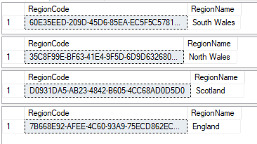
Horizontal fragmentation in the Region table is where the regionname appears in all four fragments [3]. They can be reconstructed via a union statement and are disjointed, a city can not be in four cities.
- Select * from City where City Name = ‘Swansea’;
- Select * from City where City Name = ‘Edinburgh’;
- Select * from City where City Name = ‘Cardiff’;
- Select * from City where City Name = ‘London’
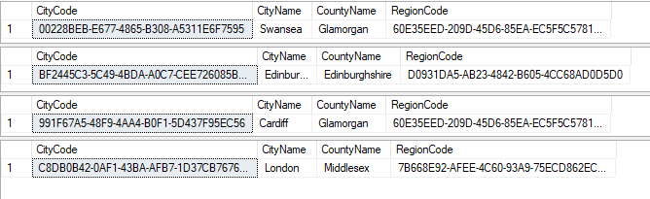
Horizontal fragmentation in the MembershipType table is where:
- the ContractType is signed or unsigned.
- Durationtype is equal to year, daily or weekly [3].
- OffPeakMembership is one or zero.
- CancelAnyTime is one or zero.
They can be reconstructed via a union statement and are disjointed.
- Select * from MembershipType where ContractType = ‘Signed’;
- Select * from MembershipType where ContractType = ‘UnSigned’;
- Select * from MembershipType where DurationType = ‘Year’;
- Select * from MembershipType where DurationType = ‘Daily’;
- Select * from MembershipType where DurationType = ‘Weekly’;
- Select * from MembershipType where OffPeakMembership= ‘0’;
- Select * from MembershipType where OffPeakMembership= ‘1’;
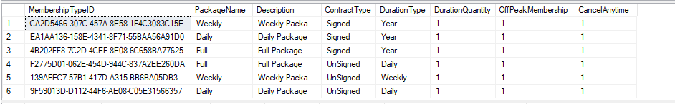
- Select * from MembershipType where CancelAnyTime= ‘0’;
- Select * from MembershipType where CancelAnyTime= ‘1’;
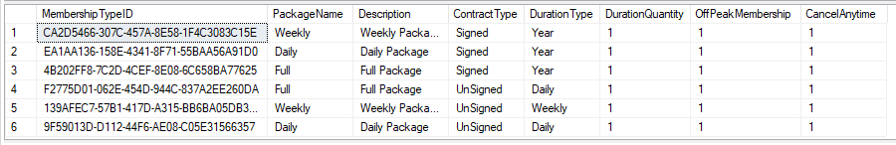
Horizontal fragmentation in the MembershipPurchase table is where the MonthlyPaymentDay appears in all seven fragments [3]. They can be reconstructed via a union statement and are disjointed by payment day.
- Select * from MembershipPurchase where MonthlyPaymentDay = ‘Monday';
- Select * from MembershipPurchase where MonthlyPaymentDay = ‘Tuesday';
- Select * from MembershipPurchase where MonthlyPaymentDay = ‘Wednesday';
- Select * from MembershipPurchase where MonthlyPaymentDay = ‘Thursday';
- Select * from MembershipPurchase where MonthlyPaymentDay = 'Friday';
- Select * from MembershipPurchase where MonthlyPaymentDay = 'Saturday';
- Select * from MembershipPurchase where MonthlyPaymentDay = ‘Sunday';

2.2 Vertical Fragmentation
Vertical fragmentation in City table satisfies fragments of city details from region details:
- Select citycode, cityname From City;
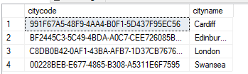
Vertical fragmentation in Customer satisfies three fragmentation uses:
- the vertical division of contact details (select customerid, firstname, lastname,dateofbirth, emaildaddress, contactphoneno from customer). This provides basic contact details of the customer such as email address and contact number.

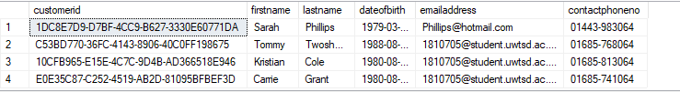
- vertical division of home address (select customerid, homeaddress,homecitycode,postcode from customer). This provides the address of the customer, which can be expanded to sow the city table and region details.
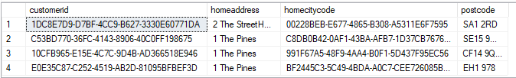
- vertical division of customer bank details (select customerid, bankaccountno, sortcode from customer). This provides the banking detaild of the customer with the columns bank account number and sort code.
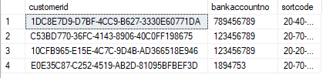
Can also be reconstructed by the primary key Customerid in each of the fragments [3]. The fragments are disjointed but can be reconstructed by the presence of the primary key [4].

2.3 Mixed Fragmentation
Mixed fragmentation in the MembershipPurchase table provides multiple fragments. The fragments are disjoined as there are no gym members who can be both active and inactive as members [3]. The fragments can be reconstructed because there are multiple primary keys to use in the PurchaseNo, GymID, CustomerID and MembershiptypeId.
- This fragmentation provides a way to view what gym members need to renew their membership.(SELECT * FROM MembershipPurchase where enddate < GETDATE();) [5]
- This fragmentation provides a way to view inactive one time free price paying gym members (SELECT * FROM MembershipPurchase where Monthlyfeeprice = 0.00 and status = 'inactive')

2.4 Derived Fragmentation
Derived fragmentation only pertains to horizontal fragmentation, it involves the joining of two tables to produce a fragmentated table of one or more sources [3].
A derived horizontal fragment in the Shape Up Database derives from the membershipPurchase table and the customer table [6]. The organisation needs to know the Customer details of all members whose membership has expired.
- select mem.Status, cus.CustomerID, cus.FirstName, cus.LastName, mem.EndDate from MembershipPurchase mem left join Customer cus on mem.CustomerID = cus.CustomerID where mem.EndDate < GETDATE();
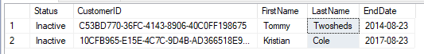

Works Cited

[1] | “uniqueidentifier (Transact-SQL),” Microsoft, 2019. [Online]. Available: https://docs.microsoft.com/en-us/sql/t-sql/data-types/uniqueidentifier-transact-sql?view=sql-server-ver15. [Accessed 10 12 2019].
[2] | B. Barnhill, “How to use indexing to imporve database queries,” The Data School, 19 02 2020. [Online]. Available: https://dataschool.com/sql-optimization/how-indexing-works/. [Accessed 25 02 2020].
[3] | D. K. Ademoye, “Dsitributed Databases,” Swansea University, Swansea, 2020.
[4] | Rahul, “Data fragmentation in DBMS,” Tutorial Cup, 03 02 2020. [Online]. Available: https://www.tutorialcup.com/dbms/data-fragmentation.htm. [Accessed 25 02 2020].
[5] | Unknown, “Fragmentation in Distributed System,” Tutorial Ride, 2017. [Online]. Available: https://www.tutorialride.com/distributed-databases/fragmentation-in-distributed-system.htm. [Accessed 25 02 2020].
[6] | Unknown, “Derived Horizontal Fragmentation in Distributed Database Systems DDBS,” T4 Tutorials, 2020. [Online]. Available: https://t4tutorials.com/derived-horizontal-fragmentation-in-distributed-database-systems-ddbs/. [Accessed 25 02 2020].

