

INTERNATIONAL FINANCIAL MANAGEMENT

Assessment 1

Module: International financial management
Code: LCBB6002
Lecturer: Dr Andry Rakotovololona
Name: Simona Vitelaru
Student ID: 2133624

Table of Contents
1.Introduction 3
1.1 Overview of Foreign Exchange Risk 3
1.2 Importance for Multinational Corporations 3
2. Literature Review 4
2.1 Theoretical Frameworks in International Financial Management 4
2.2 Types of Foreign Exchange Risks 6
3. Strategies for Managing Foreign Exchange Risks 6
3.1 Internal Hedging Strategies 6
3.2 External Hedging Strategies 7
4.Critical Analysis and Evaluation 8
Conclusion 9
References 10

1.Introduction

Overview of Foreign Exchange Risk
For multinational corporations (MNCs) in the very complex and continually shifting field of international finance, foreign exchange risk is a major issue. Linked with fluctuations in the value of currencies, this risk can have significant consequences for the financial situation and profitability of companies all around. MNCs are more likely to be impacted by these kinds of hazards since they operate in several countries. Bad fluctuations in currencies can affect their revenues, enlarge their debt, and distort their market positioning. Foreign currency risk is so complex that it requires robust management strategies grounded on thorough knowledge of both market forces and how global economic policies interact (Brunnermeier, Nagel, and Pedersen, 2019).

Importance for Multinational Corporations
Given the possibility of large losses, it is impossible to enough emphasise the need of properly managing foreign exchange risk. It is not only a defensive action; it is also a strategy required of MNCs to simultaneously safeguard their interests and seize favourable market conditions. As Jorion (2019) points out, an MNC's capacity to forecast and lower currency risk determines its long-term success in a society growingly intertwined.

2. Literature Review

Theoretical Frameworks in International Financial Management

Understanding cross-border financial management requires understanding International Financial Management (IFM) theoretical frameworks. These frameworks help multinational businesses (MNCs) negotiate currency changes, international capital flows, and financial rules. Purchasing Power Parity (PPP), which states that exchange rates should reflect price increases between currencies, is a popular theory.

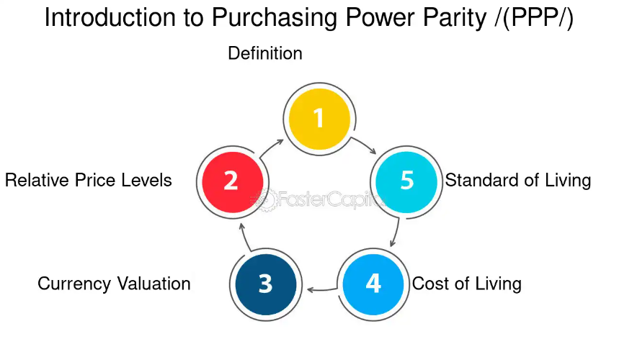
This foundational theory has weaknesses, especially in the short run, where market flaws and speculative activities typically deviate from equilibrium (Madura, Hoque and Krishnamrti, 2023).
The Interest Rate Parity (IRP) theory that future and spot exchange rates reflect interest rate differences across countries is another important concept. This theory explains why forward contracts are used to hedge foreign exchange risk, making it essential to understanding hedging methods.
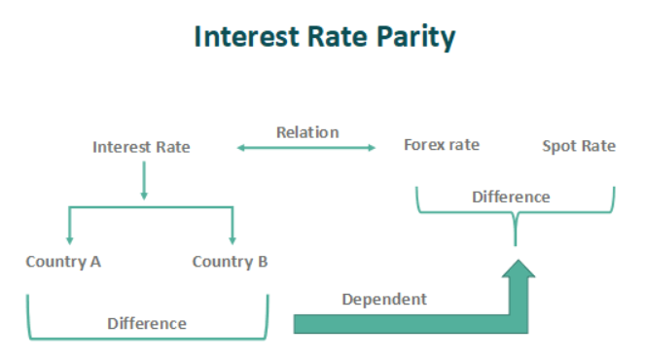
Transaction costs and capital regulations may limit arbitrage opportunities when applying IRP (Shapiro and Hanouna, 2020).
By including cross-border investment complexity, the Capital Asset Pricing Model (CAPM) becomes more relevant internationally. CAPM helps MNCs evaluate international investment returns by considering country systemic risks (Adler and Dumas, 2019).
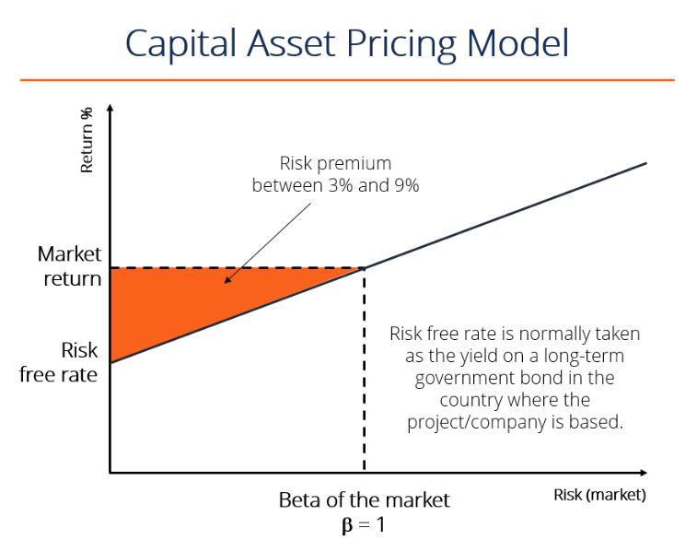
(CFI Team, 2022)

These ideas and models constitute the foundation of IFM, providing MNCs with a conceptual framework and practical instruments for global financial management.

Types of Foreign Exchange Risks

Foreign exchange risks are inherent in the operations of international organisations and can be roughly classified as transaction, translation, and economic hazards. Transaction risk is caused by the time lag between entering into a contract and settling it, during which exchange rate variations might affect the value of expected cash flows. This risk is especially high in companies with long payment cycles, where currency fluctuations can severely reduce profitability (Bernoth and Herwartz, 2021).
In contrast, translation risk refers to the impact of currency rate swings on a multinational corporation's consolidated financial statements. When overseas subsidiaries' financial statements are converted into the parent company's reporting currency, exchange rate fluctuations can cause differences in reported earnings and equity, even if the underlying economic situation stays unchanged.
Economic risk refers to the long-term impact of exchange rate fluctuations on a company's market value and competitive position. Unlike transaction and translation risks, economic risk is more subtle and pervasive, with the ability to disrupt the corporation's future cash flows and strategic outlook as exchange rates influence costs, pricing, and demand in international markets (Maggiori, Neiman, and Schreger, 2019).

3. Strategies for Managing Foreign Exchange Risks

Internal Hedging Strategies

Managing foreign exchange risks in multinational companies depends on internal hedging techniques in great part. Unlike external hedging, which uses derivatives or other financial instruments, internal hedging frequently with more flexibility and cost-effectiveness uses the operational elements of a company to reduce currency risk.
One such tactic is natural hedging, in which a company deliberately arranges its income and expenditure sources to balance possible currency swings. Matching money inflows and outflows helps the business to lower its sensitivity to negative exchange rate fluctuations. For instance, a US dollar-based company can try to incur expenses in the same currency, therefore negating the impact of exchange rate changes on its profitability (Vernimmen et al., 2012). Although this method is efficient, it depends on proper alignment of the operational structure and financial plan of the company to guarantee maximum use of natural hedging possibilities.
Leading and lagging is another internal tactic whereby one time payments and receipts to maximise expected currency changes. A corporation may decide to accelerate (lead) its receivables or postpone (lag) its payables in times of predicted devaluation of a foreign currency so optimising the exchange rates (Larcker and Tayan, 2020). Although this approach can have benefits, it depends on precise prediction of currency trends and strong knowledge of the cash flow dynamics of the company to prevent unneeded liquidity problems.
A more advanced internal method, especially helpful for international companies with significant cross-company exchanges is currency netting. Consolidating several foreign exchange transactions helps to lower the number of individual currency conversions needed, hence lowering transaction expenses and the risk to currency volatility (Bartram, Brown and Conrad, 2021). Through netting out offsetting positions across the group, the business can significantly lower the total volume of currency transactions, so lowering the risk involved in every transaction.
These internal hedging techniques taken together give multinational companies the means to control their foreign exchange risks in a way that fits their operating flow. When used well, they can be a wonderful addition to outside hedging strategies, helping companies to negotiate the complexity of international finance with more assurance and stability.

External Hedging Strategies

For multinational companies trying to control foreign exchange risks in a disciplined and proactive way, external hedging techniques are absolutely essential tools. Unlike internal strategies, which depend on operational changes, external strategies use financial instruments meant to minimise the effect of negative currency movements on the financial situation of a company.
Among the most often utilised instruments in external hedging are forward contracts. These agreements let a business fix an exchange rate for a future purchase, therefore removing the uncertainty related to currency values. Through a forward contract, a company can guarantee a certain rate and hence ensure that unanticipated exchange rate fluctuations have no negative impact on future cash flows. Companies who have a lot of foreign exchange exposure especially benefit from this strategy since it offers some degree of financial planning consistency (Jacque, 2020).
With each having different strategic uses, options and futures provide still another level of security. Although they give the buyer the right but not the duty to exchange money at a designated rate on or before a given date, currency options do This adaptability lets companies profit from positive changes in the exchange rates and provide protection against negative ones. Conversely, futures contracts are uniform agreements sold on exchanges that bind the holder to exchange money at a designated rate on a designated date. Although they provide less flexibility than options, futures are helpful for companies trying to hedge against currency risk in a highly regulated, open market (Hsiao and Tsai, 2019).
More complicated products, currency swaps entail two parties exchanging principle and interest payments in different currencies. Companies with long-term foreign exchange exposures especially benefit from these swaps since they permit management of both currency risk and interest rate risk at once. Companies can efficiently control their long-term exposure to currency volatility by switching cash flows in one currency for those in another, thereby maybe obtaining access to more favourable interest rates in other markets (James, Leister and Rieger, 2023).
By means of these external hedging techniques, multinational companies can reduce the risks related to currency fluctuation, therefore safeguarding their financial stability and improving their strategic agility in the worldwide market (Allayannis and Weston, 2020).

4.Critical Analysis and Evaluation

Foreign exchange risk management depends on market conditions. Stable markets with predicted currency movements perform well for internal and external hedging methods. Companies can reliably safeguard themselves from exchange rate movements. In turbulent or unpredictable markets, these strategies may not work. Forward contracts and options can safeguard you in unpredictable markets if you can foresee when things will happen. Options costs can exceed their benefits in unpredictable markets (Chance and Brooks, 2021).
These tactics can be effective when applied judiciously, especially for long-term currency risk exposure. Researchers concluded that companies that hedge internally and externally are more financially secure and market ready. Forward contracts and currency swaps help corporations manage long-term risks, according to studies. This can boost firm value and reduce bankruptcy risk (Hang et al., 2018). These methods aren't always effective. The company's business, geographic distribution, and currencies affect these methods' success. Foreign exchange risk management plans must be properly designed and tailored to each organisation and market to operate well.

Conclusion

All things considered, global companies have to give management of foreign exchange top priority as changes in currencies could affect their financial stability and competitive position. As this study shows, internal and external hedging techniques offer different benefits depending on the type of exposure the company has and the particular state of the market. Cost-effective and functionally integrated solutions abound from internal tactics like natural hedging and currency netting. Forward contracts and currency swaps are among outside options that offer strong defence against more erratic and volatile market conditions.
Still, the effectiveness of these approaches is not always assured; they must be painstakingly tailored to the particular situation of the company. To build a complete risk management system, multinational companies are encouraged to apply a balanced approach including both internal and external hedging techniques. This approach should be constantly assessed and adjusted to fit changing market conditions, therefore ensuring that the company stays flexible and strong in the presence of world financial uncertainty.

References

- Adler, M. and Dumas, B. (2019) The Exposure of Long-Term Foreign Currency Bonds. The Journal of Financial and Quantitative Analysis, 15(4), p.973. doi:https://doi.org/10.2307/2330573.
- Allayannis, G. and Weston, J.P. (2020) The Use of Foreign Currency Derivatives and Firm Market Value. Review of Financial Studies, 14(1), pp.243–276. doi:https://doi.org/10.1093/rfs/14.1.243.
- Bartram, S.M., Brown, G.W. and Conrad, J. (2021) The Effects of Derivatives on Firm Risk and Value. Journal of Financial and Quantitative Analysis, [online] 46(04), pp.967–999. doi:https://doi.org/10.1017/s0022109011000275.
- Bernoth, K. and Herwartz, H. (2021) Exchange rates, foreign currency exposure and sovereign risk. Journal of International Money and Finance, 117, p.102454. doi:https://doi.org/10.1016/j.jimonfin.2021.102454.
- Brunnermeier, M.K., Nagel, S. and Pedersen, L.H. (2019) Carry Trades and Currency Crashes. NBER Macroeconomics Annual, [online] 23(1), pp.313–348. doi:https://doi.org/10.1086/593088.
- CFI Team (2022) Capital Asset Pricing Model (CAPM). [online] Corporate Finance Institute. Available at: https://corporatefinanceinstitute.com/resources/valuation/what-is-capm-formula/.
- Chance, D.M. and Brooks, R. (2021) An introduction to derivatives and risk management. 8th ed. Boston, Ma: Cengage.
- Hang, M., Geyer-Klingeberg, J., Rathgeber, A.W. and Stöckl, S. (2018) Measurement matters—A meta-study of the determinants of corporate capital structure. The Quarterly Review of Economics and Finance, 68, pp.211–225. doi:https://doi.org/10.1016/j.qref.2017.11.011.
- Hsiao, Y.-J. and Tsai, W.-C. (2019) Financial literacy and participation in the derivatives markets. Journal of Banking & Finance, 88, pp.15–29. doi:https://doi.org/10.1016/j.jbankfin.2017.11.006.
- Jacque, L.L. (2020) International corporate finance : value creation with currency derivatives in global capital markets. Hoboken, New Jersey: John Wiley & Sons, Inc.
- James, J., Leister, M. and Rieger, C. (2023) Inflation-Linked Bonds and Derivatives. Walter de Gruyter GmbH & Co KG.
- Jorion, P. (2019) Value at risk: The new benchmark for managing financial risk, 4th edn. New York: McGraw-Hill.
- Larcker, D. and Tayan, B. (2020) CORPORATE GOVERNANCE MATTERS : A CLOSER LOOK AT ORGANIZATIONAL CHOICES AND THEIR CONSEQUENCES. 3rd ed. Old Tappan, New Jersey: Pearson Education.
- Madura, J., Hoque, A. and Krishnamrti, C. (2023) International financial management. 13th ed. South Melbourne, Australia: Cengage Learning Australia.
- Maggiori, M., Neiman, B. and Schreger, J. (2019) International Currencies and Capital Allocation. Journal of Political Economy. doi:https://doi.org/10.1086/705688.
- Shapiro, A.C. and Hanouna, P. (2020) Multinational Financial Management. 11th ed. Hoboken, Nj: Wiley.
- Vernimmen, P., Pascal Quiry, Le Fur, Y., Maurizio Dallocchio, Salvi, A. and Wiley, J. (2012) Corporate finance : theory and practice. 6th ed. Chichester: Wiley.

