STUDY SKILLS
Assessment 1- E-Portfolio

Contents:
P3-P4: Summarising an article: ‘How to succeed, in your degree with Psychology’
P5: Infographic on Time management
P6: Essay Plan: ‘Describe and discuss the psychological, social and physical benefits of owning a pet.’
P7- Screenshots of sources used for the essay plan
P8: Reference List

Task 1- Summarising an article
Article- ‘How to Succeed in Your Degree, with Psychology’
Introduction
- Highlights importance of studying strategies in university
- States the most common ineffective strategy of studying like rereading and self-testing along with support statistics.
- 83% of students use rereading as a study method and 53% state its their number one method.
- 10% of students use self-testing and only 1% use it as their number one method.
- The Psychology of Effective Studying: How to Succeed in Your Degree

Metacognition
- Using a retrieval practise can help assess what you know within your studies.
- How you can monitor and evaluate your knowledge.
- Dunning-Kruger (1999) study- participants were asked to estimate their performance compared to their peers at different tasks before performing.
- Showed the prevention and proof of overconfidence.
- Study Strategy: After reading, re read and test your memory by recalling key points.

Procrastination
- Use implementation to help with procrastination
- Procrastination is related to situational cues, such as time and place.
- Gollwitzer et al. 2008- suggest procrastination can be addressed using ‘implementation intentions’.
- Situational cue is preceded by the word if and the response is preceded by the word then.
- Example: ‘IF it is Wednesday at x time, THEN I will complete as many x tasks as possible’.
- Gollwitzer and Sherman, 2006, prove the positive impact of implementation intentions.

Reading and Note-Taking
- Aim to generate your own understanding, not someone else’s.
- Elaborative Interrogation, asking questions to explain the content (Pressley et al., 1987)
- Study of Ozgungor and Guthrie (2004), asked students to read a long passage then asked to explain on account of elaborative interrogation prompts, hence overperformed.
- Ask questions about the material that you can answer with an explanation.

Academic Integrity
- Focus on how the use of sources can help generate your own ideas and paraphrase effectively.
- Note-taking and reading promote good paraphrasing practise.
- Using material to express your understanding
- 3R Method: Read, Recite, Review- promotes use of own words
- Having sources out of sight when writing about them, this encourages use of own words
Preparing Written Work at Degree Level
- Keep writing simple
- The Guru Effect (Sperber, 2010), Complex and long-winded writing is easy to be impressed by.
- Oppenheimer (2006) showed that simple writing is more effective in academic context.
- Write with the aim of being understood by an intelligent but non-expert audience.

Teamwork
- Use peer evaluation to ensure accountability in group projects.
- Social Loafing (Latane et al, 1979), in which members contribute uneven work levels to group efforts.
- Williams et al 1981, shows that team members rating each other’s contributions throughout a project can increase individual accountability and group productivity.
- Feedback needs to be transparent, specific and observable

Giving Presentations
- Ensure each slide is purposeful
- Avoid unnecessary detail by focussing on a clear point with supporting evidence.
- ‘Assertion/Evidence’ approach (Alley et al., 2006), begin with a clear title and a clear purpose for relevancy within the slides.

Revision
- Make exams easier, by making revision harder.
- Cramming and short-term performance is not a reliable source for long-term learning.
- Soderstrom and Bjork, 2015
- Space study sessions out
- Bjork and Bjork (2011), ‘Desirable Difficulty’, spaced practise and retrieval, leads to more durable learning.
- Test your recall memory regularly to enhance knowledge for exams.

Conclusion
- Trial and error with study practises can lead to better academic performance through effort.
- Studying should be a part of university you enjoy not enduring.

Task 2- Infographic on Time Management
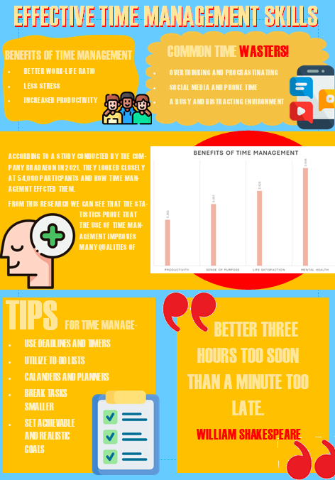
Task 3- Essay Plan: ‘Describe and discuss the psychological, social and physical benefits of owning a pet.’
Introduction:
- State how the essay will describe three distinct benefits of owning a pet. (Psychological, social and physical).
- General overview of owning a pet and the tasks and precautions that need to be carried out, for different kinds of pets such as dogs, cats, lizards etc.
Main Body:
Point 1: Psychological Benefits
- Explain how pets specifically dogs and cats, can boost emotional support and mental wellbeing, through companionship.
- The routine of caring for a pet can give a sense of structure and responsibility, hence a quality and purpose of life.
- Reference statistics of how pet ownership can reduce anxiety and stress levels.
- State how animals, mainly dogs, can have a role to care such as animal assisted therapy dogs, that can help with numerous mental conditions, such as depression, anxiety etc.
- Link any studies that have been conducted to support the statistics and evidence.
Point 2: Social Benefits
- Discuss how pets can help owners meet new people and engage in social activities. E.g, when taking the pet for a walk.
- Pets can provide emotional support in social situations, for individuals who may struggle with fear being isolated.
- Pet events, pet parks, pet competitions
Point 3: Physical Benefits
- Discuss methods in which having a pet can open new and fun physical exercises.
- State the increase in physical fitness the owner and pet would be getting, as pets require regular exercise, such as walks.
- Show statistics that can support the increase in physical fitness since the ownership of having a pet.
Conclusion:
- Briefly recap the psychological, social and physical benefits that were discussed in the essay.
- State how society would be impacted greater with the importance of pet ownership.
- Conclude with the importance of having a pet and how they positively impact personal lives, while showing companionship.

Sources I used for this Summary:
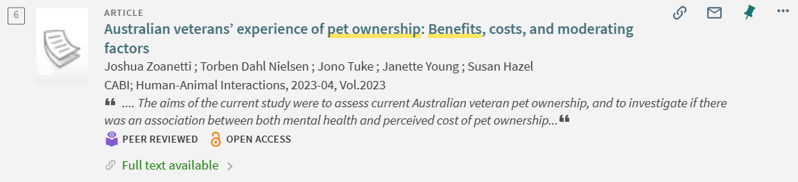
I used this article to look at statistics of the impact of mental health while owning a pet, as well as the findings of the most owned pet, showing the impact of connections with them.
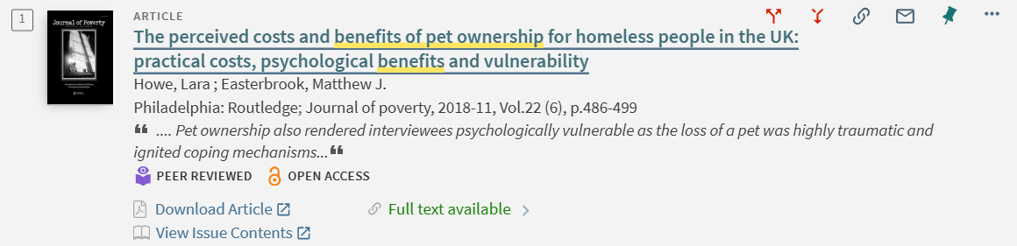
I used this article; to delve into the impacts of pet ownership and the psychological benefits it provides people.
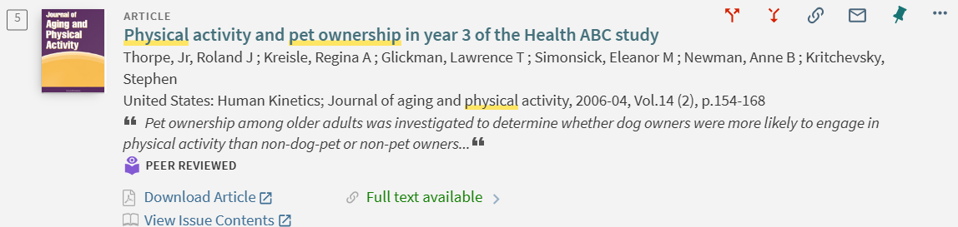
I found this article to gain statistics, in whether physical benefits have increased since having a pet, which will help support with the statement.

Reference List:
A-Z Quotes. (n.d.). William Shakespeare Quotes About Time. [online] Available at: https://www.azquotes.com/author/13382-William_Shakespeare/tag/time.
Aeon, B. (2021). What Time Management Is, And How It Affects Our Lives – Brad Aeon – Time Management Researcher. [online] Brad Aeon. Available at: https://bradaeon.com/what-time-management-is/.
BPS. (n.d.). How to succeed in your degree, with psychology…. [online] Available at: https://www.bps.org.uk/psychologist/how-succeed-your-degree-psychology.
Herrity, J. (2022). 20 Ways You Can Benefit From Time Management. [online] Indeed Career Guide. Available at: https://www.indeed.com/career-advice/career-development/benefits-of-time-management.
Howe, L. and Easterbrook, M.J. (2018). The perceived costs and benefits of pet ownership for homeless people in the UK: practical costs, psychological benefits and vulnerability. Journal of Poverty, 22(6), pp.486–499. doi:https://doi.org/10.1080/10875549.2018.1460741.
Indeed Career Guide. (2024). 9 Common Workplace Time-Wasters and How To Avoid Them. [online] Available at: https://www.indeed.com/career-advice/career-development/time-wasters-and-how-to-avoid-them.
NHS inform. (2024). Easy time-management tips. [online] Available at: https://www.nhsinform.scot/healthy-living/mental-wellbeing/stress/6-easy-time-management-tips/.
help.open.ac.uk. (n.d.). The Open University. [online] Available at: https://help.open.ac.uk/time-management-skills/finding-a-strategy.
Parsons, L. (2022). 8 Time Management Tips for Students. [online] Harvard Summer School. Available at: https://summer.harvard.edu/blog/8-time-management-tips-for-students/.
Thorpe, R.J., Kreisle, R.A., Glickman, L.T., Simonsick, E.M., Newman, A.B. and Kritchevsky, S. (2006). Physical Activity and Pet Ownership in Year 3 of the Health ABC Study. Journal of Aging and Physical Activity, [online] 14(2), pp.154–168. doi:https://doi.org/10.1123/japa.14.2.154.
Zoanetti, J., Nielsen, T.D., Tuke, J., Young, J. and Hazel, S. (2023). Australian veterans’ experience of pet ownership: Benefits, costs, and moderating factors. Human-Animal Interactions, 2023. doi:https://doi.org/10.1079/hai.2023.0013.

