Master of Business Administration
Moodle Name: International Marketing: Principles and Practices
Moodle Code: LCMB7026
Title Of the Assignment: International Marketing: Principles and Practices
Student Name: Vishwesh Anam
Student ID: 2330742
Name of the Lecturer: Dr Tushara Balendran
Date of Submission: 18-12-2025
Word Count: 5200

Table of Contents
1. Introduction……………………………………………………………………………. 4
2. Company Background………………………………………………………………… 5
3. Macro Environment Analysis (PESTEL)…………………………………………….. 6
Overview of PESTEL Framework…………………………………………………............. 6
Political Factors……………………………………………………………………………. 7
Economic Factors………………………………………………………………………….. 7
Social Factors……………………………………………………………………………… 8
Technological Factors…………………………………………………………………….. 10
Environmental Factors…………………………………………………………………… 10
Legal Factors……………………………………………………………………………... 11
Similarities and Differences in Macro Environment……………………………………... 11
4. Hofstede’s Cultural Dimensions Analysis……………………………………………. 8
Overview of Hofstede’s Model……………………………………………………………. 8
Cultural Dimensions in India………………………………………………………............. 8
Cultural Dimensions in Australia………………………………………………………….. 9
Advantages of Hofstede’s Model………………………………………………………….. 9
Limitations of Hofstede’s Model…………………………………………………………... 9
5. Segmentation, Targeting and Positioning (STP)……………………………………. 12
Segmentation……………………………………………………………………………... 12
Targeting…………………………………………………………………………….......... 12
Positioning………………………………………………………………………………... 13
6. Perceptual Mapping………………………………………………………………….. 13
7. Marketing Mix (7Ps)…………………………………………………………………. 15
Product……………………………………………………………………………………. 15
Price………………………………………………………………………………………. 16
Place………………………………………………………………………………………. 17
Market Entry Method…………………………………………………………………... 17
Promotion………………………………………………………………………………… 18
People…………………………………………………………………………………….. 18
Process……………………………………………………………………………………. 19
Physical Evidence………………………………………………………………………… 19
Similarities and Differences in the Marketing Mix………………………………………. 19
8. Evaluation of Marketing Strategy Effectiveness…………………………………… 20
Effectiveness in India…………………………………………………………………….. 20
Effectiveness in Australia………………………………………………………………… 21
Comparative Evaluation………………………………………………………………….. 21
Overall Assessment………………………………………………………………………. 21
9. Directional Development Strategy…………………………………………………... 22
10. Ethical Marketing…………………………………………………………………… 24
11. Recommendations…………………………………………………………………… 25
12. Conclusion…………………………………………………………………………… 26
References………………………………………………………………………………... 27

International Marketing: Principles and Practices
Netflix

Introduction
Netflix is one of the world’s most recognised and influential streaming entertainment brands, celebrated for its global reach, personalised viewing algorithms and extensive library of original content. The company began as a DVD-rental service before shifting to online streaming, a transition that enabled it to redefine how audiences consume entertainment worldwide. Over time, Netflix has evolved into a major digital entertainment powerhouse, shaping industry trends through innovation, data-driven insights and regional content strategies. This report examines Netflix’s international marketing strategies through key analytical frameworks including PESTEL, Hofstede’s cultural dimensions and the 7Ps of marketing, with particular attention to how the company operates and adapts within the diverse markets of India and Australia.


Source: Netflix Logo (2022)

Company Background
Netflix was established in 1997 in California by Reed Hastings and Marc Randolph. The company originally operated as an online DVD rental service and later evolved into a subscription-based streaming platform (Jati and Serenade, 2024). Today Netflix delivers digital content across more than 190 countries. The service offers movies, series and documentaries and is known for its investment in original productions such as Stranger Things, Money Heist and various region-specific films. Its mission is to entertain the world through accessible, personalised and high-quality content. This mission guides the brand’s marketing strategies in diverse markets, adapting its offerings to national preferences and cultural contexts (Rental, 2023).

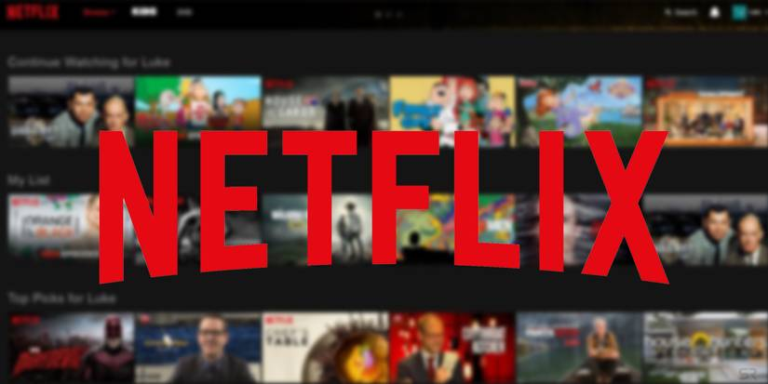
Source: Feix, (2021)

MACRO Environment (PESTEL) Analysis
The PESTEL framework is a strategic tool used to evaluate how political, economic, social, technological, environmental and legal forces shape an organisation’s external environment. It helps firms anticipate opportunities and threats arising from national market conditions and informs international marketing decisions (Whittington and Scholes, 2020). By examining these six external factors, companies like Netflix can understand how macro-level influences differ across countries and adapt their strategies accordingly.
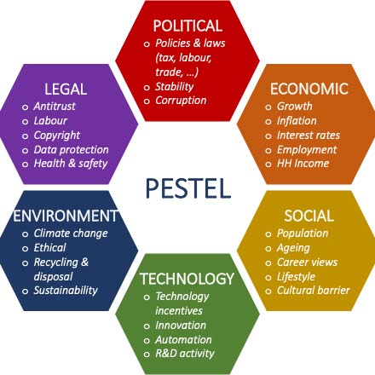
Source: PESTEL Analysis by Nyamboga, (2024).
1. Political Factor
India
Favourable: Stable governance in India supports digital expansion and foreign direct investment. Government support for Digital India initiatives increases internet penetration, enabling Netflix to reach broader audiences.
Australia
Unfavourable: Strict regulations on content classification and regional broadcasting increase compliance requirements. Additionally, competition from government-supported channels influences Netflix’s operations (Onyusheva, 2021).
2. Economic Factor
India
Favourable: Rapidly growing middle class and increasing smartphone affordability provide strong potential for subscriber growth. Low-cost mobile plans create an opportunity for Netflix’s mobile-only subscription model.
Australia
Unfavourable: High operational costs and subscription saturation create pricing pressure for Netflix, along with strong local competition from Stan, Foxtel and Amazon Prime (Rešetar, 2020).
3. Social Factor
India
Favourable: India’s large, young, digitally active population presents a massive market for streaming services. Cultural preference for entertainment and regional storytelling supports Netflix’s local content production.
Australia
Unfavourable: Strong loyalty toward local content and sports programming presents challenges for Netflix’s content acquisition. Reaching rural audiences remains difficult due to uneven content preferences (Davis, 2023).
Hofstede Cultural Dimensions

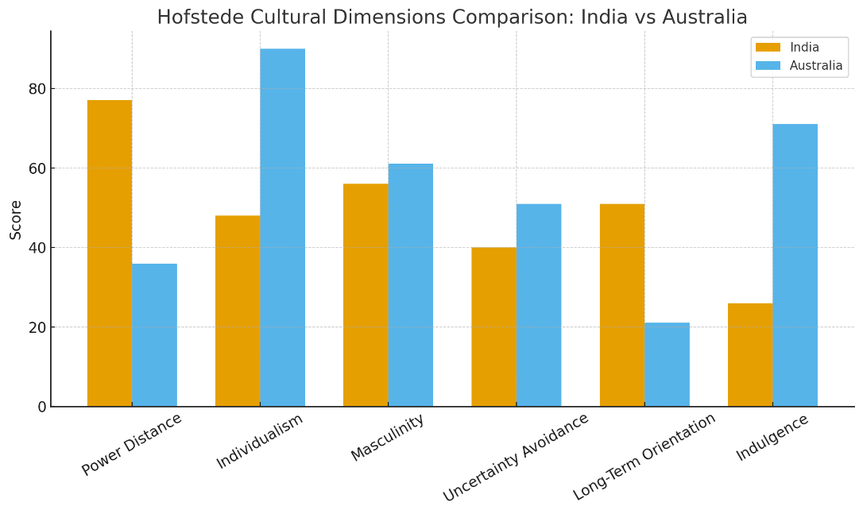
Hofsted Culture Dimension analysis for Netflix between India & Australia

Netflix tailors its marketing strategies by interpreting cultural patterns in India and Australia using Hofstede’s six cultural dimensions.
India
- High power distance (77%): Audiences in India often respond positively to authority figures and celebrity endorsements. Netflix uses this to its advantage by collaborating with well-known Bollywood actors and directors to promote major series and films, helping build trust and visibility among diverse viewer groups.
- Collectivist (48%): Indian households tend to prioritise shared activities, including family-based viewing. This encourages Netflix to highlight content suitable for group watching, festival releases and emotionally driven stories that resonate with collective cultural values (Nafees, 2021).
- Masculine (56%): A focus on achievement, aspiration and success influences entertainment choices. Netflix aligns with this by promoting high-impact dramas, thrillers and success-themed narratives that match viewers’ preference for strong, competitive storylines.
- High uncertainty avoidance (40%): Audiences often rely on familiar genres and trusted formats. This supports Netflix’s strategy of investing in well-known regional genres, adaptations and culturally rooted storylines that reduce perceived risk and increase comfort (Pahlefy, 2025).
- Long-term oriented (51%): Indian viewers value continuity, heritage and long-standing brand presence. Netflix benefits from this by building sustained engagement through multi-season series, consistent content investment and long-term partnerships with local creators.
- Restraint (26%): Social norms and values influence what people feel comfortable watching. As a result, Netflix promotes mainstream, culturally appropriate and family-friendly content, ensuring it fits within social expectations while still offering variety (Kuznyetsova, 2023).

Australia
- Low power distance (36%): Australians generally value equality and independence, meaning audiences make viewing decisions based on personal preference rather than celebrity influence. Netflix reflects this by focusing on quality, authenticity and viewer-driven recommendations instead of relying heavily on authority figures for promotion.
- Individualist (90%): Australian consumers prioritise personal interests and lifestyle fit when selecting entertainment. This shapes Netflix’s strategy to offer diverse genres, personalised suggestions and strong on-platform discovery tools that allow users to curate their own viewing journeys (Feix, 2021).
- Feminine (61%): With an emphasis on well-being, balance and quality of life, Australian culture leans toward content that supports relaxation, enjoyment and emotional connection. Netflix aligns with this by promoting uplifting narratives, character-driven stories and inclusive content that resonates with values of empathy and social cohesion.
- Low uncertainty avoidance (51%): Australians tend to be open to experimentation and innovation, making them willing to try new genres and formats. This allows Netflix to introduce unconventional shows, international content and creative storytelling styles with fewer barriers to acceptance.
- Short-term oriented (21%): Viewers often focus on immediate enjoyment rather than long-term loyalty. Netflix adapts to this by releasing frequent content updates, seasonal promotions and trending series that keep audiences engaged in the moment (Kapliar, 2025).
- Indulgence (71%): Australian society encourages the expression of enjoyment and leisure, supporting a strong binge-watching culture. Netflix capitalises on this by offering seamless streaming, auto-play features and rich content libraries that cater to entertainment as a regular part of everyday life.
Advantages and Disadvantages of the Model
Advantages of the Model
Hofstede’s cultural dimensions provide a useful foundation for understanding how cultural values shape consumer behaviour across different countries. The model helps identify key cultural differences between India and Australia, allowing Netflix to tailor its marketing strategies more precisely to each region’s expectations and norms. By highlighting contrasts in power distance, collectivism, uncertainty avoidance and other dimensions, the framework guides decisions related to promotion, content selection and communication styles (Guan, 2024). This enables the company to design campaigns that resonate more effectively with local audiences, ensuring that both messaging and content feel culturally relevant and engaging.
Disadvantages of the Model
Despite its usefulness, the model has several limitations. Hofstede’s framework tends to oversimplify cultural diversity by categorising entire nations into broad dimensions, which may not reflect the complexity of individual behaviour. It does not account for subcultures, urban–rural differences or generational variations that strongly influence entertainment preferences in markets like India and Australia. Moreover, culture evolves rapidly, especially in digital environments shaped by global media and social platforms, and the model does not fully capture these dynamic shifts (Paul, 2025). As a result, relying solely on Hofstede’s dimensions can lead to incomplete or outdated assumptions when forming marketing strategies.
4. Technological Factor
India
Favourable: Growing adoption of smartphones and affordable data plans enable Netflix’s mobile-only subscription. Investments in AI-driven recommendations improve user engagement.
Australia
Unfavourable: Comparison websites and streaming aggregators increase competition; advanced broadband supports rival platforms equally (Ninive, 2024).
5. Environmental Factor
India
Unfavourable: Electricity and internet access can be inconsistent in rural areas, limiting Netflix’s reach. Additionally, debates about digital addiction influence consumer behaviour.
Australia
Favourable: High digital literacy and stable infrastructure enable seamless streaming. Growing awareness of digital sustainability supports Netflix’s energy-efficient cloud initiatives (Lione, 2023).
6. Legal Factor
India
Favourable: Clear regulatory frameworks for digital platforms allow operational stability. Netflix remains compliant with censorship guidelines and OTT regulation frameworks.
Australia
Favourable: Strict broadcasting rules ensure quality content, which aligns with Netflix’s global standards for safety, classification and accessibility (Klatt, 2023).

Similarities and Differences
Similarities
Both India and Australia operate within stable political and legal systems, providing predictable environments for Netflix to function without major regulatory disruption. In each country, the rapid growth of digital infrastructure has supported the expansion of online streaming, with increasing internet penetration enabling broader access to Netflix services. Both markets also demonstrate clear regulatory frameworks governing broadcasting, digital content and platform compliance, ensuring that Netflix can navigate legal requirements with relative consistency.
Differences
Despite these shared characteristics, the macro-environmental conditions differ in important ways. India’s economic landscape is shaped by a growing middle class and mobile-driven digital adoption, while Australia’s mature economy presents higher operational costs and a saturated subscription market. Social environments also diverge: India’s youthful, entertainment-oriented demographic creates favourable conditions for streaming growth, whereas Australia’s mixed viewing preferences and strong affinity for local content create more competitive pressure. Technologically, India’s mobile-first ecosystem contrasts with Australia’s reliance on high-speed broadband, while environmental conditions differ due to India’s inconsistent infrastructure in rural regions versus Australia’s stable and reliable digital environment.

4. Segmentation, Targeting and Positioning (STP)
1. Segmentation
India: Netflix segments the Indian market using demographic factors such as youth and young adults who are highly active in digital entertainment. Psychographic segmentation focuses on entertainment-oriented viewers who enjoy diverse genres and storytelling styles. Behavioural segmentation highlights mobile-first consumption, as many Indian users rely on smartphones for streaming due to affordability and convenience (Brookey, 2023).
Australia: Segmentation in Australia is primarily lifestyle-based, reflecting consumers who value convenience, flexible viewing time and on-demand access. This market includes audiences with strong binge-watching habits and a preference for premium-quality content delivered through reliable high-speed internet on multiple devices (Marpe, 2022).
2. Targeting
India: Netflix adopts a differentiated targeting strategy in India by tailoring subscription plans and content offerings to multiple segments, including young adults, urban families and heavy mobile users. Affordable mobile-only plans are designed for price-sensitive consumers, while premium multi-device plans cater to households seeking broader accessibility. This approach allows Netflix to address India’s diverse income levels, digital behaviours and regional content preferences, strengthening its position among the country’s most active streaming audiences.
Australia: In Australia, Netflix also applies a differentiated targeting strategy, focusing on working professionals, family households and viewers who prioritise high-quality international entertainment. These segments are typically willing to pay for premium, ad-free content and value seamless multi-device streaming. By targeting multiple lifestyle-based groups with varied expectations, Netflix maintains strong appeal in a mature and competitive streaming market (Pratama, 2023).
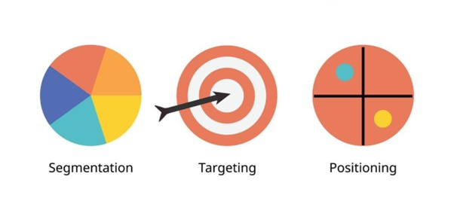
Source: STP Analysis, by Marpe (2022).
3. Positioning
India: Netflix positions itself as a premium streaming platform offering an extensive mix of regional, Bollywood and international content. The platform highlights its exclusive originals and diverse language options to attract culturally varied audiences.
Australia: Netflix positions itself as a high-quality, ad-free entertainment provider with a strong catalogue of global originals. Its emphasis on convenience, reliability and polished content supports its image as a leading premium service in the Australian entertainment market (Baranidharan, 2025).
5. Perceptual Map of Netflix
India:
In the Indian market, Netflix is positioned as a premium, high-quality streaming platform when compared to lower-priced competitors such as Disney+ Hotstar, Zee5 and local regional apps. Its strong emphasis on original content, international titles and polished production values sets it apart from budget services that operate on lower subscription fees (Barraza, 2025). As a result, Netflix occupies the higher end of the perceptual map in terms of both price and perceived quality.
Australia:
In Australia, Netflix is also viewed as a high-quality streaming provider, but its pricing falls within a mid-to-premium range. This positions it in close competition with platforms such as Stan and Amazon Prime Video, both of which offer competitive prices and strong content libraries (Mkhize, 2024). While Netflix maintains a reputation for superior global originals, the presence of well-established local competitors places it in a more balanced, competitive position on the perceptual map.
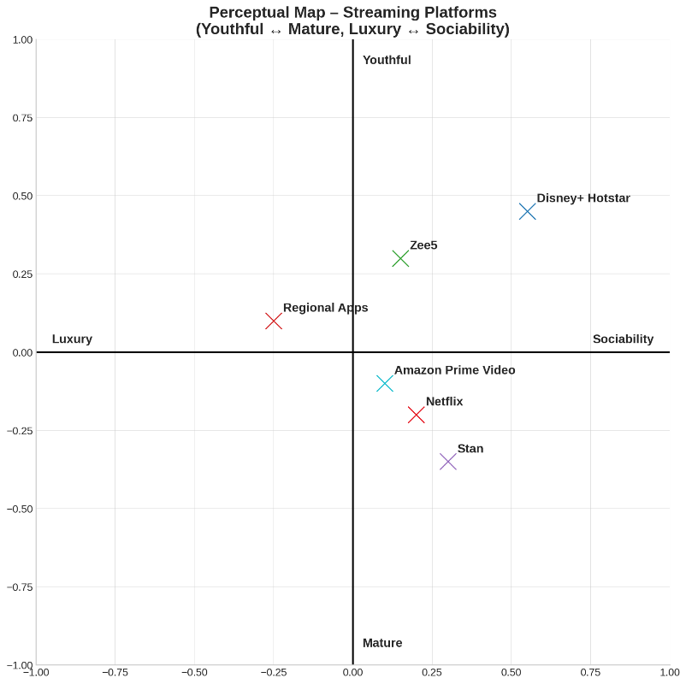
Perpetual Map for Netflix Positioning India Vs Australia

Similarities and Differences
Similarities
Netflix adopts a broad targeting approach in both India and Australia, appealing to a wide range of age groups and viewer segments, from young adults to family households. This inclusive strategy strengthens the platform’s ability to attract diverse audiences with varied entertainment preferences. Across both markets, the company maintains a consistent premium brand image built around high production standards, exclusive originals and a polished user interface. This global positioning reinforces Netflix’s reputation as a leading streaming service. In addition, personalised viewing experiences remain central to its strategy in each country. Advanced recommendation algorithms play a key role in guiding users toward tailored content, enhancing satisfaction and encouraging longer viewing times.
Differences
Despite these overarching similarities, Netflix must adjust its positioning to reflect the unique expectations of each market. In India, the platform places stronger emphasis on affordability, offering lower-priced plans and producing extensive regional content to match cultural diversity and varying income levels. This approach helps improve accessibility and strengthens engagement among India’s mobile-first population. In Australia, the focus shifts toward delivering high-quality content, seamless multi-device viewing and an elevated premium user experience. These elements help Netflix differentiate itself within a competitive streaming landscape, where audiences expect reliable performance and a rich library of global and locally relevant entertainment.

6. Marketing Mix (7Ps)
1. Product
According to Kotler and Keller (2016), a product assortment consists of product width, which refers to the number of different product categories offered, and product depth, which refers to the variety within each category. A broader width shows the range of content genres Netflix offers, while deeper product lines reflect the number of titles, formats and variations within each genre.
India
Product Width (Kotler): Netflix provides a wide assortment of content categories such as Bollywood films, regional-language series, international movies, documentaries, stand-up comedy and children’s programming. This broad width allows Netflix to reach India’s highly diverse audience.
Product Depth (Kotler): Within each category, Netflix offers deep variations. For example:
- Regional content includes extensive catalogues in Hindi, Tamil, Telugu, Kannada and Malayalam, each with multiple original series.
- Bollywood content includes a variety of genres such as romance, thriller, drama and action.
- Indian originals like Delhi Crime, Sacred Games and Kota Factory deepen the content range.
This depth supports the diverse preferences of India’s multilingual and culturally varied population.
Australia
Product Width (Kotler): Netflix offers a broad set of categories including global originals, crime dramas, documentaries, comedy, lifestyle content and family programming. This variety caters to Australia’s multi-user households.
Product Depth (Kotler): Netflix provides deep catalogues within genres that are especially popular in Australia, such as:
- Multi-season global originals (Stranger Things, The Crown, Narcos)
- High-definition formats (HD, UHD, Dolby Vision)
- Strong documentary collections (Don’t F**k With Cats, Our Planet)
This depth supports Netflix’s premium positioning and meets expectations for high production quality.
2. Price
India:
Netflix implements penetration pricing strategies, including affordable mobile-only plans designed to attract price-sensitive consumers. This enables broader adoption in a market where income levels vary significantly.
Australia:
In Australia, Netflix follows competitive pricing aligned with mid-range subscription tiers. Its pricing reflects a balance between premium content and affordability in a market with mature streaming habits (Schauerte, 2021).
3. Place
India
Netflix ensures wide accessibility across smartphones, tablets, laptops and smart TVs, reflecting India’s strong mobile-first streaming culture. Distribution is strengthened through partnerships with telecom providers such as Jio and Airtel, which offer Netflix subscriptions through bundled data plans. These collaborations broaden reach and improve affordability for diverse user groups.
Australia
In Australia, Netflix is accessed through high-speed broadband networks, smart TVs, home streaming devices and tablets. Its integration with major telecom and internet service providers enables smooth distribution and supports Netflix’s premium viewing experience across urban and regional households.

Market Entry Method
Netflix entered both India and Australia through a direct entry strategy using a wholly owned digital platform, operating independently without joint ventures or local equity partnerships. This approach is well suited to digital services, as streaming content can be scaled across markets without physical distribution constraints.
Advantages of Direct Entry
A major advantage of direct entry is full strategic control over pricing, branding, platform design and content decisions, That statement accurately describes the advantages of a direct entry strategy for a company like Netflix while adapting selectively to local markets. This control is particularly important in India and Australia, where regulatory requirements and consumer preferences differ. Direct entry also enables rapid market rollout, helping Netflix establish early presence in competitive streaming markets. In addition, full ownership allows Netflix to collect user data directly, strengthening personalisation and market-specific marketing decisions.
Disadvantages of Direct Entry
Direct entry also involves higher operational and regulatory risk, as Netflix must manage compliance, content standards and platform governance independently. In India, this includes cultural sensitivity and censorship concerns, while in Australia it involves classification and data protection obligations. The lack of local ownership partners may further limit contextual insight and political leverage, increasing exposure to market and regulatory uncertainty.
Overall Assessment
Overall, the direct entry strategy aligns well with Netflix’s digital business model and global brand strategy. In both India and Australia, the benefits of control, scalability and data-driven personalisation outweigh the associated risks, enabling Netflix to operate consistently while retaining long-term strategic flexibility.

4. Promotion
Netflix uses a consistent promotional strategy across both regions, relying on digital marketing campaigns, social media engagement, influencer collaborations and high-impact trailer launches. These approaches help generate excitement around new releases and maintain a constant presence in public discourse (Naidoo, 2024).
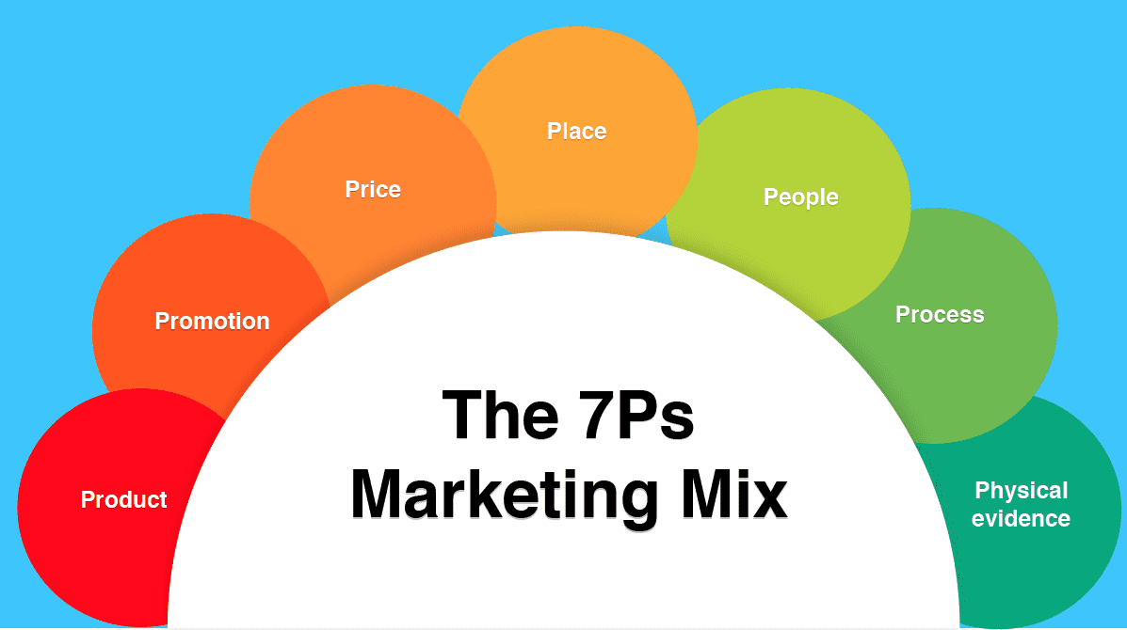
Source: Marketing Mix Analysis Framework
5. People
India:
Local production teams and collaborations with regional creators ensure that content aligns closely with Indian cultural preferences. Customer support is also enhanced through regional language options.
Australia:
Netflix employs dedicated content teams responsible for securing licensing agreements and identifying opportunities for Australian originals. Customer service is streamlined for users across the country, offering timely troubleshooting and support (Scarlata, 2025).
6. Process
India:
The subscription and payment process is designed to be quick and user-friendly, with multiple digital wallet options and instant mobile payment methods catering to India’s evolving fintech ecosystem.
Australia:
Netflix provides smooth onboarding supported by high-speed servers and stable content delivery. The platform ensures reliable streaming quality, which is essential in a competitive entertainment market (Paul, 2025).
7. Physical Evidence
India:
Netflix enhances user experience through a branded interface available in multiple local languages, visually appealing promotional posters and region-specific thumbnails that reflect cultural preferences.
Australia:
The platform maintains a clean, premium interface with strong accessibility features, ensuring ease of navigation and inclusive viewing for a wide range of users (Feix, 2021).
Similarities and Differences
Similarities
India and Australia both benefit from Netflix’s strong digital presence and globally consistent brand identity, which reinforces user trust and recognition across markets. This cohesive branding ensures that viewers associate Netflix with high-quality entertainment, regardless of where they access the platform. The service also maintains a unified interface design in both countries, creating a familiar and intuitive user experience for international audiences who may switch devices or travel between regions. Additionally, Artificial intelligence (AI) has become a disruptive force that has revolutionized industries and changed business practices. The integration of AI has brought numerous benefits to various functional areas within organizations, with marketing experiencing a significant positive impact.
Differences
Despite these similarities, Netflix adapts its on-platform experience to reflect the cultural and behavioural differences of each audience. Indian users encounter more regionally tailored content cues, including local-language thumbnails, culturally relevant visuals and recommendations based on regional storytelling traditions. These adaptations help ensure that the platform resonates with India’s diverse and multilingual user base. In contrast, Australian users are presented with suggestions that emphasise premium, cinematic and lifestyle-oriented content, aligned with national viewing patterns and preferences. This approach strengthens Netflix’s positioning as a high-quality entertainment provider in a competitive Australian streaming landscape.

Evaluation of Marketing Strategy Effectiveness
This section evaluates the effectiveness of Netflix’s marketing strategies in India and Australia by assessing market performance indicators and examining the fit between strategic decisions and local market conditions. The evaluation draws on evidence such as subscriber scale, market share positioning and competitive performance, linking outcomes to Netflix’s STP choices and marketing mix adaptations.
Effectiveness in India
Netflix’s marketing strategy in India has achieved targeted effectiveness, particularly in premium brand positioning and engagement, though overall performance is constrained by strong price competition. India is one of the world’s largest OTT markets, with dominant platforms such as Disney+ Hotstar reporting over 40 million subscribers, compared with Netflix’s approximately 6–7 million subscribers. This numerical gap highlights Netflix’s limited market share despite strong brand visibility (Feix, 2021).
From an STP perspective, Netflix deliberately targets urban, younger and content-driven consumers rather than pursuing mass-market penetration. This differentiated targeting aligns with its premium positioning, but restricts scale in a highly price-sensitive environment. The introduction of mobile-only and lower-priced plans improved accessibility and supported gradual subscriber growth, demonstrating partial effectiveness of the Price element of the marketing mix (Garthwaite, 2021).
The Product strategy has been more effective. Investment in Indian originals has generated strong engagement and international recognition, strengthening brand equity and cultural relevance. However, despite high content quality, Netflix’s pricing remains significantly higher than domestic competitors, limiting conversion among lower-income and rural segments. Overall, Netflix’s strategy in India is effective in reinforcing differentiation and brand strength within selected segments, but less effective in achieving broad market leadership (Barraza, 2025).
Effectiveness in Australia
In Australia, Netflix’s marketing strategy demonstrates high effectiveness within a mature and competitive streaming market. Netflix is estimated to have around 6 million subscribers, heavy investment in original content, a data-driven personalization approach, and sophisticated digital and experiential marketing campaigns. placing it among the leading platforms nationally and ahead of most local competitors such as Stan, while competing closely with Amazon Prime Video.
Netflix’s STP strategy aligns strongly with Australian consumer behaviour. By targeting individualistic consumers who value convenience, content variety and quality, Netflix’s premium positioning fits well with market expectations. This alignment has supported strong retention and stable market share (Klatt, 2023).
From a marketing mix perspective, the Product, Process and Promotion elements are particularly effective. A wide catalogue of global originals, combined with selected local content, enhances perceived value, while seamless multi-device performance supports consistent user experience. Pricing remains competitive within the mid-to-premium range, reinforcing value without diluting brand positioning. High engagement levels indicate that personalisation algorithms and frequent content releases effectively sustain consumer interest.
Comparative Evaluation
Comparatively, Netflix’s marketing strategies are more effective in Australia than in India. In Australia, strong alignment between positioning, purchasing power and market maturity results in higher effectiveness. In India, the same premium positioning enhances brand prestige but limits scalability due to aggressive low-cost competition (Biswas, 2024).
Overall Assessment
Netflix brand positioning and social media marketing strategies within the new media environment. The brand identity of Netflix, which is distinguished by its innovation, accessibility, and diversity, is what makes it successful. This confirms that Netflix’s international performance reflects contextual alignment rather than uniform outcomes across countries.

7. Directional Development Strategy
Netflix’s directional development strategy supports its international marketing objectives by reinforcing market responsiveness, sustaining competitive advantage and enhancing long-term growth across diverse national contexts. Rather than pursuing uniform expansion, Netflix adopts a market-oriented development approach that aligns content investment, pricing flexibility and technological capability with the structural conditions and consumer expectations of each country. This strategy enables the brand to maintain global consistency while responding effectively to local demand conditions and competitive pressures (Guan, 2024).
Directional Strategy in India
In India, Netflix’s directional development strategy prioritises market deepening through affordability and cultural localisation. The platform’s expansion of regional-language content represents a deliberate response to India’s linguistic diversity and fragmented entertainment preferences. By investing in Hindi and non-Hindi originals, Netflix increases perceived relevance among regional audiences and reduces dependence on international content, which may be culturally distant for some viewers. This approach supports subscriber acquisition beyond metropolitan centres and strengthens engagement among price-sensitive and mobile-first consumers (Löhnert, 2022).
Strategic partnerships with telecom providers further reinforce this development direction. Bundled subscription offerings reduce effective pricing barriers and improve accessibility, allowing Netflix to compete more effectively with domestic streaming platforms that operate at lower price points. The introduction of mobile-only and low-cost plans reflects a penetration-oriented development strategy, designed to build scale and brand familiarity in a rapidly expanding but highly competitive market (Lomachynska, 2023). Collectively, these initiatives demonstrate how Netflix’s directional development in India aligns closely with local economic conditions and consumption behaviour, enhancing the effectiveness of its broader marketing strategy.
Directional Strategy in Australia
In contrast, Netflix’s directional development strategy in Australia emphasises differentiation and retention rather than market expansion. As the Australian streaming market is relatively mature, growth depends less on price-led acquisition and more on perceived value and content quality. Investment in Australian original productions supports this objective by strengthening cultural relevance and meeting expectations for locally produced content. This strategy also helps Netflix maintain legitimacy within the national media landscape and differentiate itself from global competitors offering largely standardised content.
To address rising subscription fatigue, Netflix explores flexible pricing and service options that support customer retention without undermining its premium positioning. This approach reflects a consolidation-oriented development strategy, focused on sustaining long-term loyalty rather than rapid user growth. Additionally, the use of energy-efficient cloud infrastructure aligns with increasing consumer awareness of digital sustainability, reinforcing Netflix’s corporate responsibility credentials and enhancing brand perception in an environmentally conscious market (Rešetar, 2021). Together, these initiatives enable Netflix to remain competitive in Australia by aligning its development trajectory with consumer expectations for quality, responsibility and service reliability.

8. Ethical Marketing
Ethical considerations are central to Netflix’s marketing strategy in India due to the platform’s cultural influence, data-driven targeting and growing regulatory scrutiny. cultural diversity, data regulations, and complex sociopolitical landscape (Kuznyetsova, 2023). This section evaluates ethical marketing issues in the Indian market by linking them to segmentation, targeting and positioning (STP) and relevant marketing mix elements, followed by recommendations and a concluding assessment.
Ethical Issues Linked to STP and Marketing Mix
In India, the most significant ethical concern relates to cultural sensitivity and content appropriateness. Netflix targets younger, urban and digitally progressive consumers who are more open to unconventional narratives involving crime, sexuality and political themes. While this targeting strategy is commercially logical, it raises ethical concerns in a collectivist society where media consumption often occurs in shared family environments (Pahlefy, 2025). Content perceived as offensive or misaligned with cultural and religious values has attracted criticism from social groups and regulators, highlighting the ethical tension between creative freedom and societal responsibility.
From an STP perspective, Netflix’s positioning as a bold, global and original content provider risks alienating value-conscious audiences if ethical boundaries are not carefully managed. Within the marketing mix, ethical issues are most evident in the Product and Promotion elements. The product itself content is the primary source of ethical debate, while promotional strategies can amplify controversy if sensitive themes are aggressively marketed (Guan, 2024). Netflix has responded by selectively promoting culturally acceptable content, strengthening content warnings and increasing investment in locally produced Indian originals, demonstrating ethical adaptation in both positioning and promotion.
Ethical Evaluation Using Ethical Frameworks
Using a stakeholder ethics approach, Netflix must balance the interests of creators, consumers, regulators and wider society. While bold storytelling supports creative industries and consumer choice, insufficient cultural sensitivity may harm social cohesion and brand legitimacy. From a utilitarian perspective, Netflix’s presence generates overall benefits through employment, creative expression and consumer entertainment. However, ethical tensions arise when content causes social discomfort or when engagement-driven algorithms prioritise viewing intensity over consumer wellbeing (Lione, 2023).

9. Recommendations
India
Introducing hyper-local content would allow Netflix to build stronger emotional and cultural connections with audiences across India’s diverse regions. By developing stories rooted in specific communities, traditions and local experiences, the platform can appeal to viewers who seek authenticity and meaningful representation. Strengthening affordability through bundled packages is also essential, as combined plans offered through telecom operators or internet providers make subscriptions more accessible to price-sensitive users. This approach not only lowers the overall cost for consumers but also encourages wider adoption among first-time streamers. Expanding partnerships with major telecom firms further enhances distribution by improving visibility, reach and competitive pricing options. These collaborations support Netflix’s ability to penetrate new market segments and maintain relevance in a highly competitive OTT landscape.
Australia
In Australia, offering loyalty and retention programmes would help sustain long-term engagement by rewarding subscriber commitment. Providing incentives such as exclusive previews, limited-time discounts or early access to new content can reduce churn and enhance perceived value. Increasing investment in Australian original productions is equally important, as locally produced films and series strengthen cultural relevance and demonstrate Netflix’s support for national creative industries. Such investment also positions the platform favourably in anticipation of future content regulation requirements. Additionally, addressing subscription fatigue through flexible models such as adjustable pricing tiers, pause options or temporary low-cost plans can help retain users who feel overwhelmed by multiple streaming commitments. These measures reinforce Netflix’s competitive positioning in a mature and fast-evolving Australian streaming market.

10. Conclusion
Netflix has firmly positioned itself as a leading global entertainment provider, supported by strong brand equity and widespread recognition in both India and Australia. Although each market presents significant growth potential, their distinct consumer behaviours and expectations require carefully tailored marketing strategies. In India, success depends on offering affordable subscription options and investing in regional, culturally grounded content that appeals to diverse linguistic and demographic groups. Australia, by contrast, places greater emphasis on high production quality, sustainable digital practices and seamless viewing convenience across devices. By aligning its approach with these differing priorities, Netflix can enhance user engagement, deepen market penetration and reinforce a sustainable competitive advantage within its international portfolio.

References:
Jati, I.M. and Serenade, V., 2024. Netflix's Global Market Entry and Adaptation Strategies Critical Review. Jurnal Informatika Ekonomi Bisnis, pp.932-936.
Rental, D.V.D., 2023. Case Study: Netflix. Strategic International Management, 2022, p.153.
Onyusheva, I.R.I.N.A. and Baker, A.S., 2021. Netflix: A case study on international business strategy development. The EUrASEANs: journal on global socio-economic dynamics, 6(31), pp.40-52.
Rešetar, J. and Seljan, M., The Case study of Netflix. Company analysis and risk management strategies in the global business environment–a case study collection, pp.279-318.
Davis, S., 2023. What is Netflix imperialism? Interrogating the monopoly aspirations of the ‘World's largest television network’. Information, Communication & Society, 26(6), pp.1143-1158.
Nafees, L., Mehdi, M., Gupta, R., Kalia, S., Banerjee, S. and Kapoor, S., 2021. Netflix in India: expanding to success. Emerald Emerging Markets Case Studies, 11(2), pp.1-31.
Pahlefy, M.R., Wenedy, A., Rahman, M.F., Toruan, L.G.O.L. and Camila, A.C., 2025. Cross-Cultural Marketing Failures And Successes: Lessons From Global Brands. Jurnal Adijaya Multidisplin, 3(01).
Kuznyetsova, A., Garafonova, O., Yankovoi, R., Zhosan, H. and Lomachynska, I., 2023. Development of an international marketing strategy for domestic enterprises during a state of war. Marketing i menedžment innovacij, 14(4), pp.200-211.
Feix, T., 2021. The streaming revolution in global media and the down of an Epic Battle. In Valuing Digital Business Designs and Platforms: An Integrated Strategic and Financial Valuation Framework (pp. 173-224). Cham: Springer International Publishing.
Kapliar, K., 2025. THE STREAMING REVOLUTION: A COMPREHENSIVE ANALYSIS OF GLOBAL TRENDS AND STRATEGIC ADAPTATIONS IN THE ENTERTAINMENT INDUSTRY. Three Seas Economic Journal, 6(2), pp.52-58.
Guan, Q., 2024. From DVDs to data: Netflix's digital transformation and business information systems. In Exploring the Financial Landscape in the Digital Age (pp. 688-696). CRC Press.
Paul, N., 2025. OTT (Over-The-Top) Platforms: A New Era of Entertainment and Viewership. In Digital Landscape: Communication in the 21st Century (pp. 335-350). Singapore: Springer Nature Singapore.
Ninive, J.A.B., 2024. 21st Century Film Distribution (Master's thesis, NTNU).
Lione, L., 2023. Platforms interacting with Incumbents: Insights from the Audiovisual industry.
Klatt, T.J., 2023. Streaming Film and TV: Industries, Audiences, and Narratives in the Age of Big Tech and the Internet. University of Florida.
Biswas, I.B., 2024. Are You Still Watching: An Overview of Streaming in India (Doctoral dissertation, University of Oregon).
Schauerte, R., Feiereisen, S. and Malter, A.J., 2021. What does it take to survive in a digital world? Resource-based theory and strategic change in the TV industry. Journal of Cultural Economics, 45(2), pp.263-293.
Löhnert, M., 2022. The Impact of Digital Transformation on Business Models: A Literature Review with a Focus on the Media and Entertainment Industry/eingereicht von Markus Löhnert, BSc.
Garthwaite, C., Starc, A. and Pavlus, J., 2023. Over the Top: The Rise of Streaming and the Television Industry Value Chain. Kellogg School of Management Cases, pp.1-39.
Kolakaluri, V.N.S.K., 2022. New modern marketing myopia: A clouded innovation and stigmatized marketing.
Straubhaar, J., Rai, S., Santillana, M. and Dalben, S., 2025. Transnational Streaming Television: Reshaping Global Flows and Power. Taylor & Francis.
Shah, D., 2025. The Netflix Effect: Strategic Innovation and Behavioural Personalisation in the Streaming Era.
Naidoo, M., 2024. No Time to Die: Analysing and Historically Framing the Impact of Digital, Streaming and the Coronavirus Pandemic on UK Cinema Exhibition and Distribution.
Scarlata, A., 2025. Pivoting and Producing for Online TV: Australia's Transition. Taylor & Francis.
Vieželytė, K., 2022. Media transformation in the age of Netflix: user interface and user experience trends of svod platforms (Doctoral dissertation, Kauno technologijos universitetas.).
Brookey, R.A., Phillips, J. and Pollard, T., 2023. Reasserting the Disney brand in the streaming era: A critical examination of Disney+. Routledge.
Marpe, K., 2022. The Digital Art House: Independent Film Distribution in the Online Era (Doctoral dissertation, UCLA).
Pratama, O. and Narimawati, U., 2023. The influence of digital changes on media and entertainment business models: a case study of Netflix and Spotify. Journal of Principles Management and Business, 2(02), pp.108-121.
Baranidharan, S. and Kulkarni, S., 2025. Beyond binge-watching: How Netflix can adapt its digital marketing strategy for long-term success. In Cases on Effective Digital Marketing for Competitive Organizations (pp. 43-90). IGI Global Scientific Publishing.
Barraza, C., 2025. Global Brand, Local Market: A Strategic Analysis of Netflix’s Adaptation Challenges in India.
Mkhize, P.W., 2024. Sustainability of Video Streaming Services in South Africa: A Review of Digital Business Models and Strategies (Master's thesis, University of the Witwatersrand, Johannesburg (South Africa)).

