ASSESSMENT 1 – STRUCTURE AND CULTURE
STUDENT: MIHAI-LIVIU POPESCU
ID : 1919050

Table of Contents
Introduction 3
Asda’s background profile 3
Discussion 4
Organizational structure and culture of Asda 4
Relationship between the structure culture, people and performance of the organization 5
Nature of managerial work 5
Role of leadership 7
Variables determining the effectivity of leadership and management 7
A behavioral approach to management 8
Factors influencing differential behavioral among the working individuals 9
Recommendations 9
Conclusion 10
Reference List 11

Introduction
A successful organization always entails a shared culture that is supported by a potential organizational structure. Cultivation of a structure based on strict policies builds the authentic culture of the organization. The study is particularly designed to explore different dimensions of the structure and culture of Asda. By acknowledging the relationship between culture and structure with people’s performance, the essay is expecting to harness the concept of managerial nature, leadership styles, behavioral approaches to deliver some concrete suggestions for further improvement to the organization.

Asda’s background profile
Founded in 1949, Associated Dairies & Farm Stores Limited or Asda Ltd. is a famous supermarket retailer of the United Kingdom. Headquartered in West Yorkshire, UK, this Walmart subsidiary is the second-biggest supermarket chain in the UK with a market share of 15.4%. With reported revenue of 22.9 billion GBP and an employee base of 165,000 people, the organization took advantage of the economic turmoil and customer's growing interest in low-cost, convenient stores to strengthen its feet on the UK's ground.
Despite having tough competition from other retailers like Tesco, Sainsbury, Aldi, and Lidl, the supermarket giant has successfully multiplied its growth rate up to 4 times of 2.5% from March 2019. According to Roger Burnley, the present CEO, and leader of the organization, delivering goods and services to global customers with an affordable rate is the purpose of the organization. For this, he already acknowledged the importance of promising organizational culture and structure (Asda, 2020).
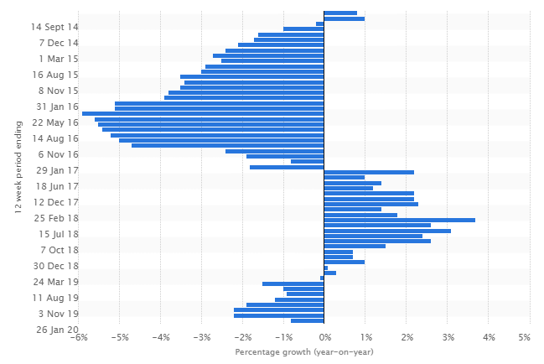
Figure 1: Change in Asda’s sales figure in the UK
(Source: Statista, 2020)

Discussion

Organizational structure and culture of Asda
Asda follows the “Formal hierarchical functional structure” in the organization, which incorporates multiple functional departments. Such an organizational structure helps the brand to manage all its departments and more than 650 stores. Such a structure is severely dependable on its top hierarchy formed by the senior managers, where vital decisions are always taken by the managers. Thus, the promotional process is time-consuming as it always ensures to promote the most skilled and experienced person into the managerial designation (Ahmadyet al. 2016). However, this often demotivates the employees and risks the organizational decision-making process. Here the managers maintain a formal relationship with the subordinates, which often delays the interchange of important information.
The organizational culture that Asda executes is the Role Culture, where each working individual is designated with specific roles and responsibilities by the hierarchical executives. Such culture type never compromises with organizational rules, and thus the managers always make sure that the employees are aware of their liabilities. However, it makes the decision-making process slow and inefficient. It may drive a claustrophobic atmosphere within the organization if not applied properly.

Relationship between the structure culture, people and performance of the organization
The ongoing structure and culture of an organization are directly related to the performance level. Asda follows the conventional hierarchical structure, which is beneficial in maintaining control of work. Organizations like Asda, which work in multiple departments, and with thousands of employees, such a hierarchical structure makes the departmentalization and work distribution process easy (Kariuki and Nguyo, 2020). This peculiar operational pattern and culture of Asda have a significant impact on its people as well. The managers of Asda following this pattern treat all the employees equally. Appreciation is only given on the basis of performance. Employees and managers both follow the formal way of communication, which signifies the authenticity and moral of Asda. Besides, Roger Burnley and other managers believe that it increases employee efficiency.
The Role culture of Asda by creating functional boundaries based on designations delivers a sense of recognition to the employees (Janićijević, 2017). However, the culture is resisting diversity and forcing its employees to follow the pre-prescribed line. Such an initiative can never articulate creativity and innovation in the work. Rather it develops a claustrophobic atmosphere for creative individuals. The rigidity of the hierarchy damages the free flow of communication between the employees and managers, which is another negative sign of employee demotivation. The top executives of Asda have to decentralize their process where employees from all levels will be allowed to take part in the decision making process.

Nature of managerial work
The structure Asda follows demands high performance from its senior managers, starting from decision making to employee motivation. The nature of management role in the context of Asda can be detailed through Mintzberg’s Managerial Roles such as; Information-Processing Roles; "Disseminator, Monitor, and Communicator," Interpersonal Roles; "Leader, Liaison, Figurehead," and Decision-Making Roles; "Entrepreneur, Negotiator, Resource allocators, and Disturbance handler” (Altamony and Gharaibeh, 2017). The nature of work these managers need to perform are detailed below;
Leader Role: It is the responsibility of the managers to articulate progress and motivation among the subordinates through inspirational words and actions.
Liaison Role: It refers to the communication and information sharing obligations of managers, which must entail an engaging exchange of vital data for operational improvements.
Figurehead Roles: Being the Face of the company, the managers must perform all his social and legal duties effectively. He or she needs to promote the same among the employees.
Disseminator: It describes the work of managers in highlighting the valuable and fractal external perspectives into the company and also to the employees.
Spokesperson: It is the responsibility of the managers to transmit important organizational information to outsiders.
Monitor: Duties include the management of departmental success through problem-solving and supervising.
Entrepreneur: The Asda managers have to encourage the employees for creativity and innovation.
Resource Allocator: The manager distributes all types of resources like responsibility, time, funding, and equipment among the workers.
Disturbance handler: Taking potential decisions in sudden difficulties.
Negotiator: Negotiating the major resources internally and externally for the betterment of the organization.
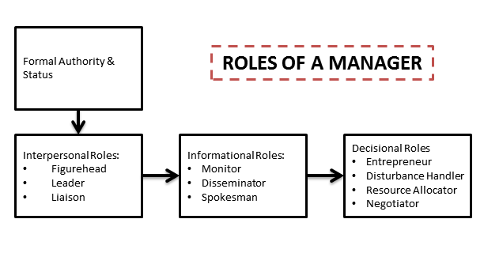
Figure 2: Mintzberg’s Managerial Roles
(Source: Altamony and Gharaibeh, 2017)

Role of leadership
Leaders accompany a significant role in the performance and behavior improvement of working individuals. Managers, in order to handle adverse situations, control activities, and motivate employees, must hold strong leadership attributes. The application of the right leadership style can lead the organization towards immeasurable growth. Under the hierarchical nature, the managers of Asda follow the Autocratic leadership style where the senior executives make the decisions, and the experienced members train the other employees based on the decision. Such leadership style is effective enough to control daily operations. But it brings employee dissatisfaction and organizational conflicts.
Thus, the managers of Asda are advised to follow the Transformational leadership style. Transformational leaders, through their enthusiastic and optimistic nature, encourage the employees towards organizational change and creativity (Veliuet al. 2017). By amplifying the moral culture and transparency standards, transformational leaders can drive productivity and a positive attitude among the workers. The managers of Asda in this leadership style have to harness open and informal communication with the employees. Along with letting the subordinates know about organizational objectives, they have to freely interact about employee's issues and opinions as well.

Variables determining the effectivity of leadership and management
There exist numerous factors that determine the efficiency of the leadership and management of an organization. The work of Asda cannot be done without employee collaboration. In order to derive employee encouragement and teamwork, the leader of Asda management has to drive diversity, leadership, and communication within the workplace.
They have to build teams of employees based on diversity in terms of experience, talents, cultures as well as personality. Diversity not only promotes creativity, team working ability, and innovation but also encourages the working individuals to upgrade their performance to meet the performance statistics of the potential fellows. The managers, through transformational leadership, have to develop a workable mentality and collaborative nature within the team-members (Smutnyet al. 2016). Besides, the leaders of Asda must sanction a portion of their resources on developing potential communication networks. Employees must be encouraged to interact freely with their team-members and also with the leaders.

A behavioral approach to management
Behavioral Management Theory has been evolved to accounting the expectancy and behavior of working individuals in an organization. The behavioral approach is nothing but a shift from Classical leadership to the leadership style that encompasses human need more. The management of Asda still follows the Expectancy Theory. According to Vroom’s Expectancy Theory, an employee develops his or her performance in case of having direct benefits (Lloyd and Mertens, 2018). As the theory suggests, individuals make conscious choices to minimize their pain and maximize their pleasure. Hence, it believes that individuals can be encouraged if they believe;
-Efforts are positively related to performance
-Effective performance provides desirable rewards.
-Such desirable rewards fulfill the most significant need.
-The urge to fulfill the need is so strong that it makes the effort worth giving.

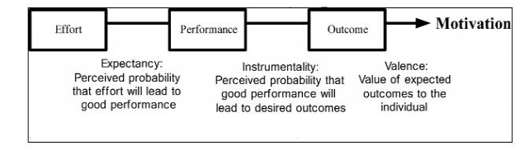Figure 3: Expectancy Theory Model
(Source: Lloyd and Mertens, 2018)
Needless to say, the managers of Asda also follow this theory, where they judge the employees based on their need statistics. However, the Expectancy theory fails to mitigate the issues of the employees properly. For this, Asda managers are advised to Hertzberg’s Motivation-Hygiene theory.
Unlike the classical approach, this theory focuses on two factors, namely the Motivation factor, which believes that employees can be motivated through shared beliefs, recognition, and deliverance of essential responsibilities (Alshmemriet al. 2017). On the other end, there are Hygiene factors that may not encourage the employees in its presence but can demotivate the employees in its absence. For instance, employees may feel demotivated if proper salary increments, recognition, and bonuses are not given. It is essential for Asda managers to bring necessary changes in the work distribution style, where they have to give proper recognition and rewards to the workers.

Factors influencing differential behavioral among the working individuals
Behavioral differences can be observed from the working individual’s side as well. Differences in personality is one of the prime reasons why individuals working in the same position with the same provision behave distinctively. The factors that may impact the difference of behavior among the working individuals are detailed below.
Intellectual abilities refer to the personas such as intelligence, reasoning ability, comprehension, and communication power. Undoubtedly, individuals with high intellectual ability can perform better than others.
Self-awareness abilities describe how the individual feels about the tasks, managers, own responsibilities, and fellow members. If a person executes self-doubt, then he or she can never become the ideal employee (Researchgate, 2020).
Perception can transform into a sensory stimulator where the person receives certain instructions, sound, and criticism based on their own perspective. While the person with an optimistic perspective can receive the criticism positively, the pessimist may take it negatively.
Conscientiousness considers the traits of a person who is highly organized and focused. People with high conscientiousness are perfect for any organization as they are well aware of their tasks.

Recommendations
From the above discussion, it has been observed that Asda’s organizational structure and culture are effective enough to control such a wide employee and departmental range. However, such a structure is leading demotivation among the employees. Apart from the above suggestions, the following are some additional advice for the Asda managers for implementation. First, the managers are suggested to step beyond their typical role of task assignment and do some activities that motivate employees. By building small teams within the department, the departmental managers can execute fun exercises to boost employee productivity. Second is one of the biggest supermarket chains in the UK, Asda is recommended to diversify their people portfolio beyond the country boundary. They have to recruit more young individuals with practical knowledge and fresh ideas irrespective of gender, caste, the background to deliver great customer satisfaction. Third, the managers are further suggested to reflect greater transparency work. Appraise in public, criticize in private should be their motto in team management.

Conclusion
Based on the acknowledgment, it can be concluded that the management style and culture of Asda is applicable and appreciable in many parameters. However, their applied strategies are rigid in some areas. In order to derive flexibility and employee satisfaction, the managers of Asda need to encounter some additional strategies. They have to make their communication channel more information so that employees can talk about their concerns and ideas freely. Besides, the paper also suggests that the managers must incorporate transformational leadership in their practice in place of autocracy to build strong bonds with the subordinates. Ways through which the management can approach the workers effectively are detailed throughout the paper.

Reference List
Ahmady, G.A., Mehrpour, M., and Nikooravesh, A., 2016. Organizational structure. Procedia-Social and Behavioral Sciences, 230, pp.455-462. Available at:https://www.sciencedirect.com/science/article/pii/S1877042816311582/pdf?md5=cfb0fa36a53a3e28da06ac53b79b48ff&pid=1-s2.0-S1877042816311582-main.pdf&_valck=1 [Accessed on: 18:08:2020]
Alshmemri, M., Shahwan-Akl, L., and Maude, P., 2017. Herzberg's two-factor theory. Life Science Journal, 14(5), pp.12-16. Available at:https://www.lifesciencesite.com/lsj/life140517/03_32120lsj140517_12_16.pdf [Accessed on: 18:08:2020]
Altamony, H. and Gharaibeh, A., 2017. The role of academic researcher to Mintzberg’s managerial roles. International Journal of Business Management and Economic Research, 8(2), pp.920-925. Available at: https://omarismailameenmohamedalkhoori.com/wp-content/uploads/2019/06/Journal-1.pdf [Accessed on: 18:08:2020]
Asda (2020), the Story behind Asda's growth, Available at: https://corporate.asda.com/our-story/our-history [Accessed on: 18:08:2020]
Janićijević, N., 2017. Organizational models as configurations of structure, culture, leadership, control, and change strategy. economic annals, 62(213), pp.67-91. Available at:http://www.doiserbia.nb.rs/img/doi/0013-3264/2017/0013-32641713067J.pdf [Accessed on: 18:08:2020]
Kariuki, P. and Nguyo, R., 2020. Firm Level Factors and Organization Performance: the Moderating Role of Industry Environment. Journal of International Business and Management, 3(3), pp.01-13. Available at: https://rpajournals.com/wp-content/uploads/2020/06/JIBM-2019-04-127.pdf [Accessed on: 18:08:2020]
Lloyd, R. and Mertens, D., 2018. Expecting more out of Expectancy Theory: History urges inclusion of the social context. International Management Review, 14(1), pp.28-43. Available at:http://americanscholarspress.us/journals/IMR/pdf/IMR-1-2018/IMR-v1-n1-2018-4-19.pdf#page=28 [Accessed on: 18:08:2020]
Researchgate, (2020), about psychological factors in employees’ behaviour, Available at:https://www.researchgate.net/publication/281035493_An_exploration_of_the_psychological_factors_affecting_remote_e-worker's_job_effectiveness_well-being_and_work-life_balance [Accessed on: 18:08:2020]
Smutny, P., Prochazka, J. and Vaculik, M., 2016. The relationship between managerial skills and managerial effectiveness in a Managerial simulation game. Innovar, 26(62), pp.11-22. Available at:http://www.scielo.org.co/pdf/inno/v26n62/0121-5051-inno-26-62-00011.pdf [Accessed on: 18:08:2020]
Statista (2020), the sales growth of Asda, Available at:https://www.statista.com/statistics/386700/asda-sales-percentage-change-great-britain-uk/ [Accessed on: 18:08:2020]
Veliu, L., Manxhari, M., Demiri, V. and Jahaj, L., 2017. THE INFLUENCE OF LEADERSHIP STYLES ON EMPLOYEE'S PERFORMANCE. Management (16487974), 31(2). Available at:https://pdfs.semanticscholar.org/9755/781471681b4cd484b26c4d5fb3ce39d17d64.pdf [Accessed on: 18:08:2020]

