  Component One: | Student No: | 2120531
 | Module Title: | Operating Hotel Facilities
 | Module Code: | BMIH4006
 | Lecturer:
Housekeeping is an essential aspect of the hospitality industry, as it plays a significant role in ensuring guest satisfaction and maintaining the cleanliness and hygiene of the establishment. As a student pursuing a degree in hospitality, I have learned about the importance of housekeeping and the key skills required for effective performance in this area
Key Skills Required for Housekeeping Team Members:
Housekeeping team members require a range of skills to be effective in their roles. Some of the key skills include attention to detail, time management, communication, physical stamina, and customer service (Altinay, Paraskevas and Jang, 2016). Attention to detail is essential in housekeeping, as team members must be meticulous in their cleaning to ensure that every surface is spotless. Time management is also crucial, as housekeeping team members often have a limited amount of time to clean and prepare rooms between guest stays (Brody, 2016). Communication skills are important for housekeeping team members to ensure that they understand the needs and preferences of guests and can communicate effectively with other team members.
Physical stamina is another crucial skill for housekeeping team members, as they often spend long hours on their feet and must be able to lift and move heavy objects. Finally, customer service is an essential skill for housekeeping team members, as they interact with guests regularly and must be able to provide a high level of service to ensure guest satisfaction (Cherry and Jacob, 2016).
Personal Reflection and Industry Examples:
In my personal experience working in the hospitality industry, I have found that attention to detail is one of the most critical skills for housekeeping team members. During my time working at a hotel, I learned that guests often notice even the smallest details, and any oversight can lead to a negative review or feedback. For example, I once forgot to replace a guest's shampoo bottle, and the guest was unhappy about it. This experience taught me the importance of being meticulous and ensuring that every aspect of the room is cleaned and restocked (Dr. TAHIR SUFI, 2019).
Another essential skill for housekeeping team members is customer service. In the hospitality industry, guests expect a high level of service and attention, and housekeeping team members play a critical role in meeting these expectations. For example, I once had a guest who had a specific request for the placement of their toiletries. By accommodating this request, I was able to provide a personalized and memorable experience for the guest.
Applying Theoretical Knowledge in the Industry:
Theoretical knowledge is essential in the hospitality industry, as it provides a foundation for understanding the industry's operations and best practices (Höchsmann, 2022). In my coursework, I have learned about various cleaning techniques, the importance of following safety protocols, and the significance of providing excellent customer service. By applying this theoretical knowledge in the industry, I have been able to perform my duties effectively and provide a high level of service to guests.
For example, my coursework has taught me about the importance of using proper cleaning equipment and chemicals to ensure that surfaces are cleaned thoroughly and safely (Ferrell, Hirt and Ferrell, 2019). In my work, I have applied this knowledge by using the appropriate equipment and chemicals to clean each surface effectively. Furthermore, my coursework has taught me about the significance of providing a high level of customer service, which I have applied in my interactions with guests to ensure their satisfaction and loyalty.
Importance of Housekeeping Skills in the Hospitality Industry:
Housekeeping is a crucial part of the hospitality industry that plays a significant role in maintaining a clean and welcoming environment for guests. In this industry, guest satisfaction and loyalty are essential, and cleanliness is a crucial factor that directly impacts these factors (G Raghubalan and Smritee Raghubalan, 2015). Housekeeping skills are, therefore, vital for ensuring a high level of service, safety, and efficiency in the hospitality industry.
One of the key reasons why housekeeping skills are important in the hospitality industry is that they directly impact guest satisfaction. A clean and well-maintained room is critical to providing a comfortable and enjoyable experience for guests. Housekeeping team members must have the necessary skills to clean, sanitize, and maintain each room effectively to ensure guest satisfaction and loyalty.
In conclusion, housekeeping skills are vital in the hospitality industry. A clean and well-maintained environment is critical to guest satisfaction, safety, and reputation (Hair and Page, 2015). Housekeeping team members must have the necessary skills to maintain a high level of service and efficiency to ensure the success of the establishment.
Word Count | 760

Component Two:
Problem | Why did it happen? | What are you going to do? | How will you prevent this from happening in the future? | What measures would you introduce to improve team effectiveness?
The guest’s room was not properly cleaned on arrival. | The cleanliness issue may have happened due to a breakdown in the cleaning process or inadequate training of the housekeeping staff (Neslihan KAN SÖNMEZ et al., 2022). | As a team leader, I would investigate the issue by speaking with the guest and confirming with the housekeeping staff who cleaned the room. | To prevent similar issues from happening in the future, I would review and improve the cleaning process, such as by introducing additional quality. | To improve team effectiveness, I would assess the skills and performance of the housekeeping staff and provide feedback.
Inadequate training of housekeeping staff. | The inadequate training of the housekeeping staff may have led to the cleanliness issue. requirements. | As a team leader, I would identify the gaps in the housekeeping staff's training to help them improve their skills (Ivanova, Ivanov and Magnini, 2016). | To prevent similar issues from happening in the future, I would implement a comprehensive training program for the housekeeping staff. | To improve the effectiveness of the housekeeping team, I would provide additional resources to help them work more.
Breakdown in the cleaning process. | The cleanliness issue may have happened due to a breakdown in the cleaning process. | As a team leader, I would investigate the breakdown in the cleaning process and identify the specific point of failure. | To prevent similar breakdowns in the cleaning process from happening in the future, I would introduce standard operating procedures to the housekeeping staff. | To improve the effectiveness of the team, I would introduce additional quality checks at different points of the cleaning process (Koren and Bisesi, 2019).
Ensuring guest satisfaction with the resolution. | Ensuring guest satisfaction with the resolution is a critical aspect of the team leader's role. | This could include offering to move them to a different room, providing a complimentary service, or offering a refund or discount. | To prevent similar issues from happening in the future, I would ensure that the housekeeping staff is properly trained (Mayo, 2014). | To improve the effectiveness of the team, I would introduce a guest feedback system to monitor any concerns raised by guests.
Preventing similar issues from happening in the future. | Preventing similar issues from happening in the future is an important responsibility of a team leader (Pappas and Bregoli, 2016). | I would investigate the root cause of the issue and take appropriate action to prevent it from happening again. | I would introduce standard operating procedures and communicate them to the housekeeping staff. | I would introduce additional quality checks at different points of the cleaning process to ensure that standards are met.

Component Three:
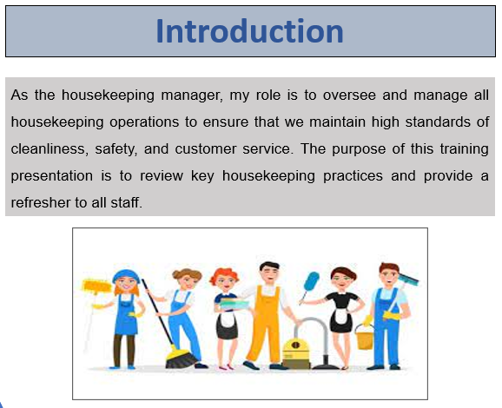
Training Notes: Introduction
As the housekeeping manager, my role is to oversee and manage all housekeeping operations to ensure that we maintain high standards of cleanliness, safety, and customer service. The purpose of this training presentation is to review key housekeeping practices and provide a refresher to all staff.
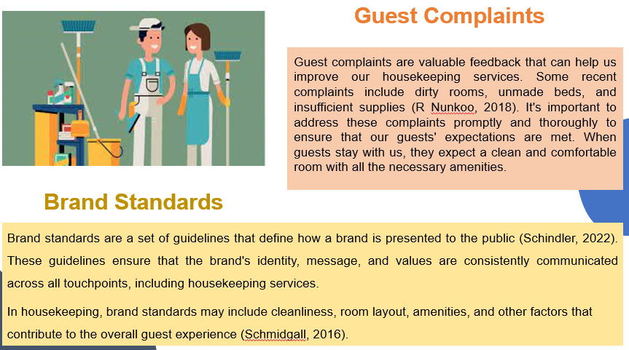
Training Notes: Guest Complaints
Guest complaints are valuable feedback that can help us improve our housekeeping services. Some recent complaints include dirty rooms, unmade beds, and insufficient supplies (R Nunkoo, 2018). It's important to address these complaints promptly and thoroughly to ensure that our guests' expectations are met. When guests stay with us, they expect a clean and comfortable room with all the necessary amenities.
Training Notes: Brand Standards
Brand standards are a set of guidelines that define how a brand is presented to the public (Schindler, 2022). These guidelines ensure that the brand's identity, message, and values are consistently communicated across all touchpoints, including housekeeping services.
In housekeeping, brand standards may include cleanliness, room layout, amenities, and other factors that contribute to the overall guest experience (Schmidgall, 2016).
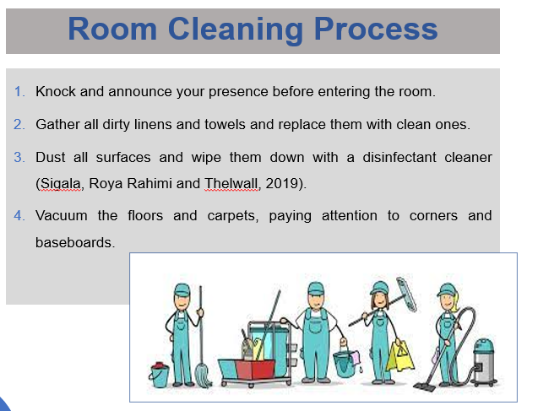
Training Notes: Room Cleaning Process
- Knock and announce your presence before entering the room.
- Gather all dirty linens and towels and replace them with clean ones.
- Dust all surfaces and wipe them down with a disinfectant cleaner (Sigala, Roya Rahimi and Thelwall, 2019).
- Vacuum the floors and carpets, paying attention to corners and baseboards.
Training Notes: Cleaning Supplies and Equipment
Using the right cleaning supplies and equipment is crucial for maintaining high housekeeping standards. Some of the supplies and equipment that should be used include all-purpose cleaners, disinfectants, microfiber cloths, vacuum cleaners, and mops. It's important to use the right supplies and equipment for each task to ensure that the cleaning process is effective and efficient (Woods et al., 2013).

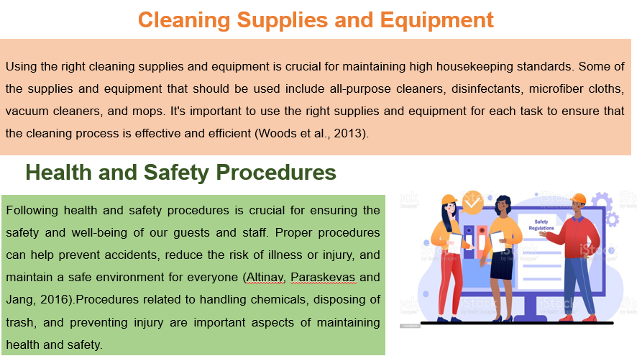
Following health and safety procedures is crucial for ensuring the safety and well-being of our guests and staff. Proper procedures can help prevent accidents, reduce the risk of illness or injury, and maintain a safe environment for everyone (Altinay, Paraskevas and Jang, 2016).
Procedures related to handling chemicals, disposing of trash, and preventing injury are important aspects of maintaining health and safety.
Training Notes: Health and Safety Procedures
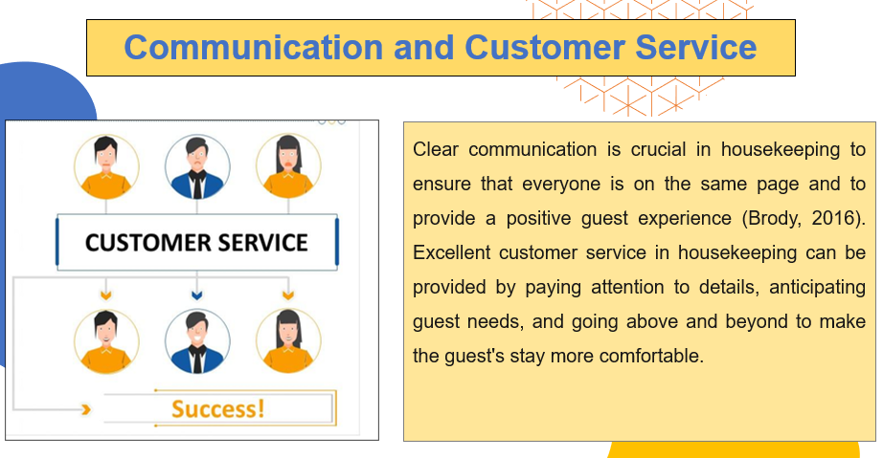
Clear communication is crucial in housekeeping to ensure that everyone is on the same page and to provide a positive guest experience (Brody, 2016). Excellent customer service in housekeeping can be provided by paying attention to details, anticipating guest needs, and going above and beyond to make the guest's stay more comfortable.
Training Notes: Communication and Customer Service
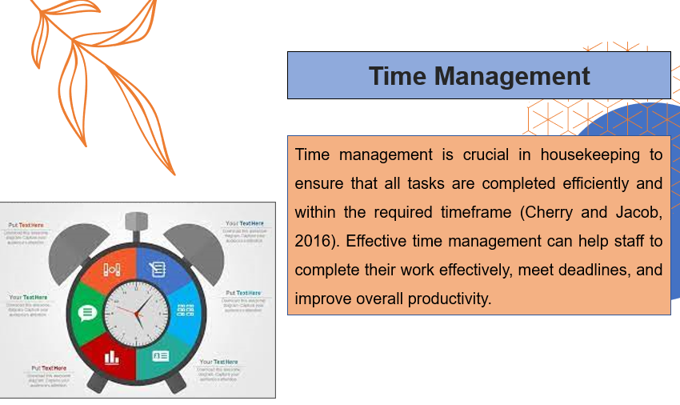
Time management is crucial in housekeeping to ensure that all tasks are completed efficiently and within the required timeframe (Cherry and Jacob, 2016). Effective time management can help staff to complete their work effectively, meet deadlines, and improve overall productivity.
Training Notes: Time Management
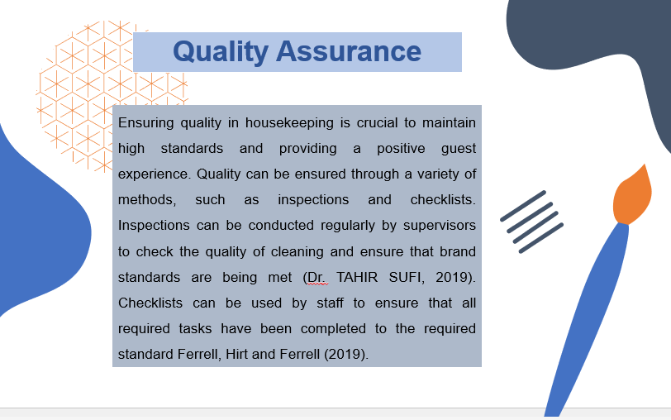
Ensuring quality in housekeeping is crucial to maintain high standards and providing a positive guest experience. Quality can be ensured through a variety of methods, such as inspections and checklists. Inspections can be conducted regularly by supervisors to check the quality of cleaning and ensure that brand standards are being met (Dr. TAHIR SUFI, 2019). Checklists can be used by staff to ensure that all required tasks have been completed to the required standard Ferrell, Hirt and Ferrell (2019).
Training Notes: Quality Assurance
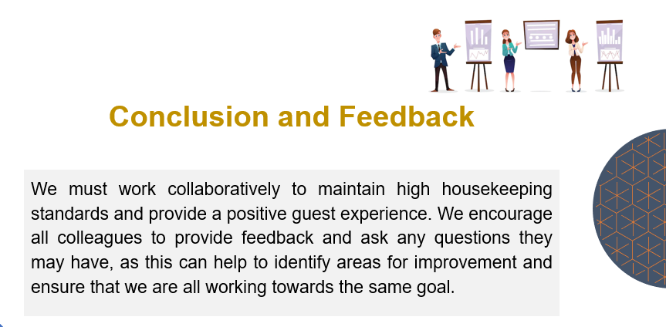
We must work collaboratively to maintain high housekeeping standards and provide a positive guest experience. We encourage all colleagues to provide feedback and ask any questions they may have, as this can help to identify areas for improvement and ensure that we are all working towards the same goal.
Training Notes: Conclusion and Feedback

References
Altinay, L., Paraskevas, A. and Jang, S. (Shawn) (2016). Planning research in hospitality and tourism. Abingdon, Oxon: Routledge Taylor & Francis Group.
Brody, D. (2016). Housekeeping by Design. University of Chicago Press.
Cherry, B. and Jacob, S.R. (2016). Contemporary nursing: issues, trends, & management. St. Louis, Missouri: Elsevier.
Dr. TAHIR SUFI (2019). PRINCIPLES OF HOTEL STAR RATINGS. Notion Press.
Ferrell, O.C., Hirt, G.A. and Ferrell, L. (2019). Business. New York, Ny: Mcgraw-Hill Education.
G Raghubalan and Smritee Raghubalan (2015). Hotel housekeeping : operations and management. New Delhi, India: Oxford University Press.
Hair, J.F. and Page, M. (2015). The Essentials of Business Research Methods. Routledge.
Höchsmann, F. (2022). Sustainable and Environmental Quality Standards for Hotels and Restaurants. BoD – Books on Demand.
Ivanova, M., Ivanov, S. and Magnini, V.P. (2016). The Routledge Handbook of Hotel Chain Management. Routledge.
Koren, H. and Bisesi, M.S. (2019). Handbook of Environmental Health, Two Volume Set. CRC Press.
Mayo, F.B. (2014). Planning an applied research project in hospitality, tourism, & sports. Hoboken, New Jersey: John Wiley & Sons, Inc.
Neslihan KAN SÖNMEZ, İbrahim Armağan AYDEĞER, Ecevit SAYILIR, Oğuzhan DÜLGAROĞLU, Yasin KARADENİZ, Musa OFLAZ, Melahat Yıldırım SAÇILIK, Emel ADAMIŞ, Çiğdem ÖZKAN, Ezgi TÜRKMEN and Bilge Çavuşgil KÖSE (2022). Analysis of New Applications in Hotel Enterprises Main Departments. Livre de Lyon.
Pappas, N. and Bregoli, I. (2016). Global Dynamics in Travel, Tourism, and Hospitality. IGI Global.
R Nunkoo (2018). Handbook of Research Methods for Tourism and Hospitality Management. Edward Elgar Publishing.
Schindler, P.S. (2022). Business research methods. 14th ed. New York, Ny: Mcgraw-Hill Education.
Schmidgall, R.S. (2016). Hospitality industry managerial accounting. Lansing, Michigan: Ahlei American Hotel & Lodging Educational Institute.
Sigala, M., Roya Rahimi and Thelwall, M. (2019). Big Data and Innovation in Tourism, Travel, and Hospitality : Managerial Approaches, Techniques, and Applications. Singapore: Springer Singapore.
Woods, R.H., Johanson, M., Sciarini, M.S. and American (2013). Managing Hospitality Human Resources (AHLEI). Pearson Higher Ed.

