Appendix List

Appendix 1. Ethics Approval Form 2
Appendix 2. Consent Form for the School 16
Appendix 3. Letter of consent for participants 17
Appendix 4. Consent form for participants 18
Appendix 5. Interview questions for staff members 20
Appendix 6. Interview questions for pupils 20
Appendix 7. The Pupil Development Grant Spending Plan 20
Appendix 8. Graph to show staff response to Question 2 24
Appendix 9. Staff responses to Question 7 25
Appendix 10. MAT pupils 25
Appendix 11. Pupils response to Question 1 26
Appendix 12. Pupils response to Question 6 26
Appendix 13. Behavioural Categories. 27
Appendix 14. Teacher response. 28
Appendix 15- The writer’s report of findings 29

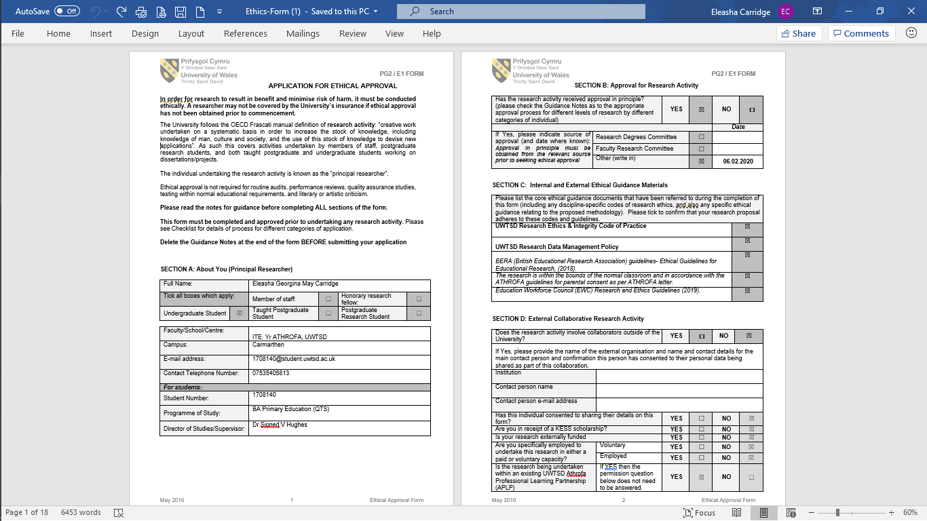
Appendix 1. Ethics Approval Form
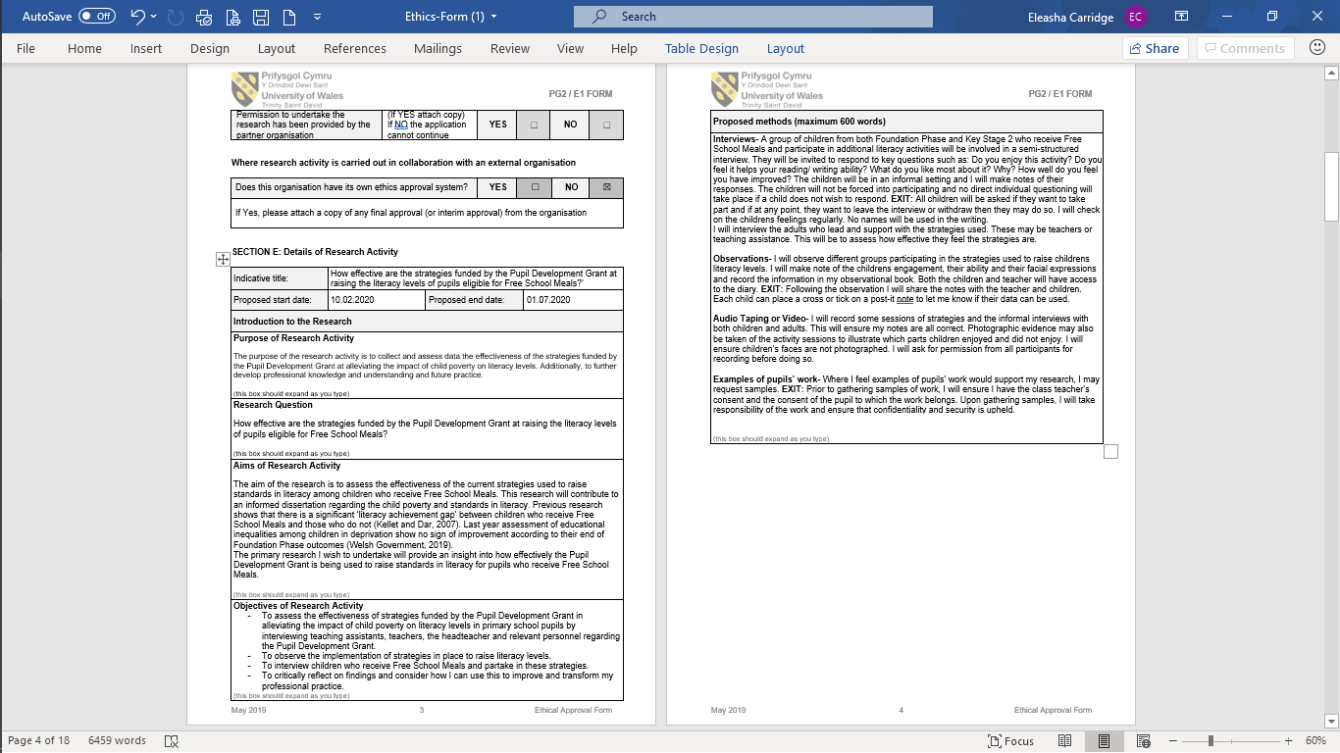
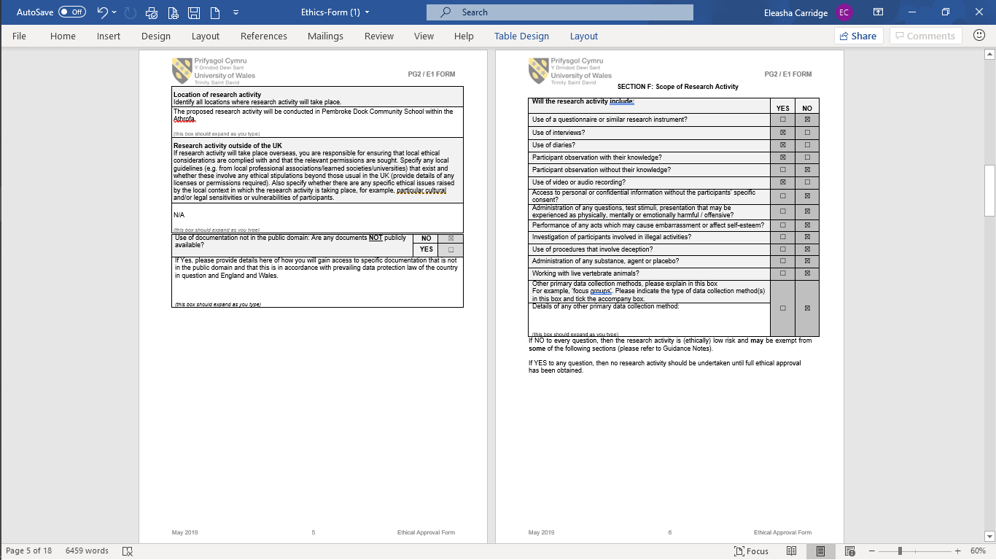
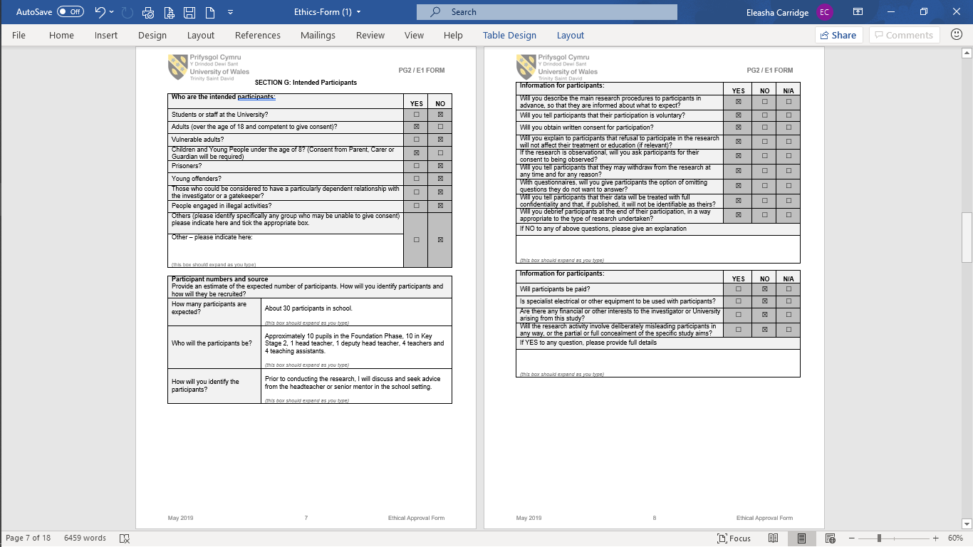
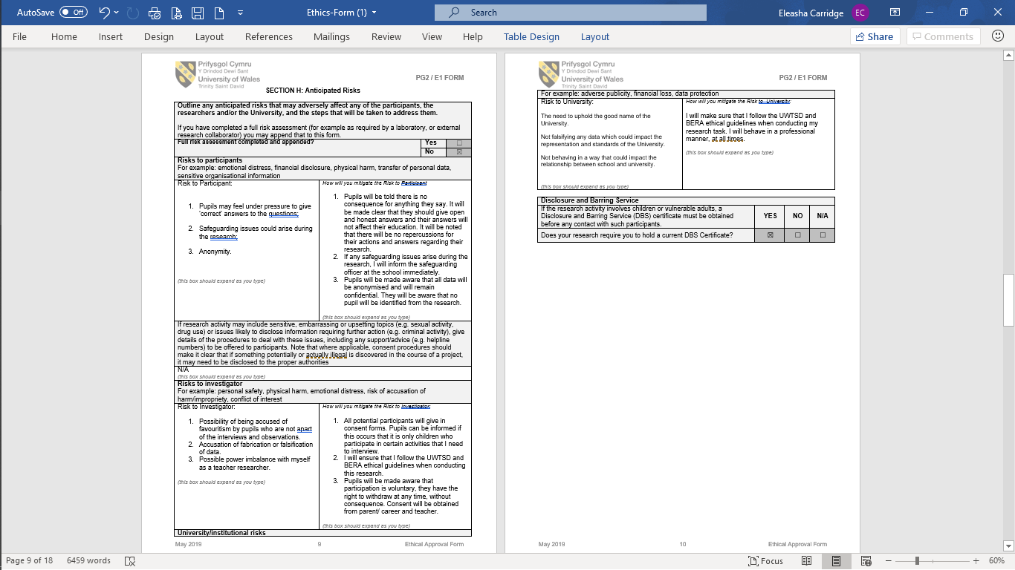

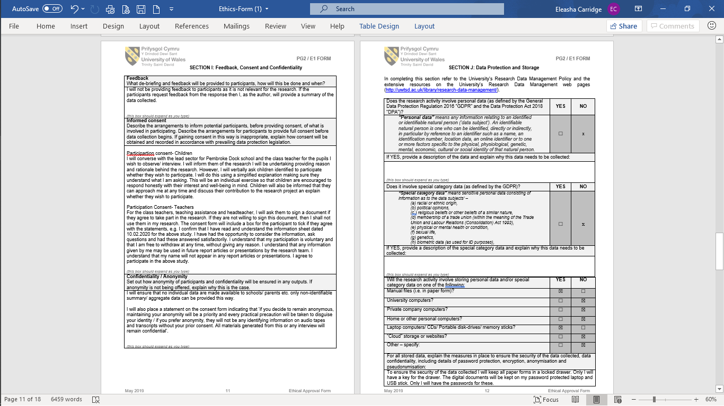
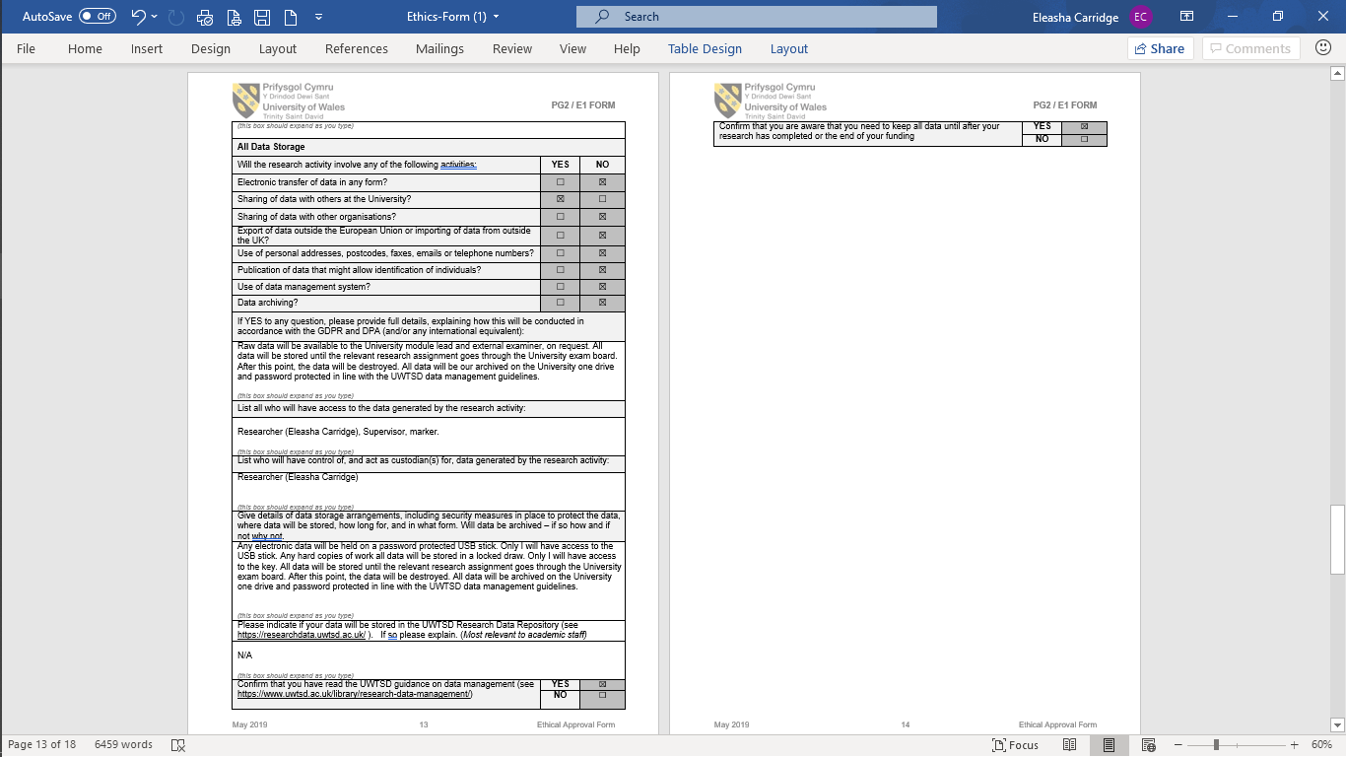
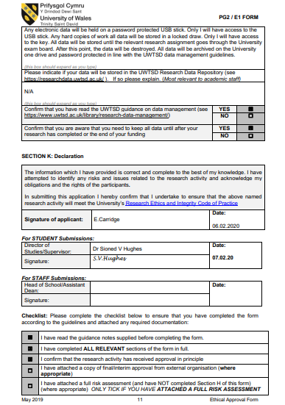

Appendix 2. Consent Form for the School
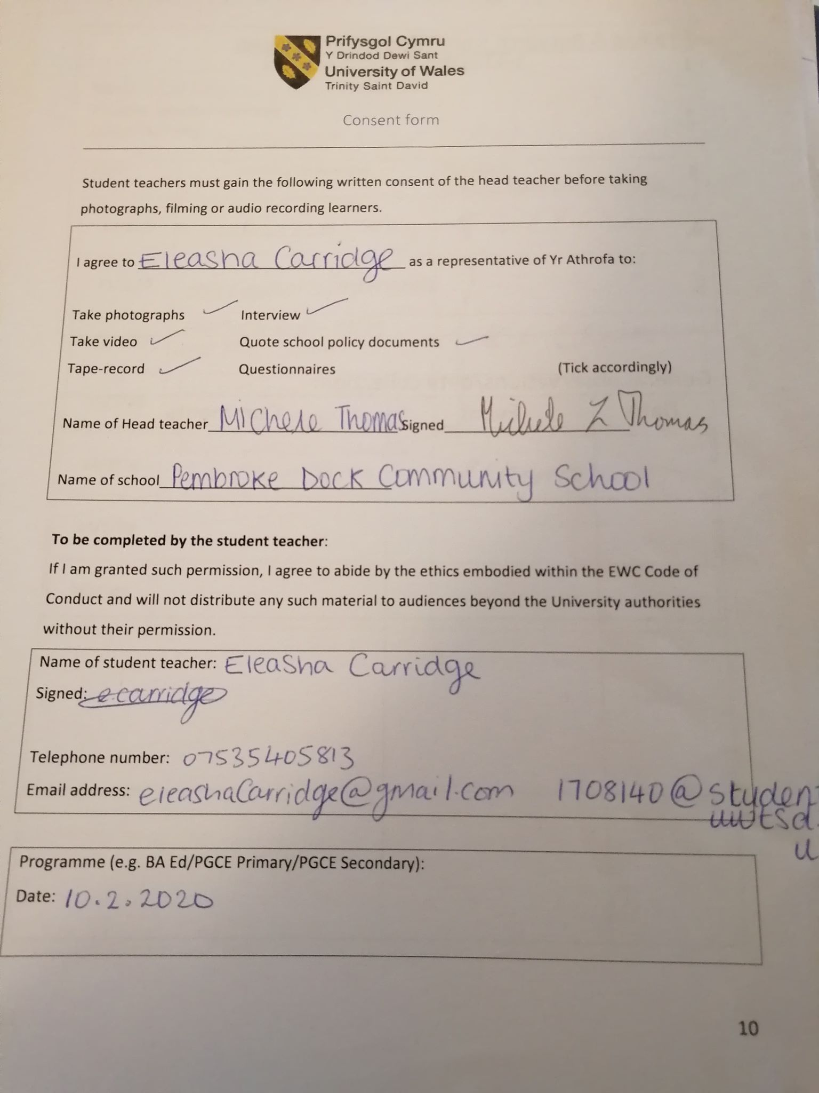

Appendix 3. Letter of consent for participants
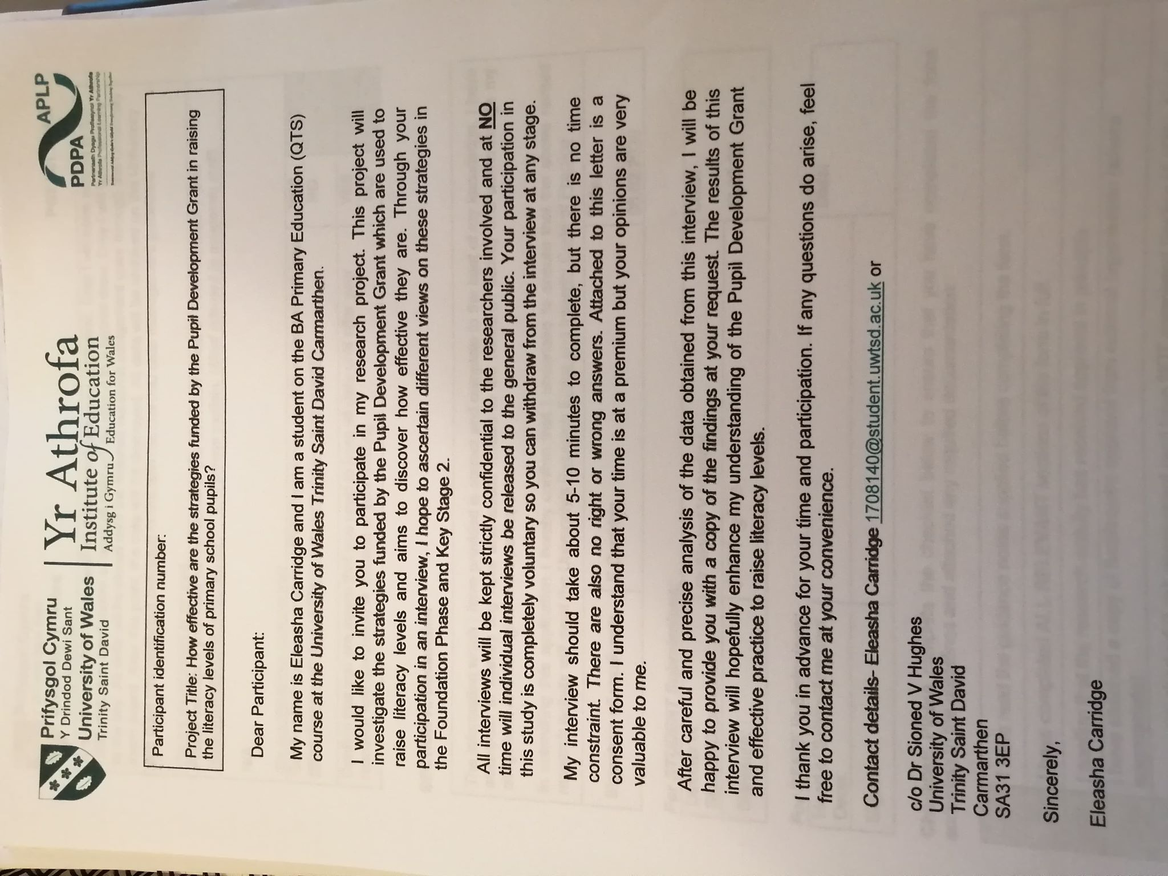

Appendix 4. Consent form for participants
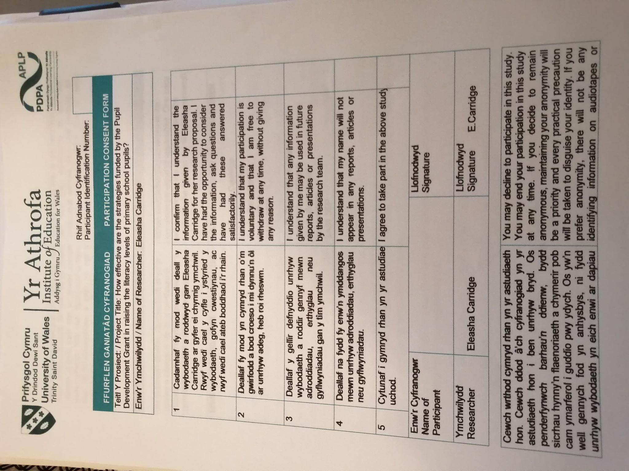
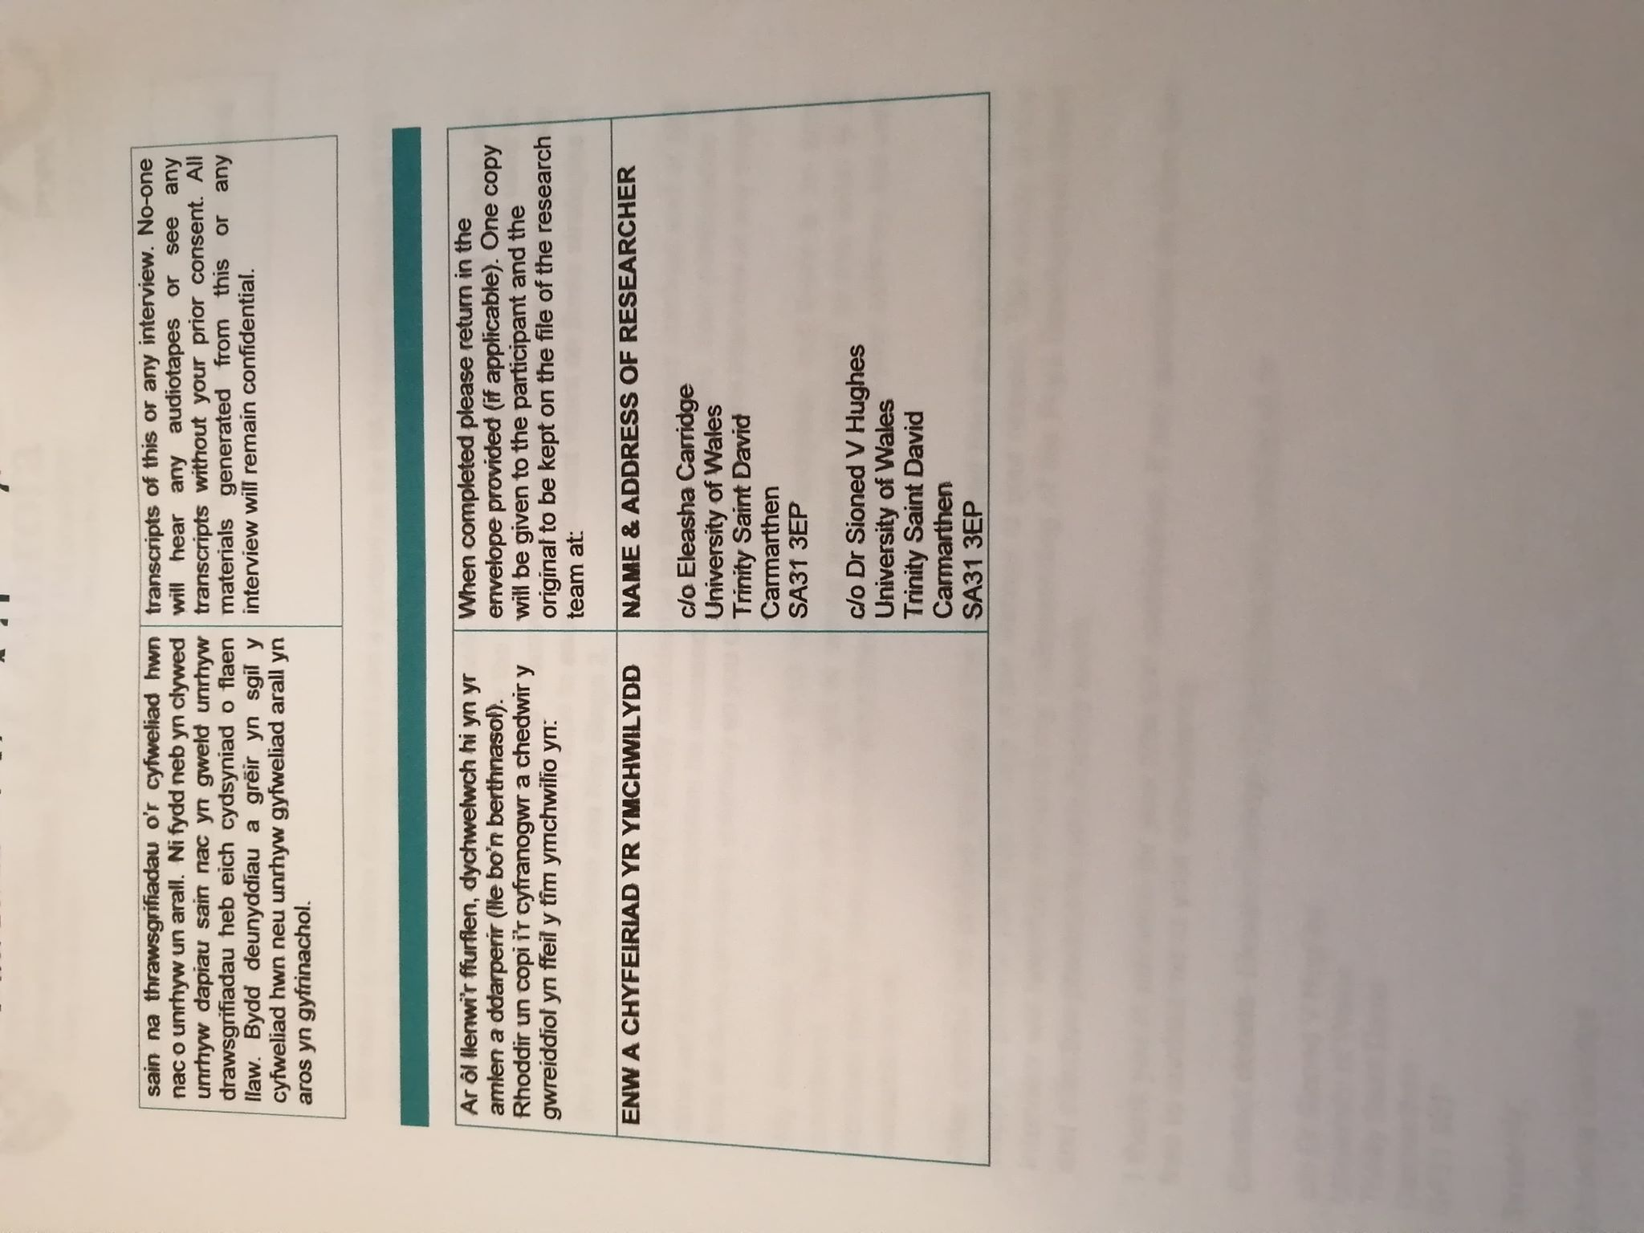

Appendix 5. Interview questions for staff members

- What is your role within the school?
- Are you familiar with the Pupil Development Grant? Within your position at this school, what do you do to ensure that eFSM pupils achieve their full potential?
- What training have you had to teach this strategy? If any?
- How long have you been teaching this for?
- Using yes, no or unsure, have the children currently participating in the strategy shown signs of improvement?
- Could you please explain in what ways they show improvement?
- Do you feel the children enjoy this activity? Why or why not?
- Please could you rate how effective this strategy is at raising literacy levels for children who receive Free School Meals on a scale of 1-10 and explain why you chose this number? 1 being not effective and 10 being extremely effective
- What parts of this strategy do you feel are the most effective?
- Do you feel that this activity could be improved to have more of an impact? If so, how?

Appendix 6. Interview questions for pupils

- Do you enjoy taking part in this activity?
- Do you think it helps you? Why?
- Has your reading/ writing / communication improved since taking part in this activity? Can you give examples?
- In what other ways does it help you?
- What parts do you like the most? Why?
- What parts would you change? Why?

Appendix 7. The Pupil Development Grant Spending Plan

Highlighted in yellow are focus groups/direct interventions.
Highlighted in green are family engagement interventions.

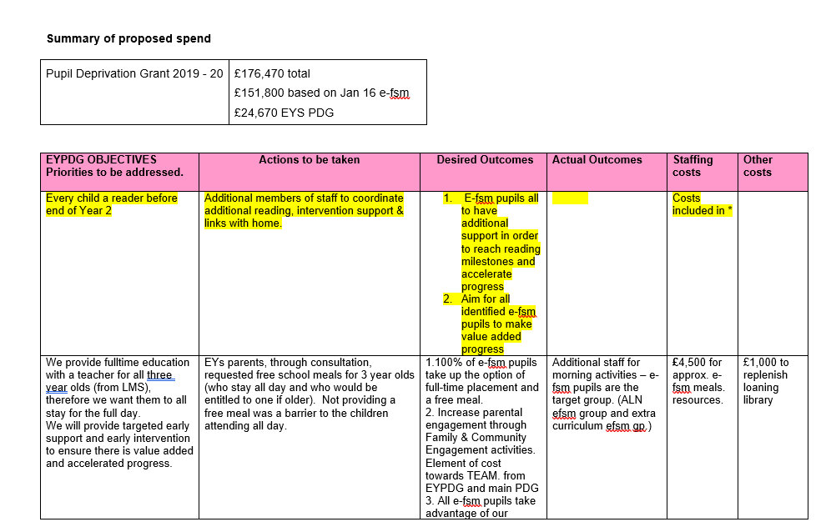

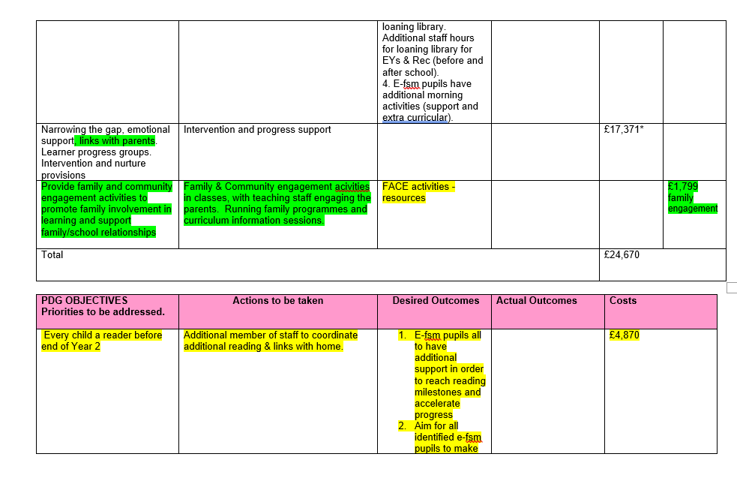

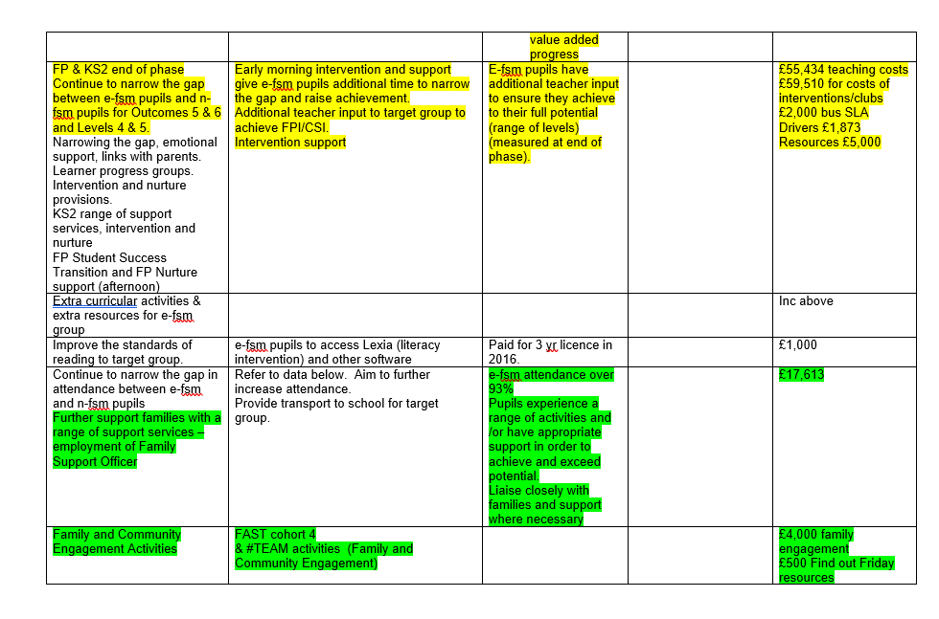

Appendix 8. Graph to show staff response to Question 2

Part 1- Are you familiar with the Pupil Development Grant?

Question 2 part 2 – Within your position at this school, what do you do to ensure that eFSM pupils achieve their full potential?

‘We use Visible Learning’

‘I tailor learning to their needs’

‘They attend Basic Skills to support the Literacy and Numeracy development’

‘I promote an inclusive environment’

Appendix 9. Staff responses to Question 7

Do you feel the children enjoy this activity? Why or why not?

‘Unsure, some do, some will ask to read’

‘Yes, most of them bug me to let them be next’

‘Yeah they love reading the newspapers’

Appendix 10. MAT pupils

Teacher response explaining how the school uses PDG funding to support MAT pupils.

‘MAT eFSM pupils are given the first opportunities to attend many of out of site experiences with external agencies e.g. Darwin science, science project with Milford cluster of schools, The Big Green Day etc... All eFSM pupils in Year 5 and 6 have access to Mrs Heeps who reads with them all twice weekly’

Appendix 11. Pupils response to Question 1

Do you enjoy taking part in this activity? Why?

Pupils who attend Basic Skills classes
‘Yes, I like having a break from class and it helps me learn’

‘Yeah, I enjoy having some quiet, class can get so noisy sometimes’

‘Yes, I like the teacher, she gives me extra help, so I understand things in class’

Pupils who have Additional reading sessions
‘Yes, I like coming out to read, I like the books’

‘I like reading the newspaper, they are better, the books are weird’

‘I enjoy it now we can choose to read the newspapers’

‘I like talking about the books the most’

Appendix 12. Pupils response to Question 6

What parts of the activity would you change? Why?

‘Nothing, I like going’

‘I would make the work harder, I don’t feel challenged, i mostly just help others’

‘I would maybe make it more fun; it can get boring sometimes’

Appendix 13. Behavioural Categories.

Session 1- Everyone’s A Reader class
Engagement
On-task | All children on task for the session
Listens attentively | 5 children showed very good listening, 2 children were put back on task 3 times.
Asks and answers questions | All pupils discussed and answered questions.
Focuses on learning with minimum distractions | 3 pupils got distracted by the resources being used over 3 times. Overall, most pupils were focused.
Expresses interest and enthusiasm | All pupils interested in the topic and discussing the subject.

Disengagement
Inattention | 3
Aggressive behaviour | 0
Inappropriate movement | 0
Inappropriate vocalisation | 3

Session 2- Everyone’s A Reader class
Engagement
On-task | 3
Listens attentively | 4
Asks and answers questions | Once prompted many times
Focuses on learning with minimum distractions | No
Expresses interest and enthusiasm | Small pockets of interest

Disengagement
Inattention | 10+
Aggressive behaviour | 0
Inappropriate movement | 7
Inappropriate vocalisation | 12

Appendix 14. Teacher response.

‘We do not assess the impact of the parental engagement activities at the present moment’

Appendix 15- The writer’s report of findings

Improving standards in Literacy among pupils eligible for Free School Meals.

School A has implemented many strategies to help raise the levels of literacy among learners eligible for free school meals (eFSM). They are working towards reducing the attainment gap and raising standards in Literacy to achieve the Welsh Government national priority.
Information about the school
School A is a large primary school situated in South West Wales. It currently has 651 students aged 3-11 years old on roll and an on-site Flying Start Centre. Most pupils are of British nationality and speak English as their first language. The school has identified 21% pupils as having Additional Learning Needs and 25% are eFSM.
School A is one of few schools to have an on-site Learning Resource Centre which supports ALN children throughout their education, providing specialised teachers, resources and care.
The school is a pioneer school for the Health and Well-being Area of Learning and Experience in the new curriculum, Successful Futures. It has taken a proactive approach to implementing Successful Futures and many aspects of the curriculum are visible throughout the school. It is clear the children are aware of the four purposes and use them frequently in the form of challenges each lesson.
Context and background to sector-leading practice
The location of the school has meant that the number of eFSM pupils remains high in comparison to other schools in the county. Within the school, there was a notable attainment gap amongst many eFSM pupils and their peers. Considering this, and the recommendations put forward by Estyn in 2017 to improve writing skills among pupils, the school has devoted a large portion of their Pupil Development Grant to improving standards in Literacy. This can be seen in the form of; parental engagement activities, the employment of qualified teachers to teach interventions, resources, day trips and additional support to name a few.
Description of nature of strategy
The aim of my research throughout this elective experience was to answer the following question; ‘How effective are the strategies funded by the Pupil Development Grant in raising levels of literacy among pupils who are eligible for free school meals?’
I gathered qualitative and quantitative data using interviews with staff and children whilst observing strategies implemented throughout the school. I also had the opportunity to analyse the data in the Effect Sizes for strategies used in Year 2.
Some strategies observed whilst attending electives included Basic Skills Intervention classes, additional reading, the Loaning Library, Mini Explorers and The Explorers. Initial observations illustrated a clear commitment to improving not only literacy but the overall attainment and well-being of eFSM pupils. The school’s Pupil Development Grant Plan shows a detailed plan for the allocation of the funding, and it is clear that this consolidates the effectiveness of the funds at raising attainment and pupil wellbeing
Upon reflection, the Basic Skills Intervention classes were examples of the strategy most effective at raising literacy levels among eFSM pupils. The strategy focuses on targeting pupils who have been predicted to not achieve the Foundation Phase or Core Subject Indicators. It involves a 25-minute literacy or numeracy session with a fully qualified teacher and focuses on raising attainment through repetition, hands-on learning and engaging resources at a level of understanding suitable for the targeted group.
Data from the interviews revealed that 100% of staff members felt this strategy improved literacy amongst eFSM children. This view was shared by the children, who also felt their skills had developed since implementing the strategy. With regards to improving the strategy, staff generally did not deem it necessary to employ any particular measures for improvement - although some felt that allocating more time could refine its outcome. The children overall had positive feedback regarding the intervention, although some Key Stage 2 pupils felt that the activities could be more engaging and challenging.
Other strategies which indirectly improve Literacy, such as the Loaning Library (an opportunity for children to loan toys and books for a week) and parental engagement afternoons are still deemed effective by staff members. Although it cannot be said whether these strategies alone would help raise attainment as effectively as others, all members of staff felt that the afternoons improved oracy. Positive feedback was also given by both children and parents - those in attendance did not feel that any improvement was needed.
Summary
Based on the quantitative and qualitative data gathered, it is clear that both pupil attainment and wellbeing are being impacted positively by the strategies implemented in this school. Pupils expressed an eagerness to participate in the strategies, with most children finding them a welcome break from regular classes. However, some students felt the intervention classes could be more engaging - a valid suggestion, since increased engagement has been shown to improve attainment (Samuels and Turnure, 1974).
The employment of qualified teachers to lead the Basic Skills Interventions has a notable effect on students’ Literacy levels - this effect is demonstrated in the Effect Sizes. However, to ensure maximum effectiveness of the interventions, teachers must be allocated an appropriate amount of time to deliver them. Although there is currently insufficient funding available to do so, hiring a full-time teacher to lead these interventions could prove highly beneficial in the long run.
Participating in this elective experience has allowed me to gain a valuable insight into the Pupil Development Grant and its role in raising pupil literacy standards. I have also had the opportunity to observe other methods of promoting pupil wellbeing, and various implementations of Successful Futures. The observations I have made throughout this experience will certainly influence my future practice. In particular, learning about Effect Sizes will enable me to measure the effectiveness of any interventions that I might introduce into a classroom in the future.

Reference List
Samuels, S. J., and Turnure, J. E. (1974) Attention and reading achievement in first-grade boys and girls. Journal of Educational Psychology, 66(1), pp. 29–32. https://doi.org/10.1037/h0035812

