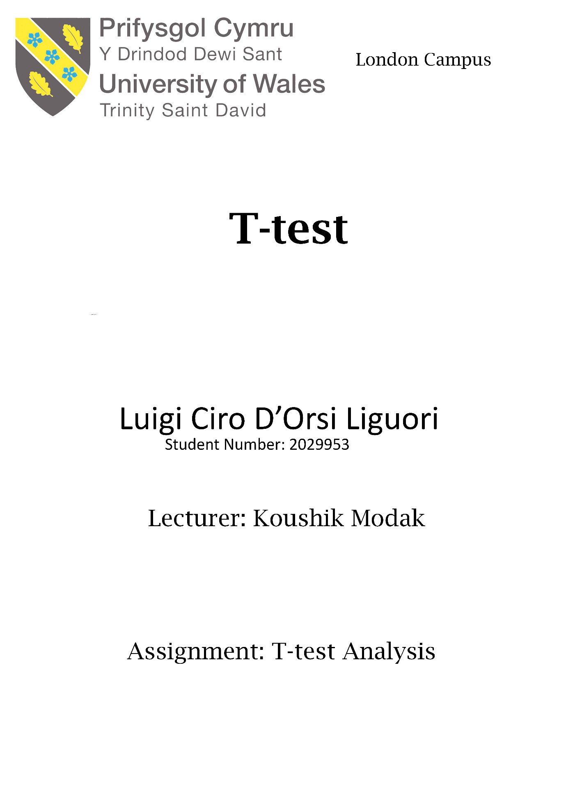

Contents
Introduction 3
Hypothesis 4
Analysis of the data set 5
Analysis of the results 6
Other factors not considered. 9
Conclusion 9
References 10

Introduction

The t-test is one of the inferential statistics, used to establish if there is a significant difference between the means of 2 sets of data [1]. This inferential statistic compares the means of the 2 groups in order to test hypothesis and determine which difference is most significant. Used to test a hypothesis. The assumption that there isn’t a significant difference between them is usually referred to as null hypothesis while the assumption that there is a significant difference between them is referred to as the alternative hypothesis [2].
To obtain the result, the t-test looks at the t-statistic, the degrees of freedom and the t-distribution aiming the statistical significance. Where there isn’t a significant, it can be assumed that they come from the same population. The operation taking a sample from the 2 sets of data, establishing the problem statement, which assumes the 2 means are equal e.g., the null hypothesis. The t-test uses applicable formulas to calculate certain values and compares them against the standard values to make the decision to accept the null hypothesis or not [3].
Where the null hypothesis is rejected, it implies that sufficient evidence has been obtained so as to make the conclusion that the relationship between the 2 data sets is strong and are probably not due to chance. The t-test is just one of the many tests used by statisticians to determine relationship between 2 data groups. For larger sample sizes, the statisticians usually use the z-test. Other examples include the chi-square test as well as the f-test. [4]
In this case, the prevalence of Covid-19 between white people and members of the BAME community in the UK is going to be observed for any statistical differences. The T-test is used to perform this test to determine whether there is a significant difference between the infection rate of white people and members of the BAME community in the UK. There is a difference in the infection rate between the 2 communities identified through the BBC news.
With the t-test, different considerations are made.
First: assumed that the scale of measurement that has been used has followed an ordinal or continuous scale.
Second: the samples are random, and the data has been collected from a randomly selected portion of the population and is only the representative of the total population.
Third: the data has a normal distribution when plotted e.g., a bell-shaped distribution curve.
Fourth: regard the homogeneity of variance. It is assumed that the 2 groups of data have equal variances and therefore the standard deviations of the 2 samples are also equal.
The t-distribution table can be one-tail or two-tail. The one-tailed is used for the cases, which have a range or fixed value with a direction (it can be positive or negative). I.e. someone can test the mean of a population based on the sample data is greater than 6. The 2 tailed determine where the parameter falls between 2 points.

Hypothesis

Hypothesis is a proposition that has been made based on limited evidence and acts like a start for further investigation. In this case, a hypothesis refers to a statement or expectation that will be proved or disapproved. The type of operation chosen by the analyst usually depends on the nature of the data and the purpose of the analysis [5]. Testing of a hypothesis is meant to assess the plausibility of the hypothesis by analyzing the sample data
To test a hypothesis, a random sample must be generated from the population [6]. From this random sample, 2 types of hypotheses are usually tested. These are the null hypothesis and the alternative hypothesis. The null hypothesis is something of equality between the populations being tested. The null hypothesis might state that the population mean of 2 samples of data is equal i.e., the difference between the mean of 2 populations is zero hence the name “null” hypothesis [7]. The alternative hypothesis on the other hand suggests that there is a difference between the parameters is not 0. The difference in the parameters can be 0 or not: only one can be true and the other one must be true [8].
Many steps are followed in the testing process.
First: what of the 2 hypotheses are based on the population parameters being tested [9].
Second: formulation of the analysis plan; an outline of the evaluation of the data.
Third: execution of the plan whereby the sample data is analyzed based on the plan.
Fourth: obtain the results of the analysis and analyzing them. Based on the results, the null hypothesis is rejected or declared plausible [10].

Analysis of the data set

Null hypothesis: No significant difference between the mean of the infection rate among the white community and the BAME community in the UK.
Alternative hypothesis: A significant difference is present between the mean infection rate among the white community and the BAME community in the UK.
The table reports the results of the t-test obtained in Excel at a significance level of 0.01
t-Test: Two-Sample Assuming Equal Variances
 | White patient |  | BAME
Mean | 36.58 |  | 60.04
Variance | 143.5138776 |  | 547.182
Observations | 50 | 50
Pooled Variance | 345.3479592
Hypothesized Mean Difference | 0
Df | 98
t Stat | -6.312037424
P(T<=t) one-tail | 4.01804E-09
t Critical one-tail | 2.36500241
P(T<=t) two-tail | 8.03608E-09
t Critical two-tail | 2.626931096

Analysis of the results
The mean has been calculated as 36.58 with a standard deviation of 11.98 for the white patient and 60.04 with a standard deviation of 23.39 for BAME. The pooled variance of the 2 data sets is 345.35. The t statistic calculated is -6.3 while the t critical is 2.63. The p value of the 2-tail is lower than 0.01 as in the above table.
Decision: Reject the null hypothesis since the P value is lower than the significance level.
Conclusion: At 99% confidence level, there is a significant difference between the infection rate in the white community and BAME. The mean in the BAME community is significantly higher than the white community.
The table below represents the results of the t test at 0.02
t-Test: Two-Sample Assuming Equal Variances
 | White patient | BAME
Mean | 36.58 | 60.04
Variance | 143.5138776 | 547.182
Observations | 50 | 50
Pooled Variance | 345.3479592
Hypothesized Mean Difference | 0
Df | 98
t Stat | -6.312037424
P(T<=t) one-tail | 4.01804E-09
t Critical one-tail | 2.081444921
P(T<=t) two-tail | 8.03608E-09
t Critical two-tail | 2.36500241

The t-statistic calculated is -6.3 compared to a t critical of 2.37. The p value is less than the significance level of 0.02
Decision: Reject the null hypothesis
Conclusion: With a confidence level of 98%, it exists a significant difference between the infection rate in the white community and BAME. The mean infection rate in the BAME community is significantly higher than the white community.
The table below represents the results of the t test at 0.1
t-Test: Two-Sample Assuming Equal Variances
 | White patients | BAME Patients
Mean | 36.58 | 60.04
Variance | 143.5138776 | 547.182
Observations | 50 | 50
Pooled Variance | 345.3479592
Hypothesized Mean Difference | 0
df | 98
t Stat | -6.312037424
P(T<=t) one-tail | 4.01804E-09
t Critical one-tail | 1.290249904
P(T<=t) two-tail | 8.03608E-09
t Critical two-tail | 1.660551217

The t-statistic calculated is -6.31 compared to a t critical of 1.66. The p value is lower than 0.1
Decision: Reject the null hypothesis
Conclusion: With a confidence level of 90%, it exists a significant difference between the infection rate of the white community and BAME. The mean in the BAME community is significantly higher than the white community.
Below there is a scatter diagram representing the infection rate among the BAME community and the white community
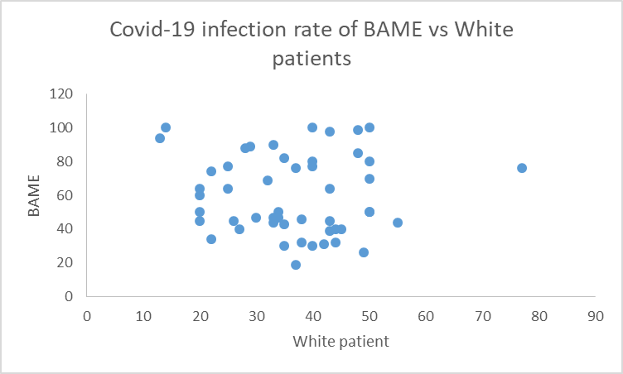
From the graph above, there appears to be very little correlation between the infection rate in the white community and BAME. Few outliers exist such as represented by the dot on the far right representing a figure of infection rate in the white community that is above the average range. These outliers are few and are not affecting the outcome of the t-test.

Other factors not considered.

It need be considered the social status of the people as well. The economic status of the people determines their capability to adopt preventive measures and thus directly determines the infection rate. It also determines the type of neighbourhoods where people live. Low-income neighbourhoods are likely to be densely populated with people very close to each other and in this environment, for sure, there is a higher infection rate.
To control these factors, the sample data needs to be truly random and from the same population. This is meant to ensure that patients, whether white or BAME come from across the income spectrum to ensure such factors do not influence the outcome.

Conclusion

The assumption of BBC news is true, according all the calculation. According to the calculation there are some variations in the infection rate between white patients and those in the BAME. As seen in the t-test performed in this document, there is a significant difference in the infection between the two groups. At the end the mean of the infection rate of the Covid-19 BAME community is higher than the other.

References

[1] | T. Kim, “T test as aparametric statistic,” Korean journal of anesthesiology, p. 654, 2015.
[2] | F. Kalinowski, “Interpreting significance: the differences between statistical significance, effect size, and practical importance,” Newborn and infant Nursing Reviews, p. 64, 2010.
[3] | G. Ruxton, “The unequal variance t-test is an underused alternative to Student's t-test and the Mann–Whitney U test,” Behavioral Ecology, p. 56, 2006.
[4] | J. Winter, “Using the Student's t-test with extremely small sample sizes,” Practical Assessment, p. 1063, 2013.
[5] | J. Hodges, “The Efficiency of Some Nonparametric Competitors of the -Test,” The Annals of Mathemaical Statistics, p. 55, 1956.
[6] | R. wilcox, Introduction to robus estimation and hypothesis testing, New York: Oxford, 2011.
[7] | N. Chukhrova, “Fuzzy hypothesis testing: Systematic review and bibliography,” Applied Soft Computing, vol. 1, no. 2, p. 45, 2021.
[8] | F. Emmert-Streib, “Understanding Statistical Hypothesis Testing: The Logic of Statistical Inference,” Machine learning and knowledge extraction, vol. 1, no. 3, p. 54, 2019.
[9] | O. Sheffet, “Locally private hypothesis testing,” International conference on Machine Learning, vol. 4, no. 1, p. 64, 2018.
[10] | L. Pfister, Debates—Hypothesis testing in hydrology: Theory and practice, London: Wiley Online LIbrary, 2017.

