
Skills for the Workplace
Module Assignment Submission
Student Name: | Laura Williams
Student Number: | 1815022
Module No: | BMSK4003
Module Title: | Digital Skills and Research Methods

Statement of Confirmation of Authenticity
By the act of making this submission, the student declares that this is the work of the student named above. The work has not, in whole or in part, been knowingly presented elsewhere for assessment, or where assessment has been built on a previous assessment, this has been identified. Where materials have been used from other sources it has been properly acknowledged. If this statement is untrue, the student acknowledges that an assessment offence has been committed.
Attention is drawn to the plagiarism and unfair practice policies of both the University and of ILM.
Permission for ILM to use this script
ILM uses learners’ submissions – on an anonymous basis – for assessment standardisation. By submitting, both the centre and the learner agree that ILM may use this script on condition that identifying information is removed. However, if you are unwilling to allow ILM use this script, please refuse by ticking the box: □

Table of Contents

Introduction…………………………………………………………………………………………………………………………………………….2
What has been the impact of 21st Century Technologies on the modern workplace? 2
Part 1 2
An Overview of the 21st Century Workplace 2,3,4
An in-depth look at technologies used in own workplace 5,6,7,8
Part 2.. .…9
An exploration of the use of social media in the workplace generally 9,10
An in-depth look at the use of social media in own workplace 10
The use of social media to enhance networking and career prospects 10
LinkedIn Profile 11
Facebook Profile…………………………………………………………………………………………………………………………………12
Conclusion 13
References 14
Appendix 1 15
Appendix 2 16

Introduction
This report will be looking into digital skills and modern technology in the workplace. It will also be looking at methods on how data is used and stored. How social media can affect your professional life and how employers use social media in recruiting, sales, advertising and how it’s used to keep a check on current employees.

What has been the impact of 21st Century Technologies on the modern workplace?

An Overview of the 21st Century Workplace

In an ever-changing business environment, using technology in various ways in the workplace increases productivity. It allows data to be easily accessible and used for the relevant purpose. Microsoft has transformed and adapted to the need for the use of technology, adapting software to suit the business needs. This software is widely used from studies in education to high profile businesses. Using technology in the workplace, allows data to be stored securely and is easily accessible, to be used for products and services that are required. It is also used for marketing purposes which helps cut the costs of advertising. If customers give consent to opt-in to marketing services, the marketing team can contact customers to promote new offers or services. By collecting data, using questionnaires or surveys, it would show how many customers responded to new offers or services. By plotting this data in a graph, it is clear to see if that offer or service was successful or not. With the results, it would determine if there is a need to carry on with that current offer or service, or to see if any changes need to be made. Having technology for this makes it cost effecting and saves time. Microsoft excel software would be used to plot the data in, as it features calculation, graphing tools and a visual basic for applications.
Top digital skills that employers in the tech sector are looking for today include:
App development
Digital design
Digital marketing
Product management
Social media
Programming and web development
We live in a world where new technologies play an increasingly important role in society. Businesses need to continually update their staff with these skills, to remain competitive. From retail to call centres, most companies need these digital skills implemented into their business to be more effective and efficient to gain more profit, growth and be a trusted reliable company.

Ackoff (1989) offers the following definition of Data, Information, knowledge and Wisdom and the transformation process as:
Data is raw. It exists and has no significance beyond its existence. It is a form of symbols are of no use until in usable in a relevant form.
Information that is contained in descriptions, answers to open questions of what, who, when and how? Information is inferred from data.
Knowledge is the Know-how, it’s the transformation of information into instructions, and knowledge can be obtained by someone else who has it, instructions or by extracting it from an experience.
Wisdom is the ability to increase effectiveness that comes from knowledge. It’s the evaluated understanding.

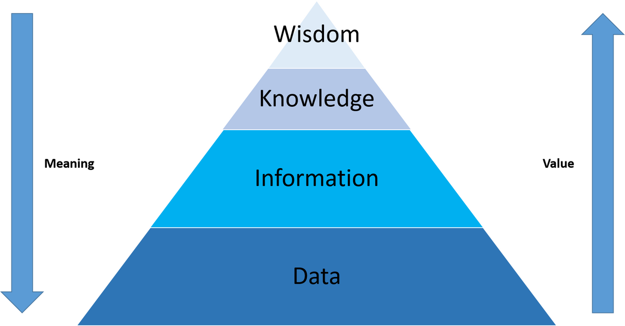

Weinberger (2010) said “We get to knowledge – especially “actionable” knowledge – by having desires and curiosity, through plotting and play, by being wrong more often than right, by talking with others and forming social bonds, by applying methods and then backing away from them, by calculation and serendipity, by rationality and intuition, by institutional processes and social roles. Most important in this regard, where the decisions are tough, and knowledge is not determined by information, for it is the knowing process that first decides which information is relevant, and how it is to be used.”
Weinberger (2010) suggests there are problems with what Ackoff (1989) states in the Data Information knowledge and Wisdom hierarchy, as knowledge can only come from relevant information. Not all information is relevant to give such knowledge. He suggests the problem with the Data, Information, Knowledge and Wisdom pyramid, is that by stating knowledge (much less wisdom) results from applying filters at each level, paints the wrong picture. Information is all about filtering out data that is not needed to make thinks clearer, but knowledge is more creative and discontinuous as its gained through various methods. Wisdom is also gained not just by knowledge but learnt experiences and trial and error.
However, Rowley (2006) argues that Ackoff (1989) theory is one of the fundamental, widely recognised and ‘taken-for-granted’ models in the information and knowledge literatures. She suggests there is “an improved appreciation of the relationships between knowledge and wisdom, as well as the ‘foundational concepts’ of data and information, may provide a context for achieving more convincing success in knowledge management, and more importantly organizational achievement’”
There is so many possible outcomes for given set information. Information is mostly based on facts if the data is true. Knowledge on the other hand is based on probabilities depending on the information. Wisdom allows us to judge what is right or wrong and what is good or bad.

An in-depth look at technologies used in own workplace

The Automobile Association (the AA) have various methods of technology at hand to obtain and use data for the relevant purpose. They have many sectors that they use technology in the workplace for. This includes: Car Insurance, Home Insurance, Travel Insurance, Breakdown assistance, Finance, Boiler cover and Driving Lessons. Insurance is regulated by the financial conduct authority (FCA). Therefore, it is essential to be compliant and have legal authorisations to use the correct wording and scripts, to provide to consumers in the market. They have a highly secured database to store customers’ details. The information held is only relevant to what the policy requires.
Qualitative data uses words or images to describe something; it can be observed and recorded. This type of data can be collected through observation methods in interviews, one to one meetings and conducting focus groups. It is important in determining someone’s traits or characteristics. Marketing researchers would collect qualitive data to answer questions like what issues the customers may be facing or what do they need to focus on to resolve problems that may be present. It helps understand the perceptions of people and how they feel. The data collected can be grouped according to the category. Surveys would also use qualitative data with open-ended questionnaires, which allows data to be collected and reviewed for customer satisfaction or to identify customer needs and wants. Collecting this type of data can assist in dealing with any issues effectively and efficiently. Once this form of data is collected it is essential to arrange it. It can be converted into text format by exporting it into a spreadsheet. This allows you to organize the data in an orderly manner. This can be based on the questions asked, answers given from negative to positive comments. It would need to be arranged in a table, so it is appearing clearly to see. An important step for the successful research is to validate the data. It is extremely important the data is not flawed by ensuring the data is accurate and reliable.
Quantitative data is information that can be used for statistical analysis or for mathematical calculation. It uses numbers, or categories that can be labelled with a number. This form of data is used to construct graphs and tables of raw data. Each bit of data would have a unique numerical value associated to it. This form of data is used to answer how many or how much or how often. It can be verified and validated. This type of data can be collected using questionnaires, a survey or polls, sent to specific areas you are looking to obtain information from. Surveys can be done via websites, online forums, emails, text messages and social media. This type of survey would be in the format of ‘on the scale of 0-10.’ You can connect descriptive statistics with quantitative data using:
Mean – an average of the values
Median – the midpoint of the value
Mode – the most common value
Frequency – the number of times a value is observed
Minimum and Maximum values – the lowest and highest values
Percentages – the format to express scores and set of values.
This data can then be converted into a table, graph or charts.
Just for an example, collecting data from 8 peers about the use of what technology they use in the workplace- computer, laptop, tablet, mobile phone, printers and online payment software. The data collected was used and put into a graph.

This information can then be used to determine how popular an item of technology is by being used in the workplace and if it could benefit other businesses by introducing new technology or software, and if it can be used more efficiently and effectively. To be successful, this data needs to be monitored, updated and tweaked in places to achieve the best outcome in the workplace.
There are six main elements of technology that are required to keep up with the modern times in the workplace are:

The CRAAP test, Blakeslee (2004) is used to check the reliability of sources across academic disciplines. As there is a vast number of sources available online to research, it can be difficult to determine if the sources are trustworthy to use for the tolls of research. The CRAAP test is made to make it simpler to determine if what you are using can be trusted and verified.
CRAAP is an acronym for
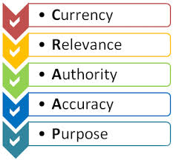
Currency – is it up to date? When was it published? Who published it?
Relevance/ reliable – can the source be trusted
Authority – who are they? What are their credentials?
Accuracy – is it accurate?
Purpose – is there a hidden agenda, are they trying to sell you something?
There are various ways of researching information online. When researching for facts about technology in the workplace it is essential to do the ‘CRAAP’ test before you even consider using the information to report about. If using Wikipedia for example, this has been found to use as an unreliable source, as anyone can adjust the information held on Wikipedia. Whereas documents created in news articles, reports, journals or accredited websites are trustworthy, as they have been monitored and verified before they have been published. Even if this has been done it is important that critical reading is used to assess the information provided and extra research is done to ensure the information that has been found if suitable, relevant and true. Google Scholar is effectively used for research as you can search across many sources in one go. It searches books, articles, theses, universities, other websites and academic publishers. This would be a more trusted way to verify information you are searching as it must be verified.
Cloud based software can be used anywhere at any time and on most devices with a connection to the internet. This is beneficial for businesses that require remote employees to work out of office. Using this software in a workplace helps colleagues to collaborate ideas and information, without the need to used fax machines, emails and phone. It is effective and efficient to use for business as its easily accessible and requires no software to download to use it. Cloud file storage acts as an online hard drive to store files and access them from anywhere in the world on a device that has internet connection. It can also be used as a backup.

Hardware is used in the workplace for helping the business run smoothly and in line with the ongoing demands of efficiency. If you are not up to date with modern technology, customers could become wary and not trust what you are doing, and you could lose the trust of a potential new customer. If you have a trusted big branded name like the AA - Automobile Association- and you do things different to competitors like Admiral, and customer experience the difference, this could have a negative impact in the customer experience which could lead to negative comments in work of mouth. Positive comments with word of mouth can have a serious impact on future sales that helps grow the business.
Hardware such as, Laptops, Computers, Turrets, Headsets, Printers, Security fobs, Mobiles, Laptops and Tablets would be used to operate the relevant software to deal with the task at hand.
The technology listed above is all used at The Automobile Association (AA) They have a strict security enforcement set up that only current staff has access to the workplace building. This prevents intruders from gaining access to the building to prevent security breaches. Software- such as - office 365, internet explorer, chrome, Microsoft office emails, the workplace intranet, team what’s app groups, schedule adherence, company websites, the shares portal, online payslips and company WIFI is all relevant for the employee to access in their role and is only accessible to staff that are granted access. This stops anyone without access, to jeopardise the security and systems in place, which determines how the business is run. Skype is used within the business for web conferencing and messaging when online. This in the best way for colleagues to communicate while in a meeting when located in different parts of the world. There are WhatsApp groups for each team to help staff communicate about work related issues. This can be annoying sometimes as there is usually around fifteen people in a team and messages could come in anytime of the day or night, sometimes the messages could be between a few people and the issue may not involve anyone else. In this scenario you could mute the notifications for a set period. There is always room for improvement for the current processes that are in place or the way systems are run to adapt to meet the current needs of the business. It is essential to stay in line with the ever-changing updates that technology can offer.
Considering all the areas of updates and changes that must take place in the workplace, it is essential to keep up to date and constantly monitor the current processes being used in the to ensure they are delivering the highest standards of service to the customer in the best possible way.

Part 2

An exploration of the use of social media in the workplace generally

Social media plays a big part in society today. Whether it is personal or business life, social media can affect you. Comments that are made or information you put out there for everyone to see can have an impact on the way you are viewed by others. If an employer was to interview someone, currently, it would be common to turn to social media, to try to find out more information on the new candidate that is aiming to get a job with the company. According to a 2016 career building survey taken by 2186 hiring professionals, more than half (52 percent) of employers reported using social media to screen candidates whereas 59% of employers, used a search engine to research them. A fifth (21 percent) said they were looking for reasons to reject the candidate due to drinking or drugs. Once hired the survey shows 41 percent of employers stated that social media is used to look up current employees, 26 percent of those found negative content that’s caused the employee to be fired. There are positive ways to use social media to your advantage. Only post content that would appear respectful with outside interests, displaying good communication skills and to show creativity. Not having social media at all could cause a negative impact with you not being present online. It causes concern with employers as they like to gather more information before inviting you for an interview.
Facebook is the social network site that shows your true self. There are positive ways to use social media to your advantage. It can also have a negative impact on you if you display the wrong behaviour. If you make comments about something in the press in a negative way or uneducated way, if you display poor judgmental views, even if you have been tagged in a video or photo that you would not want your parents to see but the whole world can see it anyway. This doesn’t always benefit the business as some individuals are more open than others and bare sensitive or personal information to others and some don’t bare any information at all. Most employers have a strict rule that under no circumstances can their staff mention work related information on their social media. If comments made on your social media, has any detrimental impact on the business, it can essentially affect your current position or could lead to problems going forward and could lead to a sack able offence.
Some businesses would have a work related social media page, which would be only used by employees. This type of social media is generally an invite only to staff, as information on that page could be sensitive to work which is not for outsiders to see. The Automobile Association (AA) have a private group for staff. This page is used to share work event photos, new promotions or internal opportunities, new products and services and general blogs about information relating to work. This page also allows the staff to connect, in a more personal way, as in the company you may not have the chance to get to know others while at work if you are working in different departments other floors. There are also other sectors of the AA that are based in Cheadle, Newcastle and Basingstoke. There is an intranet site used for all workers at the AA to obtain information relating to pensions, payroll, work rotas, human resourcing and employment benefits. This site is restricted to just employees of the AA as it contains sensitive information. To gain access you must be granted permission with your unique work identification number. This ensures that no information can be shared with anyone outside of the AA.

An in-depth look at the use of social media in own workplace

Social media can be used for networking. Using it to promote businesses and connecting with others regarding the business can help growth and open new opportunities. It helps to build stronger relationships between others.
LinkedIn is used to promote you and your business, to advertise about your business and services and attract new customers. It is for anyone who is interested in taking their professional life to another level by finding new opportunities to connect with other professionals. It can be used to reach millions of people all around the world free of charge. It allows businesses to communicate on a personal level. However, if you post anything incorrectly or offensively it would rapidly spread and could be reviewed before you can amend the mistakes. It’s important to be aware of the risks as this could jeopardise new opportunities that may come your way. You would you this site in a professional manner. The profile picture would have to be of yourself as it is all about you. Whereas on Facebook is more personalised to your life. Your profile picture could include people closer to you like your partner or children.

LinkedIn profile
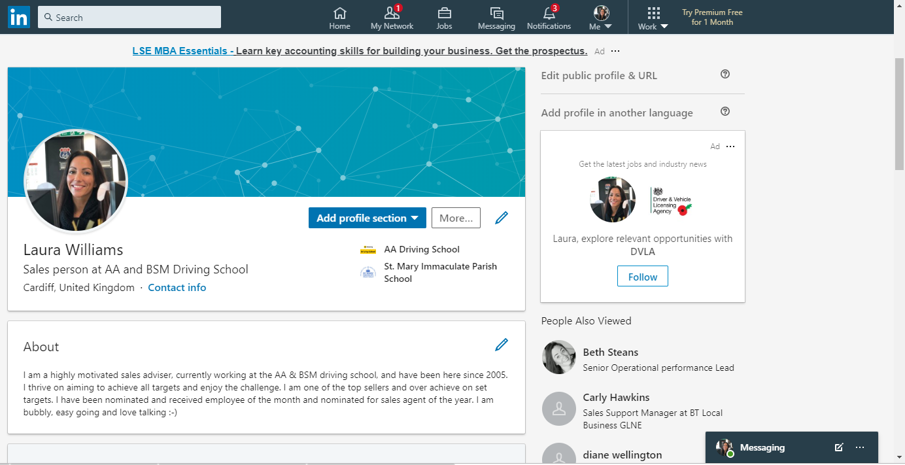

In my personal LinkedIn profile (Appendix 1), I chose a picture of myself that reflects my description which is bubbly and easy going its not too professional but acceptable to use and showing a smile. As I am content in my current position I have used a more a laid-back approach. If I was looking for a new career I would maybe choose a more professional photo, in a plain background and showing a pleasant smile. The information I entered describing myself, would change to adapt to what I was looking for. If I wanted to become a sales manager, I would change it to something like:
I am a highly motivated sales person with experience in managing a team. I am currently looking for a career change in sales management, in which I can apply my personal skills to gain a positive outcome. I am a happy easy going individual that loves a challenge and will deliver great results in achieving set targets.
The advantage of this site is that you can update the information held at any time to suit your desired career path.

Facebook profile
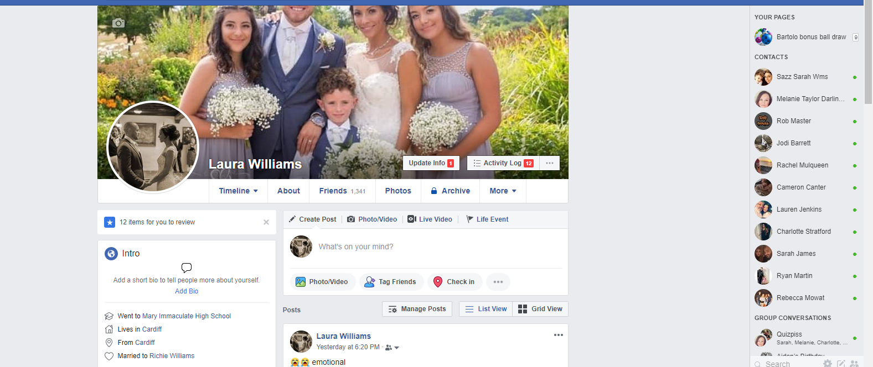
In my Facebook profile (Appendix 2), I have chosen to use a profile picture with my husband and children. I have set the privacy on Facebook so only the friends I have added can see my content. The disadvantage of using a personal photo which includes my children is that it can be viewed by anyone, even on Google search results. On this site, it is more personalised and friendly, but I always keep in mind that I would not post anything, that could be deemed as offensive or rude to anyone, as I wouldn’t want to jeopardise my current job or any friendships. Facebook can also be used to advertise. You can create an advertisement or sponsor a story for a price, that will appear to users on Facebook that may receive your message.

Conclusion

In my opinion, using technology in the workplace is the only way forward. The demand on businesses to grow and stay ahead in making money ongoing. There are so many companies and small businesses in the world that are in competition to outdo each other, or to become the most used company that it could lead to other companies to go out of business. Using technology in the work place keeps things up to date and in line with other companies. It is effective, efficient and relevant. Social media plays a dominant part in technology as it is used for networking, advertising, social connections and it used by more than half of the population.
Technology and digital skills in the workplace is forever updating and changing and it is exciting to be part of this generation and to get to experience future technologies yet to come.

References

Ackoff, R. L. (1989) from data to wisdom, journal of applied systems analysis
Blakeslee, S. (2004) the CRAAP test, Loex quarterly, California
Lebowitz, S. (2017) Your online image is more important than ever, online - the business Insider
Rowley, J. (2006) the wisdom hierarchy Bangor Business School, Bangor
Wallace, D.P. (2007) Knowledge management libraries limited knowledge management
Weinberger, D. (2010) The problem with the dikw hierarchy, online

Appendix 1

Appendix 2

