

Design and Implement a Solution for Managing Resource Demand within an IT Delivery Organisation
by
James Evans - 1910316

Supervisor: Divya Chidambaram

Project submitted as part of the requirements for the award of
BSc (Hons) Computing (Data & Information Systems)

July 2024

Declaration

I declare that this report is the product of my own work and is not being submitted for any other degree etc.
James Evans

Abstract

This project sets out to: -
“Research, Design and Implement a Solution for Managing Resource Demand within an IT Delivery Organisation.”
The key objectives here are to: -

- Show the best form of Demand Management that can / should be employed within this organisation.

- Design an appropriate solution.

- Implement an appropriate solution which: -
  - Enables strategic decision-making.
  - Shows opportunities for improvements.
  - Shows threats to delivery.
  - Provides tactical recommendations if deemed necessary.

Following key literature findings, the recommendation was for a model to be created that: -
- Absorbed known information across the organisation.
- Provided comparisons of the data.

This was primarily due to the extent to which the organisation has a clear delivery model with a well understood in flight workload.

Designs of the solution were for a relational database (selected to ensure that the organisation was comfortable with the design) to be taken through to Power BI, where visualisations will be manufactured to compare the various data sets and produce the varying visualisations.

When implementing the solution, it was discovered that, when cleaning the data, it was necessary to transform it from the layout received to one that could be successfully analysed within Power BI.

The outputs were then packaged within a reporting suite (or wraparound navigation) within Power BI, enabling administrative team members to provide the reports to Senior leaders when necessary.

The reports themselves are not enough to enable decision making. They need to be accompanied by a description of what could be observed, together with a associated analysis and recommendation for any potential actions to resolve issues that are uncovered.

All research and development have been carried out by James Evans.

Contents
I. Declaration 2
II. Abstract 3
III. Introduction 6
IV. Literature Review 8
V. Development Methodology 16
VI. Requirements Gathering and Solution Design 18
VII. Implementation 29
VIII. Project Evaluation 57
IX. Conclusions and Recommendations 60
X. Reflection 63
XI. Appendices 64
VI. References 88

Figure 1 - Thirty Years of New Zealand Health Reforms 10
Figure 2 – Process Diagram 11
Figure 3 – Solution Architecture 22
Figure 4 – Initial Database 23
Figure 5 – Second Iteration Database 24
Figure 6 – Demand Management Output – Proof of Concept 26
Figure 7 – Project Plan 27
Figure 8 – SQL Sample 30
Figure 9 Active resources 31
Figure 10 – Project Plan 34
Figure 11 – Second Iteration Design 35
Figure 12 - Redesign 36
Figure 13 – New Table Relationships 37
Figure 14 - Table of Active Resources 37
Figure 15 - Broken down by role 38
Figure 16 - Committed Demand, by Department 38
Figure 17 - Active Roles based purely on Source Data 39
Figure 18 - Committed Demand based purely on Source Data 40
Figure 19 – Project Plan 41
Figure 20 Resource Summary 43
Figure 21 Changes in Resources Status Proportionality over time 44
Figure 22 Changes in Resources Over Time, by Role 44
Figure 23 Changes in Demand Status Proportionality Over Time 45
Figure 24 Demand Model 46
Figure 25 Breakdown charts 46
Figure 26 UI Sample 1 47
Figure 27 UI Sample 2 48
Figure 28 – Project Plan 50
Figure 29 Bookings per month 52
Figure 30 Demand vs Actuals 53
Figure 31 Demand vs Actuals Breakdown 54
Figure 32 Final User Interface 54
Figure 33 – Project Plan 56
Figure 34 = Project Plan 57

Table 1 - Features 19
Table 2 – Feature Table 30
Table 3 = Phase 1 Outcomes 33
Table 4 – Feature Table 35
Table 5 – Phase 2 Outcomes 40
Table 4 – Feature Table 42
Table 7 – Phase 3 Outcomes 49
Table 8 – Feature Table 52

Equation 1 DAX query: 37
Equation 2 Example of the DAX query used 45
Equation 3 – Excel Formula 70
Equation 4 – Excel Formula 74
Equation 5 – Excel Formula 74
Equation 6 – Excel Formula 74
Equation 7 – Excel Formula 75

Introduction
Project Background
This project details a solution that an organisation can implement to assess its ability to meet demands placed upon it (in terms of resources), allowing strategic medium to long term decisions to be taken for the benefit of the business.
Demand Management seeks to: -
- Assess how much work there is for a given organisation, over time
- Measure the capacity of a given organisation to complete that work.
- Offer potential solutions to any issues that are identified.
- Highlight opportunities to make better use of existing capacity.

The key question is which kind of Demand Management is most appropriate for a given organisation and how successful is it likely to be?
The organisation (as it will be referred to throughout this document), employs the author.
Key Objectives
Through the implementation of this project, the author is attempting to: -
- Show the best form of Demand Management that can / should be employed within this organisation.

This will be a key output from the literature review.

- Design an appropriate solution.

This will most likely require the design and implementation of a database, used to enable visualisations. Any data that is ultimately housed by the database will need to be cleaned and organised appropriately.

The varying sources of data and any special circumstances surrounding them considered.

All designs should comply with the organisation’s security standards, before being implemented within the organisation.

- Implement an appropriate solution.

Building the solution will take place using dummy field names and data (details of which can be found in the appendices).

The solution should deliver the features necessary to: -

  - Enable strategic decision-making regarding Demand Management.
  - Show where there are opportunities for improvements to resource use across the organisation.
  - Show where there are threats to the successful delivery of projects or maintenance of services.
  - Provide strategic and tactical recommendations if deemed necessary.
The project, documented herein, will therefore: -
- Examine existing literature to establish the industry standards for Demand Management.
- Recommend an approach for Demand Management in this organisation that is suitable and can meet the objectives previously set out.
- Design a solution which can be employed by the organisation at minimal cost.
- Implement the solution, generate the appropriate visualisations and provide both strategic and tactical recommendations based on them going forwards.
- Evaluate its usefulness and make recommendations for further improvements in the future.
Key stakeholders are keen to see that this project is a success.

Literature Review

  - Introduction:
If an organisation has a fluid workload and/or the ability to scale its workforce, it is imperative that it has the tools at its disposal to either manage its workload or resource capacity to deliver said workload accordingly.
Whilst this might seem to be a simple and self-explanatory premise, many consumers on a day-to-day basis will encounter scenarios in which a service provider has misjudged their ability to deliver the services that we need. This often leads to customer dissatisfaction, loss of revenue, or for public sector services, mistrust in the very machine we have elected to deliver on their election promises.
The author has developed an understanding of the scale of this problem within a specific public sector body. The purpose of the literature review is therefore to verify that the exact solution is not already in place as an “off-the-shelf” product and to verify the value that the solution might in fact bring to an organisation.
The categories which will be explored are: -
- Existing solutions to managing demand across an organisation.
- Commonalities between said solutions.
- Common issues encountered.
- Effectiveness of the solution on the organisation.
- Whether the proposed solution to managing Demand across one specific public sector IT Services is the best way forwards.
  - Existing Research
The author has endeavoured to consider Demand Management from across all sectors, and not simply from the world of IT. The following areas have therefore been considered for this literature review: -
- Information Technology
- Water
- Healthcare
- Energy
The author believes that this information should be more than adequate to form a basis for this project, as whilst the activities that will be undertaken at an organisational level may differ, the outputs produced through modelling can indeed be used to adjust the workforce or constrain workload accordingly.
The key sections that will be considered throughout the literature review are: -
- Assessing Supply - an organisational entity’s ability to carry out work/deliver services.
- Assessing Demand – The workload placed on an organisation.
- Assessing Existing Capacity – Modelling Demand against Supply.
- Assessing the Validity of the Subsequent Workforce Plan – Assessing the viability of any measures that are deployed to mitigate against either a shortfall in Demand fulfilment or excess capacity.
- Industry Standard Solutions for Providing Outputs.
- Achieved and/or Failed Outcomes.

Assessing Supply
Being, potentially, the simplest variable in the equation; various organisations typically assess their existing supply in a similar manner. Most employers will have a grasp on their workforce magnitude and the roles held within that structure. Understanding exact skills at an individual level across the workforce is less common.
In the case of water supply, however, the supply is more complex to understand than Demand. This is because the amount of water available to the consumer hinges of the amount of rainfall or treatable groundwater in each area, coupled with the amount that can be fed to the system at any given time. Polemio and Voudouris [1] state that: -
“Water scarcity occurs in many countries, particularly in Mediterranean, Middle Eastern, and African countries, and many of these countries are confronted with a crucial combination of a severe lack of and increasing demand for high-quality water.”
In energy terms, this is (currently) the level provided by the grid.
NHS England [2] is typical in that it regards its supply as its existing headcount, or ability to deliver services in terms of FTEs (Full Time Equivalents).
Bruen and Brugha [3] conducted a descriptive qualitative study with policymakers, stakeholders and researchers in assessing the shortfall of doctors in Ireland.
Axelos [4] recommends that the PMO understands the available resources across an organisation.
Assessing Demand
In energy terms, this is (currently) the level consumed by the grid.
Demand for NHS England Services is primarily what one might refer to as “Operational” demand, where the workload revolves around tested, understood and common processes. This is assessed by examining the current Demand on Services and modelled outwards based on projected changes in societal demographics. The report [2] states that these changes typically revolve around: -
- Age (and age-related need for NHS Services)
- Increases or decreases in medical needs based on current societal trends and forecasts in how those associated demographics may grow or shrink (e.g. smoking and associated political interventions).
For healthcare in Ireland, Bruen and Brugha [3] again conducted a descriptive qualitative study.
Within New Zealand, Rees [5] states that demand is riven through a market model. A table showing how this changed over time can be found below: -
Figure 1 - Thirty Years of New Zealand Health Reforms
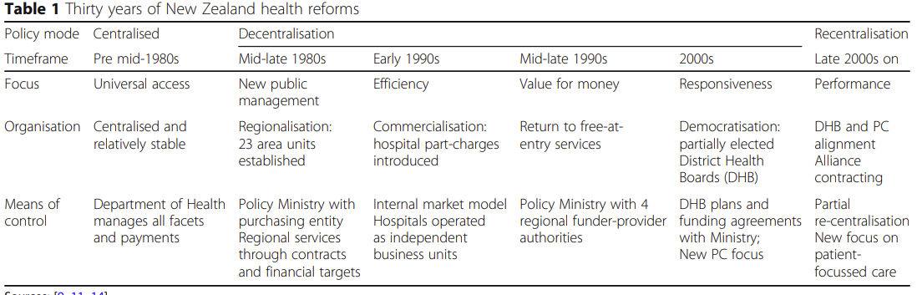
In 2017, Willis, Cave and Kunc [6] were able to use the existing data to hand for the current healthcare workforce.
In a study of anaesthetists, Davies et al [7] looked at the work that was not getting done or was being postponed due to the apparent mismatch between the workforce and workload.
The Complexities of National Healthcare Workforce Planning from 2011 [8] details how the changes in the activities undertaken by, and lifestyles of, the service users drive how Demand grows and changes. Understanding these variables and accurately modelling them is key to ascertaining the workload of the health service.
Henao et al [9] try to understand Demand in the retail industry through acceptance that, on occasion, Demand can indeed be uncertain and variable. This is echoed by Valeva [10] in an extensive study into how a workforce might adapt to uncertain Demand.
Axelos [4] recommends that engaging with subject matter experts to build a picture of demand for a given project (even at the earliest stages) can give a solid foundation for Demand across the Portfolio.

Assessing Existing Capacity
Once that Existing Supply and present Demand have been assessed and agreed upon; the initial state, in terms of capacity, is required to understand the current excess or shortfall in supply. This in turn will drive the workforce plan.
Polemio and Voudouris [1] show that, for a natural resource model, if the resource is drained, determining demand subsequently becomes problematic.
In the case of the NHS [2] the current state is such that there is a significant shortfall in Supply to deliver existing Demand.
Bruen and Brugha [3] conducted thematic analysis of interview transcripts.
In 2017, through creating the Robust Workforce Planning Framework, Willis, Cave and Kunc [6], it is revealed that their studies showed 3 method groups for workforce planning. These were: -
- Judgemental
- Mathematical
- Mixture
They [6] conclude that: -
“There is a need for studies that not only capture the existing complexity in workforce management but also explain the development and use of OR models to design policies for managing the workforce.”
Willis, Cave and Kunc [6] provide the process diagram below: -
Figure 2 – Process Diagram
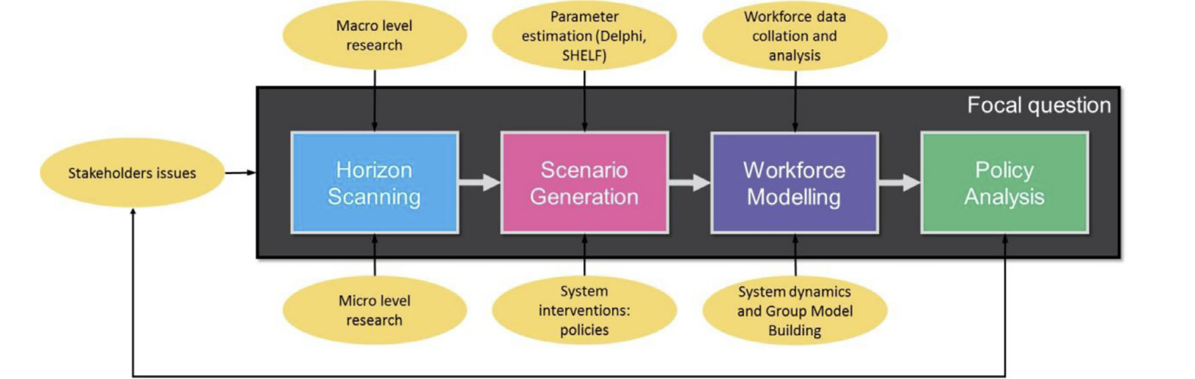
Davies et al [7] simply used the work not being carried out as a measure for existing capacity when determining the demands on the health service in anaesthesia.
According to Rees [5], the capacity to deliver healthcare in New Zealand was significantly undermined following a market driven approach to calculating demand.
Within the energy industry, Monyei and Adewumi [11] state that: -
“The energy crisis of 2008 in South Africa, due to electricity demand surpassing supply and a depleted
electricity reserve margin has exposed the need for more synergy between home energy management systems (HEMS) and supply side energy management systems (SSEMS).”
Assessing demand can be done in a smart way using Demand Side Management techniques. This would effectively measure the demand at a local level, feeding up the supply chain. However, Monyei and Adewumi [11] put it: -
“the viability of DSM is dependent on the participation of willing consumers.”
The Complexities of National Healthcare Workforce Planning from 2011 [8] goes on to state that accessing reliable data for the current situation as it stands is difficult. Therefore, any subsequent modelling would be at least somewhat unreliable.
In Managing Pandemics, Thielsch et al [12] conducted a combination of telephone interviews and online questionnaires to gauge how the workload had changed due to the pandemic and (effectively) whether resources were feeling “overworked”. This example highlights the risk that an organisation can view its peak output capability as its steady state, leading to large numbers of leavers due to sickness and/or stress.
Henao et al [9] have used models of continuously variable and unknowable Demand to Test measures put in place to strengthen the workforce’s ability to morph based on the needs which may arise. This is achieved through a method called “chaining” and are: -
“robust to demand variability, minimize the expected total cost of staff shortages, and exhibit the best cost-effective performance.”
Further that it: -
“…provides a tool for company decision makers to address the three fundamental multiskilling issues in unbalanced systems: -
- Where to add multiskilling.
- How much to add.
- How it should be added.”
Farooq and Zhu [13] recognise that, the larger the system one is attempting to manage, the more collective behaviours and subsequent needs or Demands should be recognised, and the less the needs of any given individual should be given credence. In this context, they are trying to manage the Demands emanating from the Internet of Things. The supply of these needs is somewhat contingent on resources but is more dependent on physical infrastructure.
From manufacturing in China, Zhao et al [14] articulate that their: -
“study employs survey methodology to examine a research model that explores whether and how SHRM practices influence manufacturing firms’ performance through demand-side search. Data from 151 high-tech manufacturing firms in a science park of China are analysed to test the research model.”
Axelos [4] recommends that the PMO manages Demand through comparing it with supply, then using this information to balance the Portfolio.

Assessing the Validity of the Subsequent Workforce Plan
The workforce Plan which has been modelled by the NHS [2] shows that it is indeed possible, over the coming 10-15 years, to meet the modelled Demand on NHS Services providing that several mitigating actions are indeed successful.
However, these are not dictated by the specific needs highlighted through Demand Modelling but are in fact a list of the available options with a combination of both realistic and hopeful projections of successful recruitment if they are used.
The author believes that this would be poor practice unless through critical risk management it was shown to be the only viable option.
For healthcare in Ireland, Bruen and Brugha [3] conducted thematic analysis of interview transcripts.
Ultimately Willis, Cave and Kunc [6] used a combination of horizon scanning and scenario generation to produce detailed, quantified scenarios for modelling Demand against Supply.
A formal approach was developed over time comprised of four steps: -
- Model scoping.
- Model construction.
- Model documentation.
- Model testing.
Davies et al [7] were able to show that, as not all work had been carried out, there was a clear gap. However, no effort was made to quantify this exactly.
Axelos [4] recommends that the PMO monitors Demand against supply, feeding back exceptions through an agreed reporting structure for escalation to a pre-agreed body.

Achieved and/or Failed Outcomes
The NHS [2] has shown that, providing that its projections of Demand are accurate, and its projections of recruitment are successful, the workload of the NHS in 10-15 years would be manageable.
Bruen and Brugha [3] were able to create an environment in which the experiences of those dealing with mismatches between supply and Demand were able to converse with empowered bodies and subsequently influence policy.
In 2017 Willis, Cave and Kunc [6] were able to synthesise a process in which policy would be analysed as a direct result of the modelled scenarios. This could then lead to action being taken at the highest levels to mitigate against future workforce related risks.
Davies et al [7] outline the following key recommendations based on their studies: -
- Career pacing to avoid burnout.
- Standardising retirement and return approaches.
- Recognition of health concerns.
- Reforming Pension Annual and Lifetime allowances to increase retention of staff.
- Exit interviews.
- Work life pattern negotiations.
- Working pattern discussions should be based on the impacts of ageing, well-being, and performance.
- Working less than full time should be an opportunity afforded to all.
Zhao et al [11] found that, within manufacturing in China: -
“Service Orientated Human Resource Management practices can enhance manufacturing firms’ performance, and demand-side search plays a mediating role in this relationship.”
Zhao et al [14] go on to show that, in using SHRM, the financial performance of an organisation in addition to customer satisfaction levels, can improve significantly over time.
Valeva [10] was able to show that: -
- Cross training increases as demand uncertainty increases.
- Worker practice increases as inventory holding costs increase.
- Workers with less initial experience receive more practice than workers with higher initial experience.
Valeva [10] goes on to say that: -
“By recognising individual differences in ii learning and modelling the improvement in productivity through experience, results show that the ability to manage workforce capacity can be an effective substitute for inventory.”
Valeva [10] was able to show throughout the published thesis, that: -
“…as demand is not assumed to be known with certainty, we embed this mixed integer representation of how experience translates to productivity in a stochastic workforce assignment model.”
Valeva [10] details the issues associated with task assignment to employees to increase profits. Whist this undoubtedly has short term gains; it would (perhaps counter intuitively to an organisation) be more beneficial to allow multiple individuals to work on single tasks. This would stem an organisation’s ability to contend with Demand in the short term but lead to a more flexible workforce in the medium to long term. Consequently, leading to an organisation’s ability to manage Demand more effectively and efficiently without needing to go to market and pausing a project every time a subject matter expert is lost through attrition.
Industry Standard Solutions for Providing Outputs
Looking across the industry; ServiceNow [15] seems to provide a somewhat industry standard approach to assessing capacity within an organisation.
Issues appear to be similar when using Portfolio for Jira [16].
As shown in the NHS Workforce Plan [2], this is paramount to understanding what might unfold across a large organisation.

  - Conclusion

All organisations seem to agree that, to provide the outputs required to deliver capacity visualisations, and therefore inform strategic decision making; Demand needs to be calculated based on the best information possible.
As the organisation knows its resource levels, current services, project workload and future pledges within a Portfolio, a model is recommended that seeks to absorb and compare this information.

Development Methodology

Chosen Methodology: - Agile Delivery
The author has decided to utilise an Agile Delivery Methodology for the delivery of this project.
Reasoning
This has been chosen to ensure that a minimal viable product is available for use by the organisation at the end of the development period.
According to the Agile Project Management Handbook [17], the most fundamental difference between a conventional “waterfall” methodology and an Agile one, is that the time and cost associated with an Agile delivery is fixed, but the features are variable. This is inverted for waterfall deliveries.
Advantages and Disadvantages
The advantages of this methodology are that: -
- The user will be kept abreast of the development of the project, with each stage of the development cycle resulting in a product that can be used.
- Changes to requirements and prioritisation of the remaining stages can be reordered based on the needs of the business.
The disadvantages are: -
- It can take longer to deliver solutions for all requirements.
- Replanning will potentially be continually necessary.
Chosen Software
The project needs to deliver a set of visualisations that compare multiple data sets with ease, but using industry standard applications to: -
- Keep any costs to a minimum
- Ensure that the in-house security team is comfortable with the tooling being developed and put in place.
- Take advantage of MS Application Training readily available to the organisation.
- Be accessible to (and used by) individuals working in an organisation’s Portfolio Office that may have little or no technical expertise.
The end solution will therefore be based in Access and Power BI.
Cleaning and standardisation of the data collated will be extremely important and a key factor in the success of the solution. The tooling will therefore be set up to allow for this to be carried out before any analysis is performed. This will, at least to begin with, be carried out using MS Excel.
Hardware, Material and Language Requirements
The solution will utilise a combination of SQL and built in visualisations to provide automation and reduce manual handling of data sets.
There are no additional hardware requirements for this solution.
Power BI is compatible with both R and Python. However, at this stage it is unlikely that these will be needed.

Requirements Gathering and Solution Design

This section of the report will show the designs of all the key elements of the project, regardless of the phase they fall into.
Any subsequent solutions that are designed will be clearly marked at the beginning of that phase in future chapters.

Requirements

There are several key stakeholders that each wish to gain something specific from the implemented Demand Model.
Each has been spoken to, with a list of their requirements documented. In accordance with the Agile Development Methodology [17] the properties of their requirements have been listed as: -
- Must Have
- Should Have
- Could Have
- Won’t Have
Feature Table: -
Table 1 - Features
Features | M | S | C | W
Staff Database | Y
Demand Information | Y
Reporting | Y
Advanced Reporting |  | Y
Comparison Visualisations |  | Y
Easily Reproducible Reports |  | Y
Analyses and Recommendations |  | Y
Timesheet Information |  |  | Y
Actuals Modelling |  |  | Y
Create User Interface |  |  | Y
Organisational Planning |  |  |  | Y
Decision Making |  |  |  | Y
In Flight Forecasting |  |  |  | Y
Modelling Recruitment Success |  |  |  | Y

Must Have
The following items have been identified by key stakeholders as features that must be present at the end of the project: -
- Staff Database
  - A list of all staff that work across the IT Delivery Arm of the organisation including: -
    - Role.
    - Department.
    - Start and end dates.
  - A list of previous staff.
  - A list of planned staff.
- Demand Information
  - A list of the work that the organisation is undertaking broken into: -
    - Programme / Initiative.
    - Project / Work Item.
    - Necessary resources (quantified in Full Time Equivalents).
    - Start and end dates.
- Reporting
  - The ability to obtain summary comparison tables of these data.

Should Have
The following features should be present at the end of the project. (The only reason for these features not being present would be the risk to delivery of Must-Have items): -
- Visualisations of the basic reporting listed above.
- A comparison of these data in meaningful visualisations that can drive strategic thinking.
- A set of easily reproducible reports (that can be carried out by an administrative team member).
- An accompanying set of analyses and recommendations (this has been identified as a key part of the project, as the Senior Leaders in the organisation wish to be guided through the significance of any outputs that are generated).
Could Have
Following the successful implementation of all Must Have and should have items, these can then be delivered: -
- Timesheet Information
  - A record of the time spent working on each project / work item to date, by month.
- A functional user interface.
- Actuals Modelling (Modelling featuring timesheet information).

Won’t Have
The following are excluded from the scope of the project: -
- A replacement for planning within the organisation. (The tool will be designed to aid in planning as opposed to carrying it out).
- A set decision to be taken as an output.
- A replacement for forecasting the effort involved in completing work which is underway.
- A modelling facility for projected recruitment success and / or failure.

Security Considerations
When implemented in earnest, the solution will be built within the organisation’s firewall, within a section of the Secure Network that can be accessed by only specific team members.
The database itself, data cleaning and visualisation tooling will therefore not require their own security, as placement in the Secure Network will achieve this.
The database design should have the approval of the Security Team prior to implementation.

Proposed Solution

The solution to this project has been decided based on the following criteria: -
- Cost to the Organisation
- Subject Matter Expertise Across the Organisation
- Industry Standard Tooling
- Supported by Public Sector Workplace Machines
- Adherence to local security guidelines
These criteria have led the author to believe that the most viable option for a solution is: -
- Microsoft Access Databases
- Microsoft Power BI Reporting
This will ensure that the organisation (which already employs Microsoft products across its estate) is able to deploy the solution with ease, at relatively low cost due to existing contracts, safe in the knowledge that existing employees will be somewhat familiar with the solution once completed.
Design
The design of the proposed solution can be found below: -
Figure 3 – Solution Architecture
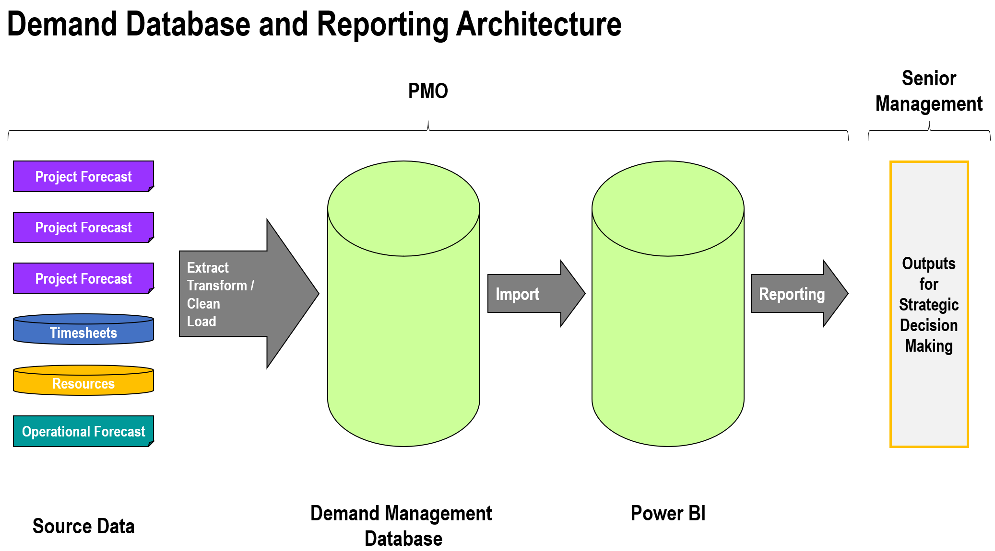
Source Data
This is composed of the following: -
- Project Forecasts
  - The workload associated with individual change initiatives that form part of the overall portfolio as defined in PRINCE2 [4].
  - Collected and supplied to the project as a single flat file in an agreed format.
- Timesheet Data
  - A download from an existing system of the time which has been booked by all staff to each work items across the organisation.
  - Collected and supplied to the project as a single flat file in an agreed format.
- Resource Data
  - The latest set of resource information.
  - Currently a flat file used instead of a database.
  - Will need to be transformed into a database as part of the requirements.
- Operational Forecasts
  - The workload that falls outside of the Portfolio as defined in PRINCE2 [4].
  - Collected and supplied to the project as a single flat file in an agreed format.
Extract, Transform / Clean, Load
This will standardise the data to ensure that it can be successfully loaded into the database in readiness for analysis.
A full breakdown of the varying resource types associated status and their definitions can be found in the appendices.
Demand Management Database
A MS Access database, designed to house the cleaned source data.
Power BI
The analysis tool that will be used to compare the source data.
Outputs
Tables and visualisations that will be both interpreted for and provided to senior leaders within the organisation to aid in strategic decision making.

Database Design

When including all four data types, the database itself is likely to be large. This would ordinarily lead the author to create a data warehouse with a Star Schema design at its core.
However, in this case, to gain confidence from the organisation’s security team when this is built within the organisation’s domain, a traditional relational database has been chosen for the design.
The design of the relational database that can service the Must-Have and Should-Have requirements can be found below: -
Figure 4 – Initial Database
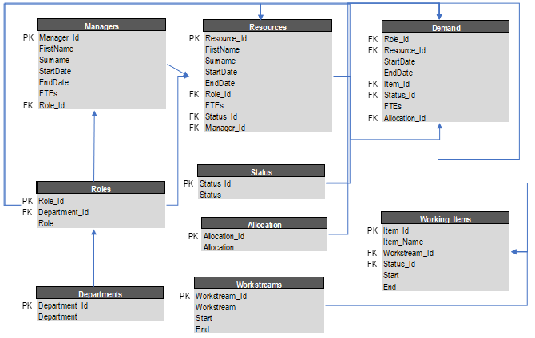
The design of the relational database that features a table capable of incorporating Booking Analysis (from the list of Could Have requirements) can be found below: -
Figure 5 – Second Iteration Database
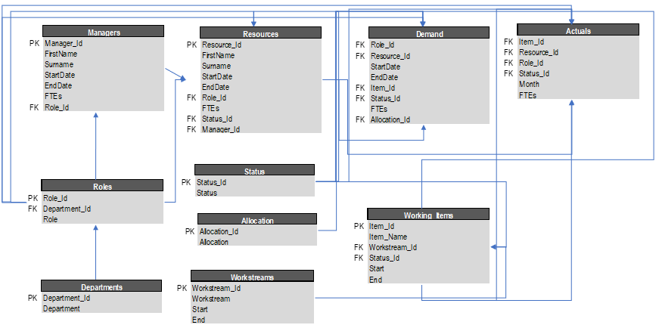

Database Dummy Fields and Data

The dummy data has been created by the author. A full breakdown of how this was designed and created can be found within the appendices.

Initial Must-Have Reporting

It is possible to create queries that could meet the basic reporting criteria set out in the requirements, using MS Access. However, as the visualisations will be created using Power BI, it seems logical and sensible to use Power BI to also create the basic reports.
This should save time in future, especially when creating a reporting suite for use by administrative staff members.
Therefore, Power BI will also be used to create the basic reporting from the Must-Have requirements.

User Interface

To successfully set up reporting that can be produced by an administrative team member, the author will need to complete the design and implementation of an appropriate user interface.
This will take place and subsequently be shown after the “Must-Have” portion of the implementation (and report).

Reporting Proof of Concept

Before build work can commence on the project, senior stakeholders have been given the opportunity to comment of a visualisation proof of concept.
Suggested Format
As uncovered during the literature review, managing Demand strategically requires an organisation to see how that Demand and any associated capacity will change over time. Any visualisation will need to show this change.
Therefore, the x axis of any graphical output should show a span of time, either starting now or, if necessary, in the past. (Showing data related to the past is useful when evaluating previous performance).
As the aim here is to assess resource capacity in FTEs, the y axis must therefore be Resources in FTEs.
This proof of concept shows stakeholders what they can expect from a Demand Model that is built to deliver Must Have and Should Have requirements, created based on the reasoning above.
In readiness for the Should-Have portion of the requirements, the author has produced the following as a potential view of the data: -
Figure 6 – Demand Management Output – Proof of Concept
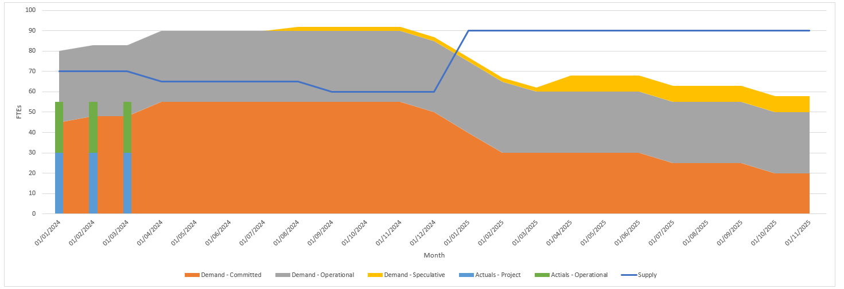
This visualisation represents the following: -
- Supply
  - Represented as a line.
  - A line is a good way to represent a “threshold”, which is effectively what the available resources will be.
  - The number of resources available to carry out work over time, based on current staffing and intended recruitment.

- Demand
  - Represented as a stacked landscape chart.
  - Formatted in this way so that we can easily tell when the workload falls below or exceeds the resource level over time.
  - Broken into its constituent categories, based on forecasts of known work.
- Actuals
  - Represented as a stacked bar.
  - Chosen
  - Broken into its constituent categories and based on bookings to work by resources.
In this case, produced using illustrative, fabricated data, we observe the following: -
Illustrative Findings: -
- Workload is currently greater than the available resources.
- Resources are due to be greater than the known workload.
- Bookings fall short of the available resources.
Illustrative Recommendations: -
- Encourage all those in the organisation to book their time to work items accordingly so that the true cost of change can be known and potentially modelled for future pieces of work.
- Planned recruitment appears to be optimistic – it should be noted that this is an ideal scenario which may be unrealistic based on previous recruitment successes.
- Move the workload of anything not business critical to a later date when resources are indeed available.

Feedback
Feedback to the proof of concept was overall positive, with stakeholders appreciating the breakdown of what can be observed within the visualisation in addition to the recommendations that are based upon it.
The following provides a summary of the feedback received rom stakeholders and fellow team members: -
- Positives
  - Shows when we are likely to be stretched / face an unrealistic workload.
  - Shows when work could move to.
  - Shows obvious booking anomalies.
- Negatives
  - Colours and design should be simpler to interpret.
  - Sorting the varying categories would be helpful. E.g. For Demand, the most committed work should be closest to the x axis.
The proof of concept was considered successful enough to lead to the implementation of the solution.

Project Plan

The following details the activities that have taken place to date and those that are remaining, with a planned timescale.
In terms of prioritisation, the “Must-Have” requirements have been given the highest priority, with the “Could-Have” requirements being given the lowest.
Figure 7 – Project Plan
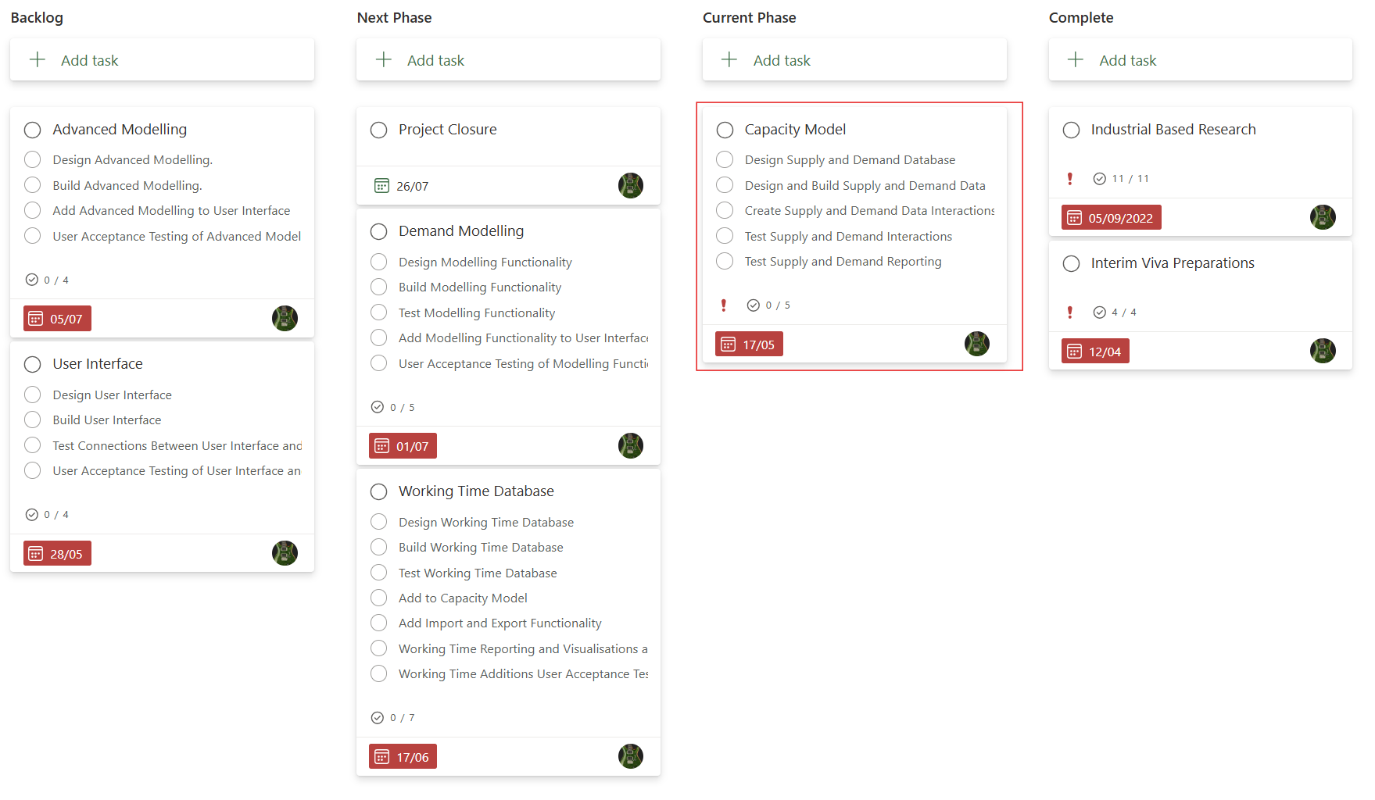
The plan reflects that the author is about to undertake the “Capacity Model” portion of the plan. (Screenshot taken retrospectively).
Tolerances have been set in line with the Agile Handbook [17]. Providing that the must haves are delivered successfully by the end of the project, any work not successfully delivered during a given phase can roll forwards to the next. If there is a risk that the must haves will not be delivered successfully, this must be escalated to senior stakeholders and sponsors accordingly when reviewing the delivery of the phase.

Archiving Considerations

The amount of data housed within the database will be considerable. However, beyond the data associated with resources (Supply data) there is no need to make considerations for archiving.
Reasons: -
- At the present time, all Project Plans are housed and archived individually. They will be imported into the database and replaced monthly. Archiving the previous intake would duplicate occupied space on the server.
- Timesheet data is downloaded from a system of record. The data in the model will therefore be replaced each month.
If a greater window of time with multiple forecast iterations is to be used for modelling, considerations should be made for both the size of any such system and the design of the database at its core.

Implementation

Phase 1 – Must Have Requirements

The following items below, highlighted in yellow, were worked on during this phase: -
Table 2 – Feature Table
Features | M | S | C | W
Staff Database | Y
Demand Information | Y
Basic Reporting | Y
Advanced Reporting |  | Y
Comparison Visualisations |  | Y
Easily Reproducible Reports |  | Y
Analyses and Recommendations |  | Y
Timesheet Information |  |  | Y
Actuals Modelling |  |  | Y
Create User Interface |  |  | Y
Organisational Planning |  |  |  | Y
Decision Making |  |  |  | Y
In Flight Forecasting |  |  |  | Y
Modelling Recruitment Success |  |  |  | Y

(Won’t have requirements have been greyed out).

Phase 1 – Source Data
Details of how the source data was cleaned and readied for the database can be found in the appendices.
Phase 1 – Supply and Demand Database
To create the database, the author has used SQL to generate the tables within MS Access.
The SQL used to create the Resources table can be found below: -
Figure 8 – SQL Sample
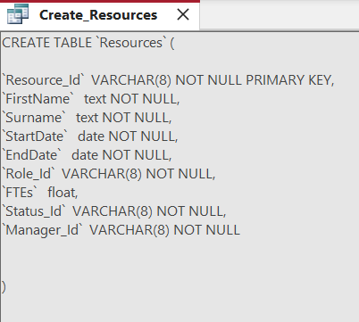
Phase 1 - Basic Reporting
Power BI was then able to absorb the whole database. Some instant benefits of using Power BI in this way proved to be: -
- Foreign Keys in tables enable the user to bring corresponding entries into a report from that key’s primary table. In other applications (such as MS-Excel) a lookup or join would have been necessary to complete such an action.
- Visualisations and filters were readily available.
Some basic transformations were undertaken, such as date formatting and renaming the “FTE” column across varying tables to differentiate between them.
At this stage, the project encountered its first major issue. Reporting needed to be carried out “by month”. Our data, as supplied, was shown based on start and end times. This meant, in the data’s current state, it could not be adequately shown in visualisations.
The table below shows that, even when filtering for “Active” resources, there is now way of selecting a specific month, with the data in its current form.
Figure 9 Active resources
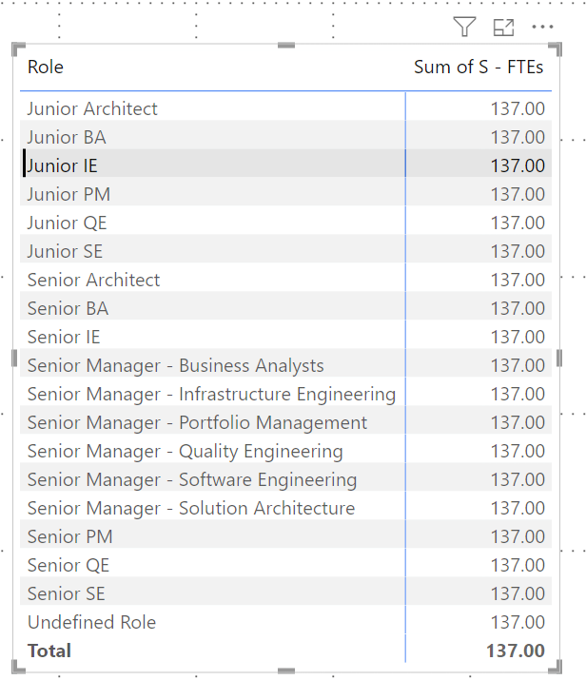
It was clear at this stage that some level of transformation and / or reconstruction would be required. The most basic of reports, such as how many active resources of each Type were available in each month, were simply not possible with the data in its current form.

Phase 1 Testing
As recommended in the Agile Handbook [17], testing should be completed at each phase.
Database: -
To test the database in its current form, the relational diagram was viewed to ensure it matched the initial design.
All relationships were adequately put in place which ensured that the database had been created successfully.
Reporting: -
As alluded to, the necessary reports could not be created at this stage, with the data available, meaning that the reporting feature was not delivered. At this stage the outputs could not be tested.
Phase 1 Evaluation
As alluded to, while the database creation, in line with its design, could be deemed a success, a lot more work must be done before reporting in a meaningful way can be carried out.
Phase 1 is summarised below: -
Table 3 = Phase 1 Outcomes
Feature | Success / Failure
Staff Database | Successfully Delivered
Demand Information | Successfully Delivered
Basic Reporting | Not Delivered Yet

Options to Improve Solution (Details in Appedices)
- Transform Data in Power BI
- Transform Data in Access
- Transform Source Data

Decision for Next Phase

Based on the options above, it is clear the best solution amendment is to create tables of data suitable for analysis, before loading it into the database.

Reporting will now be moved to Phase 2, in addition to creating the tables and readying the data for entry into them.

As the database is being added to as part of Phase 2, it has been decided in this case, to also create the Timesheet information portion of the database simultaneously.

The data and SQL are readied, which means there is little, or no effort involved in adding this to the next phase. Had the groundwork not already been done – this would have remained a part of a future phase.

Demand Modelling has been moved to Phase 3, to occur alongside the User Interface Design and Build.

The latest amended plan is therefore: -

Figure 10 – Project Plan

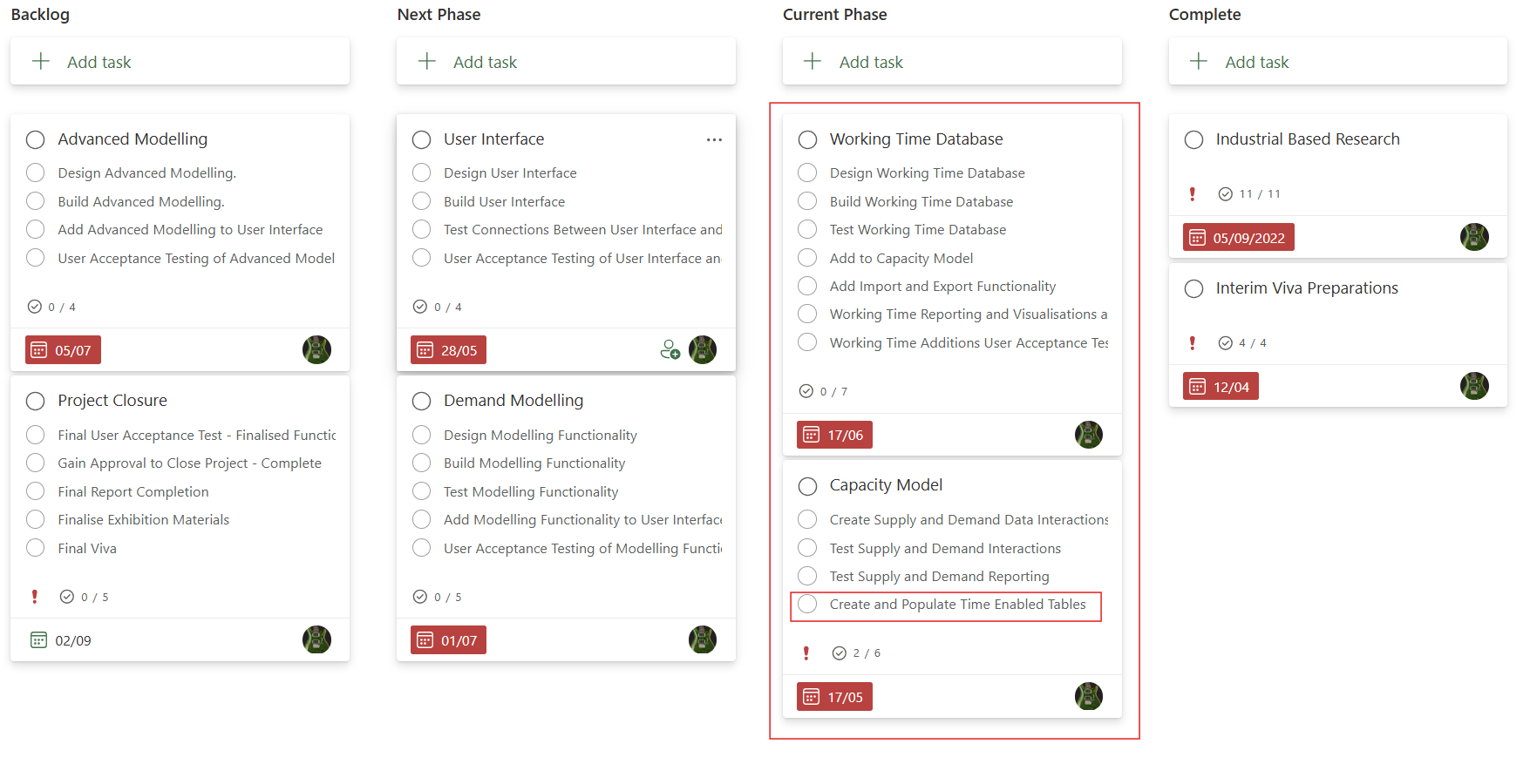
A task has been added for the new tables at the Transform / Clean / Load level.

Phase 2 – Database Completion and Basic Reporting

Phase 1 Retrospective
Whilst not all of phase 1 was delivered successfully in the time allocated to it within the plan. Whilst what was delivered in Phase 1 was accepted by the customer, the project has officially slipped.
The following items below, highlighted in yellow, were worked on during this phase: -
Table 4 – Feature Table
Features | M | S | C | W
Staff Database | Y
Demand Information | Y
Basic Reporting | Y
Advanced Reporting |  | Y
Comparison Visualisations |  | Y
Easily Reproducible Reports |  | Y
Analyses and Recommendations |  | Y
Timesheet Information |  |  | Y
Actuals Modelling |  |  | Y
Create User Interface |  |  | Y
Organisational Planning |  |  |  | Y
Decision Making |  |  |  | Y
In Flight Forecasting |  |  |  | Y
Modelling Recruitment Success |  |  |  | Y

(Won’t have and completed features (shown with a “C” have been greyed out).

Phase 2 – Design Considerations
The latest database design, including timesheet information, would have been: -
Figure 11 – Second Iteration Design
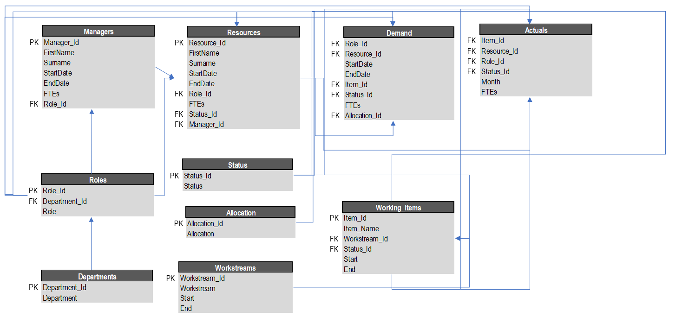
Based on the need for new tables, the design is now: -
Figure 12 - Redesign
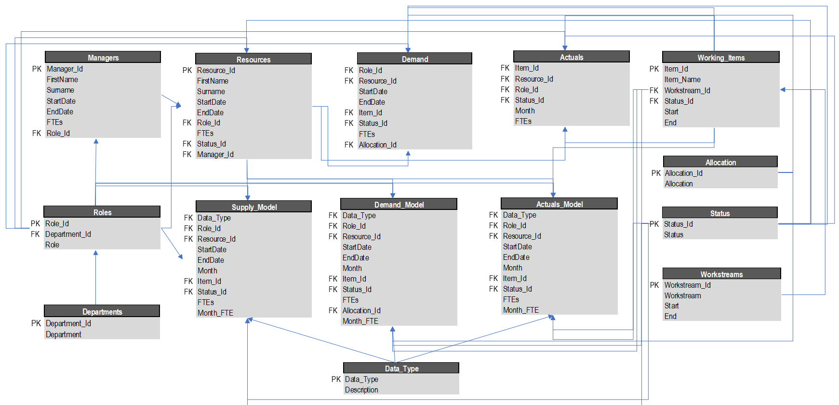
Phase 2 – Source Data
The data for all relevant tables was readied in line with the recommendations set out at the end of Phase 1, including the data relating to Timesheet Information. Regardless of the start or end date, the new date field reflects the month in question, and so are all shown as the “first of”.
Where the date field and adjacent entry equate to a non-zero FTE in the initial set of data, the FTE is added accordingly to a new “Month FTE field.

Phase 2 – Database
The SQL for the tables was created in the same manner as the SQL in Phase 1.
The database was updated successfully, following the method laid out as part of Phase 1. The new data was filtered to only bring across non-zero Month FTE values, to save space.

Phase 2 – Reporting
All tables and new data were successfully uploaded to the Demand Management Model in Power BI.
To report of the comparisons between the tables within the database, based on a period, a new date table had to be created within Power BI using a DAX query: -
Equation 1 DAX query:
Dates = calendar(date(2023,07,01),date(2025,06,30))
This set up a “period of interest” for use within the reports.
Once completed, the table of dates had to be joined to the tables which now contain specific date fields.
The diagram showing the joins can be found below: -
Figure 13 – New Table Relationships
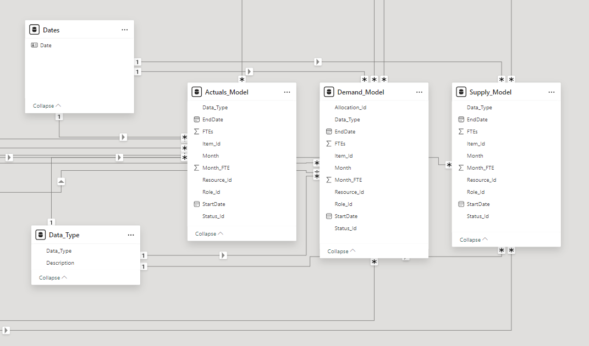
This has now enabled the basic reporting needs.
Table of Active Resources, by Department: -
Figure 14 - Table of Active Resources
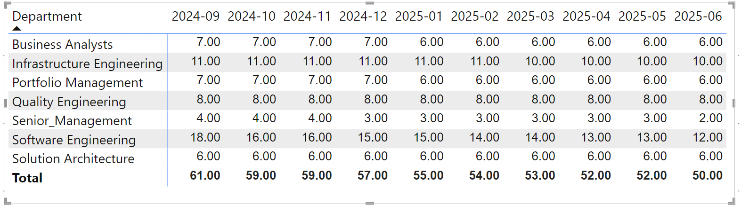
Broken down by role: -
Figure 15 - Broken down by role
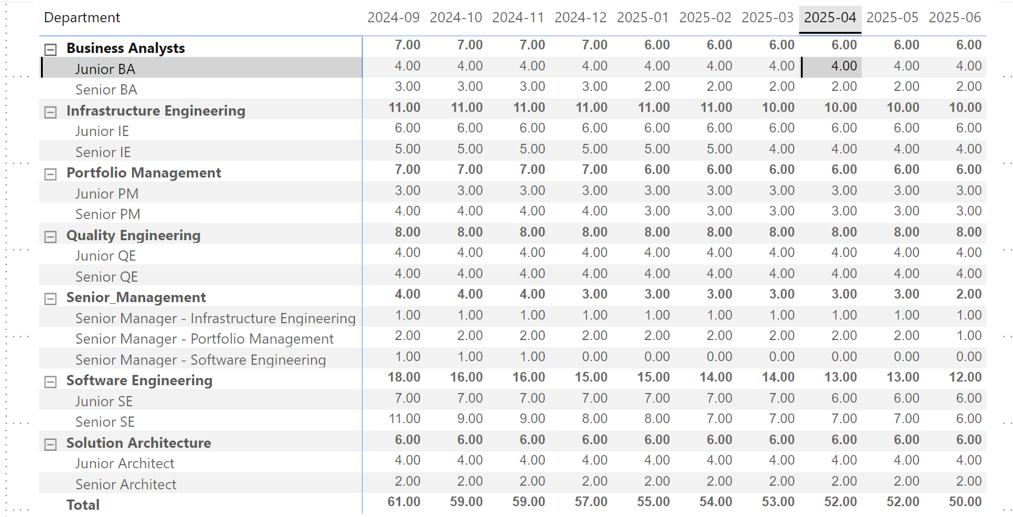
Committed Demand, by Department: -
Figure 16 - Committed Demand, by Department
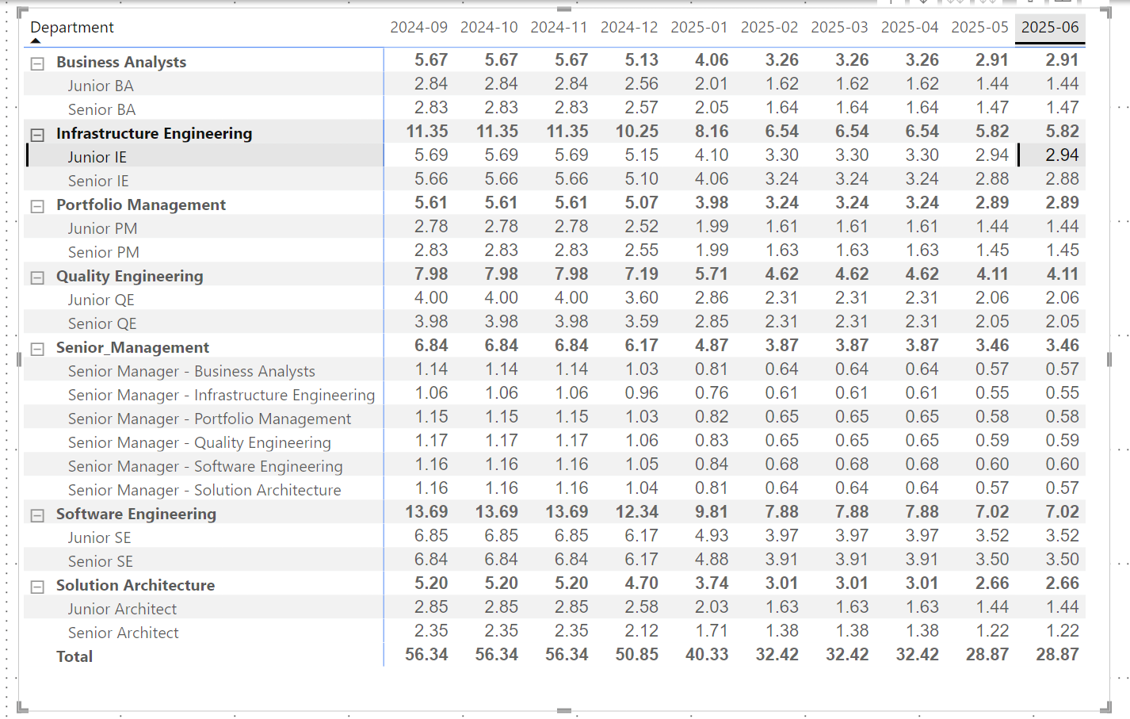
Phase 2 Testing
Database and Reporting Accuracy: -
The artefacts produced by the Demand Model have been compared against some primitive reporting carried out on the source data.
At this stage, we can observe that the data has indeed been carried over correctly and that the reporting mechanisms applied in the right way.
Active Roles based purely on Source Data: -
Figure 17 - Active Roles based purely on Source Data
Committed Demand based purely on Source Data: -
Figure 18 - Committed Demand based purely on Source Data
During testing it has been noted that, while the data summaries have indeed been replicated, care should be taken when setting up reports of this nature.
It is imperative that the correct Month-FTE Field is used from the correct table to produce the correct report.
E.g. Selecting FTE from the Demand table will produce an incorrect report.
User Acceptance Testing
Key stakeholders are content with the basic reporting functionalities but are keen to view visualisations and accompanying analyses that can enable strategic decisions.
Phase 2 Evaluation
Phase 2, when compared to phase 1, was a complete success, and is summarised below: -
Table 5 – Phase 2 Outcomes
Feature | Success / Failure
Staff Database | Successfully Delivered
Demand Information | Successfully Delivered
Basic Reporting | Successfully Delivered
Timesheet Information | Successfully Delivered

The database can now be reported on with confidence that the data is accurately represented therein.
Creating the new tables with SQL and subsequently pasting the data in was most certainly a sound decision. Using SQL to add all the rows in across the three new large tables would have potentially been time consuming and troublesome.
As alluded to un UAT, senior stakeholders are now keen to see “what the tool can do” in terms of its outputs.
The Plan for Phase 3 is therefore to: -
- Design Build and test Demand Modelling Functionality
- Design, and Test the User Interface
An updated plan can be found below: -
Figure 19 – Project Plan
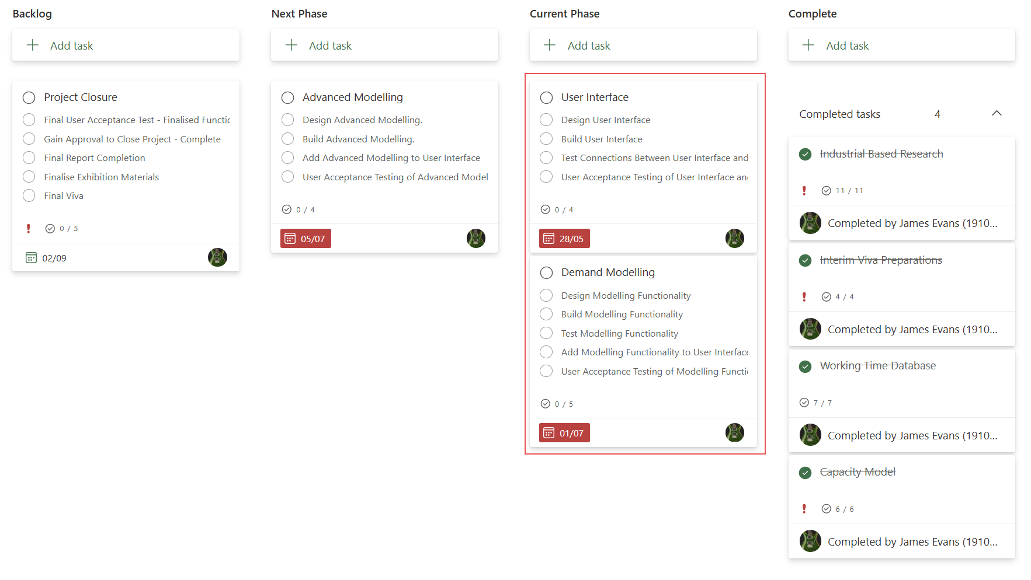

Phase 3 – Demand Modelling and the User Interface Design

Phase 2 Retrospective
Whilst the project slipped as part of Phase 1, some ground has been recovered successfully. Apart from the features that had already been realigned to phase 3, all other features remain on schedule.
The following items below, highlighted in yellow, were worked on during this phase: -
Table 4 – Feature Table
Features | M | S | C | W
Staff Database | C
Demand Information | C
Basic Reporting | C
Advanced Reporting |  | Y
Comparison Visualisations |  | Y
Easily Reproducible Reports |  | Y
Analyses and Recommendations |  | Y
Timesheet Information |  |  | C
Create User Interface |  |  | Y
Actuals Modelling |  |  | Y
Organisational Planning |  |  |  | Y
Decision Making |  |  |  | Y
In Flight Forecasting |  |  |  | Y
Modelling Recruitment Success |  |  |  | Y

(Won’t have and completed features (shown with a “C” have been greyed out).

Phase 3 – Design Considerations
For advanced reporting, the key stakeholders have confirmed they wish to see the following visualisations: -
A summary of the ideal Resources for the current month, broken down into: -
- Role Status
- Department
It has been decided that, as this visualisation does not need to show changes over time, a pie chart would be best placed to represent the data.
A summary of how the number of resources available in each role, and the associated Demand is due to change over 12 months.
As this needs to show changes over time, the design should incorporate a timeline as the X-Axis.
For comparison visualisations, the aim is to create an equivalent visualisation of the proof of concept.
Colours should be chosen carefully. Thresholds should be shown as a clearly as possible to highlight capacity concerns.
The remaining data types should be easily differentiated between and not overpowering.
For the UX design, Colours have been selected to ensure that they are easy for an individual to look at (primarily white, featuring blues and greys).
Anything that can be selected or “pushed” should stand out from the remaining items on any given screen to show that they are indeed buttons.

Phase 3 Advanced Reporting, Analyses and Recommendations
The following visualisations have been produced by the Demand Management Model: -
Resource Summary: -
Figure 20 Resource Summary
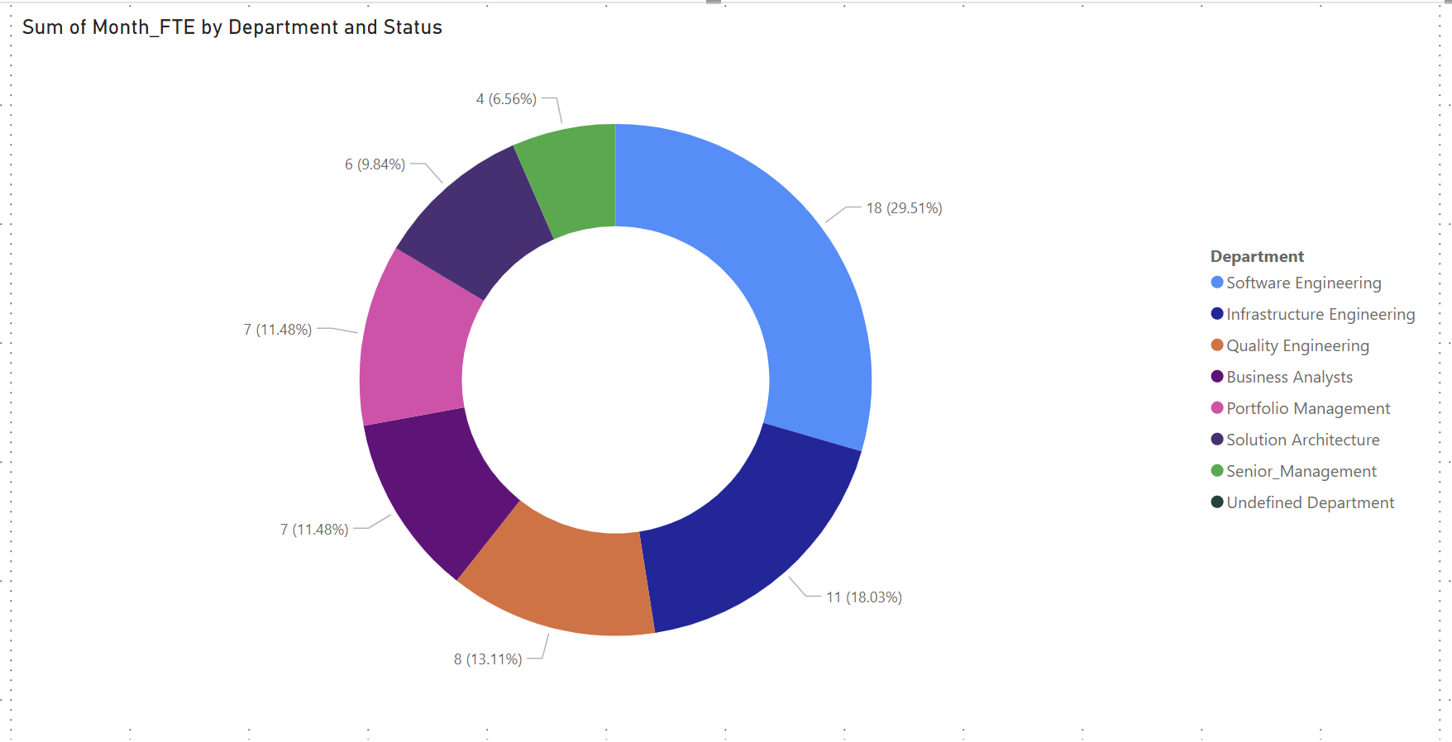
The above summarises the present breakdown of resources by Department. This can be changed to show the number of resources that are active using the filters present in the report.
Changes in Resources Status Proportionality over time: -
Figure 21 Changes in Resources Status Proportionality over time
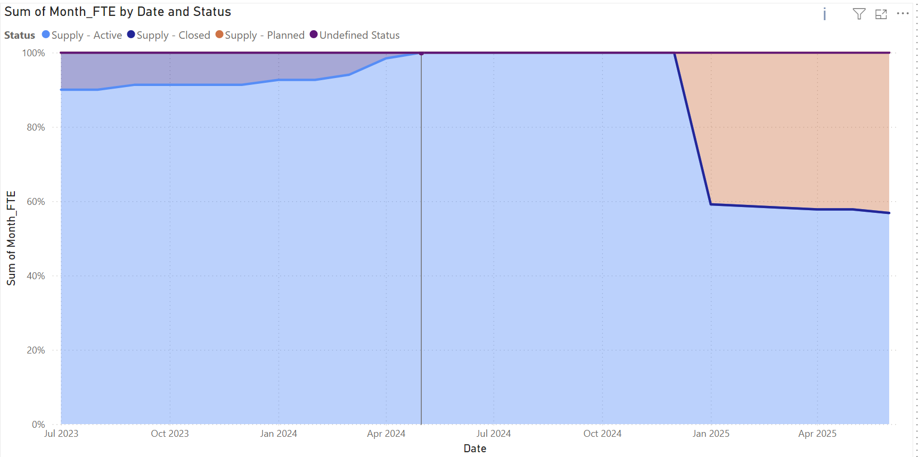
This visual shows the proportion of planned, closed and active resources over time. This makes attrition and recruitment ambitions simpler to view.
Example Analysis: -
The previous year has seen us lose roughly 10% of our ideal compliment each month. Starting in January of next year, we intend to grow our capability substantially, with 40% of our ideal compliment not actively working at present.
This is an aggressive strategy which might fail when the realities of recruitment are encountered.
Changes in Resources Over Time, by Role: -
Figure 22 Changes in Resources Over Time, by Role
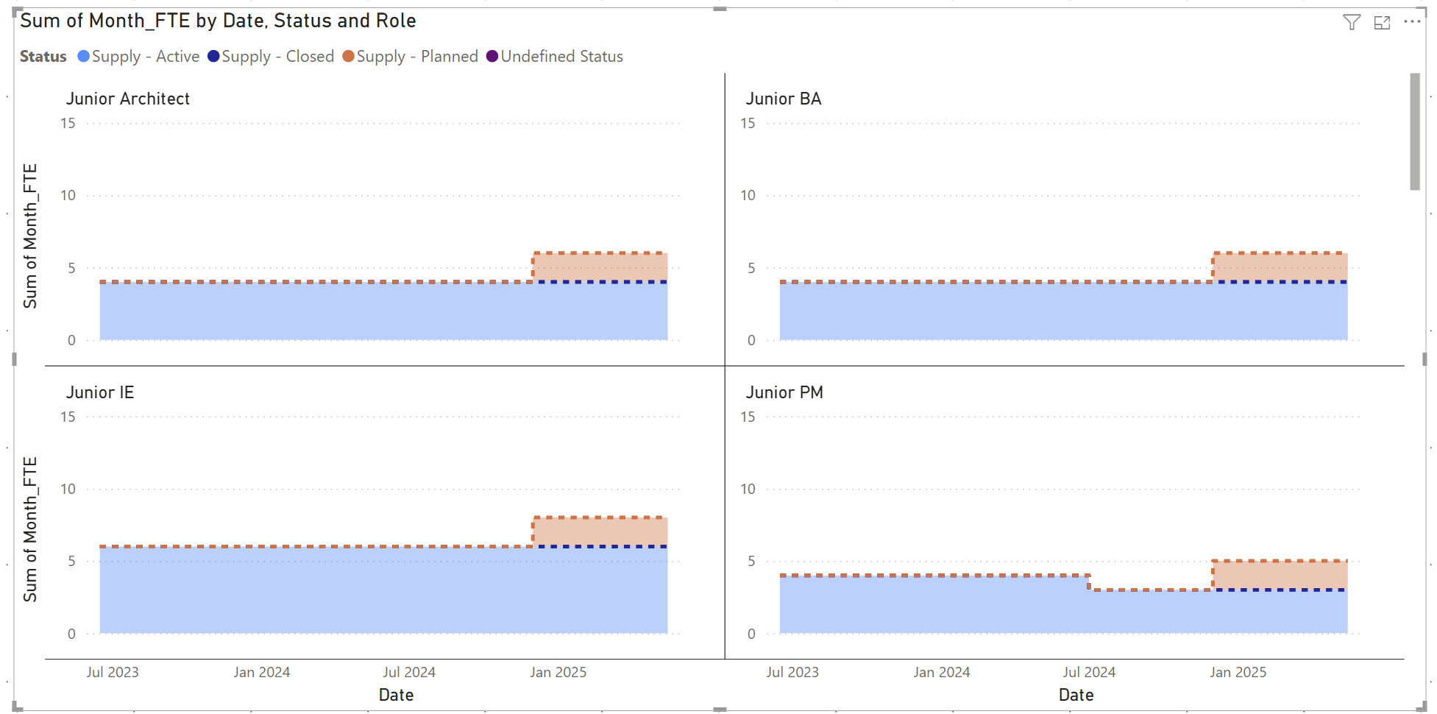
Example Analysis: -
Here we can see where key resource issues manifest from a recruitment and retention perspective. (Charts that show a drop off in staff with the most aggressive recruitment intentions would be highlighted).
Changes in Demand Status Proportionality Over Time: -
Figure 23 Changes in Demand Status Proportionality Over Time
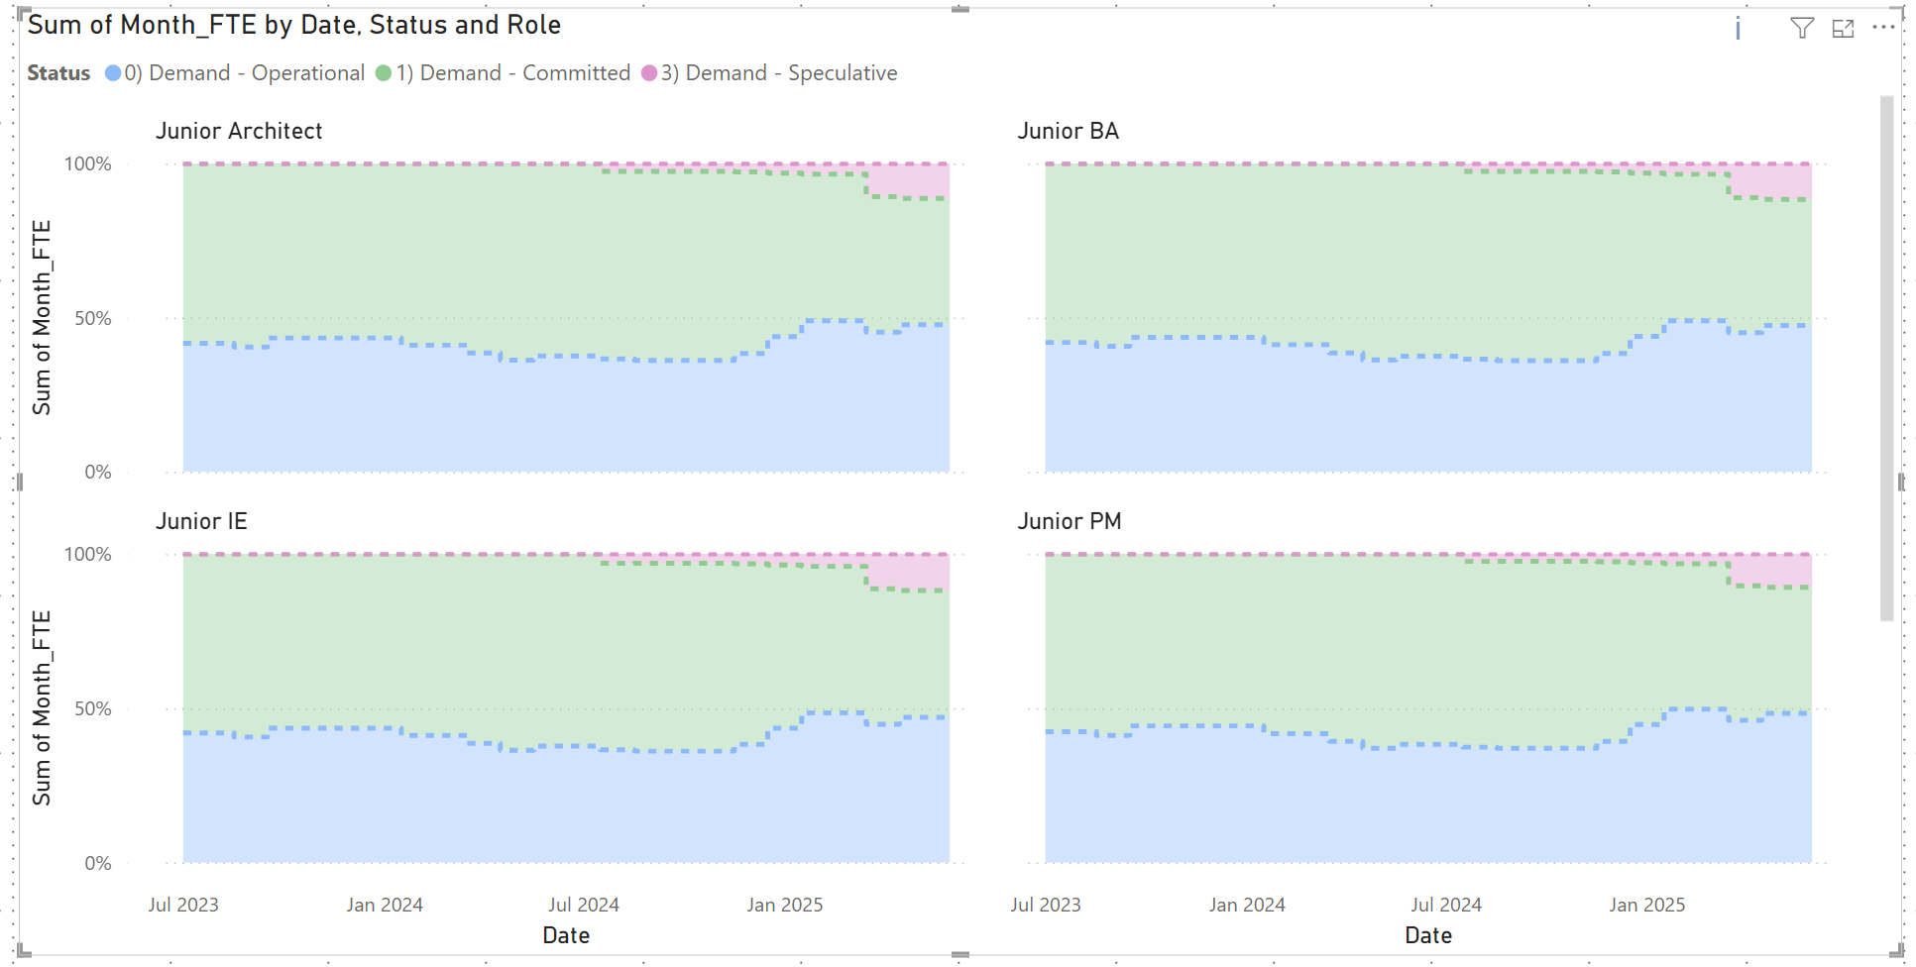
Here, we observe how the various types of work make up the total amount of work the organisation faces over time. This is to enable decisions around whether the correct mix of Operational and / or change related work is being considered.
To ensure that the Status appears in the chart in line with the requirements, they have been renamed accordingly.
An example of the DAX query used to achieve this can be found below: -
Equation 2 Example of the DAX query used
= Table.ReplaceValue(#"Replaced Value8","Supply - Planned","2) Supply - Planned",Replacer.ReplaceText,{"Status"})
Example Analysis: -
Here we can observe the amount of operational work a type of resource is likely to carry out over the coming 12 months in relation to the amount of Project work. It also includes the proportion of Project work that “may” materialise.
For resources that should be dedicating their time to change; we should investigate why the amount of “operational” work is due to be carried out.
This could potentially lead to resource gaps in other areas or roles being filled using staff that are currently planned to work on “non-essential” work.
Demand Model
Figure 24 Demand Model
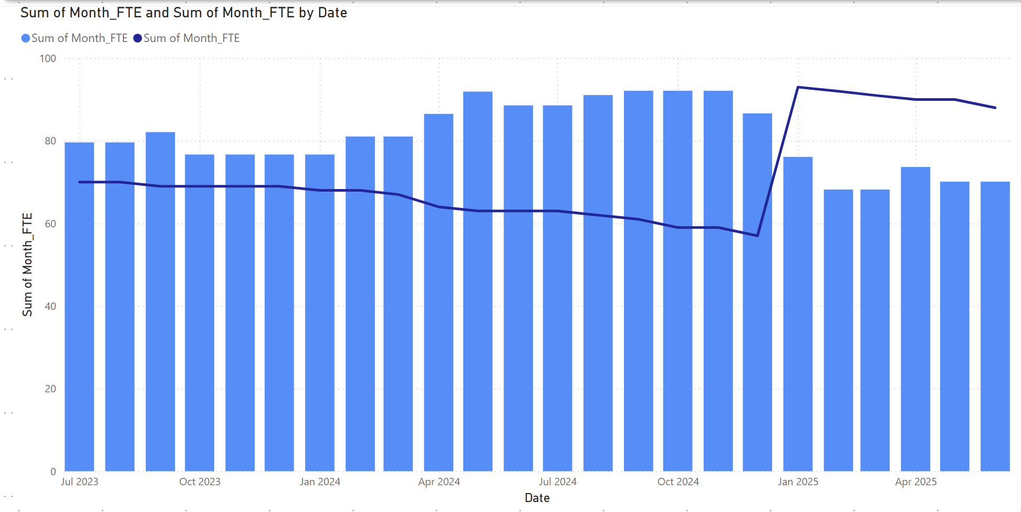
This view shows the absolute number of FTEs needed per month compared to those available. This enables the analyst to view when the current workload might feasibly be moved to, to manage strategic expectations.
Example Analysis: -
Here we can observe the work we are currently trying to carry out (the bars) is greater than the available resources (the line) for the remainder of the calendar year. If planned recruitment is successful, the workload will be achievable from January. Based on this, it is recommended that non-essential work be moved “to the right” based on the assumption that planned recruitment is at least somewhat successful.
Demand Model Breakdown by Role
Demand Status colours purposely match those in the breakdown charts: -
Figure 25 Breakdown charts
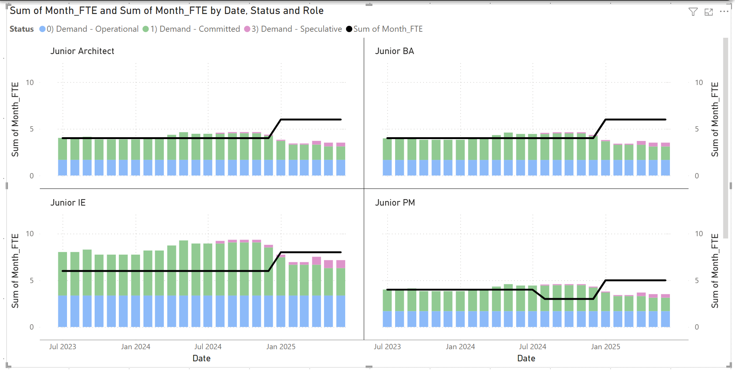
Example Analysis: -
This is like changes in Demand, except we can see the material differences made through comparisons of work and capacity.
Recommendations could include which specific resource types to target with tactical measures. These would be represented in any chart which has excessive workload and low capacity to handle it.

User Interface
A wireframe has been developed using MS PowerPoint, so that any team member in the organisation will be able to access and test it.
A sample slide can be found below: -
Figure 26 UI Sample 1
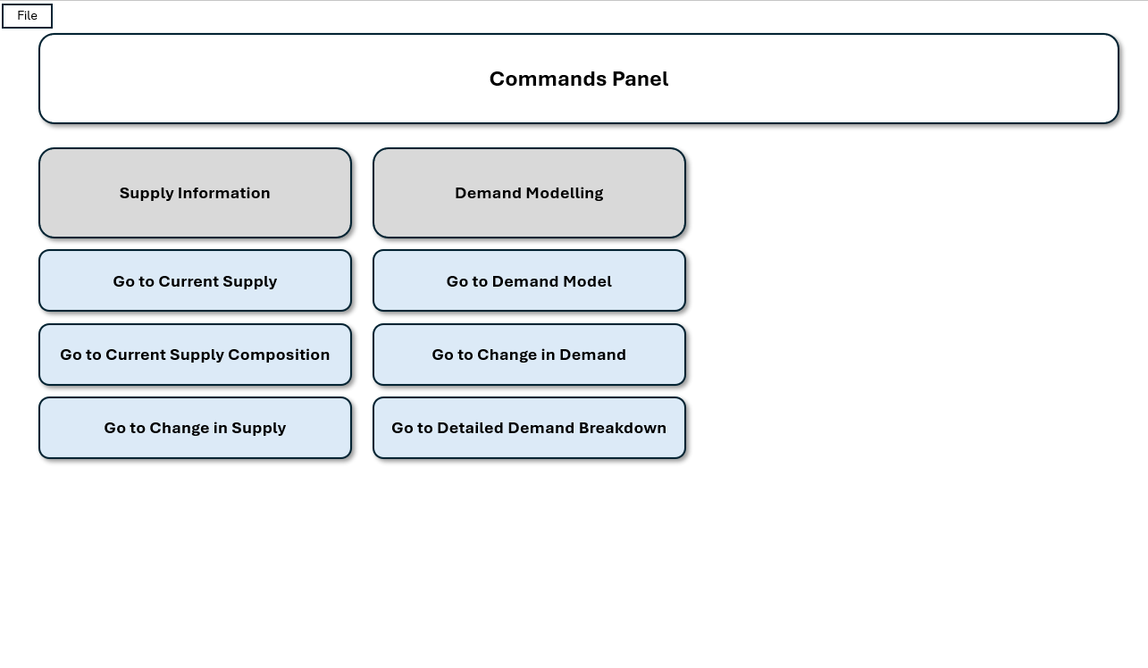
Here we observe that navigation pages are listed in blue and have shadows.
Figure 27 UI Sample 2
A sample of the contents can be found below: -
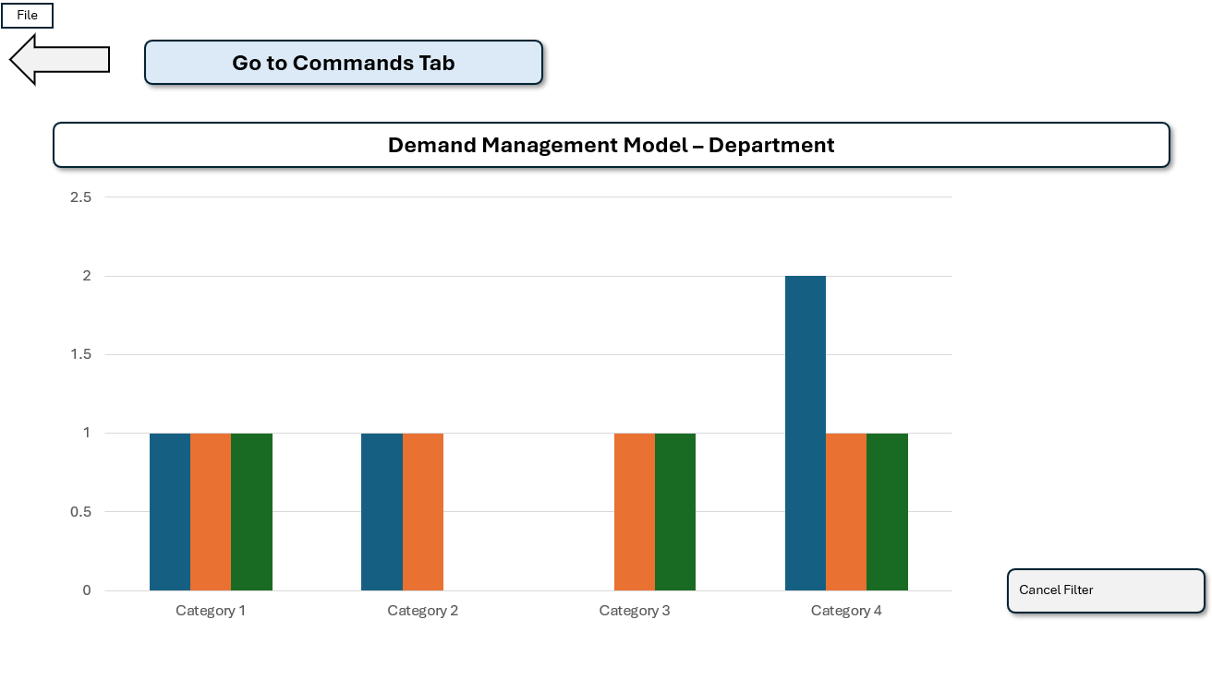
Here we can observe that we have a “back” arrow to go to the previous page, a filter for a specific area and a link to the central commands page.
Phase 3 – Testing
Demand Model Outputs: -
Outputs from the Demand Model have been well received by stakeholders but rely on the explanations that accompany them to ensure that they are fully understood.
Once understood, they can indeed be used to make meaningful medium to long term decisions regarding resource commitments.
Stakeholders are comfortable and confident that they do indeed meet their requirements.
Use Interface: -
Members of the team were asked to utilise the wireframe to carry out the following activities: -
- Navigate to and from each report.
- Apply and remove a reporting filter.
- Apply and remove a “drill down” function.
- Export the report for circulation.
The summary below provides a breakdown of the feedback that was received from the team members: -
- Non buttons are raised and are the same shape as buttons. This is confusing.
- Some instructions for filtering or drilling down are necessary as the meaning was not obvious to all team members.
- Exporting appeared relatively simple, but it was felt this would most likely be more complex when attempted.

Phase 3 Evaluation
Phase 3 has ultimately been a success and is summarised below: -
Table 7 – Phase 3 Outcomes
Feature | Success / Failure
Advanced Reporting | Successfully Delivered
Comparison Visualisations | Successfully Delivered
Easily Reproducible Reports | Successfully Delivered
Analyses and Recommendations | Successfully Delivered

Demand Modelling: -
In the case of the outputs provided, as they are based on dummy data, the annotation can assume that the data is accurate.
In practice, at present, their primary use will be to scrutinise the accuracy of data. The outputs provided are somewhat useful in this regard, but will no doubt become more useful as data accuracy improves. Stakeholders have been advised that this is only likely to happen when contributors to data are reminded of its importance through examples set by leadership team members.
User Interface: -
The design of the User Interface can now be used as a basis to create the primary interface, with the following amendments based on the wireframe feedback: -
- Any non-buttons should have their shape changed accordingly to remove confusion.
- Annotation should be used where a button or function isn’t obvious to the end user.
- Instructions could be added to ensure that the export and share with senior stakeholders can be carried out with minimal issues.
The Plan for Phase 3 is therefore to: -
- Introduce Actuals Modelling
- Create the User Interface
An updated plan can be found below: -
Figure 28 – Project Plan
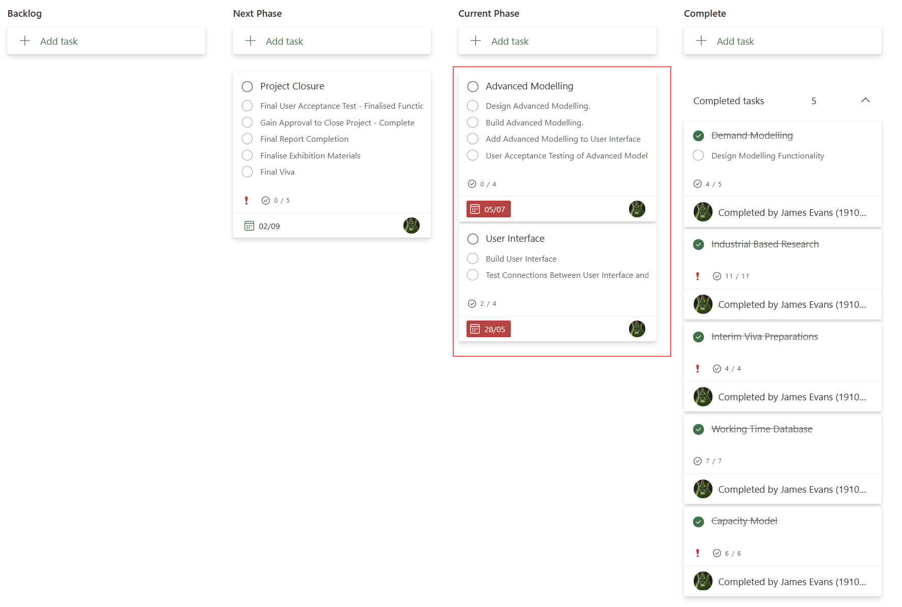

Actuals Modelling and User Interface

Phase 3 Retrospective
The project is back on track and is moving according to schedule.
The following items below, highlighted in yellow, were worked on during this phase: -
Table 8 – Feature Table
Features | M | S | C | W
Staff Database | C
Demand Information | C
Basic Reporting | C
Advanced Reporting |  | C
Comparison Visualisations |  | C
Easily Reproducible Reports |  | C
Analyses and Recommendations |  | C
Timesheet Information |  |  | C
Create User Interface |  |  | Y
Actuals Modelling |  |  | Y
Organisational Planning |  |  |  | Y
Decision Making |  |  |  | Y
In Flight Forecasting |  |  |  | Y
Modelling Recruitment Success |  |  |  | Y

(Won’t have and completed features (shown with a “C” have been greyed out).
Phase 4 – Design Considerations
For Actuals reporting, the key stakeholders have confirmed they wish to see the following visualisations: -
- Where possible, the colours should match the status already declared within the Demand reporting outputs.
- Visualisations should, again, be simple to understand.
For UI, the considerations were made clear in the Phase 3 evaluation.
Phase 4 – Actuals Modelling
The following visualisation shows bookings per month, department, to either Operational or Project booking codes: -
Figure 29 Bookings per month
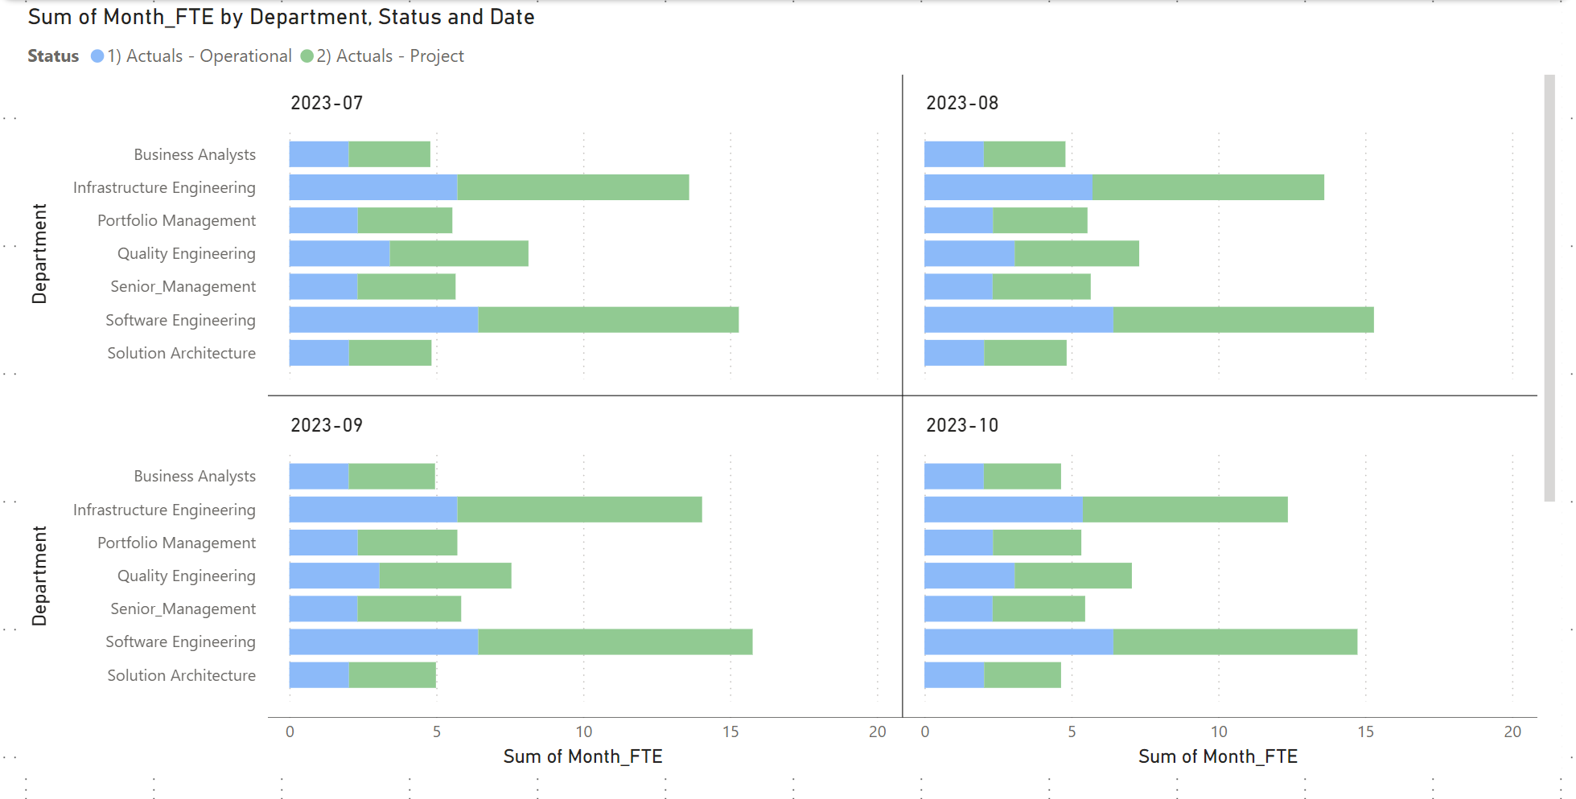
Scrolling enables the user to observe all months in the data set.
Example Analysis: -
Bookings to Operational codes seem to take up almost half of the time of each Department every month.
This should be examined to ensure that our time is being spent well. If this time is being used to fix related and recurring “breaks”, the time would be better spent developing a strategic solution to the problem.
Demand vs Actuals: -
Figure 30 Demand vs Actuals
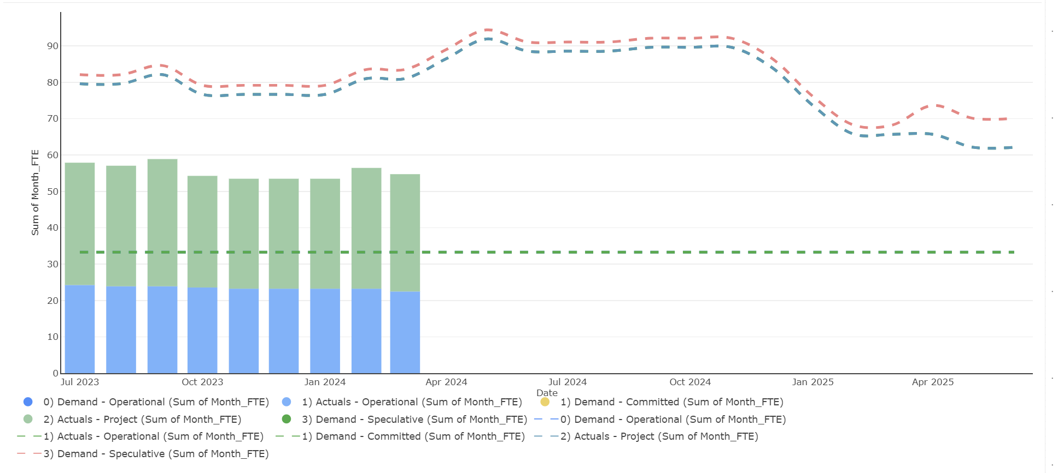
For this, slightly more complete visualisation, it was necessary to include an additional visualisation. Power BI is capable of stacking bars, or area graphs but not both simultaneously.
The different application needed to stack two differing data types has led to the visualisation being slightly different from those previously observed.
Demand vs Actuals Breakdown: -
Figure 31 Demand vs Actuals Breakdown
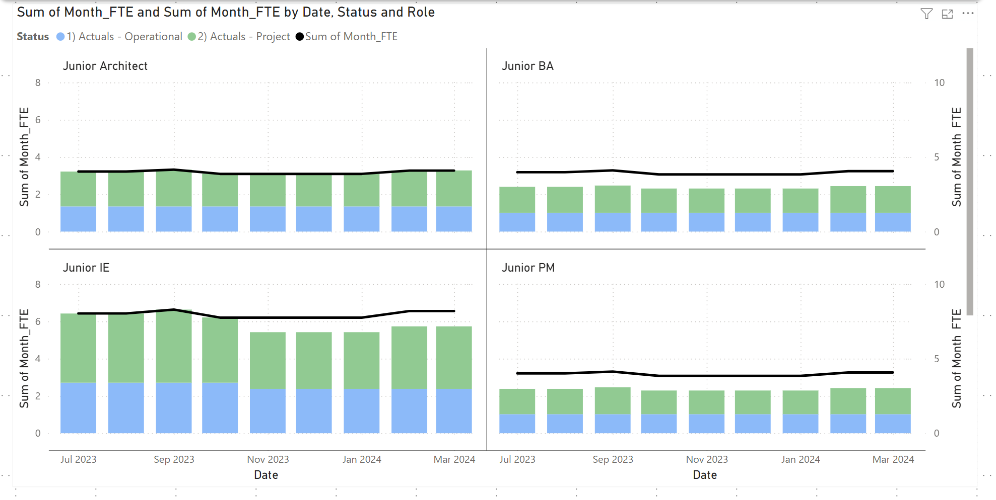
Here we can observe how bookings have compered with demand, each month, by Resource type.
Example Analysis: -
When observing bookings, not all work we are scheduling has an associated booking. This points to a potential issue with one of the following: -
- Planning assumptions.
- Productivity levels.
- Booking issues.
For the organisation to have faith in the modelling we produce, these issues should be remedied in the immediate term.
This has purposely been created in this way to reflect the reality of the situation, albeit with dummy data).
Phase 4 – User Interface
Following feedback illustrated in phase 3, the following User Interface commands page has been created: -
Figure 32 Final User Interface
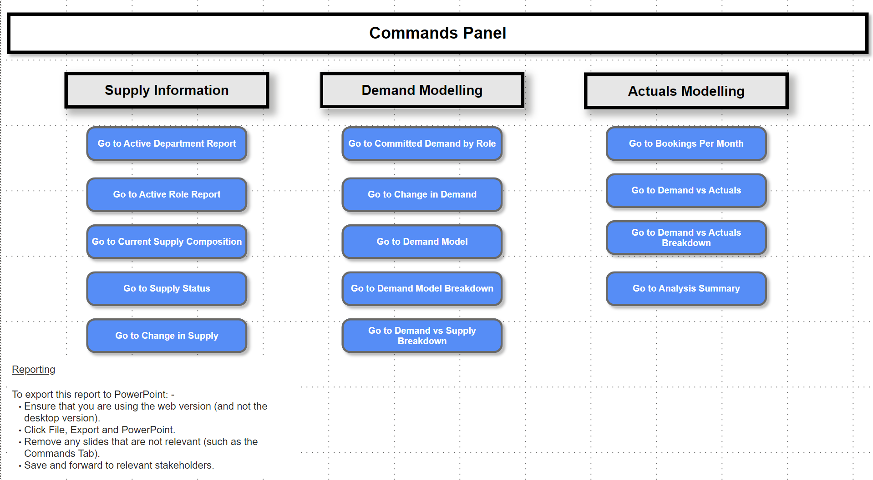
Reporting instructions have now been added, along with links to each page of interest within the model.
The final report can be produced in PowerPoint, provided that the web version of Power BI is employed.
From here any slides not required (such as the Commands page). Can be produced.
While the standard method for reporting within the organisation is PowerPoint, it will be pointed out to senior stakeholders that, to interact with any visualisations (through drilling, filtering or scrolling, the Demand Model must be opened in Power BI.
Phase 4 - Testing
Demand Modelling: -
Stakeholders are content with the analysis and visualisations in relation to Actual bookings. Feedback regarding data will feature in the Phase 4 evaluation.
User Interface: -
Following the feedback loop initiated following Phase 3, the administrative team members are content with the user interface at the current time.
All links to each page in the report are working well, with the functionality of each visual performing in the way which is expected.
In terms of the reporting that is created, senior stakeholders are somewhat content that the model will need to be viewed to gain a full appreciation of the interactive features. They still wish to receive a report in PowerPoint and accept some features will be unavailable.
Phase 4 Evaluation
The features available in Power BI have, for perhaps the first time, shown their limitations.
The author was unable to: -
- Link the exporting of the report to a button on the Commands Page.
- Introduce a chart capable of stacking lines.
- Introduce a chart that compared three differing types of data that are each broken down. To achieve this the author wanted, but was unable to produce a chart containing: -
  - Stacked Lines.
  - Stacked Bars.
  - Stacked Area.
For exporting, a work around was found and accepted by stakeholders, which features a brief set of instructions in the Commands tab. This is not ideal but delivers a workable solution.
In terms of Actuals reporting, senior leaders are divided on the usefulness of timesheets and subsequently are not all bought into ensuring they are used.
It’s clear that this model can indeed utilise the data to provide meaningful visualisations but in practice this will only be as good as the data provided.
Senior leaders and key stakeholders have accepted that the project may be closed and are comfortable that a fully working model is now in place, in readiness for population with real data.
An updated plan can be found below: -
Figure 33 – Project Plan
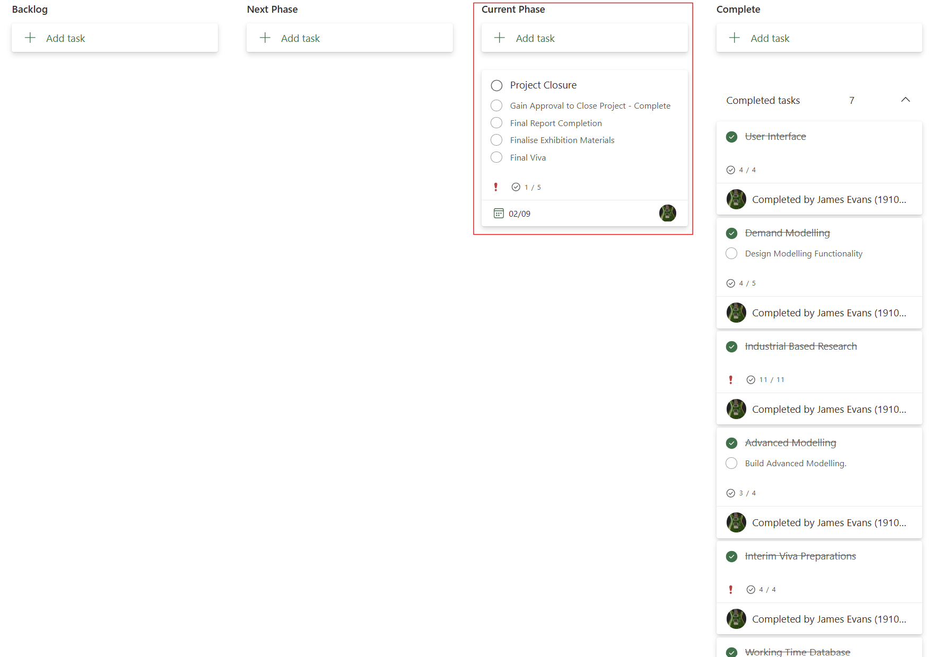
Plan Update Following Project Closure: -
Figure 34 = Project Plan
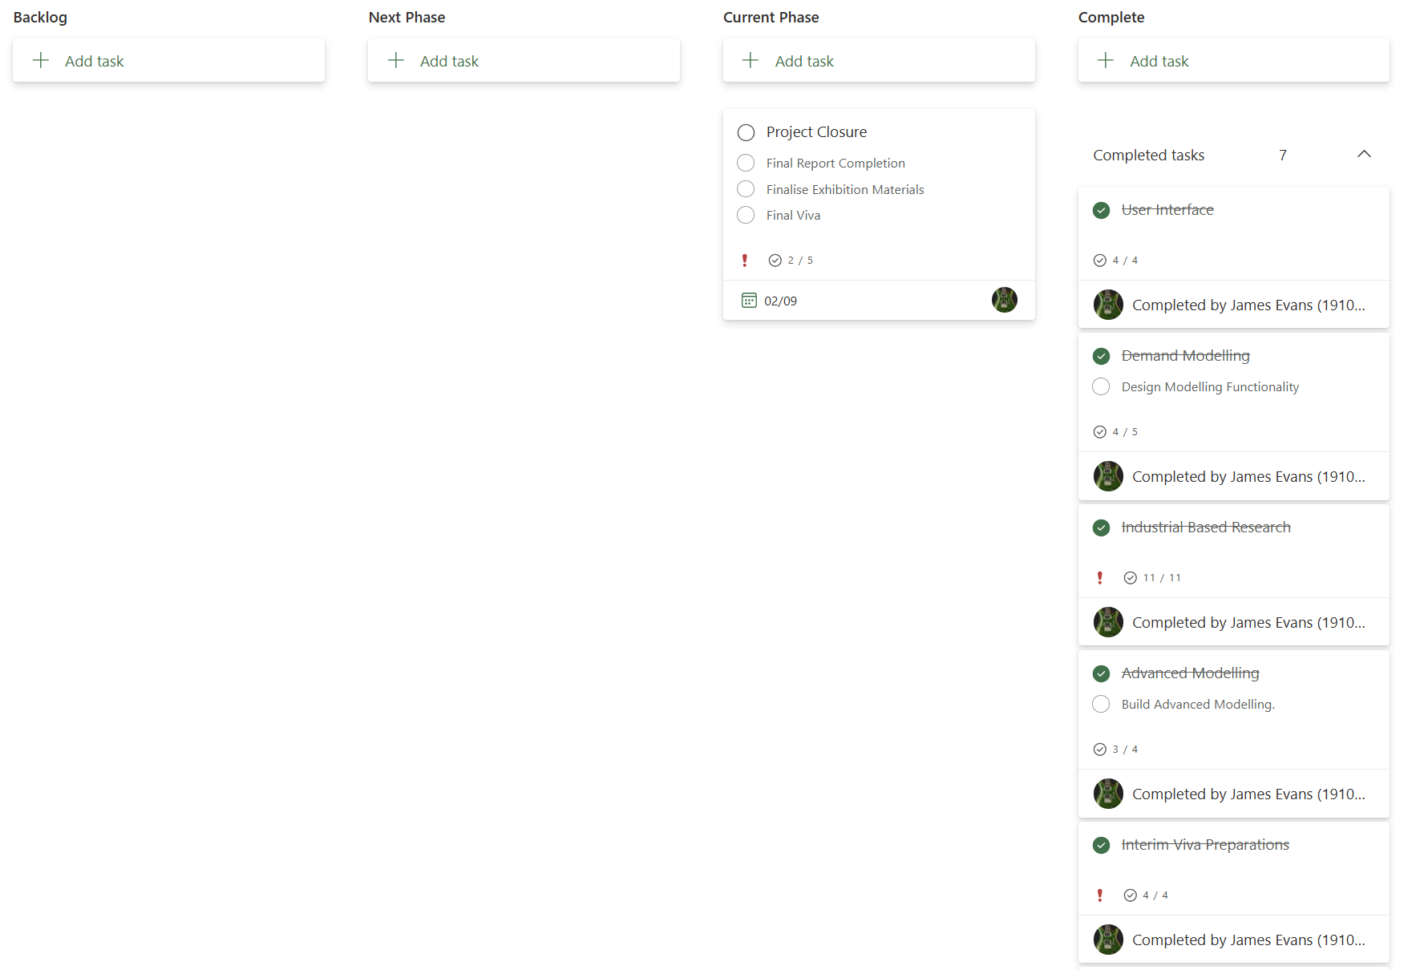

Project Evaluation

Following the closure of the project and the satisfaction of key stakeholders, the project can be deemed a success.
Here we will evaluate how well the project met each objective: -
Project Objective: - Show the best form of Demand Management that can / should be employed within this organisation.
Following the literature review, it was decided that a view of capacity through comparing Demand quantifies as known work in FTEs with Resource availability.
This proved to be a sensible approach as the outputs could ultimately meet their purpose within the organisation. This objective and associated aims can be considered met.
If carrying out a similar exercise in future, the lessons learnt during this project should be considered.

Project Objective: - Design an appropriate solution.
The initial design worked somewhat well, but was initially viewed as a failure until additional transformed data was introduced to enable data modelling namely: -
- FTEs per month with accompanying fields as opposed to start and end dates.
- A date table that could be used to give the modelled data tables context when relating to each other inside the database.
Once that these mitigations were in place, the objective was met.
The aim was to produce a design that could lead to data modelling and the production of insightful visualisations. This aim can be considered met.
When designing the solution in future, more careful considerations should be given to the capabilities of the tooling and the formats required for each data set to enable modelling.

Project Objective: - Enable strategic decision-making.
To enable strategic decision making, it is important to recognise that two things are in fact needed. Whilst one is, undoubtedly, a robust tool that can offer visualisations, the other is a reliable set of data to feed into it.
It is fair to say that this project has built tooling that does in fact provide visualisations of how capacity changes over time, which can be used to make strategic decisions, it does not ensure the data itself is reliable.
It would have been wise to list providing reliable data as a “won’t have” feature of the project. This is recommended if undertaking a similar endeavour in future.
In some senses this objective and its subsequent aim were indeed met from a development perspective, they hinge greatly on the data being accurate. This was seen as “obvious” by the author, and therefore did not anticipate that this was an expectation on the part of the organisation.
The objective was therefore somewhat met, although should not be seen as a failure.

Project Objective: - Shows threats and opportunities to / for delivery.
The visualisations that are produced can indeed highlight areas where: -
- A particular resource type has: -
  - Capacity to undertake additional work.
  - An excess of planned work.
- A department: -
  - Can undertake additional work.
  - Cannot contend with additional work.
  - Currently has too much work planned.
- The organisation can: -
  - Accept new work into the change portfolio.
  - Needs to manage delivery expectations regarding the current Portfolio preferably through “slippage”.
As anticipated, following the literature review, the data (if accurate) can pinpoint opportunities, especially when shown via informative visualisations.
This objective can be seen as met and met well, with the associated aims brought to fruition.
Project Objective: - Provides strategic and tactical recommendations if deemed necessary.
This objective was, unfortunately, less of a developmental one and more of an ensuring activity following the successful development of the tooling or a specific visualisation.
This objective was nonetheless met satisfactorily, with the author able to provide the accompanying analysis and recommendations.
Based on the data used; charts that have featured throughout the project could indeed have been used for these purposes.
Some example recommendations (from this project) are: -
- Investigate time sheeting for causes of booking mismatches.
- Identifying resources that have low workload in the short/medium term that can help with work for similar resources that are stretched.
In future it is recommended that this not be included in the scope of the project.
As with the objectives already discussed, the development aspect of this was a success, with the full realisation reliant upon: -
- An analyst that can provide the recommendations.
- Data that is reliable.

Conclusions and Recommendations

Conclusions
The objectives of this project were to: -
- Show the best form of Demand Management
- Design an appropriate solution.
- Enable strategic decision-making.
- Show threats and opportunities to / for delivery.
- Provide strategic and tactical recommendations.

Here we will discuss how the project has contributed to these objectives: -

Show the Best form of Demand Management for the Organisation
Following the literature review, the method selected was since the organisation knows its Demand across the Portfolio to a great extent.
Deciding on a capacity model comparing available / planned resources to the workload was deemed the correct approach.

Design an Appropriate Solution
Solution decided upon was: -
- Gathering data from several sources.
- Cleaning and transforming the data.
- Creating a database and uploading the data to it.
- Using Power BI to create visualisations and summaries of the data.
- Providing a way for an administrative tram member to navigate through the visualisations and produce a report.
- Provide contextual narratives when needed.

Enable Strategic Decision-Making
As an organisation, decision making at a strategic level must happen at the top of an organisation. However, these decisions should be enabled by individuals that are either close to the detail of specific issues or are capable to distilling large data sets into concise informative pictures.
The Demand Model can perform the latter, with the author capable of interpreting this information on behalf of the Senior Leadership team.
This objective was therefore completed successfully.

Show Threats and Opportunities to / for Delivery
The charts produced were able to show, using the data that had been absorbed, where any strategic capacity issues or opportunities were located.
In a similar vein to the previous objective, with the key difference being the visualisations created showed a lower level of detail.
Contextual understanding of a subject matter expert is required to make recommendations for specific resource types absorbing demand currently aligned elsewhere.
This objective was therefore also met.

Provide Strategic and Tactical Recommendations
Many of the outputs of the project relied on interpretation and a full understanding of: -
- The way in which the organisation operates: -
  - How new work is accepted into the Portfolio.
  - How Services are Managed.
  - What makes up Operational Demand and how important the varying aspects of it are.

- What the implications of the visualisations are in the context of the organisation: -
  - Understanding the key messages from a chart.
  - Which data or alternate view to use to add vital context and / or an explanation for a potential solution.

- How stakeholders within the organisation should be managed: -
  - Understanding the extent to which a set of outputs and the associated analyses can be communicated bluntly.
The outputs almost always required context and explanation when communicated to senior leaders.
It is possible that better or simpler visualisations are required.
It is likely that when tools of this nature are employed by an organisation, a senior analyst/engineer/scientist versed in the workings of the organisation is necessary to interpret the data/outputs.

Benefit Realisation
The organisation now has a robust tool capable of modelling data sets against each other and providing visualisations to that effect.
Strategic planning of the Portfolio is now enabled leading to: -
- Better end customer satisfaction.
- Better use of funds across the Organisation.
- A more productive Portfolio with fewer unexpected delivery issues.

Recommendations (Full details can be found in the appendices)
Requirements Gathering / Stakeholder Expectation Management
Tackle from a recruitment perspective, outside of the scope of the project.
Data Transformation
Use one of the following: -
- VBA
- Data that arrives in a more usable format.
Database Design
Recreate database as data warehouse.
Tooling
Select tools based on reporting needs and suitability to the function, unlimited by readily availability constraints.
Modelling
- Model Demand based on: -
  - Actuals
  - Demand forecast iterations.

Reflection

The process of bringing this project to fruition was difficult in ways that the author did not anticipate.
What Went Well?
From an application development perspective, the project was straightforward. The author was able to synthesise a solution to an issue that many organisations face at present, and that the author would be happy to see replicated across the whole of the public sector.
This was immensely fulfilling for the author, as was producing clean looking, easily understandable visualisations.
Encountering issues such as coming to the end of phase 1 and not being able to model the data the author had uploaded to the database was concerning, and certainly caused me to panic. The author was heartened by my ability to solve the issue without needing to refer the issue to an outside resource.
Again, this was immensely fulfilling and has given the author confidence when endeavouring to tackle issues of a similar nature in future.

What Were the Key Challenges?
The most frustrating aspect of this project was stakeholder management. This is plainly necessary in any organisation and yet could prove problematic on occasion.
The primary issues were conveying that: -
- Any given solution for data housing and visualising will not improve the data set provided.
- A solution can provide the comparisons but not draw conclusions nor make recommendations. This still relies on an analyst/engineer/data scientist.
The solution naturally requires reliable data to succeed. The solution can clean it, yes, but the accuracy of numerical values and the field entry they’re adjacent to can only be accurate if this is present in the unclean source data.
Stakeholders were often reluctant to engage with a need to be able to understand the visualisations themselves and simultaneously view the activity as one which was “simple”.
This was all incredibly disheartening and, as a result meant it was difficult to find motivation to continually improve the project.
How Were the Challenges Overcome?
During the project, it became increasingly obvious that it was necessary to approach a stakeholder issue from the perspective of someone that wants help in finding a common solution to an issue, and that they have the knowledge and expertise necessary to achieve this. This is, perhaps unsurprisingly, completely true. However, when undertaking a task, it is often difficult to see beyond one’s primary objective.
This led to greater levels of “buy-in” but also led the author to the understanding that, in certain organisations (where top-down mandates are hard to come by), it is often extremely difficult to convince any individual in a position of authority to encourage those who work for them to carry out an activity, if that activity holds no direct tangible benefits for said person.
Put simply – if the author’s only benefits were organisational, Team Leaders were often reluctant to put their weight behind a solution.
The challenges were therefore not entirely overcome, but the author’s abilities in this area are certainly far better than they once were.
What Has Been Learned?
The author has realised that here is a clear difference in organisations between tasks that are technically complex and those which are laborious. Both activities could be considered difficult, and both have individuals in most organisations that are suited to either one.
The author has realised that, in order to be a senior person in an organisation that also has a “foot” in the IT development world, one needs to embrace the political in order to achieve real changes in an organisation. Otherwise, even the greatest tooling would be considered redundant. In this case, it was not only necessary to persuade people that it was worth their time making the effort to understand the visualisations, but also to understand the benefits of accurate time sheeting.
Should an endeavour of this nature be undertaken in future; this will be made clear from the outset.
With all the author is extremely proud of what the project was able to deliver.

Appendices

Delivery Phase 1 – Solution Improvement Option Details

Options to Improve Solution
- Transform Data in Power BI
To transform the data in Power BI, it could potentially be possible to use a DAX query which would create date columns adjacent to each time sensitive table. These columns could then be brought into the reporting field. However – this would need to be done one at a time.
- Transform Data in Access

This could be carried out in a similar way to the Power BI method listed above. However, the issues faced would be the same, and it would add complexity to a level of the solution that, until this point, would have existed only to house the data accurately. More complexity at multiple layers of the solution could mean more might go wrong later.

- Transform Source Data

Using each time sensitive table as a starting point, in addition to the options considered above, a full table of entries, with a single time stamp in a new field, and a corresponding FTE value, could be created.

Once that this has flowed through to the database and Power BI, it would negate the need to add multiple fields to report accurately.

It would also ensure the additional complexity occurs in same level as cleaning the data. This fits with the original architecture, where the data is transformed before loading.

There are two options here. Either using VBA to create the data or formulae.
Based on the need for the solution to be delivered quickly, the tactical formula approach is recommended at this stage. Had this solution been recommended strategically, VBA coding would have been recommended instead.

Detailed Recommendations Following Conclusion: -

Recommendations
Here we will discuss future recommendations following the delivery of the project: -
Requirements Gathering / Stakeholder Expectation Management
Based on the conclusion related to this objective; recommendation is future objectives of this nature are tackled from a recruitment perspective, outside of the scope of the project.

Data Transformation
The transformation of the data was ultimately almost responsible for the downfall of this project. A tactical solution was found and implemented which ultimately led to the successful delivery. However, this is far from ideal.
In terms of the architecture, the data transformation happens at the correct point of the solution. Whilst the author has used MS Excel Formulae to turn the data supplied into a usable data set, a more robust solution should be considered in future, such as: -
- VBA
- Data that arrives in a more usable format.

Database Design
To gain confidence from the organisation in the design, a relational database was used.
However, due to the potential size of the database; it is recommended that the mechanism for housing the data be redesigned to that of a data warehouse, the design of which would use a star schema.
This would undoubtedly reduce query times, as the size of the data set increases over time and would allow the housing oof Demand Forecast iterations.

Tooling
The applications of choice were selected based on their availability to the organisation and their compatibility with existing artefacts.
A future development recommendation would be to create a bespoke system that can produce the exact format of visualisation that senior stakeholders require.
Reporting in the organisation occurs in PowerPoint. From the customer’s perspective it would have been more useful if the tool of choice was able to export all visualisations without the need to link them to the tool in question.
It is understood that this is likely to be complicated. The recommendation for future development of the tool is that this is considered. It might be possible to use Power BI to achieve this, but it has not been investigated at this time.

Modelling
The model which has been produce as part of this project meets the expectations of key stakeholders and has therefore been considered a success.
However, the model which has been produced currently only provides reporting and visualisations of data which has been loaded into it.
An ideal model would take the booking data and model it to produce ongoing forecasts. This would simultaneously generate interest in bettering bookings.
It is recommended that, to make the Demand Model a true and lasting success, that modelling of this nature is introduced including confidence intervals. This should be achievable either through using Python or R programming.
If the database was redesigned into a data warehouse and was able to house each iteration of the Demand Forecast for the Portfolio; analysis could be performed to show how the understanding of a given workload has hanged over time. This, in conjunction with accurate bookings, would be a powerful foundation for modelling future workloads.

Breakdown of Data Types

- Demand Data (or “work”) Captured: -
  - Status: -
    - Committed – Work the organisation has budget approval to carry out.
    - Uncommitted - Work the organisation is awaiting budget approval to carry out.
    - Speculative – Work the organisation is currently deciding whether to carry out.
    - Operational – The workload not associated with projects.
  - Allocation Status: -
    - Allocated – has an allocated resource.
    - Required – Is awaiting an allocated resource.

- Supply (or “People”) Captured: -
  - Active – Present Employees
  - Closed – Previous Employees
  - Planned – Increase in Employees.

- Time Bookings (or “Actuals”) Captured: -
  - Actual – Project – A booking to a project.
  - Actual – Operational – A booking to an Operational activity.

Data Collation and Cleaning Considerations in Phase 1

Phase 1 – Source Data
Collation: -
As outlined in the previous section, the data used in this project is dummy data but has been designed to ensure the solution can indeed be used by an organisation in earnest once populated with real data.
Real world data is messy, especially when considering the multiple sources that will be necessary for the intended model to be put to good use. It is therefore vital to introduce methods fir cleaning and standardising the data (as laid out in the architecture).
In this case, we shall use MS Excel to perform the cleaning of the data. This has been chosen because: -
- The data will be received using MS products (Excel and MS Project). It can easily be ported into excel for the purposes of cleaning.
- Data standardisation and cleaning is both simple and flexible, with administrative employees often having at least some experience in this area.
The data will be received in the following formats: -
Cleaning: -
- MS Project (for project plans). These can be all opened using a single template which makes them scalable and simply exported to Excel in an agreed format.
- MS Excel is used to provide an extract of the current supply information (held on a flat file).
- The bookings in the timesheet system (from a specific window) can be downloaded onto a single spreadsheet.
The data from these sources will need to be placed in the corresponding tab in the data cleaning spreadsheet.
Cleaning of the data has been based on either: -
Looking up a value that is declared in the information provided and bringing back a corresponding “clean” value from the adjacent field in a table: -
Equation 3 – Excel Formula
“=IFERROR(VLOOKUP(Y5,'Data Cleaning'!$E:$F,2,FALSE),"Check Element")”
Here, the formula will return “Check Element” if the declared value is missing from the lookup table.
Or: -
Changing the format of a given data to one which can easily be placed into the database.
Once that this has been carried out across all fields; the data from the given source can be considered clean and ready for uploading into the database.
SQL has been designed to import the data. However, once that the tables have been set up, the clean data can simply be pasted into any corresponding table.

Database Table Construction: -

Initial database design: -
The design above provides the following: -
- Managers
  - Manager Id (Primary Key)
  - First Name
  - Surname
  - Start Date
  - End Data
  - Full Time Equivalency
  - Role Id (Foreign Key)

- Resources: -
  - Resource Id (Primary Key)
  - First Name
  - Surname
  - Start Date
  - End Data
  - Role Id (Foreign Key)
  - Full Time Equivalency
  - Status Id (Foreign Key)
  - Manager Id (Foreign Key)

- Roles
  - Role Id (Primary Key)
  - Department Id (Foreign Key)
  - Role

- Departments
  - Department Id (Primary Key)
  - Department
- Status
  - Status Id (Primary Key)
  - Status

- Allocation
  - Allocation Id (Primary Key)
  - Allocation

- Workstreams (Higher Level Work Item)
  - Workstream Id (Primary Key)
  - Workstream
  - Start
  - End

- Working Items
  - Item Id (Primary Key)
  - Item Name
  - Workstream Id (Foreign Key)
  - Status Id (Foreign Key)
  - Start
  - End
In addition to the initial relational database, the second design incorporates the following: -
- Actuals
  - Item Id (Foreign Key)
  - Resource Id (Foreign Key)
  - Role Id (Foreign Key)
  - Status Id (Foreign Key)
  - Month
  - Full Time Equivalency
The third design also incorporates the following, based on the need for three new tables, namely: -
- Data_Type
  - Data_Type
  - Description

- Supply_Model
  - Data_Type
  - Role_Id
  - Resource_Id
  - Start
  - End
  - Month – New Column Necessary for Modelling
  - Item_Id
  - Status_Id
  - FTEs
  - Month_FTE – New Column Necessary for Modelling

- Demand_Model
  - Data_Type
  - Role_Id
  - Resource_Id
  - Start
  - End
  - Month – New Column Necessary for Modelling
  - Item_Id
  - Status_Id
  - FTEs
  - Allocation_Id
  - Month_FTE – New Column Necessary for Modelling

- Actuals_Model
  - Data_Type
  - Role_Id
  - Resource_Id
  - Start
  - End
  - Month – New Column Necessary for Modelling
  - Item_Id
  - Status_Id
  - FTEs
  - Month_FTE – New Column Necessary for Modelling
SQL Considerations for Resource Table: -
- Resource_Id has been set as a primary key with a maximum number of characters and is a required field.
- First name is a required text field.
- Last name is a required text field.
- Start Date is a required date field.
- End date is a required date field.
- Role_Id is a foreign key.
- FTEs has purposely been entered as a float value, as (over the course of a month) an FTE on a given Work item could potentially be very small.
- Status_Id is a foreign key.
- Manager_Id is a foreign key.
This is typical of how each table has been created. Each table was then populated accordingly using the dummy data.
As alluded to in Solution Design, reporting on the data from the database will all be carried out using Power BI.

Dummy Data Construction: -

The database that will be constructed during this project will bare no resemblance to any real-world information – especially not related to that of the author’s organisation.
The database field names, and any associated data have therefore been fabricated by the author for use in this is project. This gives peace of mind to the security team in the organisation whilst enabling the author to illustrate outputs and show how they might be used in earnest, should the database and model be populated with the real data.
Initial Base Data
The dummy data has been constructed using a combination of “lookups” and “Randbetween” functions.
For Departments, workstreams, Roles etc, a set of generic descriptors have been used that would be found in any IT delivery, support and maintenance organisation.
The tables for names feature several first and last names not related o real people, with the formulae randomly selecting combinations of them.
An example formula can be found below: -
Equation 4 – Excel Formula
=TRIM(VLOOKUP(RANDBETWEEN(1,31),Lookups!$B:$C,2,FALSE))
Similarly, to make the data realistic, the Demand types were based on whether the data said a resource was currently available, based on the start or end dates.
Equation 5 – Excel Formula
An example formula can be found below: -
=IF($O5<TODAY(),Status!$B$4,IF($N5>TODAY(),Status!$B$5,Status!$B$6))
Demand data is effectively inflated Resource availability, with Timeshgeet bookings being deflated Resource data.
This helps with creating a data set which can allow the author to make realistic recommendations based on it.
An example formula for the inflated demand can be fund below: -
Equation 6 – Excel Formula
=(IF(RANDBETWEEN(1,2)=1,VLOOKUP($F4,Lookups!$Q:$S,2,FALSE),VLOOKUP($F4,Lookups!$Q:$S,3,FALSE)))
For the data transformation, the formula that was employed took the existing set of data, compared it with a given month, and ultimately included the FTE figure if the month in question fell within the active window of the resource.
The data set would have been the same size regardless of whether this was achieved through VBA or formula, but the file size increases when formula is in a cell as opposed to hard coded data.
An example from this portion of the spreadsheet can be found below: -
Equation 7 – Excel Formula
=IF($I4924=0,0,IF(AND($N4924>=$L4924,$N4924<$M4924),$I4924,0))
Not all formulae have been explored in detail here. Details can be found in an accompanying spreadsheet.

Database View: -

Final Design

Implemented Design Within Power BI
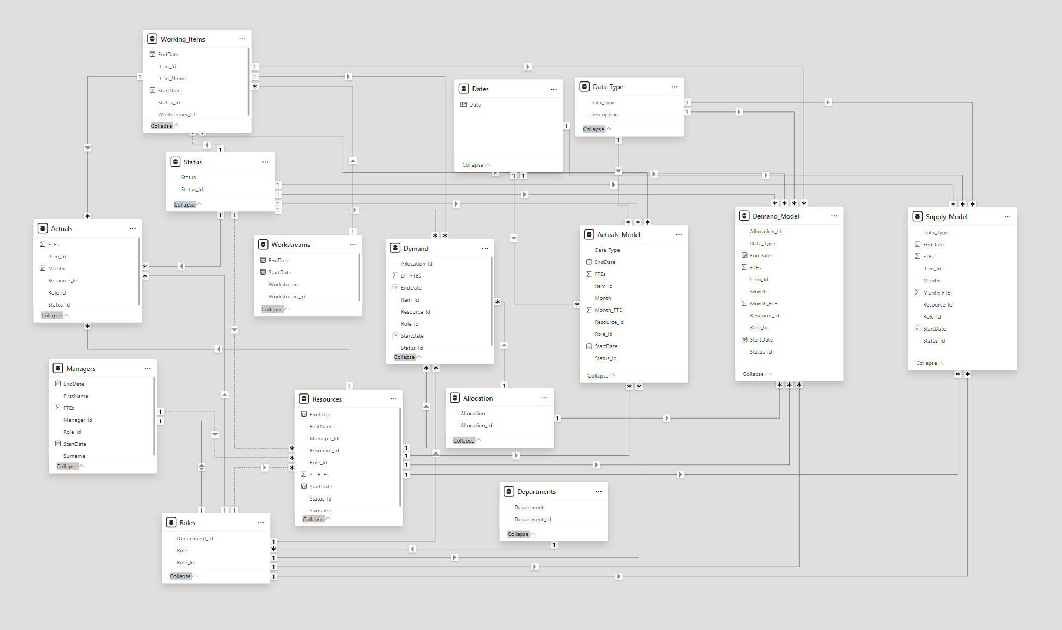

UI Wireframe Testing Results

Team Member 1: -
Task | Succsessfully Conducted? | Observations
Navigate to and from each report. | Yes | Each report is not obvious due to the buttons and categories being the same shape.
Apply and remove a reporting filter. | Yes | Not Obvious that the filter has been applied in the wireframe.
Apply and remove a “drill down” function. | No | Where is the drill down?
Export the report for circulation. | Yes | No Issues.

Team Member 2: -
Task | Succsessfully Conducted? | Observations
Navigate to and from each report. | Yes | Each report is not obvious due to the buttons and categories being the same shape.
Apply and remove a reporting filter. | Yes | No Issues.
Apply and remove a “drill down” function. | Yes | Unclear what is meant by drill down but assumed to be the arrow.
Export the report for circulation. | No | It wasn’t clear that “File” led to export.

Summary
Members of the team were asked to utilise the wireframe to carry out the following activities: -
- Navigate to and from each report.
- Apply and remove a reporting filter.
- Apply and remove a “drill down” function.
- Export the report for circulation.
The summary below provides a breakdown of the feedback that was received from the team members: -
- Non buttons are raised and are the same shape as buttons. This is confusing.
- Some instructions for filtering or drilling down are necessary as the meaning was not obvious to all team members.
- Exporting appeared relatively simple, but it was felt this would most likely be more complex when attempted.

UI Wireframe Interface Images: -
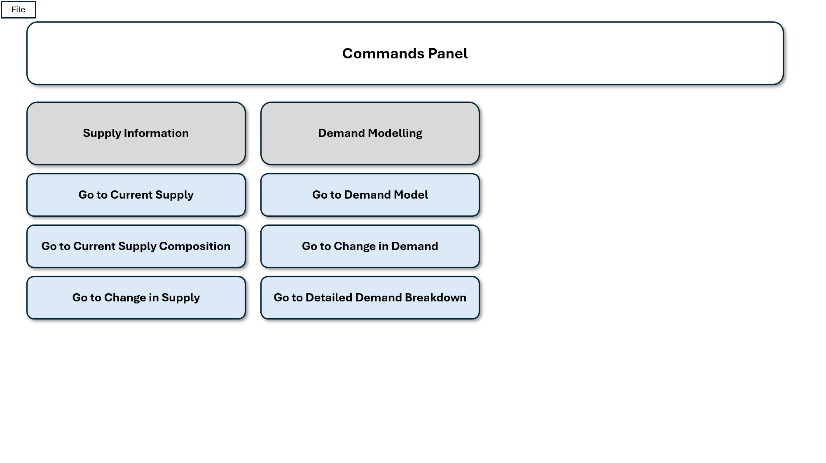
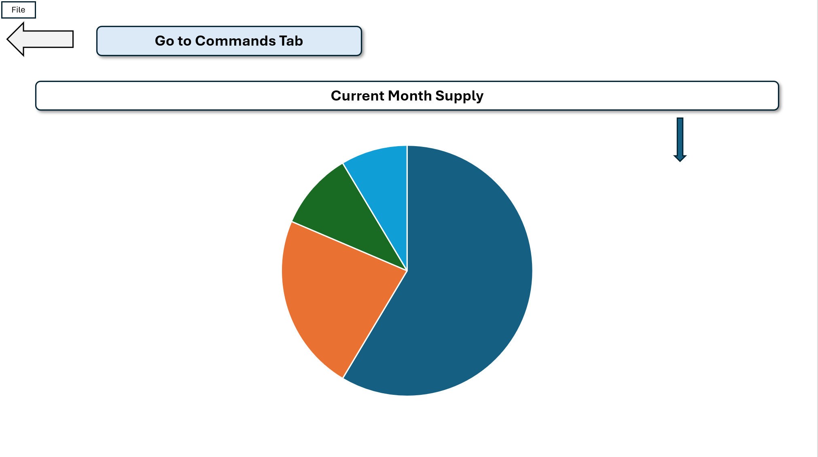
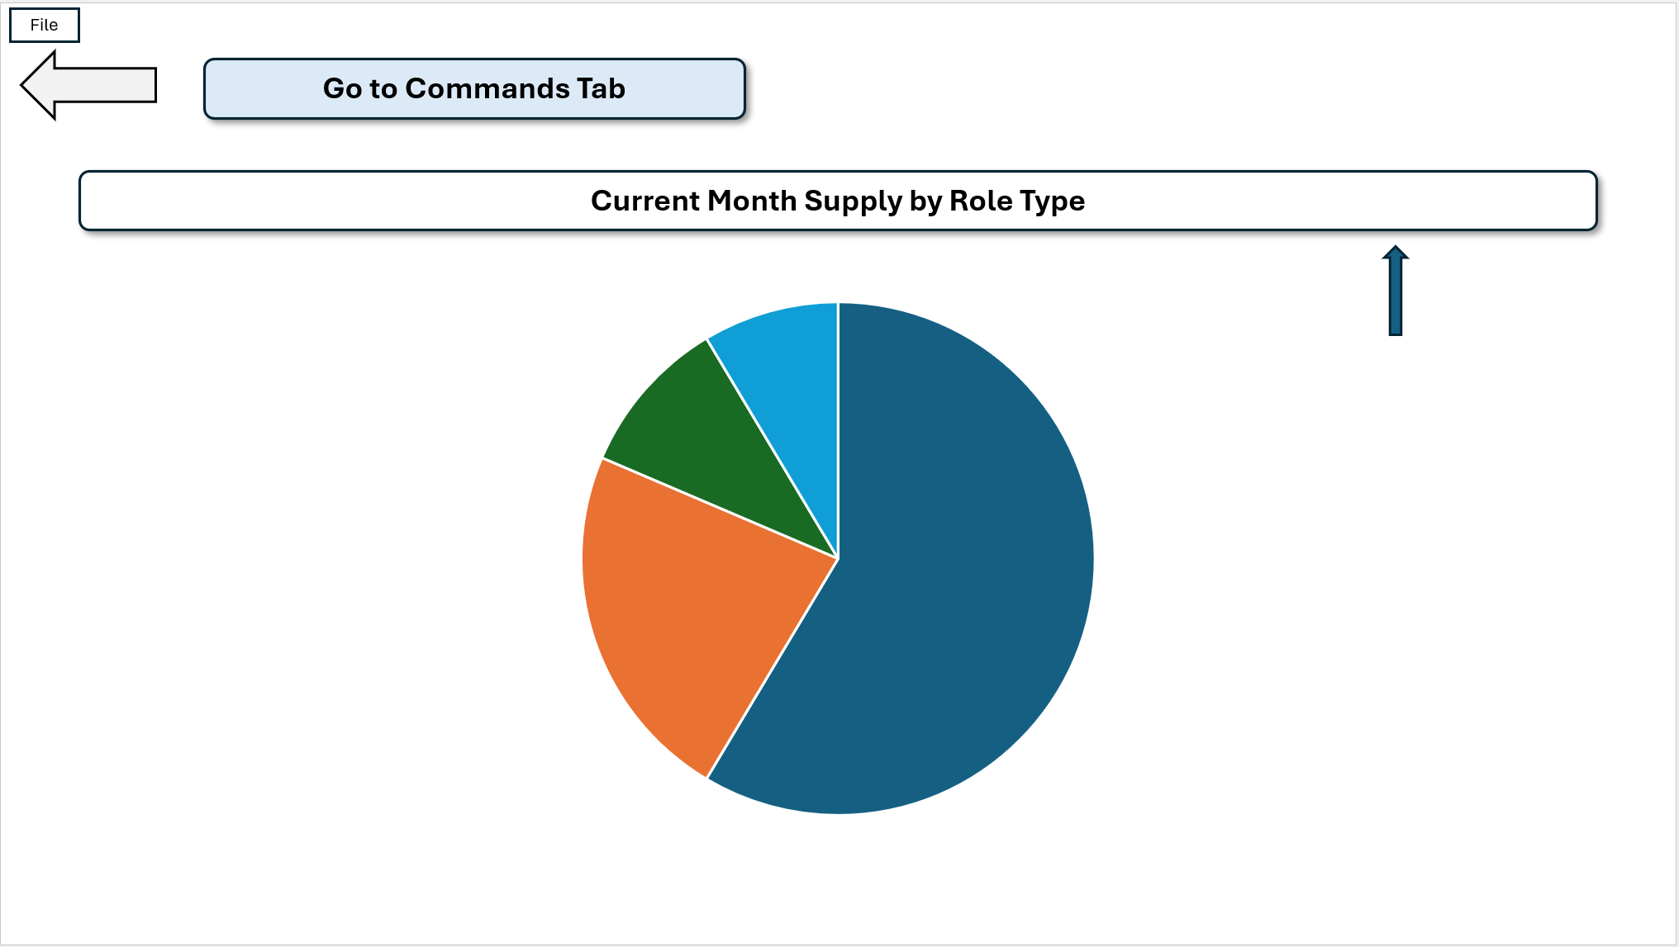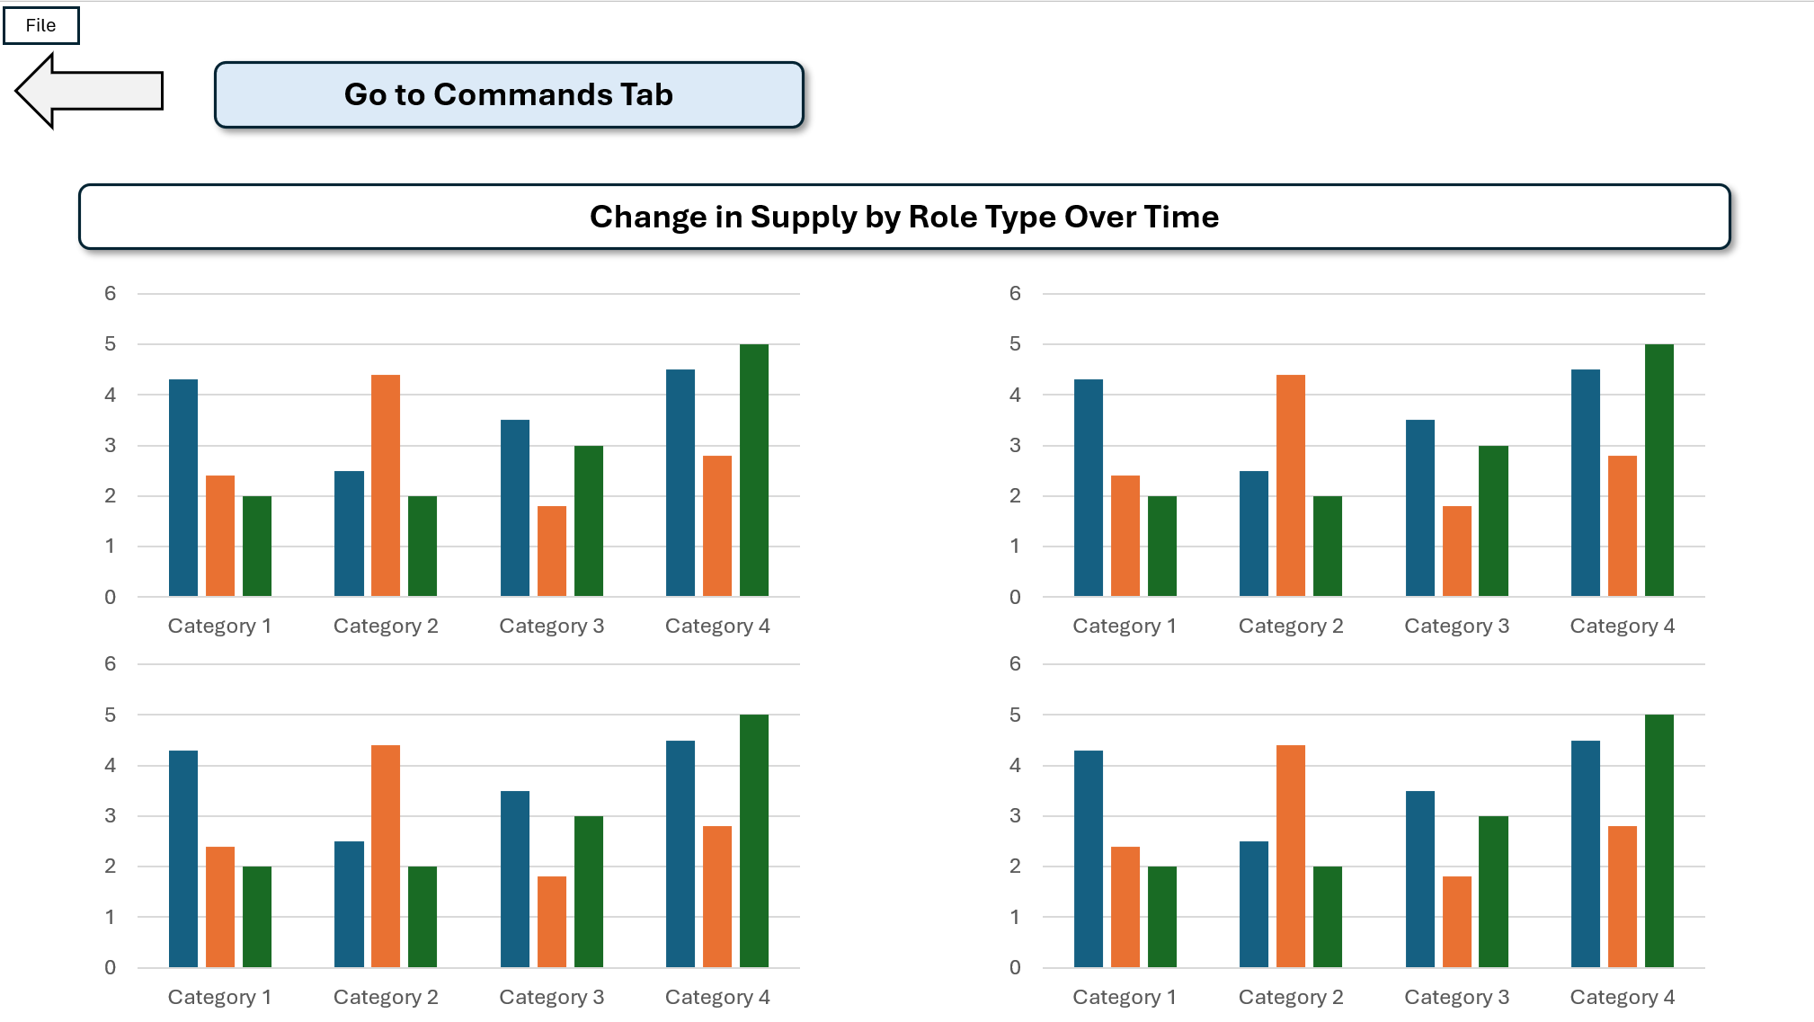
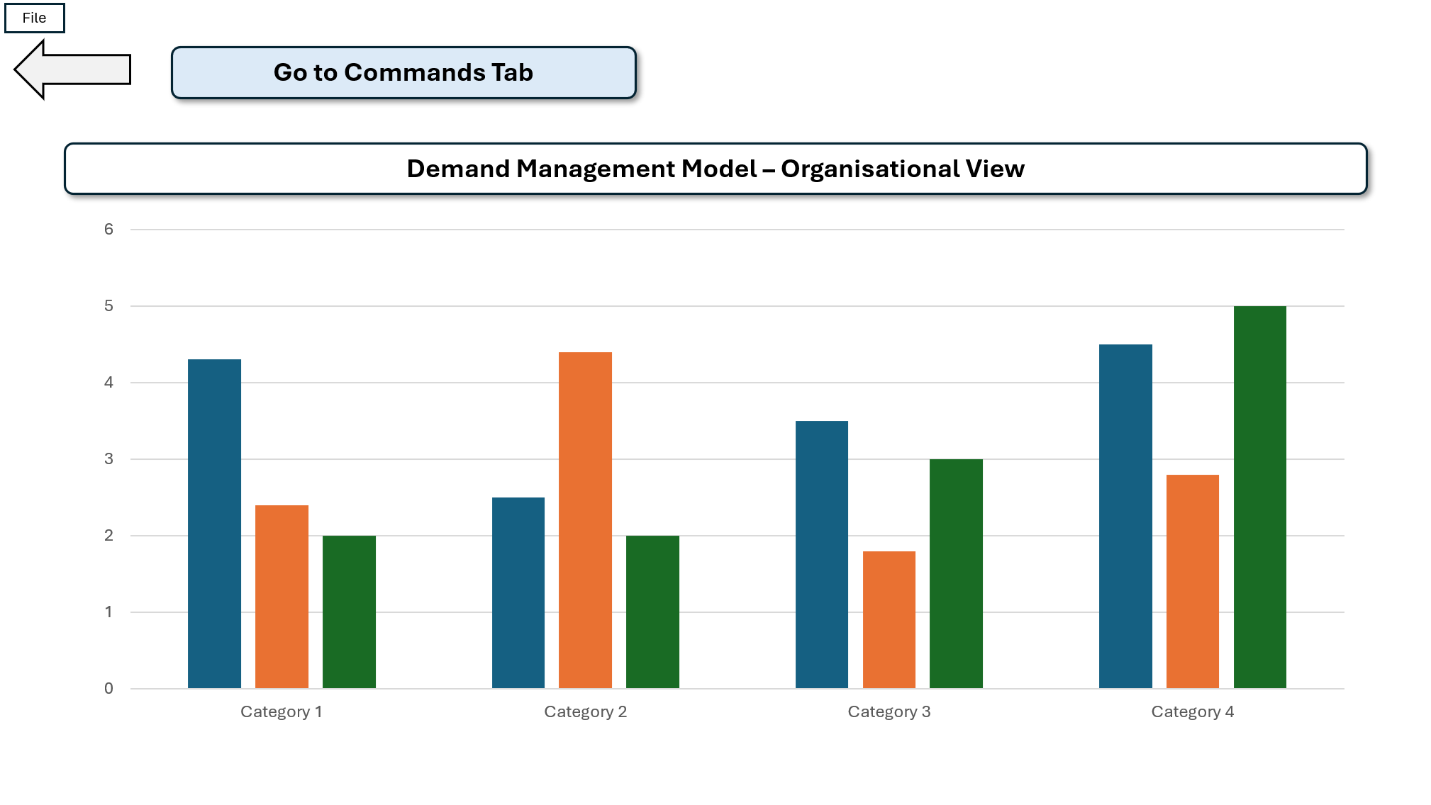
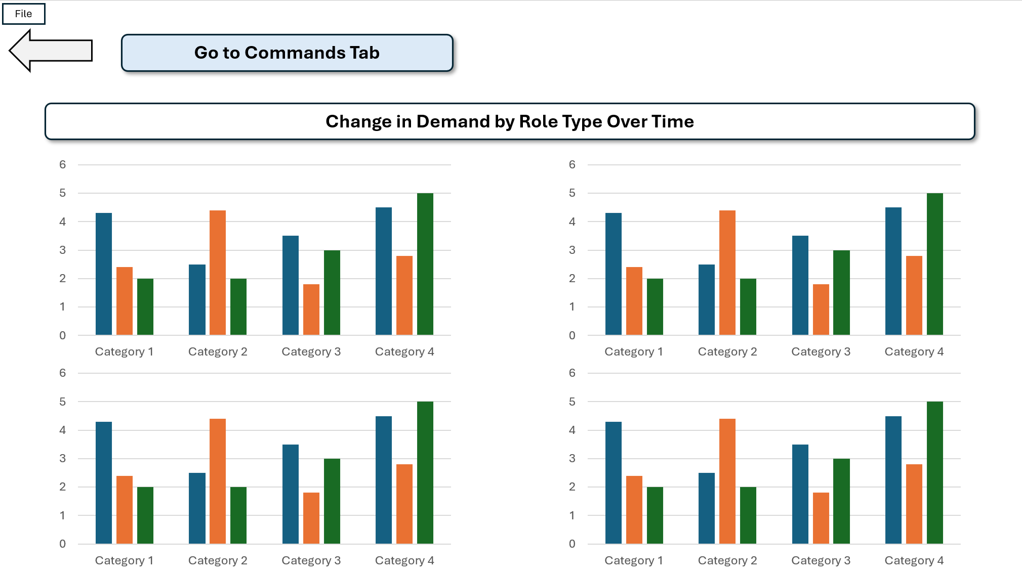
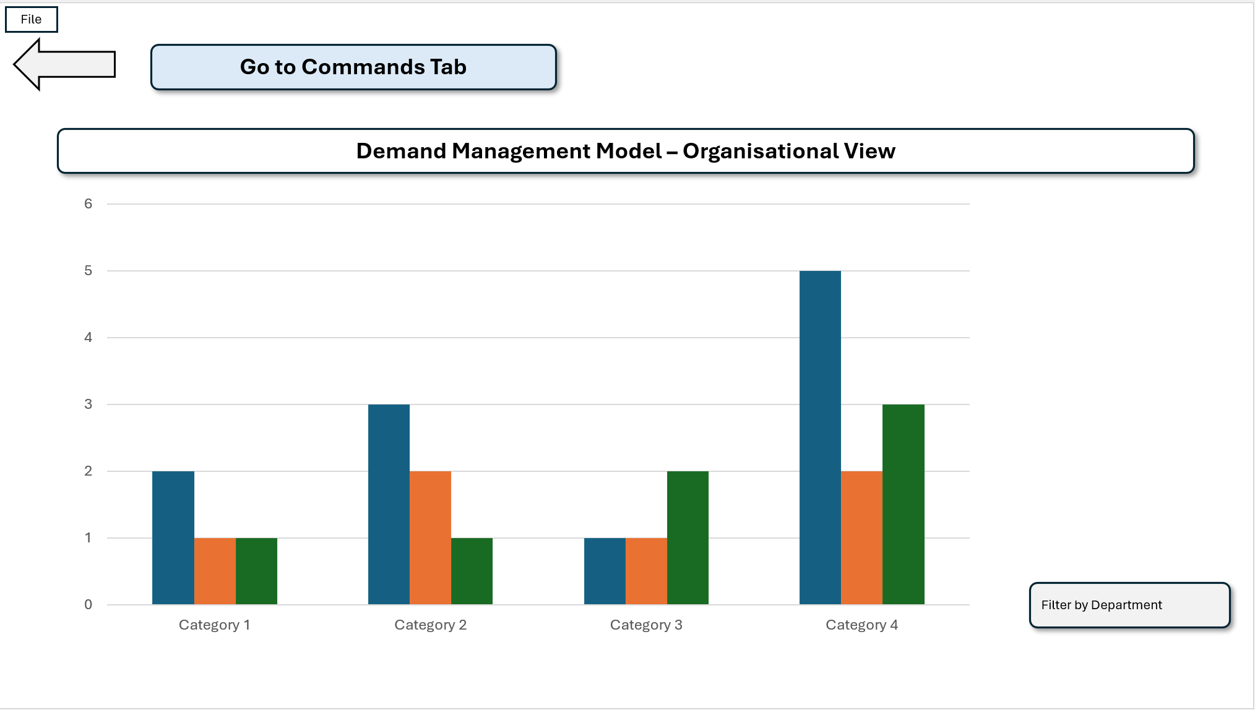
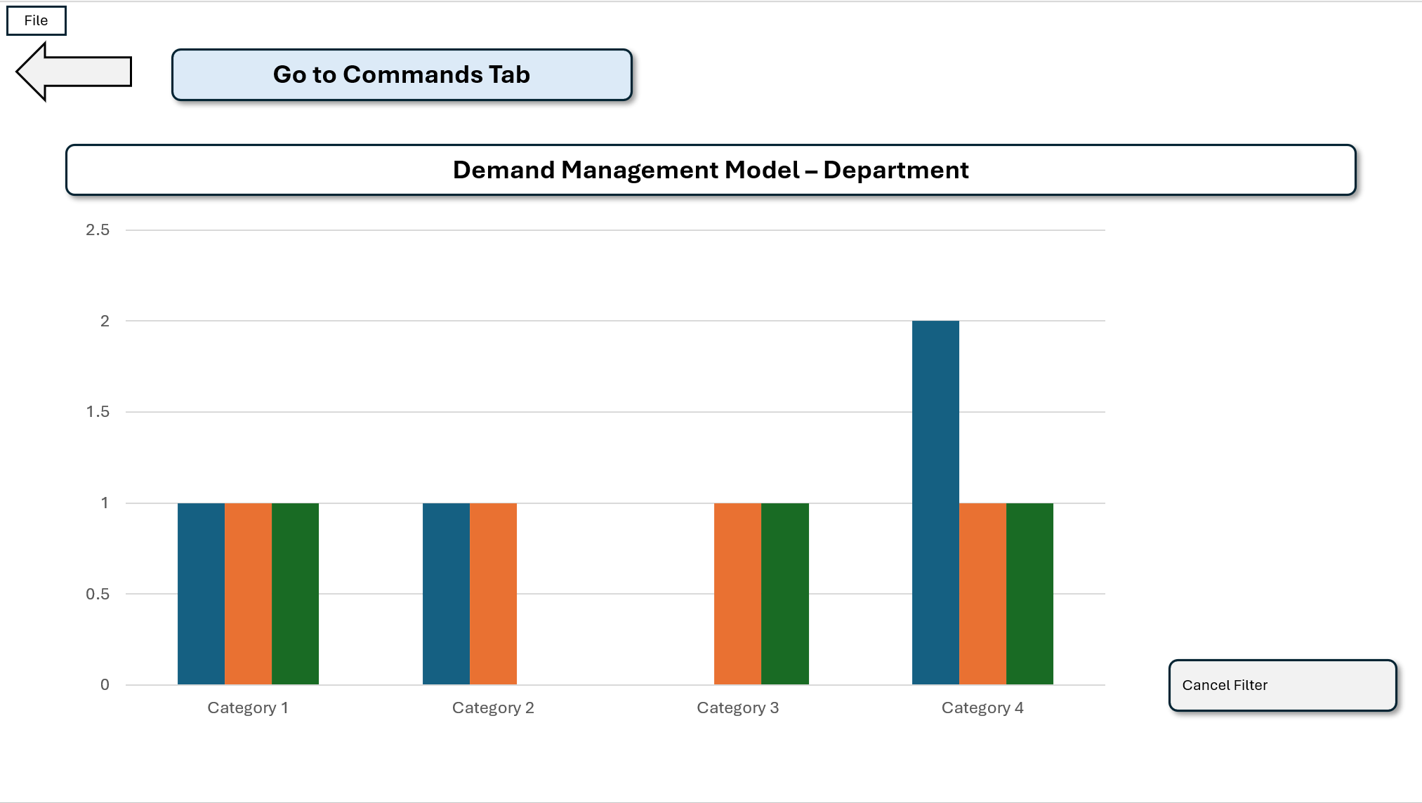

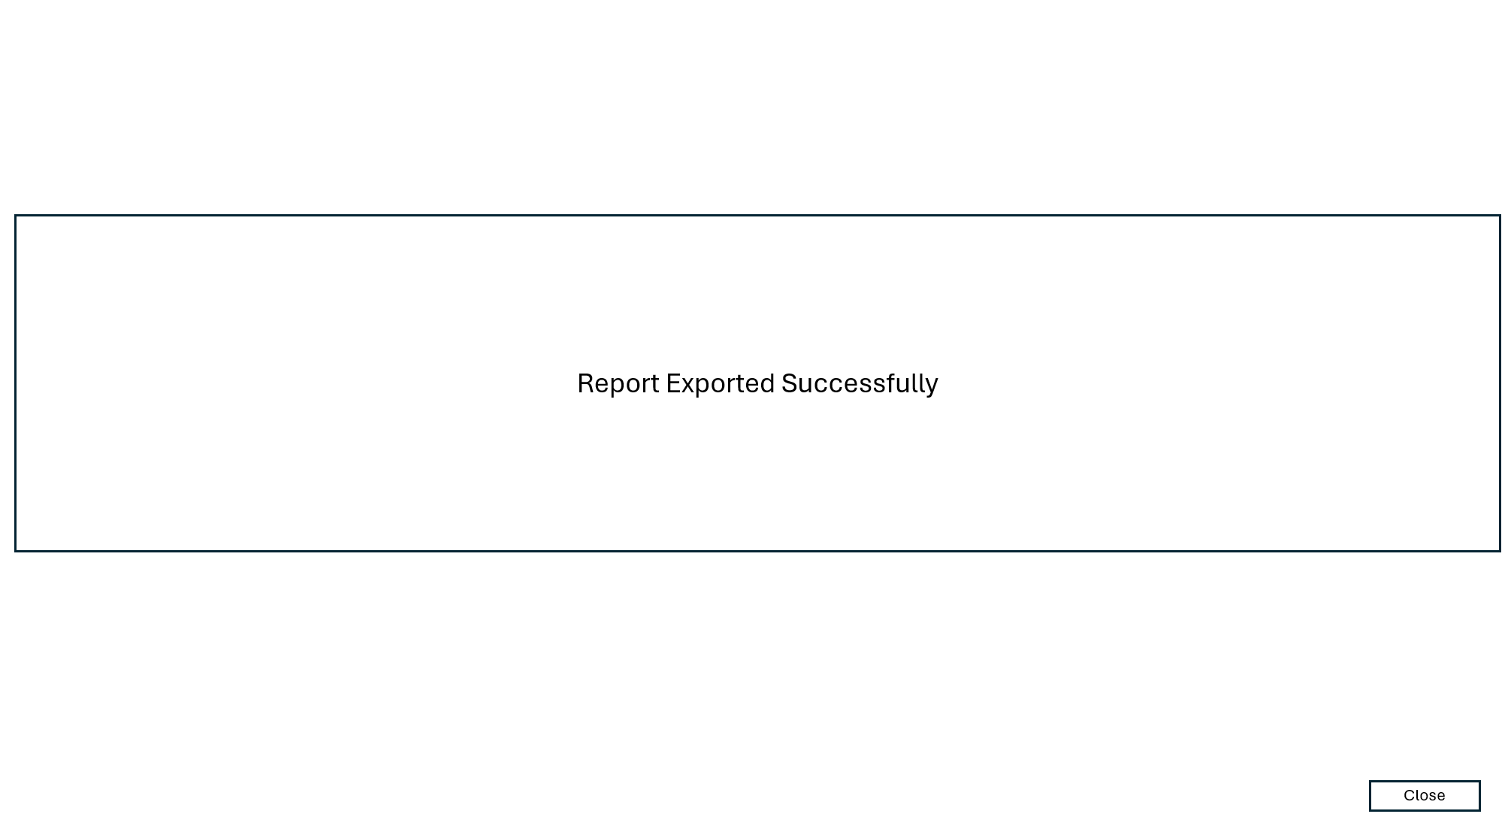

Demand Management Model UI and Output Test

Task | Succsessfully Conducted? | Observations
Navigate to and from each report. | Yes | N/A
Export | Yes | Included separately.
Apply and remove a “drill down” function. | Yes | Added brief instruction.
Check all links. | Yes. | N/A
Check formats with end users. | Yes | Explanation necessary for certain outputs. Suggested that annotation is included to remedy concerns but display full model when and where necessary.
Check data is represented correctly | Yes | Source Table and Summary Tables in Model match.
Check Narrative | Yes | Stakeholders are content with the explanations given and recommendations made as a result. Work was required to explain the diagrams in the first instance.

Demand Model Screenshots: -

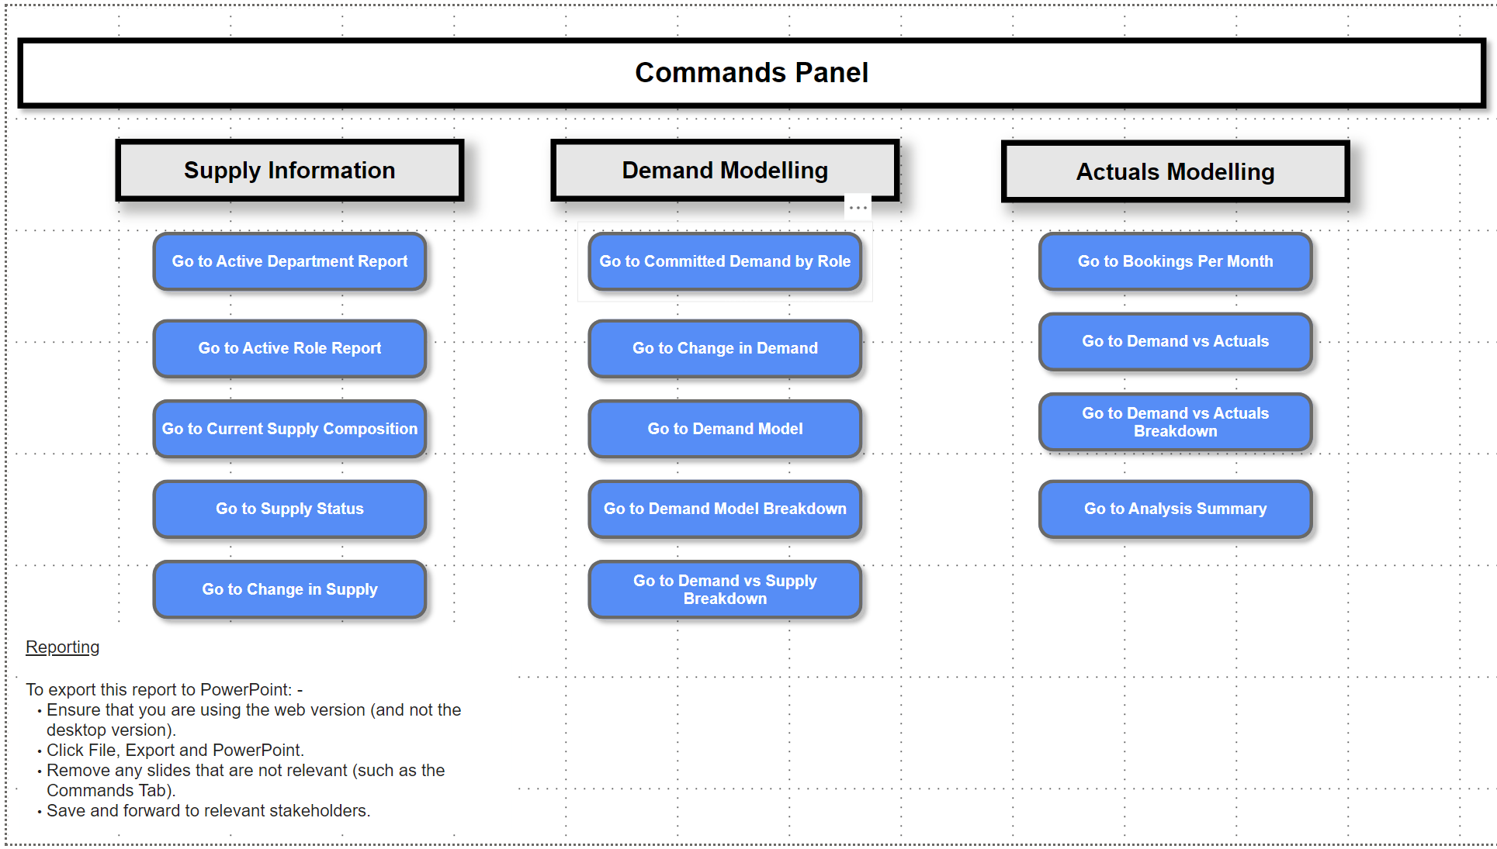
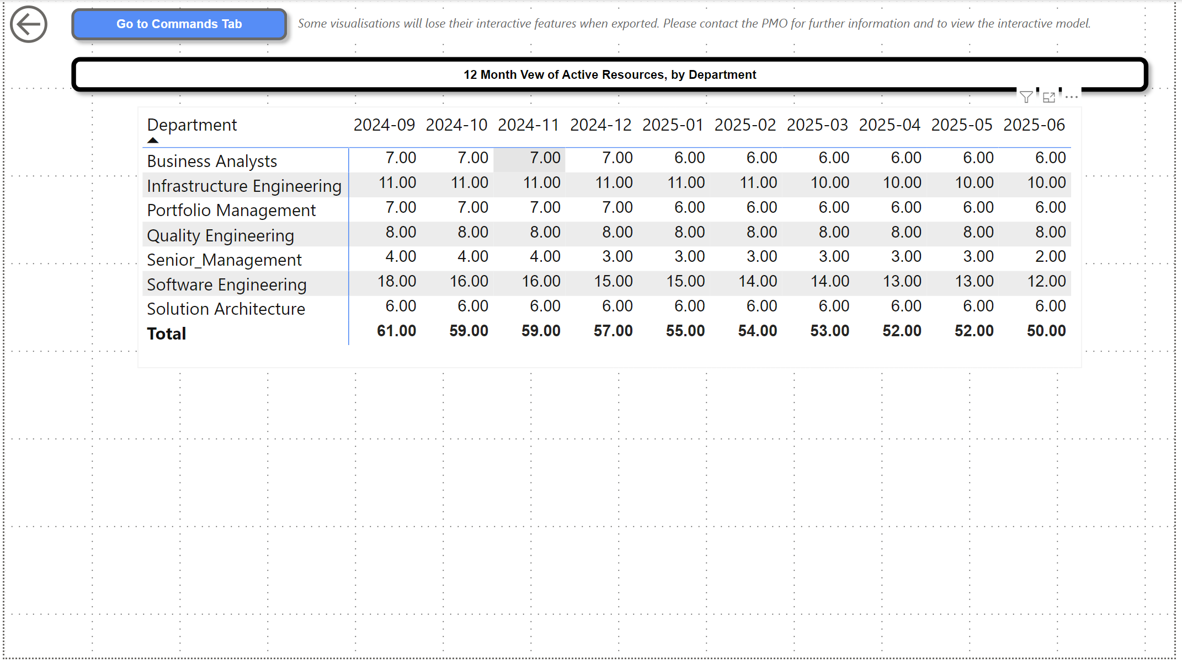
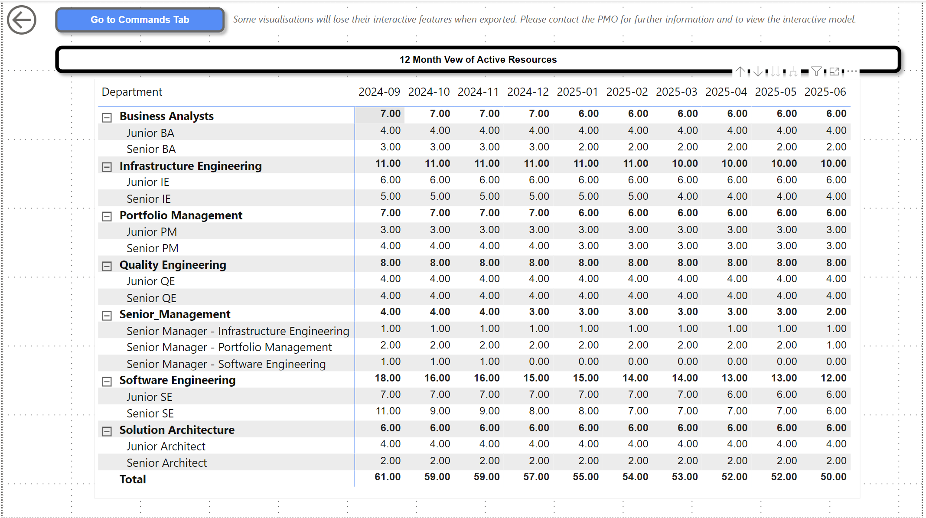
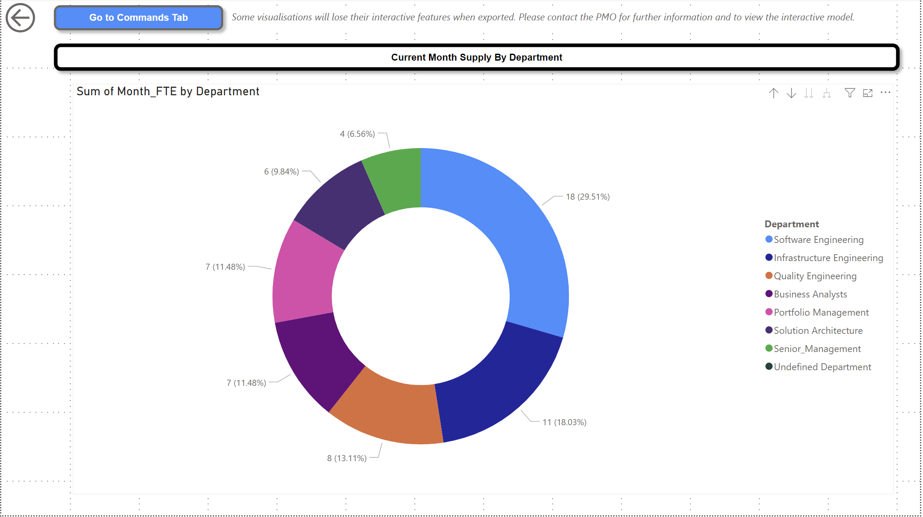
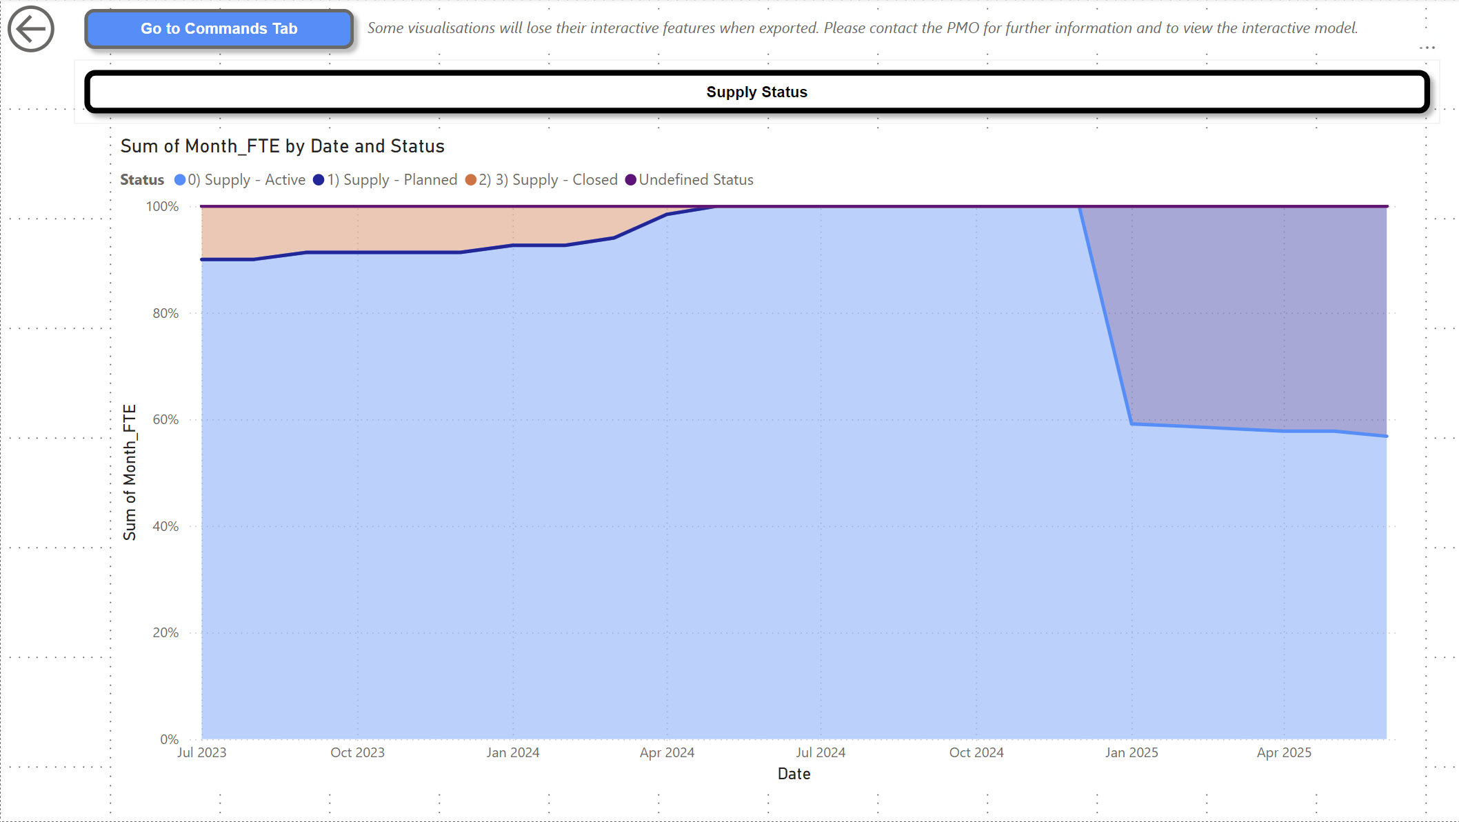
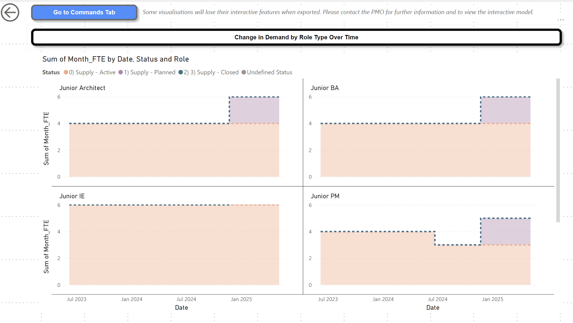
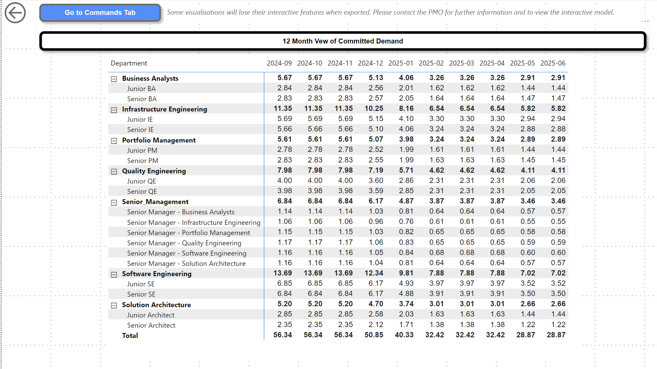
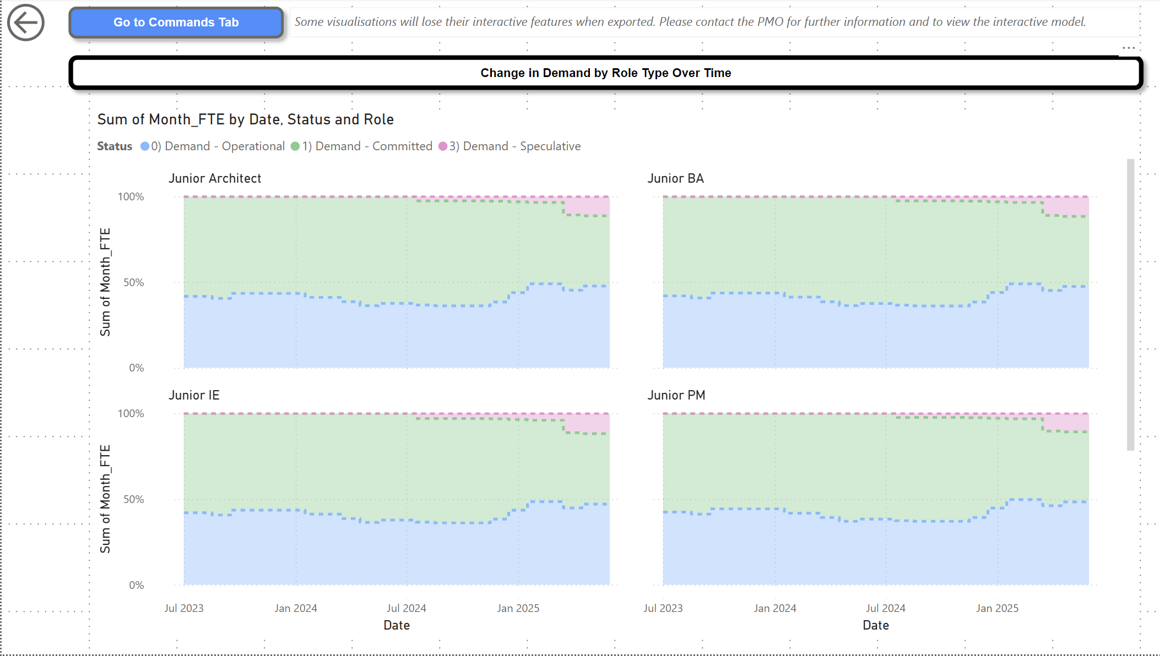
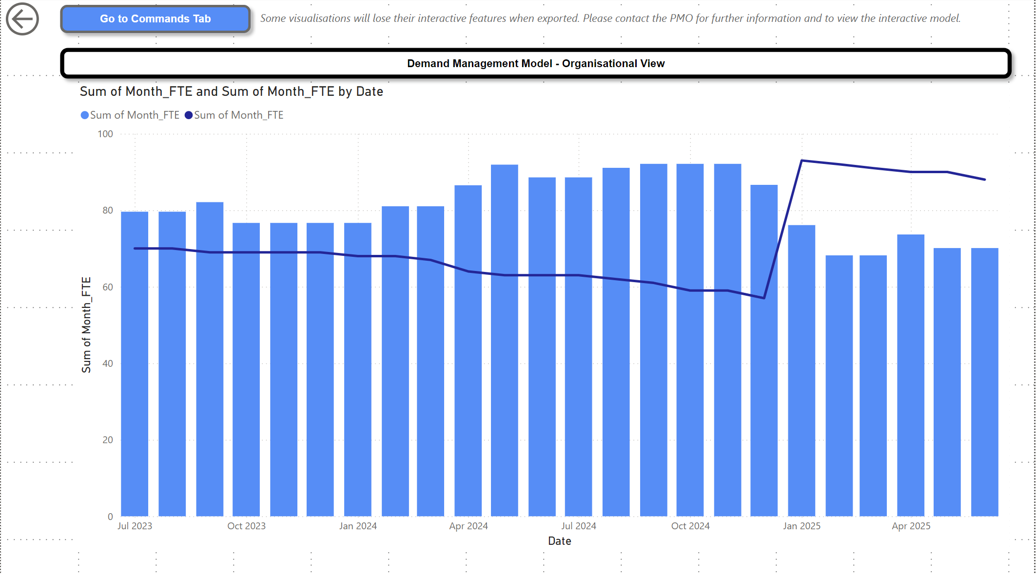
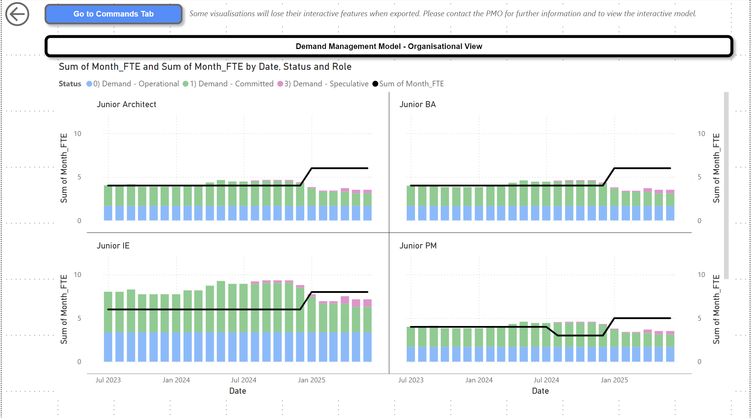
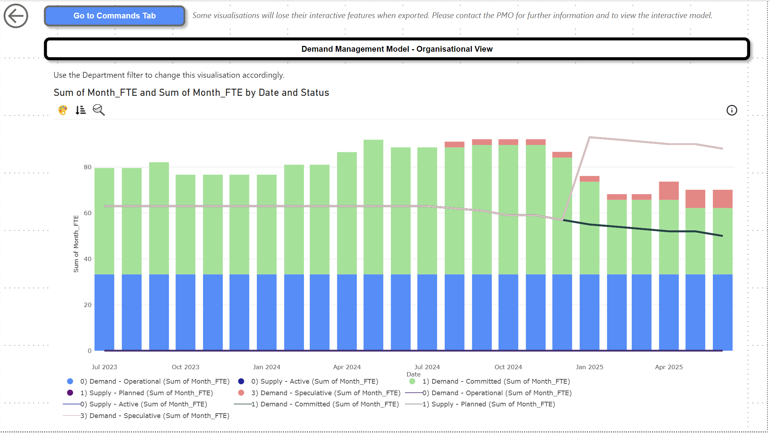
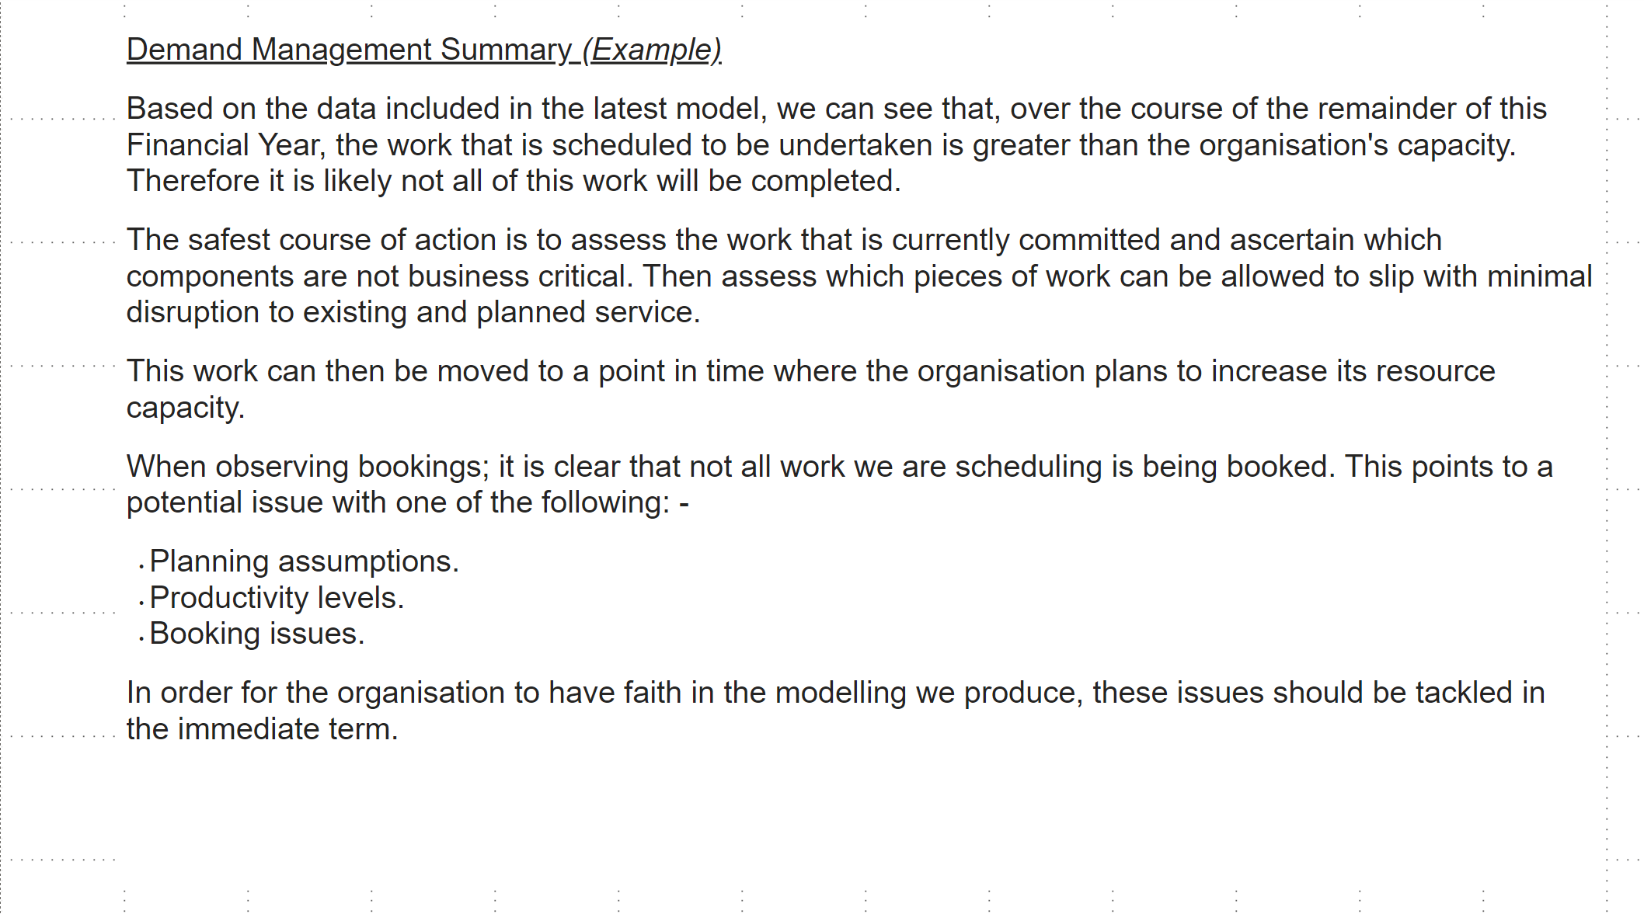
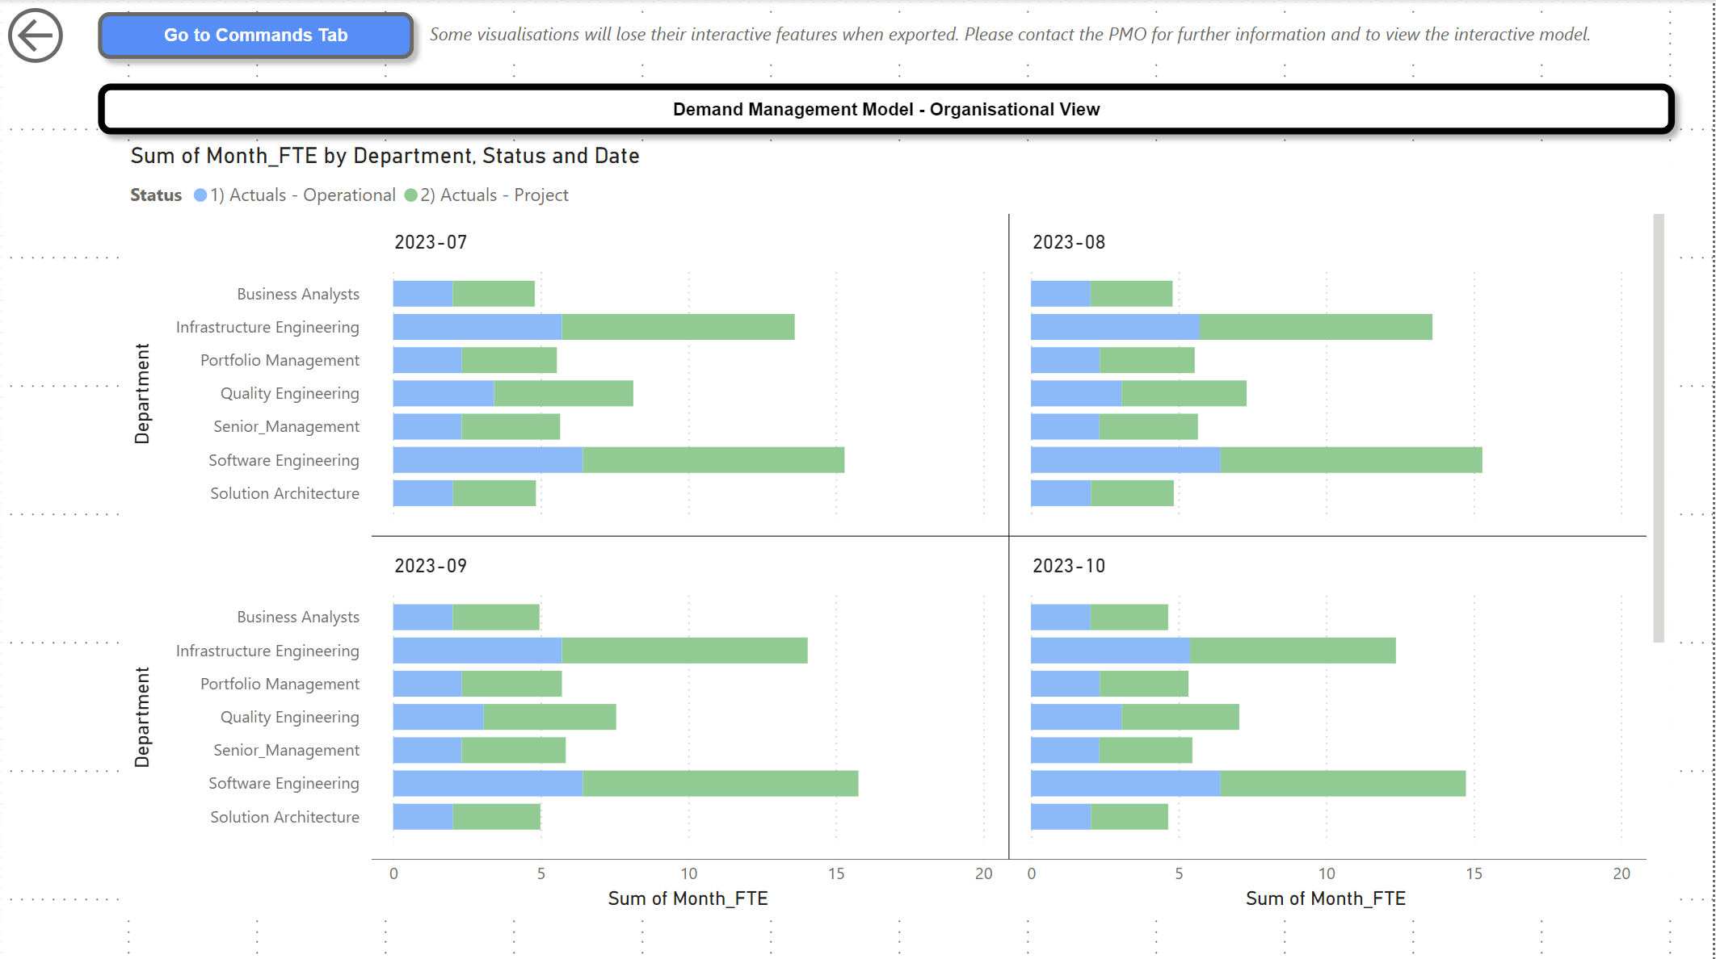
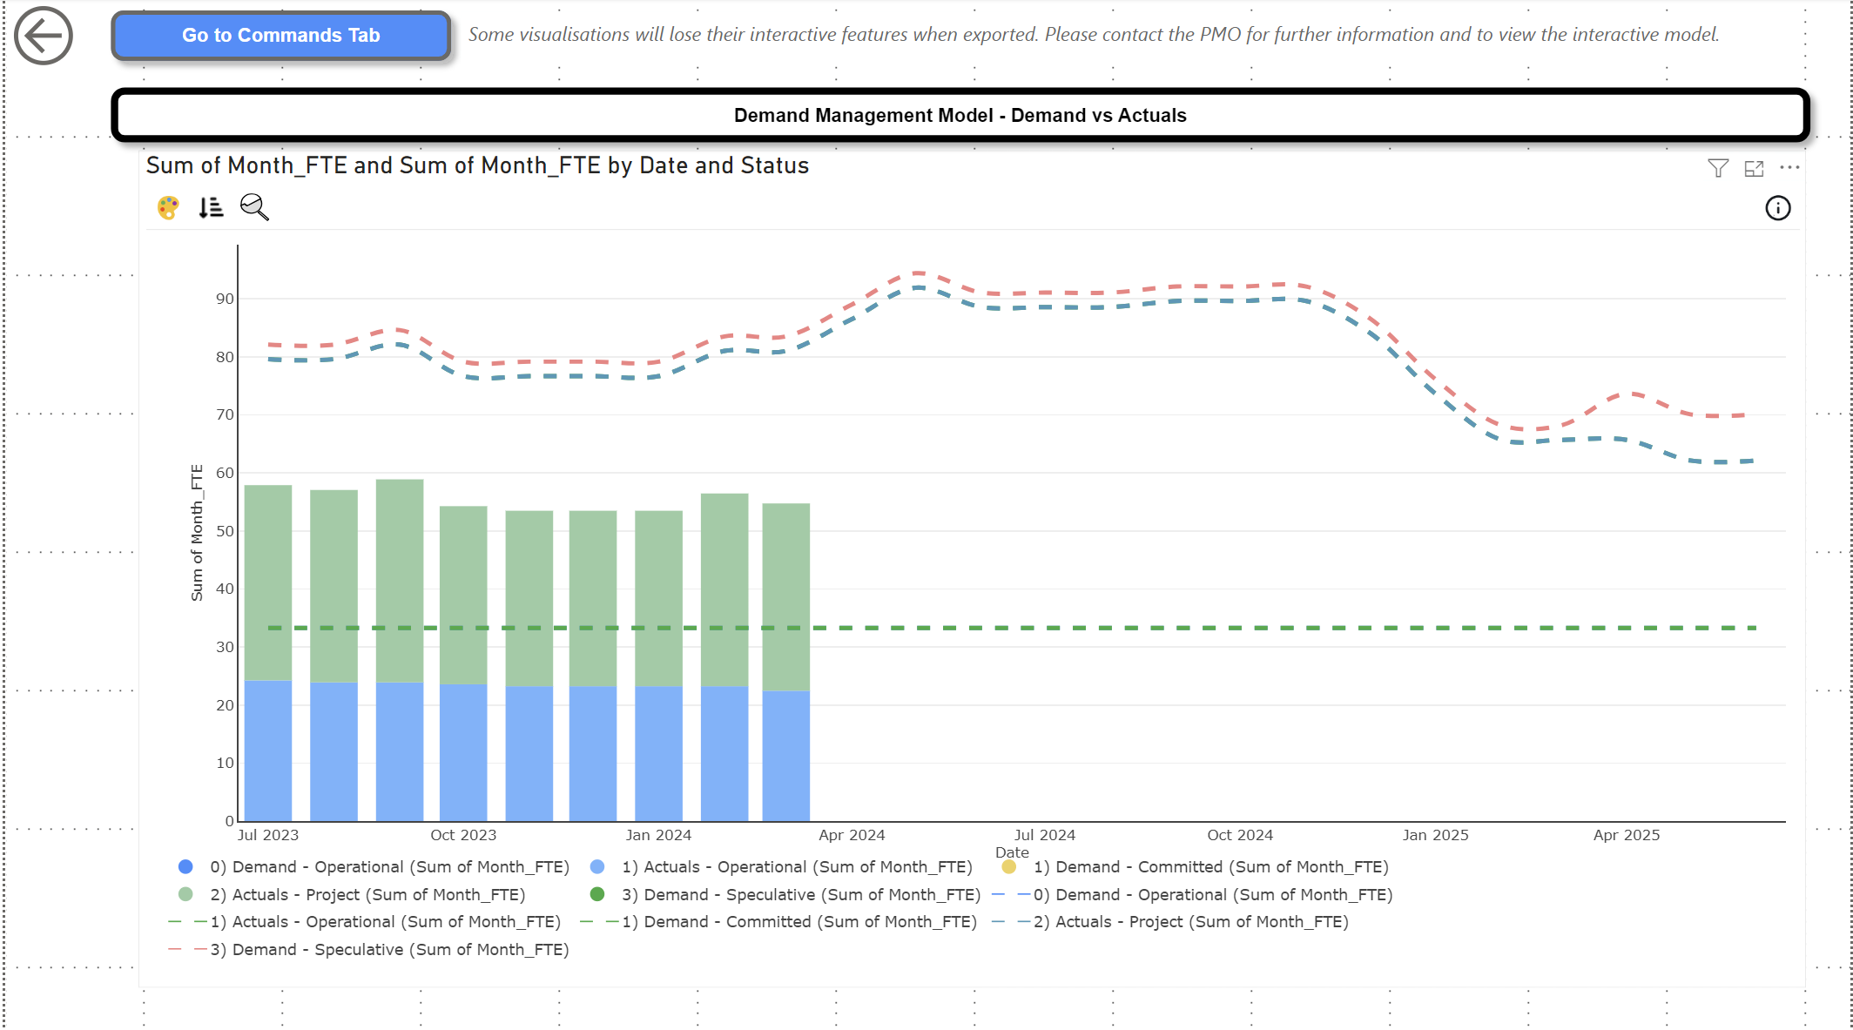
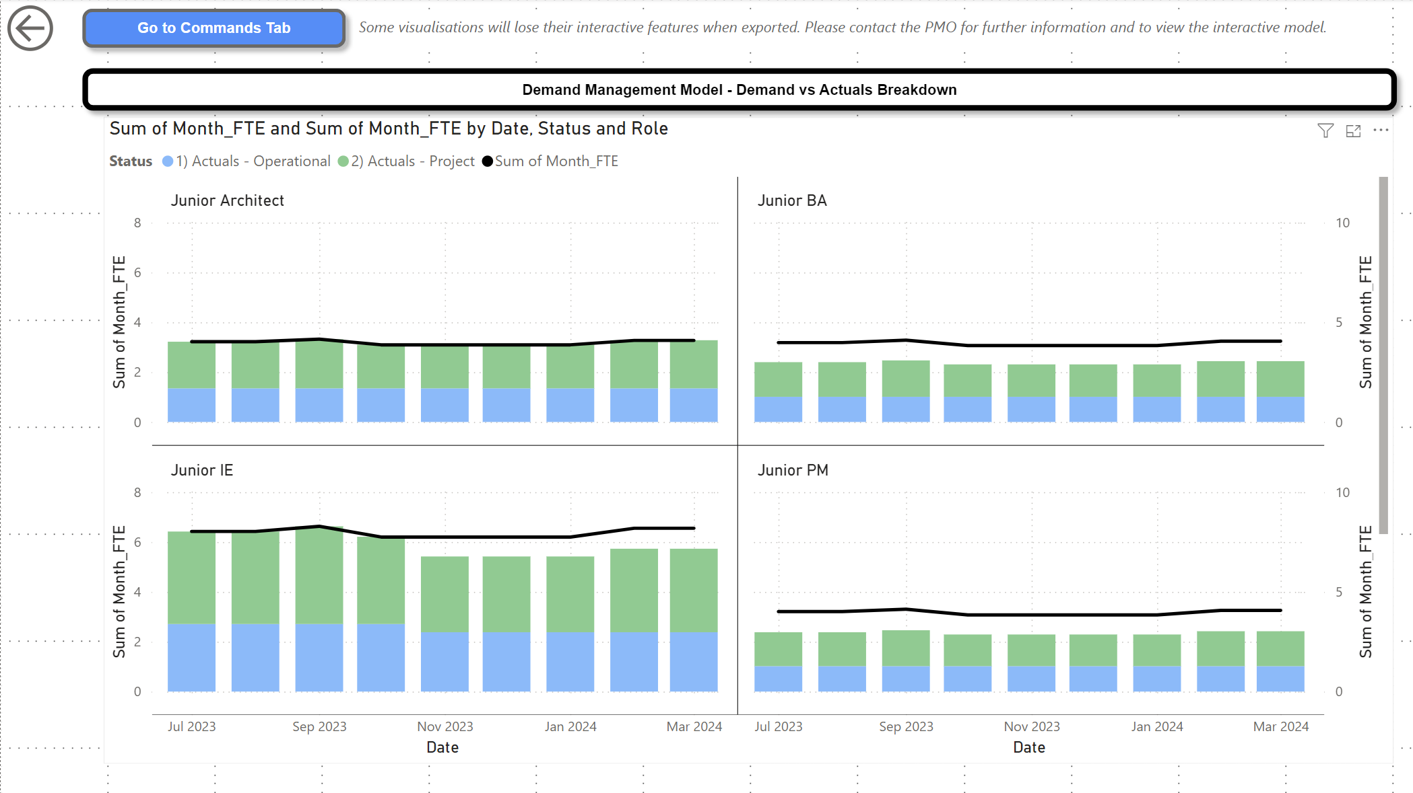

References

[1] | M. Polemio and K. Voudouris, “Groundwater Resources Management: Reconciling Demand, High Quality Resources and Sustainability,” Water, vol. 14, 2022.
[2] | N. England, “NHS Long Term Workforce Plan,” BMJ, 2023.
[3] | C. Bruena, and R. Brugha , “We’re not there to protect ourselves, we’re there to talk about workforce planning,” Health Policy, vol. 124, pp. 736-742, 2020.
[4] | AXELOS, Managing Successful Projects with PRINCE2, TSO, 2017.
[5] | The evolution of New Zealand’s health workforce policy and planning system: a study of workforce governance and health reform, 2019.
[6] | G. Willis, S. Cave and M. Kunc, “Strategic workforce planning in healthcare,” European Journal of Operational Research, vol. 267, pp. 250-263, 2017.
[7] | P. C. P. B. N. F. N. N. M. S. N. R. R. D. R. F. K. S. C. R. M. Davies, “Age and the anaesthetist: considerations for the individual anaesthetist and workforce planning,” Anaesthesia, vol. 77, p. 1259–1267, 2022.
[8] | S. C. S. G. L. K. E. S. Paul H. Keckley, The Complexities of National Health Care Workforce Planning, Bipartisan Policy Center, 2011.
[9] | J. C. M. J. C. F. César Augusto Henao, “Multiskilled workforce management by utilizing closed chains under uncertain demand: A retail industry case,” Computers & Industrial Engineering, vol. 127, pp. 74-88, 2018.
[10] | S. D. Valeva, WORKFORCE AND INVENTORY MANAGEMENT UNDER UNCERTAIN DEMAND, The University of Iowa, 2017.
[11] | C. G. A. A. O. Monyei, “Integration of Demand Side and Supply Side Energy Management Resources for Optimal Scheduling of Demand Response Loads,” Electric Power Systems Research, vol. 158, pp. 92-104, 2018.
[12] | M. T. Thielsch, S. Röseler, J. Kirsch, C. Lamers and G. Hertel, “Managing Pandemics—Demands, Resources, and Effective Behaviors Within Crisis Management Teams,” vol. 70, pp. 150-187, 2021.
[13] | Q. Z. Junaid Farooq, Resource Management for On-Demand Mission-Critical Internet of Things Applications, John Wiley & Sons, Inc., 2021.
[14] | W. Z. D. L. F. B. L. T. Yapu Zhao, “Service implementation in manufacturing firms. The role of service-orientated human resource management practices and demand-side search,” Management Decision, vol. 55, no. 4, pp. 648-661, 2017.
[15] | SERVICENOW, “Demand Management,” [Online]. Available: https://www.servicenow.com/products/demand-management.html.
[16] | Atlassian, “Portfolio for Jira is now Advanced Roadmaps,” [Online]. Available: https://community.atlassian.com/t5/Advanced-planning-articles/Portfolio-for-Jira-is-now-Advanced-Roadmaps/ba-p/1354906.
[17] | Agile Business Consortium, Agile Project Management Handbook, UK: Agile Business Consortium, 2015.

