

Student Name : RAJESH LILABHAI AGATH
Student ID :2531869
University Name: University of Wales Trinity Saint David
Programme: Master of Business Administration (MBA)
Module Name: Financial Management
Lecturer:Dr.Isaiah Oino
Module Code: LCMB7002
Assessment Title: Financial Performance and Management
Assessment Type: Individual Report – Strategic CFO Challenge
Selected Company: Toyota

Table of Contents
1. Introduction 3
2. “Financial Health Check” of Toyota 3
2.1 “Statement of Financial Position” of Toyota from 2020 to 2024 3
2.2 “Statement of Income of Toyota” from 2020 to 2024 6
2.3 “Statement of Cash Flow” of Toyota from 2020 to 2024 8
2.4 Ratios Analysis of Toyota 10
2.3 Trends, Strengths and Threats 13
3. “Working Capital Management Analysis” 15
3.1 Cash Operating Cycle (CCC) Analysis 15
3.2 Strategies to Improve Liquidity through Working Capital Reforms for Toyota 15
3.3 Comparison of “Short-Term and Long-Term Financing Options” 16
4. “Strategic Financial Restructuring Plan” 18
4.1 Financial Restructuring Options 18
4.2 Impact on Shareholder Value, Debt Structure, and Operational Flexibility 19
4.3 International and Ethical Considerations 20
5. “Investment Appraisal and Capital Budgeting” 21
5.1 Overview of “PBP, ARR, NPV, PI, and IRR” 21
5.2 Investment Projects Overview 22
5.3 Project A, B and C Evaluation 22
5.6 Project Recommendation 23
5.7 Capital Rationing Decision 24
6. Conclusion 25
7. References 27
8. Appendices 32
Appendix 1: Ratio Tables 32
Appendix 2: Ratio Graphs 38
Appendix 3: CCC Table 41
Appendix 4: CCC Graph 42
Appendix 5: Projects Table 42
Appendix 6: Projects Graphs 44

1. Introduction
Strategic financial management and financial performance are important to remain competitive in the fast-moving electric vehicle (EV) sector. With world automotive companies moving towards electrification, efficient financial decision-making is necessary to make them profitable, liquid and grow in the long-term. This report is a critical assessment of Toyota financial performance based on the last five years and the strengths, weaknesses, and new risks that are emerging. It also evaluates the efficiency of working capital, suggests a strategic financial restructuring plan, and analyzes the investment opportunities based on capital budgeting techniques. It contains four key sections in the report, recommendations and a conclusion that will assist in making informed financial decisions.

2. “Financial Health Check” of Toyota

2.1 “Statement of Financial Position” of Toyota from 2020 to 2024

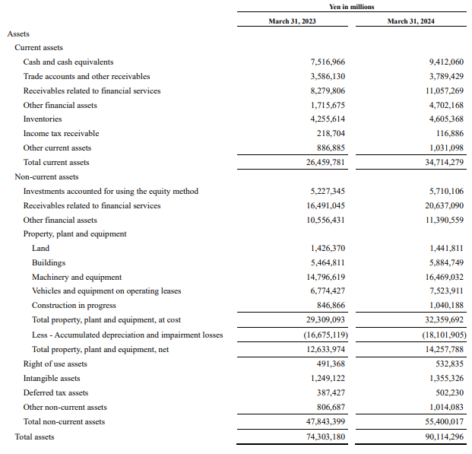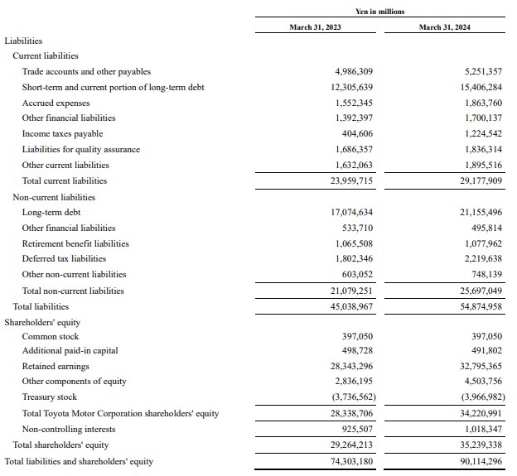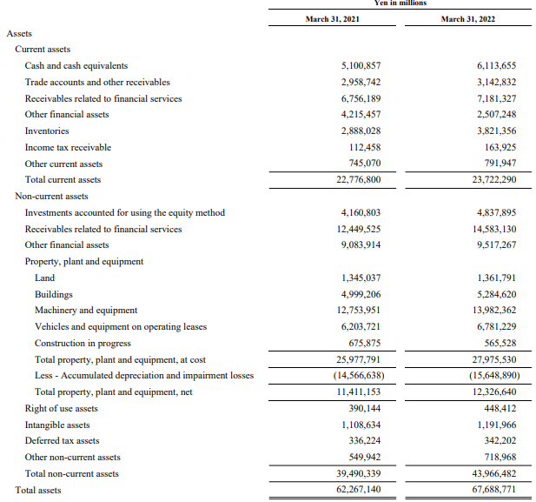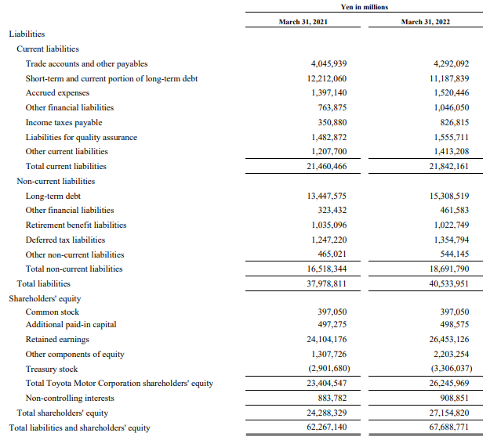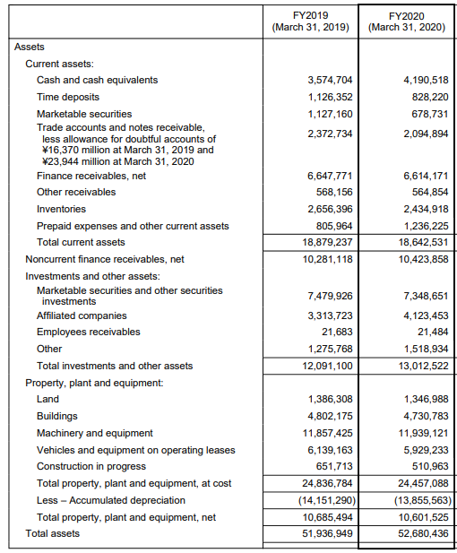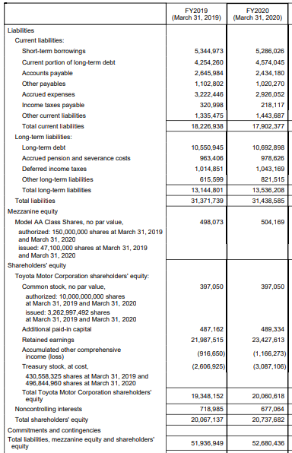
Figure 2.1: Consolidated “Balance Sheets” for 5 years
(Source: Toyota, 2020; Toyota, 2022; Toyota, 2024)
The financial position of Toyota depicts a good growth in 2021-24. Total assets increased significantly from ¥62,267,140 million in 2021 to ¥90,114,296 million in 2024, driven by rising cash reserves (¥5,100,857m to ¥9,412,060m) and financial services receivables (¥6,756,189m to ¥11,057,269m). Current assets improved to ¥34,714,279m, indicating enhanced liquidity. However, total liabilities also rose from ¥37,978,811m to ¥54,874,958m, largely due to higher debt levels, with long-term debt reaching ¥21,155,496m. Shareholders’ equity strengthened from ¥24,288,329m to ¥35,239,338m, reflecting improved retained earnings (Toyota, 2024). The growth is an expansion and financing by both internal profits and external borrowing.

2.2 “Statement of Income of Toyota” from 2020 to 2024
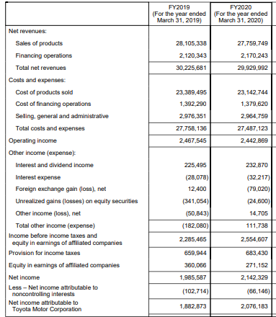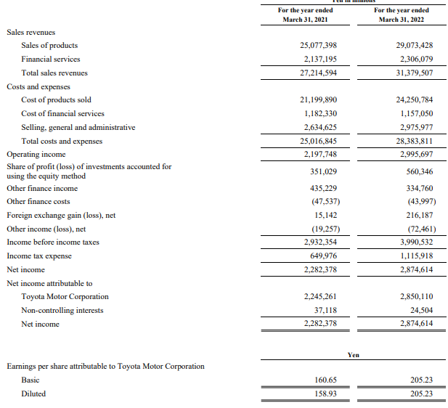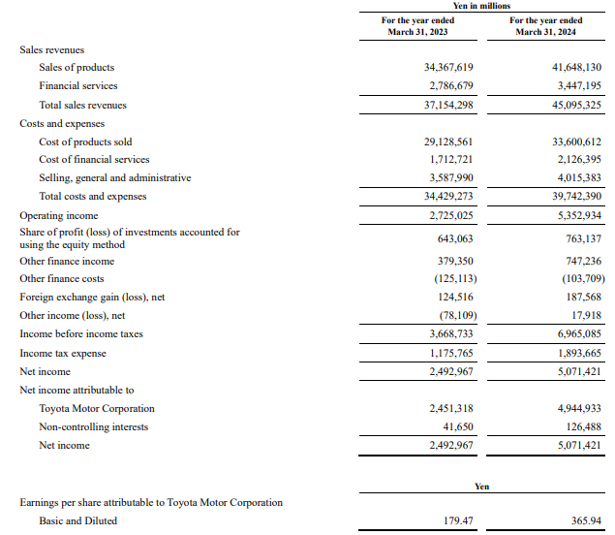
Figure 2.2: Consolidated “Income Statement” for 5 years
(Source: Toyota, 2020; Toyota, 2022; Toyota, 2024)
Toyota is financially performing well as there is growth in 2020-2024. Total revenue increased from ¥29,929,992 million in 2020 to ¥45,095,325 million in 2024, driven by higher vehicle sales and expansion in financial services. Operating income rose significantly from ¥2,442,869m to ¥5,352,934m, reflecting improved cost efficiency and pricing strategies. Net income more than doubled from ¥2,142,329m in 2020 to ¥5,071,421m in 2024, supported by higher margins and foreign exchange gains. Earnings per share also increased from ¥206.18 to ¥365.94 (Toyota, 2024). On the whole, the increase indicates a high level of profitability, efficiency of operations, and post-disruption recovery following the pandemic.

2.3 “Statement of Cash Flow” of Toyota from 2020 to 2024
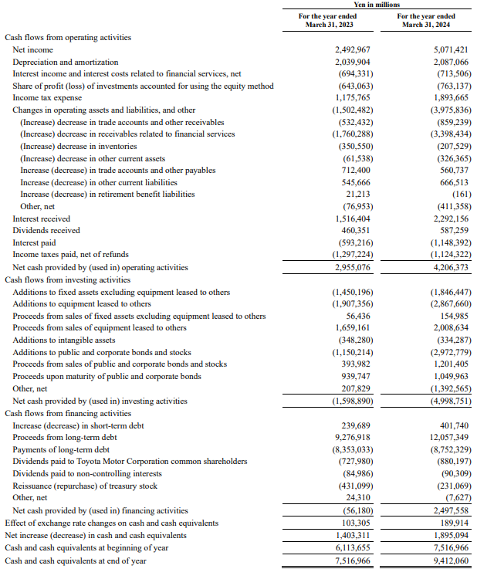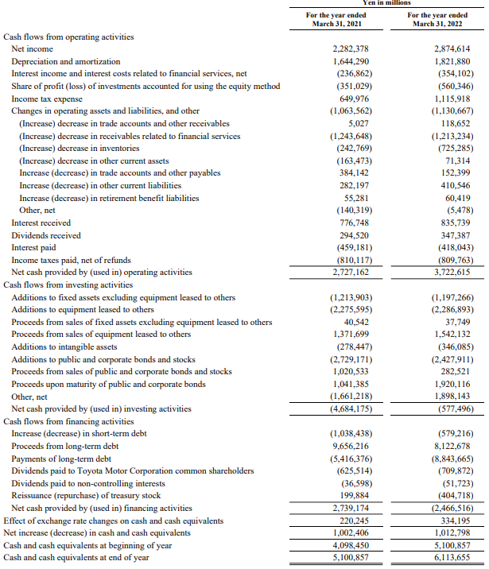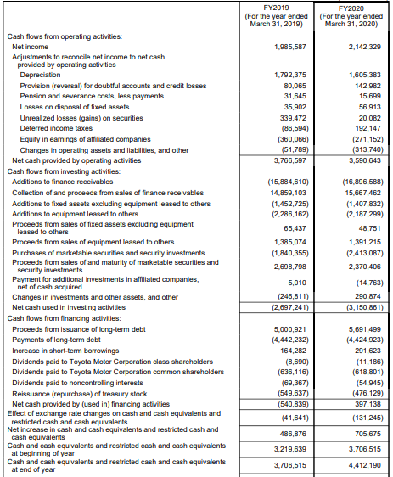
Figure 2.3: Consolidated “Cash Flow Statement” for 5 years
(Source: Toyota, 2020; Toyota, 2022; Toyota, 2024)
The 2020-2024 cash flow performance of Toyota was much better than that of 2020, which shows greater financial stability. Net cash from operating activities increased from ¥3,590,643 million in 2020 to ¥4,206,373 million in 2024, driven by higher net income (¥2,142,329m to ¥5,071,421m). However, investing activities showed consistent outflows, worsening from ¥(1,589,890)m in 2023 to ¥(4,998,751)m in 2024 due to heavy investments in equipment and financial assets. Financing cash flow turned positive to ¥2,497,558m in 2024, reflecting increased borrowing (Toyota, 2024). Cash and cash equivalents rose from ¥4,412,190m in 2020 to ¥9,412,060m in 2024, demonstrating strong liquidity growth supported by operations and financing.

2.4 Ratios Analysis of Toyota
“Profitability”:
“Profitability ratio”s indicate the capacity of a firm to produce earnings with regard to sales, assets, or capital utilised. They show operational efficiency, pricing power and cost control. The high profitability is a measure of good financial performance and sustainability, and it assists the investors in evaluating the value creation and the effectiveness of the management (Arkaan and Budianto, 2024). The profitability of Toyota increased significantly as ROCE grew to 11.43% (2024) and then 7.29% (2023), and the operating margin rose to 11.87%. Net profit margin was 25.49%, indicating good control of costs and increased revenues. The post-pandemic recovery and favourable pricing strategies will drive improvement because of higher sales and operational efficiency.
“Liquidity”:
“Liquidity ratios” determine the capacity of a company to meet short-term liabilities with its current assets. They capture the exposure to risks and financial stability. High liquidity leads to the efficient running of operations and a low risk of insolvency, so these ratios are important to creditors and investors assessing short-term financial performance (Dönmez and Özkan, 2022). The liquidity of Toyota was also gradually improving, and the current ratio has grown to 1.04 (2020) to 1.19 (2024). The current ratio was 1.03, which showed sufficient liquid assets. Cash ratio increased to 0.32, indicating increased cash reserves. Increased cash balances and improved working capital management are favourable to growth.
“Efficiency”:
“Efficiency ratios” determine the efficiency with which a company utilizes the assets to earn revenue. They quantify performance in operations, such as inventory management, collection of receivables and the utilisation of assets. Increased efficiency is a sign of greater resource control and increased potential profitability (Rahman and Acharya, 2022). The efficiency of Toyota is not that good. There was an increase in asset utilisation, with asset turnover increasing to 0.55 (2024) compared to 0.47 (2021). Nonetheless, the inventory turnover improved as 19.01 (2020) decreased to 7.58 (2024), indicating a slower movement of inventory. The turnover of receivables was steady, indicating good credit management practices.
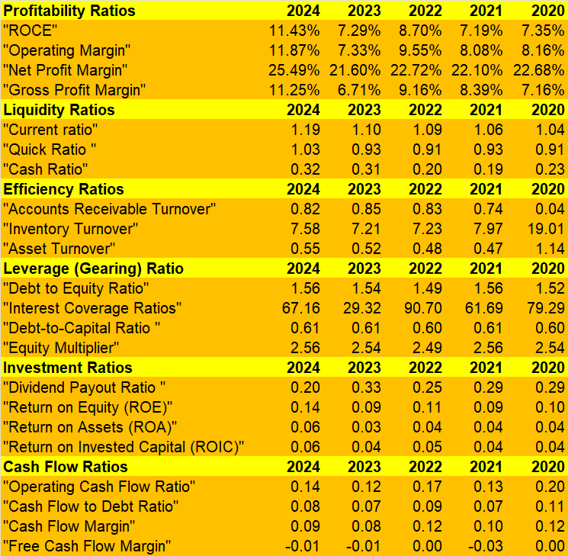
Figure 2.4: Ratios Calculated for 5 Years
(Source: Excel)
“Gearing (Leverage)”:
“Gearing ratios” are used to determine how a business is funded between debt and equity. They measure financial risk and solvency over the long term. High leverage is more likely to increase financial risk, but may also increase returns, whereas low leverage reflects conservative financing (Olayinka, 2022). The gearing of Toyota is stable, and the debt-to-equity ratio is 1.56 (2024), which is slightly greater than 1.49 (2022). The interest coverage was at 67.16, which indicates that it is very capable of paying off debt. A balanced financing is indicated by the stable debt-to-capital ratio (0.61), but more borrowing is used to facilitate the expansion and investment.
“Investment”:
“Investment ratios” measure returns which are earned by shareholders and the efficiency of using the capital. They assist investors in determining profitability, dividend policy, and value creation in general. Good investment ratios show that it is managed well and it has good returns (Arkaan and Budianto, 2024). The investment performance of Toyota has improved with ROE increasing to 0.14 (2024) as compared to 0.09 (2023), and ROA increasing to 0.06. ROIC also increased to 0.06. But dividend payout decreased to 0.20, implying that retained earnings are being used in growth and expansion.
“Cash Flow”:
“Cash flow ratios” evaluate the capacity of an organisation to produce cash through its operations to settle debts and invest in the organisation. They give information on the quality of liquidity and monetary flexibility beyond accounting profits (Dönmez and Özkan, 2022). Toyota has a moderate cash flow performance. The operating cash flow ratio has risen to 0.14 (2024), although it is less than that of 2020 (0.20). The cash flow to debt ratio is steady at 0.08, which means easy debt servicing. High capital expenditure and investment activities are reflected by a negative free cash flow margin (-0.01).

2.3 Trends, Strengths and Threats
Trends for Toyota:
Over the past five years, Toyota has shown a good upward trend in its financial performance. There is growth in revenue, which is backed by growth in sales volumes and the expansion of financial services. The company has been making great progress in profitability, and the operating margin has increased to 11.87% and ROCE to 11.43% in 2024, which means that the company is more efficient in its operation. Gradual improvement can also be observed in the liquidity ratios, as the current ratio improved over the past years, and its value rose to 1.19 (2024), which is an indicator of greater financial strength in the short-term. But, the efficiency trend is mixed with the inventory turnover decreasing between 19.01 and 7.58, indicating slow stock movement. The trends in cash flows show that there are rising operating cash flows and negative free cash flows that are being incurred as a result of high capital investment. In general, Toyota is moving towards expansionary financial performance (Olayinka, 2022).
Strengths for Toyota:
The main strength of Toyota is that its profitability and growth of earnings are on the rise. In 2024, the net profit margin rose to 25.49 per cent, which indicates good cost control and pricing policies. It also has high liquidity with a quick ratio of over 1.0, meaning that it can cover its short-term liabilities. Further, Toyota has a high interest coverage ratio (67.16), indicating a high ability to pay debts, minimising the financial risk. Another strength is the performance of the investment, where the ROE has increased to 14, which means that the shareholders' money is well utilised. Moreover, growing cash reserves (¥9.4 trillion in 2024) allow it to be financially flexible in its expansion and innovation. These advantages underscore the resilience and competitiveness of Toyota in the automotive world (Xinyao et al., 2023).
Threats to Toyota:
Although the performance is high, there are a number of financial risks. An increase in the level of debt, with a debt-to-equity ratio of 1.56, suggests that it depends more on external financing and therefore financial risk increases in cases of economic slowdown. A decreasing inventory turnover is an indication of inefficiencies in inventory management, and this may result in increased holding costs. Moreover, negative free cash flow margins indicate high capital expenditure that can pose a challenge to liquidity if not properly managed. The profitability is also likely to be affected by external threats such as the fluctuating exchange rate and the growing competition in the EV market (Bhattacheryay, 2023). Moreover, the reliance on technological change with large-scale investments generates more financial risks. These aspects underscore the importance of financial management and planning.

3. “Working Capital Management Analysis”

3.1 Cash Operating Cycle (CCC) Analysis
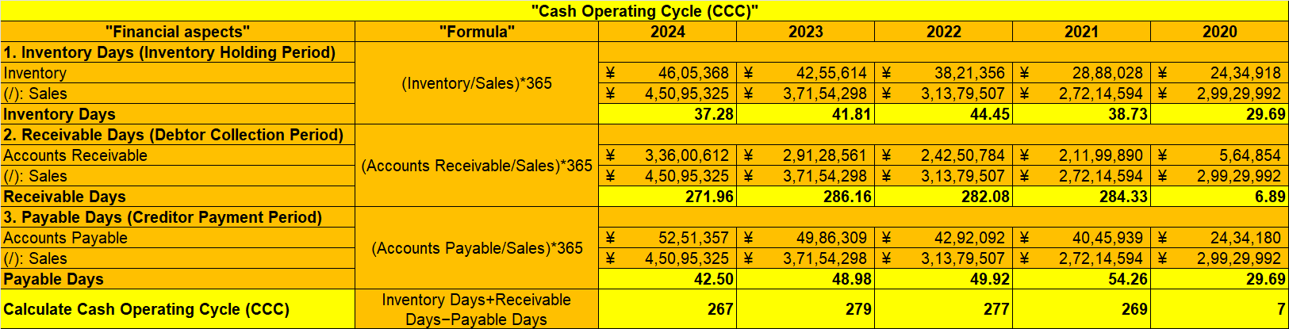
Figure 3.1: Toyota’s “Cash Operating Cycle”
(Source: Excel)
The “cash operating cycle (CCC)” is used to measure the period a company has to turn its investments in stocks and accounts receivable into sales cash flows. It indicates liquidity management and efficiency of working capital. The lower the CCC, the more efficient operations and cash flow control (Bhattacheryay, 2023). The CCC of Toyota is also extremely high, rising from 7 days in 2020 to 267 days in 2024, which means that they convert cash more slowly. The major reason is the sudden increase in the receivable days from 6.89 to 271.96, which shows the long credit terms, particularly in financial services. The number of inventory days was raised slightly to 37.28, with the stock being handled in a controlled manner as opposed to 44.45 in 2022. The payable days decreased to 42.50 (2024) compared to 54.26 (2021), minimising supplier financing benefits. In general, the long-run CCC indicates that although Toyota has consistent inventory management, its dependence on receivables considerably delays cash flows, affecting the working capital efficiency and liquidity management despite high sales growth.

3.2 Strategies to Improve Liquidity through Working Capital Reforms for Toyota
Optimisation of Receivables Management:
The reduction of exceptionally high receivable days should be prioritised by Toyota as it has reached 271.96 days in 2024. These can be done by restricting credit policies, imposing stronger credit evaluations and promoting the collection of payments by cash discounts. Moreover, collections can be sped up by the use of digital payment systems and automation (Shilpi, 2025). Receivables securitisation or factoring is also likely to enhance immediate liquidity. Toyota is highly exposed to financial services receivables; there is a need to manage and segment customers better. Good receivables management will reduce the cash conversion cycle and improve liquidity.
Efficient Inventory Management:
Toyota has quite consistent inventory days (37.28 in 2024), but they can be improved further to achieve a better liquidity level. The company may implement high-tech demand prediction methods, just-in-time (JIT) systems, and real-time monitoring of inventory to lower the quantity of unused stocks. Supply chain technologies, including AI and data analytics, can be integrated to enhance inventory turnover and minimise holding costs. Inventory optimisation helps in ensuring that capital does not go to waste due to capital being tied up in stock, thus enhancing cash flow and operational efficiency (Khalil et al., 2025). Constant performance monitoring of inventory is essential in order to have the best balance of supply and demand.
Strategic Payables Management:
Toyota needs to plan its payable days strategically because it reduced to 42.50 in 2024 compared to 54.26 in 2021. To increase short-term liquidity, paying suppliers later without ruining the relationship can be a good idea. Negotiating good terms of credit and taking advantage of supplier financing plans can give extra room (Glavee and Yang, 2025). The company should create a balance such that reputational risks or supply disruption are not experienced. Payables management maximises the efficiency of working capital because cash flows are matched with cash inflows, and this leads to better liquidity and stability of the financial position.

3.3 Comparison of “Short-Term and Long-Term Financing Options”
“Short-Term Financing”: Flexibility and Cost Efficiency:
Bank overdrafts, trade credit, commercial paper, and short-term loans are examples of sources of short-term financing. These alternatives are normally applied in order to handle working capital requirements, seasonal variations (Gandhi and Nasit, 2022). They tend to be cheaper since interest rates are lower and they have shorter maturities. In the case of a company such as Toyota, short-term financing can be used to facilitate its day-to-day operations and to cover any short-term liquidity crunch created by its high receivable days. Nonetheless, too much short-term debt will lead to an increase in refinancing risk and exposure to interest rates. Irrespective of these risks, short-term financing offers flexibility in operation and easy access to funds, which is appropriate in dealing with liquidity effectively.
“Long-Term Financing”-Stability and Strategic Growth:
Equity capital, bonds, and long-term loans are long-term financing that is normally applied in capital investments and expansion projects. These sources are financially secure, with the ability to repay through the spread of repayment. The growing long-term debt at Toyota is an indicator that the company invests in infrastructure, technology, and the development of electric vehicles. Long-term financing lessens the pressure on liquidity and facilitates massive strategic endeavours (Kostyna, 2025). Nonetheless, it is usually associated with increased interest payments and a long-term financial obligation. Equity financing can also further dilute ownership. Negative as they may be, long-term financing is obligatory to sustainable growth and to be able to sustain the competitive advantage in capital-intensive sectors.
Comparative Evaluation and Strategic Balance:
The ratio between the short and long-term financing is critical in terms of effective financial management. Short-term financing will provide more liquidity and operational flexibility, and long-term financing will be more stable and allow strategic investments (Gandhi and Nasit, 2022). Toyota ought to match its funding framework with its cash flow patterns, with the short-term funds used in working capital and long-term funds used in capital expenditure. As it has a high interest coverage and stable gearing ratios, Toyota can take advantage of both types of financing. A good financial strategy involves the minimisation of the cost of capital, liquidity and minimisation of financial risk.

4. “Strategic Financial Restructuring Plan”

4.1 Financial Restructuring Options
Divestiture of Non-Core and Underperforming Assets:
Toyota can ponder disposing of non-core or low-performing business segments to enhance financial efficiency and free up tied-up capital. Since the company has invested heavily in financial services receivables and capital-intensive assets, selective divestment has the potential to simplify operations and increase liquidity. The sale of low-return assets or subsidiaries would enable Toyota to focus its resources on high-growth segments like electric vehicles (EVs) and digital mobility. Divestiture further enhances the ratio of returns like ROCE and ROA, as it concentrates on core competencies (Zaramella, 2023). The approach boosts financial flexibility and improves the balance sheet.
Strategic Mergers and Partnerships:
Long-term competitiveness of Toyota can be facilitated by strategic mergers, acquisitions or joint ventures, especially in the EV and autonomous driving industries. Partnerships with technology companies or battery companies can minimise the cost of research and development, as well as speed up the innovation (Chen, 2022). This will enable Toyota to reduce financial risk and enter new markets effectively. Considering the growing capital needs of the EV market, alliances can offer economies of scale and enhance efficiency. Nonetheless, one must take time to prevent integration issues and cultural misfit. The strategic alliances would be able to increase the growth without being financially unstable.
Equity Injection and Capital Structure Optimisation:
Toyota can reinforce its capital structure by injecting capital in the form of equity by issuing new shares or by retaining earnings. Even though the company has already shown a good retained earnings growth, further equity financing will help minimise the use of debt, especially since the debt-to-equity ratio has remained relatively high at 1.56. Minimisation of financial risk and long-term solvency are achieved by lower leverage. In addition, growth and innovation can be promoted through reinvesting profits as an alternative to paying high dividends (Zaramella, 2023). A balanced capital structure boosts investor confidence and sustainability in terms of growth in a highly competitive industry.

4.2 Impact on Shareholder Value, Debt Structure, and Operational Flexibility
Impact on “Shareholder Value”:
The suggested restructuring measures should help in increasing the shareholder value through better profitability and capital efficiency. Disposing of less successful assets enhances returns by concentrating on high-margin businesses like electric cars, which enhances ROE and ROIC. Strategic partnership lowers the cost of capital and allows the creation of innovation, and there is long-term value creation. Also, the financial stability is enhanced by the equity injection, which can have a beneficial impact on the investor confidence and market valuation (Wang, 2024). Nonetheless, high equity issuance could dilute the ownership and earnings per share. In general, a restructuring strategy is consistent with the goals of value maximisation as it enhances financial performance and growth opportunities.
Impact on “Debt Structure”:
The reorganisation strategy has a major effect on the debt structure of Toyota since it encourages a more balanced capital structure. Equity injection decreases the debt-to-equity ratio and reduces financial risk, and enhances solvency because of the reduced dependence on debt. The divestiture will raise internal funds, which can be applied to paying the current debt, which will in turn reinforce the balance sheet. The strategic alliances also lessen the necessity to take external borrowing (Wang, 2024). The changes increase the interest coverage and minimise the exposure to interest rate changes. A more balanced debt model enhances creditworthiness and financial sustainability in the long-term.
Impact on “Operational Flexibility”:
Financial restructuring will result in operational flexibility. Divestiture eases the organisational hierarchy, enabling the management to concentrate on the main operations and strategic priorities. Strategic alliances help to access new technologies and markets without big capital ties, and it improves flexibility in an industry that is rapidly changing (Charupat and Sarkar, 2025). Moreover, limited debt levels enhance financial flexibility through decreased fixed financial obligations, permitting Toyota to react to market uncertainties at a higher level. Enhanced cash flow and better liquidity management also help in making investment decisions promptly. On the whole, the reorganisation will improve the adaptability, innovativeness, and competitive position of Toyota.

4.3 International and Ethical Considerations
Taxation and Regulatory Environment:
Toyota is a multijurisdictional company with exposure to various tax systems and regulations. The proper planning of taxes is necessary to maximise international profits without breaching the international tax regulations. To prevent fines and reputational losses, the company should control transfer pricing policies and follow the regulations, such as OECD guidelines. The importance of ethical tax practices is growing, with the most dubious tax avoidance tactics undermining corporate image and relationships (Bashir et al., 2022). Good visibility and adherence to standards will promote credibility and sustainability in the long run.
Currency Risk and Exchange Rate Exposure:
Being a multinational automotive company, Toyota is greatly exposed to currency risks because of the changes in the exchange rates. Revenues are earned in various currencies, and costs can be concentrated in certain locations, resulting in transaction and translation risks (Eyinade et al., 2022). As an illustration, an appreciating Japanese yen can decrease export competitiveness and decrease the reported earnings. In order to overcome these risks, Toyota can employ hedging tools, which include forward contracts and currency swaps. Proper currency risk management stabilises cash flows and cushions profitability in the unstable global markets.
Inflation and Cost Pressures:
The increasing inflation rates across the globe pose an urgent threat to Toyota, especially in regard to the prices of raw materials, labour and disruptions in the supply chain. Inflation may weaken profit margins when the higher costs are not fully compensated through higher customer prices. The firm will have to implement dynamic pricing and cost control measures to keep the firm profitable. Moreover, inflationary pressures can be alleviated with the assistance of effective supply chain management and long-term supplier contracts (Bukhari and Zafar, 2025). There should be strategic financial planning to be resilient to macroeconomic fluctuations and have stable financial performance.
“Corporate Social Responsibility (CSR)” and Ethical Sustainability:
Financial reorganisation should be in harmony with ethical considerations and corporate social responsibility (CSR) at Toyota. With the changing trend in the automotive sector towards sustainability, Toyota is likely to invest in environmentally friendly technology, including electric and hybrid vehicles. Fair labour practices, environmental conservation and community involvement are essential in the process of ensuring stakeholder trust (Dathe et al., 2022). CSR programs also increase brand recognition and value-generation in the long run. Financial decision-making that incorporates sustainability makes growth responsible and consistent with the worldwide environmental principles.

5. “Investment Appraisal and Capital Budgeting”

5.1 Overview of “PBP, ARR, NPV, PI, and IRR”
The investment appraisal methods are the key tools that are applied in the assessment of the financial feasibility of the projects and aid in making strategic decisions. “Payback Period (PBP)” is a measure of the time needed to break even the initial investment based on cash inflows (Arjunan, 2022). It is easy and applicable to risk measurement of liquidity but disregards the “time value of money” and cash flows outside the payback period. “Accounting rate of return (ARR)” is used to determine the average accounting profit percentage of the investment. It gives an understanding of profitability but is based on accounting data and not cash flows, and does not take into account the timing of returns. “Net Present Value (NPV)” is a technique used to assess the gap between the present value of cash inflows and outflows, discounted at a required rate of return (Shou, 2022). The positive NPV shows value creation and is generally considered the most dependable approach since it takes into account the cash flows as well as the time value of money. “Profitability Index (PI)” is used to assess the relationship between the present value of inflows to initial investment, and it can be used to rank projects when faced with capital constraints. Lastly, the “Internal Rate of Return (IRR)” is the discount rate at which NPV is zero, which is the expected return on a project. All the methods have distinct insights, and when combined, they can offer a comprehensive assessment model of investment decisions.

5.2 Investment Projects Overview
The three proposed projects need a start-up amount of £50 million all each and yield different cash inflow patterns within a period of five years. Project A and B have relatively predictable returns, whereas Project C has variable but maximum inflows. Key investment appraisal techniques are used to evaluate all the projects at a discount rate of 10%.

5.3 Project A, B and C Evaluation
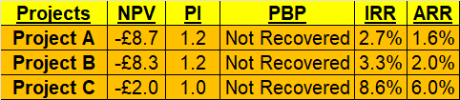
Figure 5.1: Investment Appraisal for Projects A, B and C
(Source: Excel)
Project A records a negative NPV of -£8.7m, which represents destruction of value. The project does not recover its initial investment in the period, even though PI is 1.2. The IRR of 2.7 is much less than the 10% discount rate, and the ARR is very low (1.6), which is not financially viable. Project B also yields a negative NPV of -£8.3m, indicating that it does not contribute to the shareholder value. The IRR of 3.3% is lower than the required return, even though there is a stable pattern of cash inflow and PI of 1.2. ARR stands at 2.0, which is slightly greater, but not high enough to accept investment. Project C is relatively more successful and has the lowest negative NPV of -2.0m and PI of 1.0, which means that it is at the breakeven position. It is more profitable with an IRR of 8.6 percent and an ARR of 6.0 percent. Nonetheless, its acceptance is limited because the returns are less than the discount rate of 10 percent.

5.6 Project Recommendation
Financial Performance Justification:
According to the findings of the investment appraisal, it can be suggested that Project C is the best alternative since all the projects have negative NPVs. Project C experiences the least negative NPV (-2.0m) relative to Project A (-8.7m) and Project B (-8.3m), which means that there is little destruction of value. It also has the highest IRR (8.6) and ARR (6.0), implying a relatively higher profitability. Toyota has a good financial standing, with the increase in profitability (ROCE 11.43) and liquidity (current ratio 1.19), so the company will be able to finance a somewhat underperforming project, provided that it is aligned with long-term strategic objectives. Project C has a comparatively better financial indicator, and thus it is the best option.
Alignment with Liquidity and Risk Profile:
The liquidity position of Toyota has been enhanced with time, as there is a growing cash reserve and constant cash flow generation. The company, however, also has a high cash operating cycle, which is a sign of slow cash inflows. In this regard, the increased potential of a higher return of Project C would counter the liquidity pressure from the lower returns of Projects A and B, which have the same risk of investment. Moreover, the interest coverage ratio of Toyota is high (67.16), which means that it will be able to absorb the average financial risks. Hence, choosing the project that is least harmful in terms of financial impact will ensure the level of liquidity will not decrease significantly, and the working capital will not be overloaded (Awodire et al., 2023).
Non-Financial Considerations and Strategic Fit:
Non-financially, Project C could prove to be more advantageous to Toyota in terms of strategic goals, especially innovation and long-term competitiveness. Technological development, including electric vehicles or digital transformation, is usually associated with projects that have a high potential for returns and are essential in the changing auto industry. In addition, loyalty and brand recognition of the customers require constant innovation and product enhancement. Sustainable technologies are also preferred by political risks such as regulatory changes and environmental policies, among others (Awodire et al., 2023). Despite the financial constraints in Project C, the suitability of the project in terms of future growth prospects and market demands is the best strategic option.

5.7 Capital Rationing Decision
Evaluation under Capital Constraint:
Toyota is limited to choosing two among the three projects because each project needs 50 million pounds, under a capital rationing limit of 100 million pounds. It is aimed at maximising total returns with minimum value destruction. According to the findings, Project C is lowest in negative NPV (-£2.0m), with Project B (-£8.3m) and Project A (-£8.7m). Thus, Project C, in combination with Project A or B, is better than choosing A and B. Projects B and C (-£10.3m) have a better NPV than Projects A and B (-£17.0m) and a little better than Projects A and C (-£10.7m). Therefore, the capital constraint gives the most unfavourable financial result to Projects B and C.
Profitability and Ranking Considerations:
The decision is enhanced by using profitability indicators, including IRR and PI. Project C is the most appealing investment with the highest IRR (8.6) and the highest ARR (6.0). Project B has the next IRR of 3.3% and stable cash flows, whereas Project A has the weakest returns. Even though the PI (1.2) in both Projects A and B are alike, Project B is chosen because it has a little higher returns and consistency. Thus, the choice of Projects B and C guarantees a more appropriate trade-off between stability (Project B) and an increase in the potential of returns (Project C). This strategy is in line with the principles of capital rationing, where projects are prioritised according to their profitability and are chosen based on budget constraints.
Strategic and Risk Considerations:
Strategically, it is better to combine Projects B and C as it will provide diversification of cash flows and less overall risk exposure. Project B offers predictable and stable returns, which will help in sustaining liquidity, whereas Project C offers greater growth potential, which is in line with the innovation strategy of Toyota. This is also a combination that reduces financial risk as it does not overdepend on a given project. Also, since Toyota is financially sound and requires long-term competitiveness, resilience is improved by investing in a portfolio of stable and high-return projects. This balanced investment decision is further supported by non-financial considerations like market demand, technological advancement, and regulatory pressures (Purnamasari and Adriza, 2024).

6. Conclusion
This report has critically assessed the financial performance, working capital management, restructuring strategies and investment decisions in the Toyota company in the background of the dynamic automotive industry. Financial analysis shows that Toyota has recorded a high increase in revenue, profitability, and the equity of shareholders within the five years, which has been enabled by the enhancement of the efficiency of its operations and internationalisation. Liquidity has improved to a moderate degree, but the high cash operating cycle indicates the inefficiencies in its receivables management that need to be addressed strategically.
The working capital analysis highlighted the necessity to reform the management of receivables, inventory and payables to improve liquidity and cash flow delays. In addition, the financial restructuring plan suggested divestiture, strategic partnership and equity optimisation as some of the strategies to enhance financial flexibility and long-term sustainability. These strategies were assessed on the basis of how they have positively affected shareholder value, risk mitigation, operational flexibility, as well as international and ethical considerations, including taxation, currency risk, inflation and corporate social responsibility. Investment appraisal showed that all the projects yield negative NPVs but the most viable project was determined to be Project C because of the relatively higher returns and strategic fit. In the case of capital rationing, Projects B and C were suggested as a mix to maximise returns and reduce financial risk. In general, Toyota stands in a good position to achieve sustainable growth, given that it enhances liquidity management and aligns investments with its long-term strategic goals.

7. References
- Purnamasari, P. and Adriza, 2024. Capital budgeting techniques and financial performance: a comparison between SMEs and large listed firms. Cogent Economics & Finance, 12(1), p.2404707. https://www.tandfonline.com/doi/pdf/10.1080/23322039.2024.2404707
- Awodire, M., Agboola, O., Ogundojutimi, O. and Odumuwagun, O., 2023. Capital budgeting and financial investment appraisal: A review of archival literature. American Journal of Multidisciplinary Research in Africa, 3(10.58314). https://www.academia.edu/download/115377930/Capital_Budgeting_and_Financial_Investme.pdf
- Shou, T., 2022, July. A literature review on the net present value (NPV) valuation method. In 2022 2nd International Conference on Enterprise Management and Economic Development (ICEMED 2022) (pp. 826-830). Atlantis Press. https://www.atlantis-press.com/article/125975449.pdf
- Arjunan, K., 2022. A new method to estimate NPV and IRR from the capital amortization schedule and the advantages of the new method. Australasian Accounting, Business and Finance Journal, 16(6). https://www.uowoajournals.org/aabfj/article/id/941/download/pdf/
- Dathe, T., Dathe, R., Dathe, I. and Helmold, M., 2022. Corporate social responsibility (CSR), sustainability and environmental social governance (ESG): Approaches to ethical management. Berlin, Germany: Springer. https://link.springer.com/book/10.1007/978-3-030-92357-0?source=shoppingads&locale=en-jp
- Bukhari, S.D. and Zafar, I. eds., 2025. Supply Chain Disruptions and Impact on Global Inflation. IGI Global. https://books.google.com/books?hl=en&lr=&id=6pBkEQAAQBAJ&oi=fnd&pg=PP1&dq=Inflation+and+Cost+Pressures:+Rising+global+inflation+presents+a+critical+challenge+for+Toyota,+particularly+in+terms+of+raw+material+costs,+labour+expenses,+and+supply+chain+disruptions&ots=1rJOIy_GK7&sig=7TkAztuPhcjcZcES0q8GDj81geA
- Eyinade, W., Ezeilo, O.J. and Ogundeji, I.A., 2022. A framework for managing currency risk and exchange rate exposure in international energy investment portfolios. International Journal of Scientific Research in Civil Engineering, 6(6), pp.218-230. https://www.researchgate.net/profile/Onyinye-Ezeilo/publication/393453311_A_Framework_for_Managing_Currency_Risk_and_Exchange_Rate_Exposure_in_International_Energy_Investment_Portfolios/links/686af3d5b991270ef301dc5f/A-Framework-for-Managing-Currency-Risk-and-Exchange-Rate-Exposure-in-International-Energy-Investment-Portfolios.pdf
- Bashir, M.F., Ma, B., Bashir, M.A., Radulescu, M. and Shahzad, U., 2022. Investigating the role of environmental taxes and regulations for renewable energy consumption: evidence from developed economies. Economic Research-Ekonomska Istraživanja, 35(1), pp.1262-1284. https://hrcak.srce.hr/file/435668
- Wang, D., 2024. The role of fair value accounting in debt structure decisions: evidence from priority structure and financial flexibility. The International Journal of Accounting, 59(03), p.2450017. https://www.worldscientific.com/doi/abs/10.1142/S1094406024500173
- Charupat, N. and Sarkar, S., 2025. Operating flexibility and optimal capital structure. Accounting & Finance, 65(2), pp.1863-1887. https://onlinelibrary.wiley.com/doi/abs/10.1111/acfi.13391
- Chen, Y., 2022. Research on collaborative innovation of key common technologies in new energy vehicle industry based on digital twin technology. Energy Reports, 8, pp.15399-15407. https://www.sciencedirect.com/science/article/pii/S2352484722025070
- Zaramella, G., 2023. Financial Restructuring: analysis and applications. https://unitesi.unive.it/bitstream/20.500.14247/4284/1/872666-1280209.pdf
- Kostyna, V., 2025. THE IMPACT OF INVESTMENT STRATEGIES ON LONG-TERM FINANCIAL STABILITY. Collection of scientific papers «SCIENTIA», (October 3, 2025; Berlin, Germany), pp.35-42. https://previous.scientia.report/index.php/archive/article/view/3039/3071
- Gandhi, J. and Nasit, A., 2022. Comparison of short-term financing options; factoring as the best alternative. In International Research Conference on Innovations, Startup and Investments (ICOSTART-2022) (pp. 127-141). https://rku.ac.in/icostart2022/books/14-management-jenil-gandhi-(127-141).pdf
- Glavee, P. and Yang, L., 2025. Trade credit dynamics in supply chain: The impact of supplier operational inflexibility. International Review of Financial Analysis, p.104769. https://www.sciencedirect.com/science/article/pii/S1057521925008567
- Khalil, S., Zaman, K. and Iqbal, F., 2025. The Impact of Just-in-Time Inventory Systems on Supply Chain Efficiency. Economic Trends and Business Review, 3(1), pp.1-16. https://etbrjournal.com/index.php/journal/article/download/46/46
- Shilpi, S., 2025. Integrating Automated Clearing House Modernization, Batch Monitoring, and SWIFT Support: A Unified Framework for Resilient Payment Systems. Journal of Computer Science and Technology Studies, 7(9), pp.97-103. https://al-kindipublishers.org/index.php/jcsts/article/download/10748/9502
- Bhattacheryay, S., 2023. Multinational working capital management a study on Toyota Motor Corporation. International Journal of Finance & Economics, 28(1), pp.236-256. https://www.researchgate.net/profile/Suranjan-Bhattacheryay-2/publication/348843827_Multinational_working_capital_management_a_study_on_Toyota_Motor_Corporation/links/604d719a458515e529a7a20a/Multinational-working-capital-management-a-study-on-Toyota-Motor-Corporation.pdf
- Xinyao, D., Wen, X., Jingjing, X., Xiaohui, W. and Loang, O.K., 2023. Financial and Non-Financial Analysis of Toyota and Ford: A Comparative Study. Journal of Islamic, Social, Economics and Development, 8(52), pp.203-214. https://www.researchgate.net/profile/Ooi-Kok-Loang/publication/370060687_FINANCIAL_AND_NON-FINANCIAL_ANALYSIS_OF_TOYOTA_AND_FORD_A_COMPARATIVE_STUDY/links/643d24d41b8d044c632d2f1d/FINANCIAL-AND-NON-FINANCIAL-ANALYSIS-OF-TOYOTA-AND-FORD-A-COMPARATIVE-STUDY.pdf
- Arkaan, D.U. and Budianto, E.W.H., 2024. Does Financial Ratio Have an Impact on The Growth of Sharia Banking in The World. Jurnal Tabarru': Islamic Banking and Finance, 7(1), pp.299-309. http://repository.uin-malang.ac.id/19404/1/19404.pdf
- Dönmez, N. and Özkan, T., 2022. Effects of changes in financial ratios of companies on the performance of stock prices in the exchange market: The automotive sector. EMAJ: Emerging Markets Journal, 12(1), pp.1-12. http://178.128.120.64/index.php/asset/article/download/1030/593
- Rahman, A. and Acharya, P., 2022. An examination of five financial ratios: The Altman Z Score is a technique used to assess the creditworthiness of selected passenger car companies. International Journal of Multidisciplinary Research and Explorer, 2(1), pp.1-6. https://www.academia.edu/download/79702829/IJMRE_V2N1AI217_published_paper.pdf
- Olayinka, A.A., 2022. Financial statement analysis as a tool for investment decisions and assessment of companies’ performance. International Journal of Financial, Accounting, and Management, 4(1), pp.49-66. https://www.researchgate.net/profile/Aminu-Olayinka/publication/361292771_Financial_statement_analysis_as_a_tool_for_investment_decisions_and_assessment_of_companies'_performance/links/62a90366a3fe3e3df8778ac8/Financial-statement-analysis-as-a-tool-for-investment-decisions-and-assessment-of-companies-performance.pdf
- Toyota. 2024. FINANCIAL SUMMARY FY2024. Available at: https://global.toyota/pages/global_toyota/ir/financial-results/2024_4q_summary_en.pdf [Accessed 22nd April 2026]
- Toyota. 2023. FINANCIAL SUMMARY FY2023. Available at: https://global.toyota/pages/global_toyota/ir/financial-results/2023_4q_summary_en.pdf [Accessed 22nd April 2026]
- Toyota. 2022. FINANCIAL SUMMARY FY2022. Available at: https://global.toyota/pages/global_toyota/ir/financial-results/2022_4q_summary_en.pdf [Accessed 22nd April 2026]
- Toyota. 2020. FINANCIAL SUMMARY FY2020. Available at: https://global.toyota/pages/global_toyota/ir/financial-results/2020_4q_summary_en.pdf [Accessed 22nd April 2026]

8. Appendices

Appendix 1: Ratio Tables
"Profitability Ratio"
"ROCE"
"Financial aspects" | "Formula" | 2024 | 2023 | 2022 | 2021 | 2020
"EBIT" | "EBIT / (Total Assets − Current Liabilities)*100" | ¥ 69,65,085 | ¥ 36,68,733 | ¥ 39,90,532 | ¥ 29,32,354 | ¥ 25,54,607
(/):"Total Assets" | "EBIT / (Total Assets − Current Liabilities)*100" | ¥ 9,01,14,296 | ¥ 7,43,03,180 | ¥ 6,76,88,771 | ¥ 6,22,67,140 | ¥ 5,26,80,436
"(-): Current Liabilities" | "EBIT / (Total Assets − Current Liabilities)*100" | ¥ 2,91,77,909 | ¥ 2,39,59,715 | ¥ 2,18,42,161 | ¥ 2,14,60,466 | ¥ 1,79,02,377
"ROCE" | "EBIT / (Total Assets − Current Liabilities)*100" | 11.43% | 7.29% | 8.70% | 7.19% | 7.35%
"Operating Margin"
"Financial aspects" | "Formula" | 2024 | 2023 | 2022 | 2021 | 2020
"Operating Income" | "(Operating Income (or EBIT) / Sales)*100" | ¥ 53,52,934 | ¥ 27,25,025 | ¥ 29,95,697 | ¥ 21,97,748 | ¥ 24,42,869
"(/): Sales" | "(Operating Income (or EBIT) / Sales)*100" | ¥ 4,50,95,325 | ¥ 3,71,54,298 | ¥ 3,13,79,507 | ¥ 2,72,14,594 | ¥ 2,99,29,992
"Operating Margin" | "(Operating Income (or EBIT) / Sales)*100" | 11.87% | 7.33% | 9.55% | 8.08% | 8.16%
"Net Profit Margin"
"Financial aspects" | "Formula" | 2024 | 2023 | 2022 | 2021 | 2020
"Net Income" | "(Net Income / Sales)*100" | ¥ 50,71,421 | ¥ 24,92,967 | ¥ 28,74,614 | ¥ 22,82,378 | ¥ 21,42,329
"(/): Sales" | "(Net Income / Sales)*100" | ¥ 4,50,95,325 | ¥ 3,71,54,298 | ¥ 3,13,79,507 | ¥ 2,72,14,594 | ¥ 2,99,29,992
"Net Profit Margin" | "(Net Income / Sales)*100" | 11.25% | 6.71% | 9.16% | 8.39% | 7.16%
"Gross Profit Margin"
"Financial aspects" | "Formula" | 2024 | 2023 | 2022 | 2021 | 2020
"Gross Profit" | "(Gross Profit / Sales)*100" | ¥ 1,14,94,713 | ¥ 80,25,737 | ¥ 71,28,723 | ¥ 60,14,704 | ¥ 67,87,248
"(/): Sales" | "(Gross Profit / Sales)*100" | ¥ 4,50,95,325 | ¥ 3,71,54,298 | ¥ 3,13,79,507 | ¥ 2,72,14,594 | ¥ 2,99,29,992
"Gross Profit Margin" | "(Gross Profit / Sales)*100" | 25.49% | 21.60% | 22.72% | 22.10% | 22.68%
"Liquidity ratio"
"Current ratio"
"Financial aspects" | "Formula" | 2024 | 2023 | 2022 | 2021 | 2020
"Current assets" | "Current assets/Current liabilities" | ¥ 3,47,14,279 | ¥ 2,64,59,781 | ¥ 2,37,22,290 | ¥ 2,27,76,800 | ¥ 1,86,42,531
"(/): Current Liabilities" | "Current assets/Current liabilities" | ¥ 2,91,77,909 | ¥ 2,39,59,715 | ¥ 2,18,42,161 | ¥ 2,14,60,466 | ¥ 1,79,02,377
"Current ratio" | "Current assets/Current liabilities" | 1.19 | 1.10 | 1.09 | 1.06 | 1.04
"Quick Ratio "
"Financial aspects" | "Formula" | 2024 | 2023 | 2022 | 2021 | 2020
"Current assets" | "(Current assets-Inventories)/Current liabilities" | ¥ 3,47,14,279 | ¥ 2,64,59,781 | ¥ 2,37,22,290 | ¥ 2,27,76,800 | ¥ 1,86,42,531
"(-): Inventories" | "(Current assets-Inventories)/Current liabilities" | ¥ 46,05,368 | ¥ 42,55,614 | ¥ 38,21,356 | ¥ 28,88,028 | ¥ 24,34,918
"Difference" | "(Current assets-Inventories)/Current liabilities" | ¥ 3,01,08,911 | ¥ 2,22,04,167 | ¥ 1,99,00,934 | ¥ 1,98,88,772 | ¥ 1,62,07,613
"(/): Current Liabilities" | "(Current assets-Inventories)/Current liabilities" | ¥ 2,91,77,909 | ¥ 2,39,59,715 | ¥ 2,18,42,161 | ¥ 2,14,60,466 | ¥ 1,79,02,377
"Quick Ratio " | "(Current assets-Inventories)/Current liabilities" | 1.03 | 0.93 | 0.91 | 0.93 | 0.91
"Cash Ratio"
"Financial aspects" | "Formula" | 2024 | 2023 | 2022 | 2021 | 2020
"Cash" | "Cash / Current Liabilities" | ¥ 94,12,060 | ¥ 75,16,966 | ¥ 42,92,092 | ¥ 40,45,939 | ¥ 41,90,518
"(/): Current Liabilities" | "Cash / Current Liabilities" | ¥ 2,91,77,909 | ¥ 2,39,59,715 | ¥ 2,18,42,161 | ¥ 2,14,60,466 | ¥ 1,79,02,377
"Cash Ratio" | "Cash / Current Liabilities" | 0.32 | 0.31 | 0.20 | 0.19 | 0.23
"Efficiency ratio"
"Accounts Receivable Turnover"
"Financial aspects" | "Formula" | 2024 | 2023 | 2022 | 2021 | 2020
"Accounts Receivable" | "(Accounts Receivable / Average of Daily Sales)" | ¥ 37,89,429 | ¥ 35,86,130 | ¥ 31,42,832 | ¥ 29,58,742 | ¥ 5,64,854
"(/): Average of Daily Sales" | "(Accounts Receivable / Average of Daily Sales)" | ¥ 4,11,24,812 | ¥ 3,42,66,903 | ¥ 2,92,97,051 | ¥ 2,85,72,293 | ¥ 1,49,64,996
"Accounts Receivable Turnover" | "(Accounts Receivable / Average of Daily Sales)" | 0.82 | 0.85 | 0.83 | 0.74 | 0.04
"Inventory Turnover"
"Financial aspects" | "Formula" | 2024 | 2023 | 2022 | 2021 | 2020
"COGS" | "(COGS / Average Inventory)" | ¥ 3,36,00,612 | ¥ 2,91,28,561 | ¥ 2,42,50,784 | ¥ 2,11,99,890 | ¥ 2,31,42,744
"(/): Average Inventory" | "(COGS / Average Inventory)" | ¥ 44,30,491 | ¥ 40,38,485 | ¥ 33,54,692 | ¥ 26,61,473 | ¥ 12,17,459
"Inventory Turnover" | "(COGS / Average Inventory)" | 7.58 | 7.21 | 7.23 | 7.97 | 19.01
"Asset Turnover"
"Financial aspects" | "Formula" | 2024 | 2023 | 2022 | 2021 | 2020
"Sales" | "(Sales / Average Total Assets)" | ¥ 4,50,95,325 | ¥ 3,71,54,298 | ¥ 3,13,79,507 | ¥ 2,72,14,594 | ¥ 2,99,29,992
"(/): Average Total Assets" | "(Sales / Average Total Assets)" | ¥ 8,22,08,738 | ¥ 7,09,95,976 | ¥ 6,49,77,956 | ¥ 5,74,73,788 | ¥ 2,63,40,218
"Asset Turnover" | "(Sales / Average Total Assets)" | 0.55 | 0.52 | 0.48 | 0.47 | 1.14
"Leverage (Gearing) Ratio"
"Debt to Equity Ratio"
"Financial aspects" | "Formula" | 2024 | 2023 | 2022 | 2021 | 2020
"Total Debt" | "(Total debt/Total equity)" | ¥ 5,48,74,958 | ¥ 4,50,38,967 | ¥ 4,05,33,951 | ¥ 3,79,78,811 | ¥ 3,14,38,585
"(/): Total Equity" | "(Total debt/Total equity)" | ¥ 3,52,39,338 | ¥ 2,92,64,213 | ¥ 2,71,54,820 | ¥ 2,42,88,329 | ¥ 2,07,37,682
"Debt to Equity Ratio" | "(Total debt/Total equity)" | 1.56 | 1.54 | 1.49 | 1.56 | 1.52
"Interest Coverage Ratios"
"Financial aspects" | "Formula" | 2024 | 2023 | 2022 | 2021 | 2020
"EBIT" | "(EBIT/ Interest Expenses)" | ¥ 69,65,085 | ¥ 36,68,733 | ¥ 39,90,532 | ¥ 29,32,354 | ¥ 25,54,607
"(/): Interest Expense" | "(EBIT/ Interest Expenses)" | ¥ 1,03,709 | ¥ 1,25,113 | ¥ 43,997 | ¥ 47,537 | ¥ 32,217
"Interest Coverage Ratios" | "(EBIT/ Interest Expenses)" | 67.16 | 29.32 | 90.70 | 61.69 | 79.29
"Debt-to-Capital Ratio "
"Financial aspects" | "Formula" | 2024 | 2023 | 2022 | 2021 | 2020
"Total Debt" | "Total Debt / (Total Equity + Total Debt)" | ¥ 5,48,74,958 | ¥ 4,50,38,967 | ¥ 4,05,33,951 | ¥ 3,79,78,811 | ¥ 3,14,38,585
"(/): Total Equity" | "Total Debt / (Total Equity + Total Debt)" | ¥ 3,52,39,338 | ¥ 2,92,64,213 | ¥ 2,71,54,820 | ¥ 2,42,88,329 | ¥ 2,07,37,682
"Debt-to-Capital Ratio " | "Total Debt / (Total Equity + Total Debt)" | 0.61 | 0.61 | 0.60 | 0.61 | 0.60
"Equity Multiplier"
"Financial aspects" | "Formula" | 2024 | 2023 | 2022 | 2021 | 2020
"Total Assets" | "(Total Assets/Book Value of Equity)" | ¥ 9,01,14,296 | ¥ 7,43,03,180 | ¥ 6,76,88,771 | ¥ 6,22,67,140 | ¥ 5,26,80,436
"(/): Book Value of Equity" | "(Total Assets/Book Value of Equity)" | ¥ 3,52,39,338 | ¥ 2,92,64,213 | ¥ 2,71,54,820 | ¥ 2,42,88,329 | ¥ 2,07,37,682
"Equity Multiplier" | "(Total Assets/Book Value of Equity)" | 2.56 | 2.54 | 2.49 | 2.56 | 2.54
"Investment Ratio"
"Dividend Payout Ratio "
"Financial aspects" | "Formula" | 2024 | 2023 | 2022 | 2021 | 2020
"Dividend" | "Dividends Paid / Net Income" | ¥ 10,11,753 | ¥ 8,16,968 | ¥ 7,18,211 | ¥ 6,71,029 | ¥ 6,10,847
"(/): "Net Income" | "Dividends Paid / Net Income" | ¥ 50,71,421 | ¥ 24,92,967 | ¥ 28,74,614 | ¥ 22,82,378 | ¥ 21,42,329
"Dividend Payout Ratio " | "Dividends Paid / Net Income" | 0.20 | 0.33 | 0.25 | 0.29 | 0.29
"Return on Equity (ROE)"
"Financial aspects" | "Formula" | 2024 | 2023 | 2022 | 2021 | 2020
"Net Income " | "Net Income / Book Value of Equity (Total Equity)" | ¥ 50,71,421 | ¥ 24,92,967 | ¥ 28,74,614 | ¥ 22,82,378 | ¥ 21,42,329
"(/): Book Value of Equity" | "Net Income / Book Value of Equity (Total Equity)" | ¥ 3,52,39,338 | ¥ 2,92,64,213 | ¥ 2,71,54,820 | ¥ 2,42,88,329 | ¥ 2,07,37,682
"Return on Equity (ROE)" | "Net Income / Book Value of Equity (Total Equity)" | 0.14 | 0.09 | 0.11 | 0.09 | 0.10
"Return on Assets (ROA)"
"Financial aspects" | "Formula" | 2024 | 2023 | 2022 | 2021 | 2020
"Net Income " | "Net Income / Total Assets" | ¥ 50,71,421 | ¥ 24,92,967 | ¥ 28,74,614 | ¥ 22,82,378 | ¥ 21,42,329
"(/): "Total Assets" | "Net Income / Total Assets" | ¥ 9,01,14,296 | ¥ 7,43,03,180 | ¥ 6,76,88,771 | ¥ 6,22,67,140 | ¥ 5,26,80,436
"Return on Assets (ROA)" | "Net Income / Total Assets" | 0.06 | 0.03 | 0.04 | 0.04 | 0.04
"Return on Invested Capital (ROIC)"
"Financial aspects" | "Formula" | 2024 | 2023 | 2022 | 2021 | 2020
"Net Income " | "After-tax Profit or (EBIT−Taxation) / (Total Equity + Net Debt)" | ¥ 50,71,421 | ¥ 24,92,967 | ¥ 28,74,614 | ¥ 22,82,378 | ¥ 21,42,329
(/):"Total Equity" |  | ¥ 3,52,39,338 | ¥ 2,92,64,213 | ¥ 2,71,54,820 | ¥ 2,42,88,329 | ¥ 2,07,37,682
"(+): "Net Debt (Total Debt – Cash)" |  | ¥ 4,54,62,898 | ¥ 3,75,22,001 | ¥ 3,62,41,859 | ¥ 3,39,32,872 | ¥ 2,72,48,067
"Return on Invested Capital (ROIC)" |  | 0.06 | 0.04 | 0.05 | 0.04 | 0.04
"Cash Flow Ratios"
"Operating Cash Flow Ratio"
"Financial aspects" | "Formula" | 2024 | 2023 | 2022 | 2021 | 2020
"Operating Cash Flow" | "(Operating Cash Flow/Current Liabilities)" | ¥ 42,06,373 | ¥ 29,55,076 | ¥ 37,22,615 | ¥ 27,27,162 | ¥ 35,90,643
"(/): Current Liabilities" | "(Operating Cash Flow/Current Liabilities)" | ¥ 2,91,77,909 | ¥ 2,39,59,715 | ¥ 2,18,42,161 | ¥ 2,14,60,466 | ¥ 1,79,02,377
"Operating Cash Flow Ratio" | "(Operating Cash Flow/Current Liabilities)" | 0.14 | 0.12 | 0.17 | 0.13 | 0.20
"Cash Flow to Debt Ratio"
"Financial aspects" | "Formula" | 2024 | 2023 | 2022 | 2021 | 2020
"Operating Cash Flow" | "(Operating Cash Flow/Total Debt)" | ¥ 42,06,373 | ¥ 29,55,076 | ¥ 37,22,615 | ¥ 27,27,162 | ¥ 35,90,643
"(/): Total Debt" | "(Operating Cash Flow/Total Debt)" | ¥ 5,48,74,958 | ¥ 4,50,38,967 | ¥ 4,05,33,951 | ¥ 3,79,78,811 | ¥ 3,14,38,585
"Cash Flow to Debt Ratio" | "(Operating Cash Flow/Total Debt)" | 0.08 | 0.07 | 0.09 | 0.07 | 0.11
"Cash Flow Margin"
"Financial aspects" | "Formula" | 2024 | 2023 | 2022 | 2021 | 2020
"Operating Cash Flow" | "(Operating Cash Flow/Sales)" | ¥ 42,06,373 | ¥ 29,55,076 | ¥ 37,22,615 | ¥ 27,27,162 | ¥ 35,90,643
"(/): Sales" | "(Operating Cash Flow/Sales)" | ¥ 4,50,95,325 | ¥ 3,71,54,298 | ¥ 3,13,79,507 | ¥ 2,72,14,594 | ¥ 2,99,29,992
"Cash Flow Margin" | "(Operating Cash Flow/Sales)" | 0.09 | 0.08 | 0.12 | 0.10 | 0.12
"Free Cash Flow Margin"
"Financial aspects" | "Formula" | 2024 | 2023 | 2022 | 2021 | 2020
"Operating Cash Flow" | "(Operating Cash Flow-Capital Expenditure)/Sales" | ¥ 42,06,373 | ¥ 29,55,076 | ¥ 37,22,615 | ¥ 27,27,162 | ¥ 35,90,643
"(-): Capital Expenditure" | "(Operating Cash Flow-Capital Expenditure)/Sales" | ¥ 48,48,042 | ¥ 34,96,219 | ¥ 36,11,587 | ¥ 36,09,699 | ¥ 36,03,232
"(/): Sales" | "(Operating Cash Flow-Capital Expenditure)/Sales" | ¥ 4,50,95,325 | ¥ 3,71,54,298 | ¥ 3,13,79,507 | ¥ 2,72,14,594 | ¥ 2,99,29,992
"Free Cash Flow Margin" | "(Operating Cash Flow-Capital Expenditure)/Sales" | -0.0142 | -0.0146 | 0.0035 | -0.0324 | -0.0004
(Source: Excel)

Appendix 2: Ratio Graphs
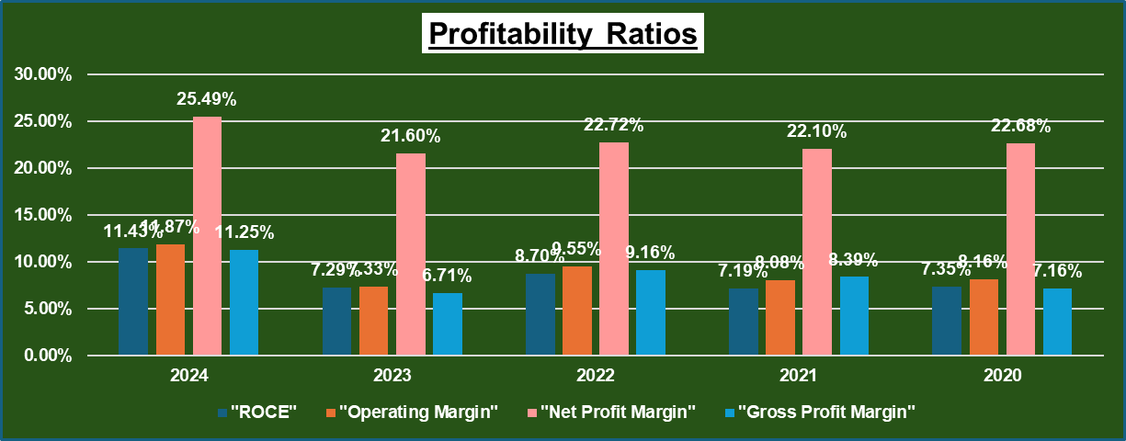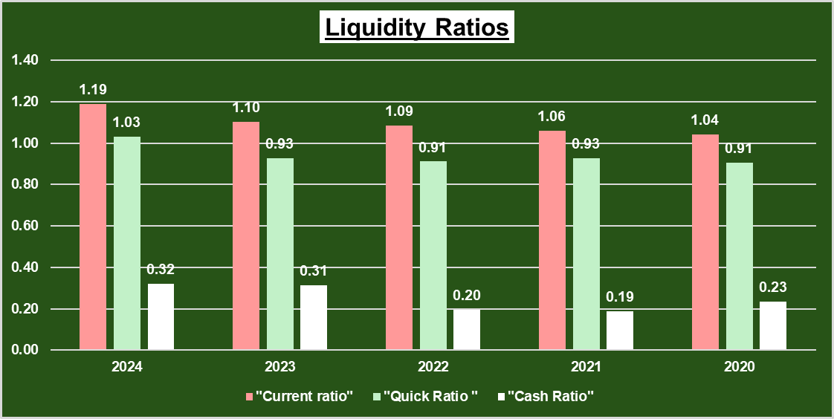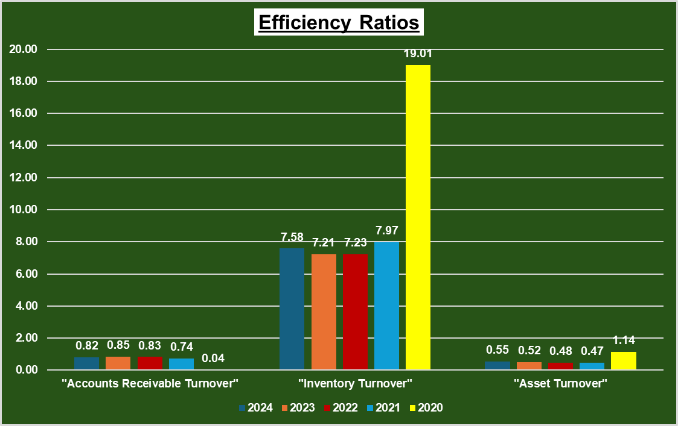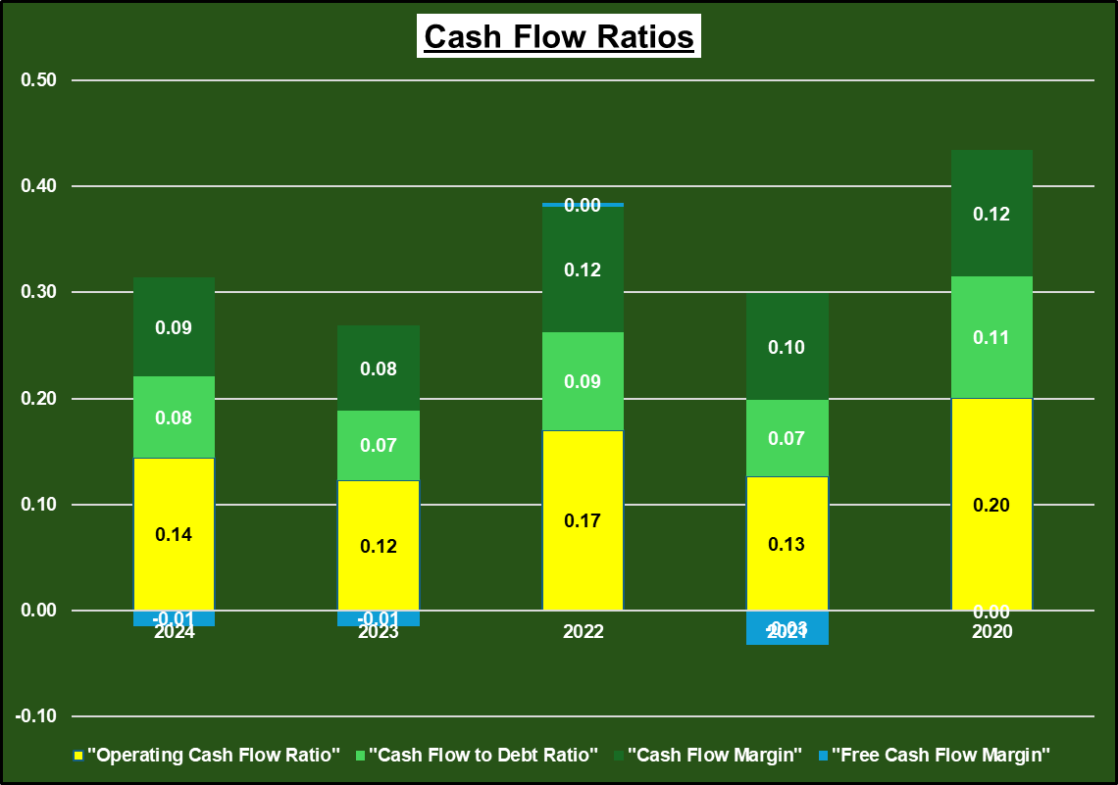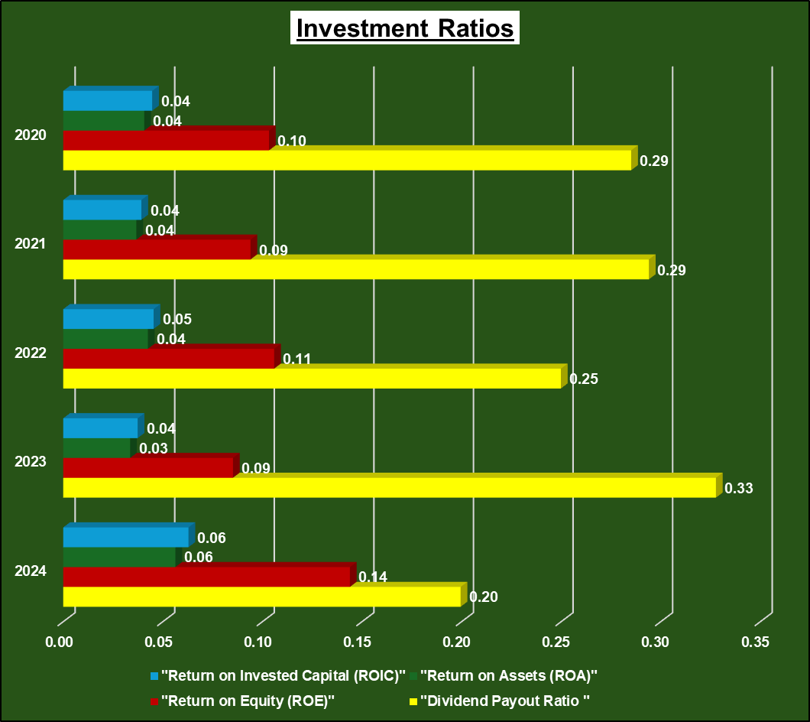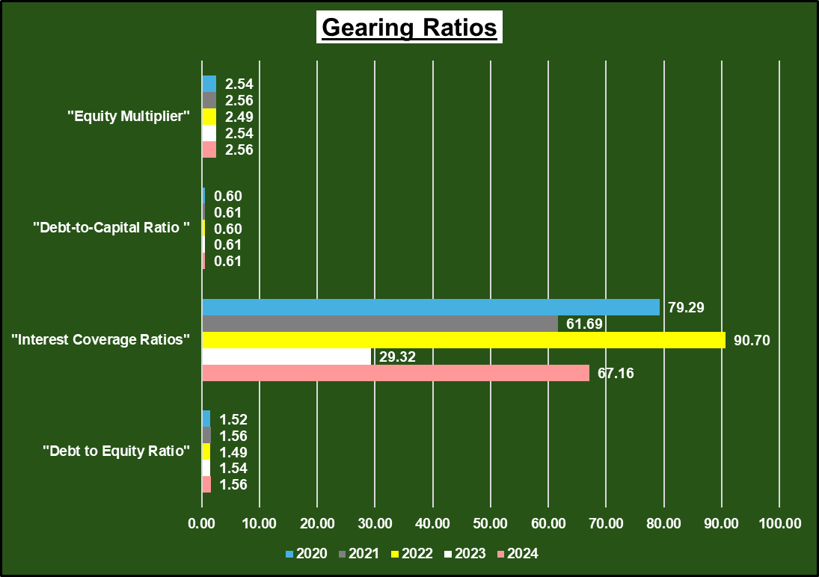
(Source: Excel)

Appendix 3: CCC Table
"Cash Operating Cycle (CCC)"
"Financial aspects" | "Formula" | 2024 | 2023 | 2022 | 2021 | 2020
1. Inventory Days (Inventory Holding Period) | (Inventory/Sales)*365
Inventory | (Inventory/Sales)*365 | ¥ 46,05,368 | ¥ 42,55,614 | ¥ 38,21,356 | ¥ 28,88,028 | ¥ 24,34,918
(/): Sales | (Inventory/Sales)*365 | ¥ 4,50,95,325 | ¥ 3,71,54,298 | ¥ 3,13,79,507 | ¥ 2,72,14,594 | ¥ 2,99,29,992
Inventory Days | (Inventory/Sales)*365 | 37.28 | 41.81 | 44.45 | 38.73 | 29.69
2. Receivable Days (Debtor Collection Period) | (Accounts Receivable​/Sales)*365
Accounts Receivable​ | (Accounts Receivable​/Sales)*365 | ¥ 3,36,00,612 | ¥ 2,91,28,561 | ¥ 2,42,50,784 | ¥ 2,11,99,890 | ¥ 5,64,854
(/): Sales | (Accounts Receivable​/Sales)*365 | ¥ 4,50,95,325 | ¥ 3,71,54,298 | ¥ 3,13,79,507 | ¥ 2,72,14,594 | ¥ 2,99,29,992
Receivable Days | (Accounts Receivable​/Sales)*365 | 271.96 | 286.16 | 282.08 | 284.33 | 6.89
3. Payable Days (Creditor Payment Period) | (Accounts Payable​/Sales)*365
Accounts Payable​ | (Accounts Payable​/Sales)*365 | ¥ 52,51,357 | ¥ 49,86,309 | ¥ 42,92,092 | ¥ 40,45,939 | ¥ 24,34,180
(/): Sales | (Accounts Payable​/Sales)*365 | ¥ 4,50,95,325 | ¥ 3,71,54,298 | ¥ 3,13,79,507 | ¥ 2,72,14,594 | ¥ 2,99,29,992
Payable Days | (Accounts Payable​/Sales)*365 | 42.50 | 48.98 | 49.92 | 54.26 | 29.69
Calculate Cash Operating Cycle (CCC) | Inventory Days+Receivable Days−Payable Days | 267 | 279 | 277 | 269 | 7
(Source: Excel)

Appendix 4: CCC Graph
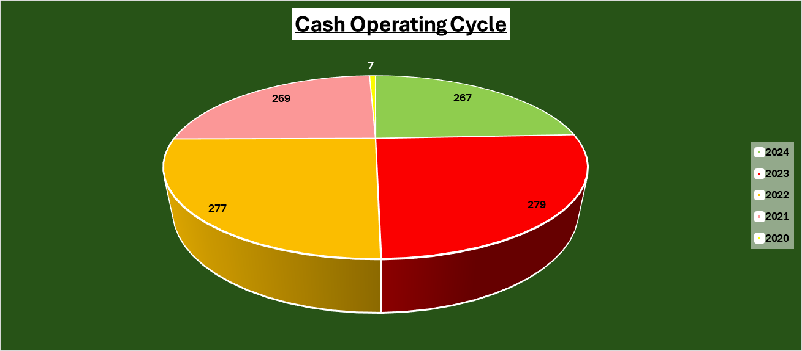
(Source: Excel)

Appendix 5: Projects Table
Projects | NPV | PI | PBP | IRR | ARR
Project A | -£8.7 | 1.2 | Not Recovered | 2.7% | 1.6%
Project B | -£8.3 | 1.2 | Not Recovered | 3.3% | 2.0%
Project C | -£2.0 | 1.0 | Not Recovered | 8.6% | 6.0%
(Source: Excel)

Appendix 6: Projects Graphs
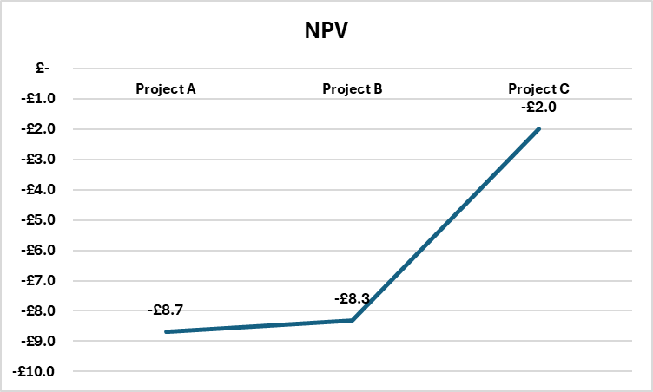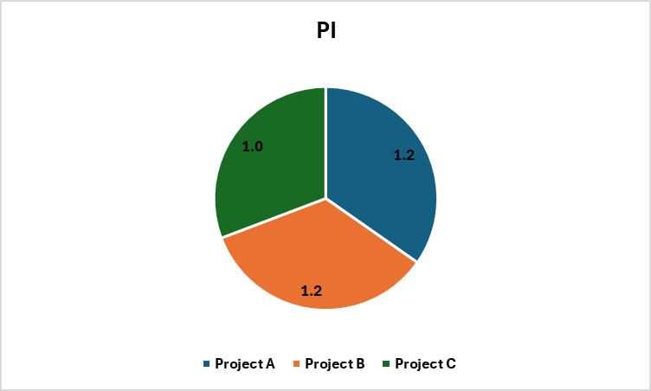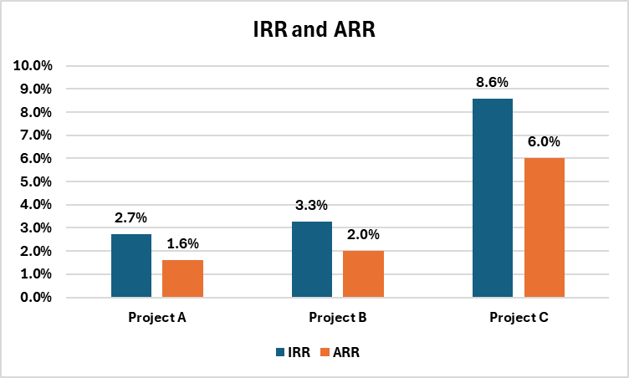
(Source: Excel)

