Student Name –Janet Ogundayo

Student ID- 1918674

Lecturer-Tushara Balendran

Course Code- LCMB7001

Assignment 75%

MBA MARKETING MANAGEMENT ASSIGNMENT 2

Table of Contents

Introduction 3
Definition of communication 3
Discussion on Linear model of communication with diagram 3
Definition of Integrated Marketing Communications 4
Promotion Applied by Adidas at the present time 5
New promotional strategies Adidas can use to raise brand Awareness 6
Definition of Branding and Brand Equity 7
Keller’s Brand Equity Model with Advantages and Disadvantages 7
Customer journey and customer touch points of Adidas 10
Total Engagement Model from the context of Adidas 12
Conclusion 13
Reference List 14

Introduction
The study focuses on the aspect that an organisation can create innovative marketing strategies based on brand awareness and evaluating the customer journey across a variety of communication channels in order to ensure current and future stakeholders’ expectations of Adidas.
Communication refers to the process of transferring ideas, feelings and information from one person to another. The communication process can be explained by linear model as it indicates that communication process includes sender receiver, message, encoding, decoding, feedback and noise. Integrated marketing communication refers to the process of developing seamless interaction between customers and brands through covering all aspects of marketing communication. Adidas is currently more focusing digital marketing in order to enhance its interaction with customers. Adidas is creating nostalgia or giveaway technique for promoting its brand. The study also covers brand equity which refers to the process of developing value through serving products which is different market. Keller’s equity model helps to describe the concept of brad equity. Adidas used different customer touch points including website, Google search, online shopping, and stores and so on. Adidas uses total engagement model to develop it retain and improve its relationship with customers through engaging customers.

Definition of communication
Communication is defined as the process and implementation of various techniques and solutions through which the intended feelings of one person is understood by another person (Ghinea, 2019).
According to Philip Kotler and Kevin Lane marketing communication is defined as process of informing, persuading customers in order to make them remember about the rand or products in a direct or indirect manner (Kotler, 2017).
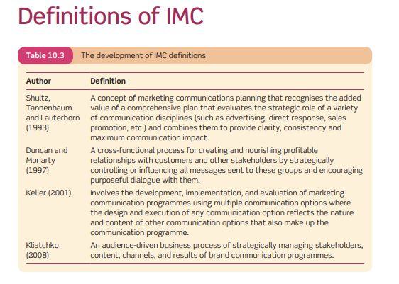
Figure 1: IMC
(Source:Ganeshaet al., 2020)

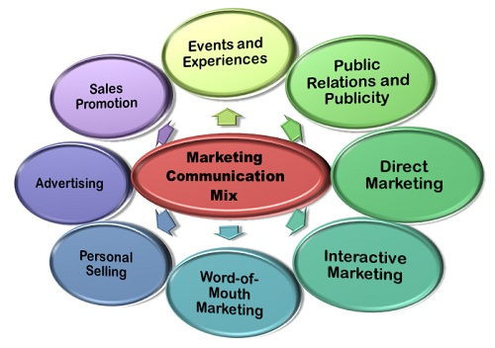
Figure 2: Marketing communication
(Source: Baciket al., 2018)
Marketing communication Mix
It refers to elements which is Adopted by adidas for conveying its message to customers. It majorly conveys message through digital medium which includes that Adidas products can be used for sports or exercise purpose. It has sportswear, shoes and accessories for men, women, and teenagers during different types of sports like running, football, soccer, golf and others. Social media helps Adidas to develop interactive marketing, sales promotion helps to attract customers, public relation builds positive brand image in the market and so on.

Discussion on Linear model of communication with diagram
The linear model of communication is a simple method of communication in which there is a straightway procedure of communicating. In other words the sender sends information and the receiver receives it, in this model of communication there is no way in which the receiver can respond back to the sender of the communication. This model of communication is mostly used in businesses through their PR agencies and through advertising agencies to communicate with their clients and customers (Wang, 2018).
There are basically three important things in this model of communication which are namely sender, channel and receiver. The importance of these three things are equal and this model works primarily in the following way: The sender decides upon what communication to send and then sends the message over the channel, the channel then transmits the message in a tangible form which can be written, audio-visual etc. that can be understood by the receiver upon receiving when the receiver can decode the message. The usability of this model of communication is debated at many levels because what experts claim is that the choice of medium can introduce a lot of disturbances in the message and thus there are instances when the message is quite altered when it is decoded at the receivers end (Song, Choiand Shi, 2018).
There is another particular problem with this model in the fact that the receiver does not have any opportunity of coming back to the sender with any feedback or queries because the messaging system does not allow such options (Ding, 2016).
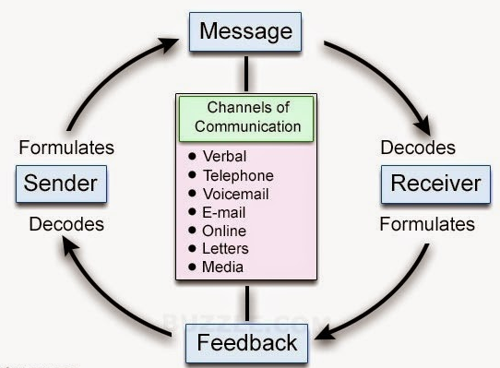
Figure 1: Linear model of communication
(Source: Influenced by ZHANG and Zhanfang, 2020, p.52)
The linear model of communication helps to explain AIDA model of marketing where the message of the communication model helps to generate awareness about Adidas through different promotional activities (Poyraz and Çetintürk, 2017). The awareness generates interest among customers regarding Adidas products. It leads towards desire of obtaining the product which leads towards the final purchasing decision of Adidas products. The action refers to feedback of the communication model where the brand act as a sender and the customer act as a receiver.

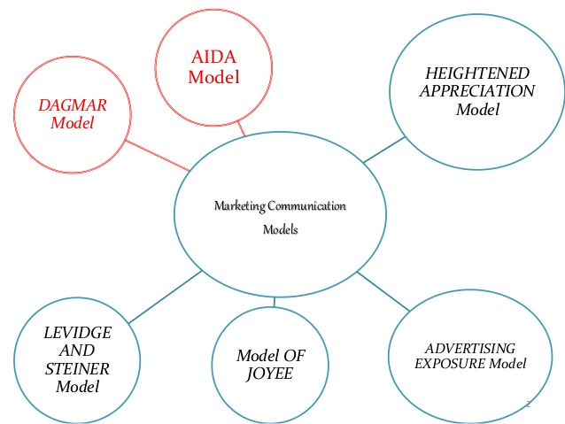
Figure 2: AIDA Model
(Source: Budiawanet al., 2017)

Definition of Integrated Marketing Communications
Integrated Marketing Communication is an advanced model of communication which actually integrates many smaller units to make a communication model and is used by brands and companies all over the world to make crystal clear communication to their clients and customers in order to increase their brand value and visibility (Wu, 2017).
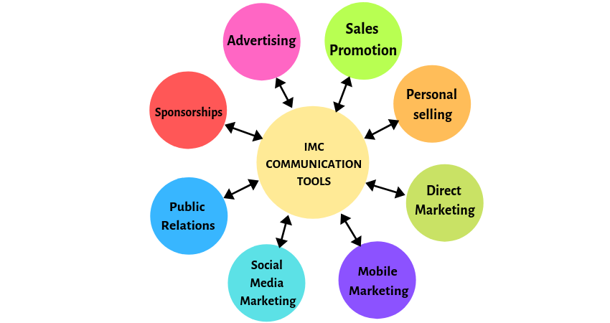
Figure 3: Integrated Marketing communication tool
(Source: Duralia, 2018)
Philip Kotler has defined integrated marketing communication as the process of as a concept which combines and coordinated different communication medium in order to provide a constant and clear message. Adidas adopts this technique for globally transmitting message to a huge number of global customers. Adidas use sales promotion, spaceship, digital marketing and others in order to apply integrated communication tools for example it sponsors events like FIFA World Cup and it also provides discounts, promo code or coupons to the customers.

Promotion Applied by Adidas at the present time
The promotions that the German sports giant has applied range from very varied campaigns that dealt with development of social causes to development of the brand image through the quality of products they provide and again through the bringing together of content creators and more. One particular thing that is very clear from the way Adidas has gone about with their promotional campaigns is their clear understanding and stress on the digital platform for their massive promotional work (Huettnerand Brem, 2017). Product Franchise, New Dimension of Drive Growth for Women, Effective marketing investment along with sustainability in terms of eco-innovation and eco-activation are the major promotional strategy Adidas is using in this present time (report.adidas-group.com, 2020).
A recent promotion that Adidas has applied and worth discussing would be the digitalization as well as associated drive that the company has taken. Digital sales are accounting for a massive amount of revenues and thus the company started getting a lot of effort from its promotional and marketing teams to go digital. Even sales were pushed through the digital channel (Bergeand Gaede, 2017). The company has used digitization even in their production and this has been duly promoted to their customers and prospective customers especially the use of the new fancy technology of 3D printing. The result has been marvellous as the production has become extremely fast and this use of new technology has created a sense of urgency among the customers to try the new products.

New promotional strategies Adidas can use to raise brand Awareness
Though there are many strategies that a brand like Adidas has already employed in their promotional activities to raise brand awareness however there are many more options and strategies that they can explore in order to raise their brand awareness. A few of those strategies can be:
- Giveaways: It is not a new thing that people love to either win things or get things that they did not expect. Contests and giveaways are a perfect way to connect to a larger crowd and given the products that are produced and sold by Adidas this can be a very effective strategy for them(Yukse, Smithand McCabe, 2017).
- Creating Nostalgia: This method of creating nostalgia is actually perfect because there could be a massive amount of marketing content that has been away from the customers for a long time (Shinand Parker, 2017).
- Adidas has successfully become partners with social media influencers under “#MyNeoShoot” campaign which is developed to engage the brand with social media users.
- Adidas has become partner with NHS after outbreak of coronavirus for a good cause as it provides 30% discount or offering discount coupon to the NHS staff in order to support them as they are serving common people in this pandemic scenario (Ang and Rusli, 2018).
- Adidas sponsored “Africa cup of Nation” and it develop partnership with “Real Kashmir Football Club” in India. Thus, partnership and sponsorship in different helps the brand to promote its products.
- Adidas can utilize social proof FOMO which indicates fear of missing out in order to promote the brand and its new products. It helps the organisation to focus on conversion optimisation in order to convert more website visitors into customers.
- The organisation already uses content marketing but it can involve influential stories of their customers which can help the brand in developing customer engaging promotional strategy.

Definition of Branding and Brand Equity
In terms of branding a business it is important to mention that brand strategy is nothing but a long term action plan based on which the overall business can be distinguished in the market with an effective image of the business organisations (Theureret al. 2018).
The assets that provide an additional value to a brand along with a recognizable name is included within brand equity. Brand equity enhances the value of the brand in the economic market along with building long terms franchises with the customers(Sallam, 2016).Brand equity refers to the financial value of a brand which generates capital value to its products. According to Kotler and Keller, it is directly related with the mind set and perception of customers related to the brand. Kotler also defines branding as a process of creating identification of a product with name, logo, symbol or combination of these characteristics (Kotler, 2016).

Keller’s Brand Equity Model with Advantages and Disadvantages
Also known as “Customer-Based Brand Equity” or CBBE Model, the Keller’s Brand Equity Model focuses on the development of a strong brand image which might influence, control or attract the buying pattern of the customers. In the below mentioned figure the overall model is being demonstrated.
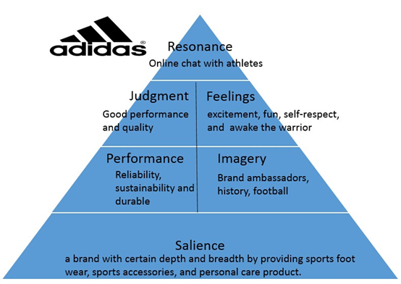
Figure 2: Keller’s Brand Equity Model
(Source: Influenced by Vasilevaand Vasileva, 2017, p.95)
Brand identity: It refers to how customers are pursuing the brand and distinguishing it from others which is the most important stage of the model and supports the rest of the stages in the form of a pyramid (Rautet al. 2019). As Adidas is mainly a sports brand, the business has sponsored a number of sports events in order to create a brand identity by showcasing its USP to the targeted customer base. The mission statement of the business organisation “to be the best sports company in the world” shows that the business designs, develops and sells the best of the sports products in a sustainable way so that the customers can make this business the best.
Brand meaning: Performance and Imagery are the two stepping stones of this step as performance helps in determining the level of attainment of predefined customer needs by the product; whereas imagery defined the meeting of customer needs in social and psychological level by the brand (Anselmsson, Burtand Tunca, 2017).
Performance: Adidas is popular for its high quality of products which makes it durable and sustainable to the customers. Financially, Adidas is the third largest apparel brand in the world which indicates its strong performance.
Imagery: Adidas develop partnership with sportsman like Adidas associates itself with various sportsmen in order encourage people towards sports which develop to create association with football, soccer, golf and other sports.
Brand response: This is the third step of development of brand equity and it deals with direct response of the customers regarding their experience of consumed products. Judgment and feelings are the two basic responses what the consumer presses. Feeling is the positive response of the customers whereas disappointment of any purchase is followed by judgment from the brand advocate who is followed by a brand detraction or market value enhancement. Quality, credibility, consideration and superiority are the base of getting the response from the customers as all of these build their individual experience; as a result of which the brand image develops in the market (Mahmood, 2018). As an example it can be stated that in order to enhance brand equity the management of the company Adidas should understand the market needs to analyze the competitors such as Puma and Nike in terms of quality as well as price so that the aspects of Quality, credibility, consideration and superiority can be attained within the response of the customers. As a result the business can be able to become the leader among the sports product brands by 2020 (adidas-group.com, 2020).
Brand resonance: Brand resonance referred to the fever towards the brand from the end of customers or the loyalty of the consumers due to its quality products or superiority. In this context format can be highlighted that the organisation has a large customer base and the business has focused on the aspects of retaining, including and converting strategy for developing brand resonance with quality management of the products. As a result of this the brand has witnessed revenue growth of 17.6% of average rate since 2015 (forbes.com, 2020).
Judgments: Customer judge the brand because of its standardized products and its performance.
Feelings: The brand generates a feeling of passion, energy, strength, control, and speed with its identity as it reflects self-respect, fun and excitements with its products.
Salience: Adidas developed provides different kinds of sportswear, footwear and accessories which has a particular width and breath which generates salience.
Advantages of this model: Thus model of brand equity helps in the estimation of present situation of a business organisation by focusing on the development of brand image by meeting customer’s psychological and physical needs. This basic model can help the business Adidas in estimating and enhancing the brand equity of the company.
Disadvantages of this model: This model seems incomplete as it fails to focus on the aspects of “Patents, IP and trading partners” and “Brand associations” as these are vital parts for managing a large business. While applying this basic level of brand equity model, Adidas should also consider these aspects for protecting the brand equity.

Customer journey and customer touch points of Adidas
Customer journey map refers to the process of visually representing a customer’s contribution for achieving an organization’s goals (Rosenbaum et al., 2017). Adidas customer journey map stated from brand awareness. It encourages customers to consider the brand which leads towards their purchasing decision through website or stores. It can take place through social media or word of mouth which encourage more people.
The first step of customer journey map is awareness and the advantage of Adidas from sport celebrity endorsement it helps to create buzz in the market and the company can reach millions of people through utilizing the popularity of celebrity (Rudkowskiet al. 2019). However, the disadvantages of sports celebrity endorsement are the image of popular celebrity can overshadow the bran image and it can divert the attention from the products. Thus, the company is recommended to involve customers in its advertisement strategy for enhancing customer touch point. This is going to make the customers feel like they are important to the company and it is going to boost the company reputation that will lead to future development of the company as well.
Adidas focused on goggle search and product knowledge aspect in consideration stage. The advantage of goggle search is obviously the reach of goggle as any customer from any corner of the world can connect with the brand through searching the company but disadvantages is it can limit the reach in rural areas because of lack of internet facility (Sepoetro, 2018). Therefore, the company is recommended to focus on traditional promotion methods like billboards or television advertisement, so it can enrich customer touch point at consideration stage.
The third step is conversation and retention which take place though understanding the actual customer requirement. Adidas’s follow up to the potential customers and provide loyalty program in order to retain customers but excess follow some-times irritate customers. Thus, the organisation can focus on solving customer queries in order to satisfy them and encourage them for converting into buyers where websites and physical stores plays an important role as a customer touch point (Marques, 2018).

Stage | Awareness |  | Consideration |  |  | Decision |  | Delight
Touch point | Advertisement endorsed by a sports celebrity | Sponsorship of sports teams or events | Google Search | Checking out the designs and reading the review | Developing knowledge about the products | Visit website or retail store | Making the final purchase | Referral to other customers
Customer process | Come to know about the product through Digital or print media | Watching the sports events | Searching the products using internet | Reading various sites related to the product | Develop a knowledge about the brand | Looking at the design and comparing with similar products in the market | Purchasing the product if the product looks convenient | Referring to the circle of family and friends if satisfied
Experience rating scale (Out of 0 to 10 Scale) | 7 | 7 | 8 | 5 | 5 | 8 | 9 | 6
Table 1: Customer touch points of Adidas
(Source: Created by Learner)

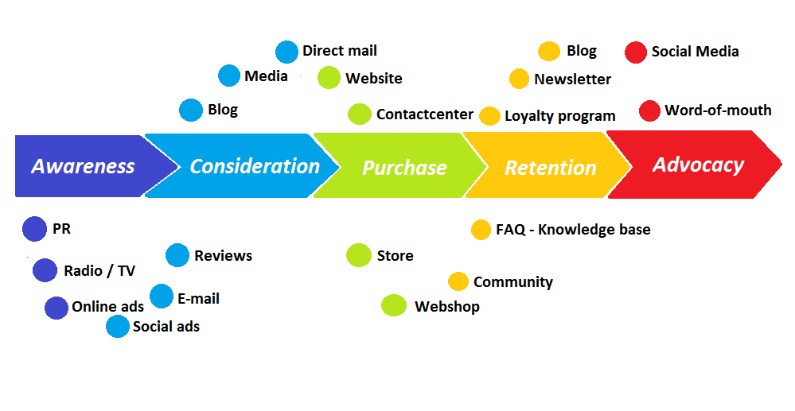
Figure 3: Diagram of Customer Journey Map of Adidas
(Source: Created by Learner)

Total Engagement Model from the context of Adidas
The brand Adidas' total engagement model is based upon their distinct ethos of being customer centric by delivering value through their product and customer services. To engage their customers the brand focuses on two factors. Firstly to communicate the brand vision to its customer base in a positive way and on a regular basis to drive the value proposition. Secondly to develop a culture in the organisation that is customer centric and delivers that value proposition to the customers through its services (Hameedet al. 2016).The brand Adidas focuses upon developing engaged employees who are committed to deliver the objectives of the company with a personalized approach. Such engaged employees are highly productive and they are inclined to service the customers in a timely manner and settle any issues peacefully. They are also a valuable asset to the company as they are loyal and trustful. A satisfied customer who is taken care of by an engaged employee creates a good relationship thereby affecting the bottom-line of the company.
The total engagement model also links four elements which are branding, culture, customer service experience and customer value proposition to deliver the best offerings to a customer. Branding is the effective communication of what the company stands for and the products' intrinsic value that it is proposing for the customers. Culture reflects the company's objectives, mission and vision that it values most. It affects the behavioural environment of the organisation where there is a growth of engaged employees who deliver outstanding customer services. The customer service experience is the overall interaction of a customer with the brand, starting with product knowledge given by the store manager to after sales service requirements if it crops up. The customer value proposition is the value offered by the company to a customer in terms of the attractions a brand offers to its customer to buy their product above others (Liang, Chuand Lin, 2020).

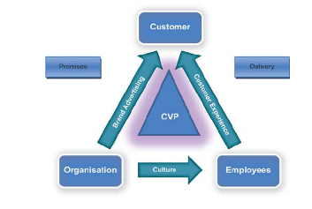

Figure 4: Total Engagement Model from the context of Adidas
(Source: Influenced by Liang, Chuand Lin, 2020, p.145)

Advertisement of Adidas always indicates passion of athletes which promise quality products in order to encourage more people towards exercise or sports. The advertising elements of Adidas includes digitalization and technology which encourages customers to engage more with the brand. The technical facilities also encourage employees to focus on the performances in order to serve customer better. The high-speed manufacturing process in adidas develops a culture of speed in the organization which enhance both customer and employee relationship.

Conclusion
The process of managing the reputation of a brand is included within brand management. It is associated with developing the outlook of the customers towards a brand effectively. The strategies involved in brand management include positioning, name selection, sponsorship, and development of the brand. In this study the aspects of brand have been discussed from the context of Adidas.
Marketing communication indicates the interaction between customers and Adidas which is explained through linear communication model. Integrated marketing communication enables Adidas to use different medium for enhancing its communication with customers in order to increase sales including sponsors, sales promotion and other. Customer journey map of Adidas indicates that customers are associated with the brand through brad awareness to advocacy. Customers, employees and organization are engaged with Adidas. The Keller model has support to determine the brand equity of Adidas through explaining judgement, feeling and other elements.

Reference List
adidas-group.com, 2020. adidas: Profile. Available at: https://www.adidas-group.com/en/group/profile/ [Accessed on: 30/06/2020]
adidas-group.com, 2020. adidas: Strategy. Available at: https://www.adidas-group.com/en/group/strategy-overview/ [Accessed on: 30/06/2020]
Ang, C. and Rusli, H., 2018. The impact of marketing mix 4ps and consumer behavior toward purchase decision of adidas products. iBuss Management, 6(2).
Anselmsson, J., Burt, S. and Tunca, B., 2017. An integrated retailer image and brand equity framework: Re-examining, extending, and restructuring retailer brand equity. Journal of retailing and consumer services, 38, pp.194-203.
Bacik, R., Fedorko, R., Nastisin, L. and Gavurova, B., 2018. Factors of communication mix on social media and their role in forming customer experience and brand image. Management & Marketing. Challenges for the Knowledge Society, 13(3), 1108-1118
Berge, F. and Gaede, J., 2017. Consumer Engagement in Social Media: A netnographic study of the company-owned Facebook pages of Nike and Adidas.
Budiawan, R., Satria, A. and Simanjuntak, M., 2017. The quasi experimental study of the influence of advertising creativity and exposure intensity toward purchasing action with AIDA approach. Independent Journal of Management & Production, 8(2), 378-394.
Ding, W., 2016. The exploratory research of the effect communication model and effect improving strategy of interactive advertising. arXiv preprint arXiv:1603.02484.
Duralia, O., 2018. Integrated marketing communication and its impact on consumer behavior. Studies in Business and Economics, 13(2), 92-102.
Eskofier, B.M., Lee, S.I., Baron, M., Simon, A., Martindale, C.F., Gaßner, H. and Klucken, J., 2017. An overview of smart shoes in the internet of health things: gait and mobility assessment in health promotion and disease monitoring. Applied Sciences, 7(10), p.986.
forbes.com, 2020. Adidas or Nike? Which Retail Giant is Winning The Sneakers War? Available at: https://www.forbes.com/sites/callyrussell/2019/08/22/adidas-or-nike-which-retail-giant-is-winning-the-sneakers-war/#45630ee112b7 [Accessed on: 30/06/2020]
Ganesha, H. R., Aithal, P. S. and Kirubadevi, P., 2020. Integrated Marketing Mix Framework for Baby Care Retailing in India. International Journal of Applied Engineering and Management Letters (IJAEML), 4(1), 191-219.
Ghinea, C.A., 2019. Rethinking Persuasion In Religious Symbolic Communication: A Marketing Point Of View. Annals of SpiruHaret University, Economic Series, 19(3), pp.101-110.
Hameed, I., Riaz, Z., Arain, G.A. and Farooq, O., 2016. How do internal and external CSR affect employees' organisational identification? A perspective from the group engagement model. Frontiers in psychology, 7, p.788.
https://report.adidas-group.com, 2020. ADIDAS BRAND STRATEGY. Available at: https://report.adidas-group.com/2019/en/group-management-report-our-company/corporate-strategy/adidas-brand-strategy.html [Accessed on: 30/06/2020]
Huettner, C. and Brem, A., 2017. Innovation in business education-the new way of learning at the Adidas Group Learning Campus. International Journal of Innovation and Learning, 21(3), pp.299-328.
Kotler, P. (2016). A framework for marketing management. Pearson Education Limited.
Kotler, P., 2017. Philip Kotler: some of my adventures in marketing. Journal of Historical Research in Marketing.
Liang, H.Y., Chu, C.Y. and Lin, J.S.C., 2020. Engaging customers with employees in service encounters. Journal of Service Management.
Mahmood, S.M., 2018. Building strong brand equity through developing and implementing strong brand strategy: in perspective of Bangladeshi supermarkets. South Asian Journal of Marketing & Management Research, 8(1), pp.19-34.
Marques, S.M.E., 2018. The disruption of retail through Gen Z: An exploratory study on the new customer journey and the impact of customer touchpoints on Brand Loyalty.
Poyraz, E. and Çetintürk, N., 2017. Defining search engine advertising metrics according to AIDA advertising model.
Raut, U.R., Pawar, P.A., Brito, P.Q. and Sisodia, G.S., 2019. Mediating model of brand equity and its application. Spanish Journal of Marketing-ESIC.
Rosenbaum, M. S., Otalora, M. L. and Ramírez, G. C., 2017. How to create a realistic customer journey map. Business Horizons, 60(1), 143-150.
Rudkowski, J., Heney, C., Yu, H., Sedlezky, S. and Gunn, F., 2019. Here Today, Gone Tomorrow? Mapping and modeling the pop-up retail customer journey. Journal of Retailing and Consumer Services.
Sallam, M.A., 2016. The impact of brand image and corporate branding on consumer’s choice: The role of brand equity. International Journal of Marketing Studies, 8(1), pp.98-106.
Sepoetro, T.D., 2018. The Future of Services in adidas Retail (Doctoral dissertation).
Shin, H. and Parker, J., 2017. Exploring the elements of consumer nostalgia in retailing: Evidence from a content analysis of retailer collages. Journal of Retailing and Consumer Services, 35, pp.1-11.
Song, X., Choi, H. and Shi, Y., 2018, June. Permuted linear model for header-free communication via symmetric polynomials. In 2018 IEEE International Symposium on Information Theory (ISIT) (pp. 661-665). IEEE.
Theurer, C.P., Tumasjan, A., Welpe, I.M. and Lievens, F., 2018. Employer branding: a brand equity‐based literature review and research agenda. International Journal of Management Reviews, 20(1), pp.155-179.
Vasileva, I.V. and Vasileva, T.N., 2017. KELLER''S BRAND EQUITY MODEL. Modern Science, (6-1), pp.93-98.
Wang, X., 2018. Linear Programming Model of Communication Capability Configuration. Advances in Computational Science and Computing, 877, p.130.
Wu, Y.C., 2017. Resource-advantage theory: A foundation of integrated marketing communication and market orientation to achieve superior performance. THE ASSOCIATION OF COLLEGIATE MARKETING EDUCATORS LITTLE ROCK, AR MARCH 9-10, 2017, p.55.
Yukse, M., Smith, R. and McCabe, C., 2017, May. Reciprocal Intentions: Effects of Promotional Giveaways on Consumers’ In-Venue Spending Intentions: An Abstract. In Academy of Marketing Science Annual Conference (pp. 657-658). Springer, Cham.
ZHANG, X. and Zhanfang, L.I., 2020. A Review of Doctor-Patient Communication Studies. Canadian Social Science, 16(4), pp.51-56.

