Networking and Cyber-Security

Computer Architecture and Operating Systems

By Gafyn Davies

1101650
Contents
31. Introduction 4
2. Key Functions of General Operating Systems 4
2.1. The Kernel 4
2.2. Process Management 4
2.3. Event Viewer 5
2.4. Device Manager 5
2.5. Performance Monitor 6
2.6. Resource Monitor 7
2.7. Reliability Monitor 8
2.8. RAMMap 9
2.9. Windows Security 10
2.10. System File Checker 11
2.11. Task Manager 12
2.12. Command Prompt 13
3. Use of Windows OS CLI Commands 15
3.1. Process Management 15
3.1.1. Get-Process -Id 15
3.1.2. Stop-Process -Id 15
3.2. File and Directory Management 16
3.2.1. cd 16
3.2.2. Mkdir 16
3.3. Network Testing/Monitoring 17
3.3.1. IPConfig /All 17
3.3.2. Get-NetTCPConnection 18
3.4. User Management 18
3.4.1. Get-LocalUser 18
3.4.2. New-LocalUser 19
3.5. Task Scheduling 19
3.5.1. Get-ScheduledTask | Format-List TaskName, TaskPath, State 19
3.5.2. Register-ScheduledTask -TaskName 20
4. Use of Linux OS CLI Commands 21
4.1. Process Management 21
4.1.1. top 21
4.1.2. ps -ef 21
4.2. File & Directory Management 22
4.2.1. rm -r 22
4.2.2. touch 23
4.3. Network Testing/Monitoring 23
4.3.1. ping -c 23
4.3.2. ip addr show 23
4.4. User Management 24
4.4.1. whoami 24
4.4.2. sudo adduser 24
4.5. Task Scheduling 25
4.5.1. crontab -l 25
4.5.2. * * * * * /usr/bin/echo “Cron job ran successfully” >> /home/gafyn/cron-test-file.txt 26
5. Use of Windows OS Scripts 28
5.1. Batch Script Screenshots 28
5.2. Batch Scripts Working 31
5.3. Code Syntax Explanation 33
6. Use of Linux OS Scripts 33
6.1. Bash Script Screenshot 33
6.2. Bash Script Working 34
6.3. Code Syntax Explanation 36
7. Conclusion 37
8. Reference List 38
9. Appendices 40
9.1. Tutorial Activity 40
9.2. Lecture Activities 43
9.3. Evidence of Engagement with 1 Online Certified Course 52

Introduction
This report examines the core functions of operating systems (OS) and the practical tools used to manage them. It outlines key operating system functions, including resource management, monitoring and security, before discussing the role of command-line interfaces in both Windows and Linux. The report also considers the use of scripting in PowerShell and Bash to demonstrate how operating system tasks can be automated and managed efficiently. Screenshots and practical examples are included throughout to support the discussion.

Key Functions of General Operating Systems

The Kernel
The kernel is the central part of the operating system that manages CPU time, memory and devices and controls the communication between software and hardware, running at the highest level of privilege. The role of the kernel is to ensure that the system runs efficiently, securely and reliably. The UI is also provided by the GUI or shell, allowing users to interact with the system [1].

Process Management
Process management is part of an operating system (OS) that manages the lifecycle processes. This can include creating, scheduling and terminating processes ensuring that the systems resources are being allocated efficiently. One application available to the user to manually manage various processes is Task Scheduler.

Fig. 1. Task Scheduler interface showing scheduled task management
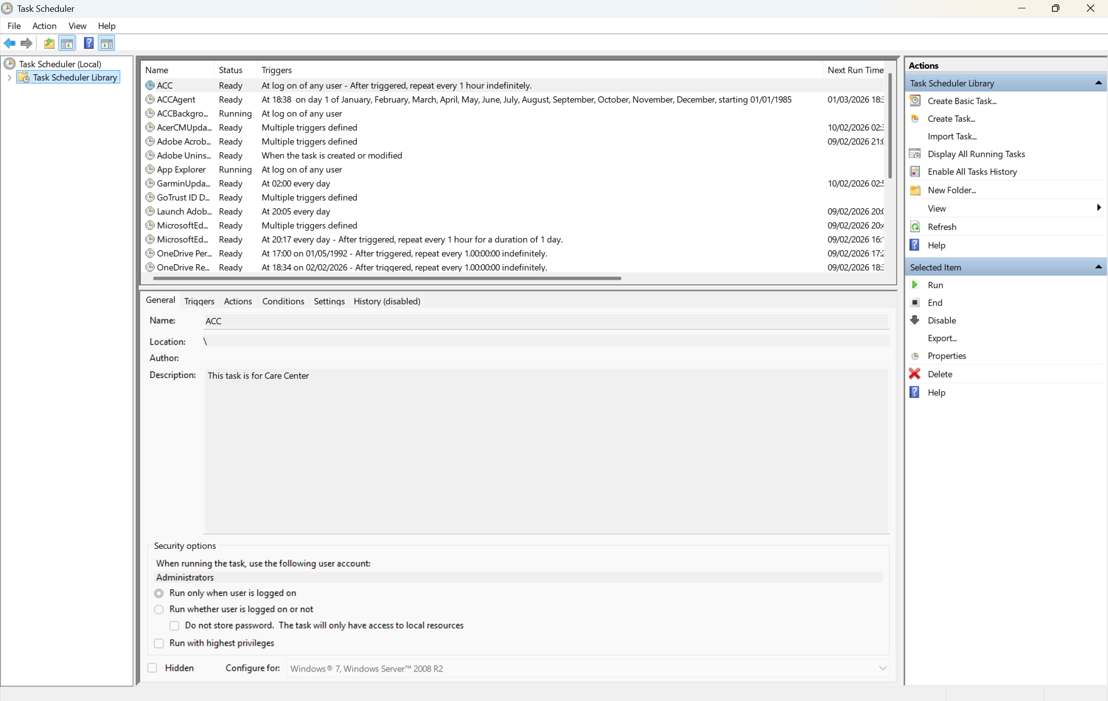

Event Viewer
Event Viewer is a built in Management tool in Microsoft’s Windows OS that records detailed logs of significant events. These include errors, warnings and various other important information that can be used to find the root cause of an issue with a PC.

Fig. 2. Event Viewer displaying system event logs.
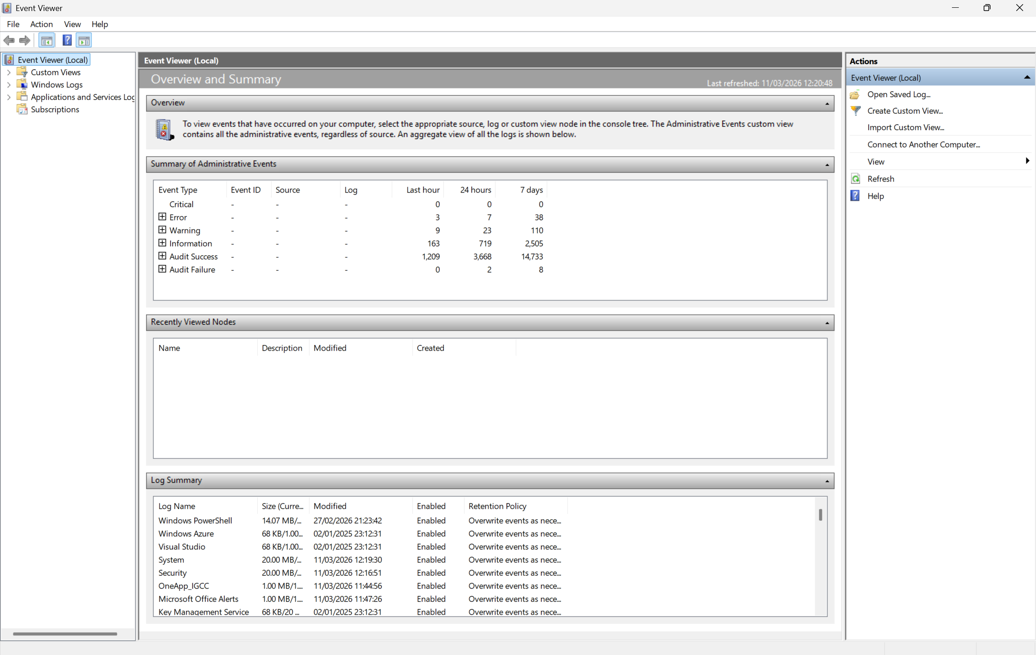

Device Manager
Device Manager is a Windows tool that allows users to manage and configure hardware devices on a PC. It allows you to view a list of installed hardware devices, view their properties and then interact with them in a number of ways, such as updating drivers or configuring any hardware settings [2].

Fig. 3. Device Manager showing installed hardware devices.
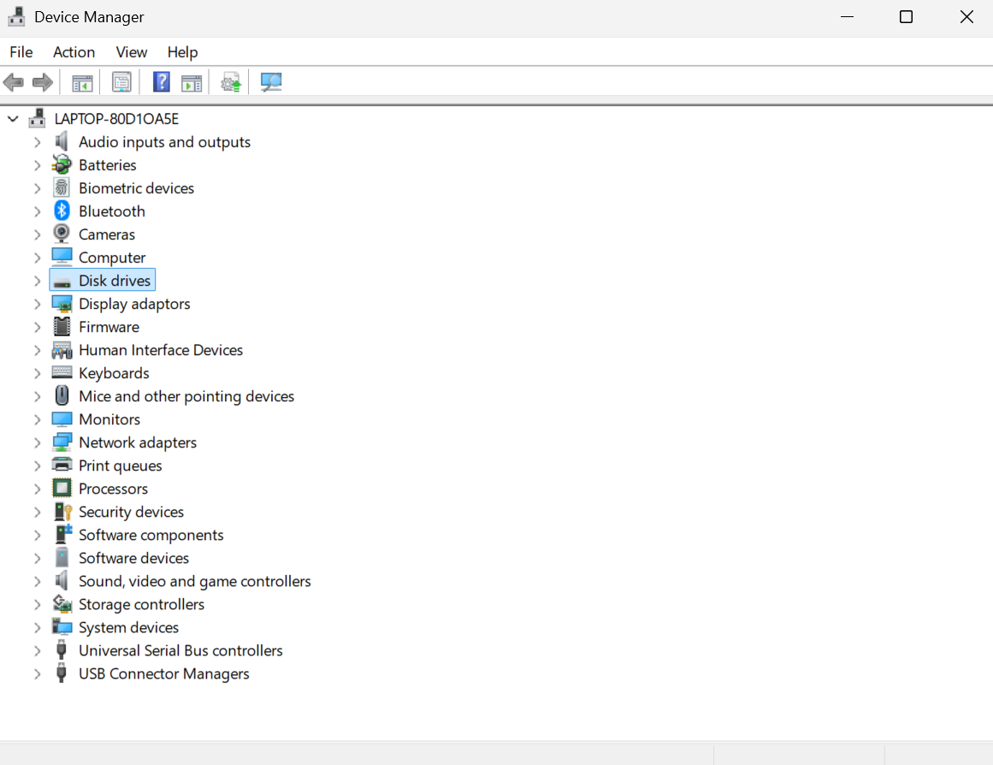

Performance Monitor
Windows Performance Monitor is a built-in tool used to track, analyse and visualise real-time or historical data on how different pieces of hardware affect system performance. The data can be viewed in custom graphs and can be used to track things such as network activity, available memory and data read/write speed.

Fig. 4. Performance Monitor displaying system performance data.
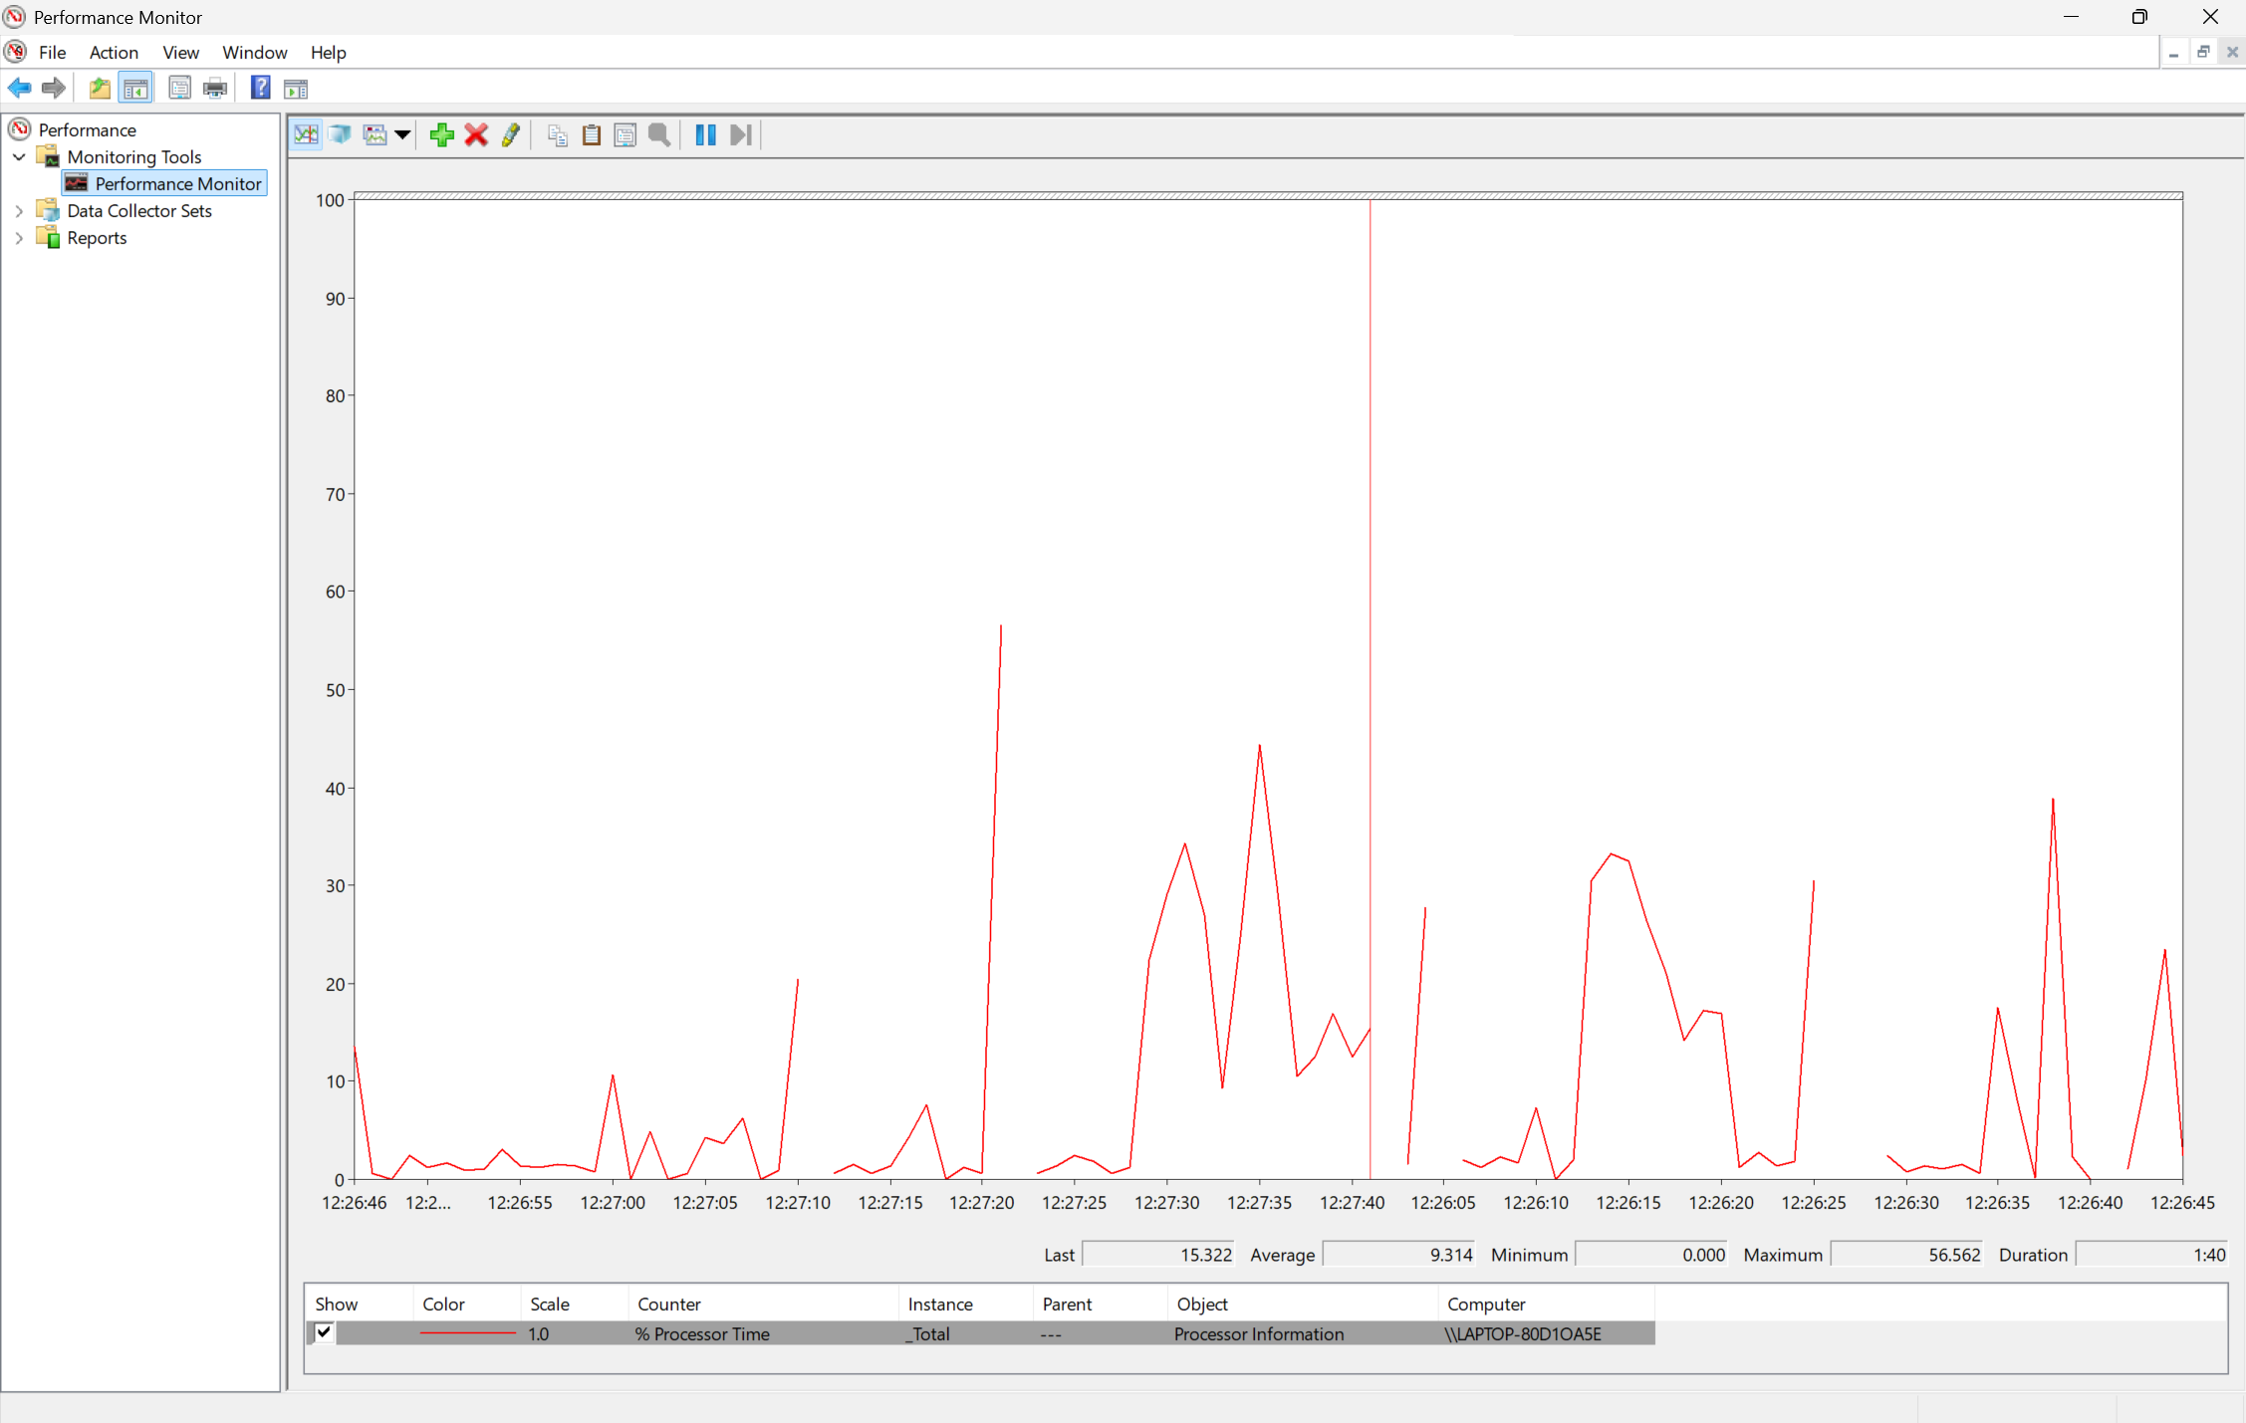

Resource Monitor
Windows Resource Monitor (resmon.exe) is a built-in tool that provides in-depth, real-time monitoring of hardware. Acting as a technical extension of Task Manager, Resource Monitor allows users to view detailed CPU activity, track physical memory usage and monitor network connections.

Fig. 5. Resource Monitor showing real-time hardware usage.
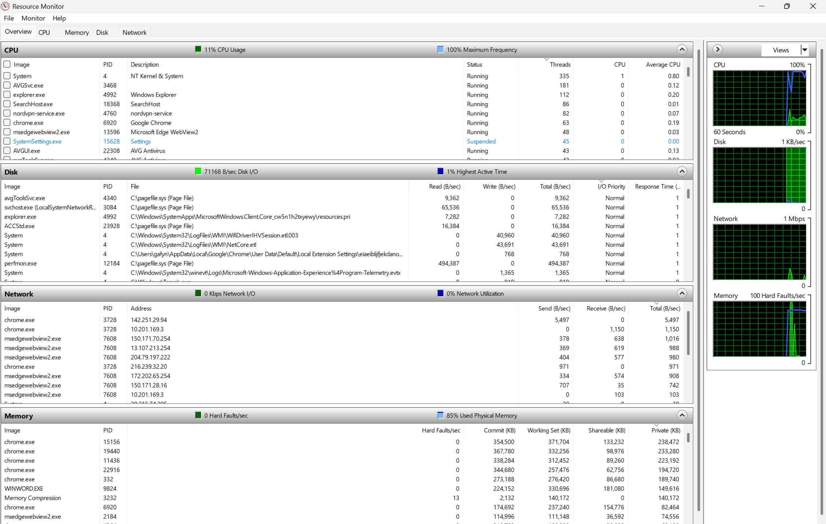

Reliability Monitor
Reliability Monitor (RelMon) is a built-in troubleshooting tool that provides a visual history of a PC’s stability on a day-to-day basis by tracking any hardware/software crashes, any failed installations, Windows updates in order to help identify anything that’s caused a drop in system performance.

Fig. 6. Reliability Monitor displaying system stability history.
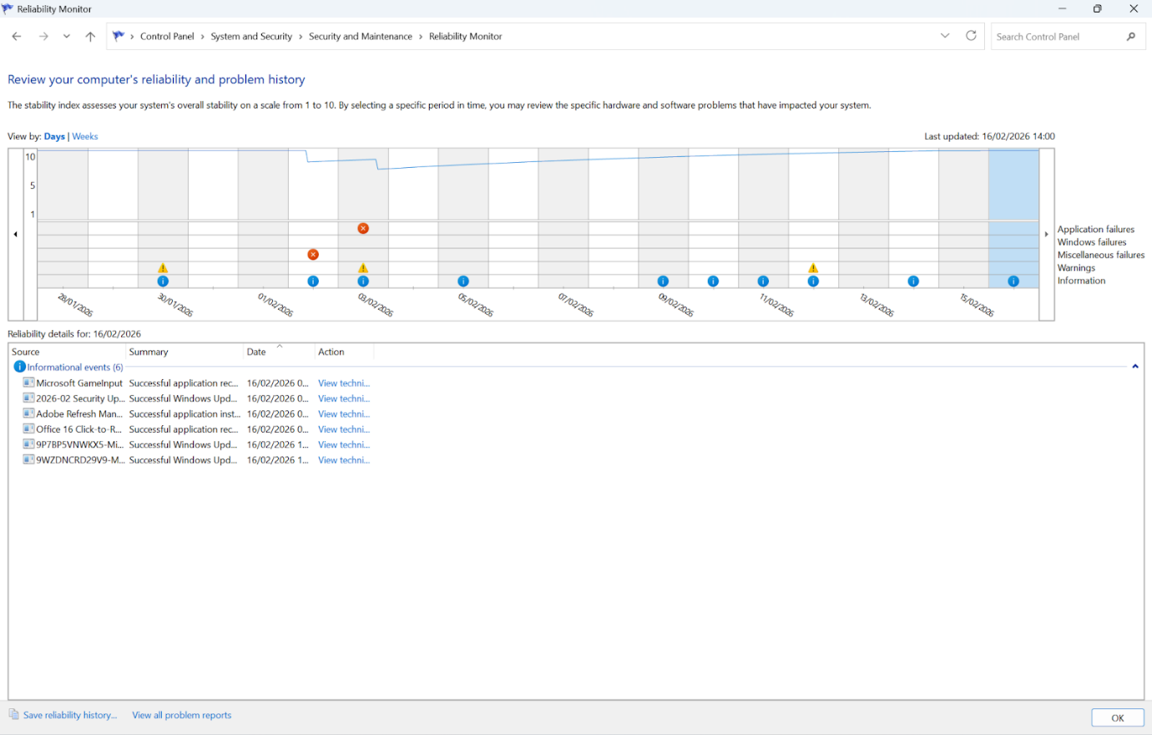

RAMMap
RAMMap is a free tool that provides advanced physical memory (RAM) analysis for Windows PCs. It allows users to view a detailed, real-time map of how RAM is allocated. Users can use this to troubleshoot high memory usage, identify what programs and drivers are consuming the RAM [4].

Fig. 7. RAMMap Application showing physical memory allocation.
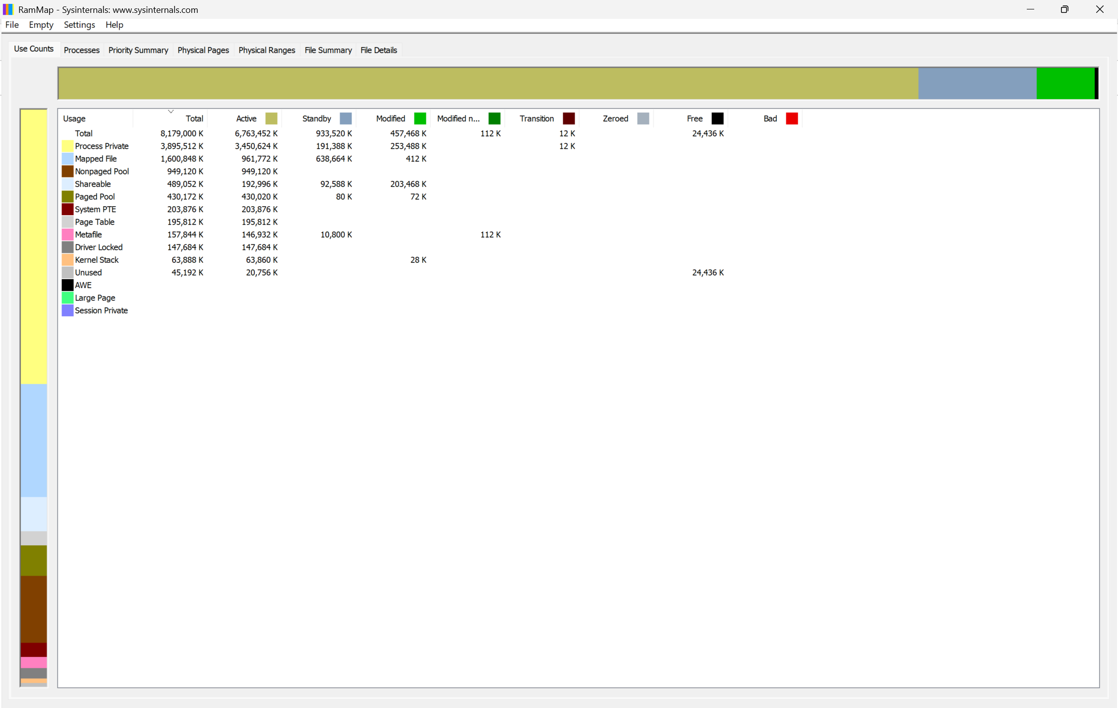

Windows Security
Windows Security is an application used to keep devices safe from various threats such as viruses, ransomware and other pieces of malware. The software is free and provides firewall protection, scans files, apps and software and provides account protection via sign-in options such as Windows Hello.

Fig.8. Windows Security interface showing built-in protection features.
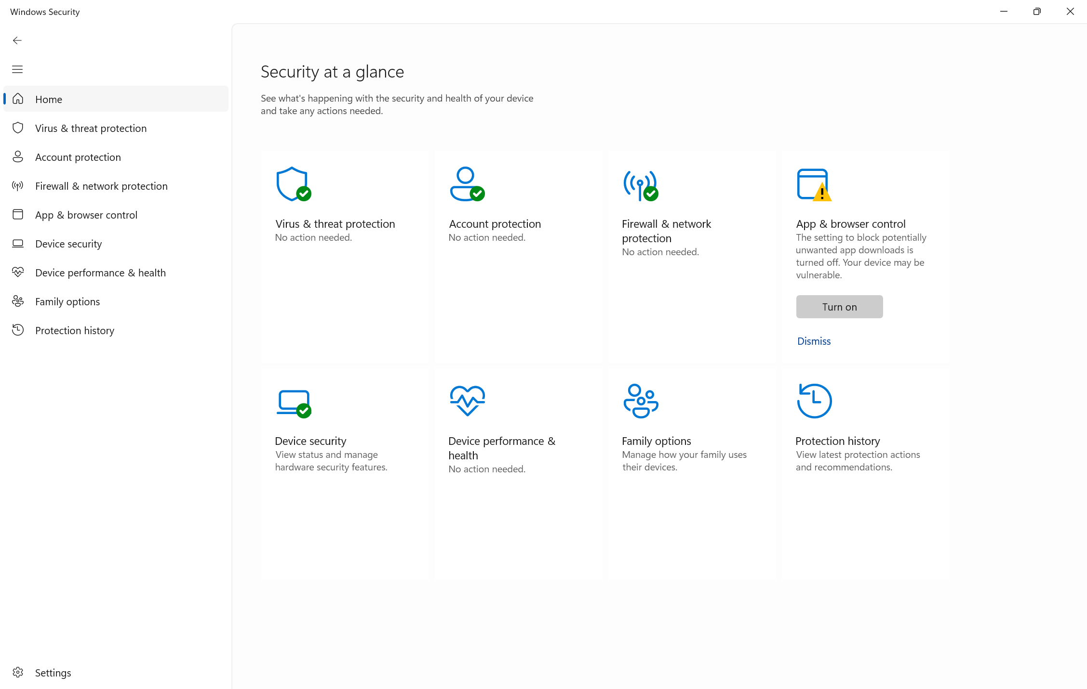

System File Checker
System File Checker is a built-in application that scans systems to help detect any corrupt, missing or damaged system files and then repair them. This tool is often used to help resolve system issues that may cause crashes, boot issues or any system instability by replacing the broken files with cached copies from the Windows component store [3].

Fig. 9. System File Checker command and scan output.
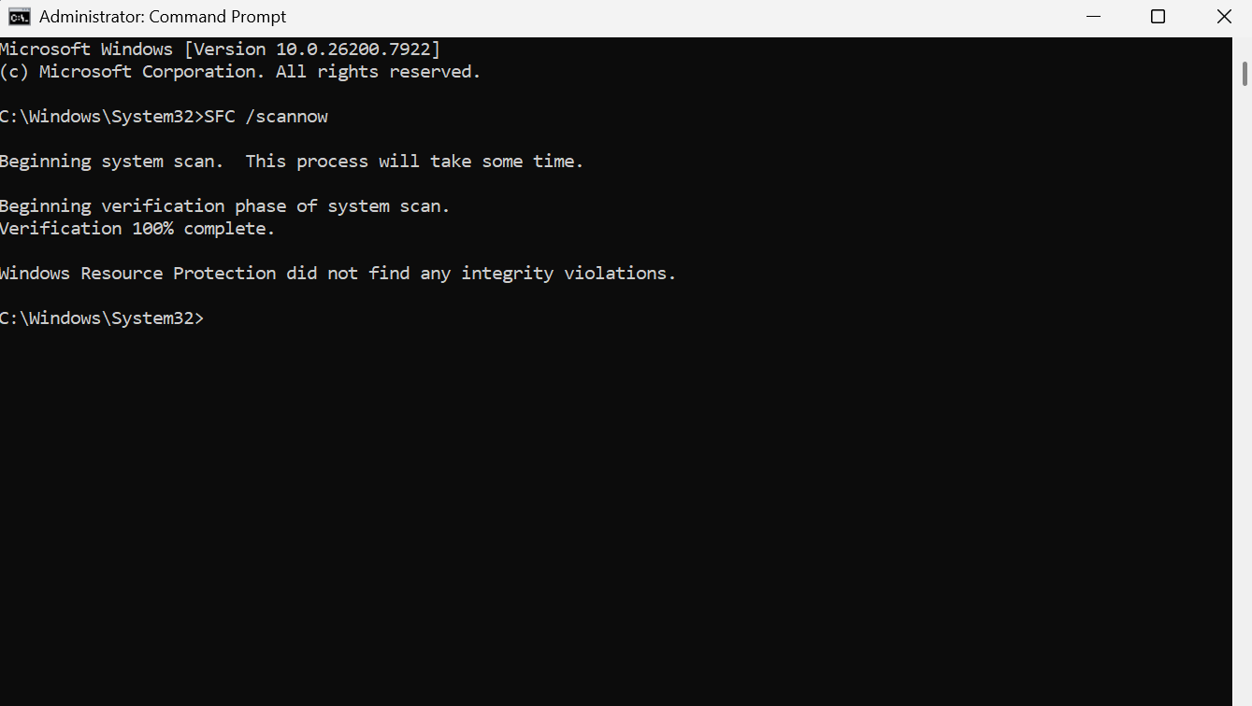

Task Manager
Windows Task Manager is used to monitor and manage running applications, background process and system services and can be used to troubleshoot computer performance issues and unresponsive programs. It can also be used to monitor real-time resource usage such as memory, disk, network and CPU.

Fig. 10. Windows Task Manager displaying active processes and resource usage.
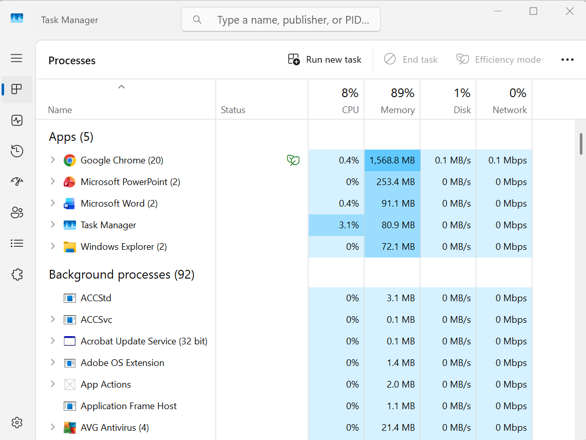

Command Prompt
Command Prompt (CMD) is the Windows command-line interpreter and provides a text-based method for monitoring and managing system activity. The ‘tasklist’ command allows users to view actives processes, making it useful for monitoring and troubleshooting. Additional switches such as ‘tasklist/fi’ enable filtered searches, whilst ‘tasklist/v’ display detailed information about each process. This tool is useful for system administrators who need quick access to process information.

Fig. 11. Command Prompt displaying process management commands.
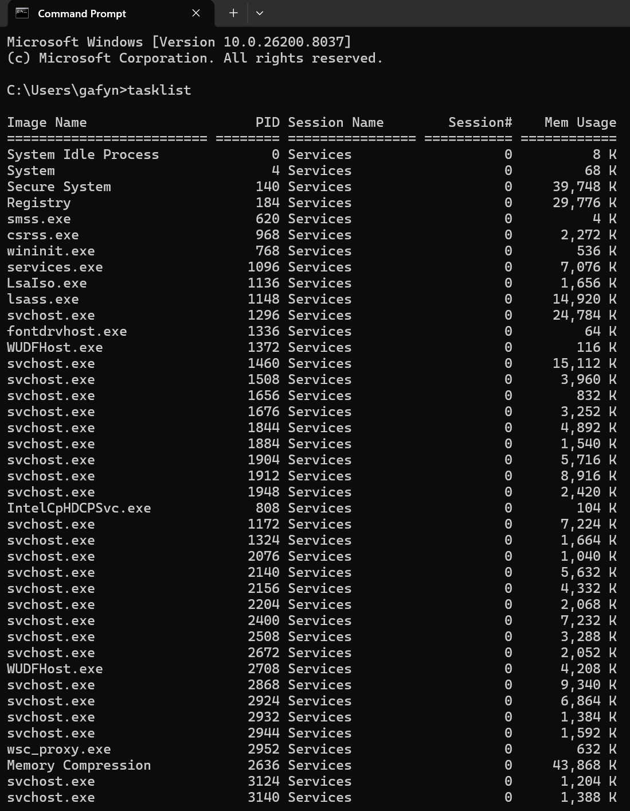

Use of Windows OS CLI Commands

Process Management

Get-Process -Id
Get-Process -Id is a PowerShell command used to retrieve information about a specific running process using its unique ID (PID) [5]. By identifying a single process, the user can view details such as its name, ID and system resource usage. In the example below, process ID 13104 is used to display Foundry Virtual Tabletop.

Fig. 12. Get-Process -Id displaying information about a specific process.
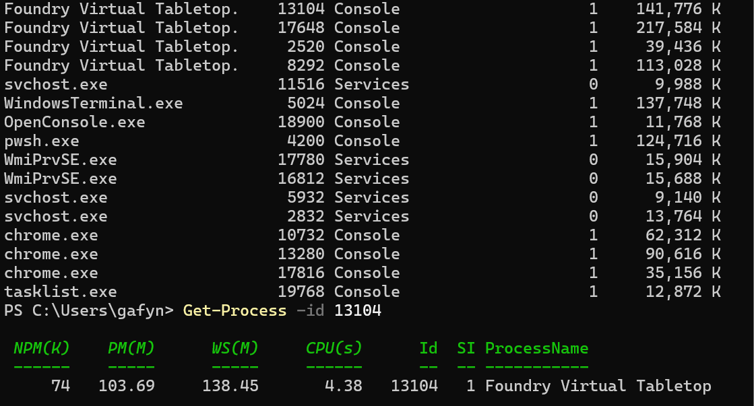

Stop-Process -Id
Stop-Process -Id is a PowerShell command used to stop a running process by using its unique process ID (PID) [5]. It can be used to terminate a specific application accurately, which can be useful when there are multiple processes with the same name. In the example shown below, PID 13104 is used to stop the Foundry Virtual Tabletop process.

Fig. 13. Stop-Process -Id terminating a selected process.
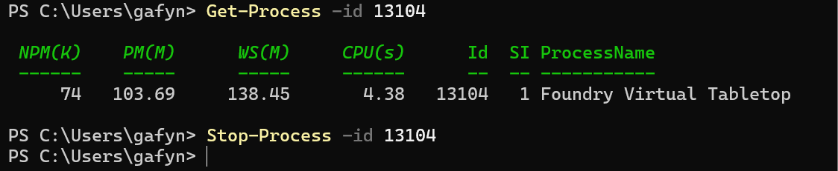

File and Directory Management

cd
In PowerShell, cd is an alias of the set-location command and is used to change the current working directory, allowing users to navigate between folders in the file system after identifying the available locations with commands such as Get-ChildItem [5] and [6]. In the example shown, the command cd Desktop is used to move from the user profile directory into the Desktop folder.

Fig. 14. cd changing the current working directory in PowerShell.
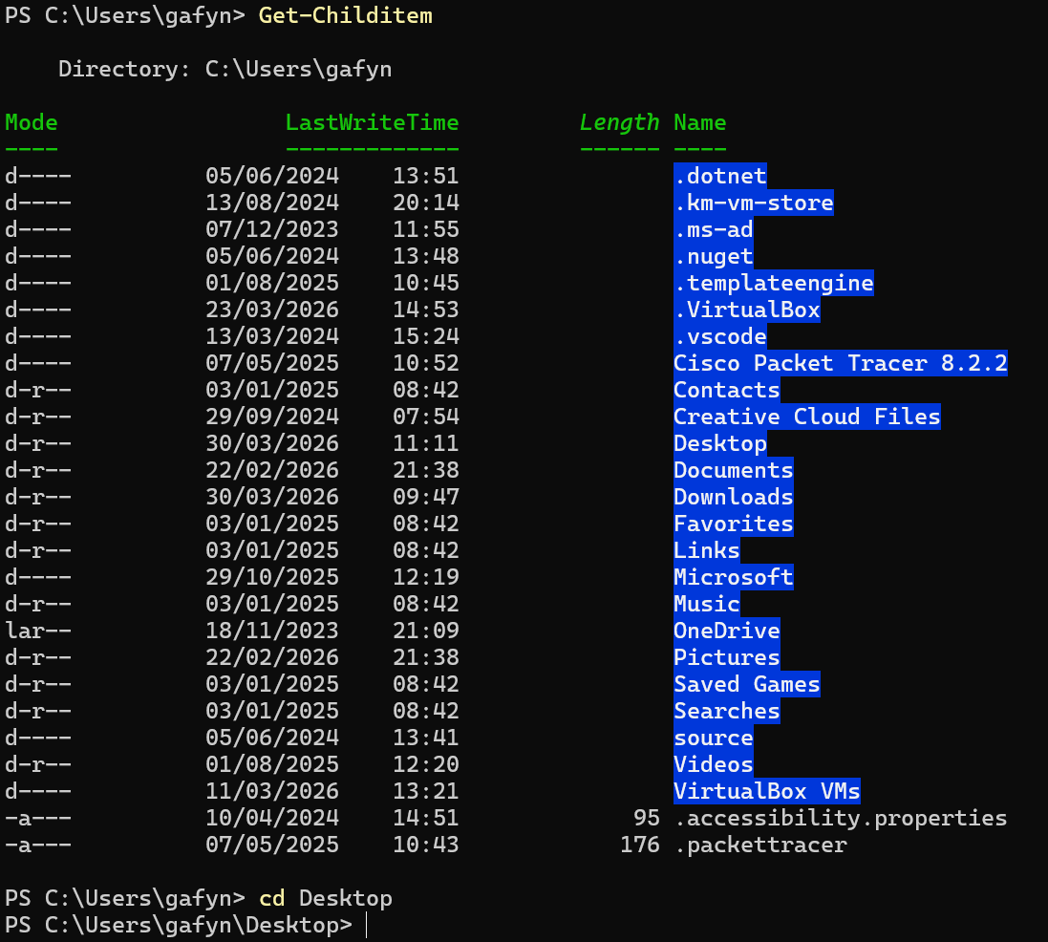

Mkdir
In PowerShell, mkdir is used to create a new directory within the current working location. This enables users to organise files and prepare new storage locations directly from the command line. In the example below, after navigating to the Desktop, the command mkdir NewFolder.test is used to create a new folder named NewFolder.test.

Fig. 15. mkdir creating a new directory in PowerShell.
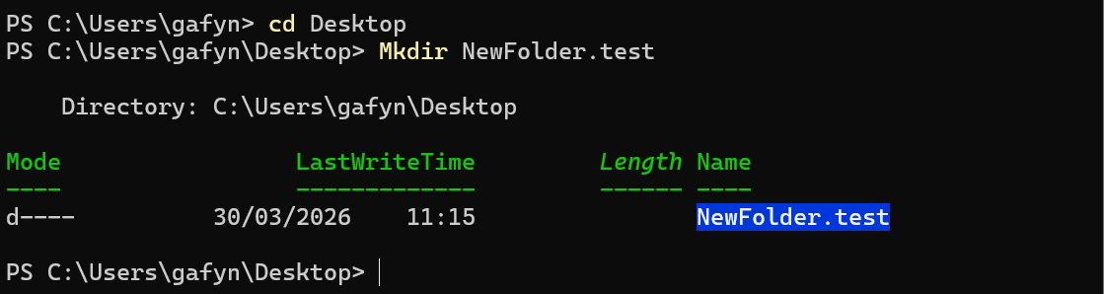

Network Testing/Monitoring

IPConfig /All
IPConfig /All displays detailed network adapter configuration, including the IPv4 address, subnet mask and adapter information. In this example, it is used to show the current settings of the active network connection.

Fig. 16. IPConfig /All displaying detailed network configuration.
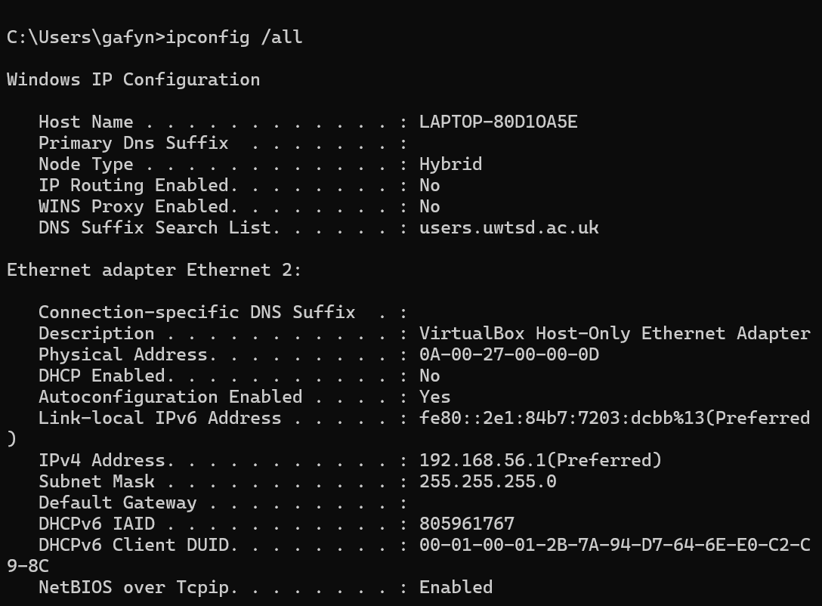

Get-NetTCPConnection
Get-NetTCPConnection displays current TCP connections on the system, including local and remote addresses and port numbers. This makes it useful for monitoring active network connections [7].

Fig. 17. Get-NetTCPConnection showing active TCP connections.
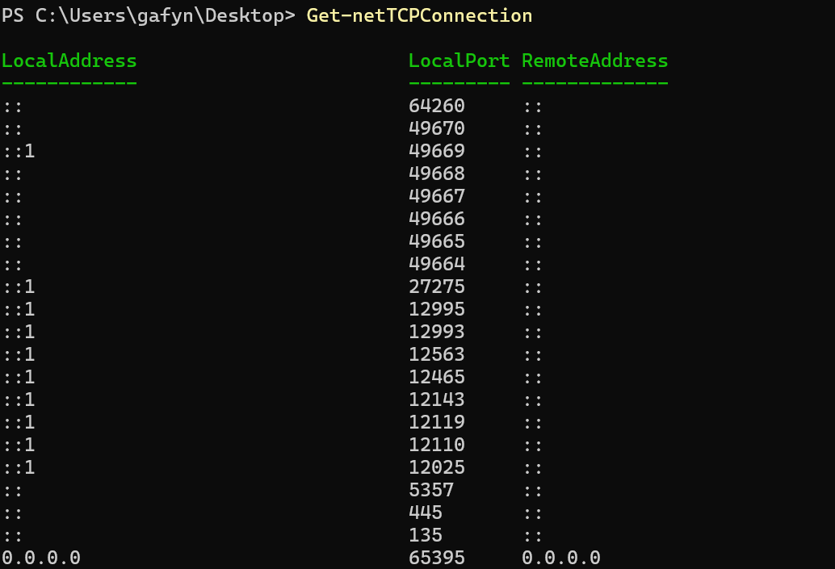

User Management

Get-LocalUser
Get-LocalUser is a PowerShell cmdlet that displays the local user accounts configured on the computer, along with basic account details.

Fig. 18. Get-LocalUser displaying local user accounts.
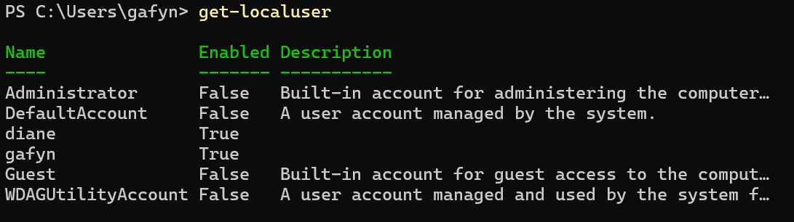

New-LocalUser
New-LocalUser is a PowerShell cmdlet used to create a new local user account. Once executed, the user is required to enter a name and password for the account.

Fig. 19. New-LocalUser creating a new local user account.
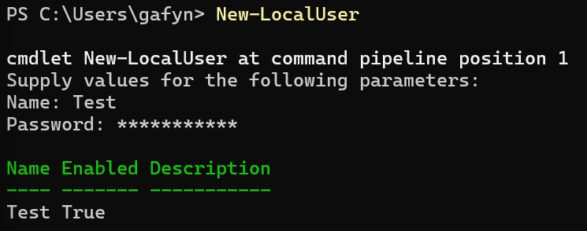

Task Scheduling

Get-ScheduledTask | Format-List TaskName, TaskPath, State
Get-ScheduledTask | Format-List TaskName, TaskPath, State is a PowerShell command used to display scheduled tasks in a clearer list format. The example below shows the task name, its location in Task Scheduled and its current state.

Fig. 20. Get-ScheduledTask | Format-List TaskName, TaskPath, State displaying task details.
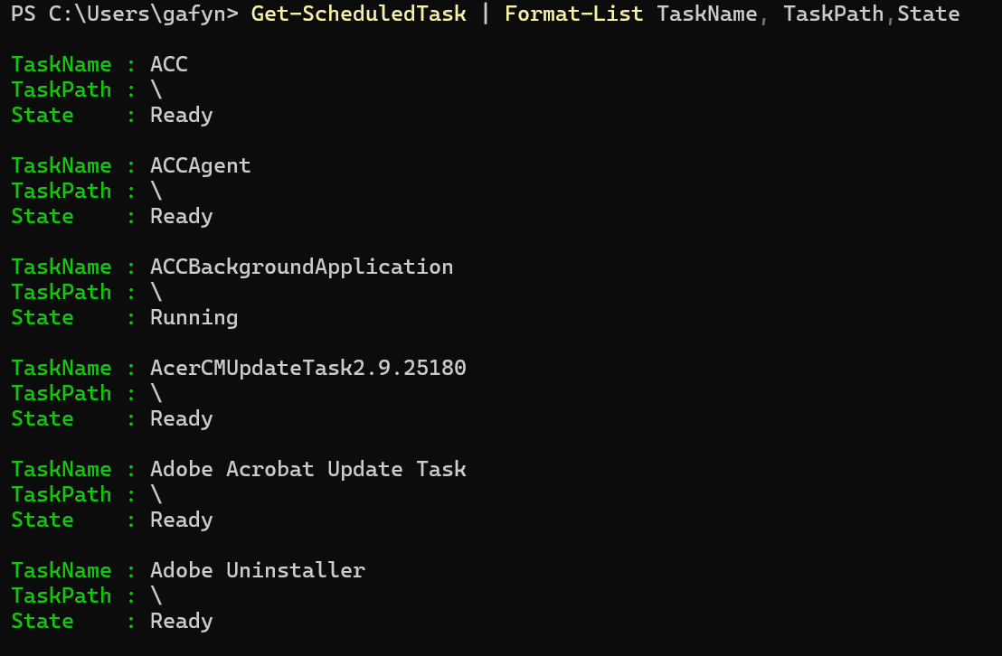

Register-ScheduledTask -TaskName
Register-ScheduledTask -TaskName is a PowerShell cmdlet used to schedule a new task in Windows Task Scheduler. The example below creates a task called Finish Assignment 1, which is configured to run at a specific time and day.

Fig. 21. Register-ScheduledTask -TaskName creating a scheduled task.
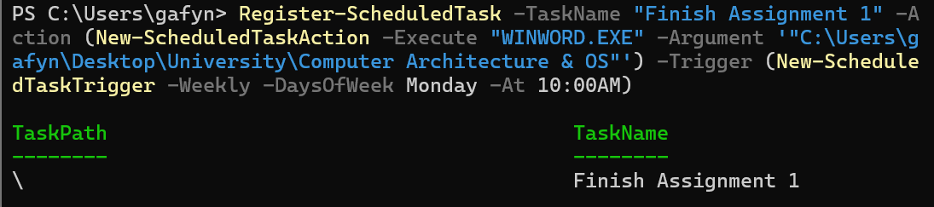

Use of Linux OS CLI Commands

Process Management

top
The ‘top’ command is used to display running processes based on how much CPU time, memory use, load information and process status they are currently consuming. In addition, processes can also be managed or terminated from within the top interface [8].

Fig. 22. top displaying active processes and system resource usage.
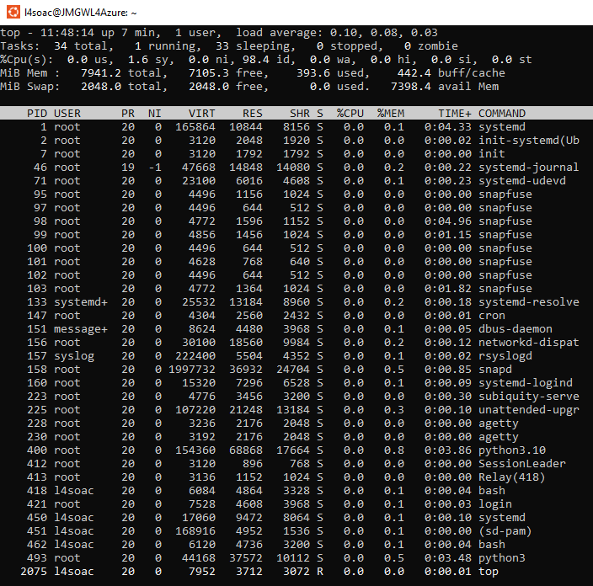

ps -ef
Whilst the ps command shows active processes, ps -ef is used to display a full list of active processes running on the system. It provides detailed information such as user ID, Process ID and start time and command, making it useful for process monitoring and troubleshooting [9].

Fig. 23. ps -ef 1 showing the first part of the full process list.
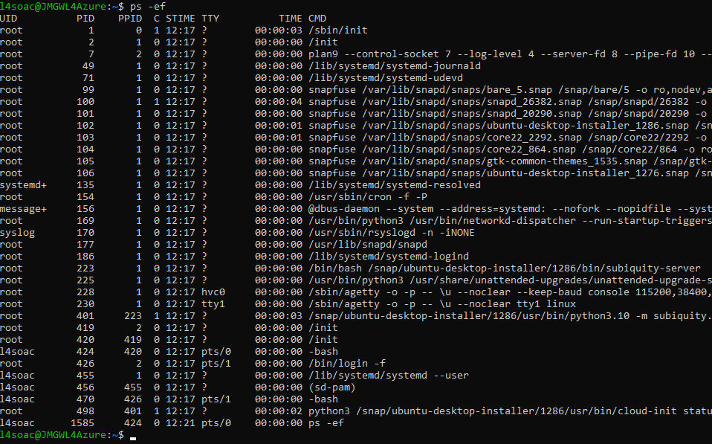

Fig. 24. ps -ef 2 showing the continuation of the full process list.
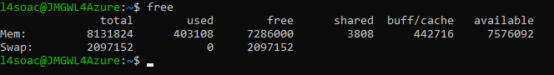

File & Directory Management

rm -r
The rm -r command is used to permanently remove a directory and all of its contents from the Linux file system [20]. In the example below, ls command is first used to show the testdir directory exists. The command rm -r testdir is then used to delete the directory.

Fig 25. rm -r removing a directory and its contents.
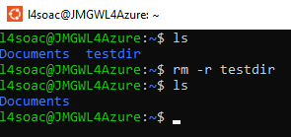

touch
The touch command is used in Linux to create an empty file [20]. In the example below, after navigating to the document’s directory, touch my_assignment.txt is used to create a new text file.

Fig. 26. touch creating anew file in the current directory.
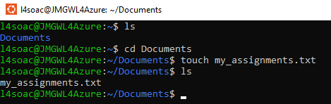

Network Testing/Monitoring

ping -c
The ping -c command is used in Linux to test whether a remote host or domain is reachable over the network [20]. This is done by sending an ICMP echo request and waiting for replies, allowing the user to measure the response time in milliseconds. The -c option stands for count and specifies how many ping requests should be sent before the command stops.

Fig. 27. ping -c testing network connectivity to a remote host.
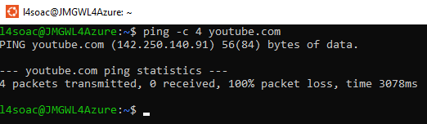

ip addr show
The ip address show command is used in Linux to display information about network interfaces, including assigned IP addresses, interface status and MAC addresses [8].

Fig. 28. ip addr show displaying network interface and IP address information.
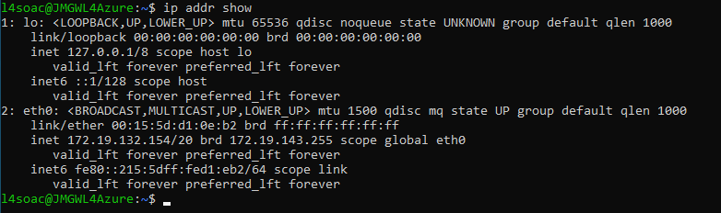

User Management

whoami
The whoami command is used to display the username of the currently logged-in user [10]. In the example below, it confirms the active user is l4soac.

Fig. 29. whoami displaying the current logged-in user.
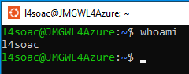

sudo adduser
The command sudo adduser is used to create a new user account on a Linux system. The sudo prefix allows the command to run with elevated privileges, which is required for user management. Once the command has finished, the user returns to their normal permission level.

Fig. 30. sudo adduser creating a new user account.
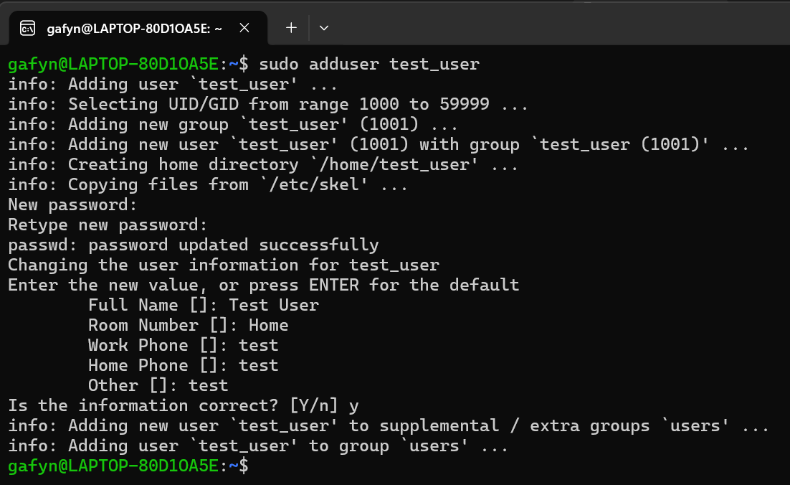

Task Scheduling

crontab -l
The crontab -l command is used to display the scheduled cron jobs for the currently logged-in user. This allows the user to review existing task entries and confirm whether the cron job has been created successfully.

Fig. 31. crontab -l displaying scheduled cron jobs.
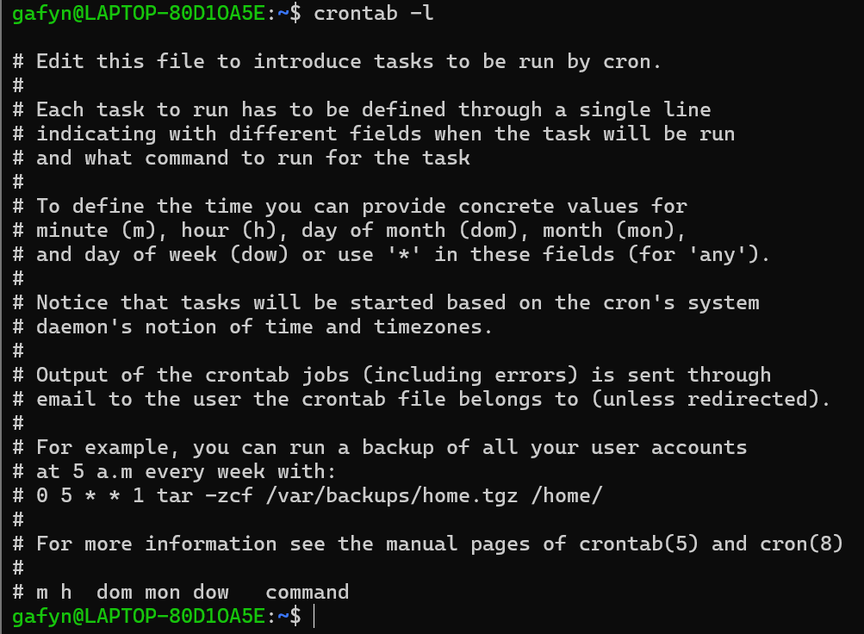

* * * * * /usr/bin/echo “Cron job ran successfully” >> /home/gafyn/cron-test-file.txt
The cron entry ‘* * * * * /usr/bin/echo “Cron job ran successfully” >> /home/gafyn/cron-test-file.txt’ command creates a scheduled task that runs every minute. Each time it runs, it uses the echo command to append the message “Cron job ran successfully” to the file cron-test-file.txt. The cat command is then used to display the contents of the file and to confirm that the cron job has run successfully.

Fig. 32. cron job entry appending a success message to a text file.

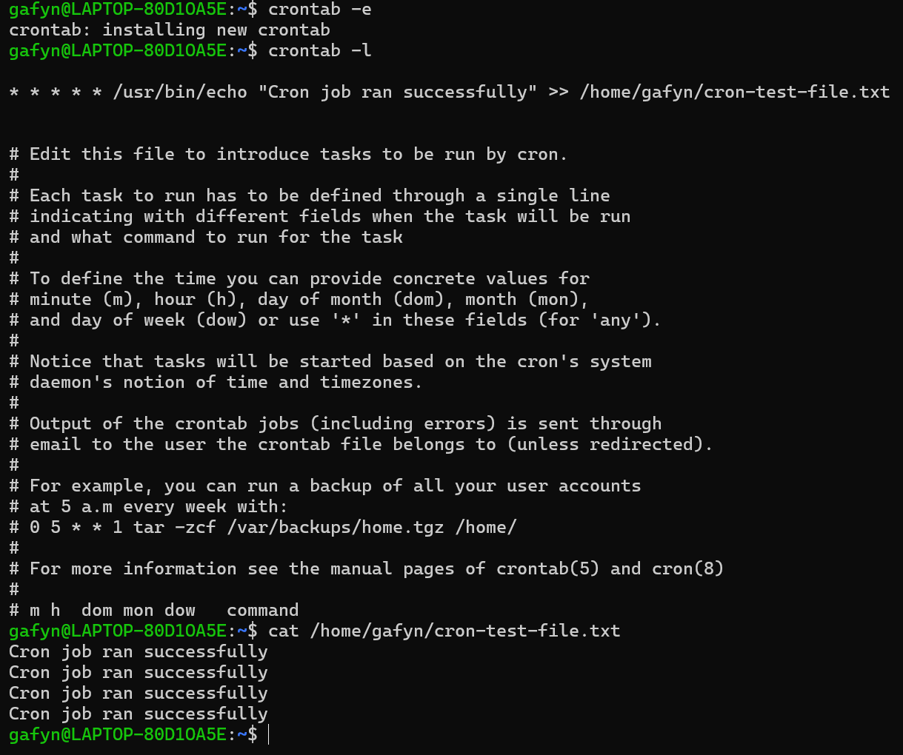

Use of Windows OS Scripts

Batch Script Screenshots

Fig. 33. Batch character creator script code, part 1.
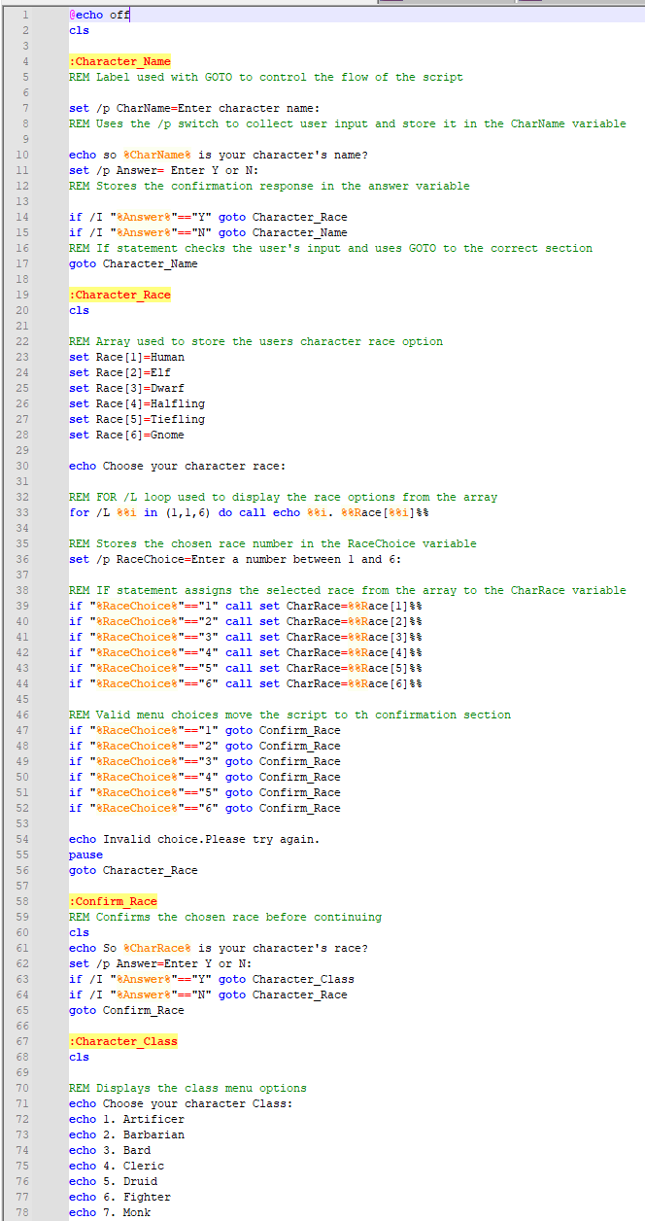

Fig. 34. Batch character creator script code, part 2.
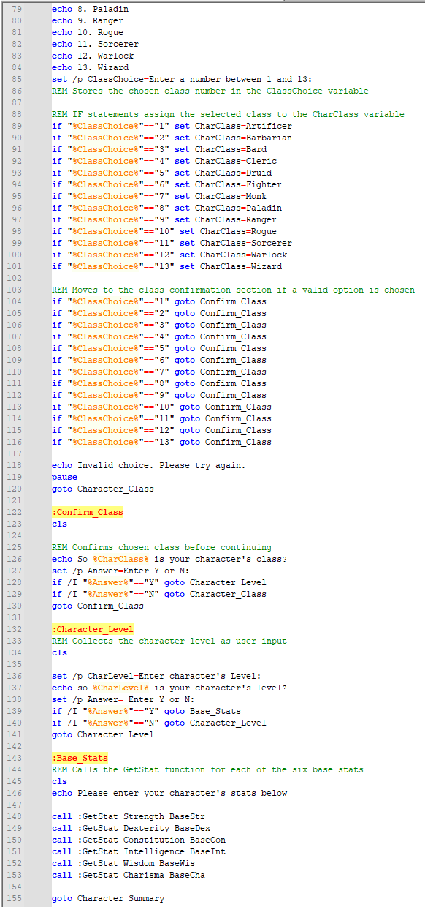

Fig. 35. Batch character creator script code, part 3.
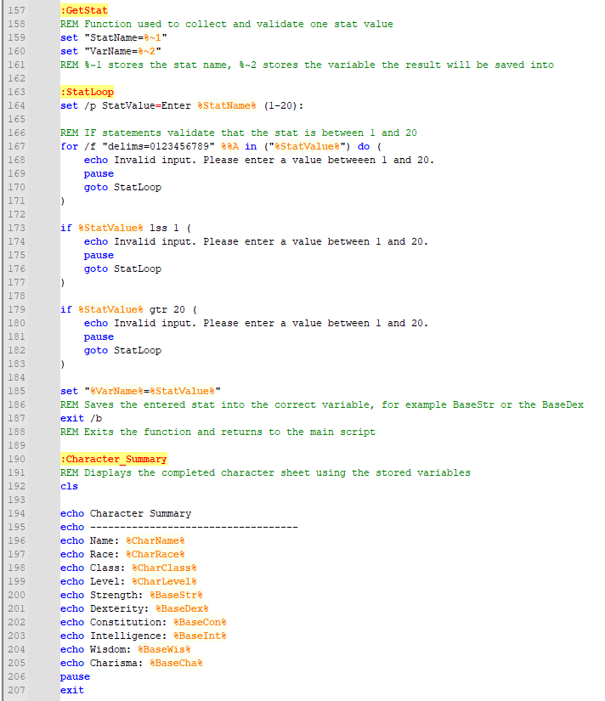

Batch Scripts Working

Fig. 36. Batch script prompting for the character name.


Fig. 37. Batch script confirming the entered character name.
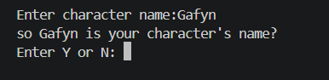

Fig. 38. Batch script displaying the race selection menu.
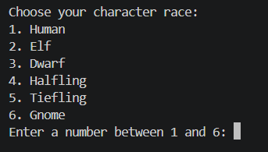

Fig. 39. Batch script confirming the selected character race.
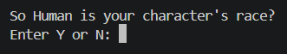

Fig. 40. Batch script displaying the class selection menu.
#

Fig. 41. Batch script confirming the selected character class.
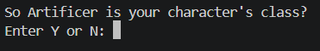

Fig. 42. Batch script prompting for the character level.


Fig. 43. Batch script collecting base stat values.
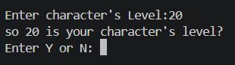

Fig. 44. Batch script displaying the completed character summary.
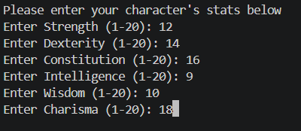

Fig. 45. Batch script displaying successful execution of the final output.
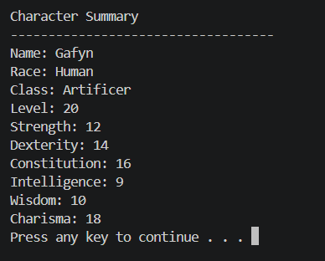

Code Syntax Explanation
This Batch script uses Dungeons & Dragons character creation as a theme to demonstrate key features of the Windows Command Shell scripting language. The script begins with ‘@echo off’ and ‘cls’, where ‘@echo off’ prevents commands from being displayed in the console and ‘cls’ clears the screen to improve readability [11]. User input is then collected with the ‘set /p’ command, which allows values such as the character name, race, class, level and base statistics to be entered and stored in variables [12]. Variables such as ‘CharName’, ‘CharRace’, ‘CharClass’ and ‘BaseStr’ are then reused throughout the script to hold and display the character data.
Labels such as ‘:Character_Name’ and ‘:Character_Race’ are used with the ‘goto’ command to control program flow and move between sections of the script [13]. Conditional logic is handled with ‘if’ statements, which are used to validate menu choices and confirm whether the user wishes to keep a selected value [15]. The ‘/I’ option is used in some ‘if’ commands to make comparisons case-insensitive [15]. This improves usability by allowing the script to accept either uppercase or lowercase input without requiring separate conditions.

The script also demonstrates the use of an indexed array by storing character race options in variables such as ‘Race[1]’ and ‘Race[2]’. These values are displayed using a ‘for /L’ loop, which repeats through a numerical range and prints each race option in the menu [14]. This reduces repetition and makes race-selection section more efficient. A function is demonstrated through the ‘:GetStat’ section, which is called repeatedly with ‘call’ to collect and validate each base stat before storing it in a variable [16]. The function uses ‘exit /b’ to return control to the main script once the value has been processed [17]. Overall, the script shows how Batch syntax can be used to create an interactive, menu-driven program.

Use of Linux OS Scripts

Bash Script Screenshot

Fig. 46. Bash dice roller script code.

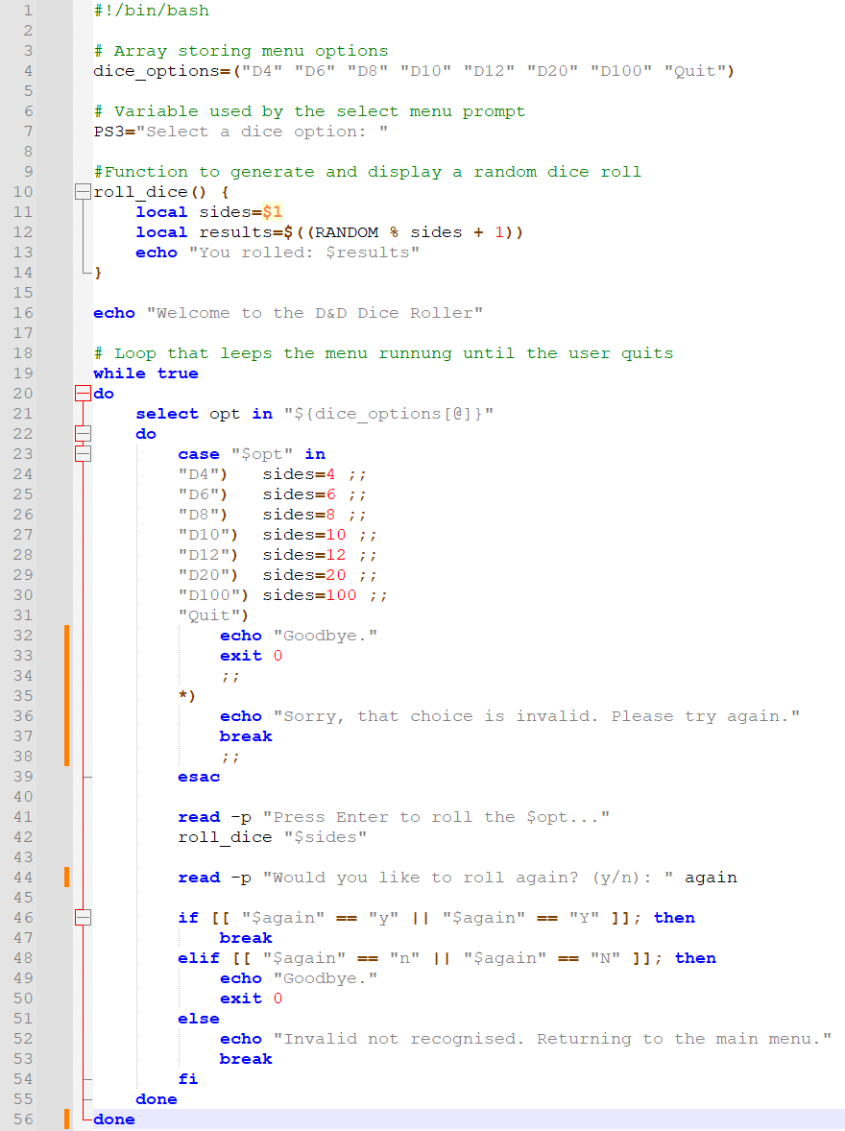

Bash Script Working

Fig. 47. Bash dice roller displaying the menu options.
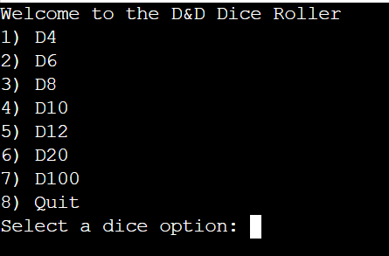

Fig. 48. Bash dice roller prompting the user to select a dice type.
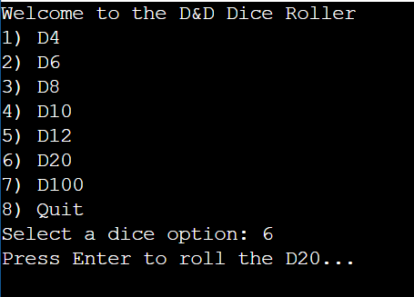

Fig. 49. Bash dice roller prompting the user to press enter to roll.
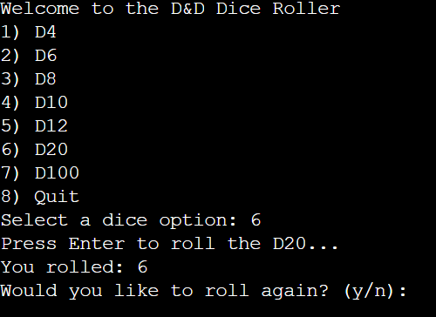

Fig. 50. Bash dice roller displaying the generated random result.
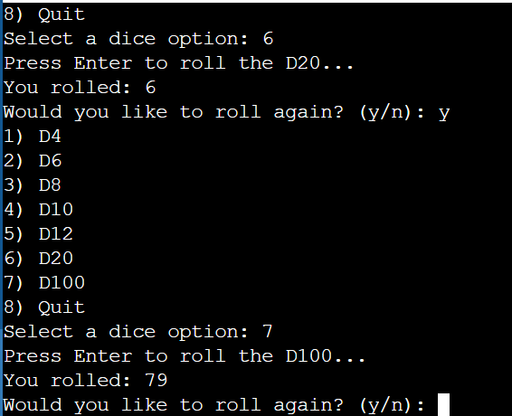

Fig. 51. Bash dice roller prompting the user to roll again or quit.
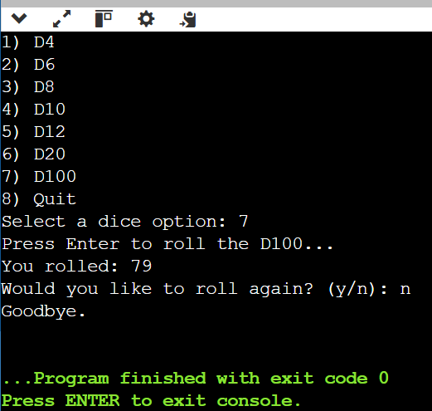

Code Syntax Explanation
The Bash script uses a Dungeons & Dragons dice roller theme to demonstrate key features of Linux shell scripting. The script begins with the shebang line ‘#!/bin/bash’, which tells the operating system to execute the file using the Bash shell interpreter [8]. The menu options are then stored in an array called ‘dice_options’, which groups the available dice types into a single indexed structure rather than requiring separate variables for each option [18]. This helps improve organisation and demonstrates Bash array syntax. Variables such as ‘PS3’, ‘sides’, ‘results’ and ‘again’ are then used to store the prompt text, the selected dice size, the random roll, and the user’s decision to continue [18]. Bash variables are created throughout the script with ‘=’ and accessed using the ‘$’ symbol.

User interaction is handled with the ‘read -p’ command, which allows the user to enter input on the same line as the prompt [19]. A ‘while true’ loop is also used to keep the menu running until the user chooses to quit [19]. Inside the loop, the ‘select’ statement works with the array to display a numbered menu [18], while a ‘case’ statement tests the selected option and assigns the correct dice value to the ‘sides’ variable [18].
A function named ‘roll_dice()’ is used to group the rolling logic into one reusable block of code, which avoids having to repeat the same code for each menu option [18]. Inside the function, the Bash variable ‘$RANDOM’ is used to generate a random number based on the sides the selected die has [19]. Finally, an ‘if’, ‘elif’ and ‘else’ structure checks whether the user wants to roll again or exit the code [8].

Conclusion
In conclusion, this report shows that operating systems perform a wide range of essential functions beyond simply providing a user interface. Key functions such process management, memory management, hardware control, monitoring and security are central to ensuring that computer systems operate efficiently, reliably and securely. The report provides practical examples throughout, demonstrating that these functions can be monitored and managed through in-built tools in Windows as well as through command-line environments in both Windows and Linux.
The report also highlights how important a role the command-line and scripting skills in modern operating system administration, with both Windows and Linux CLI both providing methods for managing a variety of aspects. These include managing processes, files, networks, users, and scheduled tasks, whilst noting the differences in syntax and structure. In addition, the Batch and Bash scripting tasks demonstrate how automation can be achieved through scripting features such as variables, input handling, conditions, loops and arrays as well as functions.
Overall, the findings of this report show that understanding both graphical tools and command-line scripting are both important for effective system management, troubleshooting and automation.

Reference List

[1] IBM, “What is the Linux Kernel?” [Online]. Available: https://www.ibm.com/think/topics/linux-kernel. [Accessed: May. 12, 2026].
[2] Lenovo, “What is a device manager?” [Online]. Available: https://www.lenovo.com/gb/en/glossary/device-manager/?orgRef=https%253A%252F%252Fwww.google.com%252F. [Accessed: Mar. 16, 2026].
[3] Microsoft, “Use the System File Checker tool to repair missing or corrupted system files.” [Online]. Available: https://support.microsoft.com/en-us/topic/use-the-system-file-checker-tool-to-repair-missing-or-corrupted-system-files-79aa86cb-ca52-166a-92a3-966e85d4094e#:~:text=When%20critical%20Windows%20system%20files,to%20provide%20the%20necessary%20files. [Accessed: Mar. 23, 2026].
[4] M. Russinovich, “RAMMap - Sysinternals,” Microsoft.com, Feb. 06, 2026. [Online] Available: https://learn.microsoft.com/en-us/sysinternals/downloads/rammap. [Accessed: Mar. 23, 2026].
[5] E. Bott and I. Pearson Education, Windows 11 inside out. Hoboken, New Jersey: Published with the authorization of Microsoft Corporation by Pearson Education, Inc., 2023.
[6] B. Stewart, "Using PowerShell Interactively," Windows IT Pro [Online], 2015. Available: https://www.proquest.com/magazines/using-powershell-interactively/docview/1691231392/se-2. [Accessed: Mar. 23, 2026].
[7] R. Harwood, “Get-NetTCPConnection (NetTCPIP),” Microsoft.com, 2026. [Online] Available: https://learn.microsoft.com/en-us/powershell/module/nettcpip/get-nettcpconnection?view=windowsserver2025-ps. [Accessed: Mar. 30, 2026].
[8] C. Negus, Linux bible, Ninth edition. Indianapolis, Indiana: Wiley, 2016.
[9] Cisco Networking Academy, “Linux Unhatched: A Free 8-Hour Course Covering the Basics.” [Online]. Available: https://www.netacad.com/courses/linux-unhatched?courseLang=en-US. [Accessed: Apr. 13, 2026].
[10] IBM, “whoami Command,” IBM Documentation, AIX 7.3. [Online]. Available: https://www.ibm.com/docs/en/aix/7.3.0?topic=w-whoami-command. [Accessed: Apr. 14, 2026].
[11] P. K. Bhardwaj, How to Cheat at Windows System Administration Using Command Line Scripts, 1st ed. Chantilly: Elsevier Science & Technology Books, 2006. doi: 10.1016/B978-1-59749-105-1.X5000-7.
[12] Microsoft, “set,” Sept. 6, 2023. [Online]. Available at: https://learn.microsoft.com/en-us/windows-server/administration/windows-commands/set_1. [Accessed: Apr. 20, 2026].
[13] Microsoft, “goto,” Feb. 3, 2023. [Online]. Available at: https://learn.microsoft.com/en-us/windows-server/administration/windows-commands/goto. [Accessed: Apr. 20, 2026].
[14] Microsoft, “for”, Sept. 6, 2023. [Online]. Available at: https://learn.microsoft.com/en-us/windows-server/administration/windows-commands/for. [Accessed: Apr. 21, 2026].
[15] Microsoft, “if,” Feb. 3, 2023. [Online]. Available at: https://learn.microsoft.com/en-us/windows-server/administration/windows-commands/if. [Accessed: Apr. 20, 2026].
[16] Microsoft, “call,” Feb. 3, 2023. [Online]. Available at: https://learn.microsoft.com/en-us/windows-server/administration/windows-commands/call. [Accessed: Apr. 20, 2026].
[17] Microsoft, “exit,” Feb. 3, 2023. [Online]. Available at: https://learn.microsoft.com/en-us/windows-server/administration/windows-commands/exit. [Accessed: Apr. 20, 2026].
[18] E. Siever, S. Figgins, R. Love, and A. Robbins, Linux : in a nutshell, 6th ed. Beijing ; O’Reilly, 2009.
[19] GNU Project, “Bash Reference Manual.” [Online]. Available: https://www.gnu.org/software/bash/manual/bash.html. [Accessed: Apr. 24, 2026].
[20] Cisco Networking Academy, “Linux Unhatched: A Free 8-Hour Course Covering the Basics.” [Online]. Available: https://www.netacad.com/courses/linux-unhatched?courseLang=en-US. [Accessed: May 12, 2026].

Appendices

Tutorial Activity

Fig. 52. Screenshot 1 of tutorial activity discussing computer operating systems (OS).
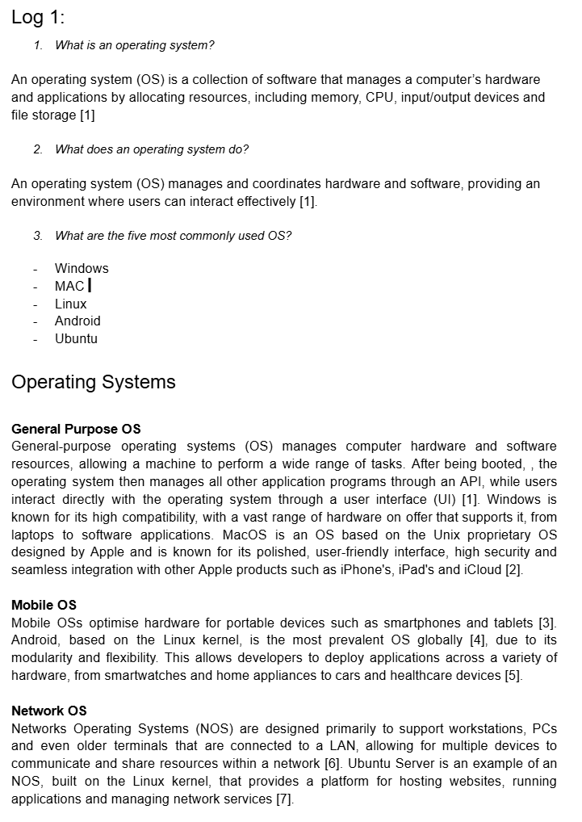

Fig. 53. Screenshot 2 of tutorial activity discussing computer operating systems (OS)
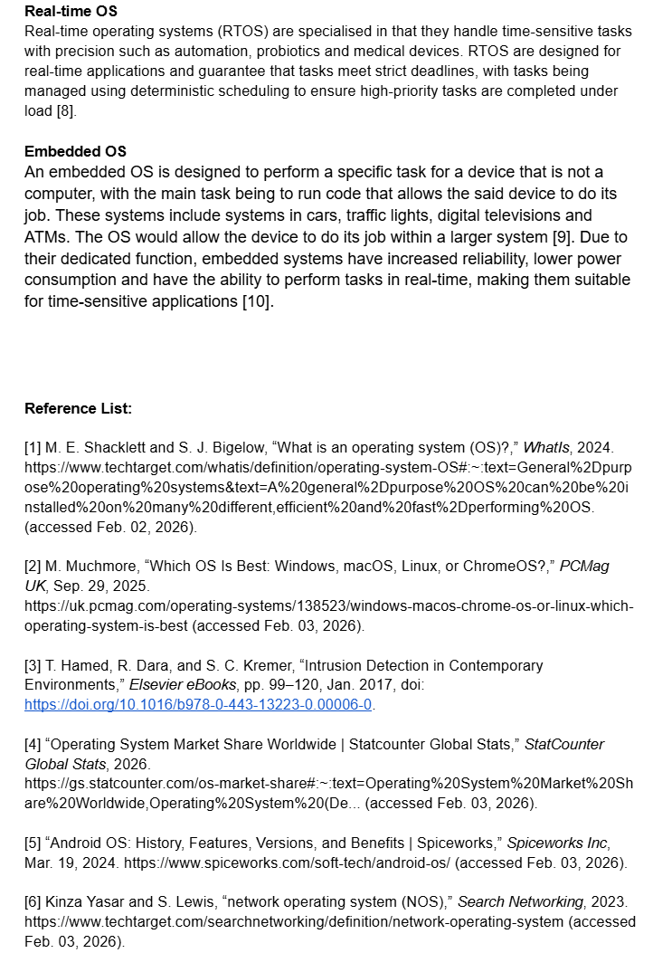

Fig. 54. Screenshot 3 of tutorial activity discussing computer operating systems (OS)
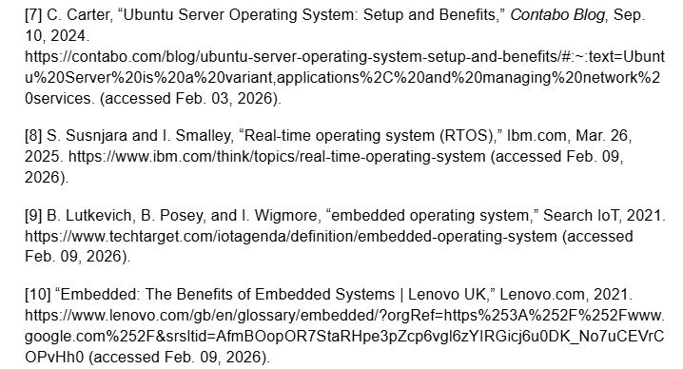

Lecture Activities

Fig. 55. Screenshot 1 of lecture activity answer/log showing notes on system monitoring tools and screenshot of Event Viewer
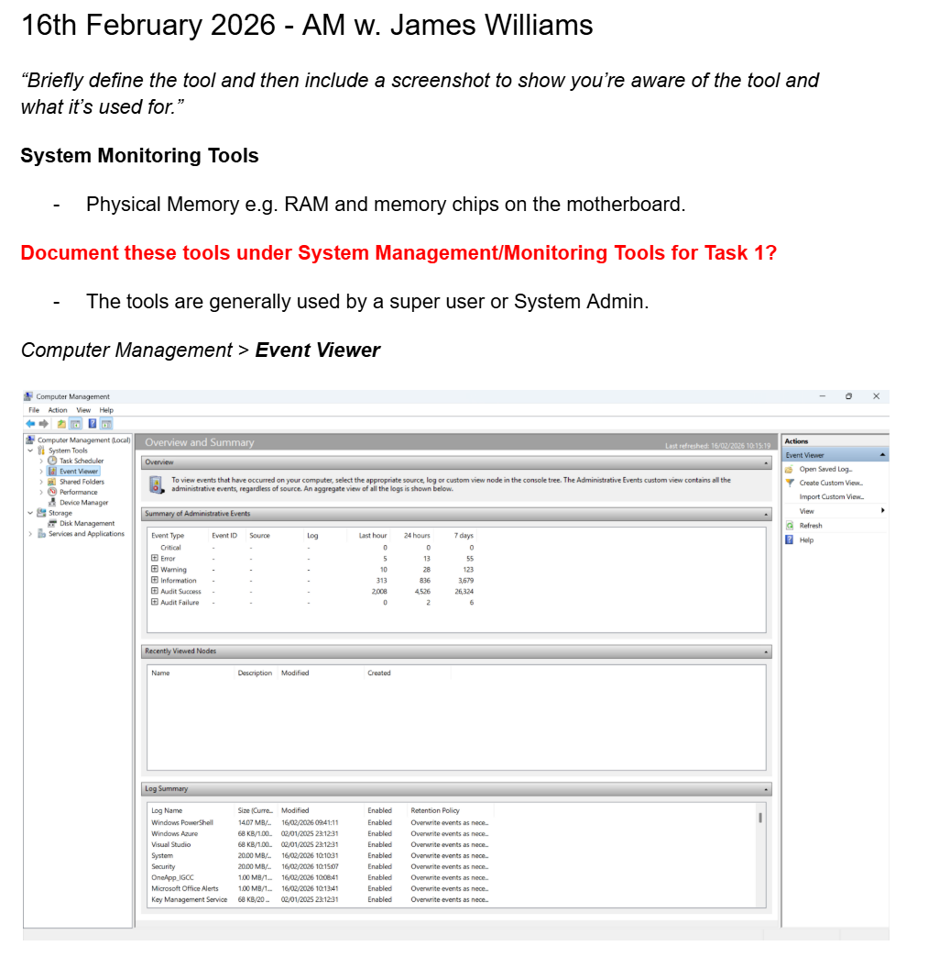

Fig. 56. Screenshot 2 of lecture activity answer/log showing screenshot taken in lecture of the Performance Monitor tool.
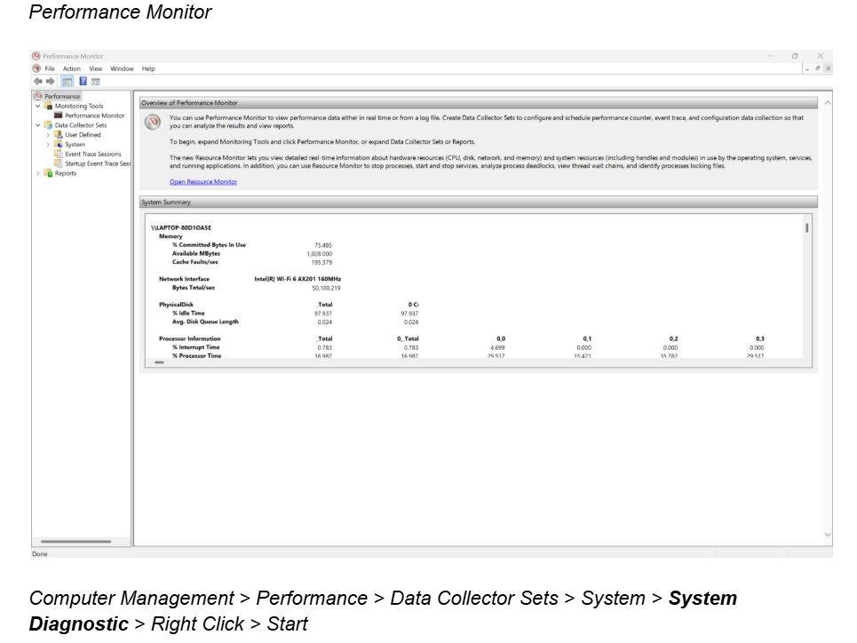

Fig. 57. Screenshot 3 of lecture activity answer/log showing testdir command, testdir | more and the creation of a test file using echo “hello world”>newfile.txt
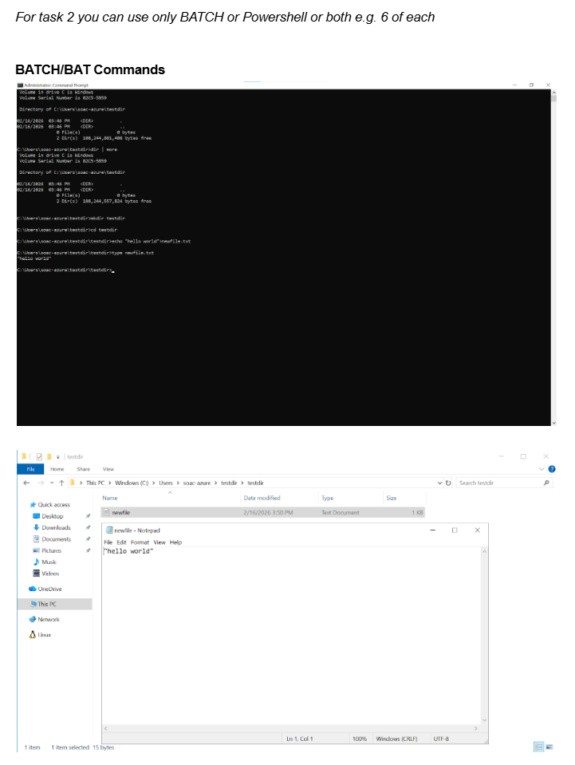

Fig. 58. Screenshot 4 of lecture activity answer/log showing assignment notes and various PowerShell verbs and commands.
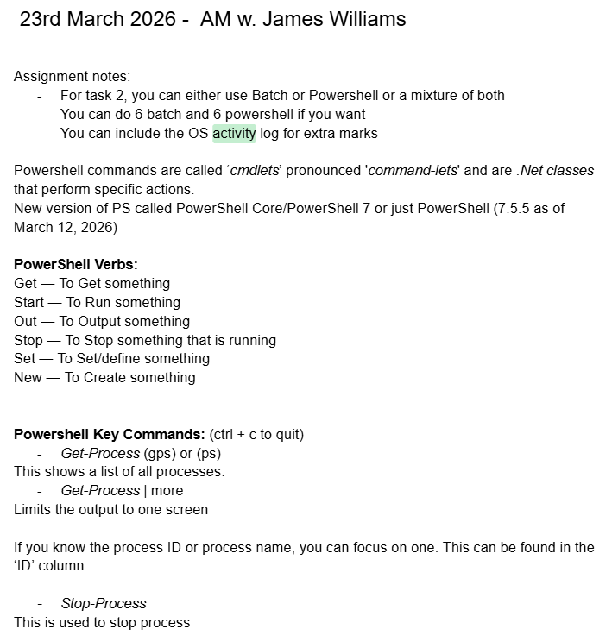

Fig. 59. Screenshot 5 of lecture activity answer/log showing screenshot of the Get-Process command.
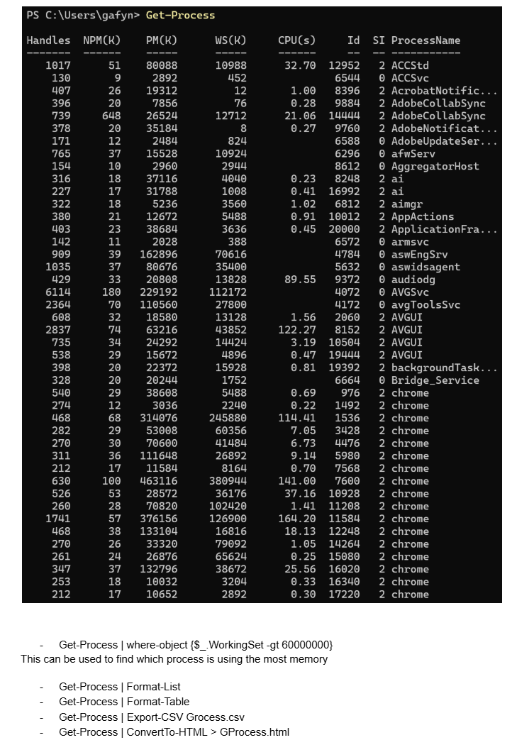

Fig. 60. Screenshot 6 of lecture activity answer/log showing screenshot of Invoke History 5 command.

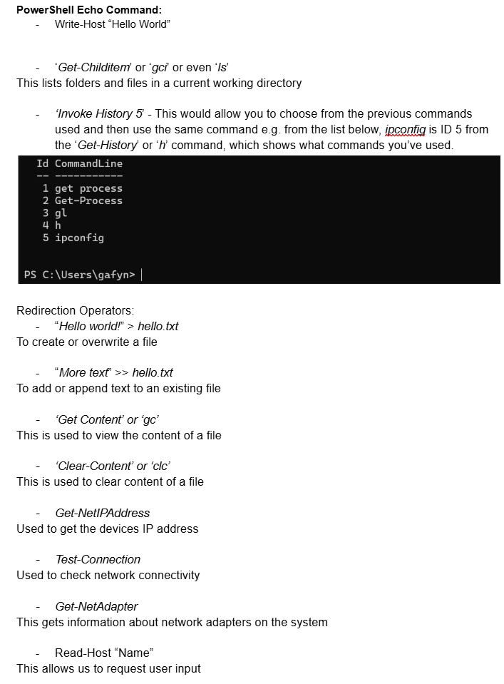

Fig. 61. Screenshot 7 of lecture activity answer/log showing screenshot the read-host command.
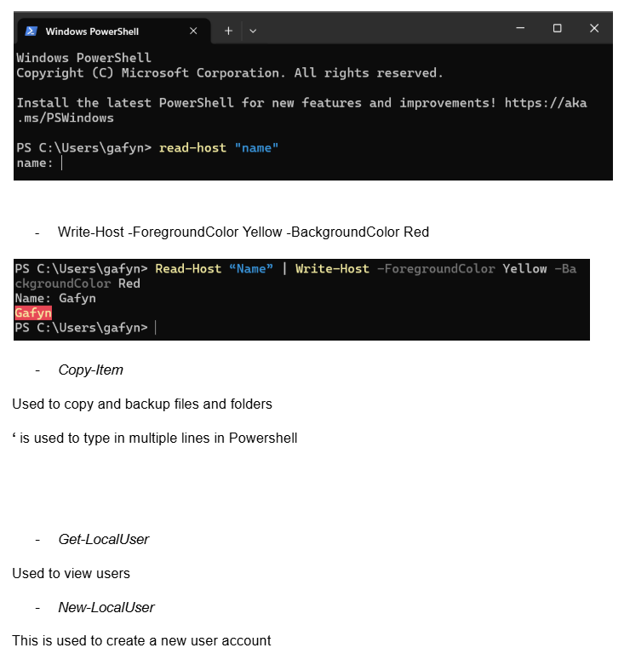

Fig. 62. Screenshot 8 of lecture activity answer/log showing a screenshot of the resource monitor.
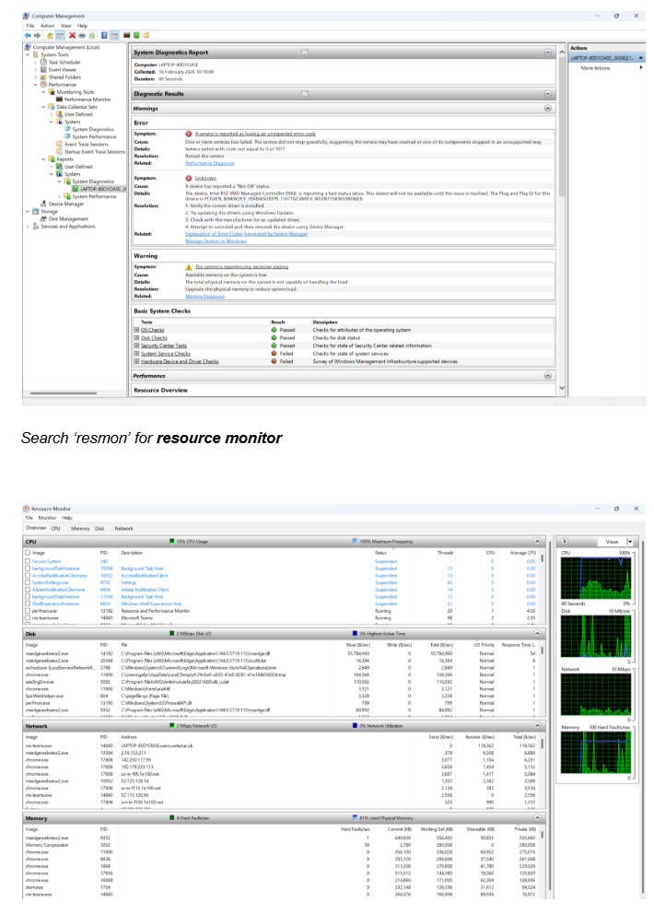

Fig. 63. Screenshot 9 of lecture activity answer/log showing a screenshot of the reliability monitor.

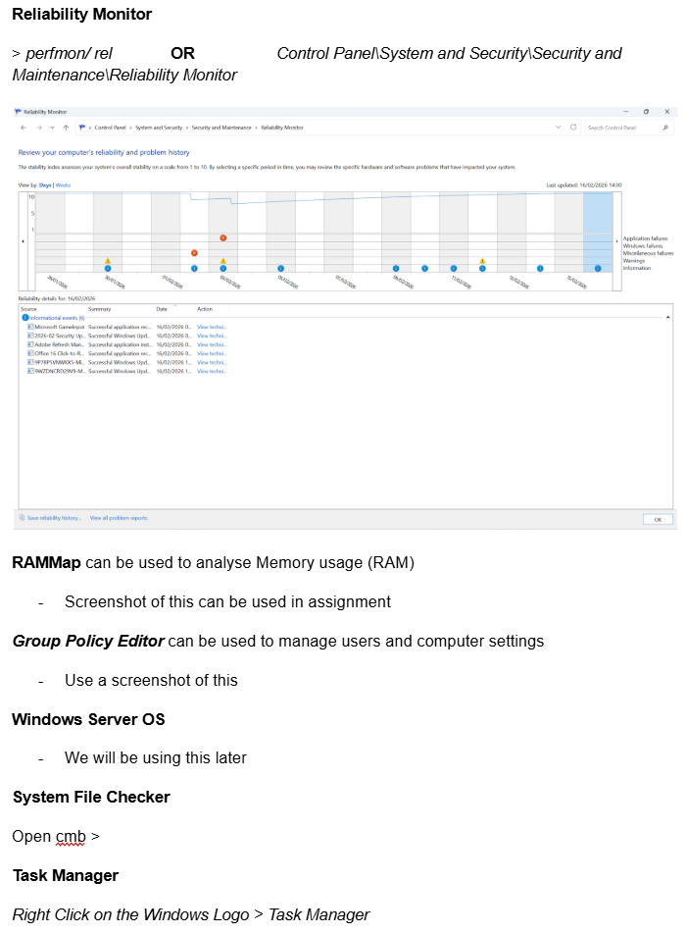

Evidence of Engagement with 1 Online Certified Course

Fig. 64. Screenshot 1 of Cisco Linux Course showing the ls command.
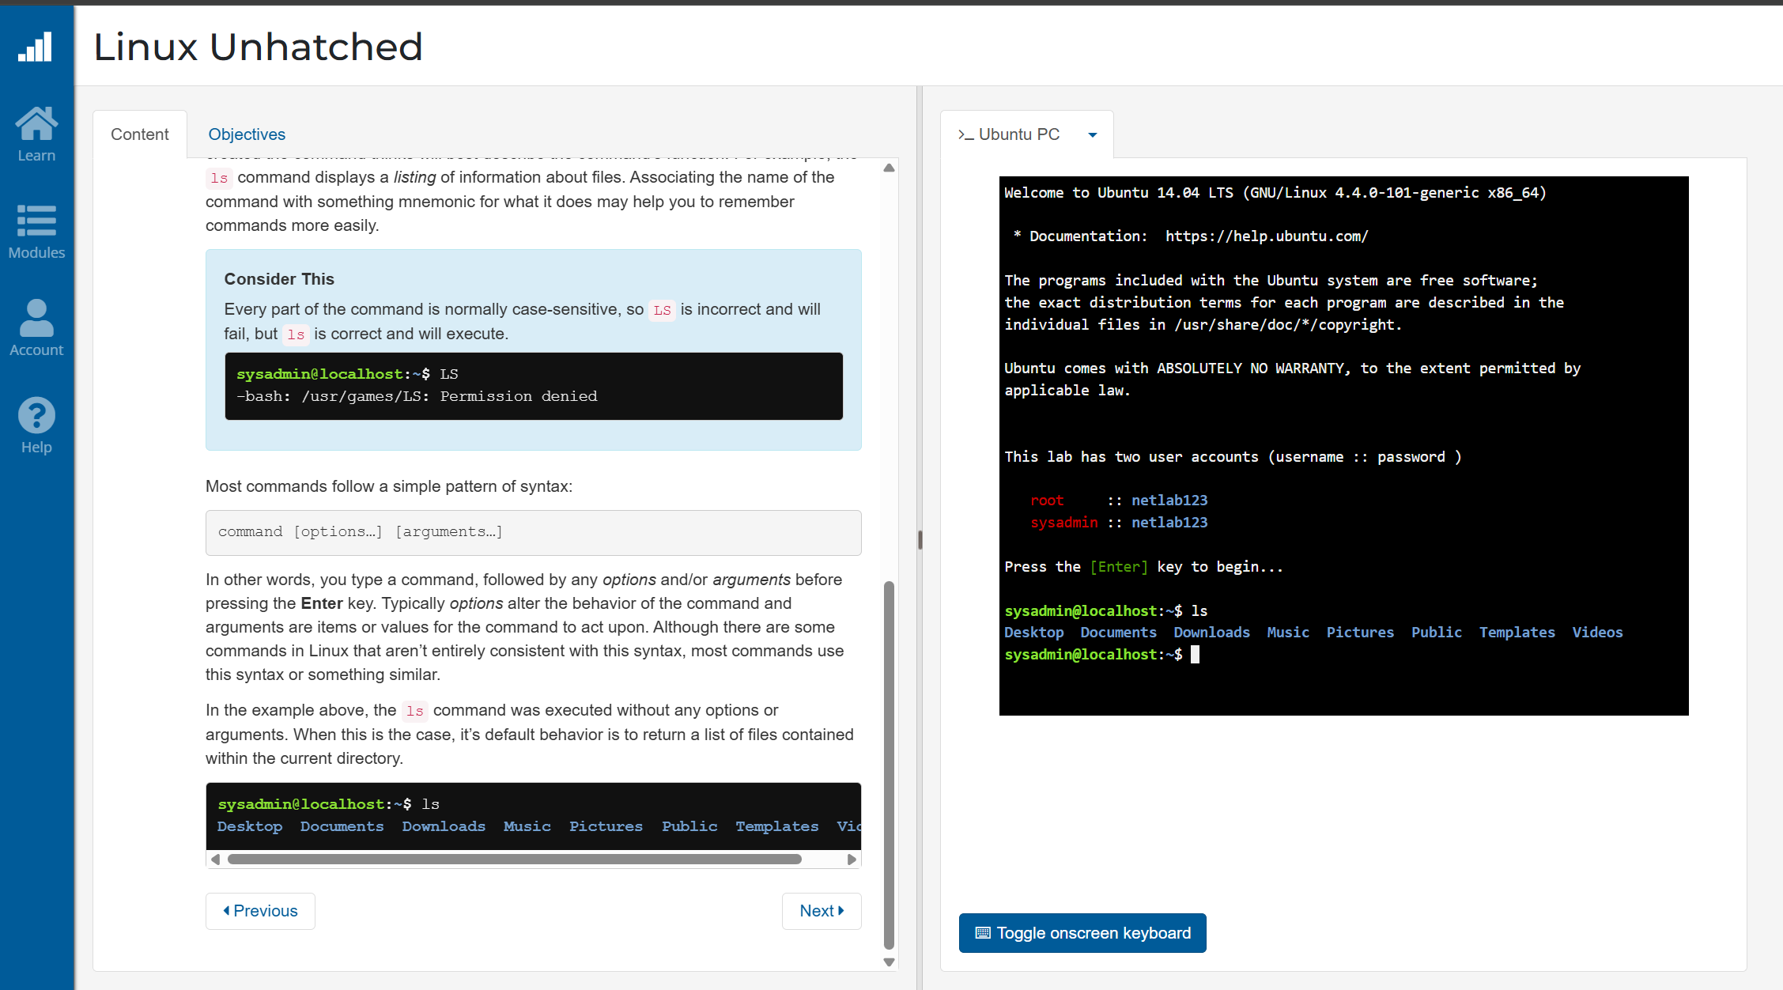

Fig. 65. Screenshot 2 of Cisco Linux Course showing the ls command followed by an argument (Documents).
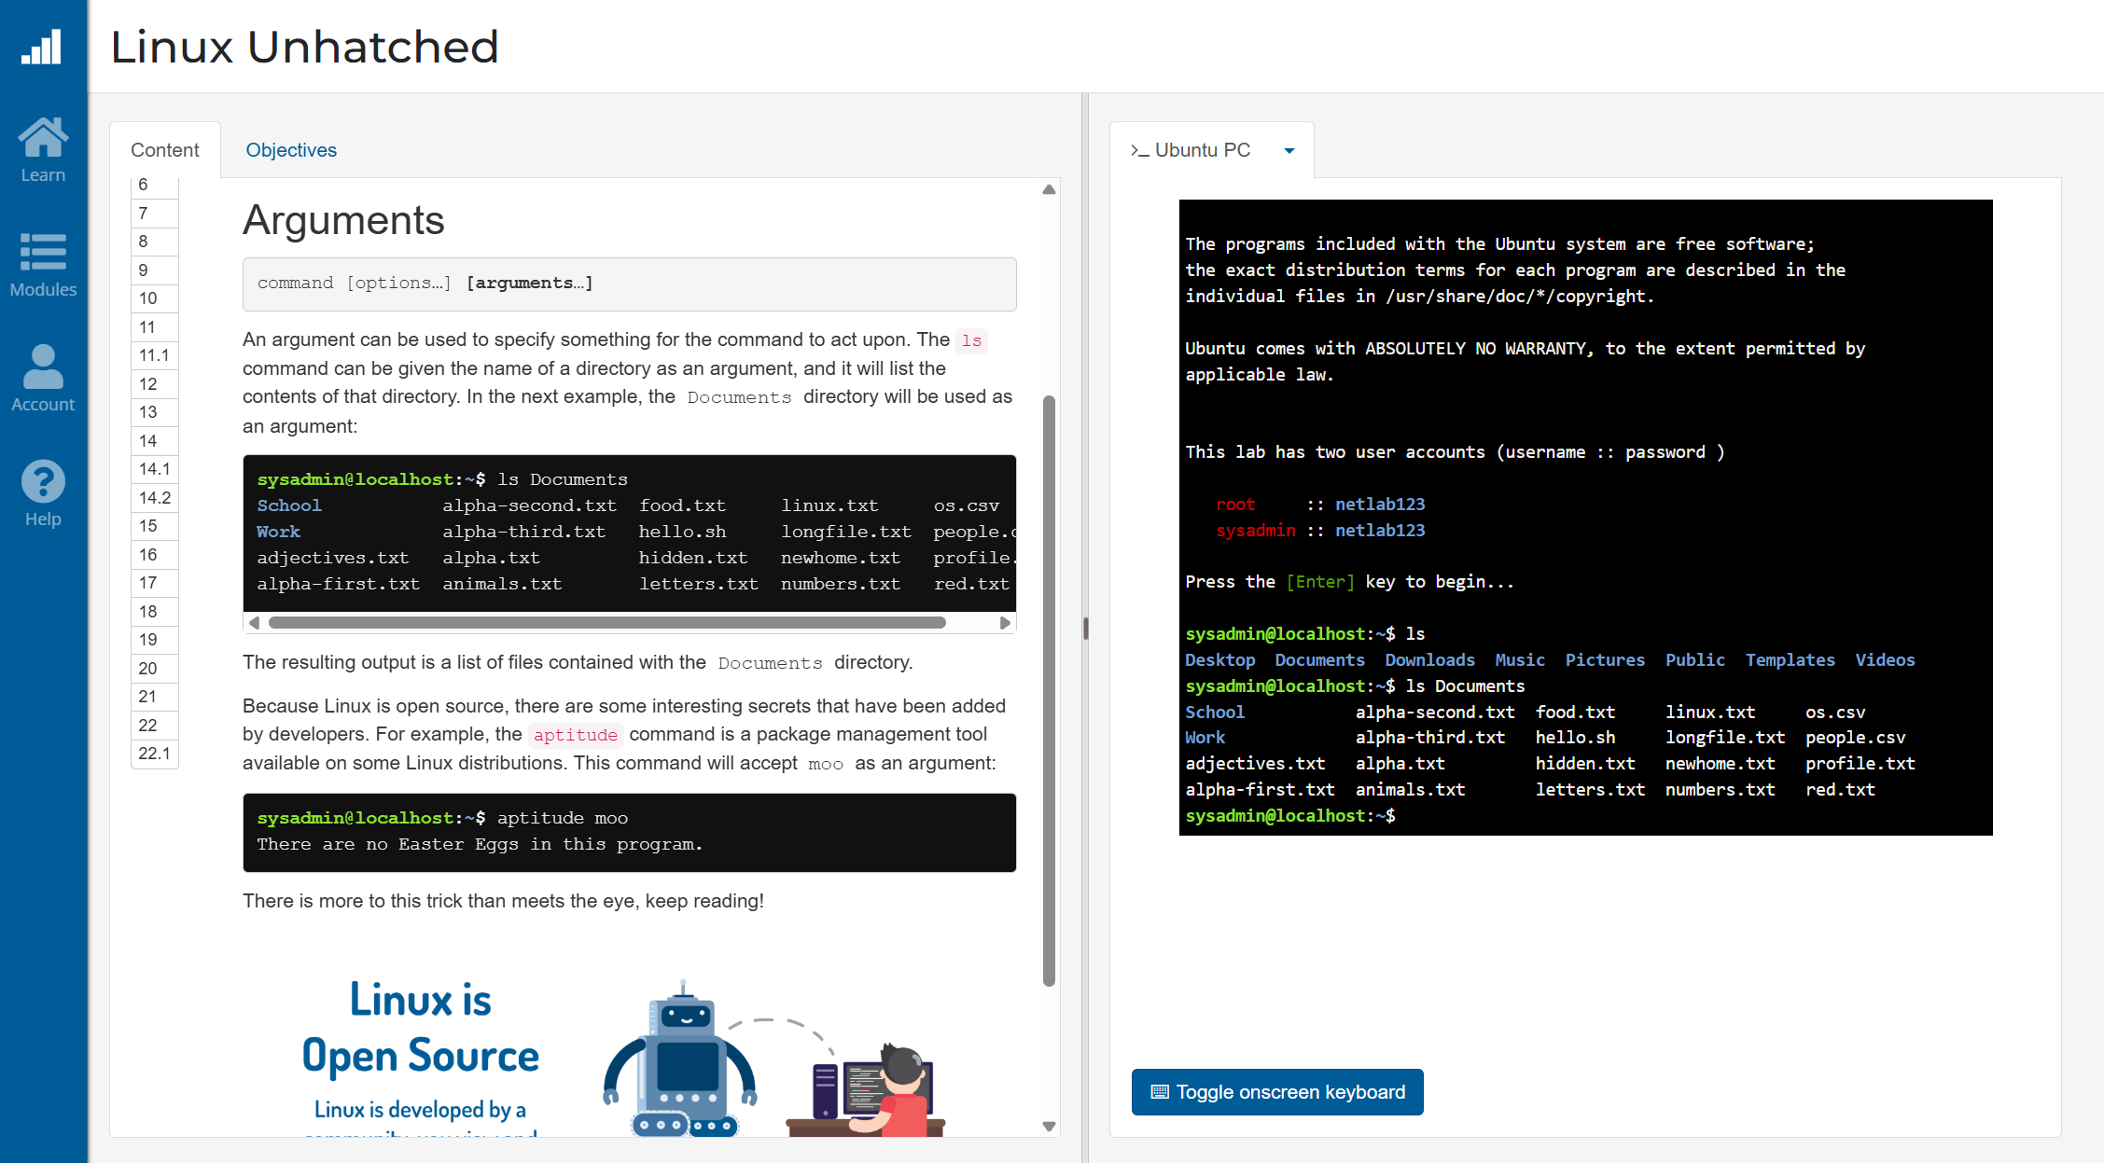

Fig. 66. Screenshot 3 of Cisco Linux Course showing various variations on the ls command (ls -l -r, ls -lr).
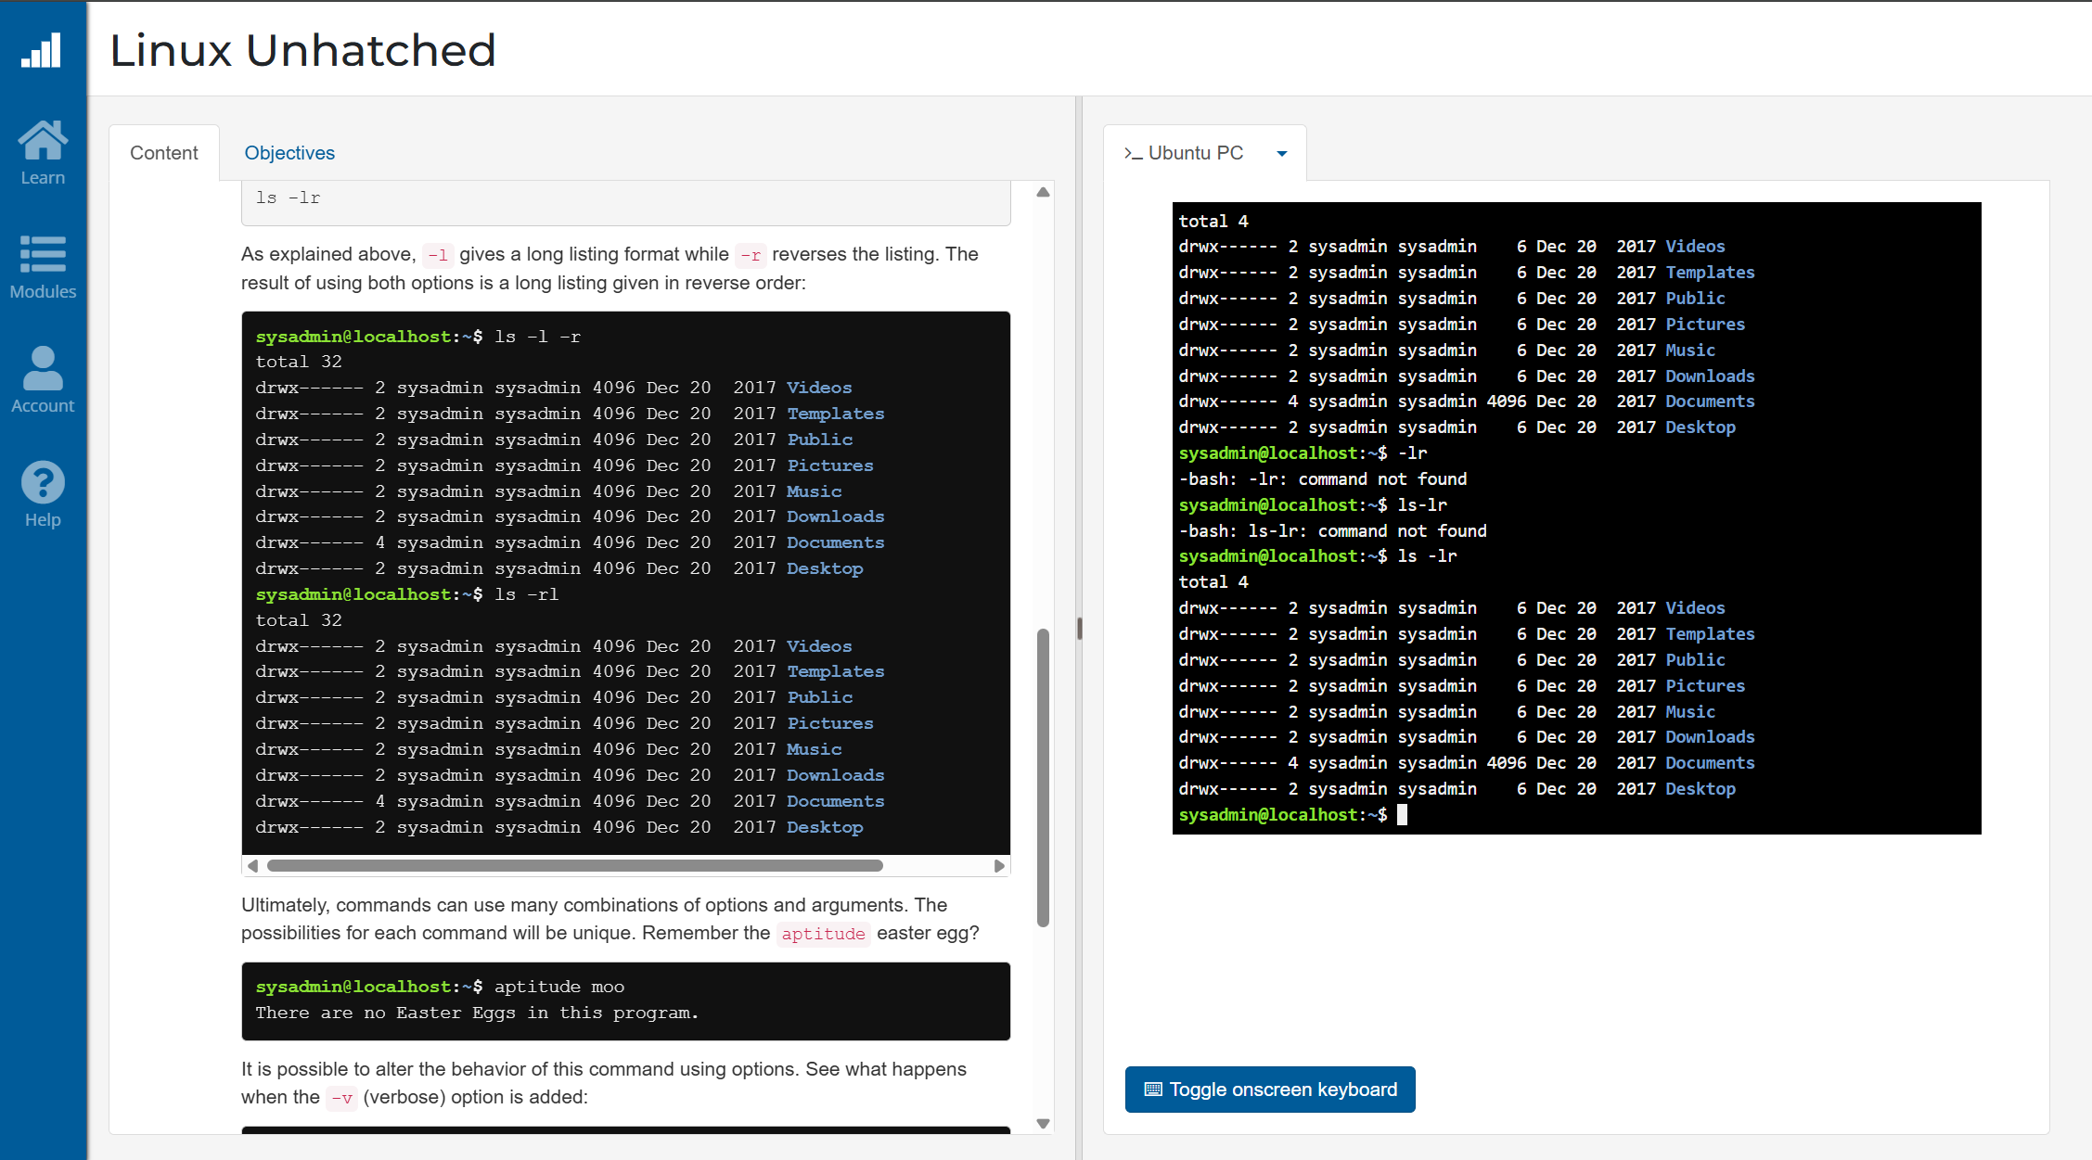

Fig. 67. Screenshot 4 of Cisco Linux Course looking at the su and sudo as a way of executing a command with administrative privileges.
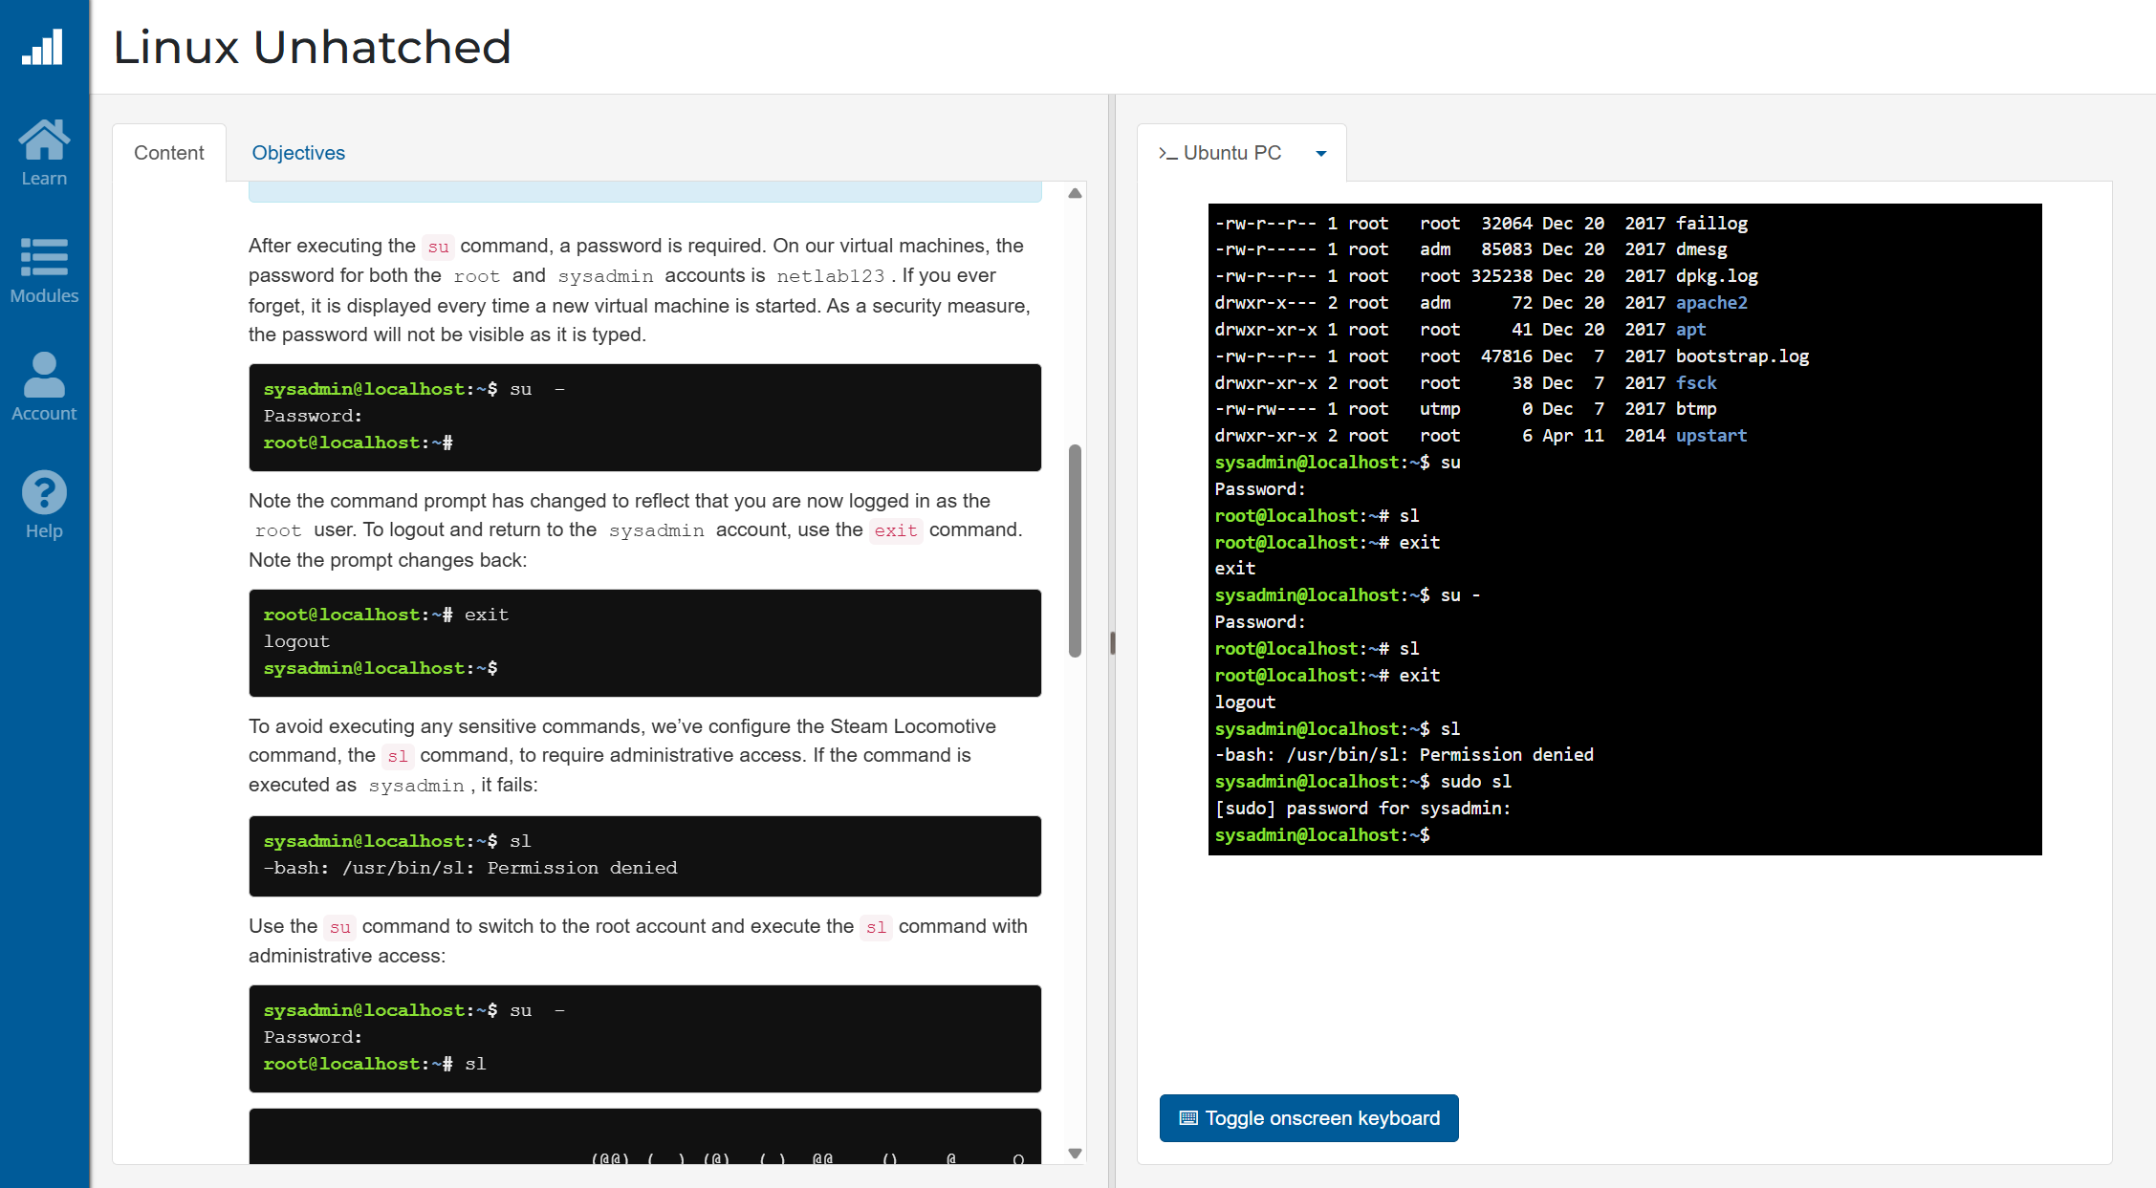

Fig. 68. Screenshot 5 of Cisco Linux Course focusing on changing file permission using the chmod command.

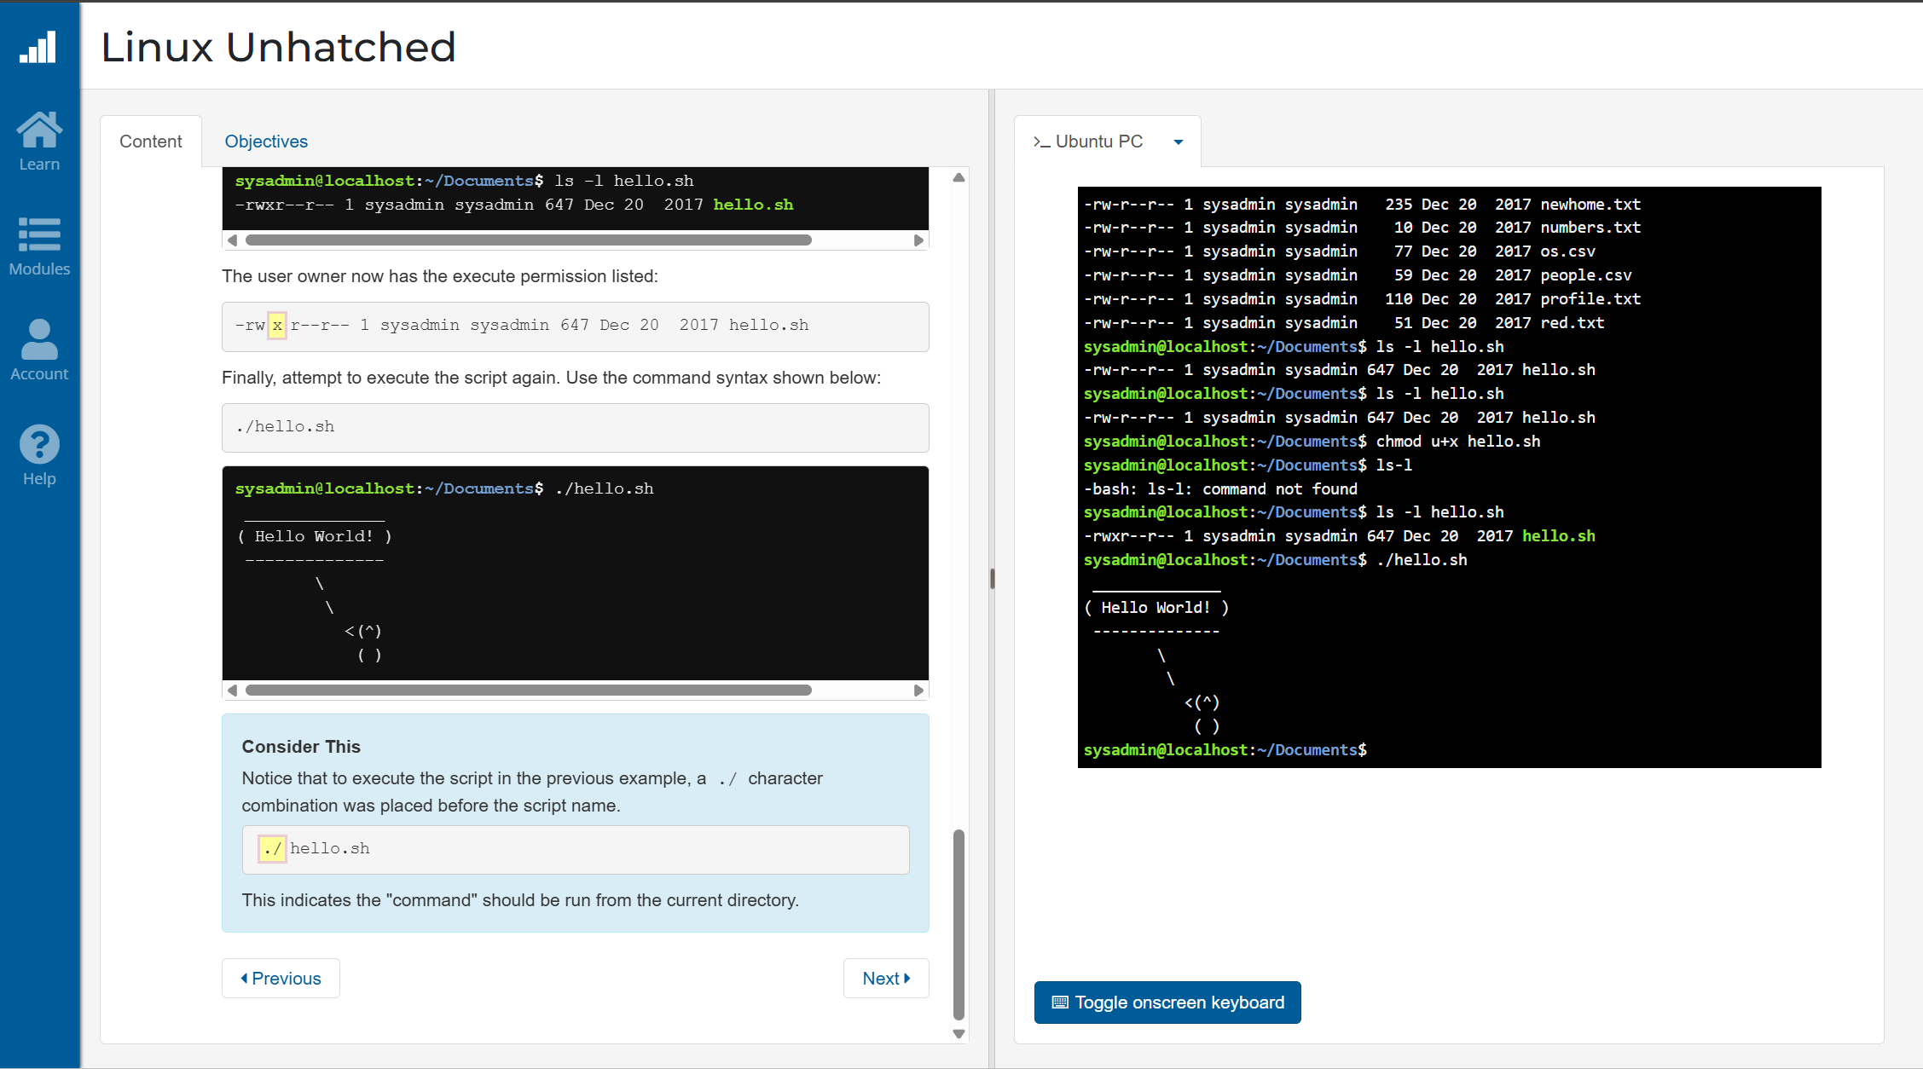

Fig. 69. Screenshot 6 of Cisco Linux Course which looks at the shutdown command.

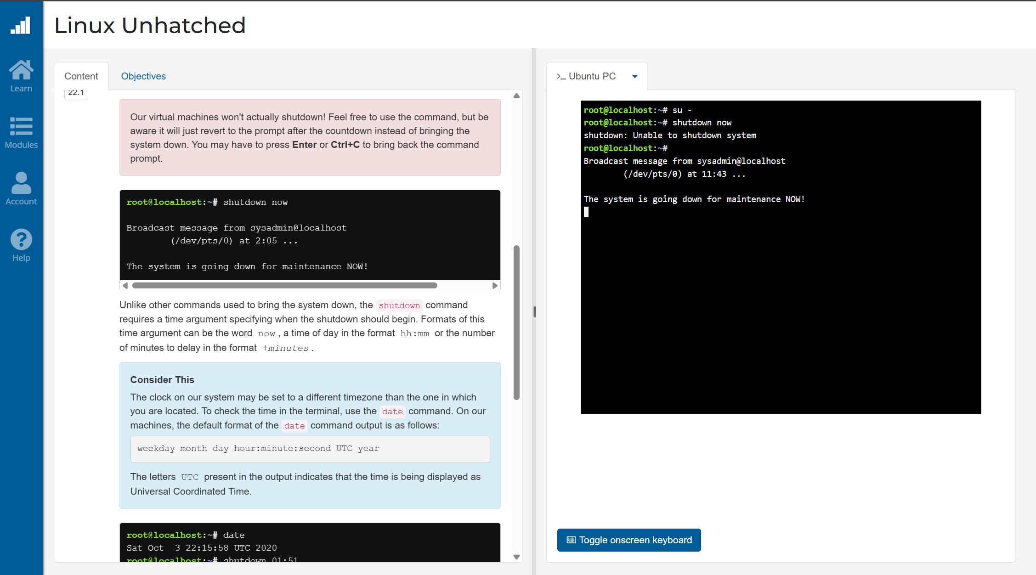

Fig. 70. Screenshot 7 of Cisco Linux Course which looks at the ifconfig command along with the ping command using -c to limit the number of pings.
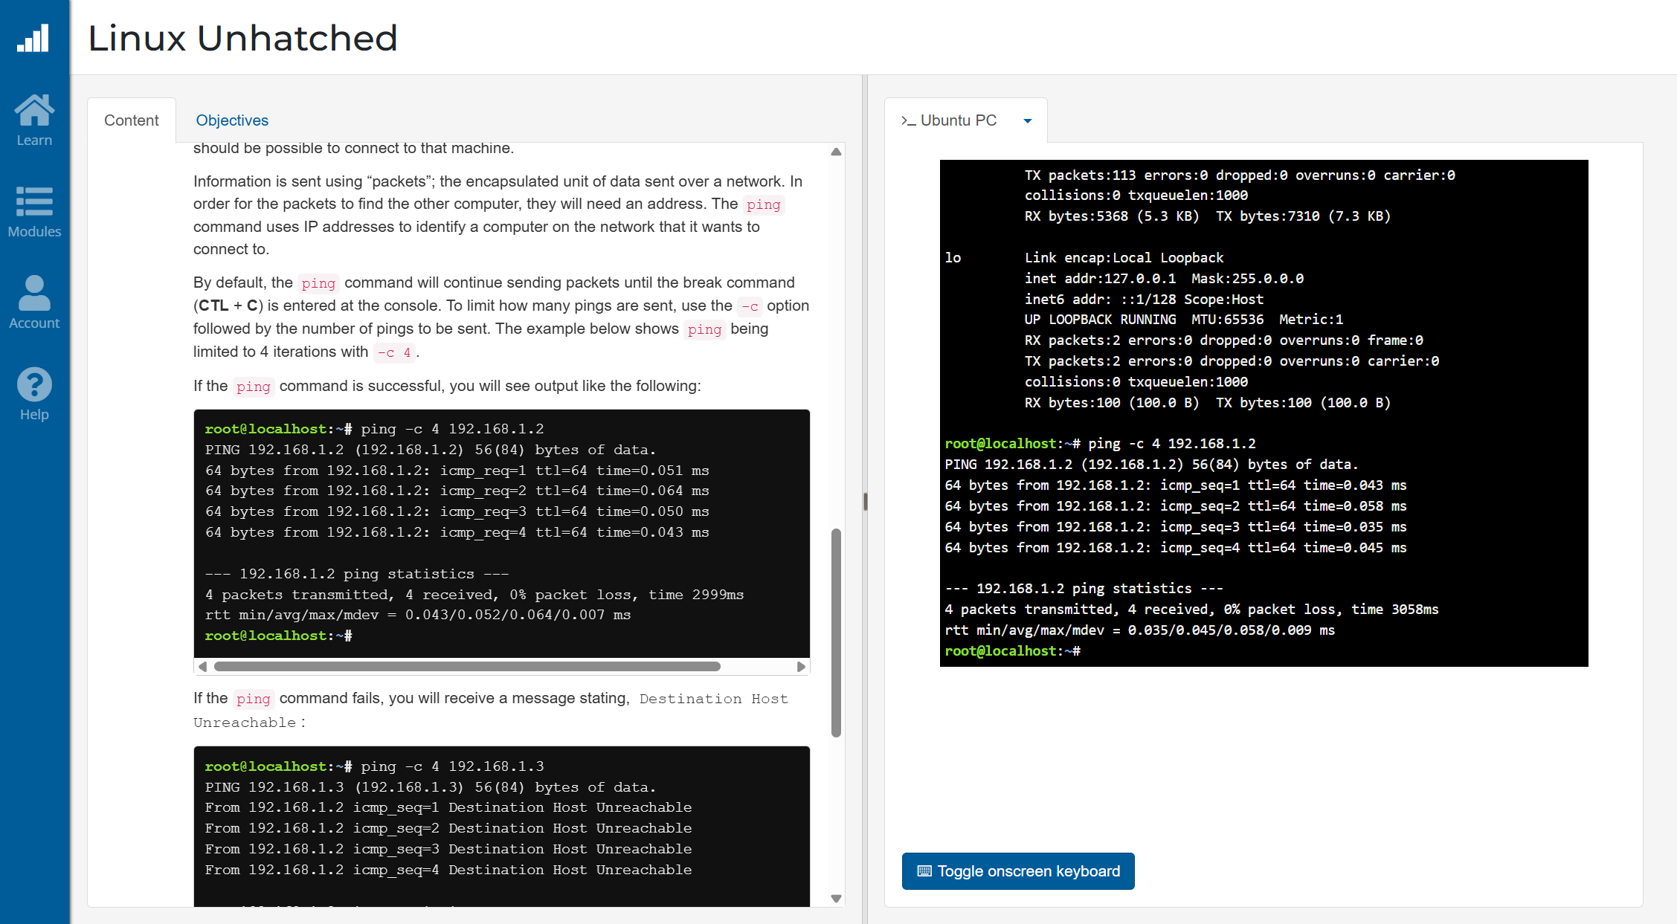

Fig. 71. Screenshot 8 of the certificate of the Cisco Linux Unhatched course, given upon completion of assessment.


