ECAD5008 - Leading the learning: what, how and why am I teaching?

Assignment Title - A written assignment critically evaluating how Assessment for Learning can be utilised in a series of learning opportunities to aid progression across chosen areas of learning and experience. (4000 words)

Introduction (approx. 750 words)
The purpose of this assignment is to focus on each of the four elements of assessment for learning while engaging in critical and in-depth background reading. To conduct a critical evaluation of the implementation of Assessment for Learning strategies for a group of learners, underpinning how they help aid progression across the six areas of learning and experiences. One of the twelve pedagogical principles listed in the Welsh Curriculum is assessment for learning. (Government, 2022) The Welsh Government suggest that Assessment for Learning plays an important approach to the role of assessment in the New Curriculum for Wales. There are four elements of assessment for learning which they suggest is what good assessment looks like, it involves sharing success criteria with learners, quality of questions/quality of talk, use and quality of feedback and peer and self-assessment. AfL helps pupils learn by having the teacher illustrate where the pupil is, what comes next in their learning, and how to get them there. (OECD, 2014)Teachers use strategies in the classroom to support children's achievements. Assessment for learning should be ongoing yet formative. (STIGGINS, 2005 )This could imply that AfL should become part of the teacher’s practice and that it’s important that the teacher must consider this progress throughout the academic year. Wiliam suggests that if AfL is successfully applied in a classroom setting, there could be many opportunities for progression. It may reduce the gap in achievement across the entire class and enhance standards of performance for every pupil, especially those with lower ability. (WILIAM, 1998)
As part of the assignment, I have selected three areas of learning and experiences and a theme to develop three lesson plans for a group of learners. For a year 5 class, which have various learning abilities, I will be planning lessons that show both progression and continuity. (Government W. A., 2010) I have created a selection of lessons which cover a range of skills covering three of the six areas of learning and experiences. The three areas I have selected to plan for are science and technology, mathematics, and language literacy and communication. I'll be interacting with the theme of Tudors by preparing a variety of fun and interesting activities that use a range of AfL strategies that consider all four elements of AfL. Since the children have already explored this topic once, they should have a solid understanding of the theme of "Tudors"
The AOLE I used in my first lesson plan was science and technology, the children carried out a marshmallow catapult investigation which will concluded whether the size of a marshmallow affects the distance travelled when launched from a catapult. The second AOLE I focused on was mathematics and numeracy. The children had to use different strategies and solutions such as addition, subtraction, and multiplication to solve money worded problem. The lesson however began with a presentation where the children learnt about the origins of money and how currency has changed in the United Kingdom throughout history such as Tutor times and right up until modern day. Finally, the last AOLE I had chosen was language literacy and communication. The children have been participating in a Talk for Writing Scheme. They have been looking at a warning story called ‘The Caravan’ They have begun planning for their own story as a class which is called ‘The Castle’ which is also a warning story. The pupils had to use the box plan created by the whole class in pervious lessons, to help engage them in shared writing by contributing ideas, sharing opinions, and collaboratively creating a piece of writing. They were then able to create their own piece of writing about their own warning story using the same structure as the shared write.

Literature Review (approx. 1,000 words)
Assessment for learning directs pupils’ progression, it is about finding out where a learner is, knowing where the learner needs to get to, and guiding the learner to get where they need to be. (Wiliam, 2005 ). This could suggest that to support both teachers and pupils in making progress in their learning, AfL strategies and procedures must be put into place within the classroom. An important component of teaching and learning in Wales is the New Curriculum for Wales. (Donaldson’s, 2015) A report from the Welsh Government focuses on how schools are developing effective approaches to assessment and improving teaching and learning. The main findings show that schools with effective assessment arrangements have clear and useful policies and practices that align with the principles and purposes of assessment in the Curriculum for Wales. (Government W. , Effective approaches to assessment that improve teaching and learning, 2022) Examples of effective assessment arrangements in primary schools involve practitioners being given support to develop a thorough understanding of assessment for learning, how it enhances pupils learning, and how it helps teachers improve the way they teach. This could suggest that planning for assessment for learning is crucial as well as being able to adjust teaching to support and challenge all pupils appropriately. (Government W. , Effective approaches to assessment that improve teaching and learning, 2022) Similarly, a guidance document also written by the Welsh Government provides essential information for practitioners which focuses on developing thinking and assessment for learning. The document suggests that some of the key principles and strategies for developing thinking and assessment for learning in the classroom is collaboration which allows learners to take sensible risks with their learning and move their learning and thinking forward. According to Benjamin Blumes, there are various areas of thinking, such as recalling, understanding, applying, creating, evaluating, and analysing. The children are encouraged to go from lower order to higher order thinking. (Bloom, 1956) Furthermore, the document suggest that challenge and interest can lead to motivation. I have ensured that my lessons encourage child participation and excites the pupils as well as ensuring they are developing their skills, knowledge and thinking. Benjamin Blume's theory of lower and higher order thinking suggest that teachers can differentiate their teaching and provide meaningful, challenging, and purposeful experiences for every child. (BeniAbdelrahman, 2020)
Assessment for learning plays an important role in supporting and challenging learners within the Curriculum for Wales. The purpose of assessment is outlined within the Curriculum to support practitioners and learners in understanding the role of assessment and progression. (Government W. , Assessment within Curriculum for Wales: Creating the culture, 2023) Assessment for learning can support both teachers and learners. This report suggest that assessment can support leaners on a day-to-day basis by identifying strengths, areas for improvement and any barriers to extending their learning forward. However, discussions between learner and teacher must be had to ensure the correct steps are provided for that pupil to move forward. D. Royce Sadler proposes that children need to know what to do and how to make wise decisions about what they know they are going to be judged on. (SADLER, 1989) This could suggest that great communication between child and teacher must be had and for the practitioner to fully support the needs of the child, AfL must be considered as ongoing and a part of the teacher’s continuum. The document also underlines the importance of planning and ensuring the children are presented with purposely enriched learning experiences. This could suggest that it is important that the teacher uses AfL strategies effectively by understanding what the assessment is for and the understanding of what will be gained from it. Therefore, by using these strategies a teacher should be informed what steps should be taken next for a child to progress such as interventions, extra support, and guidance. (Government W. , Assessment within Curriculum for Wales: Creating the culture, 2023)
Britton agrees that AfL is seen as a routine that is used on a regular basis, as a component of teaching practises and teaching for success. (Britton, 2015 ) This could suggest that assessment for learning is used as part of the teacher’s professional development, it is claimed to aid child’s success within the pupil’s educational journey. Blandford agrees that AfL empowers children to improve their learning, whereas he adds that by providing the children with opportunities to achieve this builds their self-esteem. (Blandford, 2011) This could be due to AFL focuses on the whole learning process rather than just the finished work of the learner. Wilis implies that children will have more of a positive learning experience because of this as he believes AfL encourages positive encounters between pupils and educators. (Willis, 2010) This may result in the pupils being made more aware that the teacher is there to help and to give them a fulfilling learning experience. Whilst AfL improves the teacher’s awareness of a where a child is at with their learning, it also gives the child an opportunity for growth, and ways for the teacher to best support their needs. Teachers therefore will be able to assess a child's progress using AFL. (Sammons, 2009 ) When AFL is implemented successfully in a classroom, children will be able to understand expectations. (Willis, Assessment for Learning as a participative pedagogy., 2010 )
Wiliams suggests that there are five essential AFL methods. (Wiliam P. B., 2018) Clarification, this is what the child needs to do, which is set out by the teacher, they must be provided with tools they use to accomplish it, a set of success criteria must direct them in the right direction. The third approach is engineering, which promotes discussion, it creates points of interest for discussion, and develops an environment in which pupils feel free to make mistakes and run into misconceptions. Providing, is the next step. He suggests that it helps us become excellent teachers by knowing how to give feedback. Wiliam implies that the feedback must be constructive but critical. Finally activating, these involves strategies that teachers can employ throughout a lesson to make the session fun and help aid child progression and participation. (WILIAM, 1998)

Discussion of lesson planning decisions (approx. 1,850 words)
Sharing Success Criteria / Peer-assessment and Self-assessment
One of the four elements of AfL is sharing success criteria with learners. (Gardner, 2011) Gardner suggest that children need to be provided a success criteria to ensure that they can understand what the teacher expects from them. Furthermore, for this reason, I have employed the WAGOLL approach, which stands for "what a good one looks like." The children can comprehend what is required of them as a result. The children could also benefit from having a greater understanding of the learning objectives and success criteria, which they can refer to while marking. This could have a significant impact on learning assessment. A child in the class may have made a WAGOLL, Donaldson suggest that it is crucial that as a practitioner, we pay attention to what the child has to say and write about what they believe success looks like. (DONALDSON, 2016) I agree with Donaldson as it is important that the children are involved in their own assessment process to develop and achieve success. According to Wolter, when children take an active role in their own learning, they learn more. (BERNADETTE VAN HOUT-WOLTERS, 2000) Whereas Fletcher suggest that good feedback is essential for growth, and children should be able to evaluate their own work as a result, the success criteria should be precise and straightforward. (Fletcher, 2004 ) This could suggest that children need to consider their goals for learning and what is needed for achievement therefore a clear success criteria must be shared with the pupils to do so.
One of the three lesson plans was science and technology. The children were given a worksheet with a clear example of how I would like them to write and present their science investigation plans in their books. Also known as WAGOLL. D Royce Sadler proposes that a child must understand the necessary quality that is like the teacher's. (SADLER, 1989) I chose two of the children's books to present as a WAGOLL to the rest of the class. As a practitioner I paid great attention to what the child has to say about why they think their work is considered as a WAGOLL, this enabled me to include the children in their own assessment process. I was asking the other children what makes this a WAGOLL, the children then referred to the success criteria which they had met. One of Williams five essential AFL methods is clarification, this is what the child needs to do, which is set out by the teacher, in my lesson this was the worksheet given to them and a WAGOLL of two of the children's own work. By getting the children to discuss each other’s work with their peers, they also developed peer and self-assessment. Vygotsky suggest peer-assessment is a great AFL strategy that can be utilized within the classroom and is evident when two leaners come together and discuss the learning regarding what needs to be done next and thinks of strategies of getting each other there. (Vygotskiĭ, 1987)
There can also be some limitations to presenting a WAGOLL as the children may copy this directly which means it won’t be their own work. The children may not comprehend any of the key information provided to them as they have all the information given to them. Therefore, this will make tracking progress more difficult and assesses where the child is with their learning will be more challenging. However, in my lesson the children were all carrying out the same investigation so the work that they were producing was very much the same. (DYSON, 2010)
Quality of questions and quality of talk
One of the four components of assessment for learning is the quality of questions and quality of talk. One of the two strategies I employ in my lesson plans to support AfL is hot seating. Prior to this lesson the children had been creating fact files about each of Henry VIII’s wives. The children had completed a fact file of each of the six-woman Henry had married and included information such as the order of the wives, the date of when each wife married Henry, their age, and the reasons for why the marriage had ended. Six of the children took it in turns to play a role in this approach, they then selected a character that is relevant to the lesson's topic or theme. The rest of the children in the class, then were able to activate their prior knowledge from the fact files to ask effective questions to guess that specific character. This AfL strategy was used to conclude this specific topic of Henry and his Wives. This method was employed to make sure the child in character can accurately respond to the questions. To help to enable children to ask purposeful questions and promote deep thinking in both the class and the child in character, the fact files that the children had created on the wives were positioned behind the pupils. According to Bloom, there are two distinct types of questioning: Bloom's lower and higher order thinking theory and Socratic questioning. (Nappi, 2017) My lesson plans incorporate the additional AfL technique of Edward De Bono thinking hats. He suggests that there are six distinct kinds of thinking hats, giving each one a meaning. Edward De Bono thinking hats are often used to help create balanced arguments by motivating the pupils to share their own view points. (Bono, 2000) In the classroom there is a display of the six different Edward De Bono thinking hats. The children were encouraged to refer to the meaning of the different hats. During this task the children were using the white hat as they were having to generate information and ideas about which wife was sitting in the chair. Thinking hats could help the child to evaluate their learning and thinking while promoting discussion. Opposed to Bloom's higher and order thinking, he applies adversarial thinking to parallel thinking. (Bono E. D., 2017)This could suggest that De Bono believes that since parrel thinking is the way to go, the children should be working together to ask the questions. During the ‘hot seat’ the children had the opportunity to work together to answer questions rather than compete with one another to get the right answer, this could improve the quality of talk and peer assessment. De Bono agrees that this encourages quality of the discussion and encourages a clever questioning technique. (Bono E. D., 2017)
My most recent lesson was Science and Technology. The learning intention was to design and create a catapult. I began the lesson by delivering a PowerPoint, introducing the concept of a catapult, how one works, a brief description of our investigation, the variables involved followed by a discussion about the risk assessment. The children then received a KWL chart. In the first column the children wrote down what they already know about catapults. This encouraged the children to activate their prior knowledge and connect what they already know with the new information given to them from the PowerPoint. With my lower ability group, we discussed what they already know about catapults and recorded them on the board to help aid those pupils. I felt like this motivated the children to want to know more.
The children were really engaged and showed interest in wanting to learn lots more about catapults. Finally, the 'L' or 'What I Have Learned’ is a great opportunity for the children to reflect on their learning and put together all the new information they have learned. I explained to the children that this was only to be filled out at the end of our investigation. Overall, I believe that there are many benefits to using this AfL strategy, the children were engaged and enthusiastic. They had made a good start to their KWL charts. This AfL strategy really guides the children’s learning not only at the start but the middle and throughout. (Joyce Hwee Ling Koh, 2015 )There was the opportunity for the children to learn from their peers by having discussions about what they know and what they would like to find out.
Williams suggests that there are five essential AFL methods. One of which is activating, these involve strategies that teachers can employ throughout a lesson to make the session fun and help aid child progression and participation. (WILIAM, 1998) The children participated well and were encouraged to want to learn more by thinking of questions they wanted to find out. I believe there are some limitations to using a KWL chart. They might not refer to the KWL chart and it may be quite misleading as they could have just taken ideas from their peers. So as teachers we might not get that full reflection on where they are with their learning. Also, the columns in the chart are designed to only fit a few bullet notes which doesn’t stretch the children’s learning as such. (Sastry, 2016)
Use and quality of feedback.
Assessment for learning contains four components, one of which is the quality and use of feedback. Mini plenaries are the method I've employed to promote this AfL aspect. The second AOLE I focused on was mathematics and numeracy. The lesson began with me presenting the children with a PowerPoint where the children learnt how money has changed throughout history. The main task was for the children to use different strategies and solutions such as addition, subtraction, and multiplication to solve money worded problem. A visual aid on how I wanted the children to present their sums and calculations was shown clearly on the board. Before allowing the children to begin their work I reinforced the RUCSAC method to aid the children when answering the questions and encouraged them to use highlighters to identify steps needed to solve the problems. The children were engaged and participated well in the warm up activity. During the warm up activity, the children were encouraged to talk to their talking partners to discuss answers in which I was asking them. I gave them time to think independently, then work with a peer then encouraged the pupils to share their ideas with the class.
During the lesson I walked around the class, scanning the classroom to identify if pupils were on task or needed any support. I was also live marking during the act of production whilst going around the classroom, I would use a green pen to correct an error and show that there is room for growth and a pink for good feedback. Additionally, I would keep a record of the level of support the child needed high, moderate, independent and record this in their books towards the end of the lesson. Live marking when appropriate ensures the children are on track and avoids any misconceptions and opportunity for the child to correct their work before carrying on. (Nancy Frey, 2011) I also performed some mini plenaries, known as pit stops to the children. The PIT STOP allowed me to choose using lolly pop sticks children to share some of their work with the class and allowed me to check for progress, track learning and avoid any misconceptions before moving on.

Spendlove agrees that mini plenaries could be used an excellent tool for teachers to assess how a pupil is doing during the act of production which is useful for assess if the child understands what they should be doing and to support those children who need it. (Spendlove, 2009)As a result, the children were able to comprehend where they are in the lesson and where they need to go next. The children were able to stay on track with their learning. It also serves as a chance for a quick ‘pit’ stop where pupils can correct any errors and make changes to their learning before the lesson ends. Following my lesson plan, I would ask a volunteer to showcase their work in front of a live camera, and then we would talk as a class about whether the child is achieving the success criteria and learning intentions. This allows opportunity for quality of questioning, self-assessment, peer assessment as well as use of quality and use of feedback. According to D. Royce Sadler, learners must keep an eye on their work while it is being developed. (SADLER, 1989)

Conclusion
In conclusion, this assignment has explored how assessment for learning strategies can help aid progression and support teaching and learning across the six areas of learning and experiences. Assessment for learning focuses on the learning process rather than just the finished work. It helps teachers identify where students are struggling and support their needs. There are several assessment for learning techniques teachers can use like sharing success criteria, providing feedback, using questioning to check for understanding, and mini plenaries during lessons. Sharing success criteria with students helps them understand what is expected of them. It should be specific, measurable, attainable, relevant and time bound. Using a WAGOLL (what a good one looks like) example can also help students understand the success criteria. Furthermore, effective questioning and discussions can improve the quality of talk in the classroom. Techniques like hot seating, thinking hats, and KWL charts can activate students' prior knowledge and engage them in the lesson. Providing timely feedback through methods like mini-plenaries and live marking during lessons allows pupils to correct mistakes immediately and stay on track with their learning. Therefore, for assessment for learning to be effective, children need to understand the quality of work expected of them and take an active role in assessing their own progress. The four elements of assessment for learning work to better support pupils' learning and progression.

Appendix 1 (Science and Technology)

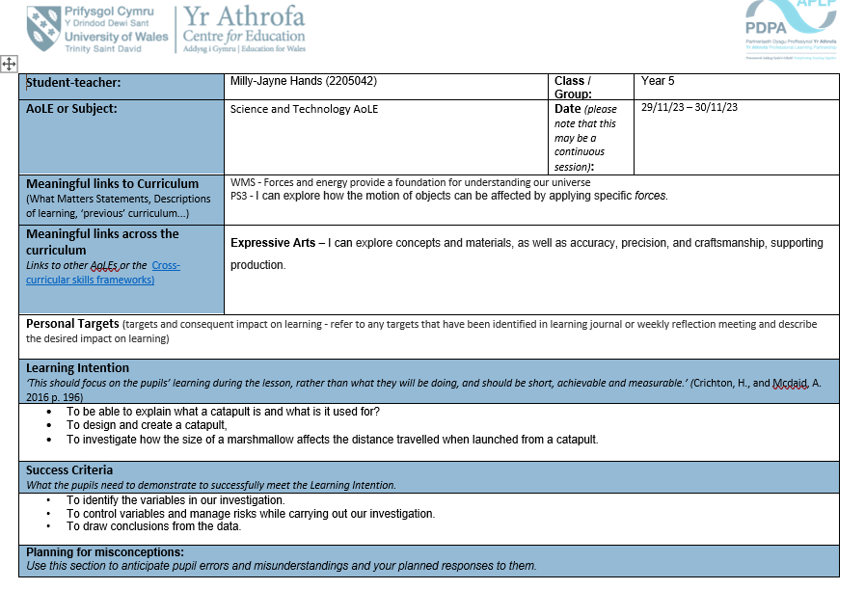
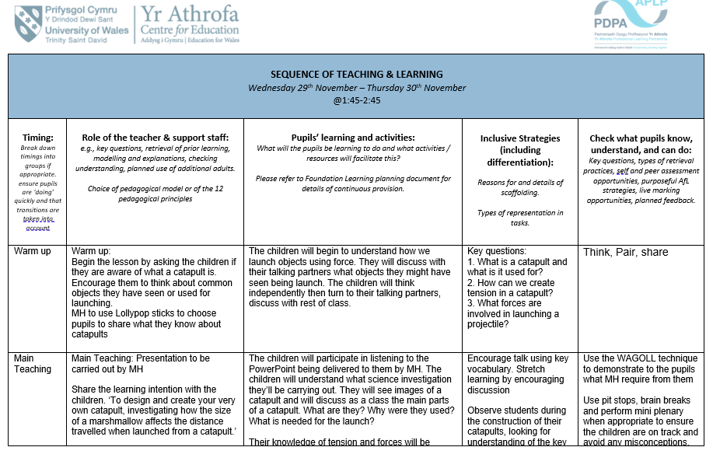
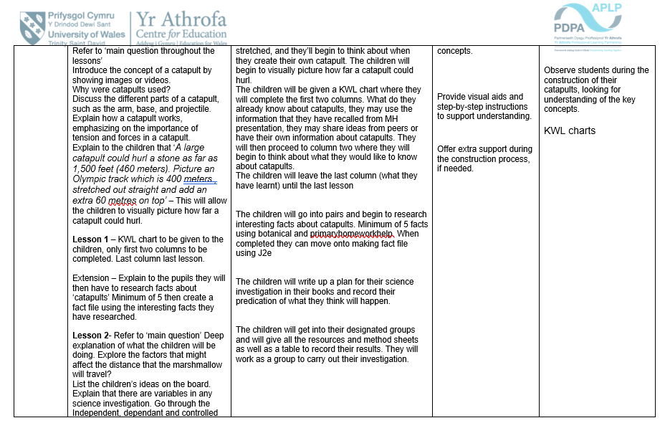
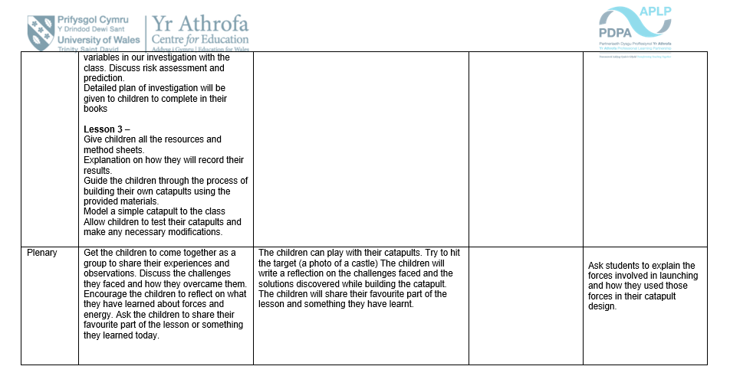

Appendix 2 (Mathematics and Numeracy)

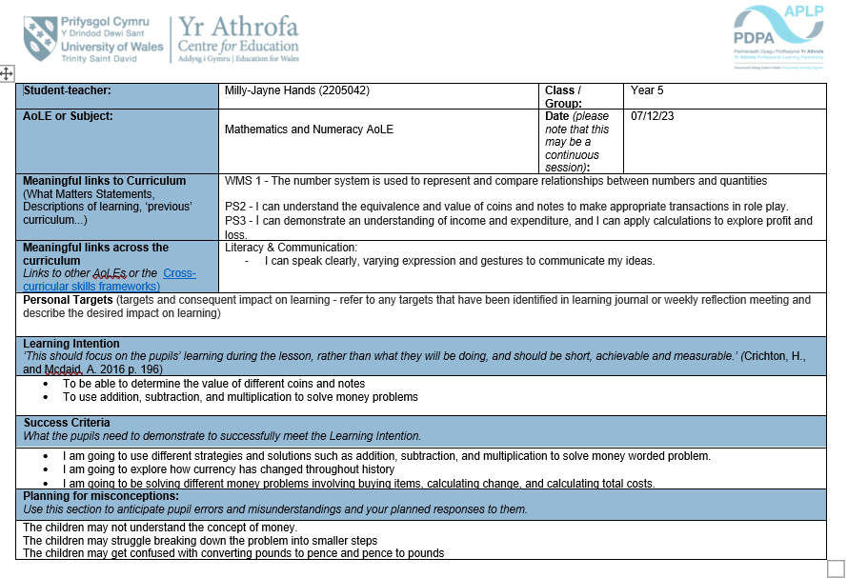
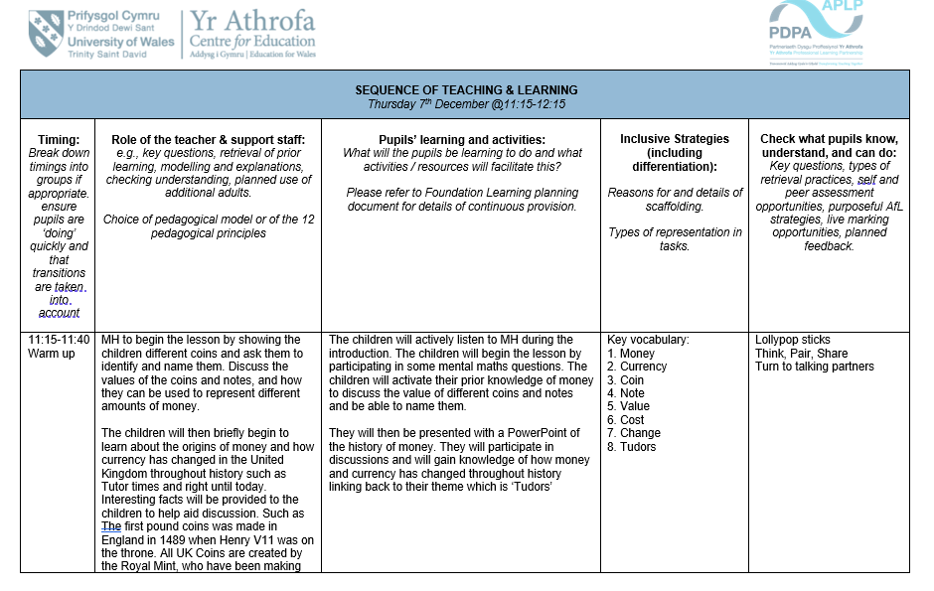
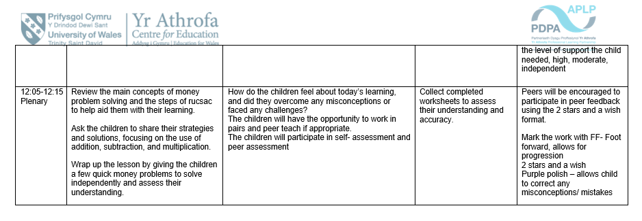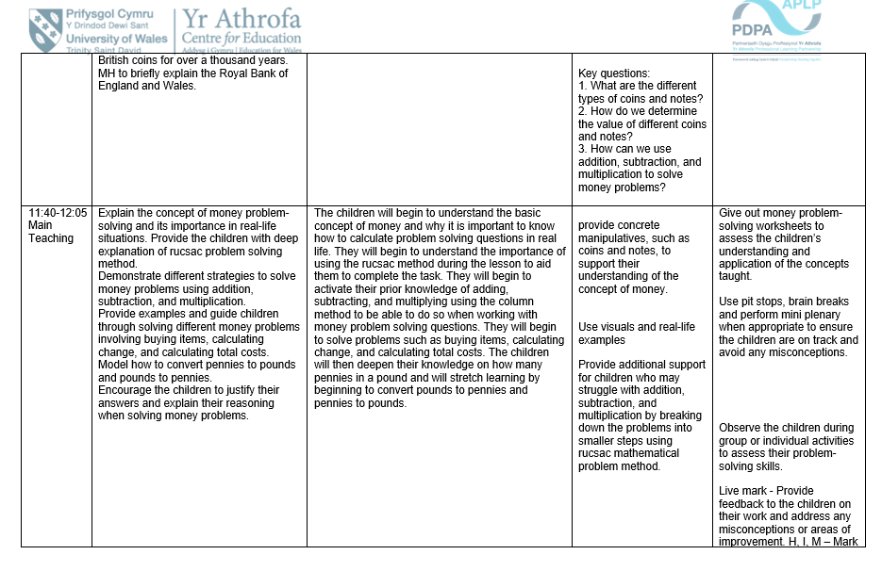

Appendix 3 (Language, Literacy and Communication)

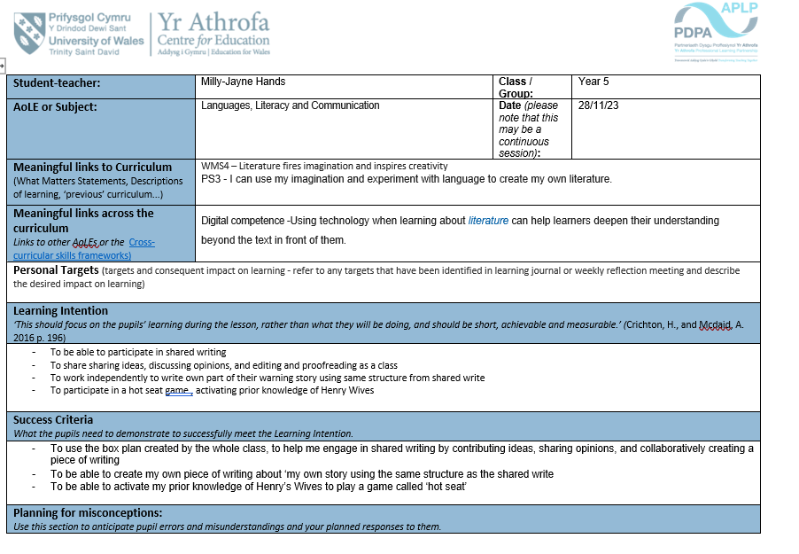
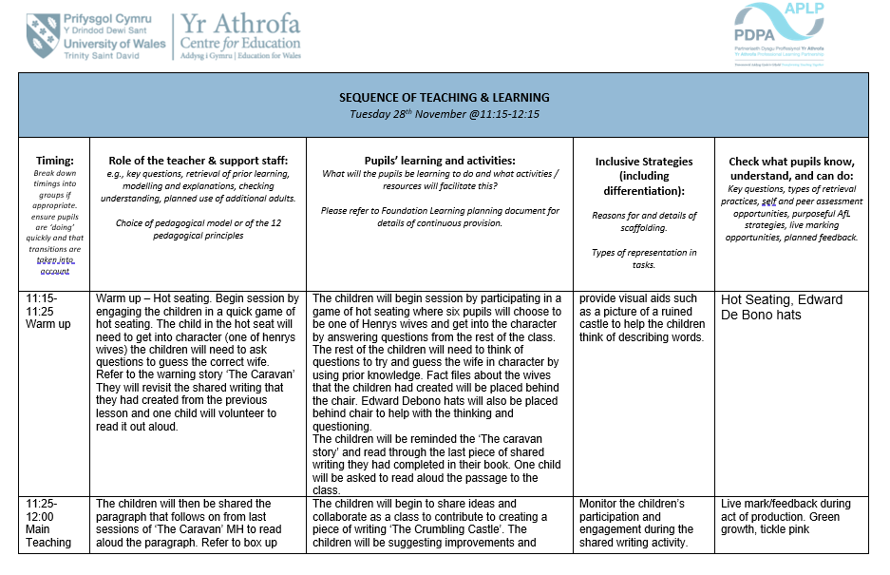
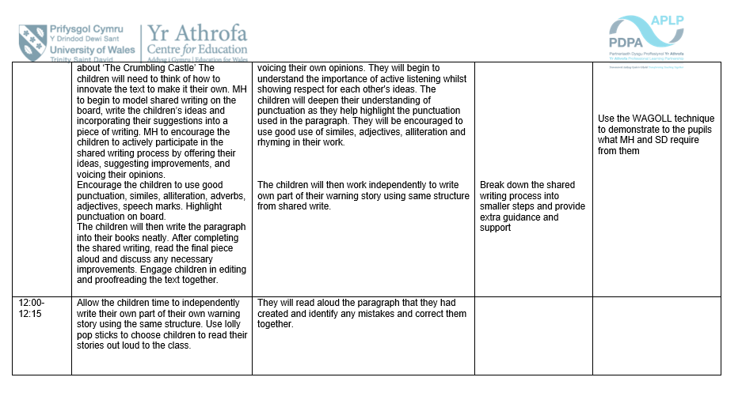

References
BeniAbdelrahman, R. Q. (2020). THE HIGHER AND LOWER-ORDER THINKING SKILLS.
BERNADETTE VAN HOUT-WOLTERS, R.-J. S. (2000). ACTIVE LEARNING: SELF-DIRECTED LEARNING AND INDEPENDENT WORK.
Blandford, P. S. (2011). Assessment for Learning: a model for the development of a child’s self competence in the early years of education. 11.
Bloom, B. S. (1956). Taxonomy of Educational Objectives, Handbook 1: Cognitive Domain.
Bono, E. d. (2000). S IX THINKING HATS. United Kingdom : Penguin Books.
Bono, E. D. (2017). Parallel Thinking.
Britton, A. M. (2015 ). Assessment for Learning in teaching English to Young Learners: teachers’ understanding, classroom practice and impact on interactions. 227.
DONALDSON, P. G. (2016). A Systematic Approach to Curriculum reform in Wales . Wales.
Donaldson’s, P. G. (2015). Successful Futures Looking at the Curriculum and Assessment Arrangements in Wales. Wales.
Drummond, B. M. (2006 ). How teachers engage with Assessment for Learning: lessons from the classroom. Cambridge .
DYSON, A. H. (2010). Writing childhoods under construction: Re-visioning ‘copying’ in early childhood.
Earle, S. (2019). Assessment in the Primary Classroom : Principles and practice.
Fabienne M. Van der Kleij, J. A. (2015). Integrating data-based decision making, Assessment for Learning and diagnostic testing in formative assessment. Netherlands: Faculty of Behavioural Science, University of Twente .
Fletcher, C. (2004 ). Appraisal and Feedback: Making Performance Review Work.
Gardner, J. (2011). Assessment and Learning . SAGE publications .
Government, W. (2022). Effective approaches to assessment that improve teaching and learning.
Government, W. (2022, July 13). Scoping study for the evaluation of the curriculum and assessment reforms in Wales: final report. Retrieved from https://oro.open.ac.uk/84542/1/Duggan%20et%20al%202022%20Scoping%20study%20for%20the%20evaluation%20of%20the%20curriculum%20and%20assessment%20reforms%20in%20Wales%20final%20report.pdf
Government, W. (2023). Assessment within Curriculum for Wales: Creating the culture.
Government, W. A. (2010). How to develop thinking and assessment for learning for learning in teh classroom . Wales.
Hearn, J. H. (2008 ). Student Self-Assessment: The Key to Stronger Student Motivation and Higher Achievement.
Joyce Hwee Ling Koh, C. S.-Y. (2015 ). Design Thinking and In-Service Teachers.
Moss, C. M. (2022). Learning Targets and Success Criteria. Routledge.
Nancy Frey, D. F. (2011). The Formative Assessment Action Plan.
Nappi, J. S. (2017). The Importance of Questioning in Developing Critical Thinking Skills.
OECD. (2014). Improving Schools in Wales: An OECD Perspective. Wales.
SADLER, D. R. (1989). Formative assessment and the design of instructional systems.
Sammons, M. T. (2009 ). Assessment for learning: effects and impact . London .
Sastry, K. S. (2016). "Effective and Active Learning in Classroom Teaching through Various Methods.
Spendlove, D. (2009). Putting Assessment for Learning Into Practice.
STIGGINS, R. (2005 ). From Formative Assessment to Assessment FOR Learning: A Path to Success in Standards-Based Schools. 328.
Vygotskiĭ, L. S. (1987). Problems of the Theory and History of Psychology.
Wiliam, D. (2005 ). FORMATIVE ASSESSMENT: DEFINITIONS AND RELATIONSHIPS. London .
WILIAM, P. B. (1998). Inside the Black Box Raising standards through classroom assessment . London .
Wiliam, P. B. (2018). Assessment in Education: Principles, Policy & Practice. Routledge.
Willis, J. (2010 ). Assessment for Learning as a participative pedagogy. 12.
Willis, J. (2010). Assessment for Learning as a participative pedagogy.

