
Postgraduate/Distance Learning
Assignment coversheet & feedback form

THIS SHEET MUST BE THE FIRST PAGE OF THE ASSIGNMENT YOU ARE SUBMITTING (DO NOT SEND AS A SEPARATE FILE)

For completion by the student:
Student Name: Colleen Galloway

Student University Email: 1603269@student.uwtsd.ac.uk
Module code: HPCA7014  Module title: Sacred Geography | Student ID number:  1603269 |  |  | Educational support needs:  No
Assignment title:
Does the standing stone burial chamber of Pentre Ifan continue to be a sacred space?

Assignment due date: 12 January 2023
This assignment is for the 1st 2nd 3rd 4th x 5th 6th module of the degree
I confirm that this is my original work and that I have adhered to the University policy on plagiarism.
Signed C. Galloway
Email submission:if you are submitting this form via email, please tick this box □
(as a substitute for your signature) to confirm that you agree to the above declaration.
Assignment Mark
1st Marker’s Provisional mark
2nd Marker’s/Moderator’s provisional mark
External Examiner’s mark (if relevant)
Final Mark

NB. All marks are provisional until confirmed by the Final Examination Board.

For completion by Marker 1 :
Comments:

Marker’s signature: |  |  | Date:
For completion by Marker 2/Moderator:

Comments:

Marker’s Signature: |  | Date:
External Examiner’s comments (if relevant)

External Examiner’s Signature: |  | Date:

Does the standing stone burial chamber of Pentre Ifan continue to be a sacred space?

Introduction
The aim of this research paper is to answer the question, whether the Pentre Ifan burial chamber continues to be a sacred space or is it, in fact just an impressive monument whose time as a sacred space has passed, along with the memory of those who built it. The location of this site adds to its mystique, which is what has drawn me to use this site for my research.
Pentre Ifan burial chamber is described as one of Wales’ best-known ancient sites. As the description suggest it was used as a site that would have honoured those who have died within the New Stone Age, around 5,500 years ago. Pentre Ifan was built using local bluestone from the Preseli Hills, they may even have come from the same quarry as the Stonehenge bluestone. With this thought in mind the paper will also explore the possibilities of the following lines of enquiry.
Is it the stone that gives a feeling of sacredness to the site or the site itself? Why does the capstone appear to be pointing? The cap stone is impressively heavy, so to have been lifted and placed pointing precisely north towards the iron age village of Castell Henllys why? Is there significance to this alignment? This research paper will aim look at the solar system, as well as the landscape for possible links to this significance.
Pentre Ifan is a Neolithic dolmen located within the Pembrokeshire National Park, with the Ordnance Survey map reference being SN099370. The address is registered as being Nevern, Crymych SA41 3TZ which is situated 2.9 miles from the village of Nevern, 11 miles from Cardigan town and 3 miles east of the town of Newport in Pembrokeshire. However, if you travelled directly north from Pentre Ifan in just over one and a half miles you would reach the iron age village of Castell Henllys.
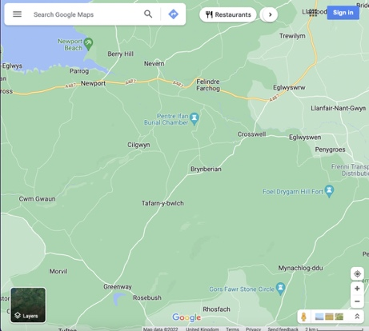
Figure 1 Google Maps, area map, 2022 digital image, Image: google maps/Google Terms Of Service
Figure 2 Author, map showing the line between Pentre Ifan and Castell Henllys, 2022, digital photo, Newport. Image: Colleen Galloway.
I have been to make multiple visits to Pentre Ifan, this has given me the ability to be able to reflect not only on my experiences, but also on my observations of the landscape and other people I observed while there. Some of the visitors were totally coincidental whilst other were planned, with the view of observing their interaction and looking for signs that the site was sacred to them. Although I did not interview any of them, I was able to observe their body language and interaction with the monument during these times. These observations are my field notes, and it is these notes that I will draw upon when asking the question, does the standing stone burial chamber of Pentre Ifan continue to be a sacred space?

Academic Rational
Tim Ingold’s theory on how places are connected through a series of points will help when looking at the link between Pentre Ifan and other burial chambers within Pembrokeshire such as Carreg Coetan. Tim Ingold, Lines, (Abingdon: Routledge, 2016) chapter 3.
Christopher Tilly’s theory on the power of place will support the thinking as to why Such magnificent monuments were built as burial chambers, and how they continue to capture the people who visit them. Christopher Tilly, A Phenomenology of Landscape Places, Paths and Monuments, (Oxford: Berg Publishers, 1994) P. 26
Emile Durkheim’s theory about how a sacred place needs to be maintained by the collective to enable it to remain a sacred space, will help to support the fact that Pentre Ifan is still a sacred site, since people still visit and maintain a respect for not only the site but the landscape around it. Emile Durkheim, The Element Forms of Religious Life, (New York: The Free Press, 1995)

Robin Heath’s theory on the alignment of Pentre Ifan and how the burial chamber, sun and moon are aligned with the significant focal point on the surrounding landscape, especially during significant times of the year such as the summer and winter solaces. He also supports Ingold’s theory of lines and how there are connections to other key points, within the landscape and beyond. Robin Heath, Bluestone Magic A Guide to The Prehistoric Monuments of West Wales, (Pembrokeshire: Bluestone Press, 2010)

Methodology
I will begin my research by familiarising myself with the Pentre Ifan site. This according to Tilly it is not something that comes within the first visit but takes time to feel the atmosphere and tune into what the site has to say, which is imperative when undergoing a personal phenomenological inquiry such as this research project. (See Tilly 1994, p. 12, 26 and 75.)
I will also look at not just the landscape but also the stones themselves. I will be visiting the site at times when I am feeling well and then comparing it to times, where I have a headache or not feeling great mentally to explore the possibility of the stones healing power. Timothy Darvill chapter on prehistoric stone working in South-West Wales where he describes the bluestone as “maintaining the well-being of individuals and the community. (See Darvill, 2011, p131-146.)
Due to Pentre Ifan being of national importance to Wales the site is visited by people throughout the day, however due to the weather at this time of year, there is the possibility, that less people will visit at the same times that I do. So, to support my research, I therefore will need to ensure that during some of my visits, there will be people there that I will be able to observe. I therefore will be increasing my observation chances by taking different people with me during my visits.

During these visits I will take photographs using a range of cameras, this giving different perspectives. I will make notes of the feeling Pentre Ifan gives me and other key findings during my observations. I will be spending time amongst the stones getting to know how they feel, gaining a clear understanding of the impact the stones have on a person. I will also be going to Pentre Ifan using different methods and directions, in which to arrive at the site to see if this enhances the sacredness.

As I will be observing how different people interact with not only the stones but also each other during the time they spend there, it will be critical that I do not influence those whom I am with. This is something that I will need to be always mindful, even when taking pictures, it will be imperative for me to allow those who I am observing, to do what comes natural to them. My observations notes will then be used to either support the argument that a sacred place needs to be maintained to remain sacred or disprove it. (See Durkheim 1995, p.36.)

As I will be researching the possibility of Pentre Ifan being a place of sacredness, I will need to be mindful of the theory that emotions can affect the way that a person views a place. The way that a person is feeling will have a great impact on their ability to listen to what the place has to say. (See Aristotle 2020, p. 17.) Therefore, when writing my notes, I will need to record any apparent emotions within not only myself, but those who I am observing.

Reflective Considerations
I am middle aged female with a keen interest in historic stone structures, especially sites which are surrounded in mystery. I am lucky to live near the Preseli Hills, which is not only the location of Pentre Ifan, but also many other stone anomalies. I am a keen walker and have spent time visiting Pentre Ifan along with the landscape that surrounds it, and will continue to do so for the duration of this research project. Although I was brought up within the catholic faith, I no longer consider myself to be a catholic, however I am still interested in religion, just from the perspective that, there are other beliefs and their practices hold merit too, such as Buddhist meditation.

Literature review
Pentre Ifan is described as a Neolithic Burial Chamber, however there is no evidence of a burial, instead there is this a monument that, as suggested by Christopher Tilly is ‘ritually important’ at the top of the monument is a capstone that looks as if it follows the same outline of Carn Ingli. The Positioning of this capstone is not only almost mythical as to how it got there, but also the monument, as Robin Heath suggest is liked to other key points throughout the area. Something that Tilly also suggests. The links to other anomalies within the landscape is something that this paper aims to research, with the possibility that it adds to the sacredness of Pentre Ifan.

Timothy Darvill suggests that the Preseli blue stone, with which not only Pentre Ifan is built, but other sacred monuments, such as Stonehenge, are believed to have bluestone incorporated into their design too. This bluestone is believed to omit a healing power. This is evident as, within some cultures, they even use pieces of bluestone as lucky charms. This adds to the suggestion made by Douglas Davis, where he suggests that such places that are associated with dead bodies, are not just there for the body or even as memory. But that they are there to bring people together, helping them to cope with the emotions that are associated with death. This will help support the feeling that are felt whilst visiting the site.

For some cultures this is more of a celebration of life, and therefore not seen as a place of sadness. Davis also suggests that Durkheim’s view is that when death and morning need to be done in public, tears are a sign of respect for the dead. Although both would be acceptable it would have to depend on the circumstances. for example, a pure cremation where there is not family involvement during the time, they collect the body and the ashes are returned, no member of staff is expected to cry. However, Davies does suggest that people have been paid to wail, in historic times. This will support the actions and language of the people who go to Pentre Ifan.

Fieldwork and Discussion
Location
Greiner suggests that open spaces were needed to give the inhabitants a ‘space to heal’. Which is supported by Tilly where he suggests that the power of a place helps us to make sense of the world in which we live in, and in the case of Pentre Ifan, they will need time to process the passing of a loved one. This healing would have been essential at Pentre Ifan burial chamber as no matter who you are everyone one is affected in some way by the loss of a loved one. At the time Pentre Ifan was built the only permanent resting places were used for honouring the dead, which then suggests that the dead were looked after differently from today. However, standing there today I get the feeling of space and calmness which is the key to being able to self-heal. This sense of space is due to the wide-open fields with only a few surrounding farms, that cannot be seen from the monument itself, therefore leaving an uninterrupted view of the landscape.

The air itself has a purity about it, that you can almost taste. Although there is a small road leading to Pentre Ifan it is not one that has traffic continually driving along it. During my many visits I only met a car coming in the opposite direction once, and although there is parking for around five or six cars, I only once found it full, this could be due to the time of year. Although Pentre Ifan is of national importance, due to it being the ‘largest and best-preserved dolmen in Wales, there is little to do at the site once you have viewed the monument and taken pictures, suggesting that most people only stay for short periods of time.

Tilly suggests that little has changed regarding the forest that is dominated by Oak, hazel and alder, and that some of the oak trees are hundreds of years old. When wandering through this enchanted forest, on one occasion I did spot the most amazing toad stall, that looked fresh out of a story book, it was such a vivid red colour that gave it an almost magical appearance. Tilly suggests that Pentre Ifan would have once been home to bos, pig, but now there few wild animals left, although you may be lucky enough to spot a deer, however on my forest wandering I was not lucky enough to spot one. You would not find bos or pigs there now, due to our animal husbandry regulations. There are sheep in the adjoining fields to Pentre Ifan, with a fence protecting the monument from any damage they may cause.

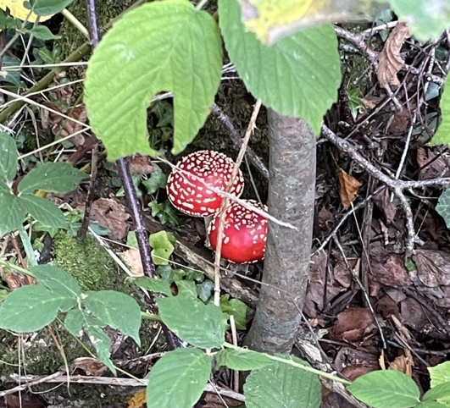
Figure 3 Author, Vivid red toadstool, 2022, digital photo, Pentre Ifan Woods. Image: Colleen Galloway.
Tilly suggest that for a site to be of significance, it would also, have lower land and water. As is clear when viewing the site today there would have been an abundance of natural resources that are needed to sustain life and promote not only growth in its human inhabitants, but their crops and livestock too. The immediate location of Pentre Ifan would not immediately offer the resources that are required, however if you walk a short distance then you would be able to find fresh water, as even from standing next to the monument, you can hear the running of water. You could also forage for food within the forest, so long as you know what you are doing, the vivid red toadstool would not be edible and could kill you.

Bill Bevan suggests that Pentre Ifan would have once been covered in earth, but it is unclear to what extent this would have been, as today all that remains is the outline of the eighteen-foot-long mound, leaving the skeletal structure in full view. In my view this is more spectacular as you can clearly see the giant capstone balancing on the thin ends of the three horizontal pillars. This is amazing how it has remained like this for the past five thousand years, and even more of an achievement was the fact they did this using only the basic tools that were available in the early Neolithic period. Thus, adding to the sacredness of the structure.

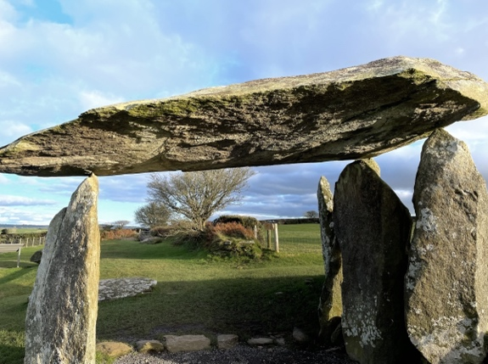
Figure 4 Author, Balancing Cap Stone, 2022, digital photo, Pentre Ifan, Image: Colleen Galloway.

Lines
Tilly suggests that sites such as Pentre Ifan, where a monument has been placed would have not been chosen lightly. It would have been a site that held a value for those people living in the area, connecting it to significant features within the surrounding landscape. This could then help to explain why Pentre Ifan was built in this exact location. It holds the key features that Tilly suggests as being significant such as, water, wood, stone, and the high ground being the hills and rocky outcrops that can clearly be seen, and which can be linked to the sun as it sets falling majestically down following the outline of the landscape.

This alignment, during the time when Pentre Ifan was in use, marked significant events such as the summer and winter solstice. Although the sun does rise and fall in the same general locations, Robin Heath suggests that due to the earths movement this is not as prominent as it would have been in the past. According to the Stanford Solar Centre, they state that “the sun only rises due east and sets due west on two days of the year”, this coincides with equinoxes. This would then lead to the suggestion that the Neolithic people who built Pentre Ifan having been able to view this alignment and mark it on these important dates.

However, the Stanford Solar Centre suggests that it was common practice for people in the prehistoric cultures to use landmarks for tracking the sun. This being backed up by Heath who suggests that during Neolithic times these alignments would have been key to understanding the season cycles and as such being guided as to when to plant and harvest crops and move livestock. He suggests such sites as Pentre Ifan were called ‘backsights. To this day farmers are still guided by the seasons, to maintain their crops.

One reason behind the sacredness feeling that Pentre Ifan emits, could also be because the sun apparently, sets following the angle of the rocky outcrop on top of the Preseli Hills when viewed from the centre of the monument, thus linking the sun, sky, and monument together. Although Heath explores this from a scientific perspective, at the time of building Pentre Ifan they relied on more practical reasoning. However, from my many visits to Pentre Ifan I have discovered that this is not something that can easily been seen. This suggests that for the people who use these methods of tracking time, dedication and patients was needed. This is also true of those trying to capture it on camera today. This alignment was not something that I was able to view and verify during the winter solstice due to cloud coverage encasing the sun and therefore blocking it from my view.

Brian John describes the area as being land, that is open common land, made up of cotton grass bog, dry heath, and heather moorland. He suggests that there are still traces of old trackways that were used during the Neolithic and Bronze age occupation, with some of these trackways still being used today. It was evident that trackways are in use throughout the woodland within the local area, although it is not evident that these are the same trackways that was used by the Neolithic people.

Although you can freely wonder around the area, Pembrokeshire Coast National Park have an array of guided walks, one of which is the Pentre Ifan woods short walk. There is a free printable map which can be found on their website. This map will help guide you through the terrain whilst also giving you an insight as to what you are looking at during the walk, with points of interest and tracks clearly marked.

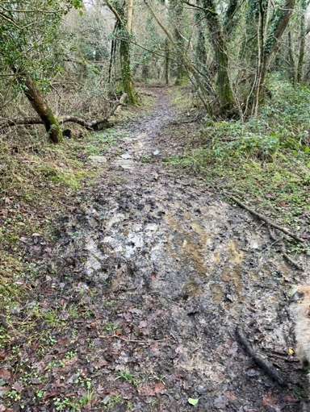
Figure 5 Author, Pentre Ifan wood track, 2022, digital photo, Pentre Ifan woods, Image: Colleen Galloway

On one of my visits to Pentre Ifan I decided to check my compass and see what direction the capstone was pointing, to my surprise the stone is pointing directly to the north directly towards castell Henllys. Once I was home, I decided to check the map to see what other key points were also in line with Pentre Ifan. When I marked the places of interest on the map, Pentre Ifan appeared to be a central point, within the area. Although you cannot view them from Pentre Ifan.

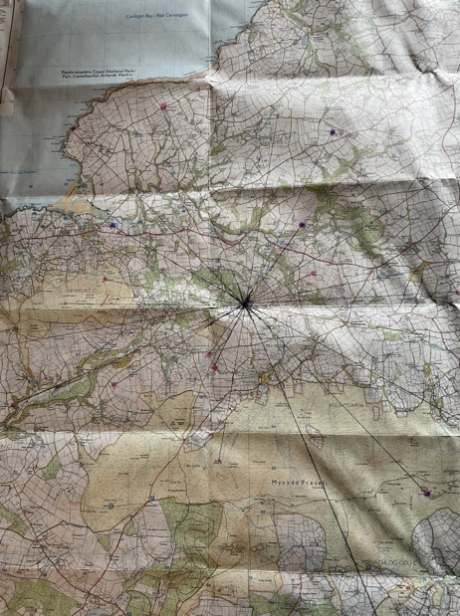
Figure 6 author, Lines Showing The Connection Of Places Connected To Pentre Ifan, 2022, digital photo, Newport. Image: Colleen Galloway.

These sites are all within easy travelling distance of each other, and are sites such as stone circles, standing stones and settlements. The standing stones could have been put there as markers to the monument, as previously suggested Douglas suggests that places such as Pentre Ifan were constructed to bring people together. Therefore it would make sense that markers were used to lead the way. This was just my observations from walking around the area and by studying the map, however Ingold suggests that although a well-worn route may be clear, at times they may have needed other makers to lead the way.

Observations
During my many visits to Pentre Ifan I have found that I am continually drawn to standing with my back against the singular upright stone that is supporting the curved end of the capstone. looking north from the capstone towards Castell Henllys, from this standpoint I am not able to view the structure, but just feel and listen to what it is saying. I did not make a conscious decision to stand in this spot, however when reading through my field notes and looking at my pictures this has been the case. There is no clear reasoning behind my chosen spot as it holds no seating or shelter, but whilst standing in there, I get the feeling of being calm and relaxed more than anywhere else within the site.

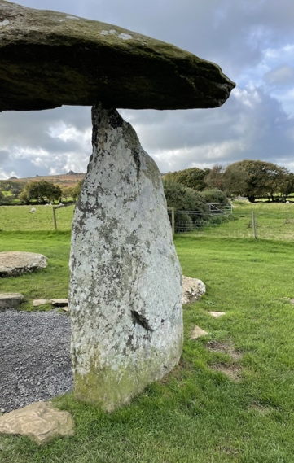
Figure 7 Author, Standing Positions Of Author Whilst At Pentre Ifan, 2022, digital photo, Pentre Ifan. Image: Colleen Galloway

I was not tuned into the sacredness at every visit, one such time was during the winter solace. I had been anticipating this day for weeks, constantly checking the weather, with the hope that it would be a clear sky. When the day finally arrived, so did the forecast of rain. This was when I should have changed my mindset to the disappointing fact that I would not witness the spectacular sunset from Pentre Ifan. That according to Robin Heath would fall following the outline of the rocky outcrop that proudly adorned the top of the Preseli Hills. This alignment could have even contributed to the placement of Pentre Ifan monument.

It was a mistake to raise my expectation because I was so disappointed, I could not feel the sacredness that I had felt before. Aristotle suggest that for a place to persuade a person that it omits a sacredness, it relies on the person to have an open mind that is opened to listening to what the place has to say. Therefore it is best to keep your expectations low and mind open, this way you can let the site talk to you. If you are entering with a pre-set mindset then your observations may be swayed into believing what it was that you expected to see or feel instead of what was portrayed during the visit.

Graham Harvey suggests that to truly understand, you not only have to observe what happened but to also participate, to understand what it truly would feel like. This is something that I was trying to do regarding the sunset over Pentre Ifan. I wanted to experience the impact of the sunset has on the sacredness of such sites, gaining a better understanding of why this location was chosen. Instead, I was frustrated and could not tune into the space at all.

As Pentre Ifan is Wales best preserved Neolithic burial chamber, I did expect it to be busy, observing numerous visitors during my visits. However, on my first few interactions I found myself in complete isolation. This was fantastic from the point of view of being able to tune into the calmness of the site and listen to what the site had to say, without the distraction of other people. However, my solitude was soon interrupted, and I have yet to find myself in the peacefulness that I once encountered. Since this time, there has been a steady stream of people eager to get a glimpse of this sacred monument.

One such occasion was, as I was walking down the track to return home, an elderly gentleman came shuffling slowly along the track supported by a woman on each arm. They were holding him in such a gentle embrace that it was clear that they were close, there were other people with them on what appeared to be a family outing, with young children running around and laughing. The two women held the man so protectively throughout his short journey, it was clear from the determination on the man’s face that he was going to achieve his goal and sit on that rock.

Once he had made it to the horizontal stone, they placed him gently down. They could be visiting, because as, Timothy Darvill suggest, that the bluestone that was used to build monuments such as Pentre Ifan were seen as having healing properties. From just my observations it was clear that this was more than a casual trip out, as there are no facilities and during December, so the weather was not great. This would suggest that this was more of a family healing time, which is what Darvill suggest monuments such as Pentre Ifan were used for. It did appear that this was a sacred space for the family, somewhere that they could celebrate life, or as Sayer suggest it could be a place where they could heal.

First school visit to Pentre Ifan. We took 20 pupils with learning differences to Pentre Ifan, this was a planned stop on the way to the park, although the pupils were not aware of this prior to stopping. This was a short visit just to observe how they would interact with the site. None of the pupils had visited Pentre Ifan before this visit.

The pupils ran down the path towards the burial chamber laughing and playing tag, except for one pupil who walked slower than normal and appeared to be in deep thought. As with most of the pupils within this group, this pupil is on the autistic spectrum. When asked what she was thinking about she replied “people”. This is not unusual for this child as she will normally relay facts about people who have died, giving dates and other information about them.

As we approach the chamber all the other pupils were still running around trying to climb the stone, however they soon realised that this was an impossible task. At the same time the one pupil just sat on the flat stone humming to herself. This was not a tune that I had heard her hum before, although this is something that she does. After about 10 minutes the other pupils got bored and were keen to go to the park. Before leaving we gathered them around the information board and read the information to them.

Second school visit to Pentre Ifan. This was a planned trip with the pupils having learnt more about the site and been shown the YouTube clip of the Pentre Ifan Fairies. As Natalie Niblet suggests people who are local to an area can sometimes invent stories that add to the mythology and sacredness of a landscape. This is evident with the legends of the Pentre Ifan Fairies, however not all folklore is as imaginary as fairies. The pupils were keen to make this visit as they knew what to expect while there.

Rituals
The pupils had done some work on Pentre Ifan and had already visited the site on one other occasion, this meant that they knew why they were going there and what it was that they would be doing. On this occasion the pupils were there to perform some music and dance as if it was in the Neolithic times using traditional instruments. I was keen to see if as suggested by Aristotle emotions play a part in the sacredness of a place. At first, I was feeling anxious as I knew that the pupils would be upset if they got something wrong. As the music started, I felt a calm wave come over me, with goose bumps, I felt as if I had been transported back in time. This for me made the site feel more sacred. As we were leaving, some of the pupils wanted to leave offerings for the fairies, this showed that they felt the place was special too.

Figure 8 Author, Pupils Playing Instruments At Pentre Ifan, 2022, digital photo, Pentre Ifan. Image: Colleen Galloway

Figure 9 Author, Pupils Dancing At Pentre Ifan, 2022, digital photo, Pentre Ifan. Image: Colleen Galloway

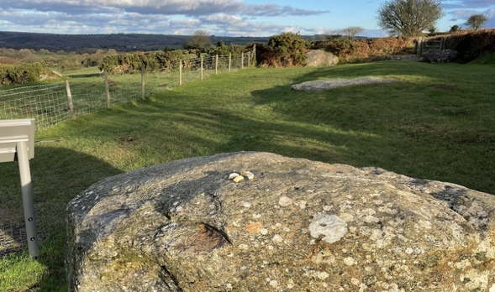
Figure 10 Author, Pupils Offering At Pentre Ifan, 2022, digital photo, Pentre Ifan. Image: Colleen Galloway

Harvey suggests that the solstices along with the equinoxes are celebrated in some form by many people no matter what their beliefs are. This would support the reasoning why Pentre Ifan is linked to the solstices, due to its positioning within the landscape. Harvey further suggests that the solstices celebrations would not just last the time it takes for the sun to set, but that the pagans would continue celebrating the dead by using light in the form of candles in their homes once the sun had set. Harvey also suggesting that over half of the Pagan festivals have links between the sun, earth, and moon, and are even still to this day place significance to these links.

Ancient Origins witter Riley Winters suggests that the Pagan stems from the Latin word Paganus which translates into ‘country dweller’ or ‘rustic’. Which in the time in which Pentre Ifan was used for ceremonies the people who predominately would have used the site would have been Neolithic people who lived a rustic life in the countryside. Adding to the belief that during the Neolithic occupation of Pentre Ifan, a vast amount of people incorporated the pagan beliefs into their daily lives, which again would support the use of the site as a sacred one.

Bill Bevan suggests that the religious leaders of the time would have performed ceremonies at the front of the monument, this could be a reason why I feel drawn to standing in this spot. He does suggest that there is a clear link between the Gods, earth, and the dead during these ceremonies. However Douglas Scott suggests, that during the Neolithic period, not only was Pentre Ifan, built with celestial connections, there were also other sacred sites, that were built with similar sun and moon alignments, where ceremonies were also held to honour the dead. Douglas Scott also suggest that it is these alignments that adds a sacredness to the magnificent monument. Today you can even attend a wicker man ceremony, at Castell Henllys which I have attended, this gave a true insight into what it would have felt like to be part of such celebrations.

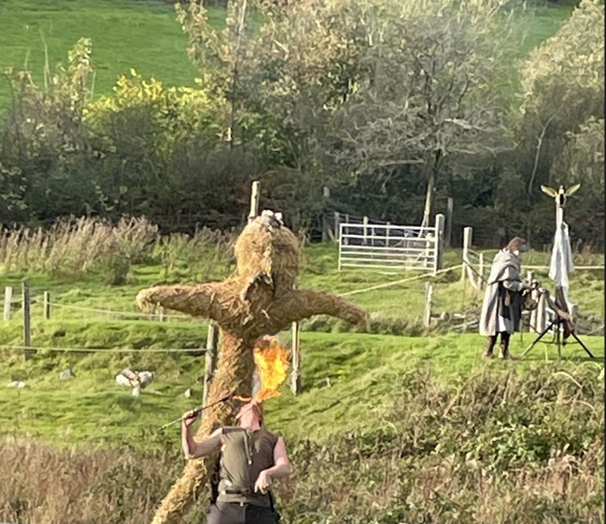
Figure 11 Author, Wicker Man Ceremony At Castell Henllys, digital photo, Castell Henllys. Image: Colleen Galloway.

Conclusion
The aim of this research was to answer the question, is Pentre Ifan a sacred site? To be able to produce a comprehensive paper, I have spent many hours either at the monument itself or within the surrounding area. This as been taking photos and notes of the things that I observed. I did this because, having lived in the area for years, I have always been drawn to exploring the Pentre Ifan landscape.

Within this research I have explored the possible links between Pentre Ifan and other local rock anomalies, supported by both Tim Ingold and Robin Heath. I also explored the reasoning behind why such monuments would have been built in the first place, as well as to why it was placed in the location that it was, supported by Christopher Tilly. While also observing the way that people responded to the site whilst they were there, particularly looking for signs of them maintain the site as a sacred one, supported by Emile Durkheim.

Upon collecting all my evidence from not only my own research, but also the work of the academics who’s work I have drawn upon. From this I have concluded, that from my observations of both the visitors and the location itself, there does appear to be something special about Pentre Ifan. The way that others have behaved during the time that they have spent there, shows the characteristics of respect, which is what you expect at a sacred place.

For myself I have found Pentre Ifan to be sacred most of the time, however at times my emotions did prevent me from connecting to the sacredness. I did find that when I was physically connected to the stones it gave me a calm feeling, almost healing. If I had longer to complete my research, or if it had been during the summer months when the weather was warmer and days longer, I may have found sacredness on more occasions. However, as emotions play a part in connecting to the sacredness of a place, I am not convinced that this would have been the case. I did find that the places that were linked to Pentre Ifan, also had something special about them, I could not define this as sacred as my visits were short, and this was not long enough to really connect with the sites, however I did find the woods to be magical.

5252 words

Bibliography

Aristotle, and Freese, Henry, J, Art Of Rhetoric, trans. By John Henry Freeze, (Cambridge, MA: Havard University Press, 2020) dio: 10.4159/DLDL.aristotle-art_rhetoric.2020
Bevan, Bill, Walking Into Prehistory, Discovering Over Forty Sites Of The Greatest Acient Sites Of Britain And Ireland, (London: Frances Lincoln LTD, 2011)
Darvill, Timothy, Misty Mountain Hop: Prehistoric Stone Working In South-West Wales, in Stone Axe Studies III, ed. By Vin Davies and Mark Edmonds (Oxford: Oxbro Books, 2011), pp. 131-146
Davies, Douglas, J., A Brief History Of Death, (Oxford:Blackwell Publishing Ltd, 2005)
Greiner, D. Rae, ‘Negative Response: Silence in Gretel Ehrlich’s The Solace of Open Spaces’, Women’s Studies, 29.2 (2000), 217–48
Harvey, Graham, Listening People Speaking Earth Contemporary Paganism, (United Kingdom: C. Hurst & Co. Publishers Ltd., 1997)
Heath, Robin, Bluestone Magic A Guide To The Prehistoric Monuments Of West Wales, (Pembrokeshire: Bluestone Press, 2010)
Ingold, Tim, Lines, (London: Routledge, 2016)
John, Brian, The Stonehenge Bluestones, (Pembrokeshire: Greencroft Books, 2018)
Leighton, Stephen R. “Aristotle and the Emotions.” Phronesis, vol. 27, no. 2, 1982, pp. 144–74. JSTOR, http://www.jstor.org/stable/4182148 Accessed 10 Dec. 2022.
Pembrokeshire Coast National Park, Pentra Ifan Short Walk (2022) < https://www.pembrokeshirecoast.wales/things-to-do/walking-in-the-park/web-walks/pentre-ifan-wood/> [accessed 29 November 2022]
Pembrokeshire Coast, Pentra Ifan Faries (2022) < https://www.pembrokeshirecoast.wales/about-the-national-park/culture-and-heritage/land-of-legends/pentre-ifan/> [accessed 16 November 2022]
Saints and stones, Pentre Ifan Burial Chamber Pembrokeshire, Wales,< http://www.saintsandstones.net/stones-pentreifan-journey.htm > [accessed 22 December 2022]
Sayer, Duncan, ‘Who’s Afraid Of The Dead?’, Archaeology, Modernity And The Death Taboo, 42.3 (2010), 481-491 (p.484) URL:< https://www.jstor.org/stable/20799442 > [accessed 01 December 2022]
Scott, Duglas, The Temples Of The Sun And Moon, 2020 < https://theorkneynews.scot/wp-content/uploads/2020/12/6-The-Temples-of-the-Sun-and-Moon-Orkney.pdf> [accessed 29December 2022]

The Stanford Solar Centre, Where Does The Sun Rise And Set, < http://solar-center.stanford.edu/AO/sunrise.html> [accessed 21 December 2022]
Thorley, Anthony and Brady, Bernadette, Sacred Geography Spica Postgraduate Journal For Cosmology In Culture, Vol IV No 2 2016 The Sophia Centre Press < http://www.sophia- project.net/Spica > [accessed 01 December 2022]
Thorley, Anthony and Brady, Bernadette, Sacred Geography Spica Postgraduate Journal For Cosmology In Culture, Vol IV No
Tilly, Christopher, A Phenomenology Of Landscape Places, Paths And Monuments, (Oxford: Berg Publishers, 1994)

Winters, Riley, The True Meaning Of Paganism, 2014 < https://www.ancient-origins.net/myths-legends/true-meaning-paganism-002306> [accessed 21 December 2022]

Christopher Tilly, A Phenomenology Of Landscapes Places, Paths And Monuments, (Oxford: Berg Publishers, 1994) p.105
Pembrokeshire Coast, Pentra Ifan Faries (2022) < https://www.pembrokeshirecoast.wales/about-the-national-park/culture-and-heritage/land-of-legends/pentre-ifan/> [accessed 16 November 2022]
Robin Heath, Bluestone Magic A Guide To The Prehistoric Monuments Of West Wales, (Pembrokeshire: Bluestone Press, 2010) p.164
Christopher Tilly, A Phenomenology Of Landscapes, p. 105
Timothy Darvill p. 138
Douglas J. Davies, A Brief History Of Death, (Oxford:Blackwell Publishing Ltd, 2005) p.115
Douglas J. Davies, A Brief History Of Death, p.115
Douglas J. Davies, A Brief History Of Death, p.124
Douglas J. Davies, A Brief History Of Death, p.124
Rae, D. Greiner, Negitive Response: Silence In Gretel Ghrlich’s The Solice Of Open Spaces, Women’s Studies, Vol. 29.5 (2000) pp. 217-248, P.225
Christopher Tilly, A Phenomenology Of Landscapes p. 26
Rae, D. Greiner, Negitive Response, p.225
Saints And Stones, Pentre Ifan Burial Chamber Pembrokeshire, Wales, < http://www.saintsandstones.net/stones-pentreifan-journey.htm> [accessed 22 december 2022]
Christopher Tilly, A Phenomenology Of Landscape, p. 83
Christopher Tilly, A Phenomenology Of Landscape, p. 22
Bevan, Bill, Walking Into Prehistory, Discovering Over Forty Sites Of The Greatest Acient Sites Of Britain And Ireland, (London: Frances Lincoln LTD, 2011) P.67
Christopher Tilly, A Phenomenology Of Landscape, p. 25
Robin Heath, Bluestone Magic A Guide To The Prehistoric Monuments Of West Wales, (Pembrokeshire: Bluestone Press, 2010)
The Stanford Solar Centre, Where Does The Sun Rise And Set, < http://solar-center.stanford.edu/AO/sunrise.html> [accessed 21 December 2022]
The Stanford Solar Centre, Where Does The Sun
Robin Heath, Bluestone Magic P.80
Robin Heath, Bluestone Magic P.80
Brian John, The Stonehenge Bluestones, (Pembrokeshire: Greencroft Books, 2018) P. 18
Pembrokeshire Coast National Park, Pentra Ifan Short Walk (2022) < https://www.pembrokeshirecoast.wales/things-to-do/walking-in-the-park/web-walks/pentre-ifan-wood/> [accessed 29 November 2022].
Douglas J. Davies, A Brief History Of Death, p.115
Tim Ingold, Lines, (London: Routledge, 2016) p.78
Robin Heath, Bluestone Magic
Aristotle, and John Henry Freese, Art Of Rhetoric, trans. By John Henry Freeze, (Cambridge, MA: Havard University Press, 2020) dio:10.4159/DLDL.aristotle-art_rhetoric.2020 P.17
Graham Harvey, Listening People Speaking Earth, (United Kingdom: C. Hurst & Co. Publishers Ltd., 1997) P. viii
Timothy Darvill, Misty Mountain Hop: Prehistoric Stone Working In South-West Wales, in Stone Axe Studies III, ed. By Vin Davies and Mark Edmonds (Oxford: Oxbro Books, 2011), pp. 131-146 (p.138).
Timothy Darvill, Misty Mountain Hop, p.131
Duncan Sayer, ‘Who’s Afraid Of The Dead?’, p. 484
Pembrokeshire Coast, Pentra Ifan Faries (2022) < https://www.pembrokeshirecoast.wales/about-the-national-park/culture-and-heritage/land-of-legends/pentre-ifan/> [accessed 16 November 2022].
Anthony Thorley and Bernadette Brady, Sacred Geography Spica Postgraduate Journal For Cosmology In Culture, vol IV No 2 the Sophia Centre Press < http://www.sophia-prodject.net/spica > [accessed 01 December 2022]
Aristotle, and John Henry Freese, Art Of Rhetoric, p.17
Graham Harvey, Listening People P.6
Graham Harvey, Listening People P.7
Riley, The True Meaning Of Paganism, 2014 < https://www.ancient-origins.net/myths-legends/true-meaning-paganism-002306> [accessed 21 December 2022]
Bevan, Bill, Walking Into Prehistory, P.67-68
Bevan, Bill, Walking Into Prehistory, P.68
Scott, Duglas, The Temples Of The Sun And Moon, 2020 < https://theorkneynews.scot/wp-content/uploads/2020/12/6-The-Temples-of-the-Sun-and-Moon-Orkney.pdf> [accessed 29December 2022]

