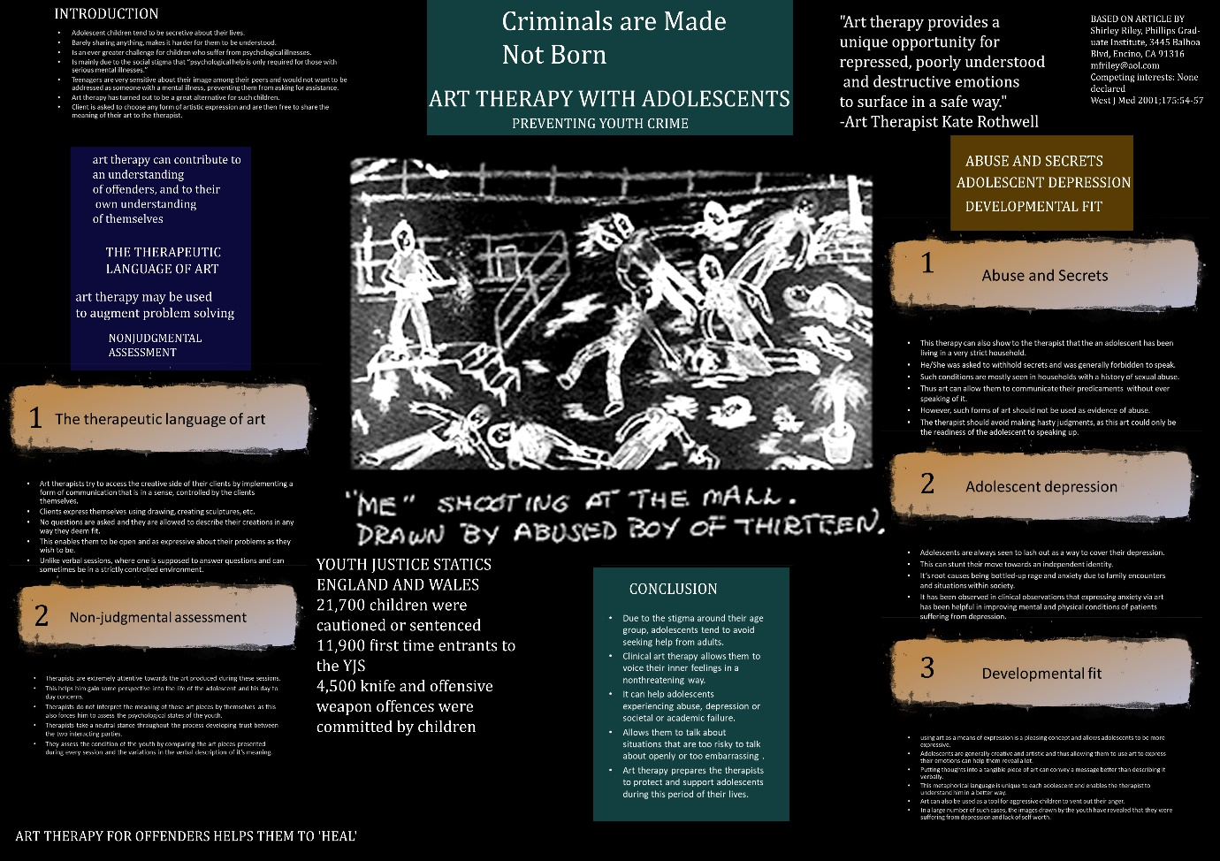

Reference

1 Blos P. On Adolescence. New York: The Free Press; 1962. 2 Bloch HS. Adolescent Development, Psychopathology, and Treatment. New York: International Universities Press; 1995. 3 Malmquist CP. The Handbook of Adolescence. New York: Jason Aronson; 1978. 4 Fishman HC. Treating the Troubled Adolescent. New York: Basic Books; 1988. 5 Landgarten H. Clinical Art Therapy. New York: Brunner/Mazel; 1981. 6 Oster GD, Gould P. Using Drawings in Assessment and Therapy. New York: Brunner/Mazel; 1987. 7 Riley S. Contemporary Art Therapy with Adolescents. London: Jessica Kingsley; 1999. 8 Seigal D. The Developing Mind. New York: Guilford; 1999. 9 Silver R. Draw a Story. New York: Adlin Press; 1988. 10 Silver R. Sex differences in the solitary and assaultive fantasies of the delinquent adolescent and non-delinquent adolescent. Adolescence 1996;31:543-552. 11 Malchiodi C. Breaking the Silence. New York: Brunner/Mazel; 1990. 12 Gleick J. Chaos: Making a New Science. New York: Viking-Penguin; 1987. 13 Riley S, Malchiodi C. Integrative Approaches to Family Art Therapy. Chicago: Magnolia Street; 1994.

ORIGINAL ARTICLE THAT I CHOSE FOR MY POSTER

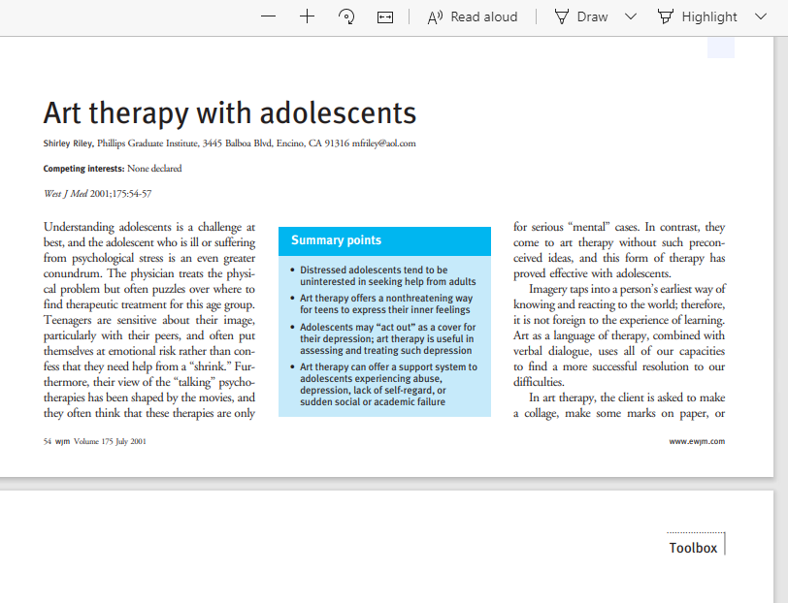

The Book Review


