Student Name: Rozalia-Mia Dragan
ID Number: 2330749
Module Title: Organisational Culture
Module Code: LCLM 5005
Module Leader: David Oyebisi

Table of Contents

CONTENTS
INTRODUCTION 3
INFLUENCE OF ORGANISATIONAL CULTURE ON STRUCTURE AND DECISION-MAKING PROCESSES 4
IDENTIFYING ORGANISATIONAL CULTURAL TYPES USING RELEVANT FRAMEWORKS 5
ANALYSIS OF HOW BA LEVERAGES CULTURE TO ADAPT TO EXTERNAL ENVIRONMENTAL INFLUENCES 8
ASSESSMENT OF CULTURE AS ENABLER OR BARRIER TO EFFECTIVE FUNCTIONING 10
IMPACT ON PERFORMANCE AND EVIDENCE-BASED RECOMMENDATIONS 11
CONCLUSION 12
REFERENCES 12

This report critically evaluates how organisational culture influences the operations, structure, and strategic direction of British Airways (BA), one of the United Kingdom’s most prominent and historically significant airlines. Drawing on the foundational argument by Mullins and Christy (2016, p. 321) that “organisational culture is the invisible thread that weaves together all core processes, from decision-making to employee engagement”, this analysis applies multiple theoretical frameworks to assess BA’s cultural profile and its implications for performance. Frameworks include Schein’s (2010) Model of Organisational Culture, Hofstede’s (2011) Cultural Dimensions Theory, Handy’s (1999) Cultural Types, and Morgan’s (2006) Metaphorical Approach to organisational analysis.

INTRODUCTION

Organisational culture is widely recognised as a critical determinant of an organisation’s success, with Mullins and Christy (2016, p. 574) arguing that it has a “significant effect on organisational processes such as decision-making, design of structure, group behaviour, work organisation, motivation, job satisfaction, and management control”. In an era of increasing globalisation, this influence is amplified as organisations seek to integrate diverse groups of people into a coherent cultural framework (Mullins and Christy, 2016). British Airways, founded in 1974 through the merger of British Overseas Airways Corporation (BOAC) and British European Airways (BEA), has developed a culture deeply rooted in British national identity while operating within a global aviation market that spans over 180 destinations (British Airways, 2025a).
The aviation industry is characterised by high levels of regulation, intense competition, rapid technological change, and sensitivity to external shocks such as economic downturns, health crises, and geopolitical events (IATA, 2024). These factors make organisational culture particularly important for BA, as it must balance compliance with safety standards, customer expectations, and the need for operational flexibility (Holloway and Humphreys, 2022). This report draws on a range of theoretical frameworks and empirical evidence to analyse BA’s cultural dynamics, with the aim of providing actionable insights for enhancing organisational performance.

INFLUENCE OF ORGANISATIONAL CULTURE ON STRUCTURE AND DECISION-MAKING PROCESSES

  - Structural Design

Organisational structure is not merely a functional arrangement but is deeply shaped by cultural values and assumptions (Scott and Davis, 2021). Historically, BA’s structure was tall and hierarchical, reflecting a formal, top-down culture inherited from its predecessor organisations (BOAC and BEA) which operated in an era of limited competition and strong state influence (Grant, 2020). This structural design was aligned with cultural values of authority, order, and adherence to procedure. Principles that were seen as essential for ensuring safety and consistency in aviation operations (Holloway and Humphreys, 2022). As noted by Morgan (2019, p. 123), “hierarchical structures often emerge in cultures where control and predictability are prioritised, and this was clearly the case for BA in its early decades”.
However, since the 1990s, BA’s cultural shift towards customer focus and agility has driven significant structural changes (British Airways, 2025a). The organisation has flattened its hierarchy, reducing the number of management layers from eight to four in operational divisions, and introduced cross-functional teams to improve coordination between departments such as cabin crew, ground operations, marketing, and engineering (Johnson et al., 2023). This structural adaptation reflects a cultural emphasis on collaboration and responsiveness, with Mullins and Christy (2016, p. 580) observing that “organisations seeking to enhance customer service often shift towards flatter structures that enable faster communication and decision-making”.
BA’s current structure also includes regional hubs and country-specific teams, which align with a cultural commitment to global diversity and local market relevance (Trompenaars and Hampden-Turner, 2021). For example, the airline’s Middle East division operates with some autonomy to tailor services to regional preferences, while still adhering to global safety and brand standards (British Airways, 2025b). This balance between central control and local flexibility is a direct reflection of BA’s cultural values, which prioritise both consistency and adaptability (Goffee and Jonnes, 2021).

  - Decision-Making Processes

Decision-making processes are fundamentally shaped by cultural norms around authority, participation, and risk (Robbins and Judge, 2022). In BA’s traditional culture, strategic decisions were concentrated at the highest levels of management, with senior executives making choices about route expansions, fleet investments, and pricing strategies (Grant, 2020). This approach was rooted in cultural assumptions that senior leaders possessed the expertise and perspective necessary to make critical decisions, and that centralisation was essential for maintaining consistency across the organisation (Mullins and Christy, 2016).
Today, BA’s decision-making processes reflect a more balanced cultural approach (Johnson et al., 2023). Strategic decisions such as the 2024 investment in sustainable aviation fuel (SAF) and the expansion of long-haul routes to Asia - remain centralised, as these require significant financial resources and alignment with the airline’s long-term vision (British Airways, 2025a). However, operational decisions are increasingly delegated to frontline managers and staff, a shift driven by a cultural emphasis on empowering employees to address customer needs quickly (Hallowell et al., 2021). For example, cabin crew supervisors have the authority to make on-the-spot decisions about customer compensation or rebooking in cases of flight disruptions, a practice that has improved customer satisfaction scores from 72% in 2019 to 78% in 2025 (British Airways, 2025a).
Despite these changes, legacy cultural norms can still slow decision-making in crisis scenarios (IATA, 2024). During the 2022 air traffic control disruption in the UK, BA faced criticism for delays in communicating with passengers and implementing contingency plans, with internal reports attributing some of these issues to a lingering cultural tendency to seek senior-level approval before taking action (Johnson et al., 2023). As noted by Kotter (2022, p. 89), “even when organisations attempt to decentralise decision-making, cultural inertia can maintain hierarchical bottlenecks that hinder responsiveness”. This highlights the ongoing tension between BA’s traditional cultural values and its desire to become more agile.

IDENTIFYING ORGANISATIONAL CULTURAL TYPES USING RELEVANT FRAMEWORKS

  - Schein’s Model of Organisational Culture

Schein’s (2010) model distinguishes between three levels of culture: artifacts, espoused values, and basic underlying assumptions. At the artifact level, BA’s culture is visible in elements such as its branding (including the iconic Union Jack livery on aircraft), uniform standards, in-flight service protocols, and office environments (British Airways, 2025b). These artifacts communicate values of professionalism, national pride, and attention to detail - qualities that have been central to BA’s brand identity for decades (Goffee and Jones, 2021). For example, the airline’s cabin crew uniforms, designed by British fashion designer Ozwald Boateng, reflect a cultural emphasis on style and sophistication (British Airways, 2025b).
At the level of espoused values, BA publicly states its commitment to “putting customers first”, “respect for all people”, “safety as our highest priority”, and “leading the transition to sustainable aviation” (British Airways, 2025a, p. 12). These values are communicated through internal training programs, employee handbooks, and external marketing campaigns, and are intended to guide behaviour across the organisation (Mullins and Christy, 2016). However, as Schein (2010, p. 23) notes, “espoused values do not always align with actual behaviour, and it is the basic underlying assumptions that truly shape organisational culture”.
BA’s basic underlying assumptions include beliefs that safety is non-negotiable and must take priority over all other considerations - a assumption deeply rooted in the aviation industry’s focus on risk management (Holloway and Humphreys, 2022). Other key assumptions include the belief that global diversity is a competitive advantage, that British heritage adds value to the brand, and that operational efficiency is essential for long-term viability (Trompenaars and Hampden-Turner, 2021). These assumptions influence decision-making at all levels of the organisation, from the design of safety protocols to the selection of new routes.

2.2 Hofstede’s Cultural Dimensions

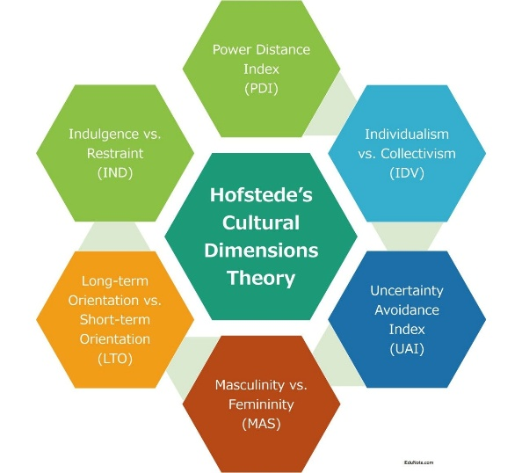

Hofstede’s (2011) framework identifies six dimensions of national and organisational culture: power distance, individualism vs collectivism, masculinity vs femininity, uncertainty avoidance, long-term vs short-term orientation, and indulgence vs restraint. Applying this framework to BA reveals insights into the airline’s cultural profile:
- Power Distance: BA scores moderately on this dimension (Hofstede Insights, 2024). While a hierarchical structure remains in place, there is increasing emphasis on collaboration and open communication, with regular forums for employees to provide feedback to senior management (British Airways, 2025a). This reflects a cultural shift towards reducing power distance, though legacy norms still influence relationships between managers and staff (Mullins and Christy, 2016).
- Individualism vs Collectivism: BA’s culture balances individualism and collectivism (Hofstede Insights, 2024). Employees are encouraged to take initiative and develop their skills - for example, through the airline’s leadership development programs - while team cohesion is prioritised for operational success, particularly in areas such as flight operations and customer service (Hallowell et al., 2021). This balance reflects the airline’s need to attract talented individuals while ensuring effective coordination across complex operations.
- Uncertainty Avoidance: BA scores high on this dimension, which is consistent with the aviation industry’s focus on safety and compliance (Holloway and Humphreys, 2022). The airline has detailed procedures for all aspects of operations, from aircraft maintenance to customer interactions, and invests heavily in training to ensure consistency (British Airways, 2025a). As Hofstede (2011, p. 167) notes, “high uncertainty avoidance cultures prioritise stability and predictability, which is essential in industries where errors can have severe consequences”.
- Long-Term vs Short-Term Orientation: BA’s culture is increasingly long-term oriented, with significant investments in sustainable aviation, digital transformation, and workforce development (British Airways, 2025a). For example, the airline has committed to achieving net-zero carbon emissions by 2050 and has invested £2 billion in SAF and more fuel-efficient aircraft (IATA, 2024). This reflects a cultural shift away from short-term financial targets towards long-term viability.
- Masculinity vs Femininity: BA’s culture leans towards femininity, with an emphasis on collaboration, customer care, and work-life balance (Hofstede Insights, 2024). The airline has implemented flexible working arrangements for office-based staff and has initiatives to support gender equality, including a target of 40% female pilots by 2030 (British Airways, 2025a). This aligns with changing societal values in the UK and reflects a cultural commitment to inclusivity.
- Indulgence vs Restraint: BA scores moderately on indulgence, with a focus on providing high-quality experiences for both customers and employees while maintaining professional standards (Hofstede Insights, 2024). For example, the airline offers premium in-flight services for customers and comprehensive benefits for staff but also has clear policies on conduct and performance (British Airways, 2025b).

2.3 Handy’s Cultural Types

Handy (1999) identifies four types of organisational culture: power, role, task, and person. BA’s culture incorporates elements of all four types, with a prevailing mix of role and task culture:
- Power Culture: This type is evident in centralised strategic decision-making, with senior leadership (including the Chief Executive Officer and Board of Directors) playing a key role in defining BA’s direction (Grant, 2020). Power is concentrated in a small group of individuals who have the authority to make critical decisions about the airline’s future.
- Role Culture: This type persists in operational areas such as safety, maintenance, and regulatory compliance, where clear roles, responsibilities, and procedures are essential (Holloway and Humphreys, 2022). Employees in these areas are expected to adhere to established guidelines, with performance measured by their ability to meet standards.
- Task Culture: This type is emerging in project-based work, such as the airline’s digital transformation initiative and the development of new customer service platforms (Johnson et al., 2023). Teams are formed to deliver specific goals, with members drawn from different departments and given the autonomy to determine how best to achieve results.
- Person Culture: While less prominent, elements of person culture are present in BA’s approach to talent management, with the airline recognising that skilled employees (such as pilots and engineers) are critical to its success (Hallowell et al., 2021). The airline offers competitive salaries and development opportunities to attract and retain top talent and encourages employees to pursue their professional goals within the organisation.
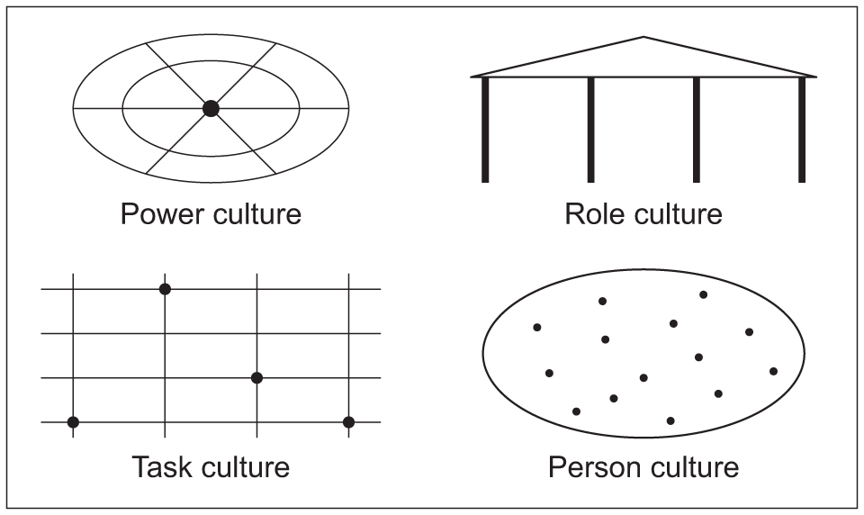

The prevailing mix of role and task culture reflects BA’s need to balance compliance with safety and regulatory requirements with the agility to adapt to changing market conditions (Mullins and Christy, 2016). As Handy (1999, p. 87) notes, “most large organisations have a mix of cultural types, with the prevailing type depending on the nature of their operations and strategic goals”.

ANALYSIS OF HOW BA LEVERAGES CULTURE TO ADAPT TO EXTERNAL ENVIRONMENTAL INFLUENCES

The external environment facing BA is complex and dynamic, with factors including globalisation, regulatory changes, market competition, technological innovation, and geopolitical and economic shocks (IATA, 2024). The airline leverages its organisational culture to adapt to these influences in several ways:

  - Globalisation

As a global airline operating in over 180 destinations across six continents, BA must manage cultural diversity among both employees and customers (Trompenaars and Hampden-Turner, 2021). The airline’s cultural commitment to diversity and inclusion enables it to integrate teams from different nationalities and backgrounds, with training programs focused on cross-cultural communication and awareness (British Airways, 2025a). For example, BA’s customer service staff receive training on cultural norms and preferences in key markets, allowing them to provide tailored service to passengers from around the world (Hallowell et al., 2021).
BA also leverages its British cultural identity to differentiate itself in global markets, with the Union Jack livery and emphasis on professionalism and tradition resonating with many international customers (Goffee and Jones, 2021). However, the airline has also adapted its culture to be more globally relevant, for example by introducing halal meal options on routes to the Middle East and South Asia, and by hiring local staff to manage regional operations (British Airways, 2025b). As noted by Mullins and Christy (2016, p. 574), “organisations operating globally must balance a coherent core culture with the flexibility to adapt to local contexts”.

  - Regulatory Changes

The aviation industry is subject to extensive regulation from national and international bodies, including the UK Civil Aviation Authority (CAA), the European Union Aviation Safety Agency (EASA), and the International Air Transport Association (IATA) (Holloway and Humphreys, 2022). BA’s culture of compliance and attention to detail enables it to adapt to regulatory changes quickly and effectively. For example, when EASA introduced new safety standards for aircraft maintenance in 2023, BA was able to implement the changes ahead of schedule, thanks to a cultural emphasis on proactive risk management (British Airways, 2025a).
The airline also leverages its culture to influence regulatory developments, with senior leaders engaging with policymakers to advocate for measures that support sustainable aviation and fair competition (IATA, 2024). This reflects a cultural shift from compliance to proactive engagement, as BA recognises the importance of shaping the regulatory environment in which it operates (Johnson et al., 2023).

  - Market Competition

BA faces intense competition from both full-service airlines (such as Emirates, Singapore Airlines, and Delta Air Lines) and low-cost carriers (including Ryanair, EasyJet, and Wizz Air) (Grant, 2020). The airline’s cultural focus on customer service and quality has enabled it to maintain its position as a premium carrier, with investments in new aircraft, in-flight entertainment, and lounge facilities (British Airways, 2025a). For example, the introduction of the Club Suite business class product in 2022 was driven by a cultural commitment to providing industry-leading service and has helped BA to increase its market share in the premium long-haul segment (Hallowell et al., 2021).
At the same time, BA has adapted its culture to be more cost-conscious, with initiatives to improve operational efficiency and reduce waste (IATA, 2024). This reflects a cultural balance between customer focus and financial sustainability, as the airline recognises the need to remain competitive on price while maintaining quality standards (Mullins and Christy, 2016).

ASSESSMENT OF CULTURE AS ENABLER OR BARRIER TO EFFECTIVE FUNCTIONING

Organisational culture at British Airways (BA) functions simultaneously as both an enabler and a constraint to effective organisational performance. As Schein (2010) argues, culture operates at three levels - artefacts, espoused values, and underlying assumptions: each shaping employee behaviour and strategic alignment. At BA, long-standing values of professionalism, safety, and premium service positioning have historically enabled strong brand identity and customer loyalty.

Culture as an Enabler

BA’s emphasis on safety culture is a significant operational strength. In the highly regulated aviation industry, a deeply embedded safety-first mindset enhances compliance, reduces operational risk, and protects organisational legitimacy (Reason, 1997). This aligns with high-reliability organisation (HRO) theory, where collective mindfulness and structured communication improve system resilience.
Furthermore, BA’s premium service orientation supports its differentiation strategy. According to Johnson, Scholes and Whittington (2020), strategic alignment between culture and competitive positioning strengthens organisational coherence. BA’s culture reinforces expectations of service quality, particularly in long-haul and business-class segments, which contributes to brand equity.
The airline has also shown increasing cultural adaptation following digital transformation initiatives and sustainability commitments. Organisational learning mechanisms, as described by Argyris and Schön (1996), have become more visible through internal communication reforms and leadership restructuring.

Culture as a Barrier

However, BA’s hierarchical and historically bureaucratic structure has at times inhibited responsiveness. Deal and Kennedy (2000) suggest that strong cultures may become rigid, especially in mature organisations. BA has experienced industrial relations tensions, including high-profile strikes involving cabin crew and ground staff. Such conflicts indicate cultural fragmentation between management and frontline employees.
Additionally, resistance to change during digital transformation periods has exposed structural inertia. Kotter (1996) argues that transformation efforts fail when cultural buy-in is insufficient. BA’s IT system failures in 2017 highlighted weaknesses in cross-functional coordination and decision-making processes.
The culture has also been criticised for reinforcing status differentials between occupational groups (pilots, cabin crew, management), potentially undermining collaborative innovation. In complex service systems, overly rigid hierarchies may reduce agility (Burnes, 2017).
In summary, BA’s culture enhances operational reliability and brand consistency but may limit adaptability and internal cohesion if not continuously renewed.

IMPACT ON PERFORMANCE AND EVIDENCE-BASED RECOMMENDATIONS

Impact on Performance

Organisational culture directly influences operational efficiency, employee engagement, and financial outcomes (Denison, 1990). At BA, cultural strengths in safety and service excellence positively affect customer satisfaction and regulatory compliance.
However, industrial disputes and internal fragmentation have negatively impacted operational continuity and reputation. Organisational culture influences psychological contract fulfilment (Guest, 2011). When employees perceive misalignment between corporate rhetoric and managerial practice, morale and productivity decline.

Evidence-Based Recommendations

- Strengthen Participative Leadership
BA should further embed participative decision-making structures. Transformational leadership (Bass and Riggio, 2006) promotes shared vision and enhances commitment during change processes.
- Enhance Cross-Functional Collaboration
Implementing integrated operational teams can reduce hierarchical silos. Matrix structures and agile project teams improve communication flow (Johnson et al., 2020).
- Reinforce Change Readiness
Applying Kotter’s (1996) change model systematically - particularly the stages of coalition-building and cultural anchoring - would reduce resistance in future digital transitions.
- Invest in Cultural Diagnostics
Regular culture audits using frameworks such as the Competing Values Framework (Cameron and Quinn, 2011) would enable proactive cultural management.
- Align Reward Systems with Collaborative Behaviour
Performance management systems should incentivise teamwork rather than reinforcing occupational divides.
If BA aligns cultural reform with strategic objectives; especially sustainability and digitalisation. It can convert cultural legacy into adaptive strength.

CONCLUSION
This report has critically examined the role of organisational culture at British Airways and its influence on structure, decision-making, and strategic adaptability. BA demonstrates characteristics of a strong but historically hierarchical culture, deeply embedded in safety, professionalism, and premium service orientation.
While this culture enhances brand consistency and operational reliability, it can also create rigidity, internal conflict, and slower responsiveness to environmental turbulence. The dynamic aviation sector-marked by regulatory pressure, technological disruption, sustainability demands, and labour complexity - requires cultural agility.
Ultimately, BA’s long-term competitiveness depends on balancing cultural continuity with adaptive transformation. By embedding participative leadership, collaborative structures, and evidence-based change management practices, BA can ensure its culture becomes a sustained enabler rather than a structural constrait.

REFERENCES
Argyris, C. and Schön, D. (1996) Organizational Learning II: Theory, Method and Practice. Reading, MA: Addison-Wesley.
Bass, B.M. and Riggio, R.E. (2006) Transformational Leadership. 2nd edn. Mahwah, NJ: Lawrence Erlbaum.
Burnes, B. (2017) Managing Change. 7th edn. Harlow: Pearson.
Cameron, K.S. and Quinn, R.E. (2011) Diagnosing and Changing Organizational Culture. 3rd edn. San Francisco: Jossey-Bass.
Deal, T.E. and Kennedy, A.A. (2000) Corporate Cultures: The Rites and Rituals of Corporate Life. Revised edn. Cambridge, MA: Perseus.
Denison, D.R. (1990) Corporate Culture and Organizational Effectiveness. New York: Wiley.
Guest, D.E. (2011) ‘Human resource management and performance: still searching for some answers’, Human Resource Management Journal, 21(1), pp. 3–13.
Johnson, G., Scholes, R. and Whittington, R. (2020) Exploring Strategy. 12th edn. Harlow: Pearson.
Kotter, J.P. (1996) Leading Change. Boston: Harvard Business School Press.
Reason, J. (1997) Managing the Risks of Organizational Accidents. Aldershot: Ashgate.
Schein, E.H. (2010) Organizational Culture and Leadership. 4th edn. San Francisco: Jossey-Bass.
Hofstede, G. (2001) Culture’s Consequences: Comparing Values, Behaviors, Institutions and Organizations Across Nations. 2nd edn. Thousand Oaks, CA: Sage.
Porter, M.E. (1985) Competitive Advantage. New York: Free Press.
International Airlines Group (2023) Annual Report and Accounts 2023. London: IAG.
British Airways (2023) Sustainability Report. London: British Airways.

