

LOCATION: Swansea | LLEOLIAD: abertawe
LEVEL 5 | LEFEL 5
EXAMINATION PERIOD | CYFNOD ARHOLIADAU
July 2021 | Gorffennaf 2021

MODULE CODE: ACDA5001
Electrical Engineering

TIME: 2 HOURS
answer all questions

Equipment or materials required – Calculator
Adnoddau neu ddefnyddiau sydd eu hangen - Cyfrifiannell

This is an open book exam

ANSWER ALL QUESTIONS

- For the circuit shown in FigQ1, given:
$L_{1}=230∠0, L_{2}=230∠120, L_{3}=230∠240, f=50Hz$,
Z1 is comprised of a 1200mH inductance in series with a 50Ω resistance
Z2 is comprised of a 70mH inductance in parallel with a 150Ω resistance
Z3 is comprised of an 800mH inductance in series with a 47μF capacitance and a 150Ω resistor.

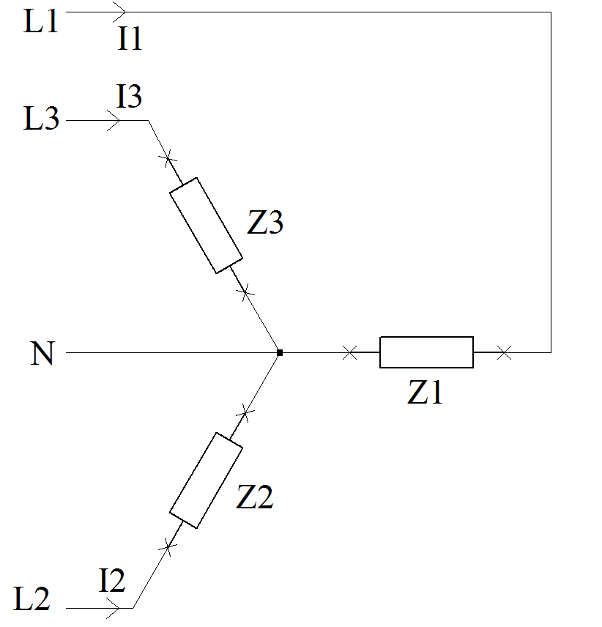
FigQ1

Calculate:
  - The three complex impedances Z1, Z2 & Z3
[6 Marks]
  - The magnitude and phase of the three phase currents I1, I2 and I3
[9 Marks]
  - The magnitude and phase of the current flowing in the neutral conductor
[4 Marks]
  - The active power dissipated by each of the impedances Z1, Z2 and Z3.
[3 Marks]
  - The reactive power dissipated by each of the impedances Z1, Z2 and Z3.
[3 Marks]
  - The magnitude of the apparent power dissipated by each of the impedances Z1, Z2 and Z3.
[3 Marks]
  - The power factor for each phase
[3 Marks]
  - The capacitance required to add to each phase to correct the power factor to 0.95
[9 Marks]

- For the circuit shown in Fig Q2, calculate V out, given:
  - C1 = 47µF
C2 = 10µF
V1 = 230V, 50 Hz
[3 Marks]

  - C1 = 47µF
C2 = 10µF
V1 = 230V, 100Hz
[3 Marks]

  - The capacitor C1 has now been replaced with a 100mH inductor. Calculate Vout given:
C2 = 22µF
V1 = 120V 60Hz
[6 Marks]

  - A 10Ω resistor is connected across V out. Calculate the current flowing in the capacitor C2 given:
C1 = 33µF
C2 = 47µF
V1 = 230V, 50Hz
[5 Marks]

  - From your answers to parts a) and b), describe the relationship between the capacitor values, the frequency of the supply voltage, and the output voltage. Give an example of an application for this type of circuit.
[3 Marks]

Answers should be given in polar form.
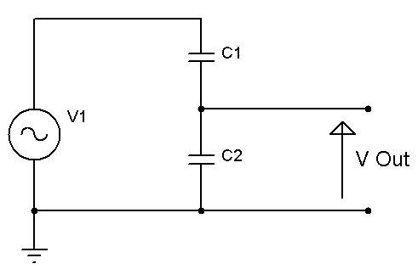

Fig Q2

- A three phase transmission network consists of a star connected source producing a phase voltage of 11kV 50Hz and supplying a current of 73A , connected to a star/delta transformer with a turns ratio of 1:12 to drive a transmission line of negligible resistance and reactance. The far end of the transmission line is connected to a delta/star transformer with a turns ratio of 220:1 which supplies the load. Calculate the phase and line voltages and currents at the load and the power which is delivered.
[20 Marks]
- For the electromagnet shown in Fig Q4, which has a cast-iron core with a relative permeability of 2142.857, it is required that a static flux is established in the air gap of 600μWb. Assuming zero flux leakage and no fringing of the flux lines, using an electrical analogue, determine the current required in the field generating coil (N=1500 turns). The mean length of the core L₁=500mm, the air gap length L_{a}=75mm and core cross section of 50mm wide x 60mm deep.

×
×
×
•
•
•
L_{a}
L₁
Fig Q4
[10 Marks]

Diwedd/End

