University Wales Trinity St David



ACDB 5015: Advanced Physics for OME

Author: Uwais Patel

Lecturer: Kelvin Donne
Contents Page

Title Page…………………………………………………………………………………………….………………………………….1
Contents Page………………………………………………………………………………………………………………..……….2
Introduction……………………………………………………………………………………………………………………………3
Part 1 – Overview of Shaped Charges……………………………………………………………………………………..4
- Application of Shape Charges
Part 2 – Core Principles of Shaped Charge Jet Formation……………………………………………………….7
- The Munroe Effect
- Gurney Theory
- Chapman-Jouguet Conditions
- Rankine – Hugoniot Relations
- Steady State Hydrodynamic Theory
- Equations of State
Part 3 – Modelling and Simulation of Shaped Charge Jets…………………………………………………….10
- Shape Charge Configuration and Material Parameters
- Johnson Cook Model
- Explosive Modelling Using the JWL Equation of State
- Explosive Liner Interaction
- Target Material Properties
- Assumptions and Limitation
Part 4 – Computational Methods for 2D Design……………………………………………………………………15
- Design One Liner Design and Mesh
- Design Two Liner Design and Mesh
- Pressure Distribution Analysis
- Principle Stress
- Velocity Analysis
- Assessment of 2D Penetration Performance
Part 5 – 3D Model Design……………………………………………………………………………………………………..20
Part 6 – Conclusion……………………………………………………………………………………………………………….23
References……………………………………………………………………………………………………………………………24

Introduction
Shaped charges represent one of the most sophisticated applications of explosive physics, combining detonation theory, high strain rate material behaviour and complex fluid structure interaction. Unlike conventional high explosives that release energy isotopically, shaped charges use geometric focusing to convert chemical energy into a coherent, high velocity metallic jet capable of penetrating armour, geological formations and reinforced structural materials. Penetration depths can exceed several charge diameters, making shaped charges indispensable in military, industrial and civil engineering applications.
The effectiveness of a shaped charge depends on multiple interrelated factors, including liner geometry, liner material properties, explosive characteristics, initiation symmetry and stand off distance. These factors interact under extreme conditions of pressure (hundreds of gigapascals), strain rates exceeding 10⁵ s⁻¹ and temperatures approaching material melting points. Under such conditions, typical elastic plastic theories become insufficient, necessitating the use of hydrodynamic approximations and empirically calibrated constitutive models.
This report addresses the design and modelling of a shaped charge device using a structured computational approach aligned with the learning outcomes of the Advanced Physics for Ordnance, Munitions and Explosives (OME) module. The work includes a critical literature review, two-dimensional numerical modelling of alternative liner designs and a final three-dimensional simulation of the selected optimal configuration. The Johnson–Cook (JC) material model is employed to capture high strain-rate metallic behaviour, while the Jones–Wilkins–Lee (JWL) equation of state is used to model explosive detonation products.
The objective is not only to demonstrate technical competence in modelling, but also to critically evaluate modelling assumptions, computational cost and results. Limitations are explicitly acknowledged and recommendations for future improvements are proposed.

Part 1 – Overview of Shaped Charges
Application of Shape Charges
Shaped charges are explosive devices specifically designed to focus detonation energy into a narrow region through the controlled collapse of a metallic liner. The fundamental configuration consists of a high explosive charge, typically cylindrical, incorporating a hollow cavity lined with a ductile metal such as copper. Upon detonation, the explosive wave collapses the liner inward, forming a high-velocity jet at the apex and a slower moving slug at the rear. This process allows a significant proportion of the explosive’s chemical energy to be converted into directed kinetic energy, producing penetration capabilities far exceeding those of conventional blast explosives.
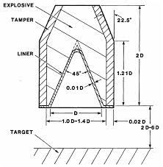
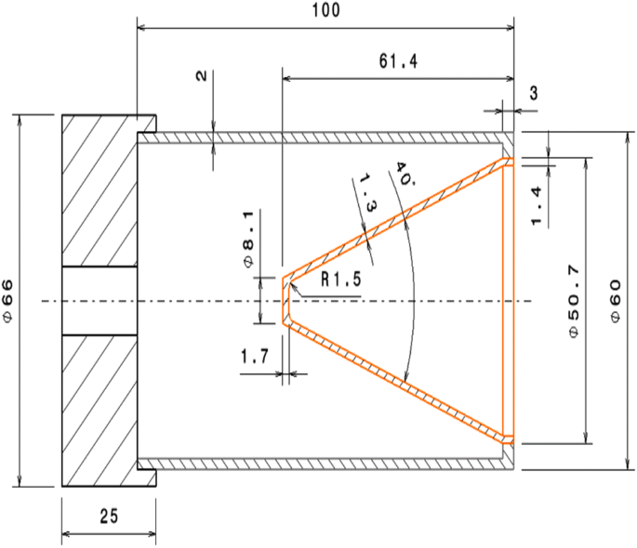[1]
[2]
I used the above references to get an idea on what my design was to look like.
The effectiveness of a shaped charge arises from the interaction between explosive detonation physics, liner material behaviour at extreme strain rates and geometric focusing. Geometric focusing on explosives is the technique of using the physical shape (geometry) of an explosive charge, sometimes in combination with a liner or different explosive materials, to concentrate the energy of the detonation wave into a specific, narrow area [3]. Pressures generated during detonation typically exceed hundreds of gigapascals, while strain rates within the collapsing liner can surpass 10⁵ s⁻¹. Under these conditions, metallic materials exhibit hydrodynamic-like behaviour, with inertial forces controlling material strength. This observation shows much of the analytical and numerical modelling approaches used in shaped charge research.
Shaped charge behaviours were first observed in the late nineteenth century when it was noted that cavities within explosive charges enhanced penetration effects. This occurrence was later formalised as the Munroe effect which is formally defined as “the greatly increased penetration of an explosive into a surface (as of metal or concrete) that is caused by shaping a conical or hemispherical hollow in the forward end of an explosive cartridge”[4] and became the foundation for systematic shaped charge development. Intensive research during the Second World War led to the widespread use of conical liners. Since then, advances in materials science, diagnostics and computational mechanics have allowed increasingly refined designs including things like trumpet-shaped liners and hemispherical liners.
The evolution of shaped charge technology has been linked to improvements in modelling capability. Early analytical models relied on simplified hydrodynamic assumptions, ignoring material strength and thermal effects. While models as such remain useful for estimates, modern design increasingly depend on simulation techniques that can record complex situations like jet instability and target interaction. The documents supporting this study highlight the importance of high strain-rate constitutive models, such as the Johnson–Cook formulation and detonation-specific equations of state, such as the Jones–Wilkins–Lee model in achieving realistic predictions.
JC
[5,6]
Material | A  (MPa) | B  (MPa) | n | m | C | $ρ$  (kgm⁻³) | E (GPa) | v | $$θ_{transition}$$ | $$θ_{melt}$$
Copper OFHC | 1425 | 168 | 0.12 | 1 | 0.032 | 8960 | 125 | 0.34 | 293K | 1356K
Steel AISI | 553 | 600 | 0.234 | 1 | 0.013 | 7850 | 210 | 0.3 | 293K | 1733K
Extruded Mg–Gd–Y alloy | 176 | 428 | 0.454 | 3.05 | 0.0147 | 1920 | 44 | 0.28 | 291K | 883K
Aluminium 2024-T3 | 369 | 684 | 0.73 | 1.7 | 0.0083 | 2690 | 74 | 0.29 | 583K | 843K

JWL
[7]
Explosive | $ρ$  (kgm⁻³) | Velocity for detonation  (ms⁻¹) | A  (GPa) | B  (GPa) | R1  n/a | R2  n/a | $$ω$$  n/a | Pre-detonation bulk modulus  (GPa) | Detonation energy Density (Jkg⁻¹)
TNT | 1601 | 8193 | 609 | 13 | 4.50 | 1.40 | 0.25 | 9.00 | 3680000
HMX | 1891 | 9141 | 774 | 11 | 4.2 | 1 | 0.3 | 10.5 | 5.5e6

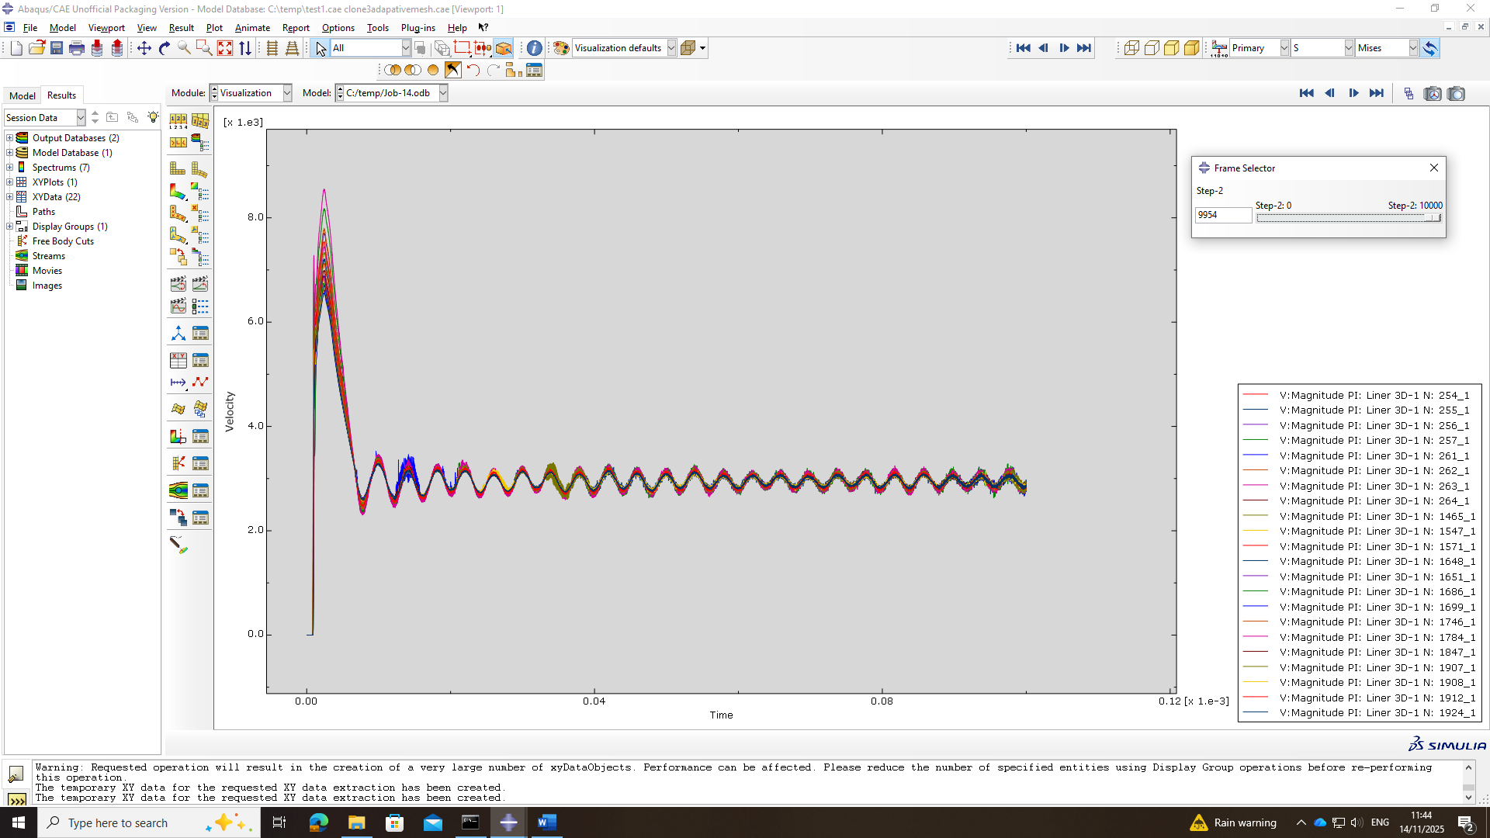

Shaped charges have extensive applications across multiple sectors due to their ability to deliver highly restricted energy with a lot of efficiency. Tandem warheads, for example, employ shaped charge to defeat reactive armour, followed by a main charge optimised for deep penetration. The ability to defeat hardened targets with relatively compact explosive masses makes shaped charges tactically valuable while reducing logistical burden [8].
In industrial applications, shaped charges are widely used in oil and gas well perforation. Here, small shaped charges are deployed in downhole tools to create precise perforation channels through steel casing and surrounding geological formations. The controlled nature of the penetration is critical, as excessive damage could compromise well integrity. As a result, shaped charge design in this context prioritises repeatability, jet coherence, and predictable penetration depth, all of which depend heavily on accurate modelling of liner collapse and jet formation.
In ordnance, munitions and explosives engineering, shaped charges are not intended to produce non-selective destruction but to deliver a controlled and predictable penetration to a specific target. The shaped charge (Munroe) effect depends on the collapse of a metallic liner into a high-velocity jet, whose consistency, velocity distribution and penetration depth are determined by factors such as liner geometry and explosive characteristics. Long-standing ordnance literature stresses that penetration must be matched to the thickness and material of the target because excessive penetration or unstable jet formation can generate unintended damage outside the target [9].
These principles apply equally to non-military and military shaped charge applications, underscoring why controlled penetration is essential and why excessive damage can compromise the integrity of the surrounding structure or system.

Part 2 – Core Principles of Shaped Charge Jet Formation
The formation of a shaped charge jet is not governed by a single physical principle, but by a combination of explosive detonation, shock wave propagation, extreme material deformation, and geometric focusing. These processes occur over extremely short timescales, typically microseconds and under conditions that are far removed from those encountered in conventional engineering problems. Pressures reach hundreds of gigapascals, temperatures rise rapidly and strain rates become so high that many materials no longer behave as solids in the traditional sense. Because of this, shaped charge behaviour must be described using specialised theoretical models that account for these extreme conditions.

The Munroe Effect
The Munroe effect describes the way in which explosive energy is focused by a cavity within the charge. When a detonation wave encounters a hollow region, the wave fronts are redirected inward rather than continuing to grow in uniform. This coming together leads to locally increased pressure and velocity along the cavity axis, which in turn drives liner collapse and jet formation [10].
The shape of the cavity and the liner, has a strong influence on how energy is focused. Traditional conical liners produce a long jet with a high velocity at the tip and a velocity gradient along its length. More complex geometries, such as trumpet-shaped liners, are designed to modify the collapse process to improve jet stability and consistency.
The Munroe effect also highlights an important practical issue; shaped charges are extremely sensitive to geometry and symmetry. Small imperfections in the liner shape or detonation timing can lead to asymmetric jet formation and reduced penetration performance leading to an imperfect jet formation weakening the power of the shape charger. This sensitivity provides strong justification for the use of computational modelling when designing and optimising shaped charge systems.

Gurney Theory
Gurney theory provides a simple analytical approach for estimating the velocity passed on to materials by an explosive charge. It is based on energy maintenance and relates explosive mass and geometry to a characteristic velocity, often referred to as the Gurney velocity [11].
While Gurney theory does not model jet formation directly, it is useful for estimating liner collapse velocities and for checking the reasonability of numerical simulation results. Its simplicity makes it valuable during early design stages or when validating computational results.
However, the assumptions with Gurney theory are restrictive. It assumes uniform energy distribution and does not account for liner geometry, material strength or thermal effects. As a result, it cannot predict jet shape or penetration depth accurately and should be used as a supporting tool rather than a primary design method.
Chapman–Jouguet Theory
Chapman–Jouguet (CJ) theory describes the ideal detonation condition of an explosive. At the CJ point, the detonation products move at the speed of sound relative to the detonation front, meaning that the detonation wave is self-sustaining and stable [13].
CJ parameters such as detonation velocity and pressure are fundamental inputs for explosive modelling. They are used to initialise equations of state like the JWL model and determine the initial loading applied to the liner.
Although real detonations may drift slightly from ideal CJ behaviour due to confinement or geometry, CJ theory provides a consistent and widely accepted reference state for explosive simulations.

Rankine–Hugoniot Relations
Shock waves play a central role in shaped charge operation and the Rankine–Hugoniot relations are fundamental to understanding their behaviour. These relations describe how mass, momentum and energy are conserved across a shock front. They apply to both fluids and solids and are therefore relevant to explosives.
When the explosive detonates, a shock wave propagates through the explosive and into the metallic liner. This shock compresses heats and accelerates the liner material, initiating the collapse. The Rankine–Hugoniot equations relate conditions ahead of the shock to those immediately behind it, allowing key quantities such as pressure and particle velocity to be determined [13].
Although these equations are rarely solved directly in engineering simulations, they underpin the equations of state used in hydrocodes and finite element solvers. An understanding of the Rankine–Hugoniot relations helps explain why shaped charge modelling requires specialised material descriptions and why conventional stress–strain models are inadequate under shock loading.

Steady-State Hydrodynamic Theory
One of the most important ideas in shaped charge theory is that under extremely high pressures, material strength becomes relatively unimportant. During detonation, the pressures acting on the liner and target are so large that elastic and plastic resistance are small compared to the inertial forces driving material motion. Resulting in the liner material being treated as if it were flowing rather than deforming in the regular solid mechanics sense [14].
Steady-state hydrodynamic theory is based on this assumption. It treats the collapsing liner as an incompressible fluid that is driven inward by the detonation wave. As opposing sections of the liner meet along the charge axis, material is forced to flow both forwards and backwards. The forward-moving portion forms the shaped charge jet, which travels at an extremely high velocity, while the rear portion forms a slower moving jet [15].
A key outcome of hydrodynamic theory is the prediction that penetration depth depends mainly on jet velocity and the density ratio between the jet and the target. Target strength plays only a minor role during the initial stages of penetration, which helps explain why shaped charges can penetrate materials that are much stronger than the liner itself.
However, this theory is clearly an estimate. It does not account for material strength recovery as pressures decrease, nor does it consider jet breakup, fracture or the thermal effects. These limitations mean that hydrodynamic theory is best used to explain general behaviour rather than to make precise predictions. It provides the conceptual basis for more advanced numerical models rather than replacing them.

Equations of State
Equations of state (EOS) are essential for modelling shaped charges because they describe how materials respond to extreme compression and heating. An EOS defines the relationship between pressure volume and internal energy, allowing shock behaviour to be captured accurately [16].
For metallic components such as liners and targets, the EOS controls volume compression, while a separate natural model describes material strength and plastic flow. This separation is important because compressibility effects take over immediately after shock loading, whereas strength effects become more relevant as pressures decrease during later stages of deformation.
Explosives require specialised EOS formulations as their behaviour during detonation cannot be described using natural material models. The Jones–Wilkins–Lee (JWL) equation of state is widely used for this purpose, as it captures both the high initial pressure at detonation and the rapid pressure decays as detonation products expand. Accurate EOS parameters are critical because they directly influence liner acceleration and collapse velocity.
Inaccurate EOS selection can significantly affect predicted jet performance, making this one of the most important modelling choices in shaped charge simulation.

Part 3 – Modelling and Simulation of Shaped Charge Jets
Accurate modelled shaped charge jet formation presents a significant challenge due to the extreme physical conditions involved. During detonation, materials are subjected to very high pressures and severe plastic deformation over extremely short timescales. Under these conditions, conventional material models based on quasi-static behaviour, which is a process that happens so slowly that a system remains in equilibrium at every infinitesimal step [17], are no longer valid. Instead, specialised constitutive models and equations of state are required to represent both the metallic components and the explosive charge in a realistic manner.
This section outlines the modelling approach adopted for the shaped charge system, focusing on the selection of material models for the liner, casing, explosive and target. Attention is given to the reasoning behind these choices and the assumptions made, as these directly influence the accuracy and reliability of the simulation results.

Shaped Charge Configuration and Material parameters
The shaped charge model used in this study consists of a metallic liner, an outer casing and a high explosive fill. While the liner geometry is varied between designs, the same material modelling approach is applied consistently to allow meaningful comparison of results. The casing is included to provide confinement and realistic boundary conditions, but it is not treated as a primary performance driver.
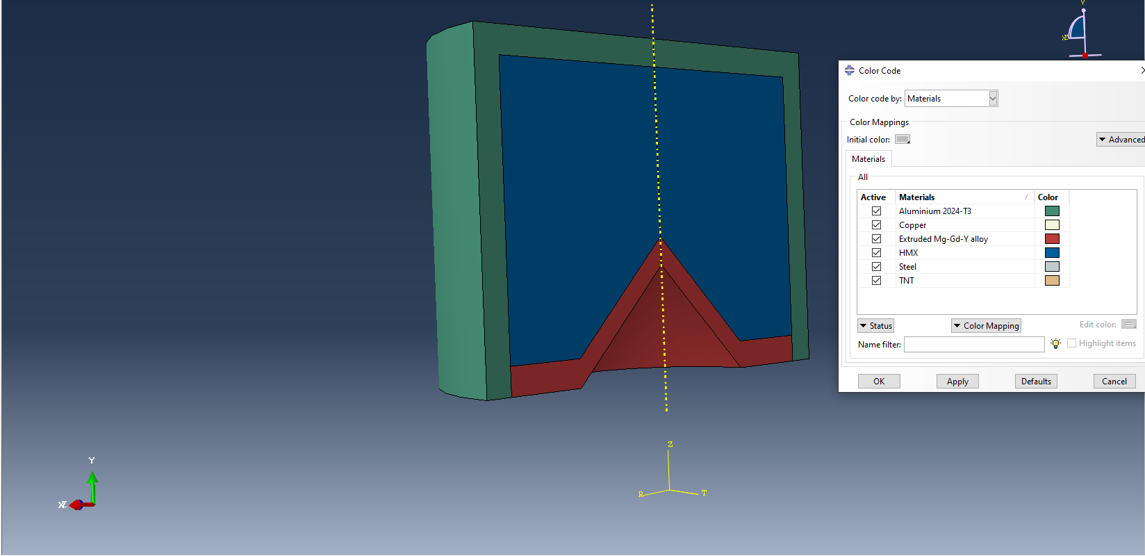
Given the extreme strain rates and temperatures experienced by the liner during collapse, a material model capable of capturing high-rate plastic deformation and thermal effects is required. For this reason, the Johnson–Cook constitutive model is used for all metallic components as provided in Part 1.

Johnson–Cook Constitutive Model
The Johnson–Cook (JC) model is widely used in impact and explosive simulations because it offers a relatively simple yet effective way of representing material behaviour under extreme conditions. It describes flow stress as a function of plastic strain, strain rate, and temperature, making it particularly suitable for shaped charge applications [18].
In this study, the JC model is used to represent the liner and casing materials. The model accounts for strain hardening as the liner deforms, increased strength at high strain rates, and thermal softening as temperatures rise due to plastic work and shock heating. These effects are all known to play an important role during liner collapse and jet formation.
Shown below is the JC Model which was used.
Material | A  (MPa) | B  (MPa) | n | m | C | $ρ$  (kgm⁻³) | E (GPa) | v | $$θ_{transition}$$ | $$θ_{melt}$$
Copper OFHC | 1425 | 168 | 0.12 | 1 | 0.032 | 8960 | 125 | 0.34 | 293K | 1356K
Steel AISI | 553 | 600 | 0.234 | 1 | 0.013 | 7850 | 210 | 0.3 | 293K | 1733K
Extruded Mg–Gd–Y alloy | 176 | 428 | 0.454 | 3.05 | 0.0147 | 1920 | 44 | 0.28 | 291K | 883K
Aluminium 2024-T3 | 369 | 684 | 0.73 | 1.7 | 0.0083 | 2690 | 74 | 0.29 | 583K | 843K

Example of Thermal Softening.
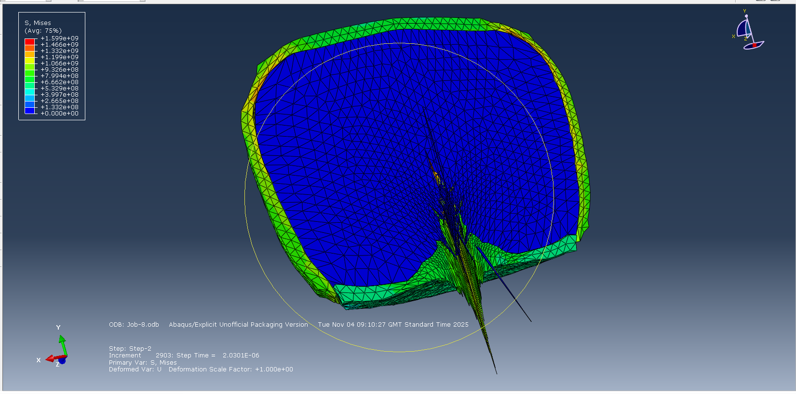
Material parameters for Copper OFHC, AISI steel, aluminium 2024-T3, and magnesium-based alloys are taken from experimentally validated studies and reference data included in Part 1. Copper is the primary liner material of interest due to its high ductility and great use in shaped charge applications. Its ability to undergo large plastic deformation without premature fracture makes it well suited for jet formation. Aluminium and magnesium alloys are considered as alternative liner materials to investigate the potential benefits of reduced density, while steel parameters are primarily used for the casing and target.
Using validated material parameters is essential, as shaped charge performance is highly sensitive to material behaviour at high strain rates. Small changes in strain-rate sensitivity or thermal softening coefficients can lead to noticeable differences in predicted jet velocity and stability. This is why the parameters were selected from published experimental sources rather than relying on generic material libraries.
It is important to note that the Johnson–Cook model does not explicitly include damage or fracture mechanisms. As a result, jet breakup and fragmentation are not modelled in a detailed manner. However, for the purposes of this study, comparing liner geometries and overall penetration performance the JC model provides a reasonable and widely accepted approximation.

Explosive Modelling Using the JWL Equation of State
The explosive component of the shaped charge is modelled using the Jones–Wilkins–Lee (JWL) equation of state. Unlike solids, explosives go through rapid chemical reactions and expansion during detonation and their behaviour cannot be represented using conventional stress strain relationships [19].
The JWL equation of state describes the pressure generated by detonation products as a function of their relative volume and internal energy. This allows both the initial high-pressure loading and the accompanying pressure decay during expansion to be captured. Accurately representing this pressure time history is critical, as it directly controls the acceleration and collapse of the liner [20].
In this study, JWL parameters for TNT and HMX are taken from reviewed literature and experimental calibration data provided above. TNT is commonly used as a reference explosive in modelling studies due to the availability of well established parameters, while HMX offers higher detonation velocity and energy density, making it useful for performance comparison.
The explosive is assumed to detonate instantaneously under ideal Chapman–Jouguet conditions. This assumption ignores effects such as finite reaction zone thickness and non-ideal detonation behaviour. However, this simplification is widely used in engineering level simulations and is considered acceptable given the focus of this study on liner behaviour rather than detailed explosive chemistry.

Explosive–Liner Interaction
One of the most critical aspects of shaped charge modelling is the interaction between the expanding detonation products and the collapsing liner. The pressure load applied to the liner surface determines collapse velocity, jet formation angle and jet performance [21].
In the numerical models used for this study, the explosive and liner are coupled using explicit formula capable of handling large deformation and rapid loading. Careful attention is paid to mesh resolution near the liner apex, where deformation is most severe and numerical instabilities are most likely to occur.

Mesh of the Shape Charger.
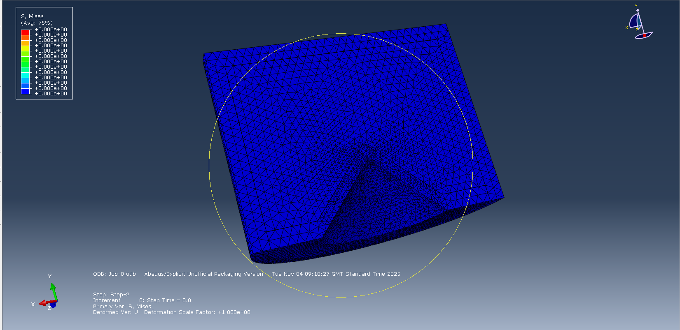

Mesh of the Liner.
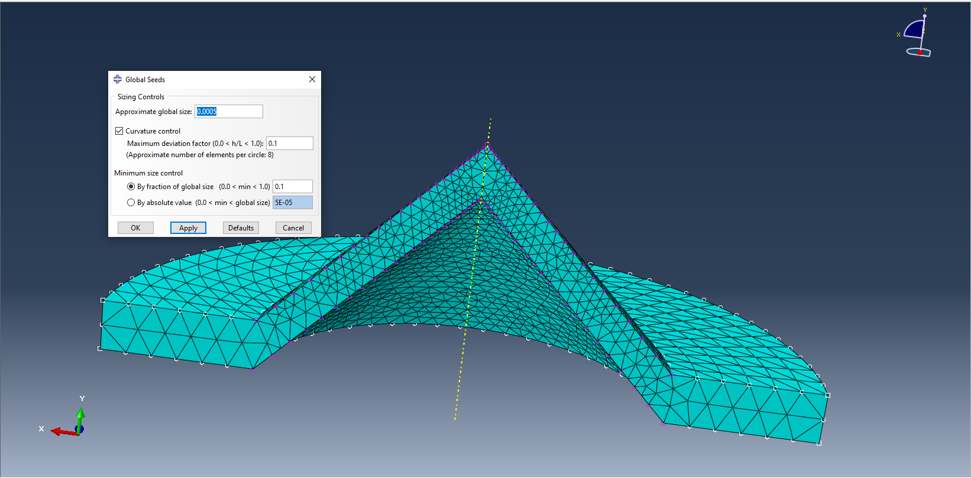

The interaction between the explosive gases and the liner is treated in a way that allows the explosive products to expand freely while keeping accurate contact with the liner surface. This approach ensures that pressure loading is transferred realistically across the explosive liner interface without introducing excessive numerical scattering.

Target Material Properties
The target material is modelled using an elastic–plastic material description with appropriate density, Young’s modulus, and Poisson’s ratio. These properties are chosen to represent a typical metallic or structural target, allowing the penetration capability of different liner designs to be compared [22].
The failure behaviour of the target is simplified, as the primary objective is to assess relative penetration performance rather than to model the detailed fracture process. During the early stages of shaped charge penetration, the target response is largely controlled by hydrodynamic behaviour, with material strength playing a secondary role. As a result, a simplified target model is sufficient for comparative analysis.
More advanced damage or failure models could be included to improve realism, but this would increase computational cost. Given the objectives of this study, the simplified approach represents a reasonable compromise between accuracy and efficiency.

Assumptions and Limitations
Several assumptions are essential in the modelling approach used. The Johnson–Cook model does not explicitly represent damage accumulation or microstructural effects, which may influence jet breakup length. Similarly, the use of ideal detonation conditions ignores confinement effects and reactions.
Despite these limitations, the modelling framework is consistent with traditional practice in shaped charge simulation and is well suited to the comparative analysis undertaken. By applying different material models and assumptions across all simulations, differences in performance can be attributed primarily to geometric effects rather than modelling inconsistencies.

Part 4 – Computational Approach for 2D Design
In the initial stages of the design process, two-dimensional simulations were used to investigate shaped charge behaviour. This approach was chosen to strike a balance between computational efficiency and physical accuracy. Because the shaped charge geometry and detonation configuration are rotationally symmetric, an axisymmetric assumption is appropriate and is commonly adopted in shaped charge modelling studies using ABAQUS. Using 2D simulations made it possible to explore different liner designs before committing to more computationally expensive three-dimensional analysis.
The main objective of the 2D modelling stage was to compare liner geometries under consistent conditions. By keeping the explosive type, material models and boundary conditions the same, any differences observed in jet formation or penetration behaviour could be attributed primarily to changes in liner shape. This approach ensured that the results provided meaningful insight into the influence of geometry rather than numerical artefacts.

Design One Liner Design and Mesh
The first design modelled was a conventional conical liner. This design was selected as a baseline because it is widely used in practice and extensively documented in the literature as well as using ideas from existing literature referenced below. Its behaviour is therefore well understood, making it a suitable reference case against which alternative designs can be compared.

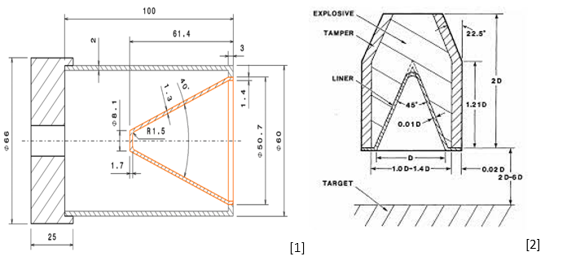

The mesh was designed with particular attention given to regions expected to experience severe deformation. A fine mesh was applied around the liner apex and along the axis of symmetry, where jet formation occurs and where pressure and velocity gradients are highest. In contrast, regions further away from the liner were meshed more coarsely to reduce computational cost without significantly affecting result accuracy.
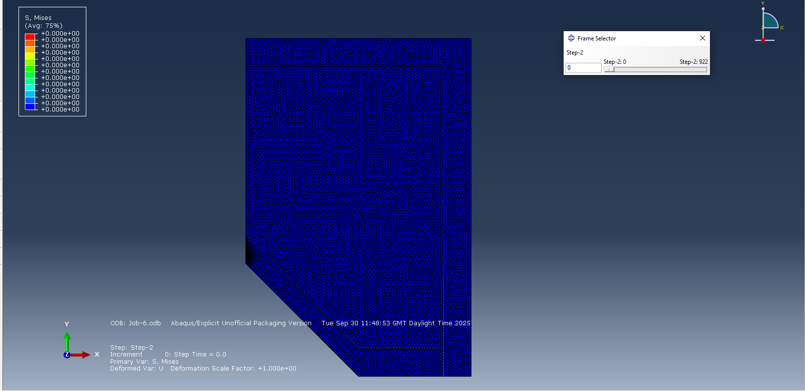

An clear time integration scheme was used due to the highly dynamic nature of the problem. Detonation and liner collapse occur over extremely short timescales and a very small time, steps were required to maintain numerical stability. While this increased overall simulation time, it was necessary to accurately capture shock propagation and liner motion during the early stages of jet formation.
The simulation results showed that the conical liner collapsed in a manner consistent with expectations. The liner material was driven inward by the detonation pressure, forming a narrow jet at the apex and a slower moving slug behind it. As the jet developed a pronounced velocity gradient became apparent, with the jet tip travelling significantly faster than the trailing material. This behaviour is characteristic of conical liners but is also associated with increased jet stretching and a greater tendency toward instability.
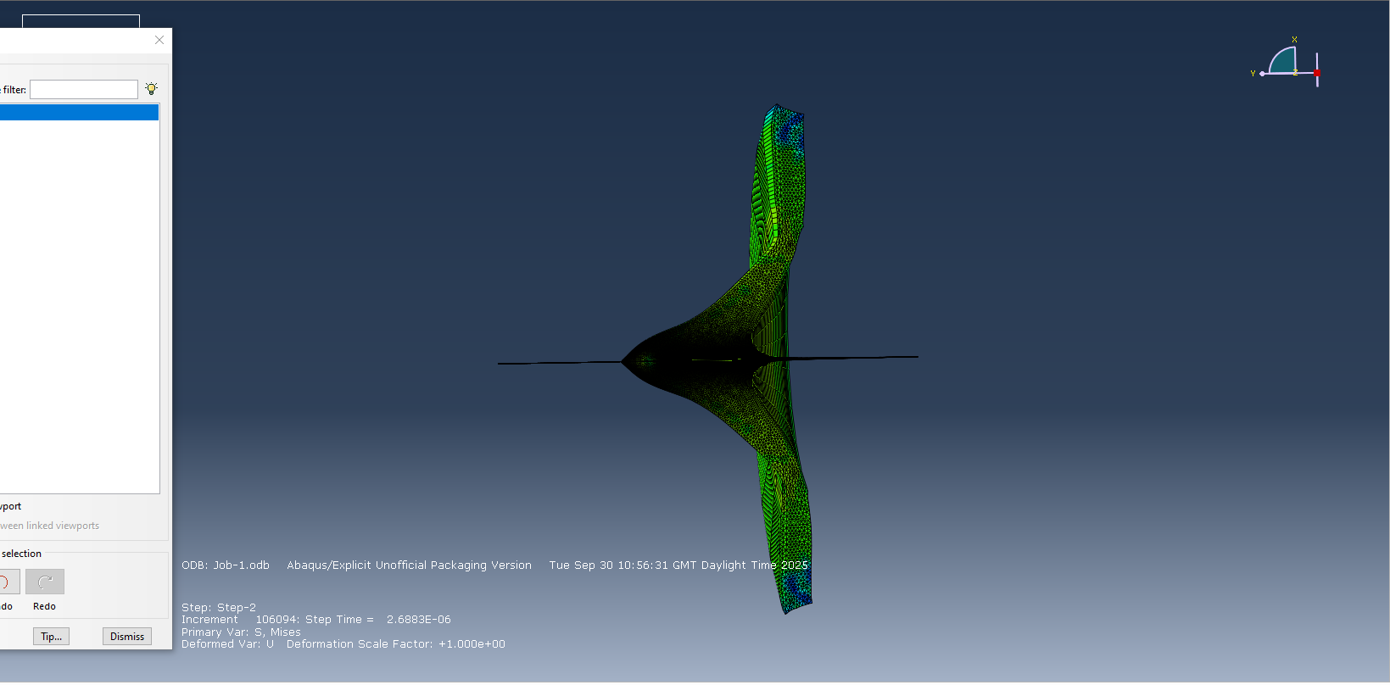
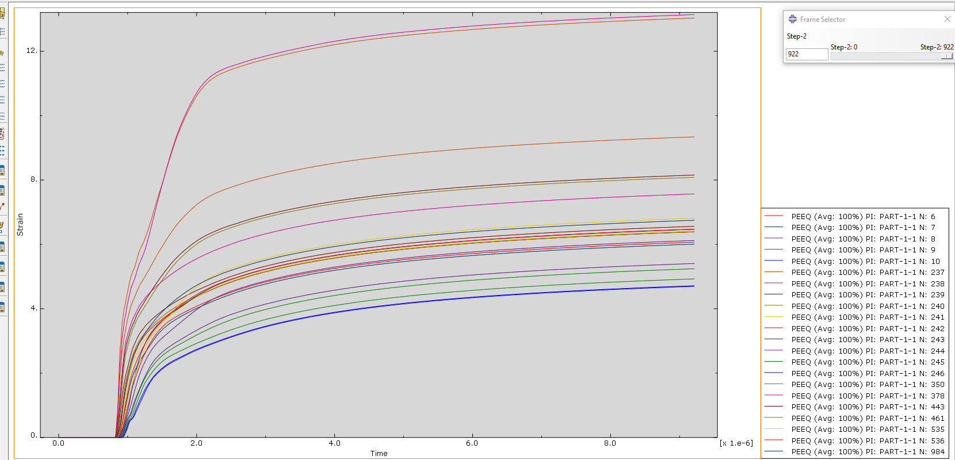

Design Two Liner Design and Mesh
The second design investigated was a liner. Unlike the normal conical liner, this geometry features a gradually varying liner angle. The motivation for this design was to achieve a more controlled liner collapse by reducing abrupt changes in acceleration along the liner length. In theory, this should lead to a more uniform jet velocity and improved stability.
From a numerical perspective, the new liner was more challenging to model. The changing curvature of the liner required careful meshing to avoid element distortion during collapse. As with the conical liner, mesh refinement was concentrated near the liner apex and jet formation zone, where accuracy is most critical.
Although the trumpet liner model required slightly greater computational effort, it remained practical within the 2D framework. This made it suitable for comparative analysis while still allowing multiple simulations to be performed within reasonable time constraints.

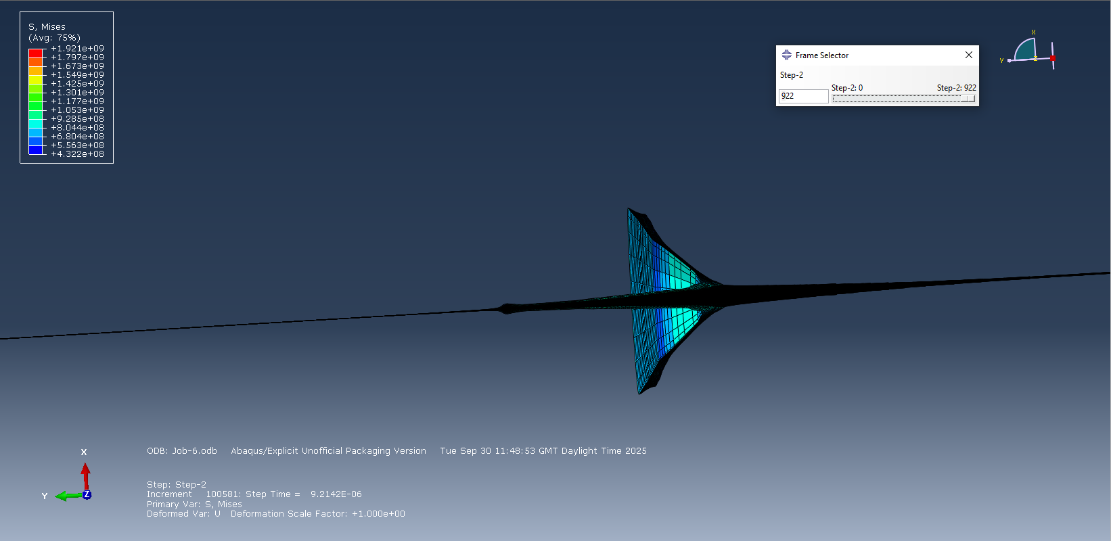

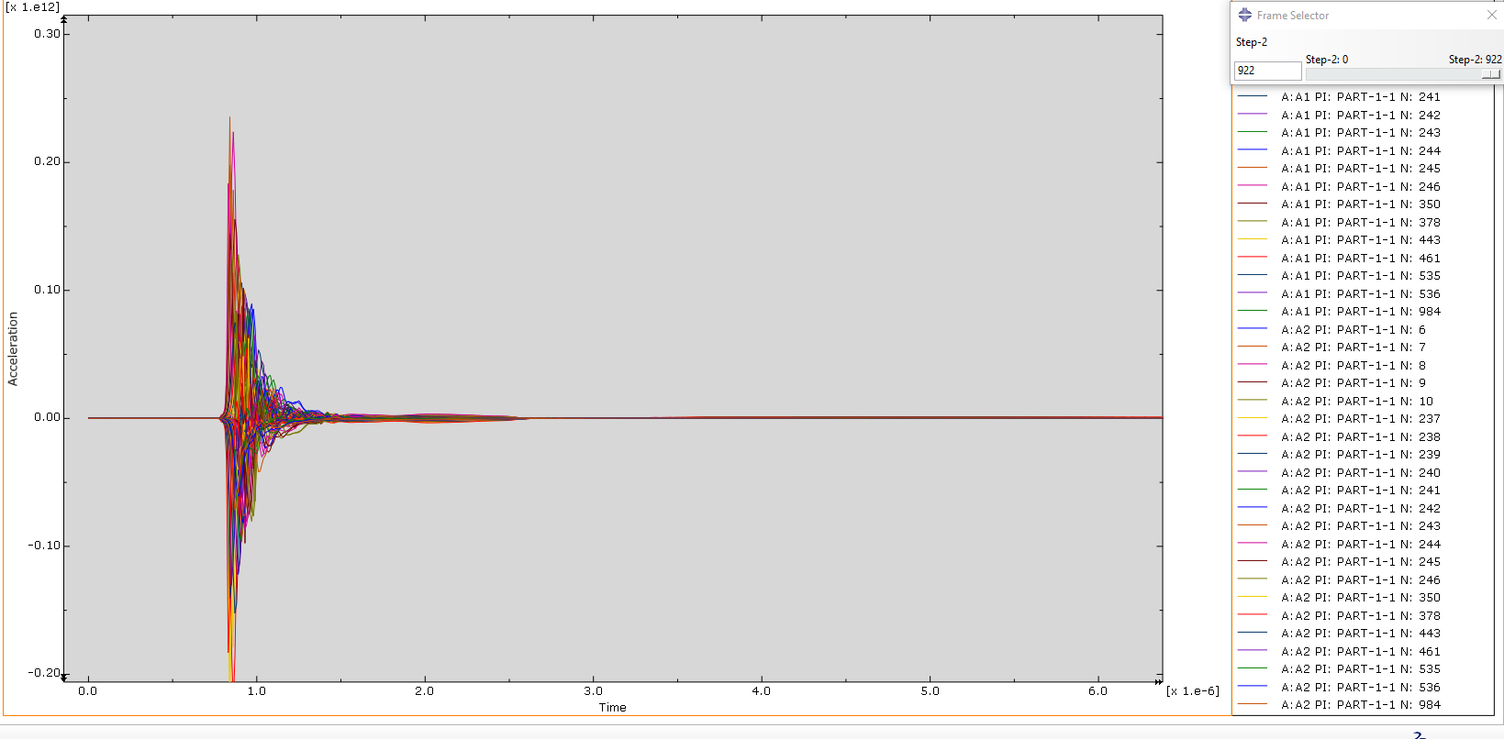
Pressure Distribution Analysis
Pressure plots revealed clear differences between the two liner configurations included above. In the conical liner simulation, pressure loading was highly concentrated near the apex during collapse. This produced very high local pressures, which contributed to the high jet tip velocity observed. However, the sharp pressure gradients also increased the likelihood of uneven liner deformation.
In contrast, the second liner exhibited a noticeably smoother pressure distribution along the liner surface. The gradual change in liner angle allowed detonation pressure to be applied more evenly during collapse. Peak pressure concentrations were reduced and the overall pressure history appeared neater.
This difference is important because extreme pressure localisation can boost jet instability and premature breakup. The smoother pressure distribution observed in the trumpet liner suggests a more controlled collapse process, which is in favour for maintaining jet consistency.

Principal Stress
Principal stress results further highlighted the differences between the two designs. In both cases, stress levels exceeded the yield strength of the liner material by several levels of magnitude, confirming that inertial and hydrodynamic effects dominate during early jet formation.
For the conical liner, very high compressive stresses were concentrated near the apex, followed by areas of tensile stress as the jet stretched. These tensile stresses are often associated with jet necking and eventual breakup.
The trumpet liner showed a more evenly distributed stress field, with reduced stress concentration at the apex and smoother transitions along the liner. This indicates that the second geometry moderates stress during collapse, which likely contributes to improved jet stability.
Velocity Analysis
Jet velocity profiles were extracted along the axis of symmetry to assess jet formation characteristics. Both designs produced jet tip velocities on the order of kilometres per second, which is consistent with analytical estimates and previously published experimental data. This agreement provides confidence in the modelling approach and parameter selection.
Despite similar peak velocities, the velocity distribution along the jet differed significantly between designs. The conical liner produced a steep velocity gradient, with a fast-moving jet tip. While this can increase initial penetration, it also increases the likelihood of jet stretching and fragmentation.
The second liner produced a more uniform velocity profile along the jet length. Although the maximum velocity was slightly lower, the reduced velocity gradient helped maintain jet consistency over a longer distance.

Assessment of 2D Penetration Performance
Penetration simulations were conducted using a representative target material to assess relative performance. While the target model was simplified, it was sufficient for comparing penetration depth between designs under identical conditions.
The results showed that the second liner achieved greater penetration depth relative to charge diameter than the conical liner. This improvement appeared to be driven primarily by improved jet stability and liner shape rather than higher initial velocity. Based on these findings, the second liner was selected for further investigation using three-dimensional modelling.

Part 5 – 3D Design
Although 2D simulations provide valuable insight, they essentially assume perfect symmetry and cannot capture three-dimensional effects such as asymmetric collapse or off-axis jet disturbances. To address this limitation, a full 3D model of the liner design was developed.
The 3D model allowed for the investigation of effects that are suppressed in axisymmetric simulations, including small geometric imperfections and complex jet breakup behaviour. These effects are particularly relevant when considering real-world shaped charge performance.

Advanced Numerical Techniques
Due to the extreme deformation involved in jet formation, advanced numerical techniques were considered. Smoothed Particle Hydrodynamics (SPH) was explored as a potential approach for modelling jet breakup, as it avoids mesh distortion issues associated with traditional finite element methods. Adaptive meshing strategies were also considered to maintain resolution in critical regions while limiting computational cost elsewhere.

Below shown is the result of adaptive meshing.
Job 1
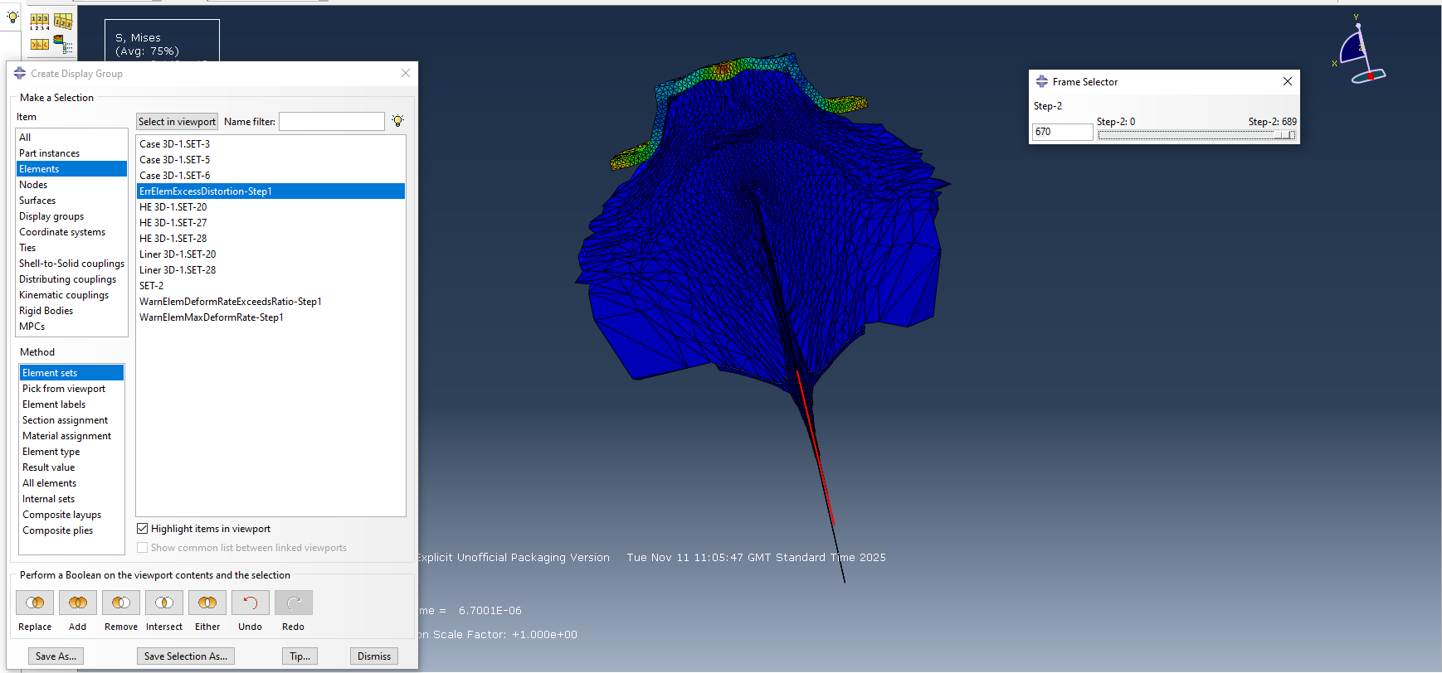

Job 2
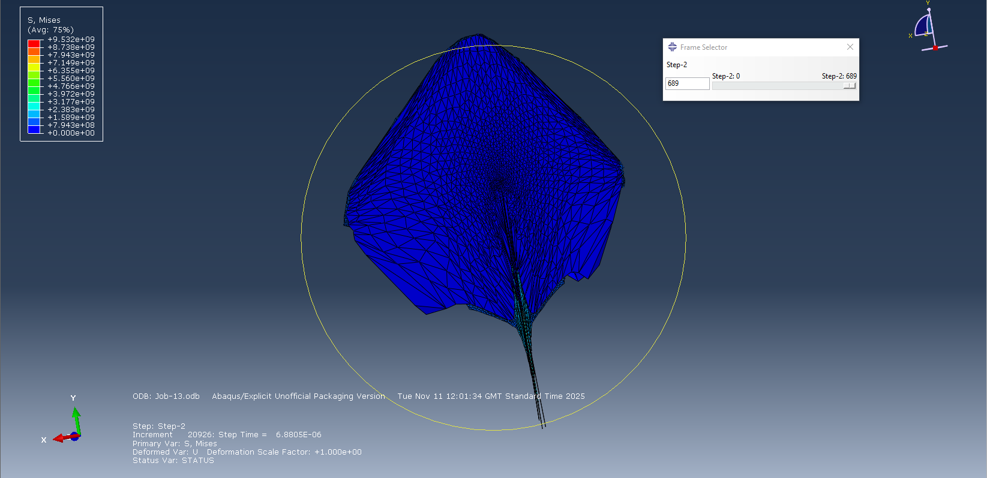

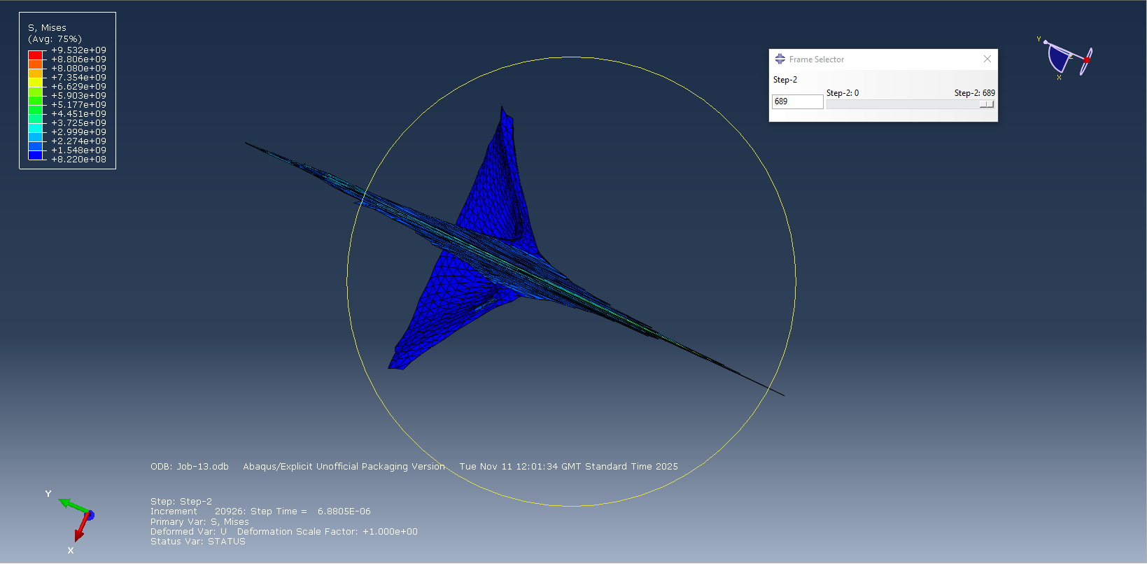

While these techniques offer clear advantages, they also significantly increase simulation complexity and runtime. As a result, their use was carefully weighed against the objectives of the study.

Accuracy and Computational Cost
One of the main challenges associated with the 3D simulation was computational expense. Simulation times were significantly longer than in 2D and agreements were required in terms of mesh density and simulation duration.

The Mesh
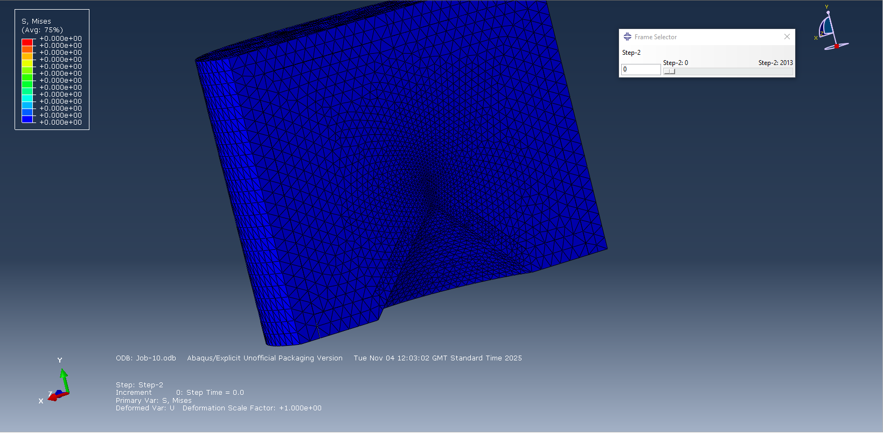

Despite these limitations, the 3D results supported the conclusions drawn from the 2D analysis. The liner continued to demonstrate improved jet coherence and reduced instability compared to the conical baseline, reinforcing its selection as the preferred design.

Graph
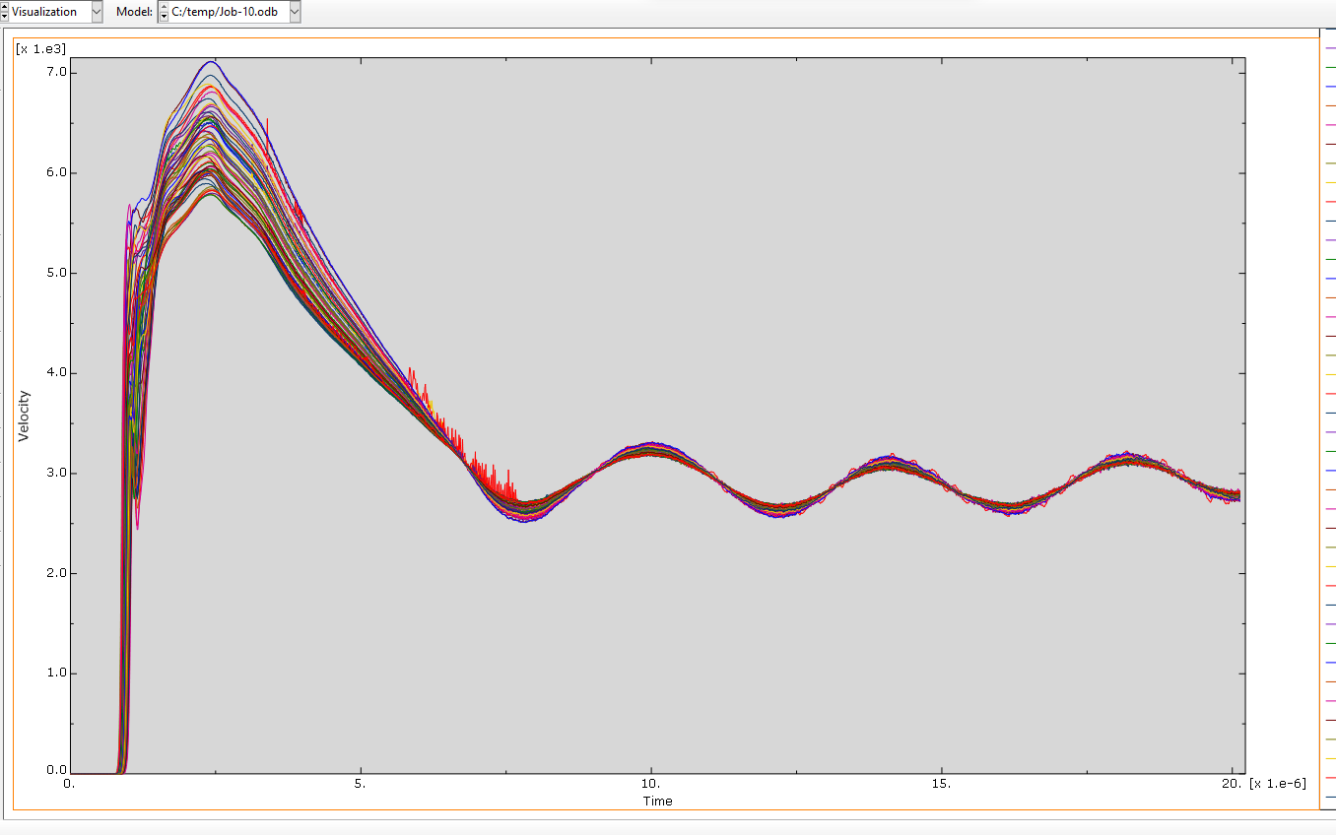

Conclusion
This project set out to investigate how liner geometry and material modelling influence shaped charge performance, using a combination of literature review and numerical simulation. The results clearly show that liner shape plays a major role in how the jet forms and behaves after detonation. By starting with 2D models, it was possible to compare different designs efficiently and identify clear performance trends without excessive computational cost. Moving to a 3D model for the final design then allowed a more realistic behaviour to be examined, including effects that cannot be captured in perfectly symmetric simulations.
Across both the 2D and 3D analyses, the liner consistently showed advantages over the conventional conical liner. While the conical liner produced very-high jet tip velocities, it also generated a steep velocity gradient, which increased jet stretching and instability. The second liner produced a smoother pressure distribution and more even stress development during collapse, resulting in a more coherent jet and improved penetration relative to charge diameter.
Although the modelling approach used was suitable for comparative analysis, several limitations were identified. Damage and fracture behaviour were simplified and ideal detonation conditions were assumed. Further work could improve common sense by containing advanced damage models, refining mesh sensitivity and comparing results with experimental data. Overall, the study demonstrates the value of computational modelling in shaped charge design and highlights how relatively small geometric changes can lead to meaningful performance improvements.

References
[1] H. Mehmannavaz, G. Liaghat, S. Rahmati, M. Najafi, and H. Fazeli, “Theoretical, numerical and experimental analysis of bimetallic Cu–Al shaped charge’s liners and its influence on the penetration depth and the crater diameter of steel targets,” Journal of the Brazilian Society of Mechanical Sciences and Engineering, vol. 41, no. 8, Jul. 2019, doi: https://doi.org/10.1007/s40430-019-1828-2.
[2] E. E. El-Sayed, T. A. Elshenawy, M. A. Shaker, and A. M. Riad, “Influence of different shaped charge parameters on jet penetration into metallic target,” Journal of Physics Conference Series, vol. 2299, no. 1, pp. 012016–012016, Jul. 2022, doi: https://doi.org/10.1088/1742-6596/2299/1/012016.
[3] jonh-explosives, “Shaped Charges: Harnessing Precision in Explosive Technology,” Alford Technologies, Jan. 20, 2025. https://www.explosives.net/shaped-charges-explosive-technology/
[4] “Merriam-Webster Dictionary,” Merriam-webster.com, 2025. https://www.merriam-webster.com/dictionary/Munroe%20effect
[5] Aerospace Specification Metals Inc., “ASM Material Data Sheet,” asm.matweb.com. https://asm.matweb.com/search/SpecificMaterial.asp?bassnum=ma2024t3
[6] Q. Y. Hou and J. T. Wang, “A modified Johnson–Cook constitutive model for Mg–Gd–Y alloy extended to a wide range of temperatures,” Computational Materials Science, vol. 50, no. 1, pp. 147–152, Nov. 2010, doi: https://doi.org/10.1016/j.commatsci.2010.07.018.
[7] “Explosive materials,” Chemring.com, 2024. https://www.chemring.com/what-we-do/countermeasures-and-energetics/explosive-material
[8] Grokipedia, “Tandem-charge,” Grokipedia, Jan. 21, 1970. https://grokipedia.com/page/Tandem-charge (accessed Dec. 26, 2025).
[9] T. Elshenawy, A. Elbeih, and Q. M. Li, “Influence of target strength on the penetration depth of shaped charge jets into RHA targets,” International Journal of Mechanical Sciences, vol. 136, pp. 234–242, Dec. 2017, doi: https://doi.org/10.1016/j.ijmecsci.2017.12.041.
[10] jonh-explosives, “Shaped Charges: Harnessing Precision in Explosive Technology,” Alford Technologies, Jan. 20, 2025. https://www.explosives.net/shaped-charges-explosive-technology/
[11] Grokipedia, “Gurney equations,” Grokipedia, Jan. 21, 1970. https://grokipedia.com/page/Gurney_equations (accessed Dec. 28, 2025).
[12] Z.-X. Zhang, “Theory of Detonation,” Rock Fracture and Blasting, pp. 197–216, 2016, doi: https://doi.org/10.1016/b978-0-12-802688-5.00009-9.
[13] J. Mccann, “Murrary-Clay Group Notes Hydrodynamic Jump Conditions.” Available: https://web.physics.ucsb.edu/~mccann/notes/Hydro_Jump_Conditions.pdf
[14] davididosa40, “Fluid and Thermal Physics (1),” Scribd, 2025. https://www.scribd.com/document/717432292/Fluid-and-Thermal-Physics-1
[15] davididosa40, “Fluid and Thermal Physics (1),” Scribd, 2025. https://www.scribd.com/document/717432292/Fluid-and-Thermal-Physics-1
[16] SimLet](https://twitter.com/getwelsim, “Equations of State (EOS) in Shock and Explosion Analysis,” WELSIM, Oct. 18, 2022. https://welsim.com/2022/10/18/equations_of_state_in_shock_and_explosion_analysis.html
[17] Caeassistant.com, 2025. https://caeassistant.com/blog/quasi-static-analysis-in-abaqus/
[18] I. Gkolfinopoulos and N. Chijiwa, “Determination of Johnson–Cook Material and Failure Model Constants for High-Tensile-Strength Tendon Steel in Post-Tensioned Concrete Members,” Applied Sciences, vol. 12, no. 15, p. 7774, Aug. 2022, doi: https://doi.org/10.3390/app12157774.
[19] G. Baudin and R. Serradeill, “Review of Jones-Wilkins-Lee equation of state,” EPJ Web of Conferences, vol. 10, p. 00021, 2010, doi: https://doi.org/10.1051/epjconf/20101000021.
[20] S. Segletes, “An Examination of the JWL Equation of State,” 2018. Accessed: Dec. 31, 2025. [Online]. Available: https://apps.dtic.mil/sti/tr/pdf/AD1055483.pdf
[21] T. Elshenawy, G. M. Abdo, and A. Elbeih, “Effect of explosives charges types on the jet characteristics, penetration performance and fragmentation patterns of shaped charges,” Scientific Reports, vol. 14, no. 1, Nov. 2024, doi: https://doi.org/10.1038/s41598-024-75727-0.
[22] A. du Plessis et al., “Properties and applications of additively manufactured metallic cellular materials: A review,” Progress in Materials Science, vol. 125, p. 100918, Apr. 2022, doi: https://doi.org/10.1016/j.pmatsci.2021.100918.

‌

