Laura’s Charm website

Login detail for Laura’s Charm website:
- 1905194@student.uwtsd.ac.uk

- Password: dob06.03.75

In this day and age, online presence is everything so my website is my key representative to the world. It’s often the first impression potential guests have on my business and brand, and it is what it drives traffic from search engines.

SEO is an important part of my web development strategy, so I’ve followed some SEO basics in order to reach a higher position in search result, more page views and increased booking. I’ve consider necessary to optimize my meta-phrases and keywords, so I’ve used geo-targeted keywords like ‘’Velden am Woerthersee’’ , ‘’Lake Woerthersee’’ and ‘’Carinthia’’ in image description, page description and web page title.
For meta-description I’ve used the target keywords in the first sentence and I’ve included a call-to-action.(www.evivo.com)

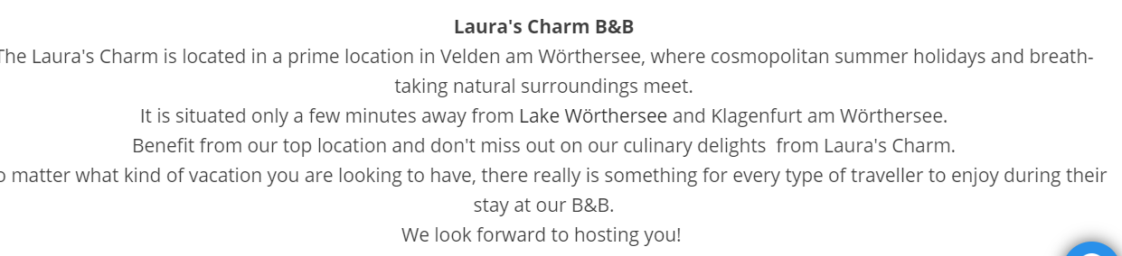
Followed by location I’ve placed high resolution, inspiring and practical photos to show the best facilities the B&B features including stunning room views, hearty breakfast, barbeque area and impetuos terrace. Because my target are millenials( acording to my survey questionare), and most of them will come with their children, I’ve wanted to attract them with the images of a splendid pool with sun lounges and kids play area.I’ve wanted to ensure that all services are clearly laid out so that the guests know exacly what they will be getting.
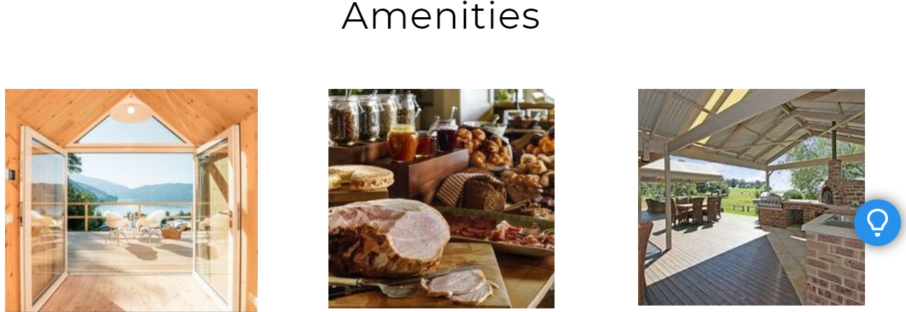
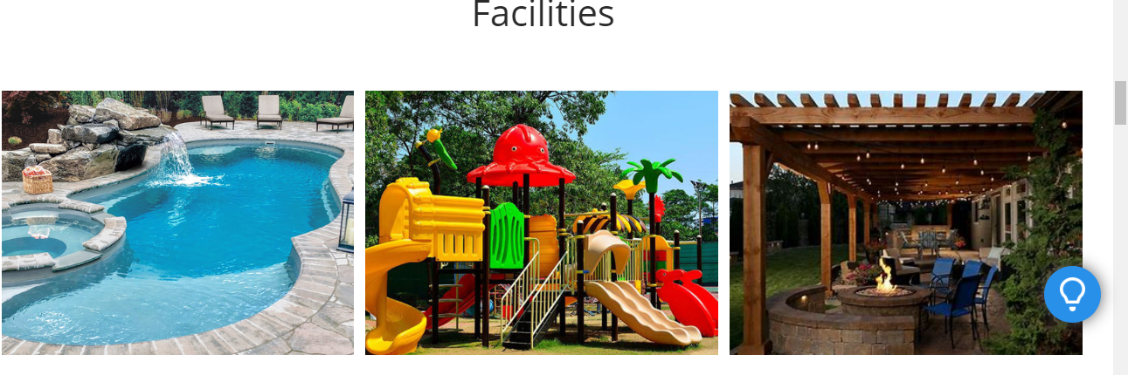

Bearing in mind that I’ve wanted to lure my guests in an adventure, I slurged them with nearby attractions, places of interest and events to feed their wonderlust and to pottentially receive a huge amount of engagement which will lead to much further growth.

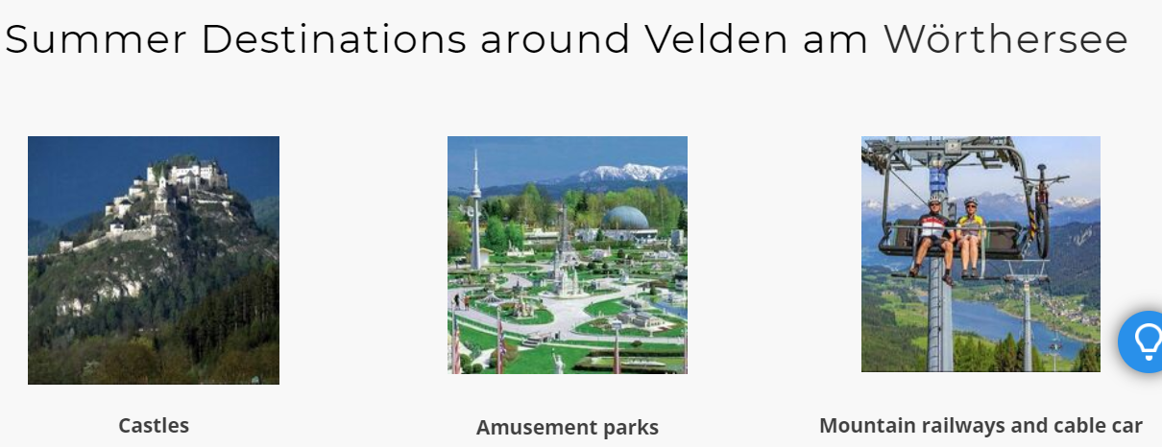
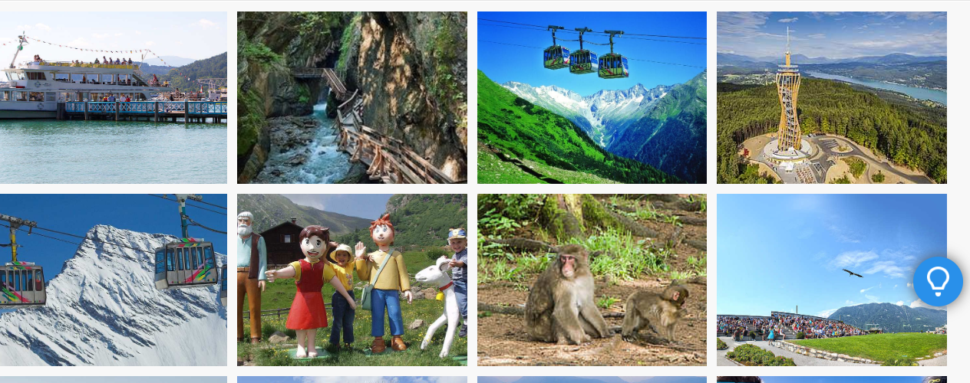
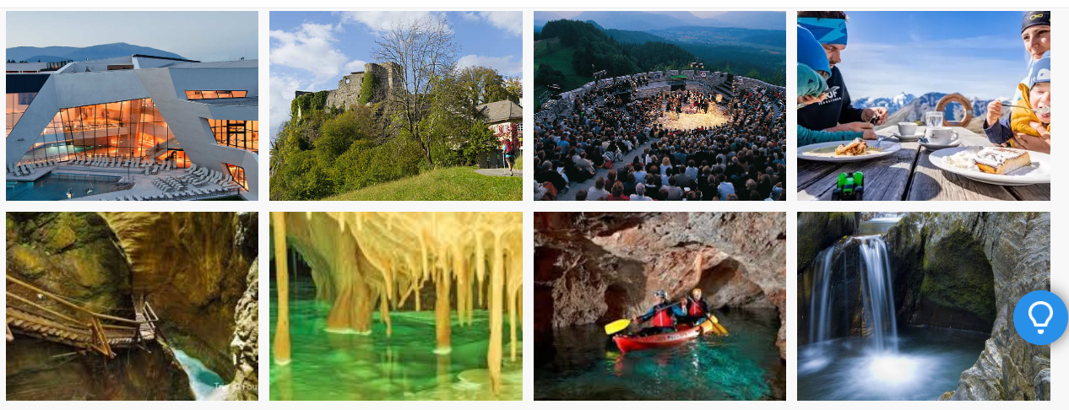
(www.visitcarinthia.at)
Putting the button ‘’BOOK NOW’’ easy to find will alow the customers to book instantly rather than having to telephone or email. I’ve also included a cool perk like ‘’Karten Card’’to atract even more guests due to its benefits, and as a special offer I gave the opportunities for people to buy vouchers from my B&B.
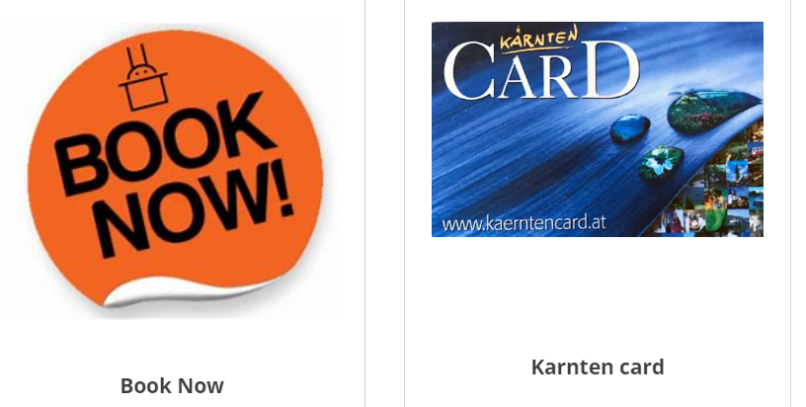
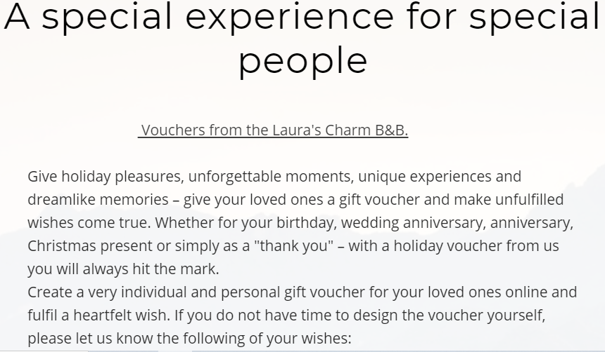
Based on my survey which concluded that most of my potential customers are booking holidays using social network (especialy Facebook), I’ve included an all pages social buttons so it will be easy for the user to share my latest news and updates. I consider social network an amazing opportunity to be able to listen the sentiment surrounding my brand, engage more directly with the guests, improve brand recognition and bring more revenue. (www.littlehotelier.com)
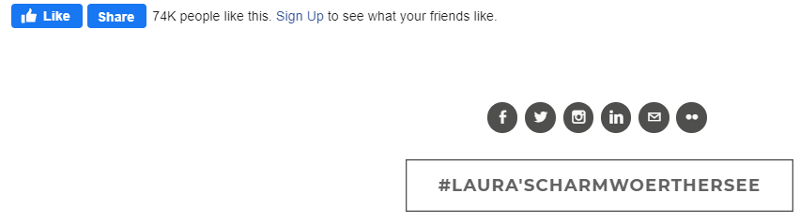
To facilitate how guests can contact and locate me I’ve also included the B&B address and contact details, a newsletter box in which they can send directly to me any inquires that they may have, and an active screenshot of Google Maps.
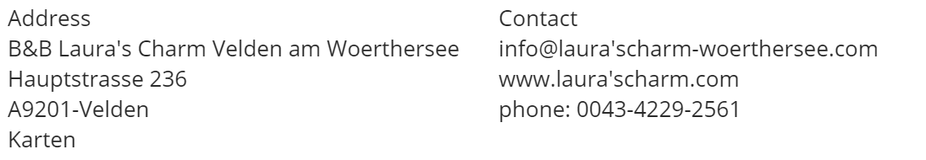
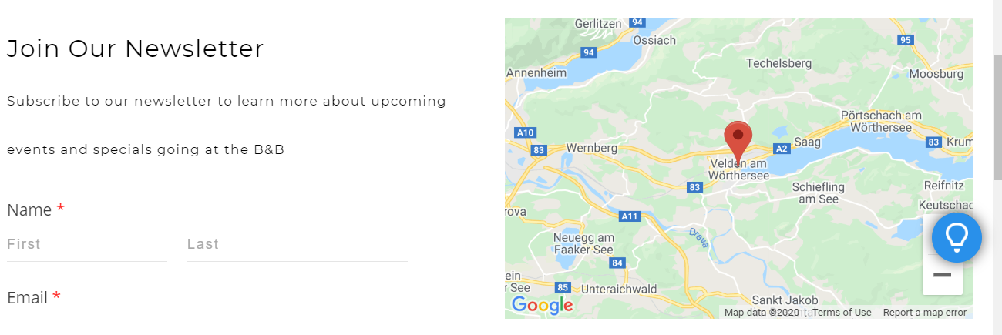
To make it as easy as possible for my potential guests to learn about my property and make a reservation, no matter what device they are using to acces my website I’ve aimed for a user-friendly navigation by keeping content short, design simple and using high resolution images and large buttons that make it easy to click.
Overall, by creating my website I’ve wanted to trigger in my potential guests the best type of emotion: Desire- desire to spend their holiday at my B&B.

References

- Unknown. (2016). Search Engine Optimisation [SEO] for B&Bs made simple. Available: https://eviivo.com/trade-secrets/getting-online/seo-for-bbs/. Last accessed 06.07.2020.
- Unknown. (2019). 7 Web Design and SEO Best Practices For Your B&B. Available: https://www.littlehotelier.com/r/hotel-marketing-tips/seo/7-web-design-seo-best-practices-bnb/. Last accessed 06.07.2020.
- Unknown.(2020).CarinthiaOfficialtouristportal.Available: https://www.visitcarinthia.at/. Last accessed 06.07.2020.

