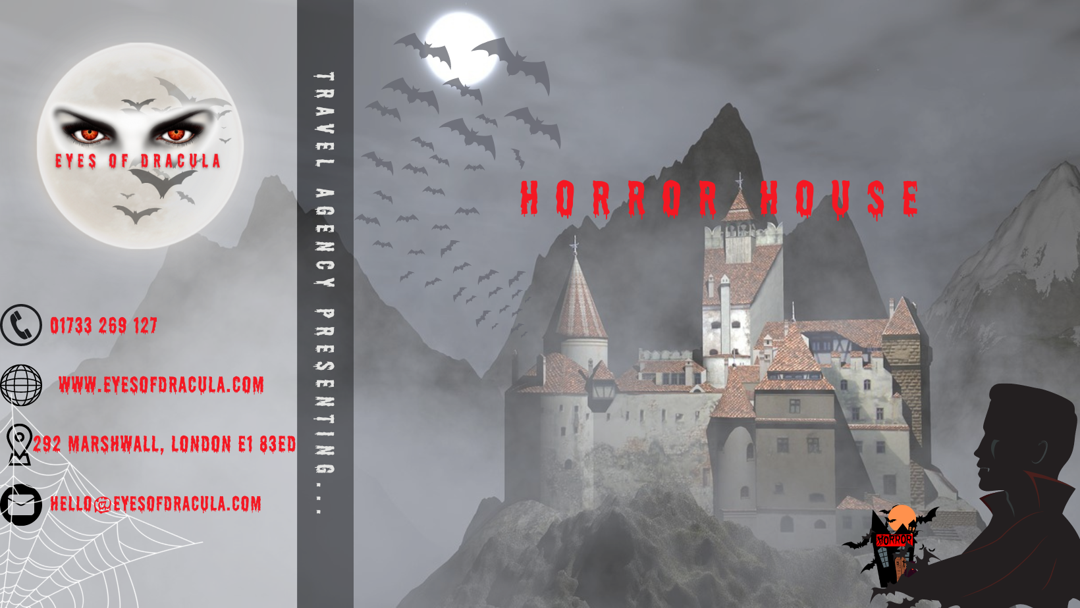
Winifred Soribe
[Company name] | [Company address]

BUSINESS DESCRIPTION / MARKET OPPORTUNITY

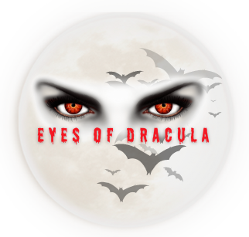
The business idea to create “Eyes of Dracula Travel Agency” is based on a Romanian Legend known as “Dracula, the vampire”, bringing it on English land, as approximately 800.000 people annually are visiting the famous Dracula Castle and a high number of people heard or know about the terrifying vampire.
Who are we? We are a horrific family partnership travel agency, based in United Kingdom, London, with Romanian roots and history acknowledge grounds and background about Transylvania and Dracula, we decided to bring the experience to any person who would like, being passionate or lover of horror.

Our mission is…. Fly to the Moon and Back and Transform your journey in frameable memory. Offering to our clients the most, unique, thrilled, and unforgettable experience under the high-quality service.
Our vision is…. To be in top recognized national and international travel agency by 2028, proving the highest quality service, amazing customer experience and to work with local people, involving the local communities.
Our travel agency and services. The product/service we are presenting is a Dracula theme horror house, where visitors can explore and enhance an experience the terrifying life of a vampire where they can spend from one hour to even 1 or 2 nights stay with the horrific facility to dare to sleep in our coffin beds.

INDUSTRY ANALYSIS – Porter’s 5 forces

Threat of new entry The Tourism, Leisure, and Hospitality industry has high entry barriers. Internet reduced tourism hindrances. Beginners can learn marketing basics by copying established chains to attract and keep customers. As technology improves, the internet makes markets more efficient, larger, and poses new substitution risks. Differentiation significantly blocks. A business with unique features like location, offerings, or facilities is more likely to attract and retain customers. Expertise and competencies demand in the Tourism, Leisure, and Hospitality sector hinder people from starting their own venture.

Threat of substitutes
New businesses can thrive well in the hospitality industry. The organizations differ in both cost and offerings. Competing for customers will be a challenge. The internet's tech advances benefit markets but create new substitution risks. Great strategy essential for industrial strength. Rival's online tactics could harm our clientele.

Bargaining power of customers
Business professionals who stay current on changes in consumer power are the wise customers who choose a company to conduct business within the tourism, entertainment, and hospitality sectors. It is becoming increasingly easy for consumers to use the Internet to explore and rate the top businesses that provide excellent services. People can now learn about available services without the help of intermediaries like travel agencies, corporate consultants, and intermediaries.

Bargaining power of suppliers
Although the Travel, Leisure and Hospitality industry may not be significantly exposed to hazards, it may, however, potentially impact suppliers operating within the region. The primary source of suppliers for companies are their employees. When there are fewer customers to occupy the service sector of the industry, labour resources hold greater bargaining power. Firms can attract highly capable staff and thereby, generate opportunities to offer exceptional service experiences to their customer base. As part of their strategic approach, it is essential for all corporate chains to incorporate the recruitment of section employees.

Competitors

As a first step before we ruled out our business idea, the key to success is to do a very good market research to know our potential customers, our rivals and how to penetrate the market and based on the research we consider our main competitors and what makes us different than them.
CRYSTAL TRAVEL is travelling agency with over 35 years of experience and has admirable partnership within in industry Their extensive global network includes more than 150 major airlines and roughly 65000 hotels, making the provision of these services conceivable. The differentiation is that our travel agency is based only on spooky experiences, collaborating with national and international horror attractions including Dracula’s Castle and his birthplace.
The London Dungeon is one the creepy and scary attraction of London of 90 min tour with 18 different shows and special effect and its location makes a competitor for us and why are more special of our horror house is that we are offering even terrifying coffin beds to sleep in.

OPERATIONS AND MANAGEMENT TEAM

Eyes of Dracula Horror House requires a place and equipment such: LED screen for virtual special effects, VR Lenses to offer the best and bring the reality in each visitor eyes, Dracula Props and decoration, Boss sound system for creepy sounds and Dracula Voice, collaboration with local and Romanian funeral companies for supplying the coffin beds, vintage lightning equipment, working in partnership with Bran Castle for proving us with exposition of original clothing of Vlad Impaler (Dracula) and furniture for more authenticity, working with custom and handmade business to create souvenirs and gifts for our clients, on spot cameras to create photography for a unique memories of our visitors, Outdoor and Indoor Banners, Digital Mirrors with Camera for scary appearance of Dracula, Fake blood, Costumes for tourists to rent them for £2, fake vampire teeth, fake dead body and skeletons, torture room Stakes to be used to impale fake bodies as Vlad Dracula did to his enemies.

The package of experience or night stay will be available to our website and working with London Eye to add as a London attraction +1 attraction but also on spot ticket available and via Wow Voucher and Groupon.

Revenue. Our goal is to gain customer loyalty first and by placing our house in a well-known and centric area, start with low affordable prices, offering student, family, group and child discount or recommendation to a friend gift will create revenue and potentially increasing.

Management and team structure
The company is a family partnership between myself and my husband both being the decision makers, and our goal is to build the dream team, focusing in hiring the people in needs or people who deserve a second chance such a single parent with flexible work available, people with low or non-mobility problem, people with minor criminal offences etc., and our company structure will be divided by see below

Leon White. The experience of 10+ years in management, his flawless skills in teamwork, great communication, leading by example and his capability of problem solving and working under pressure made him the upper management in charge of all departments.
Sherry Colman. The head of Administration, bringing to the table his strong organisational, communication, IT, customers service skills being responsible for Bookkeeper department plus the experience in tourism area.
Daniela Perez. Top skills that highlighted are employee management, the ability to read and deliver customers’ requirements, planning and consider potential risks, leadership, decision-making, moving her to operation department.
James Snowhite. The confidence, reinsurance, good listening skills made him the head of sales department and his experience of 6 years of retail/sales industry.

MARKETING PLAN

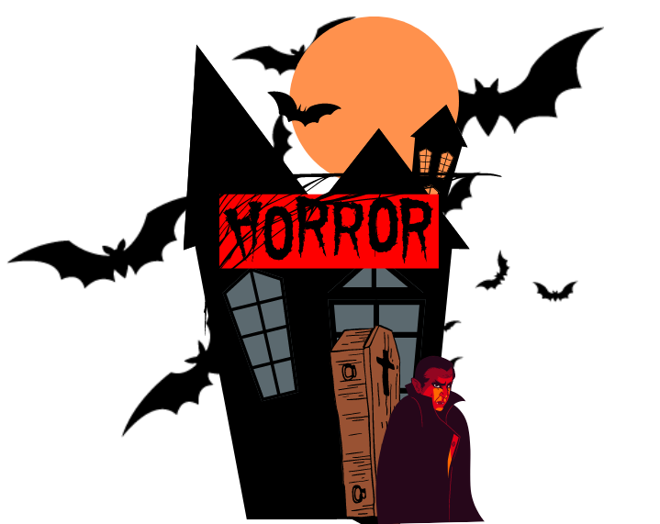
Product. The Eyes of Dracula Horror House is a haunted attraction with a vampire motif that draws inspiration from The Legend of Dracula. The establishment promises patrons one or two evenings of eerie accommodation coffin beds to create a convincingly ominous and unforgettable experience.

Price. The price for experience day starting from:
- £65 per person paid on the spot at the location.
- £55 per person paid on Groupon, Wow Voucher.
- £45 per person paid on our website.
The price for night stay starting from
- £120 per night paid on the spot.
- £110 per night paid on Groupon, Wow Voucher.
- £ 90 per night paid via our Travel Agency package.
Student, Family, Group and Child Discount may apply.

Promotion. Since promotion is vital in raising the profile of our product and services, we have utilized diverse social platforms, including Instagram, Tik-Tok, Facebook, Google Ads, YouTube ads, alongside other conventional forms of brand promotion like television advertising on channel 4, banners, flyers, e-marketing, and radio.

Place. All the available tickets can be purchased through various channels such as our travel agency website, The Eyes of Dracula Horror House website, links via Social Platforms, and vouchers from Groupon and Wow. Besides, the combo package, which includes a visit to the London Eye with one other attraction, can also be bought via the London Eye website.

People. Our primary objective is to establish an enduring and robust identity among our patrons, vendors, and team members resulting in steadfastness from employees, clients, and suppliers alike. Providing exemplary customer service in addition to effectively identifying and fulfilling client requirements with the aim of cultivating sound relationships with suppliers is a means of fostering motivation and paving the way for career advancement.

Process. Patrons have the ability to procure admission tickets via an online booking website as well as the "The Eyes of Dracula" application. This platform provides the convenience of bundling packages, locating nearby attractions and enables the opportunity for online payment with sturdy cyber protection. Moreover, there is a provision for on-site payment via cash or by utilizing the contactless alternatives - Apple Pay or Google Pay.

Physical Evidence. Our agency has established a collaborative partnership with A.M Custom Clothing. The objective of this collaboration is to procure custom-made uniforms that are environmentally sustainable, being exclusively fashioned from recyclable materials. Our Thriller house has been adorned with state-of-the-art technology, as well as authentic clothing and furniture procured from the prominent Bran Castle, to collectively engender an immersive, authentic simulation of the vampire genre. Upon their departure, guests have the option to complete a digital feedback form, providing valuable insight regarding their experience while identifying opportunities for improvement and their overall sentiment towards their visit.

FINANCIALS

Sources of funds: where would you be getting funds from? For loans, please prepare a repayment plan

Use of funds

 | Month 1 | Month 2 | Month 3 | Month 4 | Month 5 | Month 6
Revenue (from your operations and marketing section)
Fixed Costs
(List out your fixed costs)

Variable Costs
(List out your variable costs)

Profit

MARKET RESEARCH

Pestle Analysis

Political Factors
- Open Borders. Governments let foreigners in. Wealthy tourists' travel fuels the tourism industry. Certain countries allow visa-free travel, enhancing convenience.
- Steady governance. War-torn or oppressive countries do not promote tourism. Global political stability boosts tourism and economies.
- Government Registration. Governments boost tourism by giving incentives which may include paying for foreign purchases or waiving visa fees. Regulations aid tourism and economy.

Economical Factors
- Higher earnings. More people can now afford to travel internationally due to the growth of the global economy. People can frequently afford luxuries like tourism because living expenses are increasing at a slower rate than buying power. Economic growth is predicted to continue, and this will positively impact the tourism industry.

- Improved Economics Models. Uber and Airbnb have modified the way individuals explore. New economic models have been introduced, which are more user-friendly and have increased access to tourism for people. These types of businesses are referred to as sharing economies. More of these kinds of cost-saving measures are anticipated in the coming days.

Social Factors
- Trend. Social media fuels youth tourism. Tourism now symbolizes social status and wealth on social media rather than being just a means of satisfying the urge to travel or socialize. Peer pressure has contributed to the growth of tourism.
- Interracial and culture friendly embracing.

Technological Factors
- Transport system progress.
- Information availability. Thanks to smart devices, it is possible for individuals to become familiar with various locations worldwide. Travel blogs provide people with essential information to embark on journeys that they may not have been able to undertake otherwise. Technology makes travel easier and more efficient. The tourism industry has benefited greatly from this improvement.
Legal Factors
- Easy Visa Access. Getting a Visa was a long and arduous legal undertaking. Almost everyone can now apply for and get a Visa.
- Travel credit. Banks offer tourism loans. These loans aid people in traveling abroad.
Environmental Factors
- Climate Crisis. Tourism growth has spiked exhaust emissions from planes, ships and other modes of transportation.
- Tourists Pollute. Careless humans often litter. Tourism harms coastal environments, including shorelines and coral reefs.

REFERENCES (AT LEAST TEN REFERENCES)

