Fundamentals in Construction Technology
ACBA4001
Domestic New-build

Jacob Thomas
1803650

Contents
Substructure 2
Ground floor 2
First floor 3
Roof 3
Alternative Roof Structures 4
Condensation 5
Ventilation 5
Steps To Reduce Condensation 6
Bibliography 12
References 12

Substructure
A solid slab raft foundation can be used for the substructure of this project. Although the subsoil is firm it could face movement because of the water table below. The clay content of the soil could mean the ground is prone to shrinkage being so close to a water table. A solid raft sits under the whole building as a continuous concrete slab which is thickened around the edges to give a greater load bearing capacity for the external walls. This distributes the load of the building over a large area, useful for reducing stress on soil in places where there can be ground instability due to a low load bearing capacity meaning that all of the ground below the structure carries the weight. The substructure allows the building to absorb any movement caused by ground settlement rather than locking the building in one position as the raft can move with its surroundings. The concrete is strengthened using a steel reinforcing cage to improve is tensile strength. This method is typically more expensive than other substructures due to the amount of concrete used and is typically used for large commercial construction. Holmes, M. (2016).
The topsoil is removed first and put to one side as it could be used for landscaping later on in the project. The area is then excavated to the desired depth and the ground below is compacted and filled with stone and sand to a specified height. Timber shuttering is constructed around the base of the foundations to control the flow of the concrete. Typically, 200-300mm depth of concrete is poured onto the reinforced steel mesh within the shuttering. This sits on top of 75mm layer of sand and a 150mm layer of hardcore below that in compliance with British Standards. See diagram 1. Because the foundations and flooring can be made as one, it can save time, materials and less excavation is required.

Ground floor
The suspended timber floor consists of solid timber joists covered with tongue and groove timber boards that are not in direct contact with the ground. In traditional build houses the timber joists are built into the inner leaf of the external wall and project across the structure to the other facing wall. The use of galvanised steel wall hangars can also be used to fix the joists to the external wall which can stop moisture from the wall getting to the end of the joists causing damage. The timber joists are supported by a small sleeper wall which should be a minimum of 150mm from the concrete slab. They are fixed to a wall plate that lies across the top of this sleeper wall. This means that long joists are not required as smaller ones can be used to bridge the gap to the sleeper wall. To stay within British Standard requirements the ground must have a layer of concrete on the ground and there should be a gap of at least 150mm between the timber and the concrete. The specification of the house requires joists that can span 4m. This would require 170mm x 75mm joists with a spacing of 400mm to span the widest area in a domestic structure. (Haringey.gov.uk, 2019)
The sleeper is built with a honeycomb design to allow the movement of air to aid ventilation alongside vents in the external wall. The external wall has a DPC above a stepped airbrick. This airbrick allows the movement of air in and out of the space under the floor joists. There is a DPC in between the walls and the wall plates to prevent damage from rising damp and moisture. Rigid insulation can be stapled in between joists to provide a fully insulated flooring. It is important to keep the insulation dry and free of moisture in order to retain its thermal resistance. See diagram 2. (Flynn, 2013)

First floor
The main purpose of the first floor is to support the load of furniture and people above. The first floor takes the same basic structure as the ground floor. Firstly, the timber joists are fitted and act as the main structure for the floor. Diagram 3 shows how the timber joists (38 x 220mm) can be built into the inner leaf of the external wall or be hung from galvanised steel wall hangars, typically with centres 400mm apart. Tongue and groove softwood floor boards are fitted onto the solid timber floor joists to give the main structure of the first floor. Noggins are used to give strength and stiffen structure of the floor. They provide a good strong base for other materials to be fixed to. Battens can be added above joists to level flooring. Strutting could be used between the ceiling joists in order to reduce movement that could cause cracking and other damage to the ceiling when the structure comes under stress. Insulation is fitted tightly in between, and rigid insulation typically 200mm thick fitted underneath the joists to create a thermal bridge and mitigate heat loss between floors. Walls are fixed to floors using galvanised steel lateral straps that should be carried over at least 3 joists if the floor is 2m above ground level. Floor boards should be at least 16mm thick and a breather membrane added to increase infiltration.
Working at this level required the use of scaffolding. Workers also need to be trained to work at a height and follow all safety procedures. Safety measures should be introduced to ensure that workers are not in danger of falling down stairwells and other possible fall or trip hazards. Handrails should be fitted at 950mm to prevent falling before any work is undertaken. Under the working at height regulations 2005, all equipment must be maintained and inspected regularly and risk assessments undertaken as precautions.

Roof
The scaffolding must be built up to the roof level with all handrails and safety features in place and built to a satisfactory standard. Appropriate steps must be taken to ensure that workers are competent to work on the roof. Trussed rafters are to be prefabricated at 40° pitch and delivered onto site to save valuable time. 47mm x 195mm trussed rafters pitched at 40° have a maximum span of 4.81m which can be used for our structure. Purlin struts are fitted along the inside of the pitched rafters to give strength and also allow room inside the loft. The trussed rafters are first hung upside down across the span of the building and positioned. They are then turned over and fixed with temporary bracing. The trussed rafters are then lined up with one another and levelled after being mounted on bearing pieces. When this is done, they’re fixed using anchor rods and permanent bracing. The walls muse be made level using a wall plate and mortar. The loft room means that insulation has to be fitted in between the rafters with a vapor control layer. Battens must be fixed at points across the rafters specific to the slates to allow the slates to overlap. We can calculate the number of battens needed by measuring the rafter length and dividing it by desired gauge using the measurements of the slate to ensure that there is sufficient overlaps. (Home-extension.co.uk)
An air permeable breather membrane is fitted under the battens that stops further movement of moisture that has made its way through the external barrier. This protects the timber and insulation by deflecting rainwater directly into guttering as it can be hung over the guttering. Diagram 4 shows the typical design of the roof trusses that you would see with this design specification. The diagram shows what bracing the trusses would need to be able to make space available for a loft room. We can also see the position of battens in which slates are fixed to form the outer shell of the roof.
The roof will be covered using natural slate. Using diagram 5 as an aid you can see the makeup of the roof tiles. The slate should have holes punched into them to allow them to be nailed onto the battens. At junctions between rooves a waterproof membrane must be fitted to allow for the removal of water down the roof as water can enter in the gap between the curved valley slates. Roofers start with the lowest part of the roof first and work their way up so that the slates overlap. The roof must have an angular ridge tile that is typically used for slate. This is fitted last and on top of the ridge board to deflect water onto the other tiles. The slates should be centre nailed on batten just above the top of the slate below to allow sufficient overlap. The side lap of the slates should be around half the width of the slates underneath. The eave design serves as decorative and practical reasons. Closed eaves have very little and sometimes no overhang. They protect the walls from water running directly down them with help from guttering to direct the water. Eaves contain vents to encourage ventilation in the batten cavity. This allows moisture to be moved from the cavity preventing damage to the structure. Vents in the eaves allow cool air to enter into the house while allowing warm air to escape. (Traditionalroofing.com 2019)

Alternative Roof Structures
The selected trussed rafter roof structure allows ease of construction and finishing due to its versatile and lightweight structure. It is a cheap method of construction that does not require specialist tradesmen to complete the job. It is a simplistic design that means that less materials are used with less man hours used to build, making it cheaper than building a cut roof. The strength of the trussed rafters comes from triangles which can be formed as galvanised steel connectors allow the timbers to be fixed. The roof can be made weathertight at an earlier stage which can save valuable time so that work can move on to the first and second fixings. It also allows the roof to be insulated easily through ventilation in the eaves. This roof type provides limited space inside the loft room because of the pitch and trussed rafter design which is a problem for a customer that has specific preferences for a loft room.
An alternative method of the roof construction could be building a cut roof which means that the timber is individually cut and fixed on site and fixed to a wall plate. The advantages of building a cut roof include the ability to create unique roof lines using rafters and ceiling joists in comparison to more standard designs prefabricated off site. Certain designs use struts, hangars and collars positioned in specific places giving strength to the rafters whilst creating a far larger living space in the loft, optimum for this specification. This design allows more freedom for customisation as the roofers can create dormers and other designs to create loft space. However, cut rooves do come with some drawbacks. The construction process does take much longer than using prefabricated trussed rafters because they have to cut the timber to the correct size as well as fix each piece. Measuring and cutting the timber can use up precious time on a project where deadlines need to be met. This method is typically more expensive as the construction of a cut roof requires a skilled worker to complete. The extended completion time the timbers used both contribute to the greater expense. (Ebcsltd.co.uk)

Condensation
Water condenses from the air when the air has a high-water vapour content and comes into contact with a cold surface that is below the dew point relative to the humidity. The water vapor reaches 100% humidity and water droplets appear on the surface. This is extremely bad for construction because the presence of water from condensation can lead to damage and rotting to materials. Improving ventilation is by far the best way to reduce condensation. Many people deal with condensation by reducing water content in the air by using things like dehumidifiers. However, removal of the cause is a far better and more cost-effective way of dealing with the condensation.
The warmer the air is, the more potential it has to carry more water vapour. We often see condensation appear on single glazed windows as the warm, humid air inside a room hits the cold surface of the window. We typically see condensation appear from drying wet clothes, cooking, showering and even from bodily functions like breathing.
The presence of moisture can cause damage to all different types of materials. You an often see damage left on homes after a cold and wet season as warm, inside air, rich with water vapour has reacted with cold outside air. The presence of moisture can cause rusting and the deterioration of metals. Damp can have a detrimental effect on concrete as it creates spaces between the aggregate that is replaced with air when the water evaporates. The concrete becomes less compact, thus causing the concrete to lose its compression strength. If reinforced concrete becomes damp then the steel reinforcing bars will rust and corrode and compromise the tensile strength of the structure.
Damp wood rots and deteriorates very quickly and can become dangerous if pressure is applied to it. Wood is a hydroscopic material that absorbs moisture and can swell and shrink depending on its moisture content. This can have a damaging effect on structures as moisture content can cause movement. Treatments can be used to help avoid moisture absorption, but it does not stop it. If someone walked over floorboards that were moisture damaged, they would be at risk of falling through which could cause serious harm. Moisture can encourage the growth of mould which could spread through the whole house and have a serious effect on peoples health. Brickwork can be affected by moisture if they are not completely waterproof from the outside. Rotting to walls and frost damage is typical in older buildings that have developed defects.

Ventilation
Ventilation can be achieved at every floor. Wall vents should be used below ground floor to eliminate rising damp from the ground and allow moisture to escape as well as Sleeper walls built with a honeycomb design allow the subfloor to be fully ventilated to stop damp rising up through the building from the ground. A fireplace is a good method of passive ventilation as air can continuously move up and down the chimney breast. A fireplace is not included in this design specification. The different floors could contain kitchen and bathroom extractor fans to remove moisture that accumulates from cooking and bathing/showering. These mechanical devices actively removes air from within a room and replace it with fresh air from outside. The first floor should allow movement of air out of the floor boards and walls should contain vents to allow moisture to escape. Keeping flooring well ventilated is very important because this is where the insulation is stored. If the insulation becomes wet, then it loses its insulation properties. Dry lining walls can be used to encourage movement of air up the walls behind the plasterboard. Eaves and roof vents allow air to move around the roof space. Blue arrows on diagram 6 show how cool, fresh air from outside can be drawn in through eaves, windows and vents. The exit of warm air is shown by the red arrows. As the cool air enters the warm air is driven out along with moisture. This reduces condensation within the house.

Steps To Reduce Condensation
Using a washing line outdoors rather than drying clothes indoors can reduce the amount of water vapour emitted into the air. A tumble dryer produces a huge amount of water vapour that can be avoided if exhaust pipes are directed out of open doors and windows. Reducing the amount of moisture in the air means that when the temperature in the room drops and reaches the dew point then less water vapour turns to liquid.
Chimneys typically have residue like soot from smoke fumes that were created by fire. This residue often contains salts which attracts water vapour. Chimneys need to be cleaned to remove excess salt in order to stop the build up of moisture in the chimney breast. Keeping chimneys open also provides a good way of ventilation for the home. Many old chimneys are blocked but if possible, this should be avoided to act as another vent for the home.
Keeping internal doors and windows open improves the airflow throughout the whole house. Circulation of air is the simplest and most effective method of reducing condensation because the humidity of the air is reduced as moisture can escape. Water vapour travels better in warmer air so a warm room quickly cools quickly as the vapour escapes through a vent. Opening a window before showering or bathing allows much of the water vapour in the air to escape before it is able to come into contact with cold surfaces and condensation occurs.
Using an extractor fan above the cooker during and after you have finished cooking and the use of lids on saucepans when cooking stops the moisture from being released when the water is boiling. This also applies to the bathroom as steam produced from hot water reacts with cold surfaces in the bathroom. Opening windows allows steam to escape before condensation arises.
Installing good insulated walls and double or triple glazed windows can provide better economy because less heat can escape from the property. The amount of condensation on the window decreases because the double glazing minimises heat transfer across the window. Double glazing allows for the possibility of window insulation because of the space in between the glass. This causes a thermal bridge as the inside layer of the window is not as cold as a single glazed window which would be susceptible to condensation. Installing insulation in walls and adding double glazed windows also has its negatives. With blocked chimneys and fires, insulated walls, central heating and energy efficient windows, new homes provide ample conditions for condensation as temperatures within the home are higher and standard ventilation is decreased.

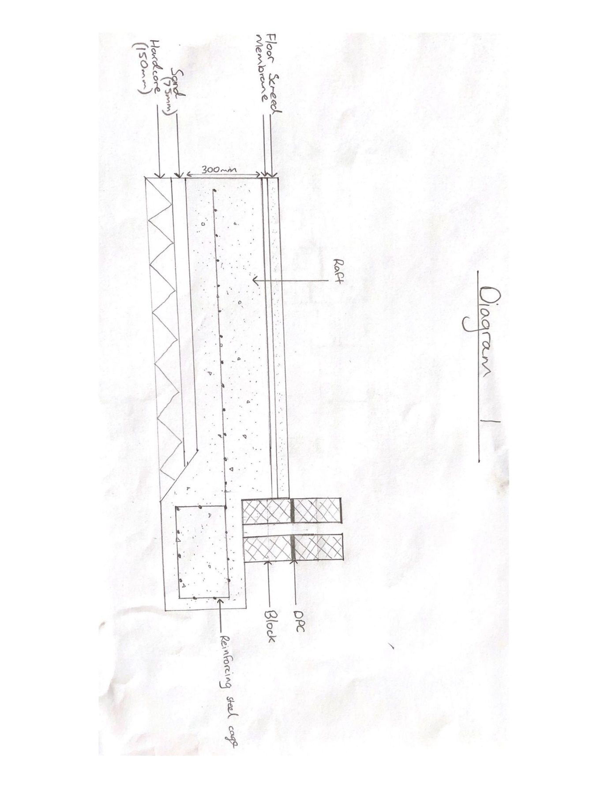
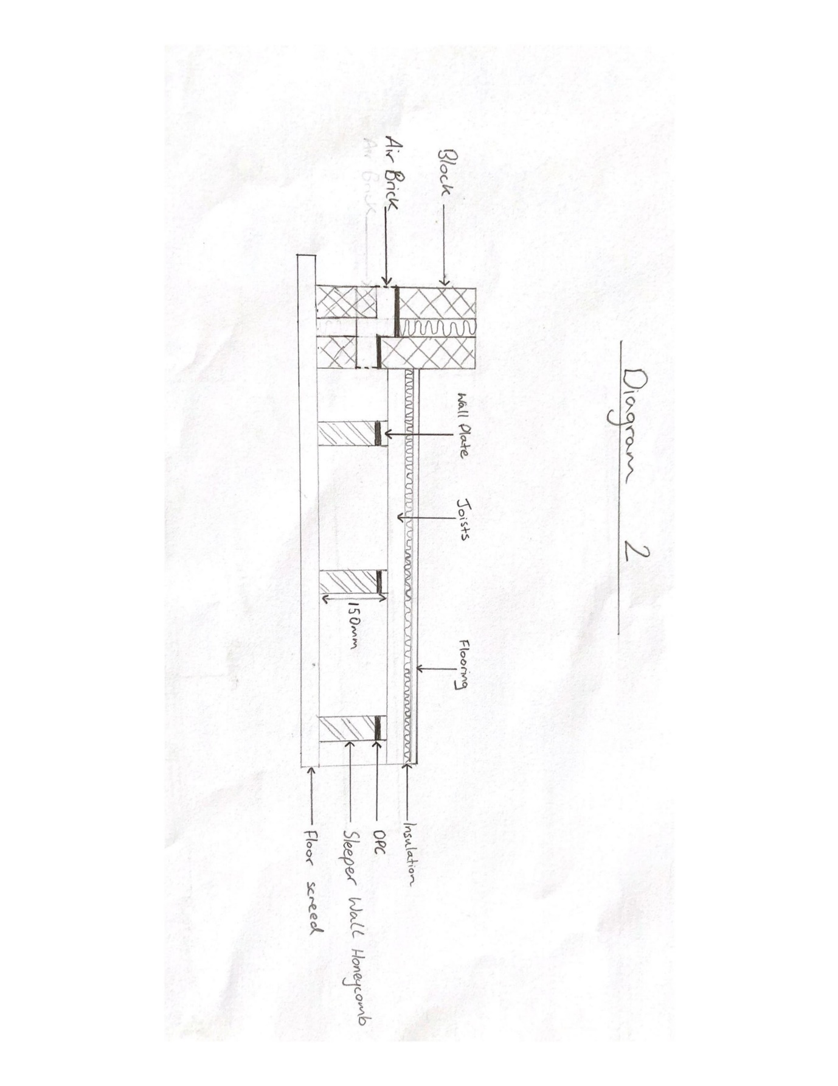

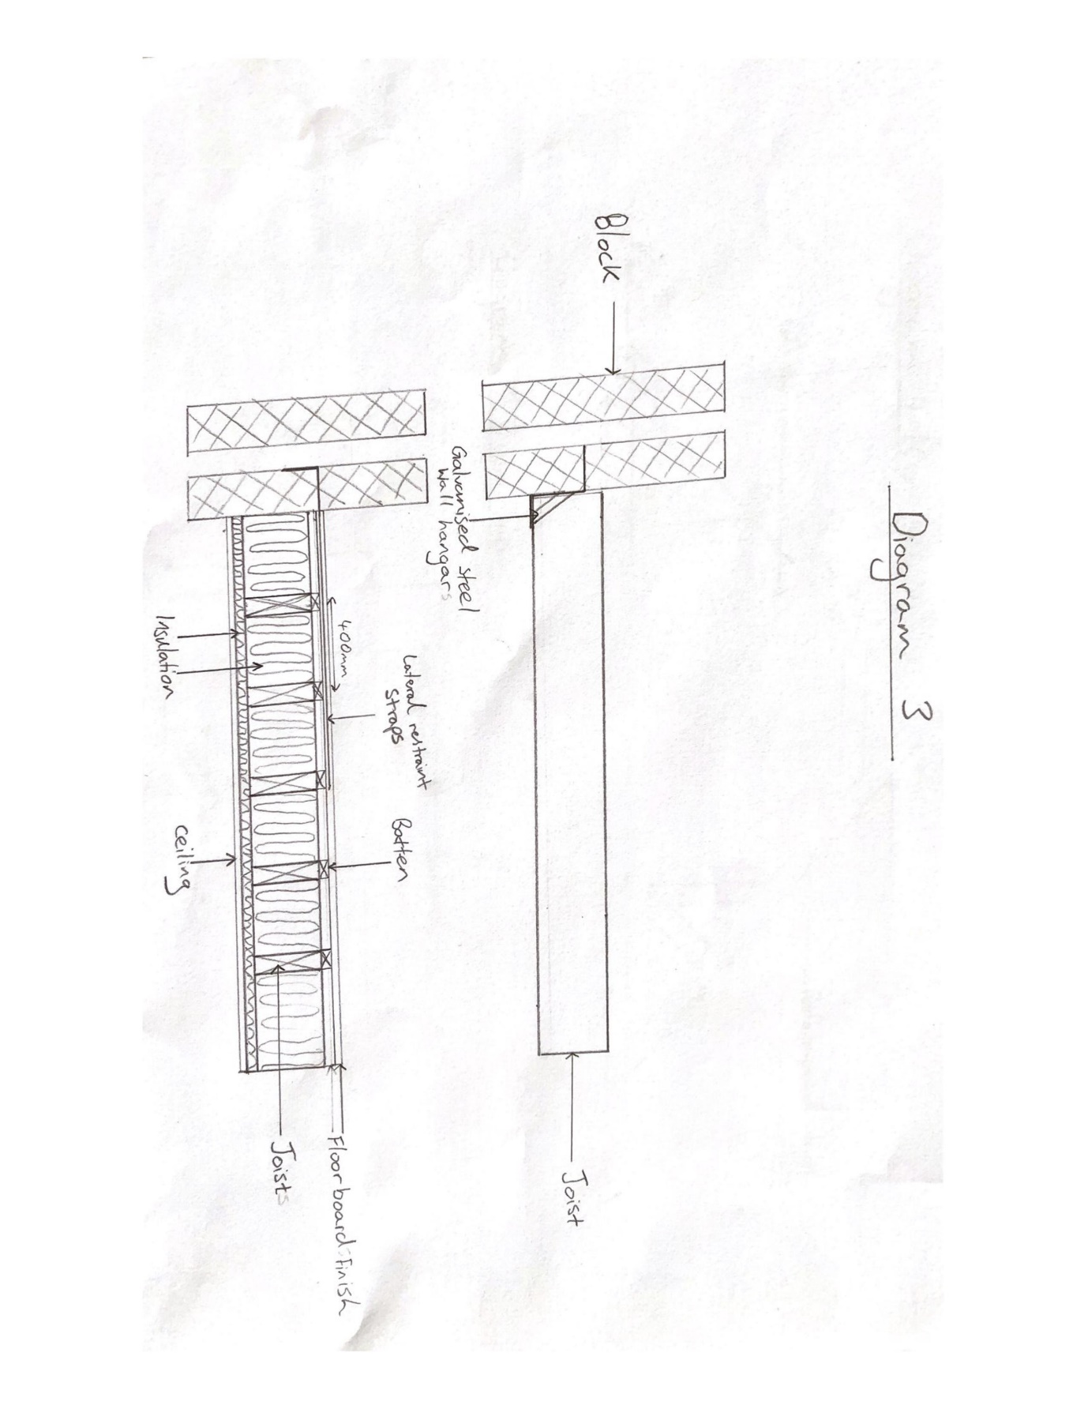

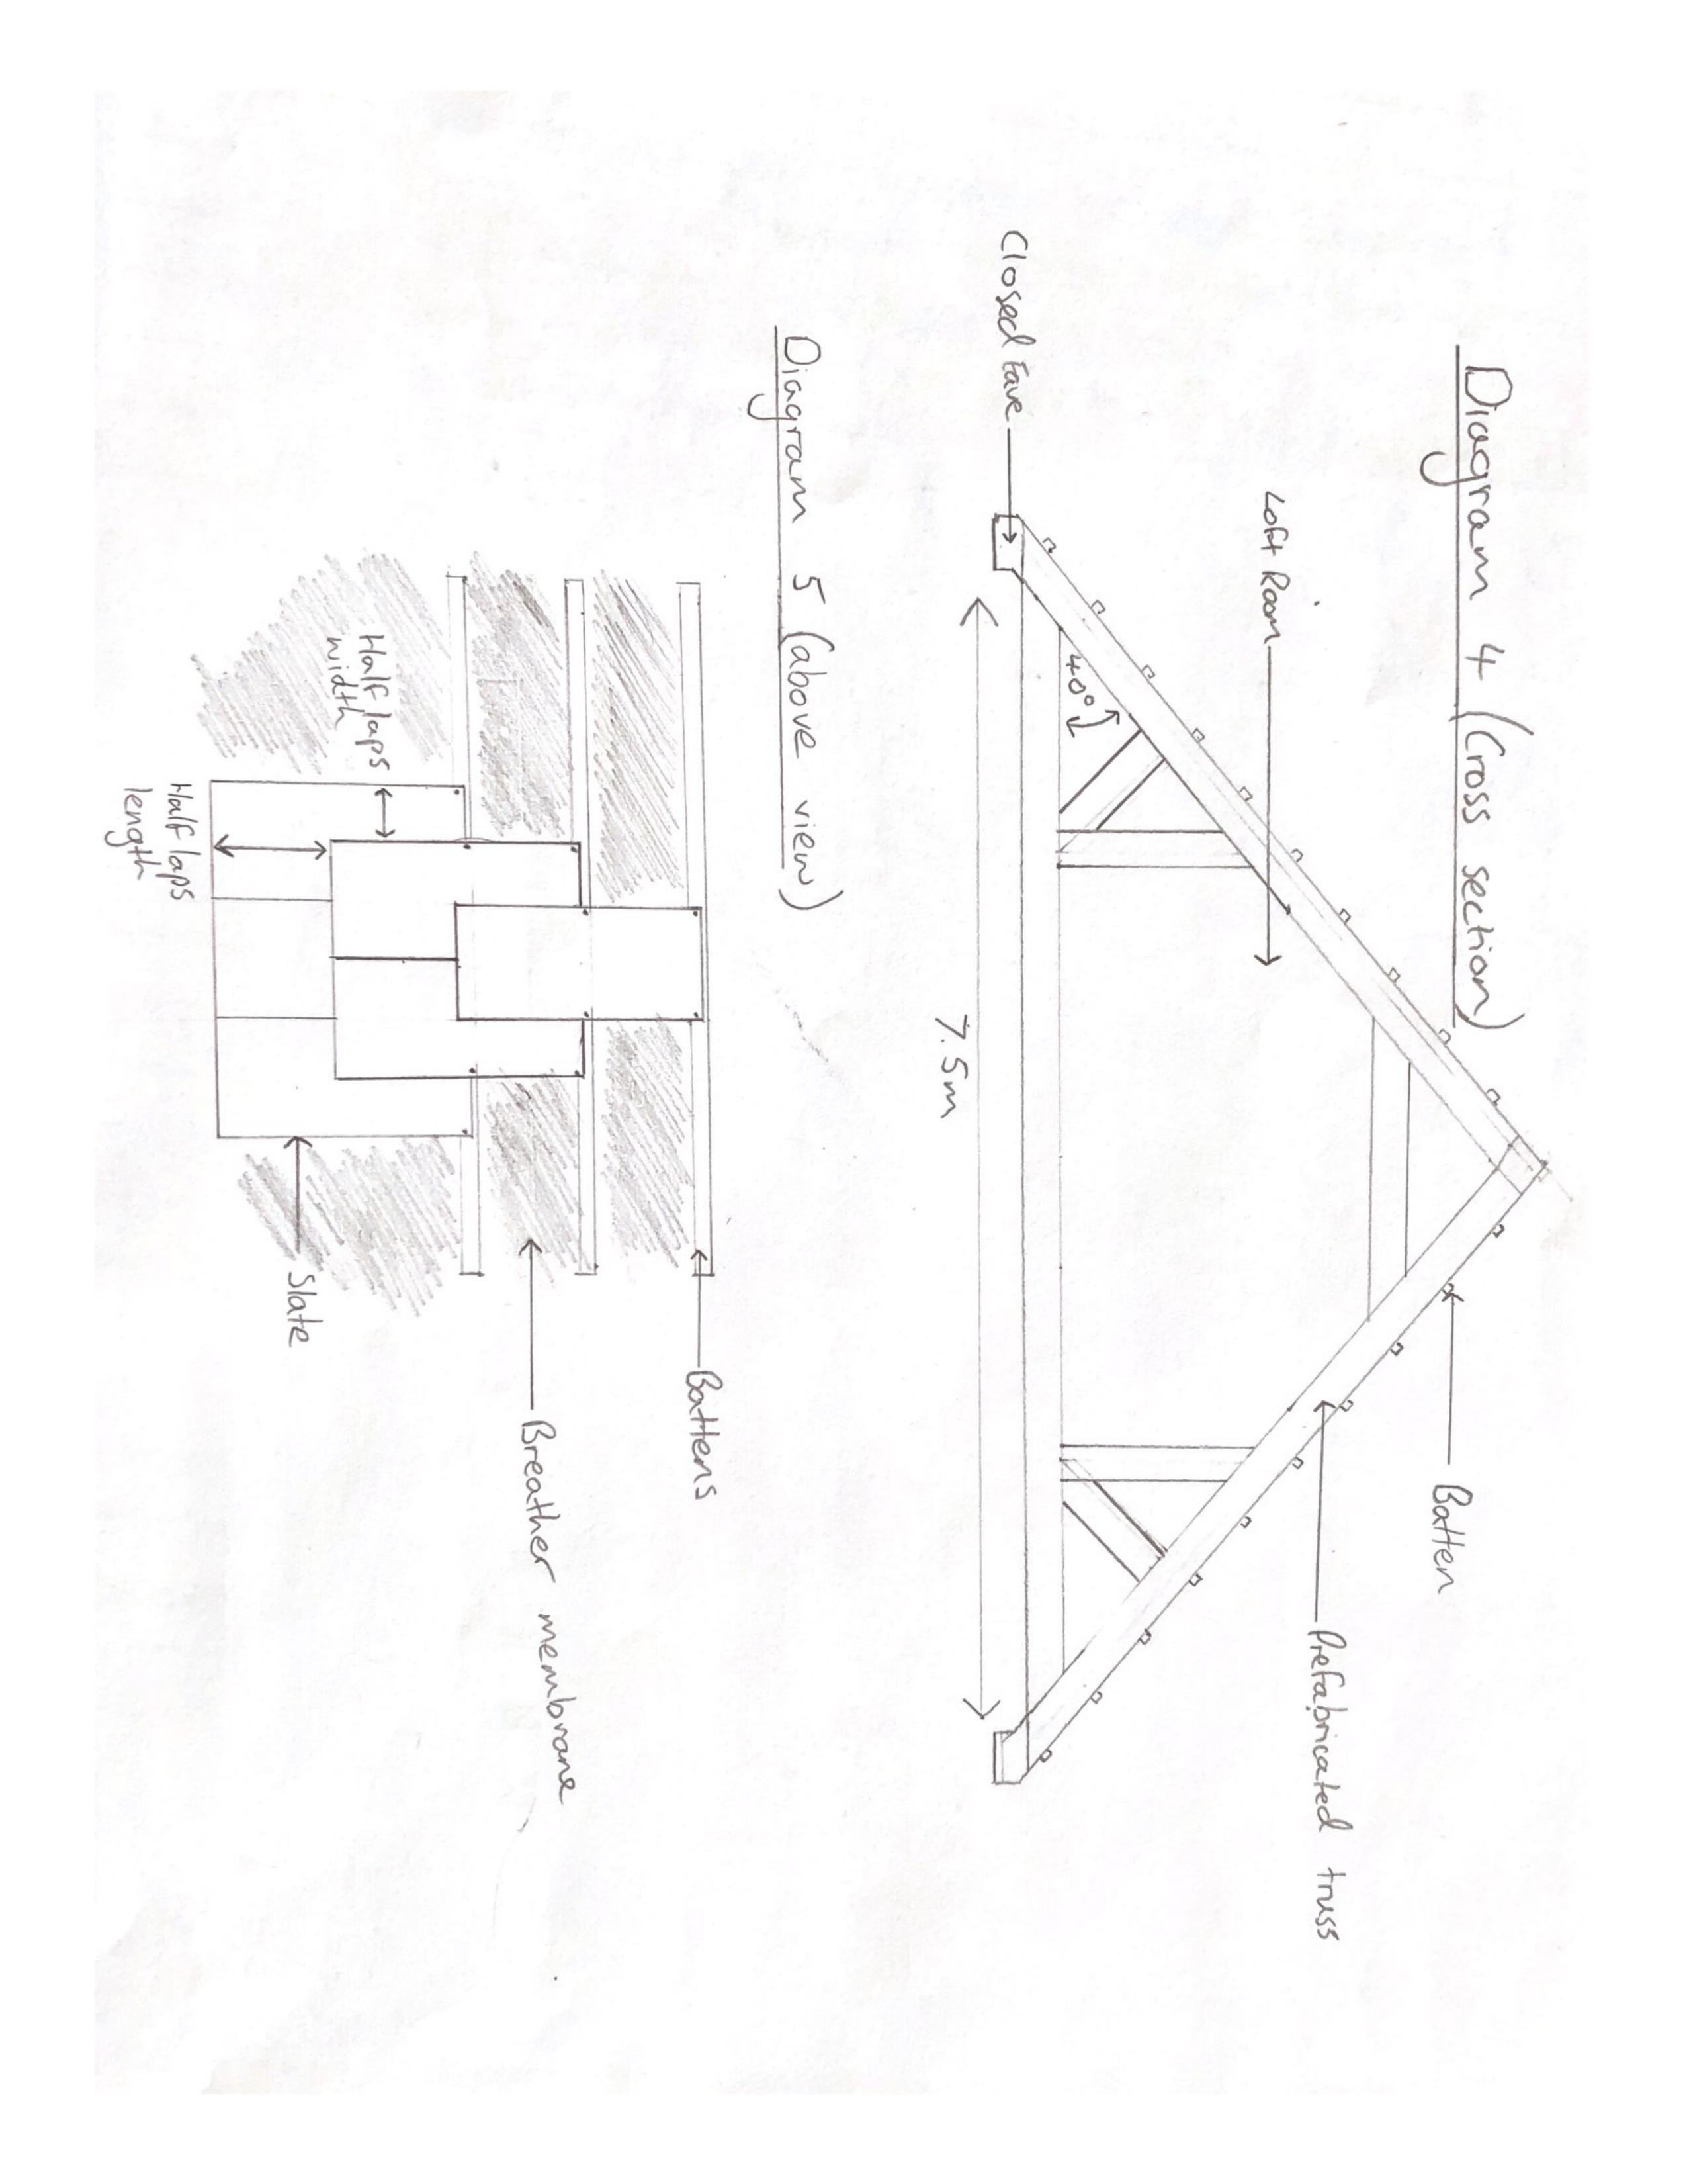

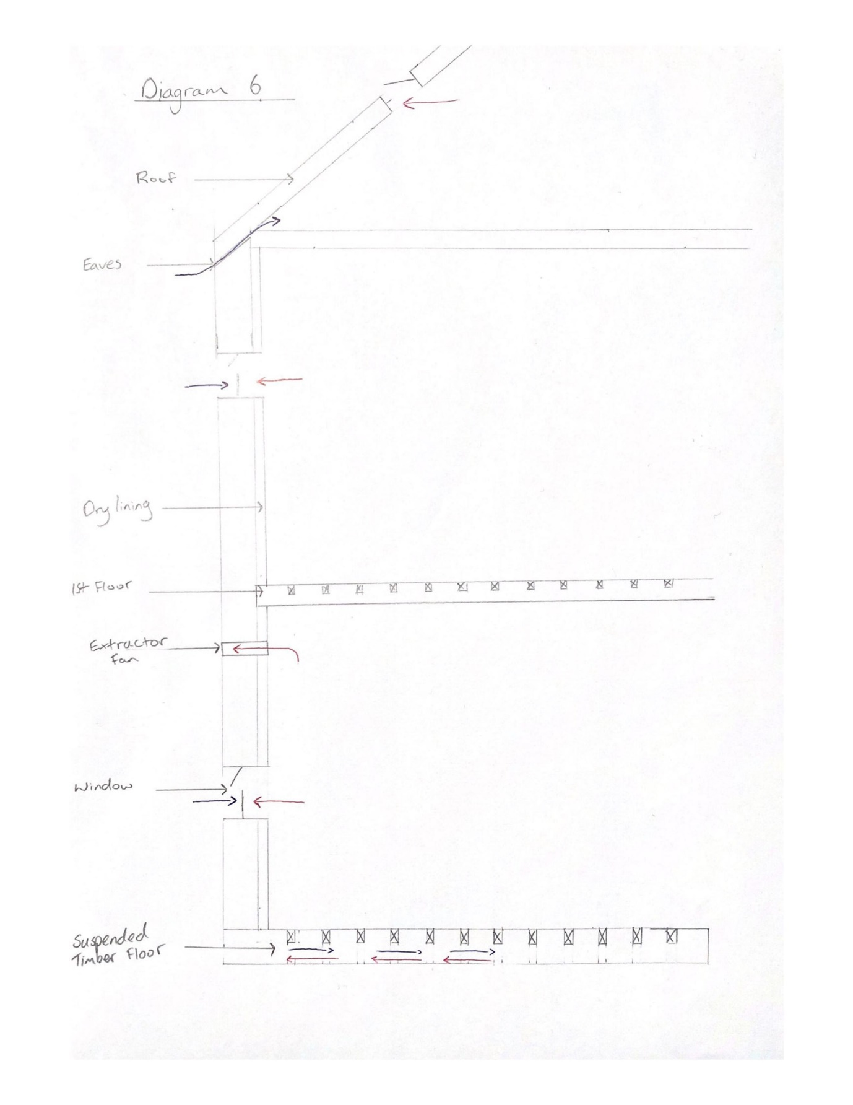

Bibliography
Holmes, M. (2016). Foundation Systems and Soil Types | Homebuilding & Renovating. [online] Homebuilding & Renovating. Available at: https://www.homebuilding.co.uk/foundation-systems-and-soil-types/ [Accessed 24 Feb. 2019].
CHUDLEY, R., and R. GREENO. Building Construction Handbook. Elsevier Ltd, 2010.
Ltd, E. (2014). 14 Ways To Help Reduce Condensation In Your Property | EnviroVent. [online] EnviroVent Ltd. Available at: https://www.envirovent.com/blog/14-ways-to-help-reduce-condensation-in-your-property/ [Accessed 26 Mar. 2019].
Diydata.com. (2019). Pitched roof types explained - cut and truss roofs. [online] Available at: https://www.diydata.com/general_building/roof_construction/roof_construction.php [Accessed 30 Mar. 2019].

References
Haringey.gov.uk. (2019). Building Control Guidance Notice. [online] Available at: https://www.haringey.gov.uk/sites/haringeygovuk/files/note07_-_domestic_timber_floors.pdf [Accessed 30 Mar. 2019].
Flynn, C. (2013). Suspended Timber Floor. [online] Construction Studies Q1. Available at: http://constructionstudiesq1.weebly.com/suspended-timber-floor.html [Accessed 24 Feb. 2019].
Traditionalroofing.com. (2019). TRADITIONAL ROOFING MAGAZINE - HOW TO INSTALL SLATE ROOF STARTER COURSES. [online] Available at: http://www.traditionalroofing.com/TR5_starters.html [Accessed 27 Feb. 2019].
Home-extension.co.uk. .roof-rafter-span-tables.html. [online] Available at: http://www.home-extension.co.uk/roof-rafters-span-tables.html [Accessed 30 Mar. 2019].
Ebcsltd.co.uk. Pitched Roofs. [online] Available at: https://ebcsltd.co.uk/wordpress/wp-content/uploads/2016/09/12pitchedroofs.pdf [Accessed 8 Apr. 2019].

