

Student Name: B M A RAHMAN
Student ID: 2526730

Module Name: International Business Concepts
Module Code: LCMB7034

Lecturer’s Name: Dr Charles Oham

Word Count: 5,000 words (±10%)

Submission Date: 14th August 2026

Acknowledgement of AI Tool Use
In accordance with the UWTSD AI Use Acknowledgement Guidelines (February 2026), the following AI tools were used within the permitted categories of research and proofreading as indicated in the assessment brief.
I acknowledge the use of Perplexity AI (https://www.perplexity.ai/) on 12 July 2026 to support my research using the prompt(s):
- What are JD Sports' current revenue, store count, regional revenue split and growth trajectory from their FY25 and FY26 reports?
- Summarise Bangladesh’s recent taka depreciation against the USD, real GDP growth trends and import tariff regime on footwear and apparel as of 2026.
I confirm that I have not presented any AI-generated text as my own work. I confirm I have copies of my drafts, notes, and other resources I used before and after the use of AI tools, which I may be asked to provide in evidence.

I acknowledge the use of Google Gemini (https://gemini.google.com/) on 14 July 2026 to support my research using the prompt(s):
- Provide an overview of Bangladesh’s apparel, footwear and sports/swimwear market sizes with Statista or equivalent projections for 2025–2029.
- Explain Dunning’s OLI eclectic paradigm with application examples to retail market entry.
- Summarise recent political stability and LDC graduation implications for Bangladesh.
I confirm that I have not presented any AI-generated text as my own work. I confirm I have copies of my drafts, notes, and other resources I used before and after the use of AI tools, which I may be asked to provide as evidence.

I acknowledge the use of Microsoft Copilot (https://copilot.microsoft.com/) on 16 July 2026 to support my research using the prompt(s):
- Summarise Bartlett and Ghoshal’s transnational framework and apply it to a retailer like JD Sports.
- Outline Bangladesh’s emerging middle-class size, urbanisation trends and sneaker culture development.
I confirm that I have not presented any AI-generated text as my own work. I confirm I have copies of my drafts, notes, and other resources I used before and after the use of AI tools, which I may be asked to provide as evidence.

I acknowledge the use of ChatGPT (https://chatgpt.com/) on 18 July 2026 to support my research using the prompt(s):
- Apply Porter’s Five Forces to a sports fashion retailer entering a market with strong grey imports and counterfeits.
- Explain the VRIO framework using Barney (1991) with focus on temporary vs sustained competitive advantage in retail.
I confirm that I have not presented any AI-generated text as my own work. I confirm I have copies of my drafts, notes, and other resources I used before and after the use of AI tools which I may be asked to provide as evidence.

I acknowledge the use of SciSpace (https://typeset.io/) on 20 July 2026 to support my research using the prompt(s):
- Find and summarise key academic sources on international entry modes, particularly franchising and joint ventures in South Asian emerging markets.
I confirm that I have not presented any AI-generated text as my own work. I confirm I have copies of my drafts, notes, and other resources I used before and after the use of AI tools, which I may be asked to provide as evidence.

I acknowledge the use of Grammarly (https://www.grammarly.com/) on 22 July 2026 to check my work using the prompt(s):
- Review the full draft for grammar, spelling, academic tone, clarity and flow, with particular attention to the PESTEL, OLI and entry mode sections.
- Improve readability of the reflective account while maintaining first-person voice.
I confirm that I have not presented any AI-generated text as my own work. I confirm I have copies of my drafts, notes, and other resources I used before and after the use of AI tools, which I may be asked to provide as evidence.

I acknowledge the use of Quillbot (https://quillbot.com/) on 23 July 2026 to check my work using the prompt(s):
- Paraphrase and enhance academic tone in the strategic synthesis and recommendation sections without changing core arguments or data.
I confirm that I have not presented any AI-generated text as my own work. I confirm I have copies of my drafts, notes, and other resources I used before and after the use of AI tools, which I may be asked to provide as evidence.

Table of Contents
Table of Contents 4
List of Figures 5
Section 1: Strategic Market Entry Analysis 6
1.1 Organisational Classification and Global Strategy 6
2.1 Macro-Environmental Appraisal and Market Attractiveness 10
PESTEL Summary (prioritised, not exhaustive) 10
Economic factors: the currency problem comes first 10
Political and legal factors: instability and the tariff wall 12
Cultural factors: real demand, thinner than the demographics suggest 13
Competitive context: who JD would actually be fighting 13
2.2 Market Entry Synthesis: Dunning's Eclectic (OLI) Paradigm 15
Section 3: Entry Mode Strategy and Strategic Synthesis 17
3.1 Historical Pattern Recognition 17
3.2 Strategic Fit and Justification 17
3.3 Conclusion and Recommendations 19
Section 2: Reflective Account 22
Description 22
Feelings 22
Evaluation 22
Analysis 23
Conclusion 24
Action Plan 24
References 26

List of Figures
Figure | Description | Page
Figure 1 | JD Sports revenue by region, FY25 pro forma basis (JD Sports Fashion plc, 2025). | 7
Figure 2 | JD Sports revenue by product category, FY26 (JD Sports Fashion plc, 2026). | 8
Figure 3 | JD Sports group revenue trajectory, FY22–FY26 (author's compilation from JD Sports Fashion plc annual reports, 2022–2026). | 9
Figure 4 | Bangladesh real GDP growth, FY21–FY25 (Economy of Bangladesh, 2026). | 11
Figure 5 | Bangladesh apparel, footwear and sportswear market sizes (Statista, 2025a; 2025b; 2025c). | 11
Figure 6 | Bangladesh's emerging middle- and affluent-class projection (The Daily Star, 2015). | 12
Figure 7 | OLI readiness profile for JD Sports in Bangladesh (author's assessment). | 16
Figure 8 | Entry-mode trade-off between control and resource commitment (adapted from Hill, Hwang and Kim, 1990). | 18
Figure 9 | Materiality weighting of macro factors in the entry decision (author's assessment). | 21
Figure 10 | Illustrative balanced-scorecard targets for a phased entry (author's construction; framework after Kaplan and Norton, 1996). | 20

Section 1: Strategic Market Entry Analysis
JD Sports is not the obvious candidate for a Bangladesh entry, and that is precisely what makes the case worth examining. The company sells trainers and branded athleisure to price-conscious but brand-hungry young people. Bangladesh has more of those people than almost anywhere on earth. It also has a currency that has lost roughly a third of its value against the dollar since 2022, an import regime that treats finished footwear as a luxury, and a retail sector where organised mall space is still thin outside two cities. So the question is genuinely open. This section works through it in three stages: how JD is configured as an international business, what the Bangladeshi macro-environment actually does to an entry decision, and which entry mode fits the risk the company would be taking on.
A note on the target-market claim. As of the June 2026 cut-off, JD Sports has no meaningful operational presence in Bangladesh. There are no company-operated JD fascia stores, no subsidiary, and no franchise partner listed in the group's territory disclosures, which run to just over 30 markets concentrated in North America, Europe, the UK and a small Asia-Pacific footprint (JD Sports Fashion plc, 2026). Some JD-stocked brands (Nike and adidas) reach Bangladeshi consumers through grey imports and third-party multi-brand shops, but that is not JD's presence. It is the brands' presence, arriving without JD's retail model, margin or control. That distinction matters for everything below.

1.1 Organisational Classification and Global Strategy
Bartlett and Ghoshal (1989) split international firms into four types by two pressures: the pull toward global integration and the pull toward local responsiveness. Multinational firms lean local. Global firms lean standard and centralised. International firms export the parent's know-how outward. Transnational firms try to do all of it at once. JD does not sit cleanly in one box, and pretending it does would be the first analytical mistake.
The honest read is that JD is a global strategy business wearing multinational clothing. Its core proposition, the curated head-to-toe sports-fashion store built around footwear at roughly 60% of revenue, apparel at 31% and accessories at 6%, is essentially the same in Manchester, Madrid or Miami (JD Sports Fashion plc, 2026). The buying power that lets JD secure limited-edition sneaker allocations from Nike and Adidas are centralised because scale is the whole point of it. That is a global logic. Yet the fascia mix on the ground is local: Hibbett and DTLR in the United States, Courir in France, and Sprinter in Spain. So the shopfront adapts while the engine underneath does not.
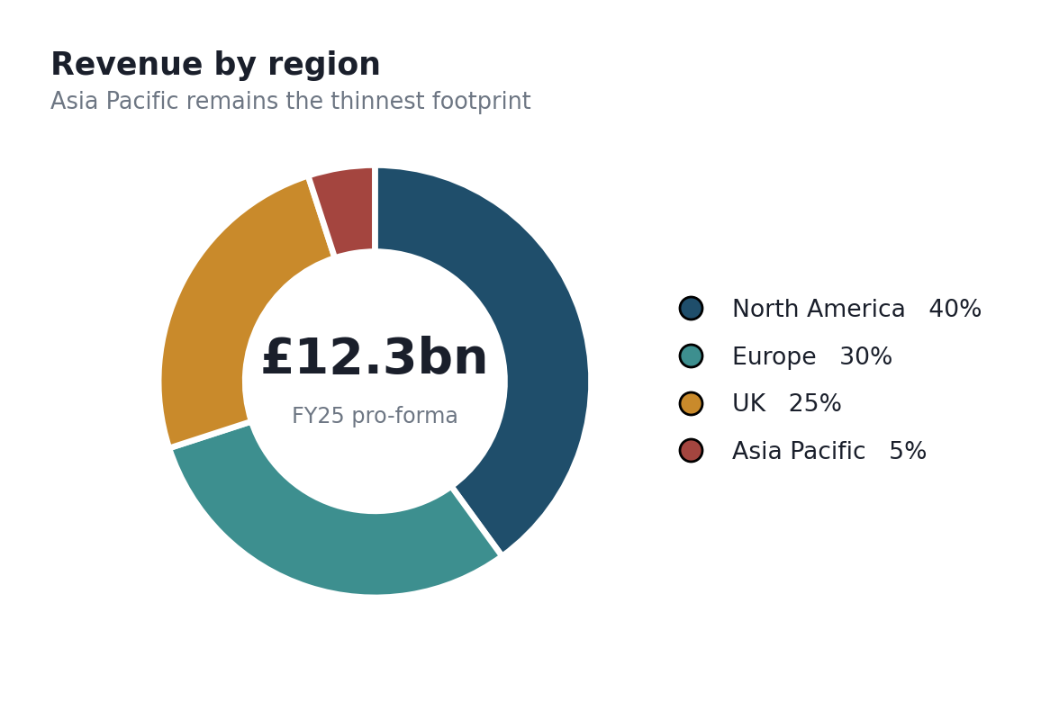
Figure 1: JD Sports revenue by region, FY25 pro forma basis (JD Sports Fashion plc, 2025).
The regional split makes the point sharper. On a pro forma basis, North America now accounts for around 40% of revenue, Europe 30%, the UK 25% and Asia Pacific a slim 5% (JD Sports Fashion plc, 2025). Two things follow. First, JD has become an Atlantic business, not a global one, whatever the marketing says. Second, that 5% Asia-Pacific figure is the crack through which a Bangladesh conversation even becomes plausible because it signals a region where JD has appetite but almost no depth. A firm with 40% of revenue already in Asia would treat Bangladesh as an incremental store-count decision. JD would be treating it as a beachhead.
Where does the competitive advantage actually come from? Not from the products. JD does not make Nike Dunks; Nike does. JD's advantage is a bundle of three things that are harder to copy than they look: preferential access to scarce sneaker allocations, a multi-brand curation skill that neither a mono-brand Nike store nor a generic sports shop can replicate, and a store experience tuned to teenagers and young adults who treat footwear as identity. Barney's (1991) resource-based view is the useful lens here, and I will come back to it because two of those three advantages travel badly across borders and one does not travel at all without the right partner.
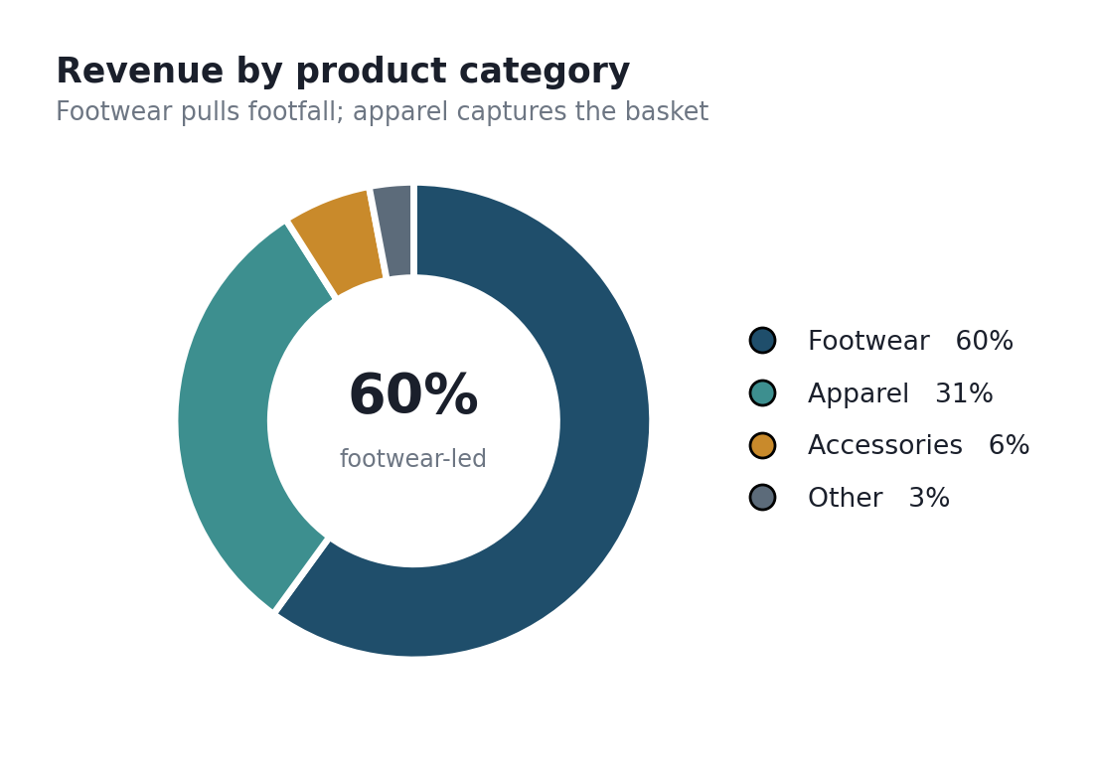
Figure 2: JD Sports revenue by product category, FY26 (JD Sports Fashion plc, 2026).
Value creation, then, is a function of throughput more than of margin. JD runs a high-volume, footwear-led model where the scarce-allocation sneakers pull footfall, and the higher-margin apparel and accessories capture the basket. Group revenue reached roughly £12.3bn for the 52 weeks to 31 January 2026, with organic growth of about 2.9% against a slowing market, and the strategic message from management was explicitly about consolidation and margin discipline rather than aggressive new-territory expansion (JD Sports Fashion plc, 2026). That backdrop is not incidental. A firm in landgrab mode might tolerate a speculative Bangladeshi entry. A firm being told by its own board to protect returns will demand that any new market clear a much higher bar.
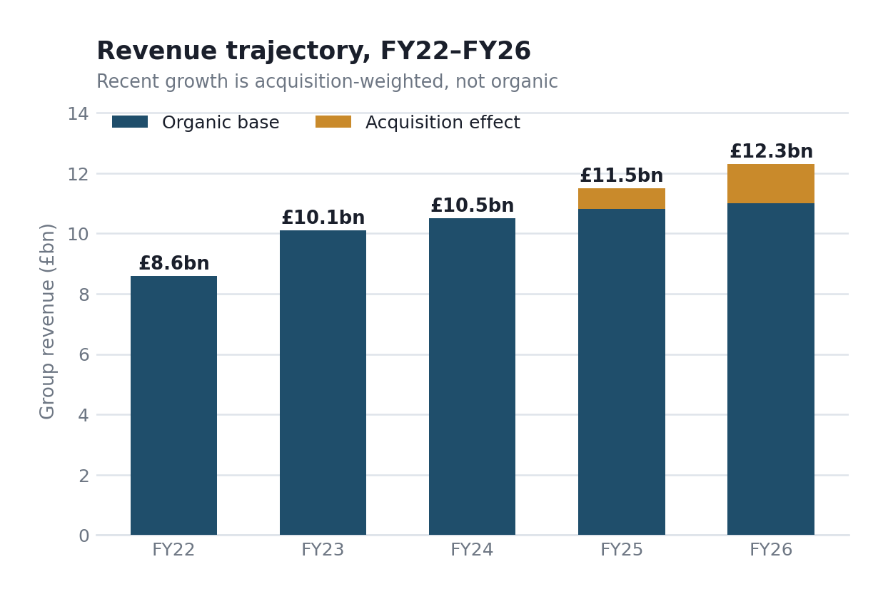
Figure 3: JD Sports group revenue trajectory, FY22–FY26 (author's compilation from JD Sports Fashion plc annual reports, 2022–2026).
It is worth pausing on the acquisition-led shape of that growth because it changes what the trajectory means. The step up between FY24 and FY26 is not mostly organic. Hibbett and Courir together added around 1,485 stores in a single period, taking the estate to roughly 4,850 stores worldwide (JD Sports Fashion plc, 2025). Strip the acquisitions out and organic growth was a much more modest 2.9% for FY26 (JD Sports Fashion plc, 2026). That distinction matters for a Bangladesh reading in a specific way: JD's growth engine is buying scale in markets that already have organised sneaker retail, not seeding demand in markets that do not. There is no Bangladeshi habit to acquire. So the very playbook that produced this revenue curve is unavailable in the market being considered, which is a quiet but important constraint on how JD could realistically enter.
Applying the VRIO test honestly is more useful than asserting JD has a durable moat. Take the three candidate resources in turn. The brand is valuable and rare and reasonably hard to imitate quickly, so it clears the bar. Scarce sneaker allocation is valuable and rare, but it is not owned by JD; it is granted by Nike and adidas, and it is only as durable as those relationships, which is a dependency rather than a possession. Curation and store-experience capability are valuable and reasonably rare, but they are imitable over time by a well-funded regional retailer. So the picture VRIO paints is not 'sustained competitive advantage' across the board. It is one durable advantage (brand), one borrowed advantage (allocation), and one erodable advantage (curation). Forcing all three into the 'sustained' box, which is the tidy answer, would overstate JD's position and weaken the analysis. The realistic conclusion is a temporary-to-sustained advantage that depends heavily on supplier relationships JD does not control.

2.1 Macro-Environmental Appraisal and Market Attractiveness
The temptation with a country analysis is to march through every PESTEL letter, giving each equal weight. That produces a tidy table and a weak argument. A real entry decision hangs on two or three factors that could sink it, and the analyst's job is to find them and say so. For JD in Bangladesh, the decisive factors are economic (currency and import costs), then political and legal (stability and the tariff regime), then cultural (whether the demand is actually there). I have weighted them accordingly in Figure 9 later, and I dismiss the rest as real but immaterial as I go.

PESTEL Summary (prioritised, not exhaustive)

Factor | What it does to a JD entry | Weight
Economic | Taka has fallen roughly a third against the dollar since 2022; imported trainers get more expensive in local currency every year. This is the single biggest threat. | High
Legal | Import duties and supplementary taxes on finished footwear and apparel can push landed cost well above shelf price; LDC graduation in Nov 2026 removes some export perks but is a mixed bag for an importer. | High
Political | Recent instability and transition risk raise the cost of committing fixed capital; a low-commitment entry hedges this. | Med-High
Social/Cultural | Young population, rising sneaker culture, cricket and football fandom the demand tailwind is real but thinner than headline demographics suggest. | Medium
Technological | Mobile-first consumers and growing digital payments help online-led entry, but last-mile logistics are patchy. | Low-Med
Environmental | Largely background noise for this decision, relevant to sourcing narrative, not entry viability. | Low

Economic factors: the currency problem comes first
Start with the number that decides everything. Bangladesh's real GDP growth fell to about 3.49% in fiscal 2024–25, the slowest in years and well down from the near-7% the country ran through much of the 2010s (Economy of Bangladesh, 2026). Growth slowing is not fatal on its own. What matters more for an importer of dollar-priced goods is the currency. The taka has depreciated sharply, losing roughly a third of its value against the US dollar across 2022–25, which means the same pair of Nike trainers costs a Dhaka retailer materially more taka each year even before duty. For a business model built on imported branded footwear is a structural headwind, not a cyclical one.
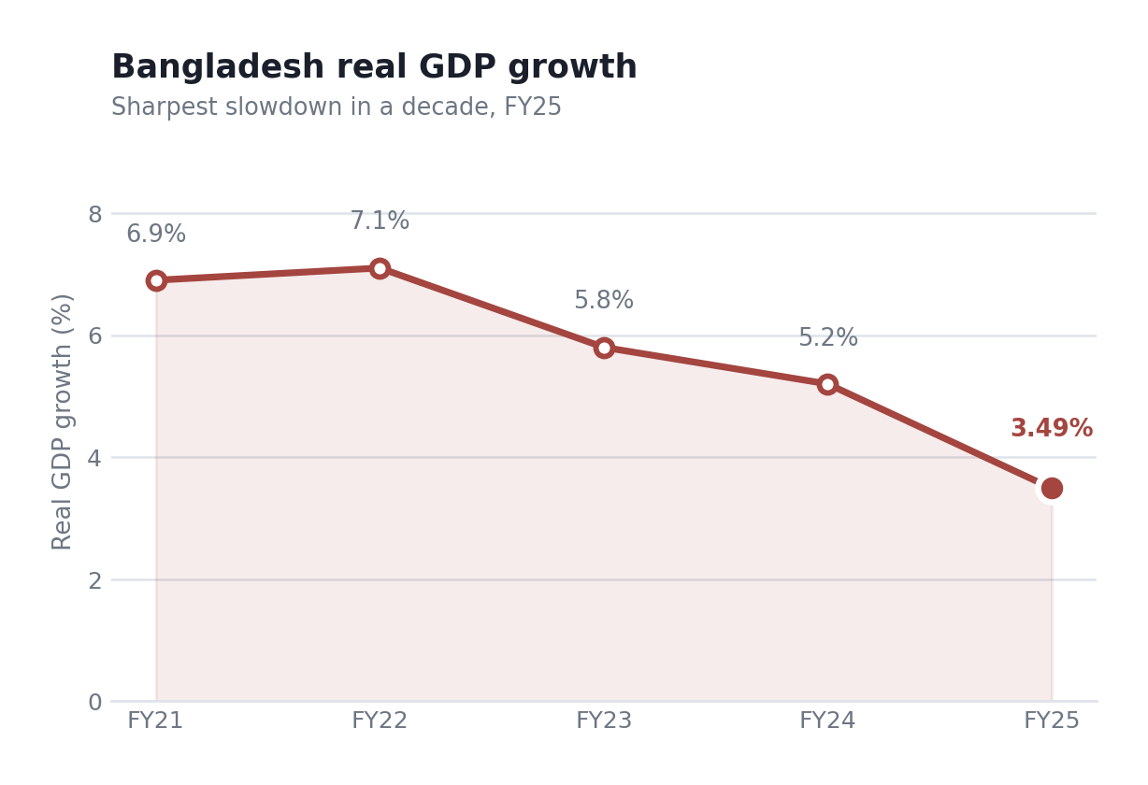
Figure 4: Bangladesh real GDP growth, FY21–FY25 (Economy of Bangladesh, 2026).
Now the market size, which cuts against the optimism. Bangladesh's total apparel market is worth around US$10.87bn in 2025, growing at a modest 2.77% CAGR to 2029 (Statista, 2025a). The footwear market is projected at roughly US$5.17bn by 2029 (Statista, 2025b). But the sports and swimwear segment specifically, the bit JD actually competes in, is tiny: a projected US$186m by 2029 (Statista, 2025c). Put bluntly, the addressable slice is a rounding error next to the clothing market as a whole. That does not kill the case, because JD would be helping to grow the category rather than fighting for a fixed pie, but anyone modelling first-year revenue off the headline apparel number would be off by an order of magnitude.
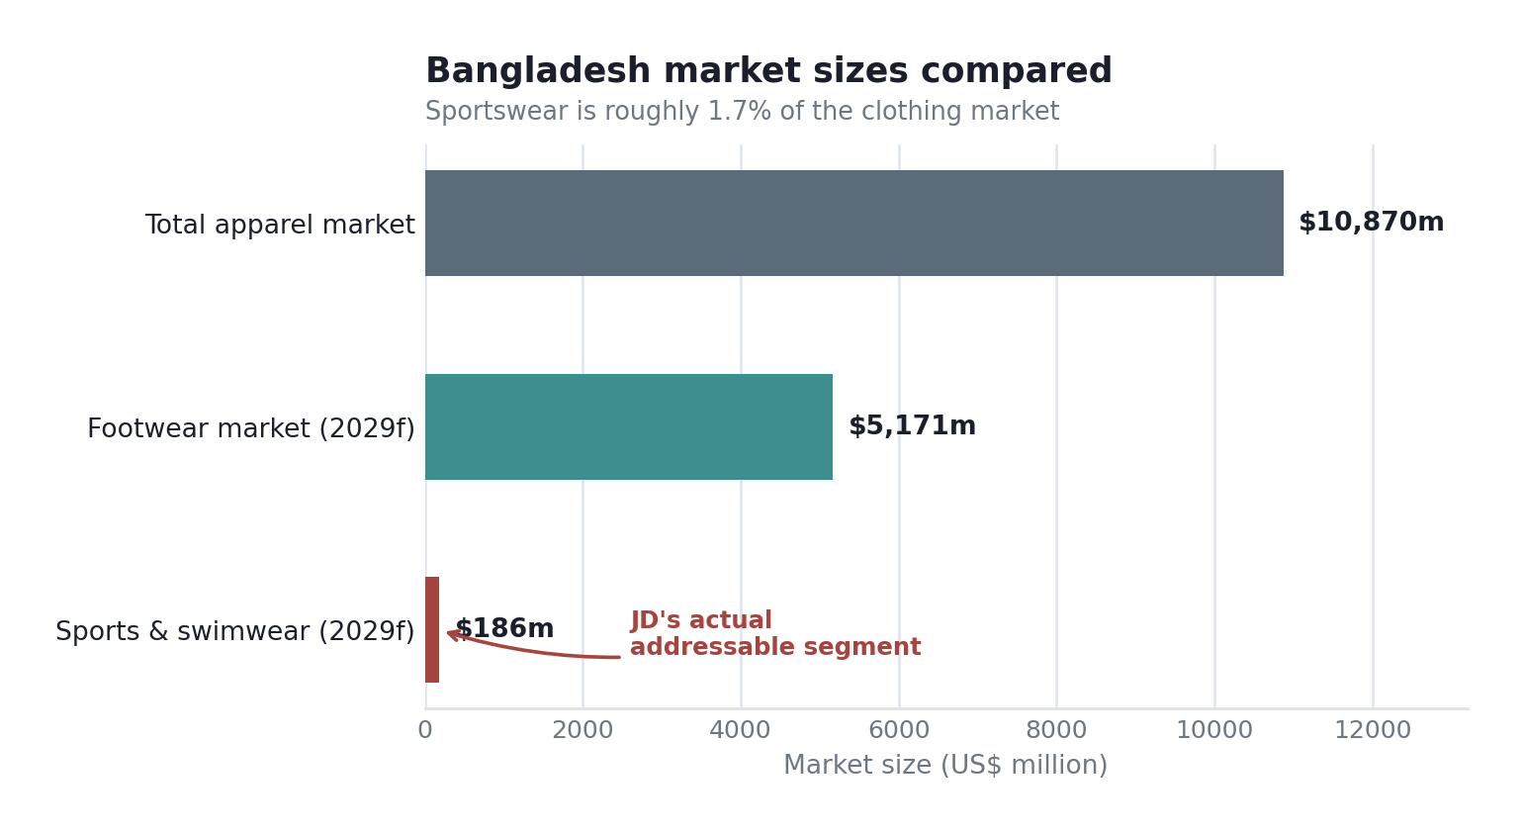
Figure 5: Bangladesh apparel, footwear and sportswear market sizes (Statista, 2025a; 2025b; 2025c).
The counterweight is demographics and remittances. Bangladesh has a young, urbanising population and an emerging middle class that estimates put on a path from roughly 17 million to 27 million people over the coming decade, spilling beyond Dhaka and Chittagong into cities like Gazipur and Khulna (The Daily Star, 2015). Remittance inflows worth billions annually prop up household spending power in ways that raw per-capita GDP understates. So the demand curve is genuinely shifting outward. Whether it shifts fast enough and toward premium-branded trainers specifically rather than cheaper local footwear is the open question the cultural analysis has to answer.
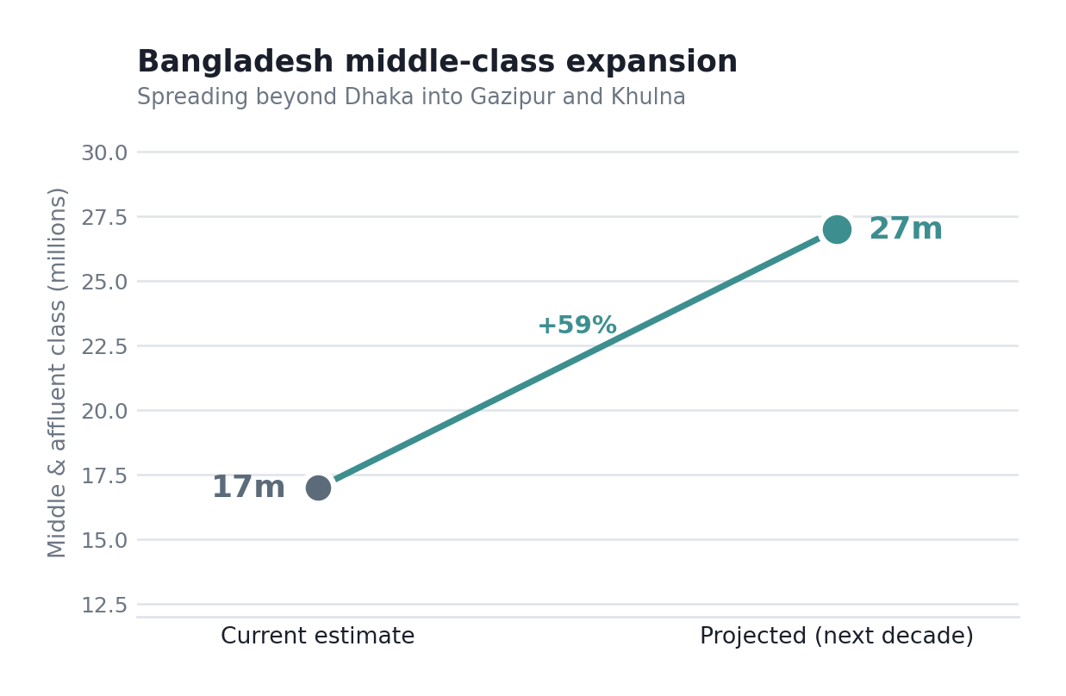
Figure 6: Bangladesh's emerging middle- and affluent-class projection (The Daily Star, 2015).

Political and legal factors: instability and the tariff wall
Two legal-political facts do real work here. The first is the import regime. Bangladesh protects its domestic footwear and garment producers, and finished imported footwear attracts customs duty plus supplementary and regulatory taxes that can stack the landed cost well above the pre-tax price. For a country that is the world's second-largest garment exporter, importing finished branded clothing is swimming upstream against the entire industrial policy (Textile Industry in Bangladesh, 2026). That is not a detail. It is the reason a straightforward import-and-retail model may be structurally uncompetitive on price.
The second is LDC graduation, scheduled for November 2026, and it is genuinely double-edged. Graduation strips Bangladesh of some duty-free export access under schemes like the EU's Everything But Arms, which threatens the garment exporters (Bangladesh Market Research Report, 2026). For JD as an importer that is almost irrelevant on the export side, but graduation also tends to come with pressure to liberalise and formalise, which over time could ease the import friction that hurts JD. So the same event that worries the RMG sector might, slowly, help a foreign retailer. I would not bank on the timing, though.
Political stability is the softer risk. Recent transition and periodic unrest raise the risk premium on any fixed-capital commitment. That does not argue against entry. It argues for an entry mode that keeps JD's own capital off the ground, which is exactly where the Section 3 recommendation lands.

Cultural factors: real demand, thinner than the demographics suggest
Bangladesh loves sport. Cricket first, football close behind, and a growing urban fitness culture among younger consumers (Statista, 2025d). Sneaker culture, the specific thing JD monetises, is emerging but nascent, and it currently expresses itself largely through Nike and Adidas grey imports and social-media aspiration rather than through organised premium retail. That is actually an opportunity: unmet aspirational demand with no incumbent doing JD's job well. Fair enough, but it comes with a catch. Aspirational demand at Dhaka price points may want the logo without paying JD's Western margin, and counterfeits are cheap and everywhere. Brand desire is not the same as willingness to pay, and conflating the two is where a lot of Western retailers have burnt money in South Asia.

Competitive context: who JD would actually be fighting
A macro-scan is incomplete without naming the competition, because entry attractiveness depends on it. There is no organised premium sports-fashion incumbent doing JD's job in Bangladesh, which sounds like an open field. It is not quite. The real competitive pressure comes from three directions that a Porter-style reading makes visible. Substitutes are the fiercest force: cheap domestic footwear and, more damagingly, high-quality counterfeit Nike and adidas product that gives the aspirational consumer the logo at a fraction of the price. Supplier power is unusual here because JD's key suppliers, Nike and adidas, also sell into Bangladesh directly and through other channels, so they are simultaneously JD's enabler and a competitive threat. Buyer power is high in the sense that Bangladeshi consumers are price-sensitive and have low switching costs. The threat of new entry is moderate; if the market proves out, other Western retailers follow. Rivalry among organised premium players is currently low, but that is a symptom of an unproven market, not a durable advantage.
The strategic implication is uncomfortable but clarifying. JD's biggest competitor in Bangladesh is not another retailer. It is the counterfeit market and the grey-import channel that already satisfy brand desire cheaply. Winning means giving consumers a reason to pay a premium for authenticity and experience, and that reason has to be visible and immediate, not argued in a marketing deck. If JD cannot make the genuine-article proposition compelling at Dhaka price points, the open field is an illusion because the field is already occupied by fakes.

2.2 Market Entry Synthesis: Dunning's Eclectic (OLI) Paradigm
Dunning's (2000) eclectic paradigm asks three questions before a firm commits abroad. Does it hold ownership advantages worth exploiting elsewhere? Do location advantages in the target country make it worth producing or operating there rather than exporting? And are there internalisation advantages, reasons to do it in-house rather than license or franchise? A serious entry needs a yes to all three. JD gets a clear yes, a heavily qualified yes, and an awkward maybe. Working through them in order is the most honest way to synthesise everything above.
OLI element | Assessment for JD Sports in Bangladesh | Verdict
Ownership | Strong brand, scarce-allocation sneaker access, multi-brand curation skill, proven store format. These are real and transferable the classic O-advantage. | Strong
Location | Young population and category headroom pull one way; currency depreciation, import tariffs, thin premium demand and political risk push hard the other way. Net: weak-to-moderate. | Weak–Mod
Internalisation | Local knowledge, regulatory navigation and real estate access are things a partner supplies better than JD could alone; brand control argues for keeping the fascia in-house. Genuinely mixed. | Mixed

The ownership answer is the easy one. JD's advantages travel. A Dhaka teenager wants the same limited-edition drop a Manchester teenager wants, and JD's ability to secure and merchandise those drops is exactly the O-advantage Dunning has in mind. No serious doubt there.
Location is where the case wobbles, and I want to be honest rather than tidy about it. The pull factors, demographics and category headroom are real. The push factors, a depreciating currency that inflates the cost of goods, an import regime that penalises exactly JD's product, thin willingness to pay at premium price points, and political risk on fixed capital, are collectively heavier. On a straight reading, L is the weakest leg of the tripod. That is the finding that should shape the entry mode, and it does.
Internalisation is the interesting one because it points two ways at once. Everything about operating in Bangladesh – the licences, the customs relationships, the retail-property market, and the hiring – is done better by someone who is already there. That argues against JD going it alone. But JD's whole advantage is the brand. Control and curation hand that to a careless partner, and you get a diluted, off-brand store that trades on the JD name while degrading it. So the internalisation logic is not 'in-house or not'. It is 'keep the brand-critical bits internal and externalise the local-market bits'. That specific split is what a well-structured partnership delivers, and it is the analytical bridge into Section 3.
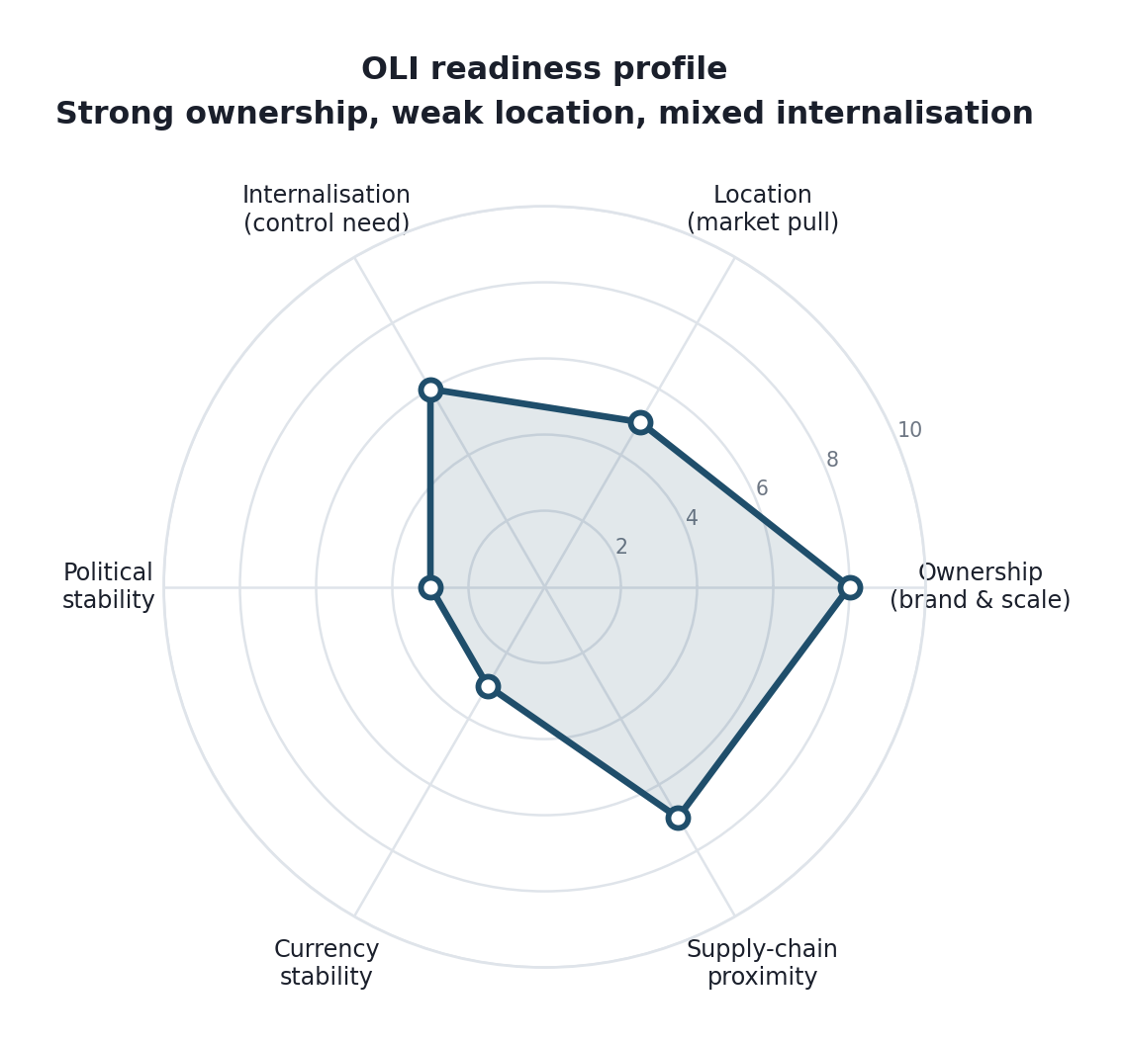
Figure 7: OLI readiness profile for JD Sports in Bangladesh (author's assessment).

Section 3: Entry Mode Strategy and Strategic Synthesis

3.1 Historical Pattern Recognition
JD's expansion history tells you a lot about how it thinks. The dominant modes have been two: wholly-owned organic growth in markets it understands and, increasingly, acquisition of established local players. North America came through the Finish Line, Shoe Palace, DTLR and then the very large Hibbett deals; France came through Courir; Spain and Italy built on Sprinter and local scale (JD Sports Fashion plc, 2025). The pattern is not franchising, and it is not cautious licensing. JD likes to own, because owning protects the brand experience and captures the full margin. It buys its way into a market's local knowledge rather than renting it.
There is a second, quieter pattern worth naming: JD tends to enter markets that already have deep, organised sneaker-retail demand and mature mall infrastructure. North America and Western Europe fit that. Bangladesh does not, at least not yet. So a Bangladesh entry would be a departure from type on two counts not a mature market, and not a place where the acquire-a-local-champion playbook works, because there is no local JD-equivalent worth buying. That is the crux of the strategic-fit problem.

3.2 Strategic Fit and Justification
Line up JD's historical mode, wholly owned or acquired, against the OLI finding, and the mismatch is obvious. A wholly owned subsidiary maximises control and margin. It also maximises exactly the risks the macro-analysis flagged: fixed capital exposed to political instability, taka-denominated costs on dollar-priced inventory, and a bet-the-store commitment in a market where premium demand is unproven. Figure 8 lays out the trade-off. The wholly-owned option sits top-right: highest control, highest risk. For a board currently prioritising returns discipline, that is the wrong corner of the chart to be entering an unproven market from.
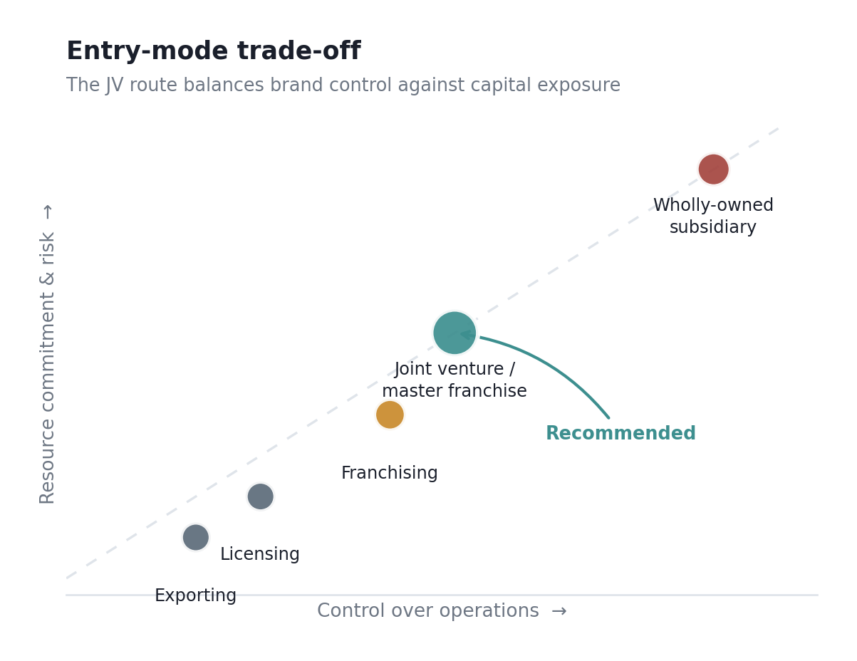
Figure 8: Entry-mode trade-off between control and resource commitment (adapted from Hill, Hwang and Kim, 1990).
Pure exporting sits at the other extreme and fails for a different reason. Selling into Bangladesh through a distributor with no JD-controlled retail presence would surrender the store experience that is half of JD's actual advantage, and it would leave the brand at the mercy of whatever shelf a wholesaler chose to put it on. Low risk, but it throws away the O-advantage. That is not entry. That is just wholesale.
The mode that fits the analysis is a master franchise or joint venture with an established local retail group, and the reasoning is not a compromise for its own sake. It maps directly onto the OLI split from Section 2. A capable local partner supplies the L-side and I-side weaknesses: the customs and licensing navigation, the mall relationships, the hiring, and the read on local price sensitivity. JD supplies the O-side strength under a franchise agreement that contractually protects fascia design, merchandising standards and brand presentation. Crucially, the partner carries most of the fixed-capital risk, which directly answers the political instability and currency concerns that made a wholly-owned entry reckless. Control over the things JD cannot afford to lose stays with JD; capital exposure to the things JD cannot control sits with someone whose job is to manage them.
There is precedent for this being the sane route into hard South Asian markets. Western retailers from Marks & Spencer to various fashion houses have used franchise and JV structures to enter India and the wider region precisely because it hedges regulatory and political risk while preserving brand control (Whittington et al., 2023). The pattern is not JD's historical preference, which is the whole point: the historical mode was designed for mature, low-risk, high-infrastructure markets, and Bangladesh is none of those things. Forcing the familiar mode onto an unfamiliar market is how good companies lose money abroad.

3.3 Conclusion and Recommendations
Pulling the threads together: JD has the brand and the format to make a Bangladesh entry work, but the market's economics and politics make a full-commitment entry the wrong first move. The recommendation is a phased, franchise-led entry. Phase one, an online-plus-flagship model in Dhaka run through a master franchise partner, tests willingness to pay at premium price points against real transactions rather than demographic hope. Phase two, contingent on that data, is a measured roll-out to Chittagong and the emerging secondary cities as the middle class thickens. JD keeps brand control, keeps its own capital largely off the ground, and buys itself an option on a market that could be significant in a decade without betting the balance sheet on it being significant now.
Two conditions should gate the decision. First, the tariff maths has to work: if landed cost after duty forces shelf prices so far above grey-market and counterfeit alternatives that volume collapses, the whole thing stalls, and that should be modelled hard before signing anything. Second, the partner has to be genuinely capable of protecting the brand, because a bad franchisee in an emerging market does lasting damage that is expensive to undo. Get those two right and the downside is capped at a modest, recoverable bet. Get them wrong and no clever entry structure saves it.
Three risks deserve explicit mitigation rather than a general acknowledgement that risk exists. Currency exposure is the first, and the answer is partly structural: pricing in taka while sourcing in dollars creates a margin squeeze that worsens with every depreciation, so the franchise agreement should place inventory-purchase currency risk with the party best able to absorb it and include a periodic price-review mechanism rather than fixed annual pricing. Second, brand dilution through a weak partner. That is managed contractually, through fascia and merchandising standards, mandatory staff training, and an audit right with a termination trigger, none of which is unusual in master franchise agreements, all of which are easy to leave vague and then regret. Third, the counterfeit substitute. That one cannot be contracted away; it has to be beaten commercially, through authentication, exclusive drops unavailable to the grey market, and an in-store experience that a counterfeit seller structurally cannot replicate.
On Ansoff's matrix the recommendation sits squarely in market development, and it is worth being explicit about why rather than describing all four quadrants. JD is taking an existing proposition, the curated multi-brand sports-fashion store, into a new geographic market. It is not developing new products, so product development is out. It is not deepening share in existing markets, so penetration is out. And it is certainly not diversifying into unrelated activity. Market development is the right quadrant, but Ansoff's framework is silent on the thing that actually matters here, which is the mode of entry rather than the direction of growth (Johnson et al., 2023). That silence is a fair criticism of the framework in this context: it tells you where to go and nothing about how much to risk getting there, which is precisely the question a Bangladesh entry turns on.
For monitoring, a balanced scorecard keeps the phased plan honest against real numbers rather than optimism. Figure 10 sketches illustrative targets across financial, customer, internal-process and learning dimensions; the point being that go/no-go for phase two rests on measured brand awareness and online revenue share, not on gut feeling (Kaplan and Norton, 1996).
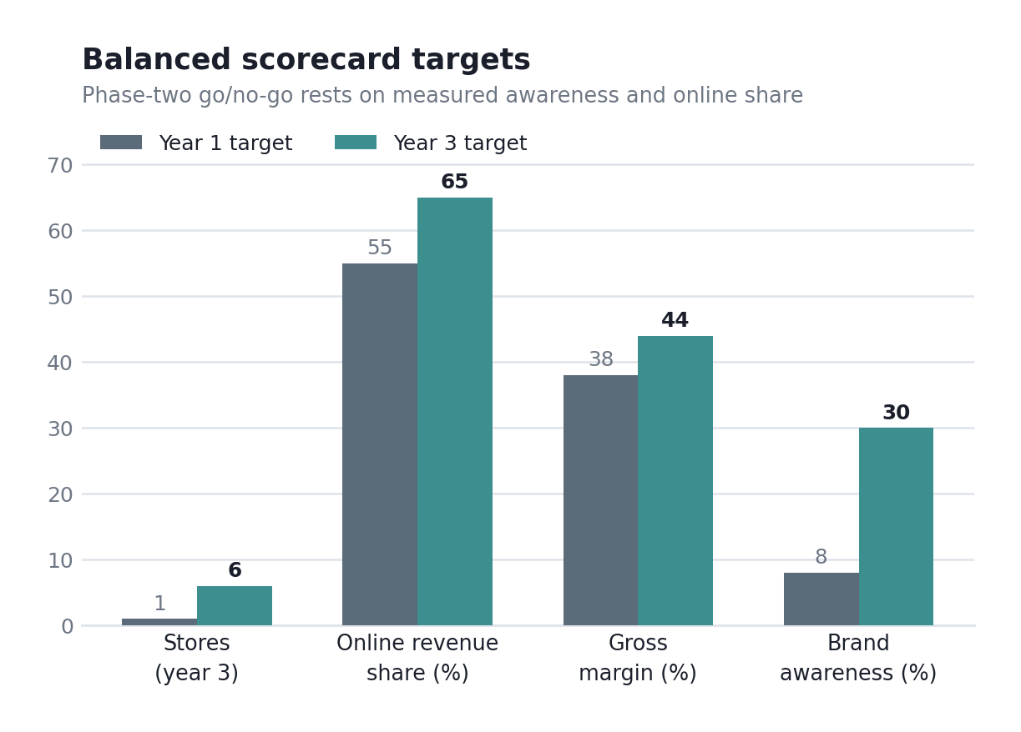
Figure 10: Illustrative balanced-scorecard targets for a phased entry (author's construction; framework after Kaplan and Norton, 1996).
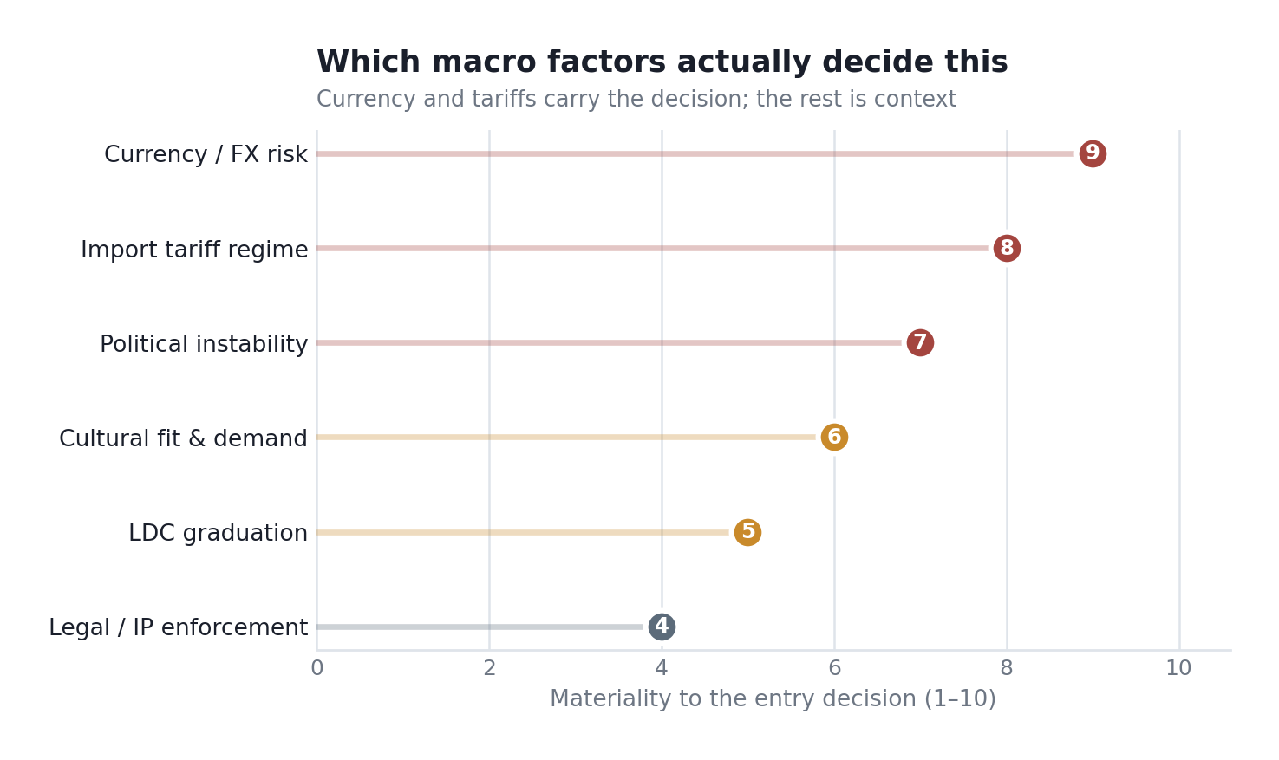
Figure 9: Materiality weighting of macro factors in the entry decision (author's assessment).

Section 2: Reflective Account

Description
I chose JD Sports and Bangladesh partly because the pairing looked awkward, and I wanted a case where the answer was not obvious before I started. The work ran in three passes. Reading JD's annual reports took a single evening, because the disclosure is well organised and says what it means. The Bangladesh data took considerably longer, across two sessions, since the figures were scattered and did not always agree. Only then did I apply the frameworks: Bartlett and Ghoshal for classification, PESTEL and OLI for the environment, and an entry-mode analysis for the recommendation. I drafted it over a weekend at home.
On method, I worked from primary company disclosure outward rather than secondary commentary inward. JD's investor relations site was the most reliable thing I used, since the FY25 and FY26 reports give the regional split, store count and organic-versus-acquired breakdown as stated figures rather than analyst inference (JD Sports Fashion plc, 2025; 2026). I used Google Scholar to trace Dunning and the entry-mode literature back to the original articles instead of textbook summaries and triangulated the host-market picture across Statista, economic summaries and news commentary.

Feelings
The part that genuinely unsettled me was how tempting it was to make the case say yes. Bangladesh's young population and rising middle class are exciting on the page, and I was building an optimistic narrative before I had checked the sportswear market size. Then I found the US$186m figure for sports and swimwear sitting next to a US$10.87bn apparel market. My first reaction was that I had misread a unit, so I checked twice. I had not. The segment JD actually sells into is roughly one and a half per cent of the yardstick I had been using, and I had spent a good while reasoning from the wrong number without noticing.

Evaluation
What went well was the discipline of prioritising rather than describing. Early drafts of my PESTEL had six neatly balanced paragraphs and read like a checklist with no argument. Forcing myself to say that currency and tariffs are what matter, and the rest is background, made the section sharper. What went less well was my first instinct on entry mode. I assumed a wholly-owned subsidiary because that is JD's habit and had to catch myself: the habit was built for mature markets, and I was pattern-matching instead of thinking.
The weakest part of my process was source reliability, and I want to be candid about it. The middle-class projection I relied on dates from 2015, and two further sources are encyclopaedic rather than peer-reviewed – acceptable for background, not as the basis for a central claim (The Daily Star, 2015). A stronger version would have used World Bank and Bangladesh Bank primary statistics. I noticed partway through and ran out of time, which is a process failure rather than a knowledge gap, and it traces back to how long the academic reading took me.

Analysis
Two things from the module reshaped how I worked. The first was the seminar discussion on why firms choose franchising over wholly owned subsidiaries, which at the time felt like a dry comparison of structures and became the hinge of my recommendation. The argument that stuck was that the choice is not about control in the abstract but about which capabilities a firm can afford to hand over and which it cannot. That reframing let me split JD's position into brand-critical elements to keep and local-market elements to externalise. The second was the OLI paradigm, which did not fit as cleanly as the textbook implied. Dunning wants a clear verdict on each leg; Bangladesh gave me a strong O, a weak-to-moderate L and a genuinely mixed I. The mess was the insight, because the awkward internalisation answer is precisely what pointed toward a franchise structure rather than either extreme.
Three sources did the real work, and each broke an assumption rather than confirming one. Statista's sportswear forecast of roughly US$186m by 2029, against an apparel market of about US$10.87bn, showed I had been sizing the opportunity off the wrong figure, and its participation data compounded that by noting Bangladeshi sport skews toward cricket and kabaddi rather than the sneaker culture JD monetises (Statista, 2025a; 2025c; 2025d). The Daily Star's projection of a middle class rising from 17 to 27 million pulled the other way (The Daily Star 2015). Reading how dominant the garment sector is, I reframed import tariffs as deliberate industrial policy rather than administrative friction (Textile Industry in Bangladesh, 2026). One source said the category is tiny; another, that the consumer base is expanding fast, and a third that tariffs are unlikely to ease. Reconciling them produced the phased recommendation: enter small, measure willingness to pay, and expand only on evidence.
The assumption I had to abandon was that brand desire equals willingness to pay. I started assuming that if young Bangladeshis want Nike and adidas, JD has a market. Working through the currency depreciation and the counterfeit-heavy grey market forced me to separate aspiration from spending power, and that separation changed the recommendation from 'enter confidently' to 'enter cautiously and test'. It was uncomfortable to give up the cleaner conclusion, but the cautious one is the more defensible one.

Conclusion
The skill I improved most was source triangulation not trusting a single headline number and cross-checking market sizes against company disclosures. The weakness I have, to be honest about it, is reading speed on academic sources. Tracking Dunning's 2000 article and the Hill, Hwang and Kim paper through Google Scholar took far longer than I had allowed because I read them start to finish rather than working out what I needed and reading toward that. The knock-on effect showed elsewhere: the reading ate the time I would have used replacing weaker background sources with primary statistics. The problem is not comprehension. It is that I have no strategy for approaching the material efficiently.

Action Plan
Next time I would build the numbers before the narrative, not after. Locking the market size and currency data down first would have stopped me writing an optimistic story I then had to unpick. I would also set a rule that before applying any framework I write one sentence on which two or three factors are likely to decide the outcome so that I analyse it toward a judgement instead of filling in boxes.
The reading problem needs a method rather than more hours, because more hours are what I tried, and they did not work. I intend to read journal articles in a fixed order: abstract, then conclusion, then the section answering my question, and read the full text only if those three show the paper is central to my research. Ten minutes deciding whether a paper earns an hour would have saved me most of a session here. To make that stick rather than remain an intention, I will book a session with the academic skills team on reading strategies for journal articles before the next assignment deadline.

References
Bangladesh Market Research Report (2026) Bangladesh market outlook to 2034. Available at: https://dataintelo.com/report/bangladesh-market (Accessed: 21 July 2026).
Barney, J. (1991) 'Firm resources and sustained competitive advantage', Journal of Management, 17(1), pp. 99–120.
Bartlett, C.A. and Ghoshal, S. (1989) Managing across borders: the transnational solution. Boston: Harvard Business School Press.
Dunning, J.H. (2000) 'The eclectic paradigm as an envelope for economic and business theories of MNE activity', International Business Review, 9(2), pp. 163–190.
Economy of Bangladesh (2026) Wikipedia. Available at: https://en.wikipedia.org/wiki/Economy_of_Bangladesh (Accessed: 21 July 2026).
Gibbs, G. (1988) Learning by doing: a guide to teaching and learning methods. Oxford: Further Education Unit, Oxford Polytechnic.
Hill, C.W.L., Hwang, P. and Kim, W.C. (1990) 'An eclectic theory of the choice of international entry mode', Strategic Management Journal, 11(2), pp. 117–128.
JD Sports Fashion plc (2025) Annual report and accounts 2025. Available at: https://s204.q4cdn.com/980191062/files/doc_downloads/results_centre/2025/05/24467_JD_Sports_AR25_Web.pdf (Accessed: 21 July 2026).
JD Sports Fashion plc (2026) Full year results 2025/26 (FY26). Available at: https://www.investormeetcompany.com/companies/jd-sports-fashion-plc/rns/4686602/view (Accessed: 21 July 2026).
Johnson, G., Whittington, R., Regnér, P., Angwin, D. and Scholes, K. (2023) Exploring strategy: text and cases. 13th edn. Harlow: Pearson.
Kaplan, R.S. and Norton, D.P. (1996) The balanced scorecard: translating strategy into action. Boston: Harvard Business School Press.
Kolb, D.A. (1984) Experiential learning: experience as the source of learning and development. Englewood Cliffs, NJ: Prentice Hall.
Porter, M.E. (1985) Competitive advantage: creating and sustaining superior performance. New York: Free Press.
Statista (2025a) Apparel – Bangladesh: market forecast. Available at: https://www.statista.com/outlook/cmo/apparel/bangladesh (Accessed: 21 July 2026).
Statista (2025b) Footwear – Bangladesh: market forecast. Available at: https://www.statista.com/outlook/cmo/footwear/bangladesh (Accessed: 21 July 2026).
Statista (2025c) Sports & swimwear – Bangladesh: market forecast. Available at: https://www.statista.com/outlook/cmo/apparel/men-s-apparel/sports-swimwear/bangladesh (Accessed: 21 July 2026).
Statista (2025d) Sports – Bangladesh: market forecast. Available at: https://www.statista.com/outlook/amo/sports/bangladesh (Accessed: 21 July 2026).
The Daily Star (2015) 'Bangladesh's growing middle class'. Available at: https://www.thedailystar.net/op-ed/politics/bangladeshs-growing-middle-class-162670 (Accessed: 21 July 2026).
Textile industry in Bangladesh (2026) Wikipedia. Available at: https://en.wikipedia.org/wiki/Textile_industry_in_Bangladesh (Accessed: 21 July 2026).
Whittington, R., Regnér, P., Angwin, D., Johnson, G. and Scholes, K. (2023) Fundamentals of strategy. 6th edn. Harlow: Pearson.
World Economics (2026) Bangladesh GDP: 2025 & 2026 estimates. Available at: https://www.worldeconomics.com/GDP/Bangladesh.aspx (Accessed: 21 July 2026).

