Risk Management - Design, Development and Evaluation of a Small Scale Weapons Trial
This document will document the processes followed in the delivery of a large caliber, high-explosive shell proof. This report will detail each step of the process, from Customer Specification through to the Trial Closure Procedure.
Mr Harry McAuliffe
P144278
Systems Engineering; M3X00947
Mr Richard Morgan; Mr Graham Howe


Table of Contents

Table of Contents 1
1. Introduction 2
2. Customer Specification 3
2.1 Scope 3
2.2 Proof Method 3
2.3 Measurements 3
2.4 Proof Standard method 3
3. Hazardous Activity Management 4
3.1 Best Practice 4
3.2 Risk Register 4
3.3 Hazardous Activity Risk Assessment & Safety Briefing 4
3.4 Safety Trace & Access Control 5
3.5 1st Level Peer Review 5
3.6 Lessons Learnt 6
4. Trial Delivery 7
4.1 STOP Moment 7
4.2 IREP System 7
4.3 Equipment Safety 7
4.4 Process Safety 8
5. Trial Closure 8
5.1 Trial Closure Meeting 8
5.2 Technical Data Quality Review 8
6. Conclusion 9
References 9
Appendices 10

Introduction
The Weapons Test and Evaluation business, by its very nature, encompasses a wide array of potentially hazardous activities. Very often, we are required to design and deliver bespoke engineering solutions to meet the requirements of our customers. The vast majority of these activities involve the successful operation and function of articles that are designed to kill people, penetrate structures, and cause long-term harmful effects.
The aim of this report is to identify the systems in place at QinetiQ Shoeburyness for the purposes of risk management. This will be achieved by conducting a step-by-step analysis of the system, starting with the customer specification, through the Hazardous Activity Management process, trial delivery, and trial closure procedure.

Customer Specification
The customer specification is the first step in the design of a small scale weapons trial. Its purpose is to clearly define the Scope and Method to deliver a specific result. This can range from the delivery of an established standard (such as proofing activities), or to provide real life data of a weapons capability, suitable to establish a computer model. From a risk management perspective, it allows QinetiQ to clearly define the steps required to fulfil the customer requirement; and to understand the potential pitfalls in the delivery process. An example specification can be found below.

Scope
This specification governs the proof firing and sentencing of 105mm High-explosive Shell, L31A4.

Proof Method
- The shell, propelling charge and propellant are to be conditioned to 21 ±2°C for a minimum of 16 hours prior to firing.
- Facilities are to be available for charge adjustment. This is required to achieve a firing pressure of 3760-3900bar. All charges are to be adjusted on a round by round basis.
- Rounds are to be fired in the design configuration.
- Pressure Measurement shall be recorded using 3x Mk.9 Copper Crusher Gauges per round.
- Ordnance; L118 Light Gun, L13 or L19 Barrel; Maximum barrel wear of 1.27mm.

Measurements
- Date & Time of firing  - Meteorological Conditions  - Gun Type, Barrel No, Barrel Wear  - Quadrant Elevation  - Ammunition Details | - Charge Adjustment Weight  - Depth of Ram for each Round  - Chamber Pressure  - Muzzle Velocity  - Visual Observation of Shell Impact/Function

Proof Standard method
Not expressly stated in the Specification, the term “fired in the design configuration” denotes that firing procedures are in accordance with the drills laid out in Pamphlet 19: (1). This document clearly defines the activity and risk associated with this work.
Rate of Fire Potential Hot Gun Hazards
Ordnance Set-up Manual Handling Hazards
Instrumentation Set-up Electrical Hazards
Ammunition Delivery Explosive Hazards
Round Conditioning
Charge adjusted to give proof pressures
Shell and Charge Transported to the Gun
Loading Drills
Instrumentation Check
Undercover Signal
Round Fired
Gun Clearance
Gun Cleaning

Hazardous Activity Management

Risk is best defined as an “Exposure to Danger”. This takes many forms. A health risk is a danger that may cause harm, injury or death to a person; whereas business or reputational risk is a danger that could cause strike a loss to the organisation. All of these potential dangers must be considered when designing a trials activity.
For this reason, QinetiQ employ a process of Hazardous Activity Management (HAM) based on the “as low as is reasonably practicable” (ALARP) principle as defined by the Health & Safety Executive (HSE). This method defines goals for duty-holders, as opposed to setting a minimum requirement for controlling risk. These goals are typically established by looking at current industry best practice, with new or novel activities pushing the boundaries of the prescribed best practice (2). After all activates, lessons learnt are formally recorded and implemented in future work.

Best Practice
Within the defence sector, the defined “best practice” is typically set by the military, as they have the most exposure to the articles involved. Regularly updated information is broadcast within the defence sector through Joint Service Publications (JSP), Allied Ordnance Publications (AOP) Approved Codes of Practice (ACOP) and Defence Ordinance Safety Group (DOSG) Advice. This forms a collective of information regarding incidents and effective control measures for most test items.
Furthermore, QinetiQ operates on Ministry of Defence (MoD) owned land across the UK under a contract known as the Long-term partnering agreement (LTPA). As a direct result this agreement; QinetiQ are contractually obligated to follow established MOD procedures with minimal deviation. Any deviation must be subject to scrutiny and suitably authorised by a responsible person within QinetiQ.

Risk Register
Upon receiving a request for tender, the pre-bid team begin to analyse the risks posed by delivery. It is at this point that the applicable lessons learnt are highlighted and communicated, and a peer review is conducted to provide confidence that the bid team have suitably assessed the activity.
A risk register is produced to highlight the various potential means of failure, assigning these to either QinetiQ, or to the customer. This forms an understanding of inherent liability to both QinetiQ and the Customer before the contract is signed. As such, milestone payments missed due to customer failings can be mitigated. This Risk Register and the associated liability are agreed by both parties when the contract is signed.

Hazardous Activity Risk Assessment & Safety Briefing
“It shall be the duty of every employer to ensure, so far as is reasonably practicable, the health, safety and welfare at work of all his employees.” (3)
Under the Health and Safety at Work Act (1974) it is a legal requirement to carry out a risk assessment before undertaking any aspect of work. This document is designed to capture an assessment of hazards to health arising from a specific activity within the workplace.
This process has the potential to expose significant health risks before they come to fruition. As a result, QinetiQ Policy is to include shop floor employees to review the Risk Assessment before the activity is authorised. This alternative perspective can often reveal additional hazards, and generate improvements to operating procedures.
“Engagement and dialogue with those interested in and affected by risk issues is vital. It should be an integral part of every process for the management and/or regulation of risks.” (4)
QinetiQ Codes of Practice state that it is not a mandatory requirement for those undertaking an activity to read the risk assessment. Instead, the outcomes of a risk assessment are collated and delivered to the technicians in the form of a Safety Brief. This is a verbal communication of every aspect of the trial including an outline of the task, munition hazards, security aspects, emergency procedures, first aid, thunderstorm actions, electro-static discharge precautions, manual handling risks, site regulations, ammunition movements, PPE and any other activity specific hazards. Attention is confirmed by a Q&A at the end of the brief. All employees involved in the activity are to sign a form to state that they fully understand the risks that they are to be exposed to.

Safety Trace & Access Control
Due to the hazardous nature of the industry, incidents regarding explosives happen relatively often. However, UK Land Ranges operate safety on two primary principles; high levels of staff competency and access control. Provided that both are held in high regard, incidents can be handled effectively, carefully and calmly. How do QinetiQ ensure that these principles are maintained?
It is well understood that familiarity breeds contempt, however the ingrained safety culture at QinetiQ does go a long way to address this. There is no long working regarding explosives; the company provide incentives to join the ground-up “Safe 4 Life” team; a volunteer group who lead safety investigations; weekly safety newsletters are broadcast via internal email; and much more. Competency is handled by local Labour Managers who update a global competency matrix. Within each role, required competencies are clearly defined and retested over time.
Access Control is far harder to control, as each munition poses a unique risk. A fragmentation Grenade would have a far lesser area of effect that a rocket motor or shaped charge fragment or the same net explosive quantity (NEQ).

1st Level Peer Review
It is the role of Peer review to determine if an activity complies with the principles of ALARP, in line with QinetiQ guidance (see Appendix A). If an activity is deemed to be ALARP, but still presents a significant risk, it is escalated to a 2nd Level “Ordinance, Munitions and Explosives; Hazardous Activity Safety Panel” (OME HASP) Review. This brings together industry leading technicians from within the business and high level management from across the country to determine if the activity may proceed. All business deemed new or novel must be presented to 2nd Level Review.

Lessons Learnt
On the conclusion of a trial, a trial closure meeting is held with representatives from all aspects of the task. Project Managers, Schedulers, Trials Managers, Foremen and Team Leaders are all consulted as to what succeeded or failed at managing the risks associated with the work.
Furthermore, QinetiQ employ a system known as “Incident Reporting and Environmental Protection” (IREP), in which Behaviours, Hazards, Near misses and injuries are recorded for each activity. The assembled persons are to review all IREP reports and suggest potential mitigations.
This data is then captured on a shared area document called the “Lessons Learnt Register”. This list is categorised by 15 different headings including Trial number, Test Item and Incident type. It allows the lessons pertinent to any future activity to be easily accessed, understood and implimented in further activities.
In this example, the lessons learnt register has flagged up a number of concerns regarding the trial ahead. These must be pursued so as to prevent reoccurrence. As a result of these reports, I must do the following while planning the activity:
1) | Contact the project manager to clarify the customer requirement. Advise the customer to amend future specification language.
2) | Contact the Ammunition Manager to ensure that we have enough staff to accommodate the activity on the date scheduled.
3) | Contact the QinetiQ SHB Head of Engineering to determine if these components have been replaced. Also enquire as to the status of the Mobile Conditioning Unit (MCU) upgrade project.
4) | Ensure that this lesson learnt is reiterated in both the Movement Plan and Safety Briefing for the Trials Technicians benefit.

Trial Delivery

STOP Moment
QinetiQ employ a no-blame safety culture. At its core is the “STOP moment”. Any member of staff, at any time during the delivery of an activity has the authority to stop any activity on the basis that they believe it to be unsafe. In this event, the activity must cease as soon as is safe to do so.
The individual is then to communicate their observation to the most senior member of staff present. This will then be discussed in an open forum.
If the individual was not aware of the mitigations in place, they may choose to end the stop moment, to allow the activity to continue. However, if the individual cannot be convinced that the mitigations applied are suitable and sufficient; the activity is cancelled, and an investigation is started.
Under no circumstances is the individual liable to disciplinary action for enacting this procedure. All stop moments must be recorded on the IREP System.

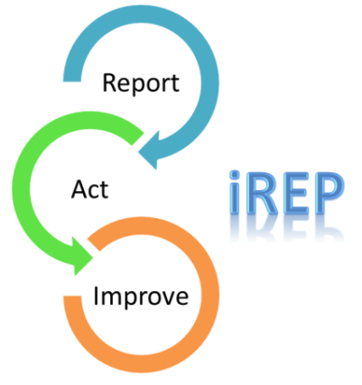
IREP System
iREP is an online reporting tool that enables the capture of consistent data across four incident types i.e. behaviour, hazard, near miss and injury. The user answers a series of questions and chooses from dropdowns while reporting an incident. This data can then be used to promptly resolve issues, provide performance reports and analyse incident trends within QinetiQ.
Employees must report incidents to their manager and raise a report via iREP whenever they identify unsafe working conditions. This report details immediate actions taken, observed unsafe behaviours and hazards, or to highlight good practice that can be transported across the business quickly.
Incident reporting enables prompt remedial action to be taken with authority, thus reducing the chances of further incidents, and developing improved safe systems of work. It also assists the implementation of policies, future decision making, planning and resource allocation. This system also ensures that QinetiQ meets its statutory obligations and reporting requirements.

Equipment Safety
The term “reasonably practicable” when applied to QinetiQ, is very different to the “reasonably practicable” measures that may be applied to another company of a different capacity or capability. Specialising in Defence Engineering determines that QinetiQ often maintain and develop equipment specific to the business. As a result, the safety of equipment within QinetiQ is of the highest priority.
Maintenance tasks on all assets is meticulously recorded and monitored through the use of the Strategic Maintenance Information System (SMIS). This program generates email prompts to engineers to ensure that equipment maintenance is carried out according to schedule. It also “Red flags” conflicts between this schedule and trials activities. As such, engineers only ever have access to serviceable safe equipment.

Process Safety
To safeguard our processes and procedures, each site employs a Trials Safety Manager (TSM). This individual holds the authority to permit or restrict any activity with regards to testing. The TSM is also responsible for the production and maintenance of a comprehensive Fault Tree Analysis document for all Test & Evaluation activities. (An example of this can be seen in Appendix B.) This document forms a key part of the corporate probabilistic approach to quantifying risk against reward. It also provides delivery teams with a specific focus to minimise the probability of risk to personnel health and to the business.

Trial Closure
“I have no desire to suffer twice, in reality and then in retrospect.” ― Sophocles, Oedipus Rex
Upon the delivery of an activity, all risk outcomes have been realised. It is known at this stage whether the risk mitigation applied to an activity was suitable and sufficient. It is entirely possible that undue controls caused to activity to be delivered inefficiently or generated further hazards; or perhaps the applied methods did not go far enough, and are in need of revision.
Trial Closure is an appropriate time to evaluate the successes and failures of the risk management system. This occurs in two ways. The first is the Trial Closure meeting, providing a retrospective of the task delivery. The second; is the Technical Data Quality Review, which provides a retrospective of the data capture methods and quality of result, in relation to the Customer Requirement.

Trial Closure Meeting
Bringing together Technicians, Team Leaders, Range Foreman, Resources managers, Trials Managers and Trials Safety Managers; the Trial closure meeting is seen as a key step in the Hazardous activity management process. The meeting agenda follows a strict routine; Risk Assessment review, STOP Moments, Lessons Learnt, with an open forum towards the end of the schedule to allow for any other comments or observations to be captured. The output of this meeting is recorded within the lessons learnt database, to be implemented in future work.

Technical Data Quality Review
Before the trials data is sent to the customer, a senior instrumentation technician reviews the measured results. The instrumentation technicians are then subject to scrutiny to ensure that the equipment used was set-up correctly, within calibration date, and any issues with measurement are recorded. If the Technical reviewer realises a trend with regards to instrumentation failures, a meeting is called to determine alternative processes or mitigations to limit such problems.

Conclusion
In this document, the author has defined the processes and design methods used by QinetiQ staff to deliver a Small Scale Weapons Trial to a customer. This analysis has covered all aspects of product delivery from customer specification to system evaluation; stating how risk is managed at each stage of the process.

References
1. Royal School of Artillery. . Pamphlet 19 - Regulations for Planning, Control, Conduct and Safety for Firing Practices. . Larkhill : UK MoD, 2012.
2. Health and Safety Executive. Risk Management: ALARP at a glance. [Online] http://www.hse.gov.uk/risk/theory/alarpglance.htm.
3. Act of Parliament. Health and Safety at Work etc. Act 1974. London : s.n., 1974.
4. HSE: ILGRA. Risk Communication: A Guide to Regulatory Practice. 2002.

Bibliography
1. Ministry of Defence. JSP 403 Handbook of Defence Ranges Safety. London, 2016
2. QinetiQ Operating Framework. OME Explosives Risk Assessment. Shoeburyness, 2017

Appendices
Appendix A – ALARP; QinetiQ Implementation Guidance
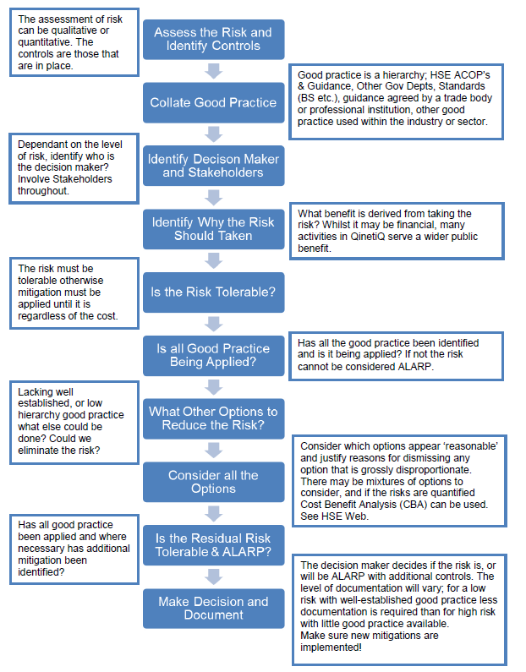
Appedix B – Fault Tree Analysis; Death or Injury to 3rd Parties from Exposure to Dynamic Trials Activities

