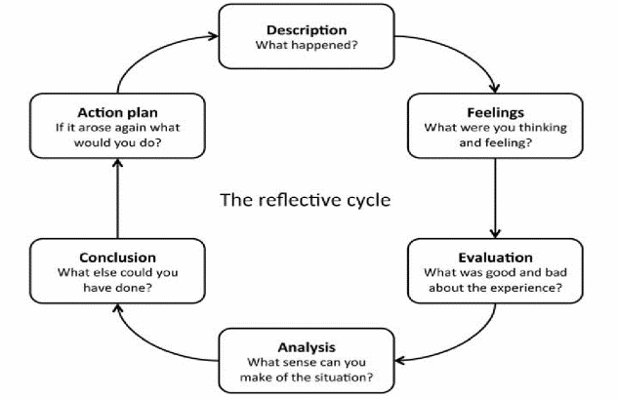
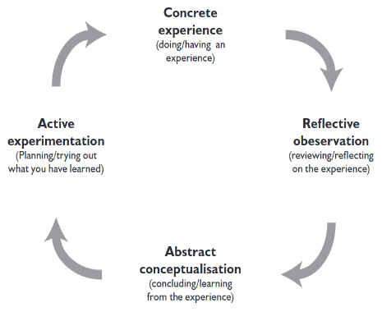
What is reflection and reflective practice?
Reflection and reflective practice are core values of professionals and have a key role in professional training. Reflection is promoted in a range of disciplines, particularly in education, health and social care, and is an essential part of professional practice (Brock, 2014). Lucas (1991) provides a useful definition of reflective practice when he argues that it involves a systematic enquiry to improve and deepen an individual’s understanding of practice. To achieve a deep understanding of professional practice, practitioners must be able to examine what happened on an occasion and as a result open themselves up to reflect on the situation individually or with other practitioners. Bolton (2010, quoted in Tarrant, 2013) agrees with Lucas (1991), a successful practitioner will be able to openly discuss their practice to enhance and develop their own professional knowledge. Hallet (2013) also argues that a reflective practitioner is able to improve the care and practice they provide by making more informed decisions based on their reflections, allowing them to apply the most effective planning to their practice. However, the University of Cambridge (2021) believes there is no correct or incorrect method of reflection. Suggesting that reflection is personal with many ways to carry it out dependent on circumstance or preference.

Reflection within professional practice
As a professional practitioner reflection is important within any professional practice. Having the ability to reflect on personal practice, will enable practitioners to continuously improve and develop professionalism. According to Tarrant (2013) Professional practitioners have a responsibility to ensure that the upmost care and learning opportunities are available for all children. He also suggests that by applying a reflective approach to their work, practitioners will become more aware, in control and more able to identify their own strengths. Tarrant (2013) believes these are crucial tools that will support a practice in times of change, where attitudes and approaches must adapt and develop. Furthermore, Fullen (2008) suggests that all practitioners, having already trained and qualified in their chosen professions, should continue to develop their skills and knowledge in their practice. This continuous development and updating knowledge and expertise, is what he believes will form a successful professional practitioner. Fullen (2008) also emphasises that professional practitioners, working with children in particular, are learning and developing their knowledge daily, requiring them to reflect almost daily. Brock (2014) has also recognised this and suggests reflection, within the early years setting, needs to be used in everyday practice to improve and develop professional practice. In addition to this, he also suggests that in order for reflection to be most effective it needs to be meaningful, for this practical type of professional practitioner it would best if related to their work with children within the early years.

The importance of reflective practice as a professional practitioner

Erin Lawrence Student Number: 2216689 ECEY4002/C

(Turner et al, 2018)
(Zwozdiak-Myers, 2012)
Reflection within the early years setting
Finlay (2008, p.1) describes reflective practice as a ‘process of learning through and from experience towards greater insights of self or practice’. Based on this definition, the goal of reflection in early years should be to better understand teaching and learning, and as a result, improve practice. Practitioners need to continually carefully consider how they practise and reflect upon their work with children (Dewey 1933). Dewey argued that if a practitioner fails to operate as a reflective practitioner, they risk basing practice on prejudice, outdated or uniformed thinking. By critically reflecting on practice, practitioners will develop skills such as observation and reasoning, ensuring their work is responsible and ethical within the early years setting.
Tarrant (2013) emphasises that it is beneficial for practitioners to carry out both self-reflection and reflection as part of a team within the setting. Doing so allows practitioners to support one another through the reflection process, whilst also creating a safe and professional working environment for reflection to take place. Within an early year setting, it is important for a practitioners observe one another during an activity carried out with children. This will enable practitioners to reflect on their findings together in order to further develop professional practice. Cotter (2014) also suggests working alongside trusted colleges to reflect will enable a practitioner to add a new depth to both their professional and personal reflection.
In addition to this, reflection also ensures that children within the setting are gaining from the planned activities and curriculum. Practitioners are required to observe the children whilst carrying out activities in order for them to carry out reflection and assess their findings (Reed and Canning. 2009). When observing, practitioners are able to take note of many different things they see or hear and from this carry out a reflection. This enables them to improve practice in many ways:
- Overcoming Barriers: Through reflecting on practice, practitioners are more likely to identify barriers to learning that individual children may have. This will allow the practitioner to identify potential challenges and implement extra support within the setting.
- Innovation: Reflecting on practice requires a practitioner to stop, think and then act. Practitioners will find new ways to encourage children’s development by learning things such as their likes and dislikes.
- Problem-Solving: Reflection also requires practitioners to problem solve across different exercise. Through questioning pre-existing assumptions with a focus to implement changes based on their findings, practitioners will become more flexible in their learning approach.
- Self-awareness: Learning to reflect within practice, will provide practitioners with the opportunities to develop self-assessment and an appreciation of a child’s abilities and triumphs. It requires the practitioner to not only look at what could go or did go wrong, but also using the opportunity to identify and celebrate the child’s strengths.
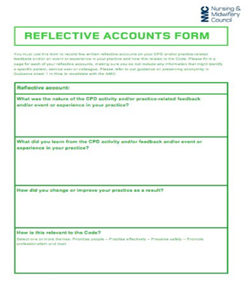
Conclusion
To conclude, following any one of the above methods and theories proposed will enable practitioners to begin reflecting within their practice. Learning to reflect is a crucial skill for any practitioner to develop whilst working within an early years setting. Carrying out reflection to a high standard will ensure the practitioner is providing the upmost care and learning to all children within the practice. Whilst also developing the practitioners own professional development, in both knowledge and understanding. Furthermore, a successful reflective practitioner will have a greater understanding of children, their developmental stage, needs and also identifying likes and dislikes. All of which improves learning and development within the workplace and also aids future planning.

(NHSGGC Practice Education 2020)
When carrying out reflection as a practitioner, it may be useful to use a reflective accounts form. Settings may provide these for their practitioners, to allow them to able to easily document their reflection process, using any one of the above models or theories. These forms can be helpful for practitioners to maintain a detailed record of the reflection taking place within the practice. Reflection account forms are typically brief and allow practitioners to document a written description of an experience or simply note down their own actions to later reflect on what went successfully, unsuccessfully and any improvements needing made for future practice.

Models and theories of reflection
There are many different models and theories of reflection that can be used as a guide to help and support the reflection process. Schon (quoted in Aubrey and Riley,2019, p. 181-194) theory suggests there are two types of reflection, reflection on practice and reflection in practice. Reflection in practice requires practitioners to reflect whilst in the situation. Schon believes that by doing so, professional practitioners may be at risk of missing opportunities to reflect and evaluate in order to improve their knowledge and future planning. Whereas refection on practice is a higher level of reflection. This requires practitioners to carry out planned activities with a purpose of reflecting on those activities once completed. This will enable practitioners to better identify what could be done differently to improve practice, further develop skills and allow them to record their thinking process for future practice. By following Schon's model of reflection, practitioners will develop a questioning approach to their practice (Roffey and Malthouse, 2020). Practitioners will learn to consider why things are as they are, and how they could be. Whilst also learning to consider the strengths and areas of development in their own professional practice, by questioning learning experiences and considering how to develop them. As a result, practitioners will be more carefully planned, informed by research and previous experience, and focused, with logical reasons. As with all reflective models, practitioners will need to also ensure the cycle is repeated, so that that knowledge is secure, and progression is continued.
Another model of reflection is Gibbs Reflective Cycle, one of the most famous models used by practitioners. The Gibbs reflective cycle, created in 1988 by Graham Gibbs, is made up of six dialogical movements to lead practitioners through reflection (Johns and Burnie, 2013). The six stages to the cycle are: Description, Feelings, Evaluation, Analysis, Conclusion and lastly Action plan. Bassot (2016) describes Gibb’s reflective cycle as very detailed, having six steps and providing useful questions as prompts to help practitioners to explore what they have learned at a deeper level. Allowing for Gibbs model to be easily implemented in practice. It was designed as a continuous cycle of improvement for a repeated experience but can also be used to reflect on a standalone experience (The University of Edinburgh, 2020). Furthermore, Bassot (2016) discusses how Gibbs cycle is strongly recognised for the acknowledgement of the importance of feelings in reflection. The second point on the cycle, focuses on those feelings and our emotional response to situations. For those professionals supporting people in challenging circumstances this aspect of Gibbs’ cycle is particularly helpful. Professional practitioners are not expected to turn emotions off and respond objectively, instead feelings and emotions are taken into consideration. In contrast to other models, Gibbs also separates and places an emphasis on Evaluation, to allow practitioners to evaluate what when well and what could have been improved. Ahmed (2019) also discusses the fourth step of the cycle entitled ‘Analysis’. This step requires practitioners to think at a deeper level still in order to make sense of an experience. This could involve looking at the experience from different perspectives, to try to identify what was happening and why. Practitioners will not always be able to make sense of every experience, however Gibbs circle certainly encourages practitioners to try.
Bassot (2016) goes on to discuss another reflective theory, David Kolb’s Experiential learning cycle. Kolb’s learning cycle provides a powerful foundational approach to all forms learning, development, and change. Kolb’s theory explains that Experiential learning is a learning process where knowledge is created from the combination of grasping and transforming an experience. Similar to Gibbs Reflective Cycle, Kolb’s theory emphasises learning that takes place from experience, occurring in a particular sequence. Rushton and Suter (2012) describe the four stages to Kolb’s learning cycle: Concrete experience, Reflective observation, Abstract conceptualization, and Active experimentation. The ‘Reflective observation’ stage is where the experience starts to be turned into learning. Kolb argued that this is where the skills of the practitioner are most needed, to help facilitate the learning of the learner. At the completion of the ‘Reflective observation’ stage, the practitioner will start to reflect on the experience and have general principles of what is being learned. From which point the practitioner moves to the ‘Abstract conceptualization’ point on the cycle, in which reflection gives rise to a new idea, or a modification of an existing abstract concept. Allowing for the practitioner to fully learn from the experience. In the final stage, Practitioners will apply their new ideas to the world around them. Allowing the practitioner to see if there are any changes to future experiences. As such, this stage offers an opportunity for learners to test out their new ideas and lessons gathered from the experience. By actively experimenting with different concepts, practitioners are able to learn how to associate what they have experienced with new ideas and innovations. This experimentation results in new concrete experiences that effectively trigger the beginning of the next cycle. Furthermore, Kolb (1984) views learning as an integrated process, with each stage mutually supportive and following into the next. Kolb has created this cycle to make it possible for practitioners to enter the cycle at any stage and follow it through its logical sequence. In addition to this, he also states that effective learning can only be achieved when a learner can execute all four stages of the model. Therefore, no one stage of the cycle is effective as a learning procedure on its own.

Bibliography
Ahmed, A.M. (2019) ‘Students’ reflective journaling: an impactful strategy that informs instructional practices in an EFL writing university context in Qatar’, Reflective practice, 20(4), pp. 483–500.
Aubrey, K. & Riley, A. (2019) Understanding and using educational theories. 2nd edn. London: SAGE Publications Ltd
Bassot, B. (2016) The Reflective Practice Guide : An Interdisciplinary Approach to Critical Reflection. Abingdon, Oxon: Routledge. (Accessed: 26 October 2022).
Brock, A. (2014) The Early Years Reflective Practice Handbook. London: Taylor & Francis Group. (23 October 2022).
Cotter, R.J. (2014) ‘Reflexive spaces of appearance: rethinking critical reflection in the workplace’, Human resource development international, 17(4), pp. 459–474.
Finlay, L. (2008) Reflecting on ‘Reflective practice’. Practice-based Professional Learning Paper 52, The Open University.
Dewey, J. (1993) How We Think: A Restatement of the Relation of Reflective Thinking to the Educative Process. Boston: D. C. Heath.
Hallet, E. (2013) The Reflective Early Years Practitioner. London: SAGE Publications Ltd.
Ian Rushton and Martin Suter (2012) Reflective Practice for Teaching in Lifelong Learning. Maidenhead: Open University Press. (Accessed: 26 October 2022).
Johns, C. and Burnie, S. (2013) Becoming a reflective practitioner. 4th ed. Chichester. West Sussex: John Wiley & Sons.
Kolb, D. A. (1984). Experiential learning: Experience as the source of learning and development (Vol. 1). Englewood Cliffs, NJ: Prentice-Hall.
Lucas, P. (1991) ‘Reflection, new practices and the need for flexibility in supervising student teachers’. Journal of Further and Higher Education, 15 (2), 84–93.
NHSGGC Practice Education (2020) Reflective template [online image] Available at: https://www.nhsggc.org.uk/media/263190/flyingstartbooklet-2.pdf (Accessed on: 26 october 2022).
Reed, M. & Canning, N. (2009) Reflective Practice in the Early Years. London: SAGE Publications Ltd. (Accessed: 23 October 2022).
Roffey-, BJ, & Malthouse, R. (2020) Reflective Practice in Education and Training. London: SAGE Publications, Limited. (Accessed on: 23 October 2022).
Tarrant, P. (2013) Reflective Practice and Professional Development. London: SAGE Productions Ltd.
Aubrey, K. and Riley, A. (2019) Understanding and using educational theories. 2nd edn. London: SAGE Publications Ltd.
Turner, T, Lucas, M, & Whitaker, C 2018, Peer Supervision in Coaching and Mentoring: A Versatile Guide for Reflective Practice. Milton: Taylor & Francis Group. Pp. 31, diagram. (Accessed: 27 October 2022).
University of Cambridge. (2021) Reflective practice toolkit. Available at: https://libguides.cam.ac.uk/reflectivepracticetoolkit/introduction (Accessed on: 22 October 2022).
University of Edinburgh. (2020) Gibb’s Reflective Cycle. Available at: https://www.ed.ac.uk/reflection/reflectors-toolkit/reflecting-on-experience/gibbs-reflective-cycle (Accessed on: 26 October 2022).
Zwozdiak-Myers, P. (2012) The Teacher’s Reflective Practice Handbook: Becoming an Extended Professional Through Capturing Evidence-Informed Practice. London: Routledge. Pp. 42, diagram. (Accessed: 27 October 2022).
Fullan, M. (2008) The Six Secrets of Change: What the Best Leaders Do to Help Their Organizations Survive and Thrive. Chichester: John Wiley & Sons.

