Group Project Report

Shallow Water Retrieval

Assignment 1

Hayden Taylor

12/12/2025

Table of Contents
1 Table of Figures 2
2 Table of Tables 3
3 Introduction 4
4 Design Project Management 4
4.1 The brief 4
4.2 The team’s goal 4
4.3 The team’s process 4
5 Role in the Team 5
5.1 Location of the lakes 5
5.2 Disposal of OME 5
5.2.1 3kg practice bomb 5
5.2.2 1000lb bomb 6
5.2.3 BL755 cluster bomb 6
5.3 Flow chart 6
6 Presentation 7
7 Feedback and Reflection from Presentation 7
7.1 The group feedback 7
7.2 The individual’s feedback 8
7.3 Questions from feedback 9
7.3.1 Alternatives to burning 9
7.3.2 Overall time 9
7.3.3 Communication 10
8 Conclusion 10
9 References 10
10 Annexe 11

Table of Figures
Figure 1 - Opening slide 11
Figure 2 - Background information of project 11
Figure 3 - Location of 4 lakes 12
Figure 4 - Lake Neuchatel for shallow water 12
Figure 5 - Munitions 13
Figure 6 - Overview of BL755 13
Figure 7 - BL755 functions 14
Figure 8 - BL755 submunitions overview 14
Figure 9 - 1000lb bomb overview 15
Figure 10 - 1000lb bomb functions 15
Figure 11 - Fuses found in 1000lb bomb 16
Figure 12 - 3kg practice bomb overview 16
Figure 13 - Area control 17
Figure 14 - Locating the OME 17
Figure 15 - Water survey 18
Figure 16 - Environmental considerations 18
Figure 17 - Removal of the OME 19
Figure 18 - On shore inspection 19
Figure 19 - Low order techniques 20
Figure 20 - Disposal methods of the 1000lb bomb 20
Figure 21 - disposal methods of 3kg practice bomb 21
Figure 22 - High order of 1000lb bomb 21
Figure 23 - Post disposal processes 22
Figure 24 - transport 22
Figure 25 - In depth process flow chart 23
Figure 26 - Actual flow chart process 23
Figure 27 - question slide 24
Figure 28 - Disposal notes 25
Figure 29 - Feedback from presentation 26

Table of Tables
Table 1 - Group feedback 8
Table 2 - Individual feedback 8

Introduction
This report will cover the shallow water retrieval teams’ group-based project presentation. It will include the research tasks, presenting task and the feedback. The look into how the team work together, the challenges that were overcame and the solo role in the team. The overall project was about a real-life project of removing OME from Swiss lakes and disposing of them, it focused on the shallow water retrieval. This report is an overview of the whole process that the group went through.

Design Project Management
This part of the role covers the assignment brief, the goal for the team, the individual roles within the team and the process the team went through to gain the end product.

The brief
To start the group project the level 4 HNC in ordnance munitions and explosives course was split into two groups and each group had a slightly different project to undertake. The authors group looked into the shallow water retrieval of munitions from the Swiss lakes. The assignment was to accumulate information regarding a real-life scenario where the Swiss military were using lakes to dump and use as bombing practice as this was determined to be a safe way of dumping fused munitions. The Swiss defence department were offering prize money of 50,000 Frances (£45,000) for project ideas to remove and dispose of these munitions. As a group the job was to undertake research and create a presentation to show the groups thoughts and project idea for this scenario.

The team’s goal
The shallow water retrieval and disposal team were given three different munitions to research, it was stated that these munitions aren’t the actual munitions in the lakes but for the project these were what the group looked at:
- 1000lb bomb – torpex liquid biscuit filled
- BL755 cluster bomb – 147 submunitions
- 3kg practice bomb – pyrotechnic composition
Once the team understood the idea of the project and the different munitions to research it was understood that the best method was to assign roles to all the individuals:
- Jack Burden – Project manager – oversaw the removal of OME, area control and transport.
- Jamie Hodges – oversaw the locating the OME, the water survey and the environmental considerations.
- Tom Greenwood – oversaw the understanding the munitions and the onshore inspection
- Hayden Taylor (the author) – oversaw the locations of the lakes and the disposing of munitions.

The team’s process
For the beginning part of the process the team were at UWTSD and used this time to understand the brief and the individual roles within the team. Once this had been completed the group used a scatter gun approach where individuals went away to find the vital information on the given roles, with constant emails of information and questions for the group would be included. To ensure that everyone was on the same path weekly meetings on a Friday morning were put into place by the project manager where the group evaluated the information already gained and the next goals. By having co-ordination with the team constantly it allowed for everyone to have a good understanding of the whole project which was identified as being an important part when producing a presentation. Once all information was attained producing a presentation to incorporate everything was the next step. The team did this process together in a university block, by going slide by slide to incorporate vital information, visuals and a presentation theme. By doing this approach it allowed for input from the whole team of what was good and what needed adapting. Once the presentation had been finalised the groups next job was to ensure everyone had a script on what would be said during the presentation. Multiple run throughs were then completed to improve the presenting skills and understanding how the presentation flowed.

Role in the Team
The different roles in the team were an important first step to begin research on all topics that needed to be covered, the roles that each member chose to research was the same ones that they would present on the day. The authors role in the project was the location background, the disposal methods and the systems engineering flow chart.

Location of the lakes
The first task that the author undertook was research into the background of the locations in Switzerland. This was done by looking into news articles and information given regarding the real-life project of removing and disposing of the OME from the Swiss lakes. From these news articles it was identified that there were four lakes where the Swiss military used to dump different OME into. These were lake Neuchatel, lake Lucerne, lake Thun and lake Brienz. After acknowledging this information, it was vital to understand the depths of these lakes as not all of them will fit the criteria of shallow water retrieval. It was identified that for the majority of these lakes the munitions were dumped at around 150 to 220 metres deep. However, lake Neuchatel were just dumped at around 6 to 7 metres deep. After finding this information it allowed for the team to focus more on this lake for all further research. [1] Once the background information for the lakes had been identified it was time to put these into slides for the presentation these can be seen in figure 3 and figure 4.

Disposal of OME
The next task for the author was to investigate the disposal of the three identified OME. The first stage that was undertaken was research into all different ways of disposing before moving onto specific methods of the individual OME. To complete this the author made a notes page on the pros and cons on the different types of disposals of OME in general. The ideas include open detonation, closed detonation, closed incineration, industrial demilitarisation and manual disassembly. The notes on these include where it has been used before, the cost and the environmental considerations. [2] The notes page that the author made can be seen in the annexe under figure 28. Once the background information was researched the author then had to identify the three munitions and the best way for each to be disposed, this is because the munitions work in different ways, and this was important to know as this would affect the disposal process. The idea of the author was to find the safest way environmentally and for the personnel, with this in mind low order techniques was the first thought. However, this would not be possible for all the munitions. Therefore, the next part was to investigate both low and high order techniques.

3kg practice bomb
The first munition that the group would look to dispose of was the 3kg practice bomb. The reason for this is it was identified that it is the safest munition to remove from the lake and dispose of because of its features. It was identified that there were two safety features on the munition – a safety pin and an inertia induced striker. Therefore, the bomb would not gain enough inertia as the bomb was stationary on the seabed. Knowing these safety features it was identified by the author that the 3kg practice bomb would be safe to move to the shore and then the disposal on the munition could take place. The next part of the authors research was to look at the booster and main charge of the munition to determine the best method for disposal. The booster was a pyrotechnic composition called SR800, and the main charge was magnesium which allowed for the smoke and flare charge of the bomb. After researching this information, the author investigated how to dispose of the bomb, it was identified that the best and safe way to complete this was to function the bomb as designed by a trained individual in a controlled area.

1000lb bomb
The next munition that the group would dispose of was the 1000lb bomb. For this munition it was vital to understand what fuse was attached, as one of the types is more dangerous. The different fuses mean the method of disposal would be different. If attached with the No44 fuse a high order technique underwater would be the only possible method as it would be too dangerous to touch or move. If attached with the No27 fuse then a disruptor would be used to neutralize the fuse before removing the munition out of the lake. The disruptor would be set up next to the fuse underwater with zero standoff because the density of water is greater than that of air. Once the fuse has been de-armed it was identified that the munition can be removed from the lake and then a low order technique can be used to dispose the munition.
There were two methods that the author researched and identified that would work for the 1000lb bomb. These were Vulcans and flexible linear cutting charge (FLCC). The Vulcans is a shaped charge technique to allow for low order destruction for target munitions. There are a range of six different projectiles which can be used depending on the munition. [3] This would be used to break the casing of the munition and allow for burning once completed. The flexible linear cutting charge (FLCC) is a cut and burn technique which allows for the munition to be cut in half leaving the exposed explosive composition. This technique has three charges, one through the centre of the bomb and two on either sides, they will all be initiated simultaneously to prevent the detonation of the bomb. [4] The two charges on either side allow for ventilation of gas and heat to stop high order. For both processes, the exposed explosive composition will then be burnt using a flare igniting electric and a low temperature thermite. By completing this all the explosive material with be burnt in a low order technique.
After considering both options the author set on using the flexible linear cutting charge to break the munitions casing and then burning the explosive material.

BL755 cluster bomb
The last munition that the group will look to dispose of is the BL755 cluster bomb. The first part of the authors research investigated how the munition worked, and it was identified that it contains 147 submunitions which get immediately armed when the springs get released. After knowing this information, it was determined that there was no possible way of determining whether the submunitions were armed or not. Therefore, the author decided it would be unsafe to move the munition from the seabed. This left two options, the munition doesn’t get touched and is left in the lake or a high order technique would be used underwater to dispose the bomb. As the brief stated that the munitions had to be disposed the high order technique detonating the bomb was chosen. This would be a successful and complete detonation of the explosive munition underwater.

Flow chart
The last task that the author undertook was the systems engineering flow chart for the whole project. This was completed to show the whole groups thought process and decision making throughout the project. It includes the different methods and ideas that the group came up with from the research. By looking into the different ideas and methods it allowed the group to gain the best outcome for the project. This task was completed throughout the months of preparing this project via communication with the group to show that multiple methods and decision making went into the end product.

Presentation
Creating a presentation that included the vital information, visual imagery and a consistent theme was an important task for the group project. This was the method that the group would be showing the audience and stakeholders to get the group project idea across so ensuring that all the criteria were captured.
The group came together to build the presentation together, this allowed for everyone’s thoughts on different sections could be gathered. The first point the group came up with was having minimal information on the slides with photos to aid explanation. This allowed each member to have more time speaking straight to the audience instead of reading from the slides. Throughout this process there was adaptations to the order of the slides and more slides added to aid with the flow of the presentation.
Once the presentation was made the group spent a lot of time doing run throughs to determine what to say and improvements to the presenting skills. By doing this it gave the group confidence presenting the presentation and the timing was more accurate to the allocated 40-minute time that was stated. As a group there was often a third party who had not seen the presentation that watched so that it felt just like the presentation day. This also allowed for early feedback and changes to be made.
On the presentation day, the group decided that looking smart gave across the professional look that was wanted. The group also did a final preparation run through so that everyone was confident going into the presentation.
On reflection of the presentation, the author feels that all information and work building up to the presentation helped to produce the end product everyone wanted. The author completed the presentation fulfilling the roles that was intended, explaining every point that was prepared. As a whole group everyone was proud of how well it worked as a team and the support throughout the project was completed to the best standard.

Feedback and Reflection from Presentation
On completion of the presentation feedback was given to the group and the individuals, this can be seen in figure 29. The section will cover the feedback given, the positives, the negatives, the authors thoughts and the potential changes.

The group feedback
A well delivered and well-rehearsed presentation. We joked about being well turned out, but it did make a good impression on the visitors.
Good introductions all around. We knew who the players were.
Names and roles were well defined.
Post it for questions was a good idea that I will be stealing.
Overall, I’d like to have seen a little more on the decision-making processes and the selection logic and a look at other disposal methods for the explosives, recycling etc.

Good use of post it notes for recording questions throughout. Introduction to the project and background information provided. Slides have a nice, simple theme that is consistent throughout. Some text was a little small but mostly easily readable by audience. Helpful visual imagery used throughout to aid the audience understanding. Cohesion between presented sections, clear evidence of working well together as a unit. Detailed considerations for health and safety and environmental challenges. Retrieval and disposal proposals explained clearly and simply enough for non-experts to understand. Legality of post-disposal transportation considered and discussed both within the UK and Switzerland.
Table 1 - Group feedback
In table 1 shows the feedback given to the group by the markers that attended the shallow water retrieval presentation. The feedback above gives the positives and negatives of the presentation. The positives are that the author has acknowledged from the group feedback is that the presentation was well delivered, good introductions and impressions on visitors, worked well as a team and all areas for the project was covered. The author agrees with these points because as one of the important parts of the group’s decision making was to ensure that the presentation was completed in the best possible way, this included how everyone articulated themselves, the flow and design of the presentation. The author is pleased that the thought process for this was noticed by the audience and stakeholders were happy with the presentation aspect.
One of the negatives that can be seen in table 1 is the amount of decision-making process and selection in the presentation. The author has acknowledged this feedback and reflected via relooking at the presentation. On reflection the author can agree that there were sections were as a group there were multiple different paths that could have been taking but this was not portrayed as much as it should have in the presentation. When completing a project in the future the author will look at including more of the decision-making progress to the presentation as this shows that there was a reason the team chose a certain solution.

The individual’s feedback
Took over locations and highlights for each explained.
Shallow water

Looked at disposal techniques
Cut and burn to go low order

Pyro, Function as designed.

Look at probability of failures?? What it the likely state of ordnance?

Good pace, reasonable volume. Presented side on to the audience facing more to the screen, try and avoid this and face the audience directly as this can come across as being unprepared for the presentation which was clearly not the case. Did not really participate in answering the questions.
Table 2 - Individual feedback
Table 2 shows the feedback given to the individual (the author) from the presentation, it includes what the individual covered and the presentation skills that were shown.
The positives from the individuals feedback indicates that the sections that the individual covered was understandable to the audience, the speaking pace was good, and the individual was prepared for the presentation. The author agrees with the given feedback and is pleased to know that all the information that was stated was clear to the audience. When practicing the presentation, the author worked on presenting skills to ensure that the information was given in a good way without missing any sections. The author is pleased that the prior work on these skills came across when presenting to the audience and the stakeholders.
The negative feedback that the author can work on to improve includes looking into potential failures, the state of munitions, positioning when presenting and the question answering. All the feedback given has allowed the author to reflect on the improvements that can be made. The author agrees that there should have been more information regarding the probability of failures and the state of munitions as these were only briefly mentioned in the onshore inspection slide (figure 18) and the post disposal process slide (figure 23). However, the author does disagree as there was mention of these questions during the presentation.
The next improvement that was stated was regards to the positioning when presenting, the author agrees that when presenting it should be opened bodied as this shows confidence in what was understood and saying. The author believes that the reason behind the side on was when pointing towards the visual imagery on the slide to aid explanation. The author will take this information on board when presenting tasks in the future as it is an important part to show the audience confidence and being prepared.
The final part of the feedback stated the answering questions section of the presentation. The author agrees that the participation could have been more in this section but felt the questions were aimed more towards the other team members areas and allowed them to comment as they had a more in depth understanding. The author made a comment regarding the communication question so feels this comment was harsh. However, going forward the author will be conscious about being more involved in answering this section.
Overall, all feedback given will be noted and remembered by the author to aid in a better presentation in the future.

Questions from feedback
There were three questions given in the feedback to investigate for the author, these were:
- Disposal…Alternatives to burning? Is there a more environmentally friendly means of disposal.
- How long would it take overall to dispose of the ordnance?
- Biggest challenge…. How did you talk together? (For the whole team)

Alternatives to burning
One of the other methods which would be more environmentally friendly is to heat up the explosive material using hot water or steam to melt and allow for the explosive to flow out of the casing. This would allow for the potential for the casing and the explosive material to be reused or repurposed.[5] However, on consideration of this technique the author believed that this would impact the safety of the personnel carrying out this process as the munitions have been left underwater for a long period of time so therefore the state of the munition is unknown.

Overall time
One of the groups questions was the length of time and as stated in the presentation the group believe that this answer is dependent on the amount of munitions and the resources that the project can attain. For these reasons the time frame will vary but to dispose of all munitions and complete the whole project it is understood that this would take between 5 and 10 years.

Communication
One of the groups biggest challenges was the communication between members. This is because the team work at different companies far away from each other. There were members from AWE Aldermaston and QinetiQ Shoeburyness and QinetiQ Fort Halstead. Knowing this information, it was identified that face to face meetings were going to limited opportunities when at UWTSD for the planned blocks. To combat this an email chain and weekly meetings were configured. These were used to have constant communication regarding the information gathered and planning for next goals.

Conclusion
To conclude this report, it was identified that the group project was successful in terms of the research, working well as a team and presenting the idea to an audience and stakeholders. Throughout this project the group showed a sense of individual initiative and teamwork to get the desired result. The report contains an insight into how this result was attained and the feedback on completion. The author feels that this project has allowed for a gain in confidence when presenting a product to an audience and has taken all feedback on board to become better in this area.

References
[1] I. Foulkes, “Switzerland offers prize money to get munition out of lakes,” BBC News, Aug. 17, 2024. Available: https://www.bbc.co.uk/news/articles/cdd7y3nm09lo
[2] S. Conway, “A GUIDE TO CLUSTER MUNITIONS A Guide to Cluster Munitions, Third Edition,” 2016. Accessed: Aug. 04, 2025. [Online]. Available: https://www.clusterconvention.org/files/publications/A-Guide-to-Cluster-Munitions.pdf
[3] A. Technologies, “💣️Vulcan | Alford Technologies,” Alford Technologies, Nov. 14, 2024. https://www.explosives.net/products/vulcan/
[4] Suprameca, “Supraflex – Flexible Linear Cutting Charges - Suprameca - Our Energy Your Power,” Suprameca.com, 2025. https://www.suprameca.com/en/supraflex/ (accessed Nov. 10, 2025).
[5] A. S. Cumming, Energetics Science and Technology. IOPScience, 2022.

Annexe
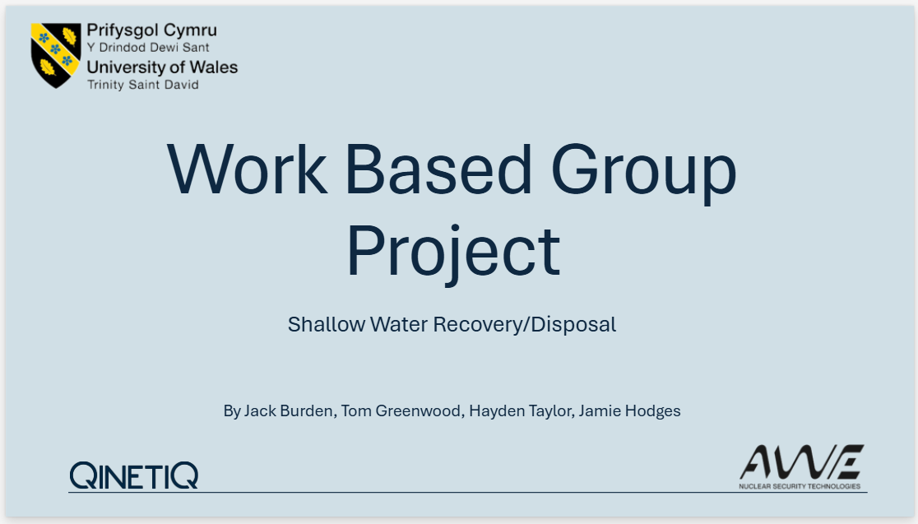
Figure 1 - Opening slide

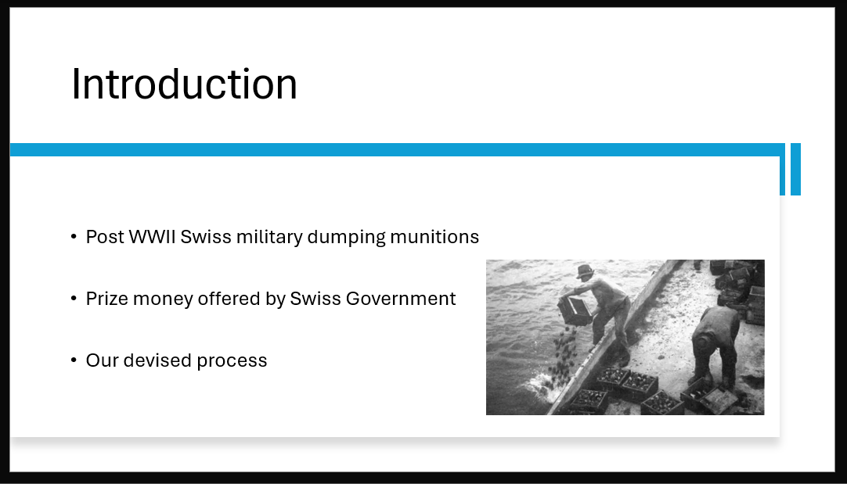
Figure 2 - Background information of project
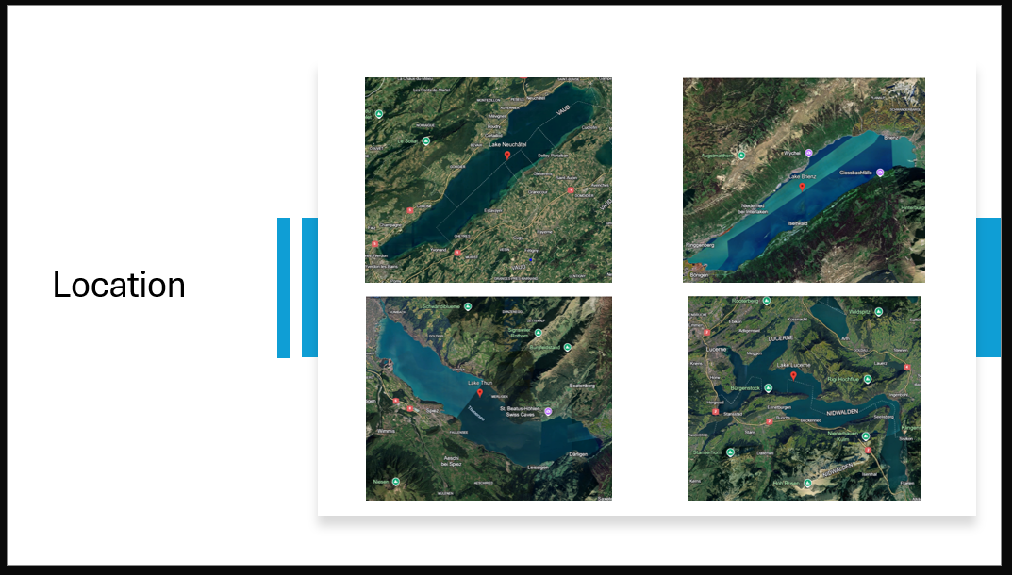
Figure 3 - Location of 4 lakes

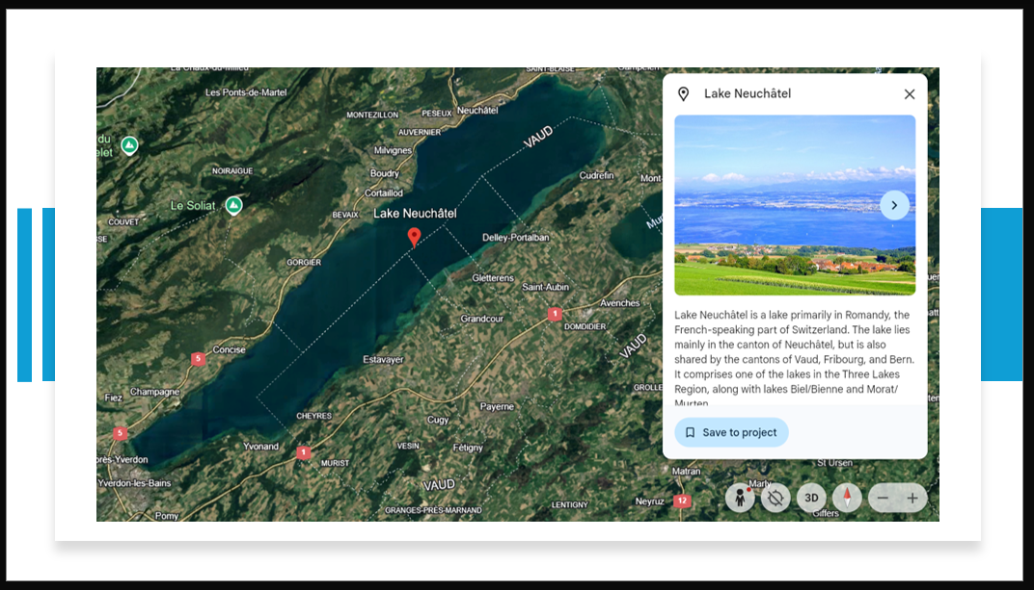
Figure 4 - Lake Neuchatel for shallow water

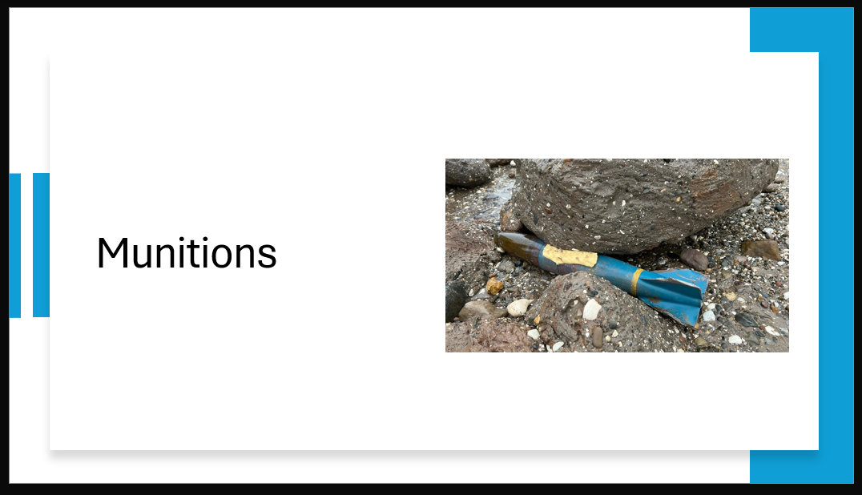
Figure 5 - Munitions

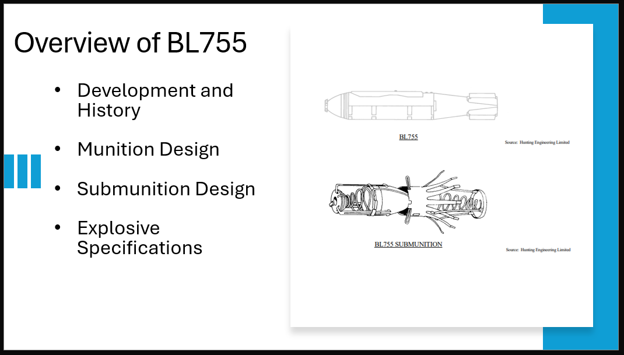
Figure 6 - Overview of BL755

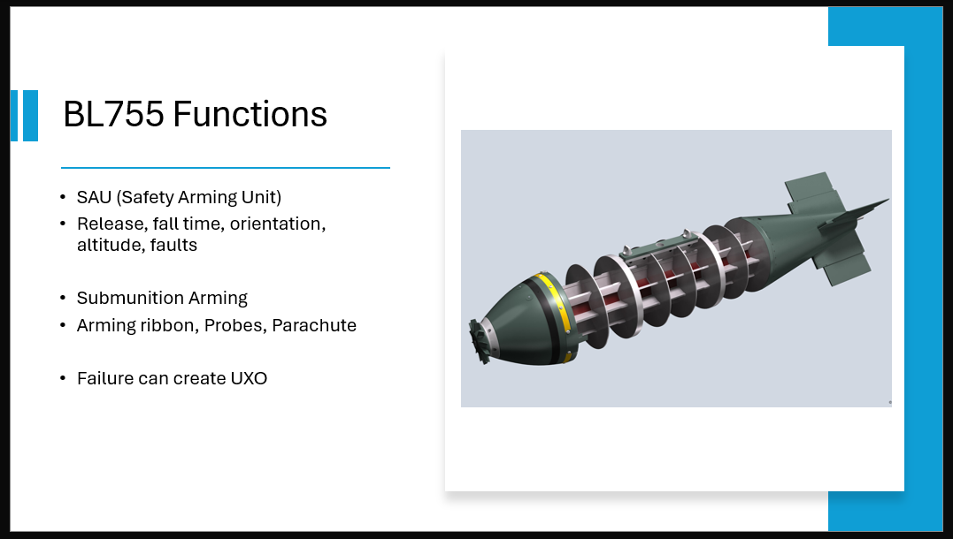
Figure 7 - BL755 functions

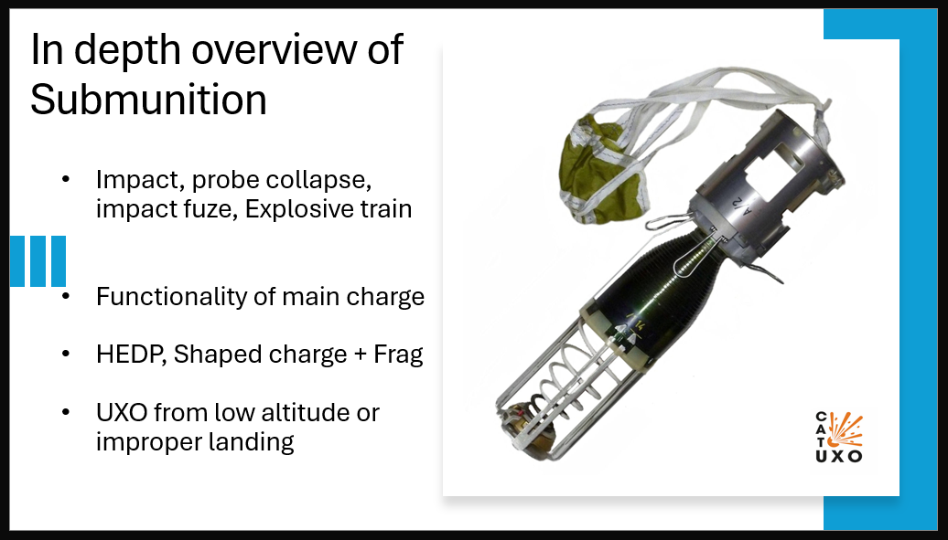
Figure 8 - BL755 submunitions overview

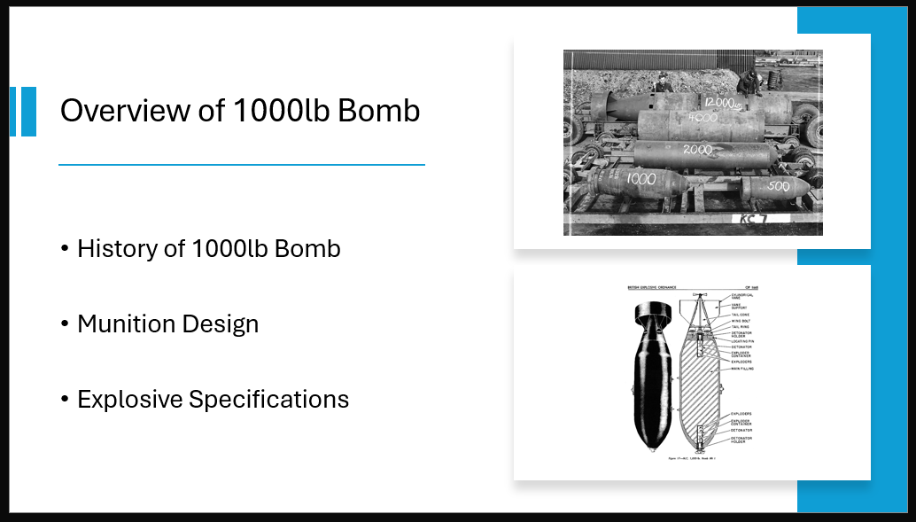
Figure 9 - 1000lb bomb overview

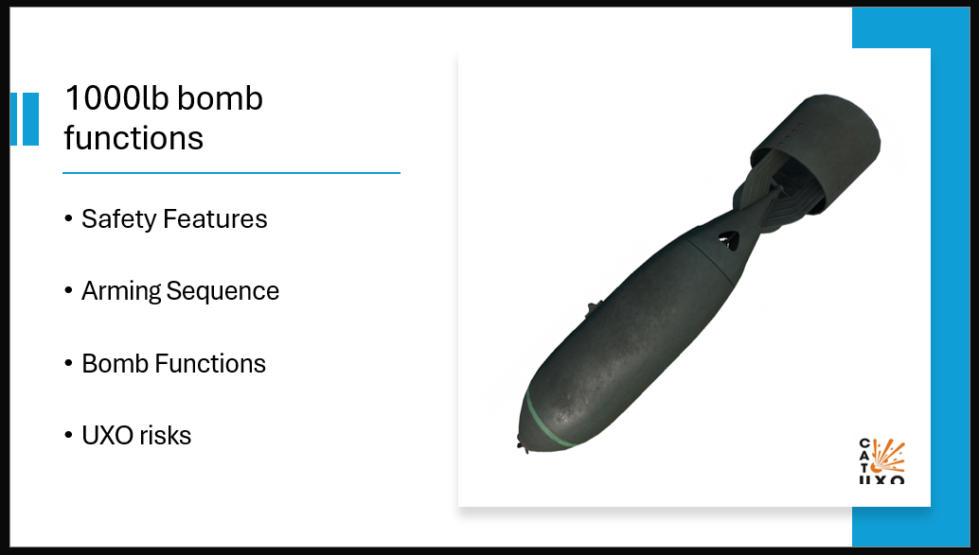
Figure 10 - 1000lb bomb functions

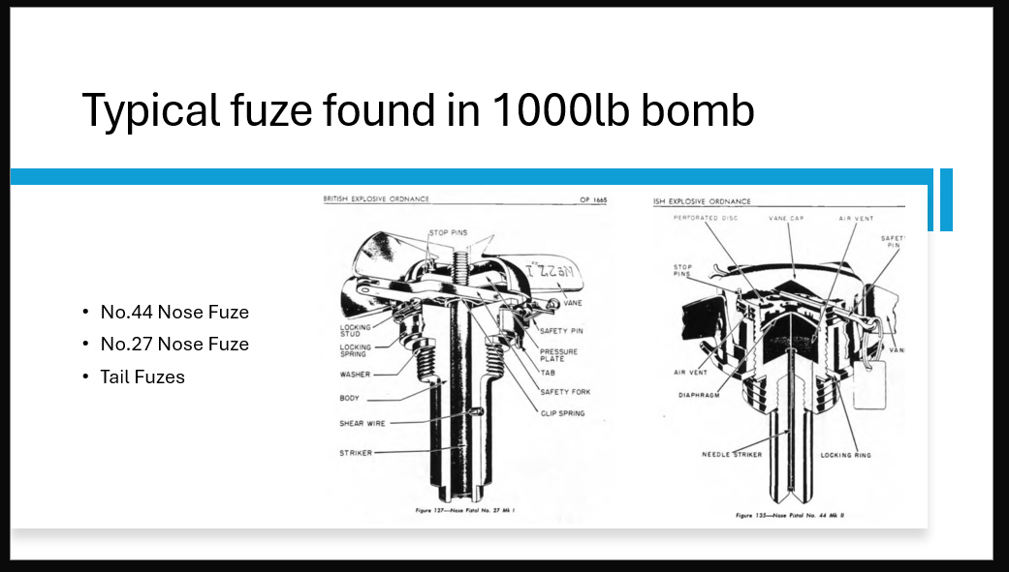
Figure 11 - Fuses found in 1000lb bomb

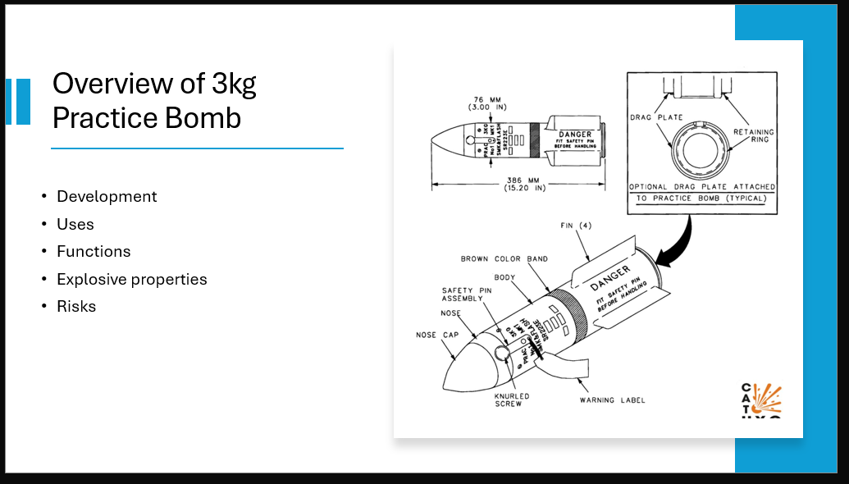
Figure 12 - 3kg practice bomb overview

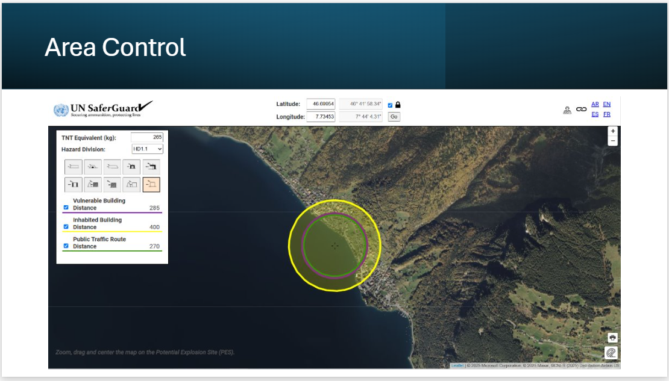
Figure 13 - Area control

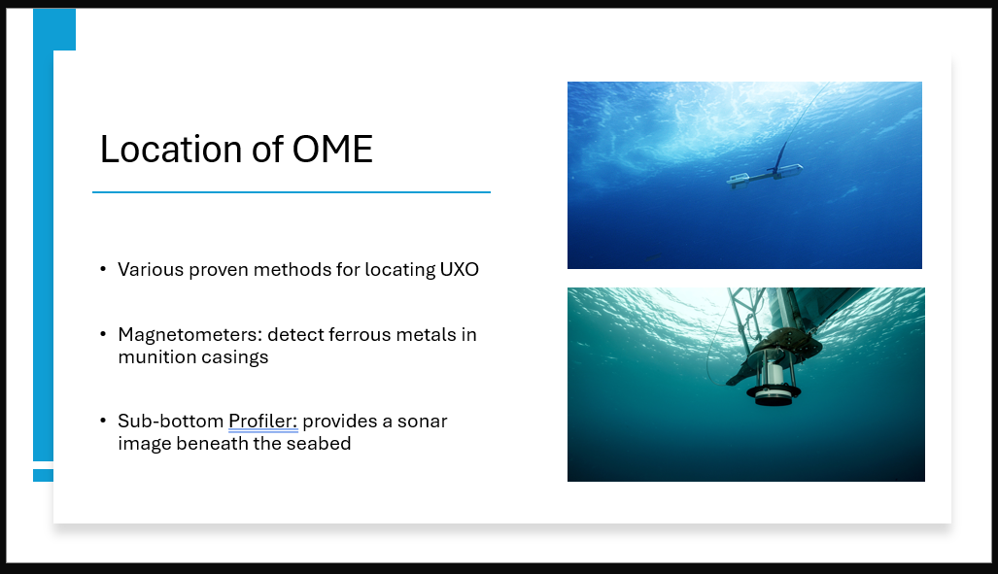
Figure 14 - Locating the OME

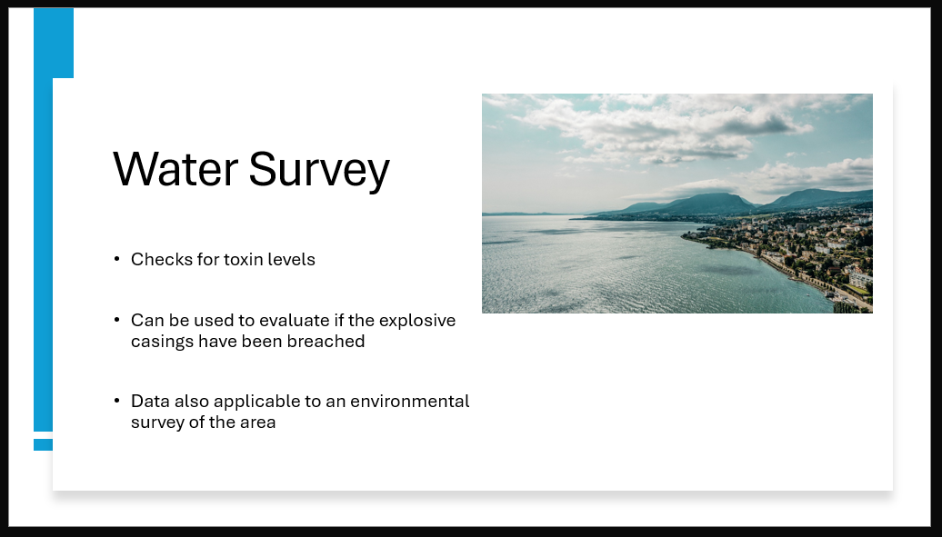
Figure 15 - Water survey

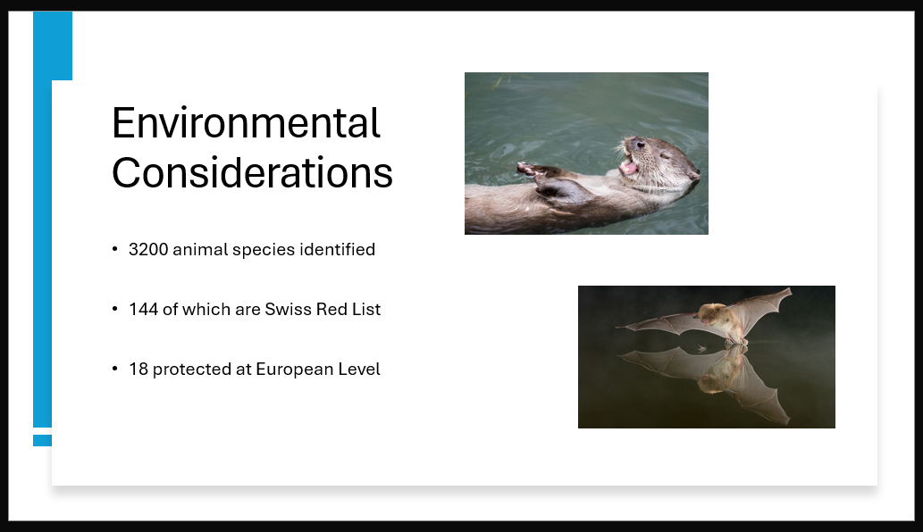
Figure 16 - Environmental considerations

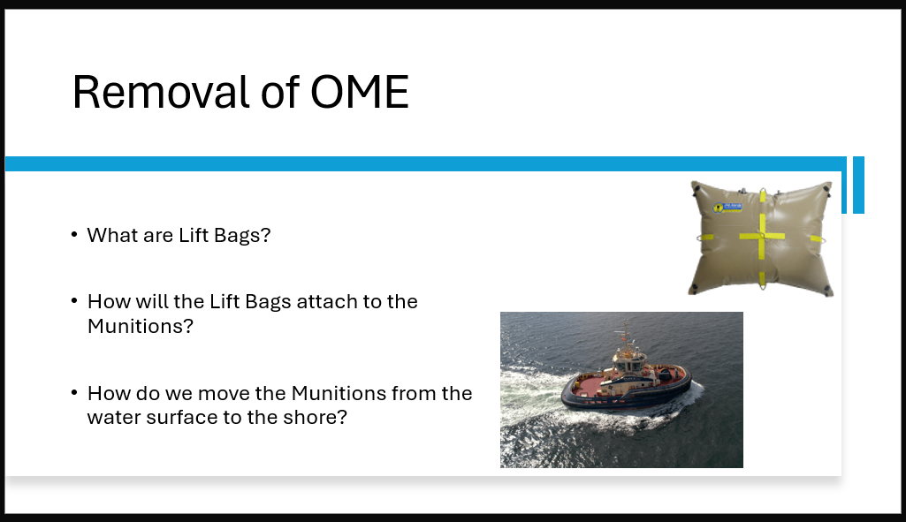
Figure 17 - Removal of the OME

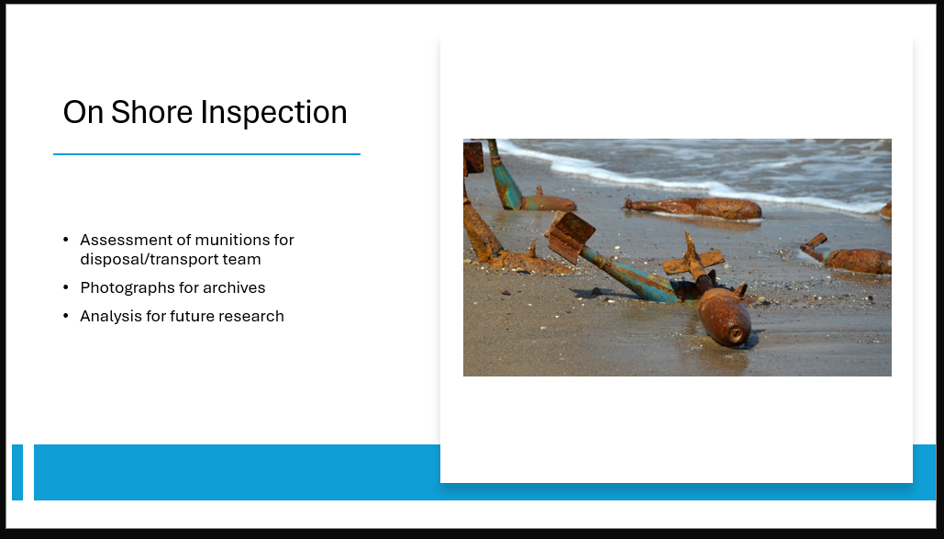
Figure 18 - On shore inspection

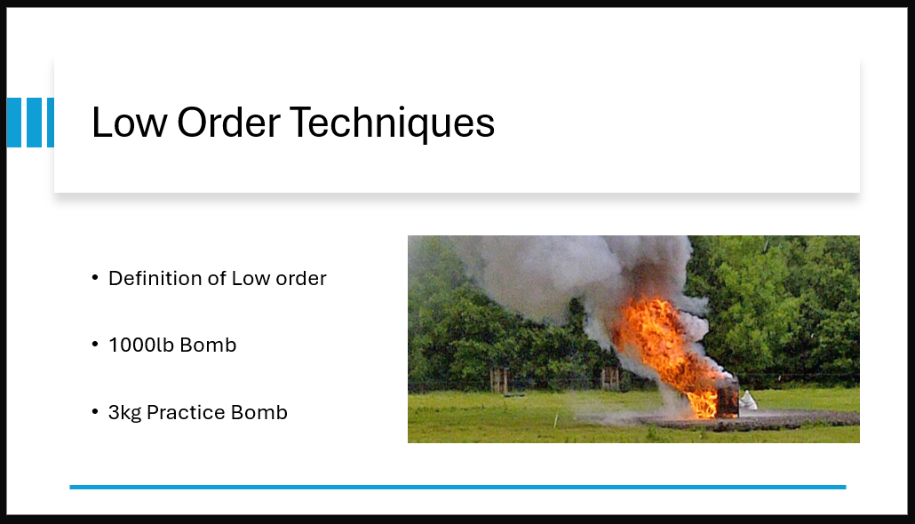
Figure 19 - Low order techniques

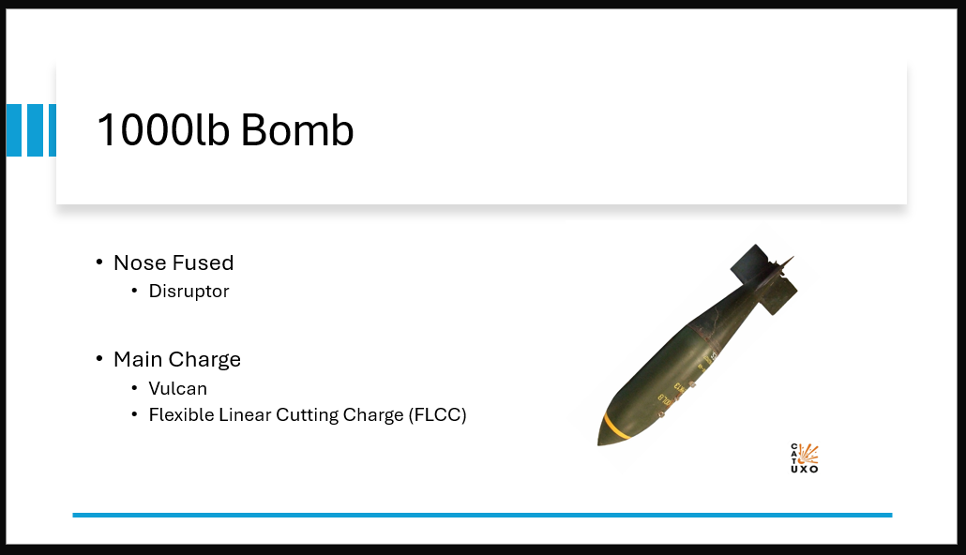
Figure 20 - Disposal methods of the 1000lb bomb

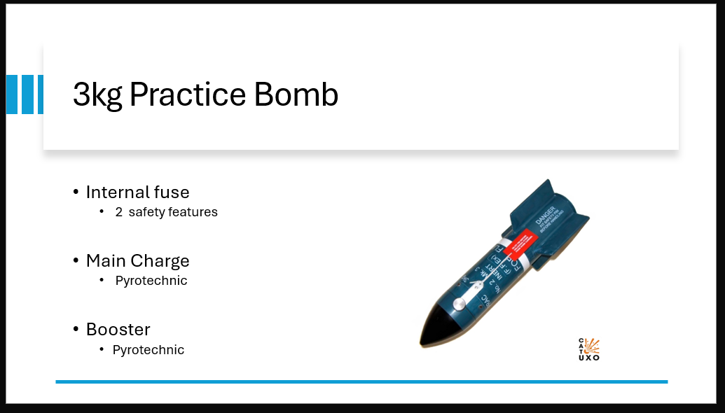
Figure 21 - disposal methods of 3kg practice bomb

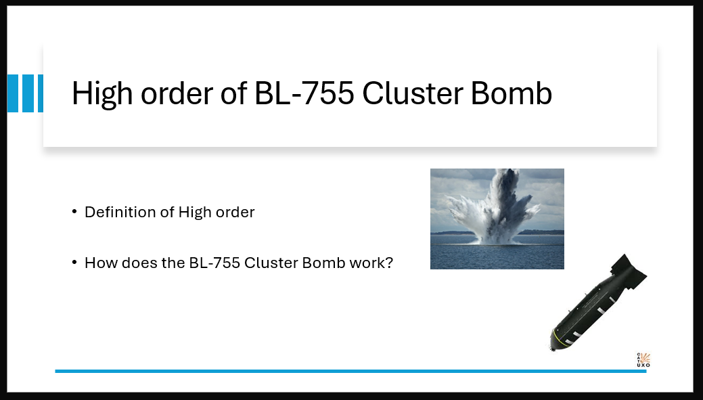
Figure 22 - High order of 1000lb bomb

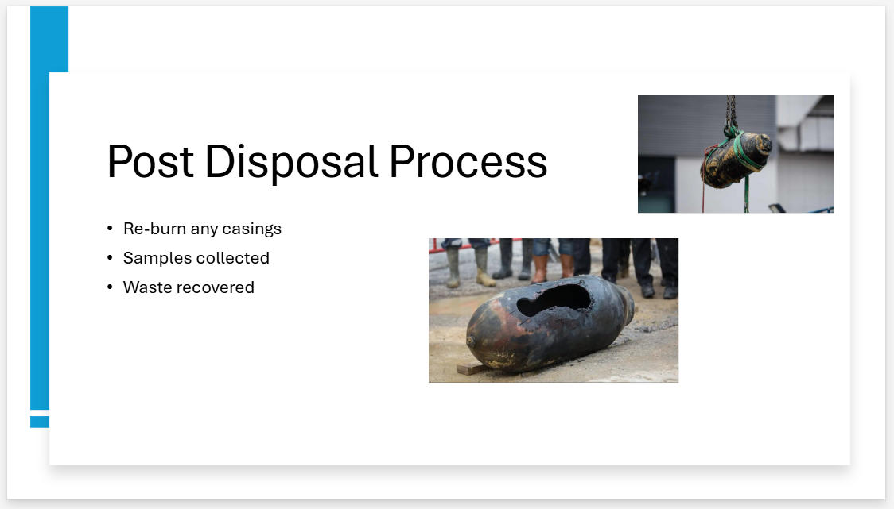
Figure 23 - Post disposal processes

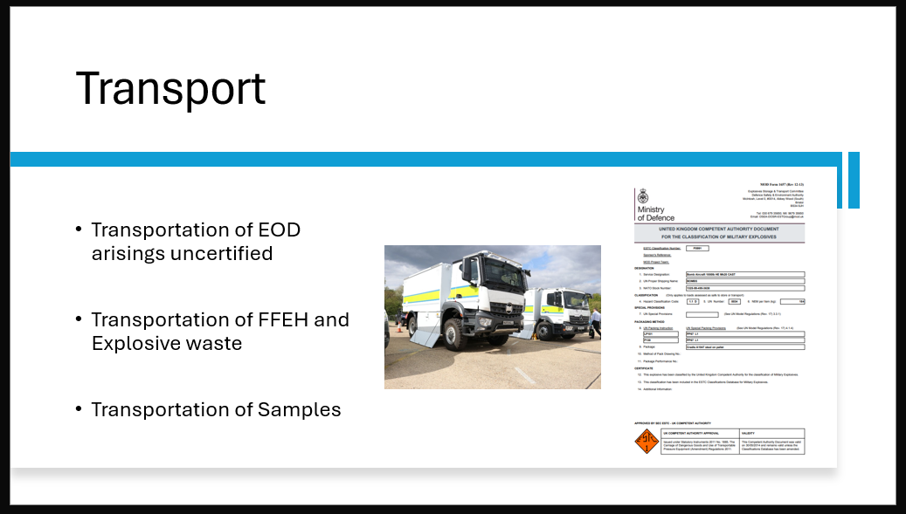
Figure 24 - transport

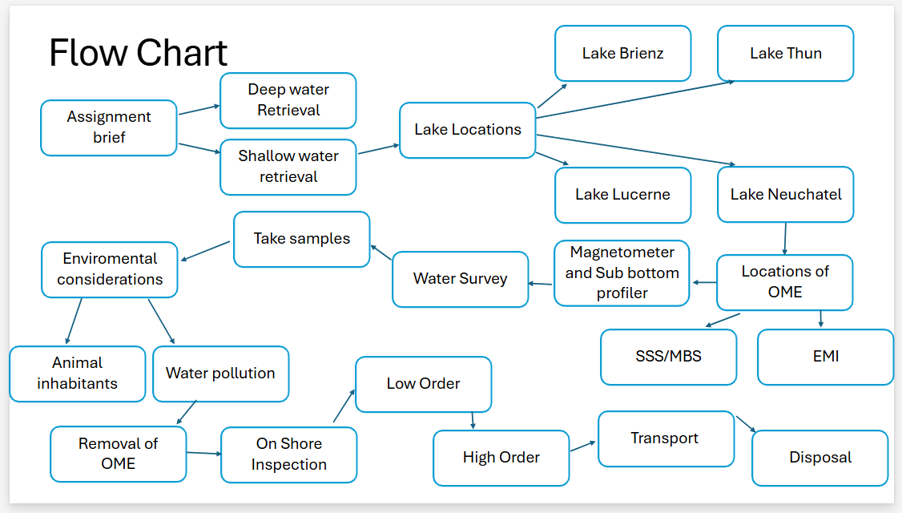
Figure 25 - In depth process flow chart

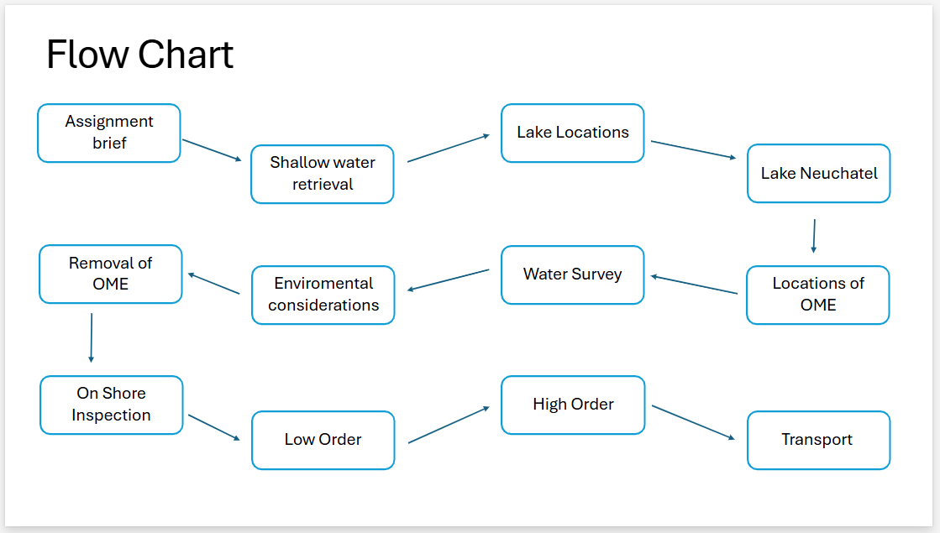
Figure 26 - Actual flow chart process


Figure 27 - question slide
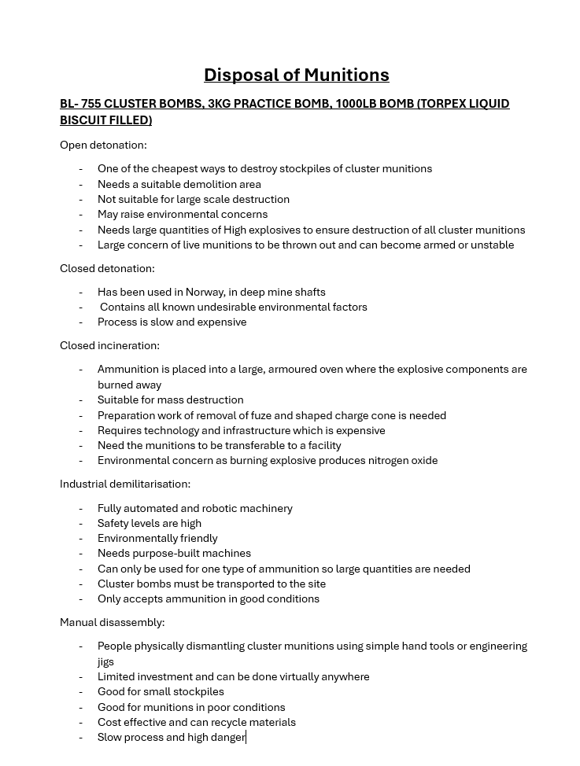
Figure 28 - Disposal notes
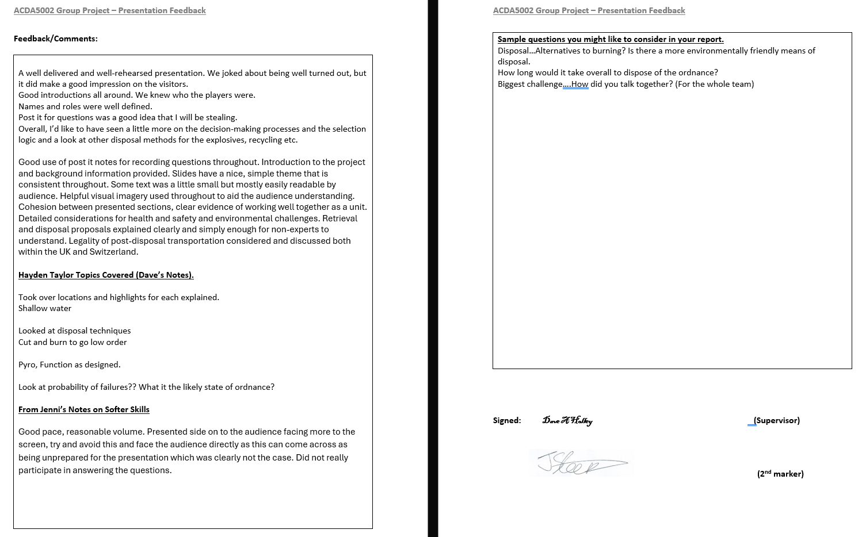
Figure 29 - Feedback from presentation

