University of Wales Trinity Saint David
School of Engineering

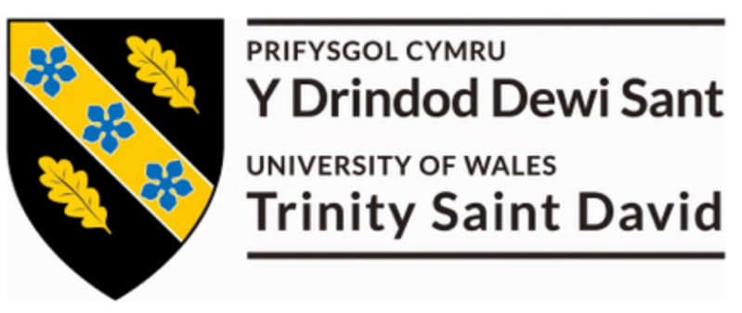

Title of Coursework: Failure Mode & Effects Analysis Technical Report
Module Name and Code: Engineering Applications & Study Skills - ACMA4007

Student Name: Owen Bell
Student Number: 2316885
Date: 12/02/2024
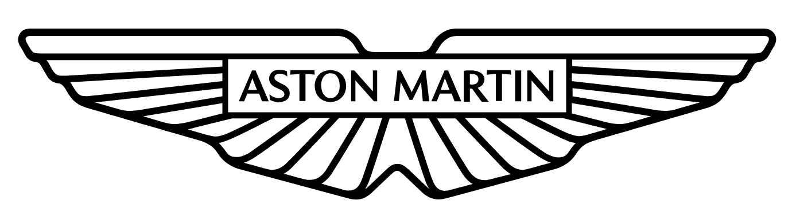

Contents
1 Introduction 1
1.1 Aims 1
1.2 Objectives 1
2 Literature Review 2
3 FMEA Study 7
4 Conclusion 9
5 References 10
6 Appendix 11
6.1 Personal Development Plan 11
6.2 Technical Poster 13

Table 1 - Required Departments to conduct an FMEA study (MDT) 2

Figure 1 - Blank FMEA Study - Aston Martin Lagonda Ltd, 2024. 1
Figure 2 - FMEA Severity Ranking Chart - Aston Martin Lagonda Ltd, 2024. 3
Figure 3 - FMEA Occurrence Ranking Chart - Aston Martin Lagonda Ltd, 2024. 4
Figure 4 - FMEA Detection Ranking Chart - Aston Martin Lagonda Ltd, 2024. 5
Figure 5 - Risk Limiting Matrix Scoring Chart - Aston Martin Lagonda Ltd, 2024. 5
Figure 6 - Completed FMEA Study Sheet - Aston Martin Lagonda Ltd, 2024. 7

Introduction

Aims
The aim of this study is to review the current assembly line process of fitting the Upper A Post Trim used by Aston Martin Lagonda (AML). This Failure Modes and Effects Analysis (FMEA) will attempt to identify weaknesses and potential failures, with the intention to implement appropriate improvements to ensure that the correct components are installed to the corresponding vehicle as per the customer order specification.

Objectives
To create an FMEA to reduce the risk of failure during the fitting of the Upper A Post Trim assembly line process and calculate an overall Risk Priority Number (RPN), based off Severity (Sev), Occurrence, (Occ) and Detection (Det) scores. Propose and trial potential solutions to reduce RPN values for each failure identified in the study. Conduct the FMEA study again reviewing the improvements made and modifying the Sev, Occ, and Det scores since the introduction of the changes and updating the RPN rating of each failure initially identified.

The FMEA template used is shown in Figure 1, the study will focus on the primary and secondary functions of the Upper A Post Trim after fitting into the vehicle.

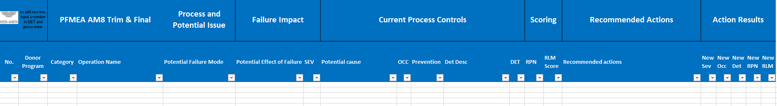
Figure 1 - Blank FMEA Study - Aston Martin Lagonda Ltd, 2024.

Literature Review
Research has been conducted into understanding and defining an FMEA and how to undertake a comprehensive study. The first step is for all responsible parties to collaborate in the review and creation of the FMEA. “Although an individual is usually responsible for the preparation of an FMEA, input should be a team effort. A team of knowledgeable individuals should be assembled (e.g., engineers with expertise in Design, Analysis/Testing, Manufacturing, Assembly, Service, Recycling, Quality, and Reliability).” (Ford Motor Company FMEA Handbook, 2011). For this report, we are conducting a Process Failure Mode and Effects Analysis (PFMEA), resulting in experts from Design, Analysis/Testing, Recycling and Reliability not required to attend this review, as they would have produced the Design Failure Mode and Effects Analysis (DFMEA). We will reference the DFMEA to generate some of the figures on the PFMEA. A Multidisciplinary Team (MDT) will need to collaborate and recommend actions to minimise the risk of failure to the current installation process. A representative from each relevant department needs to be present, as seen in Table 1.

Table 1 - Required Departments to conduct an FMEA study (MDT)
Department | Manufacturing Engineering (Man-Eng.) | Production (Prod) | Manufacturing Business Office  (MBO) | Quality Management  (QMS)
Required | Yes | Yes | Yes | Yes

As stated in a case study “The lean approach in this paper is approach made of using lean thinking, principles, and tools for solving PFMEA. Lean principles can be understood best through 4 basic Toyota principles: Genchi Genbutsu (go and see for yourself), Kaizen (continuous improvement), teamwork and respect for people, and challenge.” (Banduka et al. (2016) found 5 February 2024). This is the generally accepted best approach to conducting an FMEA as it gains the truest reflection on how the process under review is carried out, and which potential failure modes that are observed by the Technicians, who will have pivotal knowledge of the process which could be overlooked by the MDT.

Using the lean manufacturing four phase cycle, Plan (P), Do (D), Check (C), and Act (A), we can create a detailed analysis of the Upper A Post Trim Fit Process. During the ‘Plan’ phase, the MDT will visit the point of fit and record how the process is completed. In the ‘Do’ stage we will review the findings from the ‘Plan’ phase and generate the Sev, Occ and Det scores. The ‘Check’ section is necessary for ensuring the suggested actions that have been made have reduced the RPN. The ‘Act’ phase is to establish and standardise the improvements across the assembly line.

Below are the ranking charts which will be referenced to when assigning the Severity (Figure 4), Occurrence (Figure 5) and Detection (Figure 6). Which are the current scoring methods used internally at AML to calculate the RPN score and should be used as a guide to understand the following report. Furthermore, the MDT will use a Risk Limiting Matrix (RLM), to help determine which potential failure modes should be prioritised and categorise each potential failure mode by risk of failure between 1 (High Risk), 2 (Medium Risk) and 3 (Low Risk) as seen in Figure 7.

ean principlescanbeunderstoodbestthrough4basicToyotaprinciples:
Genchi Genbutsu (go and see for yourself), Kaizen (continuous improvement), team work and
respectforpeople,andchallenge.
Lean principlescanbeunderstoodbestthrough4basicToyotaprinciples:
Genchi Genbutsu (go and see for yourself), Kaizen (continuous improvement), team work and
respectforpeople,andchallenge.
Lean principlescanbeunderstoodbestthrough4basicToyotaprinciples:
Genchi Genbutsu (go and see for yourself), Kaizen (continuous improvement), team work and
respectforpeople,andchallenge.
Lean principlescanbeunderstoodbestthrough4basicToyotaprinciples:
Genchi Genbutsu (go and see for yourself), Kaizen (continuous improvement), team work and
respectforpeople,andchallenge.
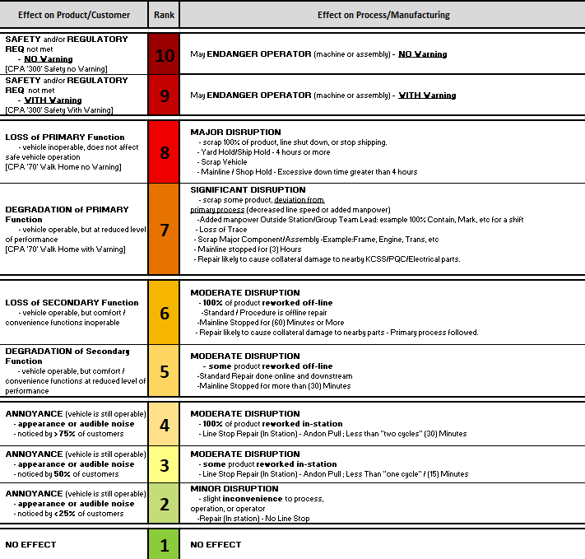
Figure 2 - FMEA Severity Ranking Chart - Aston Martin Lagonda Ltd, 2024.
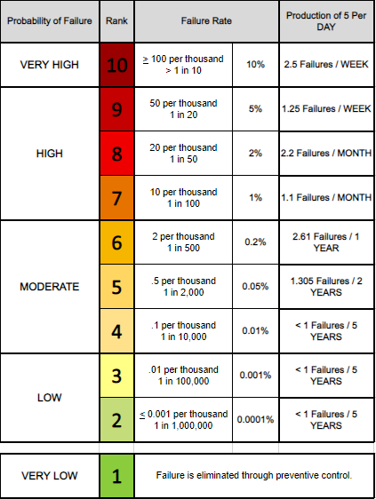
Figure 3 - FMEA Occurrence Ranking Chart - Aston Martin Lagonda Ltd, 2024.
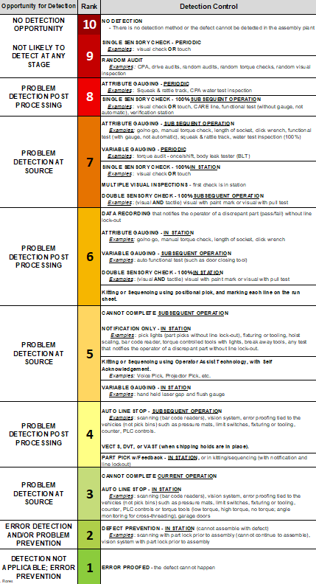
Figure 4 - FMEA Detection Ranking Chart - Aston Martin Lagonda Ltd, 2024.

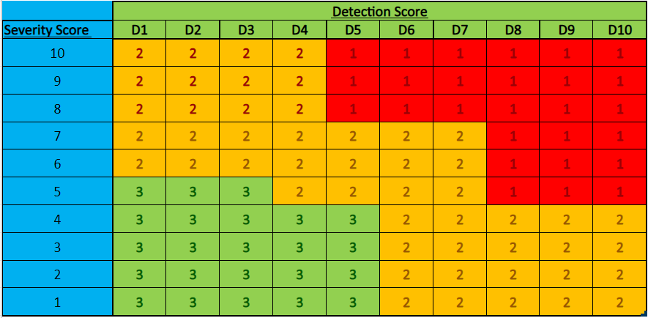
Figure 5 - Risk Limiting Matrix Scoring Chart - Aston Martin Lagonda Ltd, 2024.

During the creation of this technical report for the Upper A Post Trim Fit FMEA study, the MDT referred to the IMechE Code of Conduct and considered the 4 main expectations, these expectations will be upheld and influence the decisions made during this reports creation and aid our daily roles and responsibilities.
- 1) Practice competently & maintain up to date skills
- 2) Act with integrity & respect for others
- 3) Promote sustainability
- 4) Exercise engineering leadership
(Institution of Mechanical Engineers, 2018).

FMEA Study
As seen in Figure 6, two potential failure modes have been identified with the current process by the MDT, the FMEA sheet has then been filled out with the relevant information, leading the FMEA sheet to indicate that the potential failure mode ‘Trapping of Airbag’ has the highest RPN score being 360 and an RLM score of 1, informing the MDT the potential failure mode was a high risk requiring actions that reduce the RPN. The values for the RPN and RLM are calculated by multiplying our Sev x Occ x Det and Sev x Det successively. The recommended actions were to create an In Process Check (IPC), resulting in the technician to conduct an inspection, ensuring the airbag is not trapped and then recording the results on EASE, potentially leading to the assembly line to halt until rectified lowering the Det score from 8 to 4. This caused the RPN value to decrease to 180 and the RLM score to drop to 2 making the failure mode a medium risk.

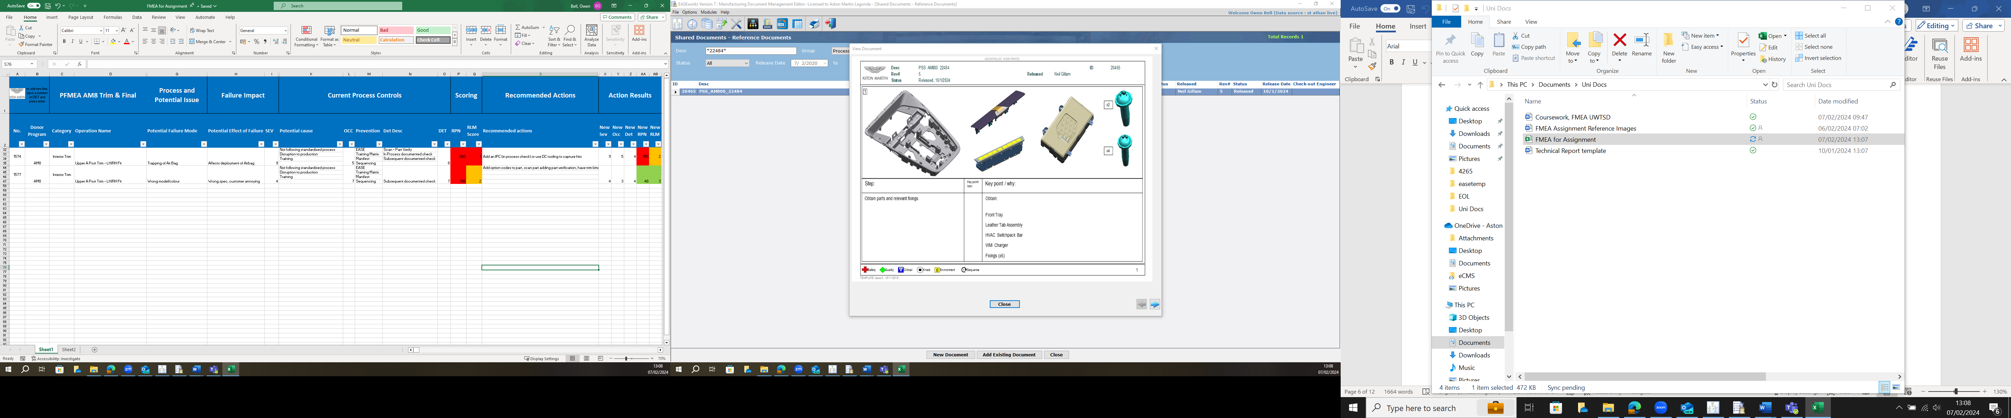
Figure 6 - Completed FMEA Study Sheet - Aston Martin Lagonda Ltd, 2024.

Another highlighted potential failure mode is if the wrong model/colour trim is fitted. The MDT determined the severity was 4, as if the issue occurs it will cause an annoyance to customers, with 75% noticing the error but the vehicle would be operable. The occurrence value was agreed to be 7, suggesting the error occurred once every 100 built. A score of 7 was assigned to detection for a visual inspection against the build sheet informing the technician what trim should be fitted. This created an RPN score of 196 and an RLM of 2 indicating the potential failure is a medium risk. The MDT concluded the best actions to minimise the overall RPN was to assign option codes to the models/colours of trim, for example, Leather trim will have the option code HLP4, these option codes will be linked to a part number that is stored in the Bill of Materials (BOM) and will filter the parts according to the specification. Alongside introducing options, part verification should be created where the part number can be scanned on a barcode on the part, if the incorrect trim or colour has been scanned the part will be reject and prevent the assembly line to progress until the correct trim is scanned. These actions caused a drop in occurrence to 3 with the error expected 1 in 100,000 vehicles and the detection dropping to 4. Which in turn lowered the RPN score by 148 creating a new RPN of 48 and RLM of 3 categorising the failure mode as a minor risk.

Conclusion
From this study, the usefulness of using an FMEA as a decision-making tool to drive improvement in industry can be seen by the tool highlighting potential failures and effects within the design and manufacturing process. FMEAs when used correctly, can identify which of these potential failures should be prioritised through assigning an RPN value to each failure mode which is used to calculate a RLM score at AML, ranking every failure mode identified from High to Low risk. The tool can help identify what actions should be taken to reduce the risk of failure.

During this study we identified potential failures for incorrect parts and fitment. Where applicable the MDT decided to apply the same recommended actions across the assembly line for other similar process at AML, such as adding part verification scans and option codes to all trim parts that vary due to vehicle spec.

With the aid of RPN and RLM values we can develop better quality, robust and safety-focused processes, helping AML produce cars to the highest standard whilst reducing the risk of failure to a minimum. The MDT have planned to review other FMEAs on a regular basis, with the aim to lower all processes to a Medium or Low risk of failure determined by AMLs Risk Limiting Matrix.

References
Aston Martin Lagonda Ltd, 2024. s.l.: s.n.

Ford Motor Company, (2011) FMEA Handbook. Available at https://fsp.portal.covisint.com/documents/106025/14555722/FMEA+Handbook+v4.2/4c14da5c-0842-4e60-a88b-75c18e143cf7?version=1.0 (Accessed: 24 January 2024).

Banduka, N et al. (2016) ‘An integrated lean approach to Process Failure Mode and Effect Analysis (PFMEA): A case study from automotive industry’, in N. Bakunda, I. Veža and B. Bilić (eds) Advances in Production Engineering & Management (APEM). Available at https://apem-journal.org/Archives/2016/APEM11-4_355-365.pdf (Accessed: 5 February 2024).

Institution of Mechanical Engineers, (2018) Code of Conduct Explained. Available at: https://www.imeche.org/about-us/imeche-governance/governance-and-finance-reviews/code-of-conduct-explained (Accessed: 5 February 2024).

Appendix

Personal Development Plan
Name – Owen Bell
Degree – (Studying towards) - BEng (Hons) Manufacturing Systems Engineering
Goal Description | Planned Actions | Support/Resources Required | Target Date
Research into FMEA studies and how to conduct a thorough FMEA. | To carry out research online and find references and make notes of sources which could be used in report. | Arrange a meeting with manager for recommended sources which could help with completion of report. | 24/01/2024
Conduct an FMEA study that can be used for my report. | To create an FMEA with the support of an MDT to identify areas within the manufacturing process where potential failures could occur. Assign Severity Occurrence and Detection scores to generate a RPN and RLM value for each identified potential failure. | Speak with colleagues to gain guidance on how an FMEA study is conducted at AML.  Assemble an MDT which can support the creation of this FMEA study and hold regular meetings to collaborate and identify potential failures alongside assigning scores. | 25/01/2024
Trial actions which can reduce the RPN and RLM scores. | To trial recommended actions which could improve the processes and study the impact of the changes made to identify any improvements. | Collaboration with the MDT to come up with potential actions which could reduce the likelihood of risks occurring or improve the methods of identifying the failure. | 31/01/2024
Assign new scores based off the results the trial. | To re-evaluate the RPN and RLM of the identified potential failure modes. | Assemble the MDT and generate new Occurrence and Detection scores and recalculate the RPN and RLM scores and see if the potential failure mode as lowered in classification of risk. | 07/02/2024
Compile FMEA Report. | Create the FMEA report compiling all the research and documents which were used and relevant to completing the FMEA study. | Gain copies of the FMEA study carried out with the MDT, FMEA ranking charts used to calculate the scores for Severity, Occurrence, Detection and how to calculate the RLM score. Collate all references which are used and correctly cite them in the report using Cite Them Right. | 12/02/2024
Completion of Report. | To have a fully completed report on the FMEA study conducted with correct formatting and accurate citations using Harvard style. | UWTSD templates for proper formatting and Cite Them Right to correctly reference. | 12/02/2024

Technical Poster


