University Of Wales Trinity Saint David
London
Level 5
Module Code: LCBB5000
Data Handling and Business Intelligence
Assessment 1

Lecturer: Joy Botu

Submitted by :
Ion Gingureanu
Student number: 2009134

The Use of Excel and SPSS in Data Mining and Analysis

PART 1: Analyzing Crime Data Using Microsoft Excel
Microsoft Excel is one of the most crucial software programs ever produced. Microsoft launched the program in 1985 and has since made numerous updates and sold billions of copies. Interestingly, the software was first released for Macintosh computers since it was launched before the flagship Windows OS. The advantages of Excel over other spreadsheet software is its easy-to-use interface and its unmatched cache of functions. The most important excel functions include IF, AVERAGE, SUM, SUMIF, "VLOOLUP," INDEX & MATCH, and Pivot Tables. This study will focus on the analysis of the crime data. The dataset has 14 columns: CrimeRate, Youth, Region, Education, ExpenditureYear0, LabourForce, Males, MoreMales, StateSize, YouthUnemployment, MatureUnemployment, HighYouthUnemploy, Wage, and BelowWage. Moreover, the dataset has 47 observations; the task is to analyze the crime rate using excel formulas and pivot tables.
Picture 1. Sum of crime rate by region
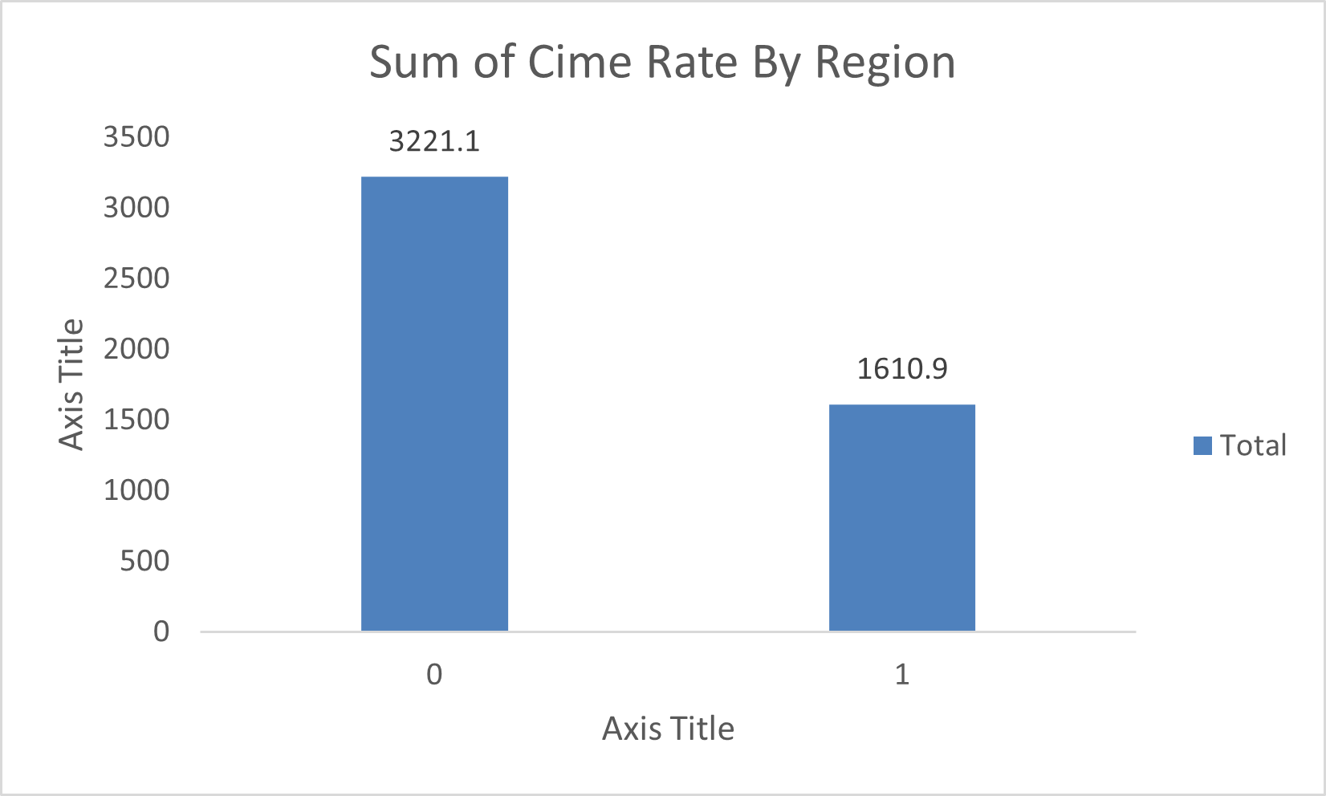
Picture 1 is a bar chart indicating the sum of crime rates by region. Since the crime rate represents the number of cases per million population, it is possible to sum the number unlike if it was a percentage. The analysis was calculated using a Pivot Table. A Pivot table is a Microsoft Excel tool that allows the manipulation of variables against each other (Stratvert, 2019). In this case, it was possible to use columns and rows, and crosstab values. The rows were labeled with the region, and the values represent the sum of the total crime rate. The coding for regions is that 0 represents Northern while 1 represents Southern. The bar chart indicates more crime in the north than in the south. In this case, a bar graph was chosen because it represents categorical data on the bars; the values of the bars themselves are from a continuous variable.
Picture 2. Sum of crime rate by a high unemployment rate
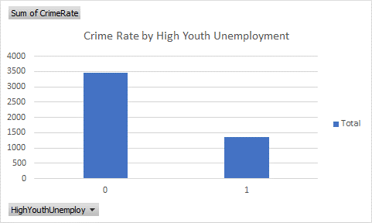

Picture 2 is also a bar graph representing the sum of the "crime rate" against the presence of high youth unemployment. The crosstabulation of the data was also obtained using a pivot table with the binary variable of youth unemployment. Intuitively, 0 represents a negation of the variable, while 1 represents a positive. Ironically, the data suggests that low youth unemployment contributes to a higher crime rate which could mean a mislabelling of the data.
Picture 3. Sum of crime rate vs. the presence of more males
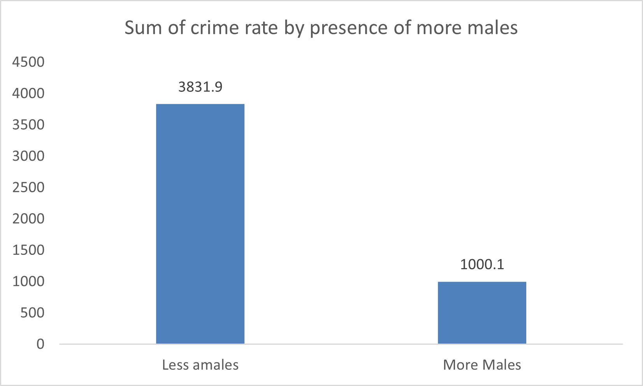

Picture 3 indicates the sum of crime rates by the presence of more males. Again, the coding was 0 and 1 for the variable "moreMales," which was interpreted to mean that "0" means fewer males while "1" is affirmative for more males. Once again, the graph indicates that more males result in less crime which is counterintuitive since one expects males to be more aggressive. However, there is a possibility that more males create a less vulnerable society leading to less crime.
VLOOKUP
VLOOKUP is one of the handiest excel formulas. It stands for vertical lookup and is used to query tabular data using values of specific columns. Excel currently has its horizontal equivalent called "XLOOKUP." The function works by performing a vertical check on the first column and returning a value in that particular row in the index number column (Gharani, 2017). The function can be used as a worksheet function in an excel cell. Unfortunately, the crime dataset has no primary key as a unique identifier. This problem was solved by having an autoincremented identity for every observation such that the first row received an ID number 1 while the last record received ID number 47.
A general-purpose table was developed that precludes the need to enter the ID values manually but instead selects them from a dropdown menu. This was achieved by using the data validation tool on the Data tab and selecting 'list,' and then choosing the column of IDs; this will be used as the variable for 'lookup value' in the VLOOKUP function. The following argument in the VLOOKUP function is the table array. The next argument on the function is col_index_num which would also be tedious to keep changing manually.
The columns are numbered, and a separate table is formed from column names and column numbers; this makes the column index dynamic. These are then transposed to create a column of row names and a column of column numbers. Next to the cell on IDs, the next cell will be filled with VLOOKUP and used to match a column number with the column name dynamically. All the arguments for the utility function are complete, and one can now have a third cell that returns the value of the VLOOKUP of the entire table with dynamic input of ID and column number. Picture 4 is a screenshot of the UI where the selected ID from the dropdown menu is 5, and the column value is 5, obtained by choosing its corresponding column name. The value obtained is 40, which is the value in the table. Picture 5 shows the result obtained by changing the column value to the crime rate.
Picture 4. Results of the VLOOKUP function
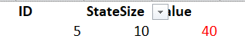

Picture 5. Results of the VLOOKUP function
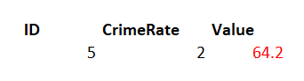

Index and Match
A more elegant option for the "VLOOKUP" function in excel is a combination of two different excel functions: Index and Match. "MATCH" is a function that returns the number of a row or column (Stratvert, 2021). The first step, just like in the previous section, is to add an ID column for the dataset because it was missing a unique primary key. This was achieved by having the first observation as ID number 1 and incrementing the IDs until the last record is ID 47. The next step is to construct an interface where one can select the column using a dropdown, match the exact number of the column, select the row through a dropdown, match the row number and then use these values to match the precise value of the query like coordinates.
Picture 6 indicates a simple UI created using index and match. The figure shows that the match function has indeed matched the crime rate as the first column; the dropdown can dynamically change this to a different column, automatically matching it to a different column number. In addition, the match column has also matched the row index of the first observation to 1, which can be changed dynamically by selecting a different ID number from the dropdown list. These row and column numbers are then fed as arguments into an index function with an exact match that shows the crime rate for the first observation is 45.5. Finally, Picture 7 indicates the values automatically generated by selecting BelowWage as the column name and row number 3.

Picture 6. Index and match table
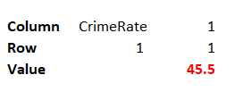
Picture 7. Index and match table
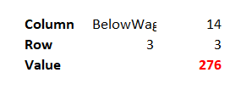

Charting the Crime rate based on a value
Excel has many ways of filtering values depending on a specific cut-off. This can be achieved through the GUI or particular functions. This section is intended to map out the crime rate below or above 100. The goal is to establish how many jurisdictions had a crime rate of over 100. The "COUNTIF" function was used with the condition of >=100 and the other of <100. The results are indicated in figure 8.
Picture 8. Zones where the crime rate is less than or greater than 100
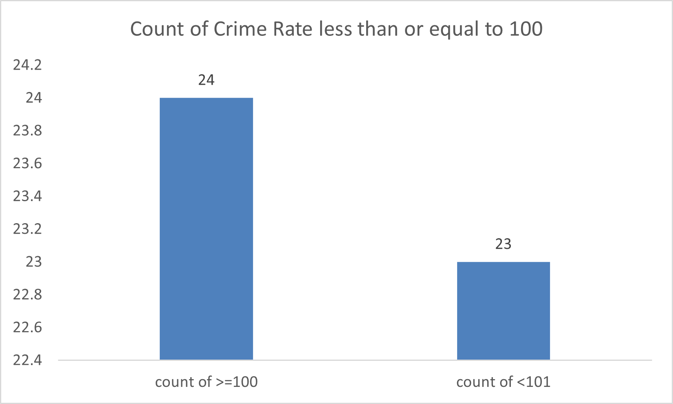
SUMIF
Excel has many functions that perform a mathematical operation based on a particular condition(s). In this section, the goal is to obtain the sum/average of males by region. There are two regions; Northern denoted by 0 and Southern denoted by 1. Many ways can get the sum by region in Excel, such as using the filter functionality and pivot table. However, in this section, the SUMIF/AVERAGEIF functions are used. The analysis shows that the sum of males in the Northern region is more than in the Southern. The information is consistent with Picture 1, which focused on the sum of crime rates by region. This indicates the probability of the Northern region being bigger sizewise.
Picture 9. Sum of males by region
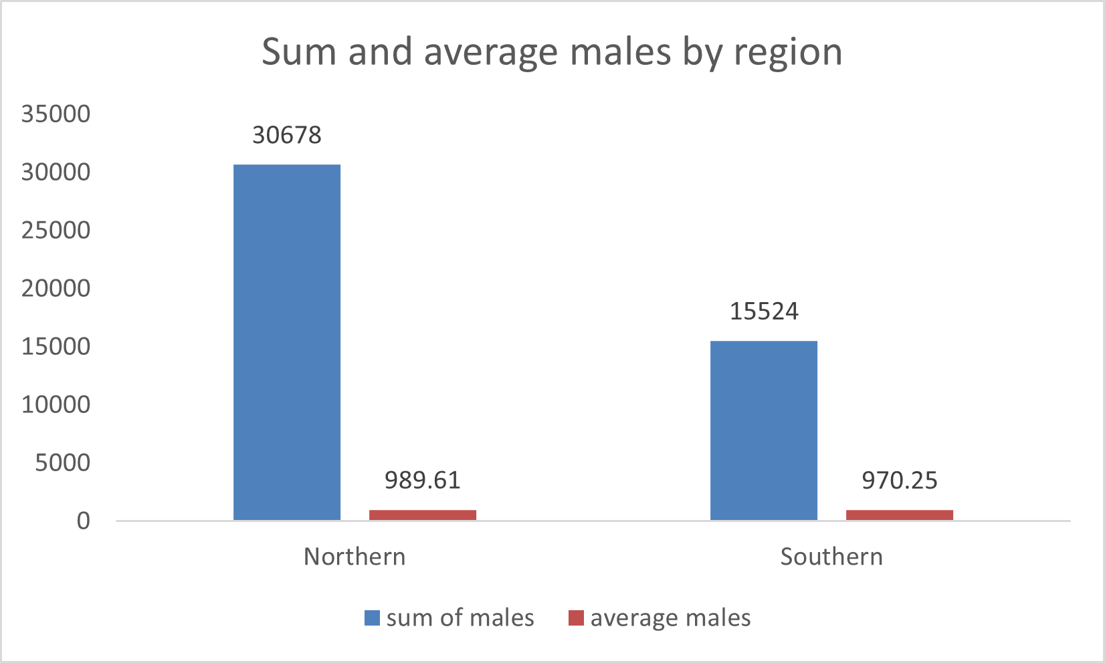

More Pivot Tables
VLOOKUP, INDEX, MATCH, AVERAGE, SUM, SUMIF, COUNTIF, and others are useful functions, but they are all aggregated into one overarching tool: pivot tables. Under pivot tables, one gets to select specific variables into rows and columns and get values from adding, aggregating, averaging, summing, and grouping them into bins. For example, Picture 10 represents a bar chart where the data has been generated from a pivot table. Bins are obtained by grouping the variable 'Wage' by intervals of 50. The values of the bars are generated by adjusting the value section of the pivot table from the default' count of' to average. This calculates the arithmetic mean of the crime rate. The result indicates no particular pattern emerging with a wage increase.
Picture 10. Average crime rate per wage group
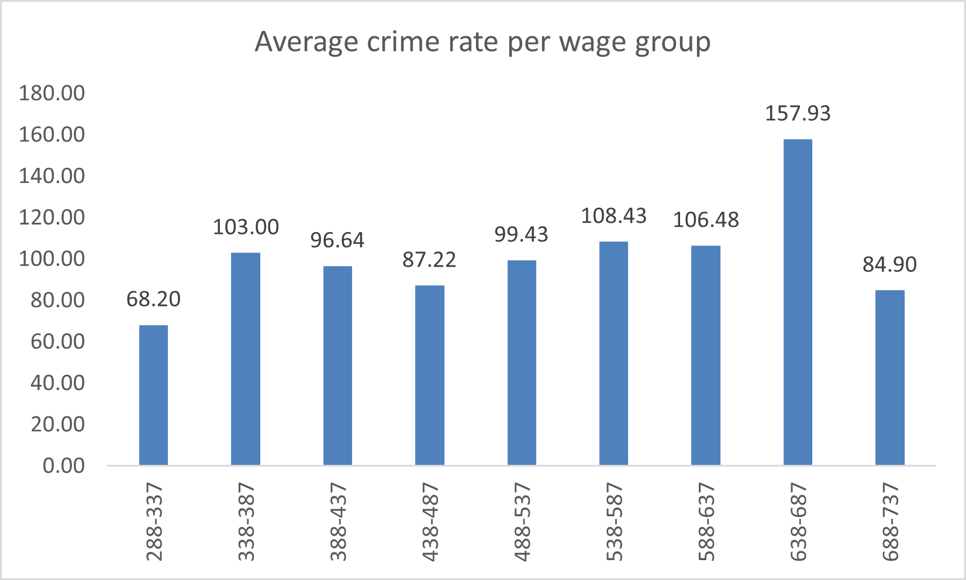

Analysis of Ice Cream Dataset Using IBM SPSS
After launching the IBM SPSS program, the first step is to head to the directory where the file is located and select the file (Figures 11 and 12). Since the file contained other text messages on the worksheet, these were deleted, and the data loaded. However, the categorical variables, female and ice cream, had not had their values added, as shown in figures 13 and 14. The values for "female" were 0 for "male" and 1 for "female." On the other hand, the values for ice cream were 1 for vanilla, 2 for chocolate, and 3 for strawberry.
Picture 11.
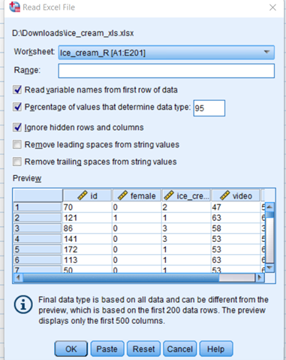

Picture 12.
Adding the categories
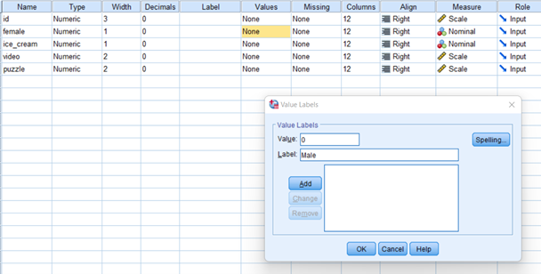
Picture 13.
Adding the categories
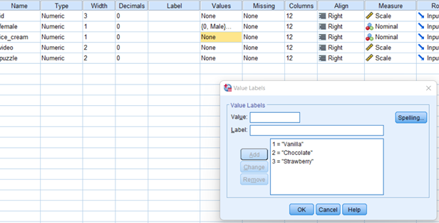

Table 1.
Summary Statistics
The table indicates the calculation results for finding the frequencies for the various categorical variables. Table 1 shows that the dataset had no missing records since all the shapes are the same. Table 2 indicates that for gender, 91 students were male while 109 were female. On the other hand, Table 3 shows the frequencies for the ice cream variable, where 95 students preferred vanilla, 47 preferred chocolate, and 58 preferred strawberry flavour. The next step involved getting the means and medians of the continuous variables video and puzzle. This involved selecting analyze tab, selecting compare means, and adding video and puzzle into the dependent box while adding ice_cream into layer 1 of 1, as shown in Picture 14. Finally, on the options, one has to select the statistics they need, such as median and mean in this case. After clicking Okay, the analysis results are in Table 4 and the charts in Picture 16
Statistics
 |  | female | ice_cream | video | puzzle | id
N | Valid | 200 | 200 | 200 | 200 | 200
N | Missing | 0 | 0 | 0 | 0 | 0

Table 2.
Frequency of the gender variable

female
 |  | Frequency | Percent | Valid Percent | Cumulative Percent
Valid | Male | 91 | 45.5 | 45.5 | 45.5
Valid | Female | 109 | 54.5 | 54.5 | 100.0
Valid | Total | 200 | 100.0 | 100.0
Table 3.
Frequency of the gender variable
ice_cream
 |  | Frequency | Percent | Valid Percent | Cumulative Percent
Valid | Vanilla | 95 | 47.5 | 47.5 | 47.5
Valid | Chocolate | 47 | 23.5 | 23.5 | 71.0
Valid | Strawberry | 58 | 29.0 | 29.0 | 100.0
Valid | Total | 200 | 100.0 | 100.0

Picture 14. Comparing means for the variables' puzzle' and 'video' grouped by categories.
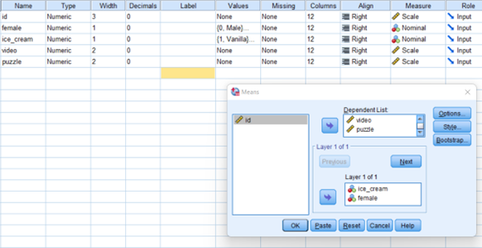
Picture 15. Comparing means for the variables' puzzle' and 'video' grouped by categories.
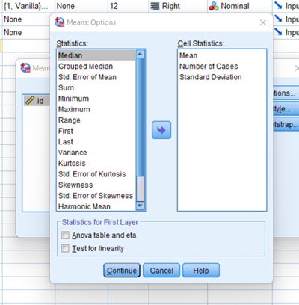
Table 4 . Comparing means for puzzle and video variable
Report
Chocolate | Mean | 47.70 | 47.32
Chocolate | Median | 47.00 | 46.00
Strawberry | Mean | 55.45 | 57.14
Strawberry | Median | 58.00 | 61.00

Picture 16. Means for the various icecream categories
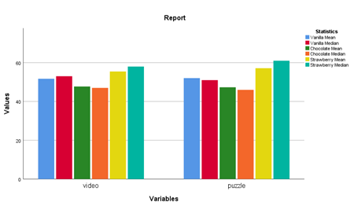

Clustering Using K-means Algorithm
The first step in performing the k-means algorithm in SPSS is standardizing the variables. The variables to be standardized are the continuous variables. This transforms the data to have a mean of zero and a standard deviation of 1. This is achieved by clicking analyze, then 'descriptives'; the window that appears gives the options to choose the variables, which are video and puzzle, and ensure to check the 'save standardized values as variables' box (Grande, 2015). This adds two variables to the variables columns: Zvideo and Zpuzzle.
Picture 17. Standardizing the variables
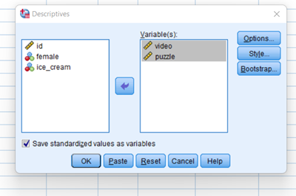
The next step is to classify the variables by clicking on the analyze tab, selecting "Classify" on the menu, and selecting the k-means cluster from the side menu. The window pops with the option to choose the variables to be analyzed, which in this case are the standardized variables obtained from step 1 labeled Zpuzzle and Zvideo. One should check 'Anova table,' and 'initial cluster centers on the options. It is also important to click on the save button that gives the option to check 'cluster membership.' This will add a column assigning each student to a specific cluster. The number of clusters selected was 3. After clicking okay and running the algorithm, the results of the ANOVA table indicated that both variables were significant in the clustering since they had a significance level of less than 0.05.
Picture 18. K-means clustering using SPSS
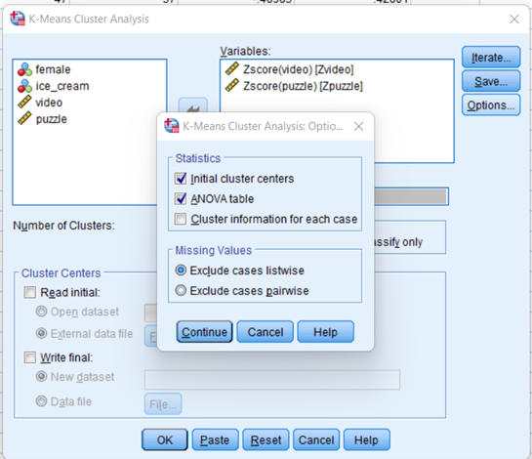

Table 5. Significance of the variables used in k-means clustering

ANOVA
 | Cluster |  | Error |  | F | Sig.
 | Mean Square | df | Mean Square | df | F | Sig.
Zscore(video) | 62.705 | 2 | .374 | 197 | 167.861 | .000
Zscore(puzzle) | 61.358 | 2 | .387 | 197 | 158.456 | .000
The F tests should be used only for descriptive purposes because the clusters have been chosen to maximize the differences among cases in different clusters. The observed significance levels are not corrected for this and thus cannot be interpreted as tests of the hypothesis that the cluster means are equal.

Data Mining and Text Mining Methods and Applications in Business
Text mining is the process of extracting meaningful information from text data in the form of a standard language. This data is generated from documents, email messages, files, and standard language text (Jo 2018). Text mining is also a multidisciplinary field that incorporates tools and methods such as information retrieval, data mining, statistics, machine learning, and computational linguistics. Natural language text can be stored in a structured and unstructured format. The process of text mining involves preprocessing, transformation, and application of methods.
Preprocessing involves steps such as cleanup, tokenization, stemming, filtering, lemmatization, and linguistic processing (Sun et al., 2018). On the other hand, transformation involves selecting features and generating more features. In feature generation, a document is reflected by words contained and word occurrence where word order is insignificant.
Text mining methods are the techniques used in classification, classification, and summarization. Term-based methods use words that are well-explained in the document. Under this method, an inspection of the document happens based on terms. On the other hand, phrase-based methods inspect documents based on phrases. The advantage of this method is that phrases are less ambiguous than individual terms. Under Concept-based methods, the conclusion of words occurs on document and sentence level and uses analysis of words and phrases. In the pattern taxonomy method, the analysis applies patterns such as association rule, frequent itemset, and closed pattern mining (Fellmann et al., 2019). Text mining has applications in business, such as in customer service, such as chatbots. Sentiment analysis is used to gauge the feedback of customers. In risk management, text analysis can be used to give information about industry trends through sentiment analysis.
Excel vs. SPSS
Excel and SPSS are both software programs; SPSS is a statistical program that stands for Statistical Package for Social Science, while Excel is a spreadsheet program developed by Microsoft (Stat Analytica, 2019). A separate company developed SPSS before it was acquired by IBM. SPSS is more of a statistical package applied primarily in research, while Excel has many applications from finance to medicine. Both are not open-source, and a license is required to operate, although there are student plans ("SPSS vs. EXCEL | Top 8 Significant Differences You Need to Know," 2018). Unsurprisingly, the license for SPSS is way more expensive than it is for excel which comes under the Microsoft office license.
SPSS | EXCEL
It is a tool specifically tailored for statistical analysis | It is a tool developed for data entry, manipulation, and storing of information
Performs statistical calculations as per IBM guidelines | Performs data storage and formulated operations as per Microsoft guidelines
Has the advantage of speed and performance | An advantage in reducing data redundancy
It is a statistical analysis software | It is a spreadsheet software
More powerful in statistical analysis | Less powerful in statistical analysis
One can perform more complex analytics such as logistic regression, neural networks | Less suited for advanced statistical work such as factor analysis and neural networks
In SPSS, every column represents one variable | Excel does not treat data that way

References:
- Fellmann, M., Koschmider, A., Laue, R., Schoknecht, A., & Vetter, A. (2019). Business process model patterns: State-of-the-art, research classification, and taxonomy. Business Process Management Journal, 25(5), 972–994
https://doi.org/10.1108/BPMJ-01-2018-0021
- Grande, G. (2015, September 22). K-Means cluster analysis in SPSS
https://www.youtube.com/watch?v=YRue69W-dYU
- Gharani, L. (2017, March 04). Excel VLOOKUP: Basics of VLOOKUP and HLOOKUP explained with examples
https://www.youtube.com/watch?v=E7gQ-PgYkMc
- Jo, T. (2018). Text mining: Concepts, implementation, and big data challenge. Springer Science+Business Media.
- K-Means Cluster Analysis in SPSS. (n.d.).
https://www.youtube.com/watch?v=YRue69W-dYU
- SPSS vs. EXCEL | Top 8 Significant Differences You Need To Know. (2018, May 19). EDUCBA.
https://www.educba.com/spss-vs-excel/
- Stat Analytica. (2019, July 8). SPSS vs. Excel: Which One Is The Best Tool For Statistics.
https://statanalytica.com/blog/spss-vs-excel/
- Stratvert, K. (2021, July 14). INDEX MATCH Excel Tutorial
YouTube. https://www.youtube.com/watch?v=6JhbY8Mku1A&t=667s
- Stratvert, K. (2019, May 21). Pivot Table Excel Tutorial
YouTube. https://www.youtube.com/watch?v=m0wI61ahfLc

