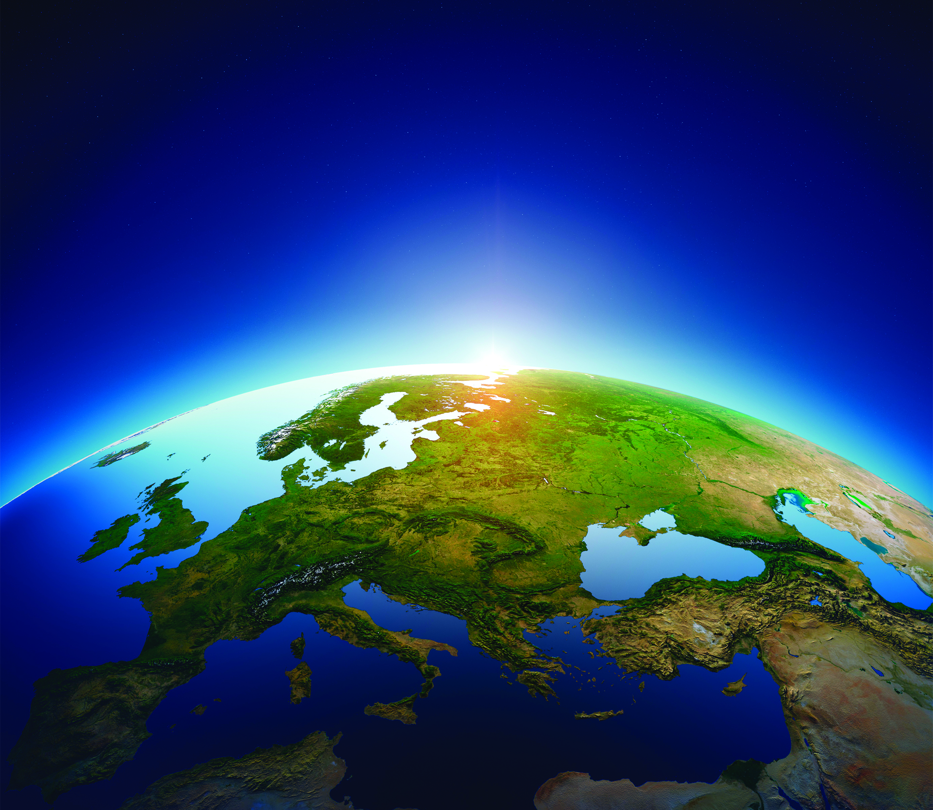
Written by: Julie Higgins

The Challenge of Sustainability

The Triple Bottom Line: Challenge or Opportunity?
The Triple Bottom Line: Challenge or Opportunity?

And so it Begins…
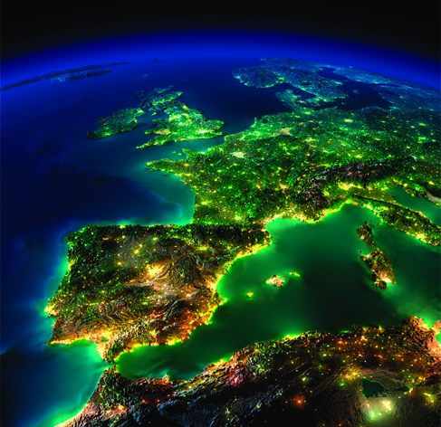
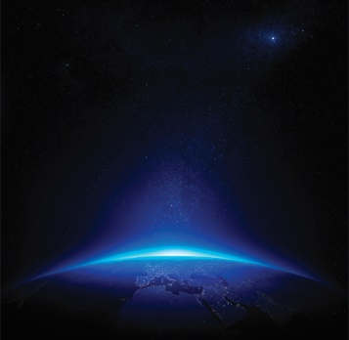
In 1994, John Elkington claims to have coined the term “Triple Bottom Line”. It is this precise term which was specifically chosen in order to resonate with business minds in particular, and to incorporate the 3Ps – People, Planet and Profits (Henriques, Richardson 2004) to the already existing definition of sustainability according to The Brundtland report: “development that meets the needs of the present world without compromising the ability of future generations to meet their own needs” (World Commission on Environment, and Development 1987). The world has higher expectations from businesses today, and it is no longer acceptable for a business to focus solely on their own prosperity and gains, and those that choose to continue with a „business as usual” strategy may not be able to sustain their customer base for many more years to come.

”Today we are in the midst of a rapid global transformation with increased demand on corporations to perform not only financially but to be good corporate citizens. One of the most important aspects of this transformation is the critical importance of Corporate Social Responsibility (CSR) programs. Climate change; community health, education and development; and business sustainability are some of the most pressing issues of our time”(Sherman 2012). Making a shift from „business as usual” to achieving this triple bottom line presents numerous challenges, and in various degrees within each industry, yet perhaps one challenge which every business faces, regardless of which industry it falls under, is either retaining or building trust from the consumer or client themself in this shift towards a higher demand for sustainable practices. After all, what is a business without a customer base?

Trust: just another 4 letter word?
A relatively small word, yet hidden within these 4 letters lies a huge implication for every business and its future success. A crucial link between an organization and the consumer is trust (Dirks, Lewicki et al. 2009). It would be of importance at this stage to analyze the current state of trust from the consumer perspective. According to research conducted by Accenture: 10 out of 15 industries experienced a decline in trust in 2017(Long, Roark et al. 2018).
Is that a once-off drop, or is there more to this decrease in consumer trust? In order for a company to have continued success in the future, is a trusting customer base a necessity? According to the Edelman Trust Barometer of 2019, of the 33000 individuals surveyed, the need for trust in companies is apparent: a staggering 81% selected this statement “I must be able to trust the brand to do what is right” as a deal-breaker or deciding factor when it comes to their brand buying decision. Yet only 1 in 3 (34%) can trust most of the brands they buy (Edelman 2019a). These findings from the 2019 Trust Barometer report indicate an increasing need from the customer to be able to trust companies when it comes to their CSR approach, yet at the same time, find it increasingly difficult to grant this trust.
The Social Media Effect
The emergence and rapid growth of the social media phenomenon now enables anyone, provided they have access to the internet, to research prior to any purchase as well as to communicate with thousands of other potential or existing consumers about any product, brand or service which any company provides. “A company’s behaviors and actions have an immediate impact on reputation because they can now be shared virally, universally—and instantly” (Long, Roark et al. 2018).

“The digital era has fundamentally shifted assumptions for how individuals will do business and engage with companies. Once trust has been lost, it’s nearly impossible for brands to rebuild sustainable, honest relationships with their customers”
Kevin Cochrane, Chief Marketing Officer at SAP (2018).

“It takes 20 years to build a reputation and five minutes to ruin it. If you think about that, you'll do things differently.” Warren Buffet - chairman and CEO of Berkshire Hathaway

This now means that marketing has evolved into a two-way form of communication, whereby companies communicate to the consumer, and the consumers have access not only to the company, however also to other consumers with an instantaneous channel to voice opinions and personal experience of any organization and its product (Pourkhani, Kh. Abdipour et al. 2019). Gone are the days of traditional one-way advertising, where a company could transfer their chosen message to the masses, without any fear of public rebuttal from the consumer. Company reputation is no longer purely under their own control, the power of knowledge has shifted and lies in the hands of the consumer. This does, however, lead to the possibility of information overload for the consumer, who has access to endless amounts of nonfactual personal reviews and opinions about any single product or service, which may result in doubt and confusion when determining which product or service is a viable choice and aligned with their own moral code.
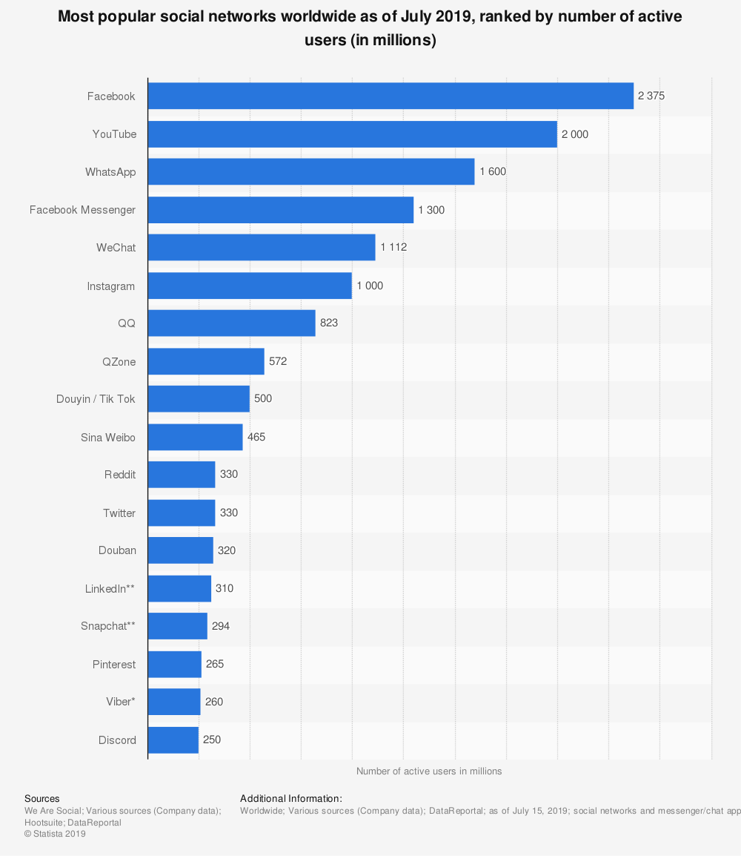
Diagram 1

There are approximately 2 billion internet users who use social media today, and this figure is still on the rise (Statista 2019). Diagram 1 represents the most used Social Media channels and their relative amount of users as of July 2019 (Clement 2019). This diagram shows the exponential growth Social Media has achieved since its inception approximately 16 years ago, and which does not yet show signs of stopping.

If we look at the US population alone, 48,2% of the Baby Boomers generation are social media users, compared with an impressive 90,4% of the Millennial generation population who are active on social media channels (eMarketer 2019). This is an important indicator of times to come and the rise of future generations, and the ever-increasing importance of social media and its potential impact on business and consumer relations. The impact of social media on an organization should not be seen as a threat to the business itself, but rather as an opportunity to build long term relationships based on trust, and as a significant and valuable interactive tool to engage with the customer and gain a better understanding of the customer’s needs, resulting in a mutually beneficial relationship for the organization and for the customer (Jones 2003).
“In Brands We Trust”

According to an aptly entitled special report released by Edelman, consumers do not currently appear to be convinced of a brand's commitment to society. In their survey conducted on 25500 consumers, findings were that:

56% of those surveyed felt that too many brands use societal issues as a marketing ploy to sell more of their product, and 67% agreed with the statement “A good reputation may get me to try a product, but unless I come to trust the company behind the product, I will soon stop buying it” (Edelman 2019b).

“Trust changes depending on the experience and outcomes of the actions and interactions and other events taking place over time in the focal as well as in connected relations.” (Huang, Wilkinson 2013) If an organization handles customer posts with due caution and professionalism, ensuring they show respect to the expectations and sentiments posted by the consumer, they can, in fact, increase the level of trust (Ahearne 2007).
Research has shown that social media offers a platform for engagement to both existing and potential customers, allowing for expression, and thereby resulting in the increased trust from their side towards the product, service or organization (Singhal 2016).

Reputation is Key
As we know well, businesses are now under continuous scrutiny and held accountable for how their operations impact the natural environment and societies (D'Amato, Henderson et al. 2009). Natura’s CEO João Paulo Ferreira says, “If at any point, consumers learn that a company or brand cannot be trusted, those brands will be heavily damaged.”(Winston 2019)

When a company makes a claim regarding its own CSR approach or product alignments, such as recycled goods, organic ingredients or fairly paid employees, the consumer suffers from an informational disadvantage due to their inability to verify or confirm the corporate claims of being green (Lyon 2013). It is due to this perceived disadvantage, that skepticism towards companies and their brands arises in the consumer. It has become harder for companies to be able to achieve or maintain trust purely on own merit. The consumer has reasonable doubts as to which companies claims can be trusted, and which cannot. Fair or not, the term „greenwashing” has a lot to do with it.

“Green∙wash
(gren’wosh’,-wôsh’) – verb: the act of misleading consumers regarding the environmental practices of a company or the environmental benefits of a product or service.” (Terrachoice 2010)

Due to certain companies' purposeful efforts in greenwashing being exposed as a sham, companies such as Volkswagen with their infamous emissions scandal, for example, have done a lot of damage in terms of general corporate reputation when it comes to sustainability and trust (Ottman 2011). These revealed scandals may even amount to the consumer not believing in actual green implementations by companies who announce it themselves (Chen 2013). Care needs to be taken in how a company approaches its CSR communications and reporting as a whole, ensuring it is not communicated solely as a marketing ploy, but based on credible measurements and factual evidence.
The rise of social media has played a large role until now in exposing companies who have used greenwashing tactics to enhance their image of sustainability in the eye of the consumer. That being said, that then implies determining which product or service is a viable choice and aligned with their own moral code. that social media plays a role in the decreasing trust of companies in general today. As green claims rise year by year in the form of advertising, so too does the consumers skepticism (Lyon 2013). In the recently released documentary, "The Green Lie”, Werner Boote and environmental expert Kathrin Hartmann investigate and call into question several claims from various corporations and the validity of their "green” products (2018) It is productions such as these which further fuel consumer doubt regarding companies approach to sustainability and their honesty towards the consumer.

The Triple Bottom Line: Challenge or Opportunity?
The need for Transparency

So how can businesses restore trust? According to Rachel Botsman, you should rather be asking the question “how do we become more trustworthy? “(Muldowney 2018).

The solution here is actually quite simple, and goes back to the age-old saying of „honesty is the best policy”. Transparency is an essential condition of a company's CSR strategy, not only for the benefit of the customer, however also to increase accountability within the firm. There are both economic and moral benefits that come with increased transparency. Economically speaking, in looking with honesty at the current CSR level, it allows for further and continuous innovation in companys current processes and output, relevant to their future CSR goals. It allows companies who are performing well in sustainable standards to distinguish themselves from those who do not, thereby creating a competitive edge, and transfers the incentive of product and process innovation to one of social and environmental focus. Morally, by communicating honestly to the consumer, you are supplying them with the information which they have every right to have, making it possible for them to confront a company who is not aligned with CSR expectations (Dubbink, Graafland et al. 2008).

The people have spoken

A company can ensure the longevity of consumer trust by allowing modern-day technology such as social media to work for them, instead of against them, and transparency is a key condition to abide by.

Once trust has been built by a brand or company with the consumer, they will be rewarded in the longer term: 53% would buy first from a brand that they have trusted for a long time. 62% would remain loyal (so long as conditions remained consistent). 51% would be advocates of the brand/company and 43% would even defend them if a situation arose (Edelman 2019).

The building of trust and long-lasting relationships with the consumer are essential to the success of any organization, including your own. Nurturing a relationship of trust with your consumer leads the way to a sustainable future for your company, and allows for companies and consumers to work together as a joint force with a common goal, achieving the Triple Bottom Line, for the sake of profit, our Planet, and its people.

Bibliography

AHEARNE, M., 2007. Why sales reps should welcome information technology: Measuring the impact of CRM-based IT on sales effectiveness. International Journal of Research in Marketing, 24(4), pp. 336-350.
CHEN, Y., 2013. Greenwash and Green Trust: The Mediation Effects of Green Consumer Confusion and Green Perceived Risk. Journal of Business Ethics, 114(3), pp. 489-501.
CLEMENT, J., 2019-last update, Global social media ranking 2019. Available: https://www.statista.com/statistics/272014/global-social-networks-ranked-by-number-of-users/ [Nov 9, 2019].
COCHRANE, K., -06-13T13:30:57Z, 2018-last update, To Regain Consumers’ Trust, Marketers Need Transparent Data Practices [Homepage of Harvard Business Review], [Online]. Available: https://hbr.org/2018/06/to-regain-consumers-trust-marketers-need-transparent-data-practices [Nov 6, 2019].
D'AMATO, A., HENDERSON, S. and FLORENCE, S., 2009. Corporate Social Responsibility and Sustainable Business : A Guide to Leadership Tasks and Functions. Greensboro: Center for Creative Leadership.
DIRKS, K.T., LEWICKI, R.J. and ZAHEER, A., 2009. Reparing relationships within and between organizations: building a conceptual foundation. Academy of Management Review, 34(1), pp. 68-84.
DUBBINK, W., GRAAFLAND, J. and VAN LIEDEKERKE, L., 2008. CSR, transparency and the role of intermediate organisations. Journal of Business Ethics, 82(2), pp. 391-406.
EDELMAN, 2019a-last update, 2019 Edelman Trust Barometer. Available: https://www.edelman.com/trust-barometer [Nov 5, 2019].
EDELMAN, 2019b-last update, Edelman Trust Barometer Special Report: In Brands We Trust?. Available: https://www.edelman.com/research/trust-barometer-special-report-in-brands-we-trust [Nov 3, 2019].
EMARKETER, 2019-last update, US Social Media Users, by Generation, 2019 (% of population). Available: https://www.emarketer.com/chart/226029/us-social-media-users-by-generation-2019-of-population [Nov 6, 2019].
HENRIQUES, A. and RICHARDSON, J., 2004. The triple bottom line, does it all add up? assessing the sustainability of business and CSR. London; Sterling, VA: London; Sterling, VA : Earthscan Publications.
HUANG, Y. and WILKINSON, I.F., 2013. The dynamics and evolution of trust in business relationships. Industrial Marketing Management, 42(3), pp. 455-465.
JONES, E., 2003. Firm market orientation and salesperson customer orientation: interpersonal and intrapersonal influences on customer service and retention in business-to-business buyer–seller relationships. Journal of Business Research, 56(4), pp. 323-341.
LONG, J., ROARK, C. and THEOFILOU, B., 2018-last update, Using Competitive Agility Index to Measure Trust in Business | Accenture. Available: https://www.accenture.com/sa-en/insights/strategy/trust-in-business [Nov 3, 2019].
LYON, T.P., 2013. Tweetjacked: The Impact of Social Media on Corporate Greenwash. Journal of Business Ethics, 118(4), pp. 747-758.
MULDOWNEY, S., 2018. Who can you trust? Recent high-profile corporate scandals have seen business trust take a further dive. How can this fragile commodity be restored? (cover story). Acuity, 5(2), pp. 26-32.
OTTMAN, J., 2011. The New Rules of Green Marketing. US: Berrett-Koehler Publishers.
POURKHANI, A., KH. ABDIPOUR, BAHER, B. and MOSLEHPOUR, M., 2019. The impact of social media in business growth and performance: A scientometrics analysis. International Journal of Data and Network Science, 3(3), pp. 223-244.
SINGHAL, T.K., 2016. Impact of Social Media Expressions on Engagement and Trust of Customers. Amity Business Review, 17(2), pp. 96-100.
STATISTA, 2019-last update, Global social media ranking 2019. Available: https://www.statista.com/statistics/272014/global-social-networks-ranked-by-number-of-users/ [Nov 6, 2019].
TERRACHOICE, 2010-last update, The Sins of Greenwashing: Home and Family Edition. Available: http://sinsofgreenwashing.com/ [Nov 6, 2019].
WINSTON, A., -09-24T12:05:17Z, 2019-last update, What 1,000 CEOs Really Think About Climate Change and Inequality. Available: https://hbr.org/2019/09/what-1000-ceos-really-think-about-climate-change-and-inequality [Nov 6, 2019].
WORLD COMMISSION ON ENVIRONMENT, AND DEVELOPMENT, 1987. Our common future. Oxford: Oxford : Oxford University Press.

