Appendix 1- Lesson observation.
Appendices.
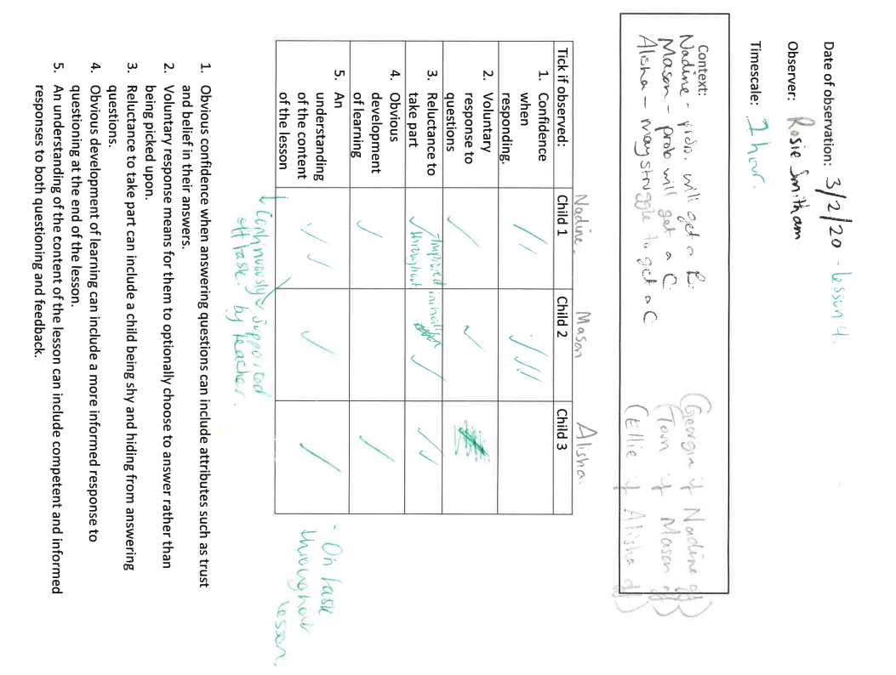

Appendix 2 – Second lesson observation.

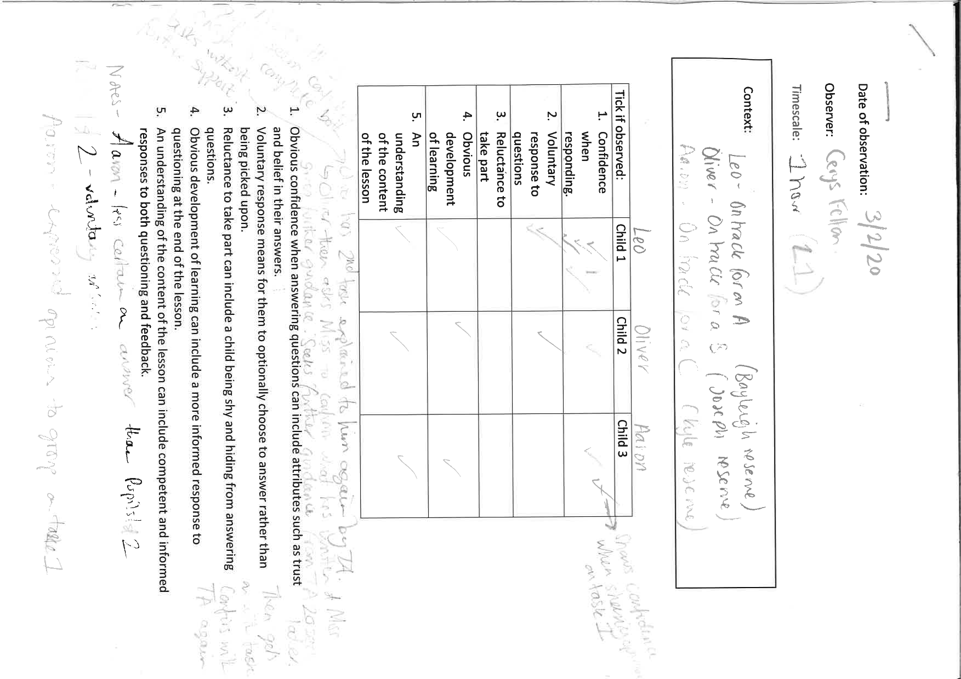

Appendix 3 – Lesson reflection.
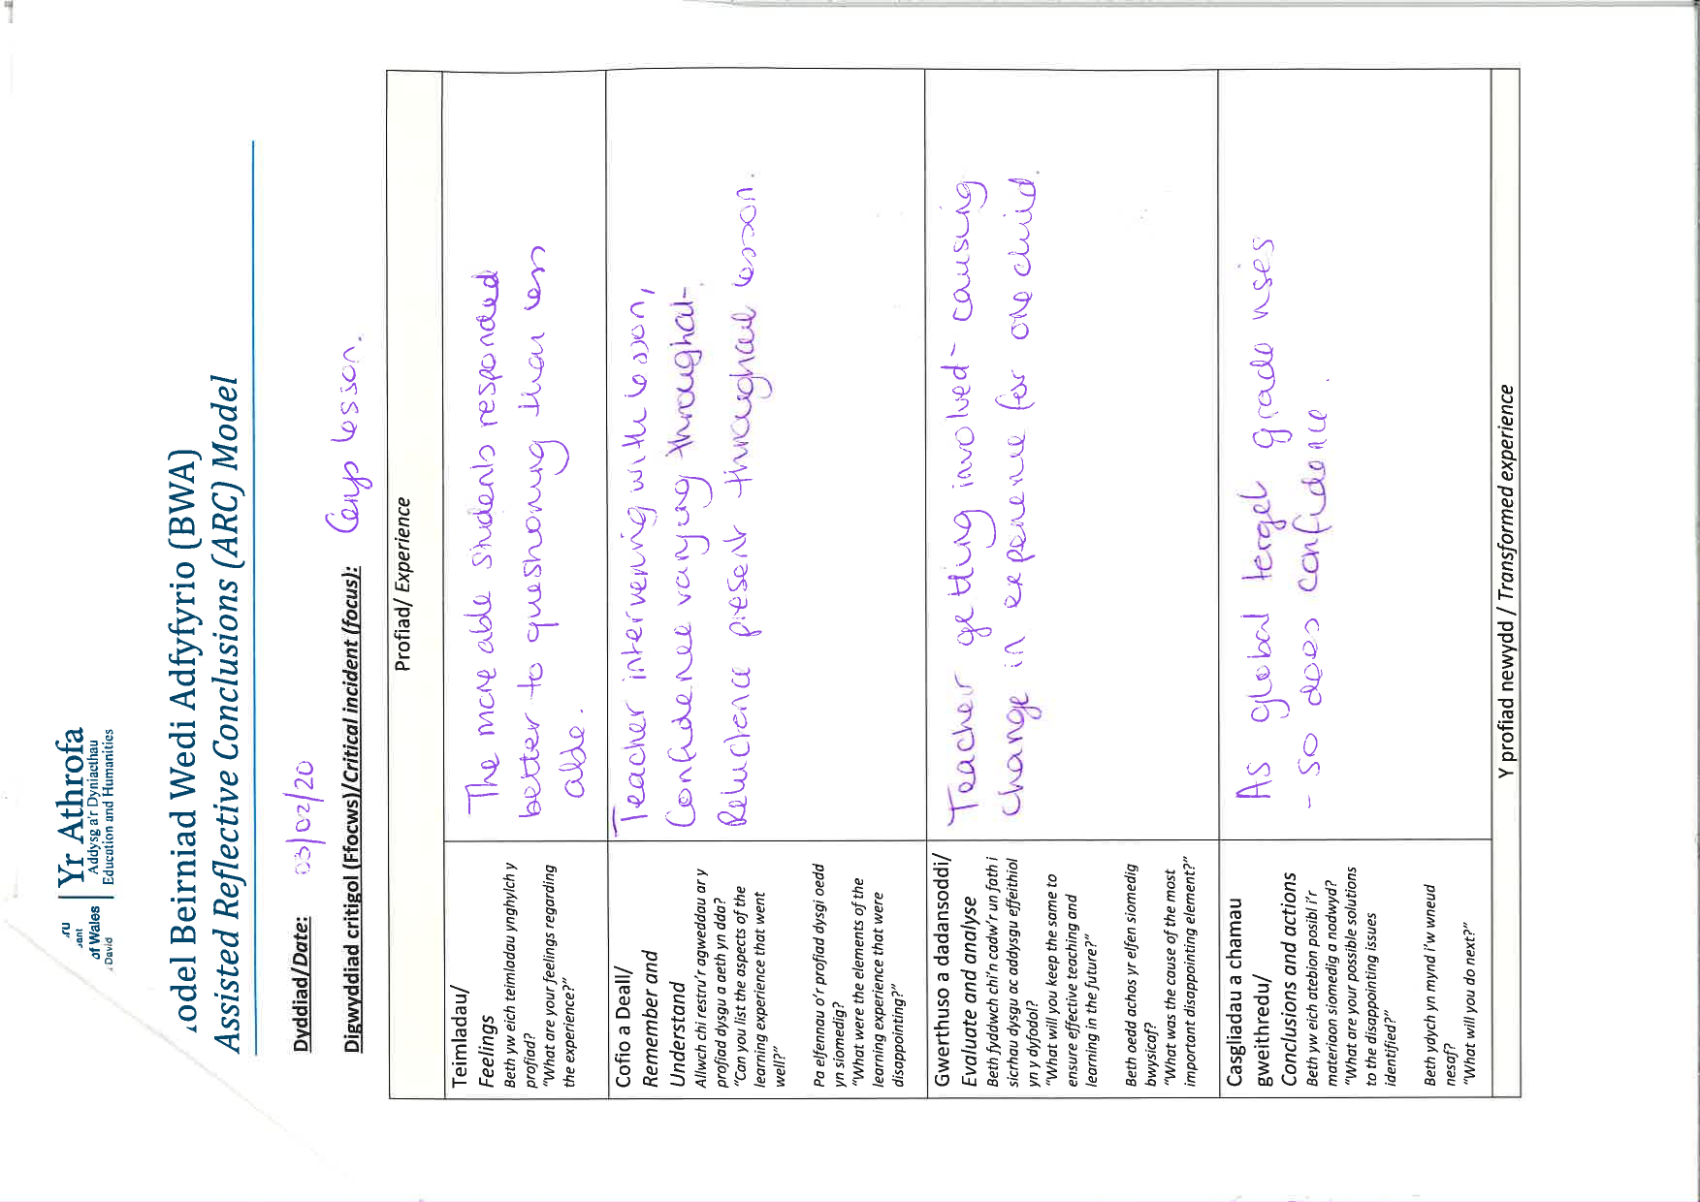

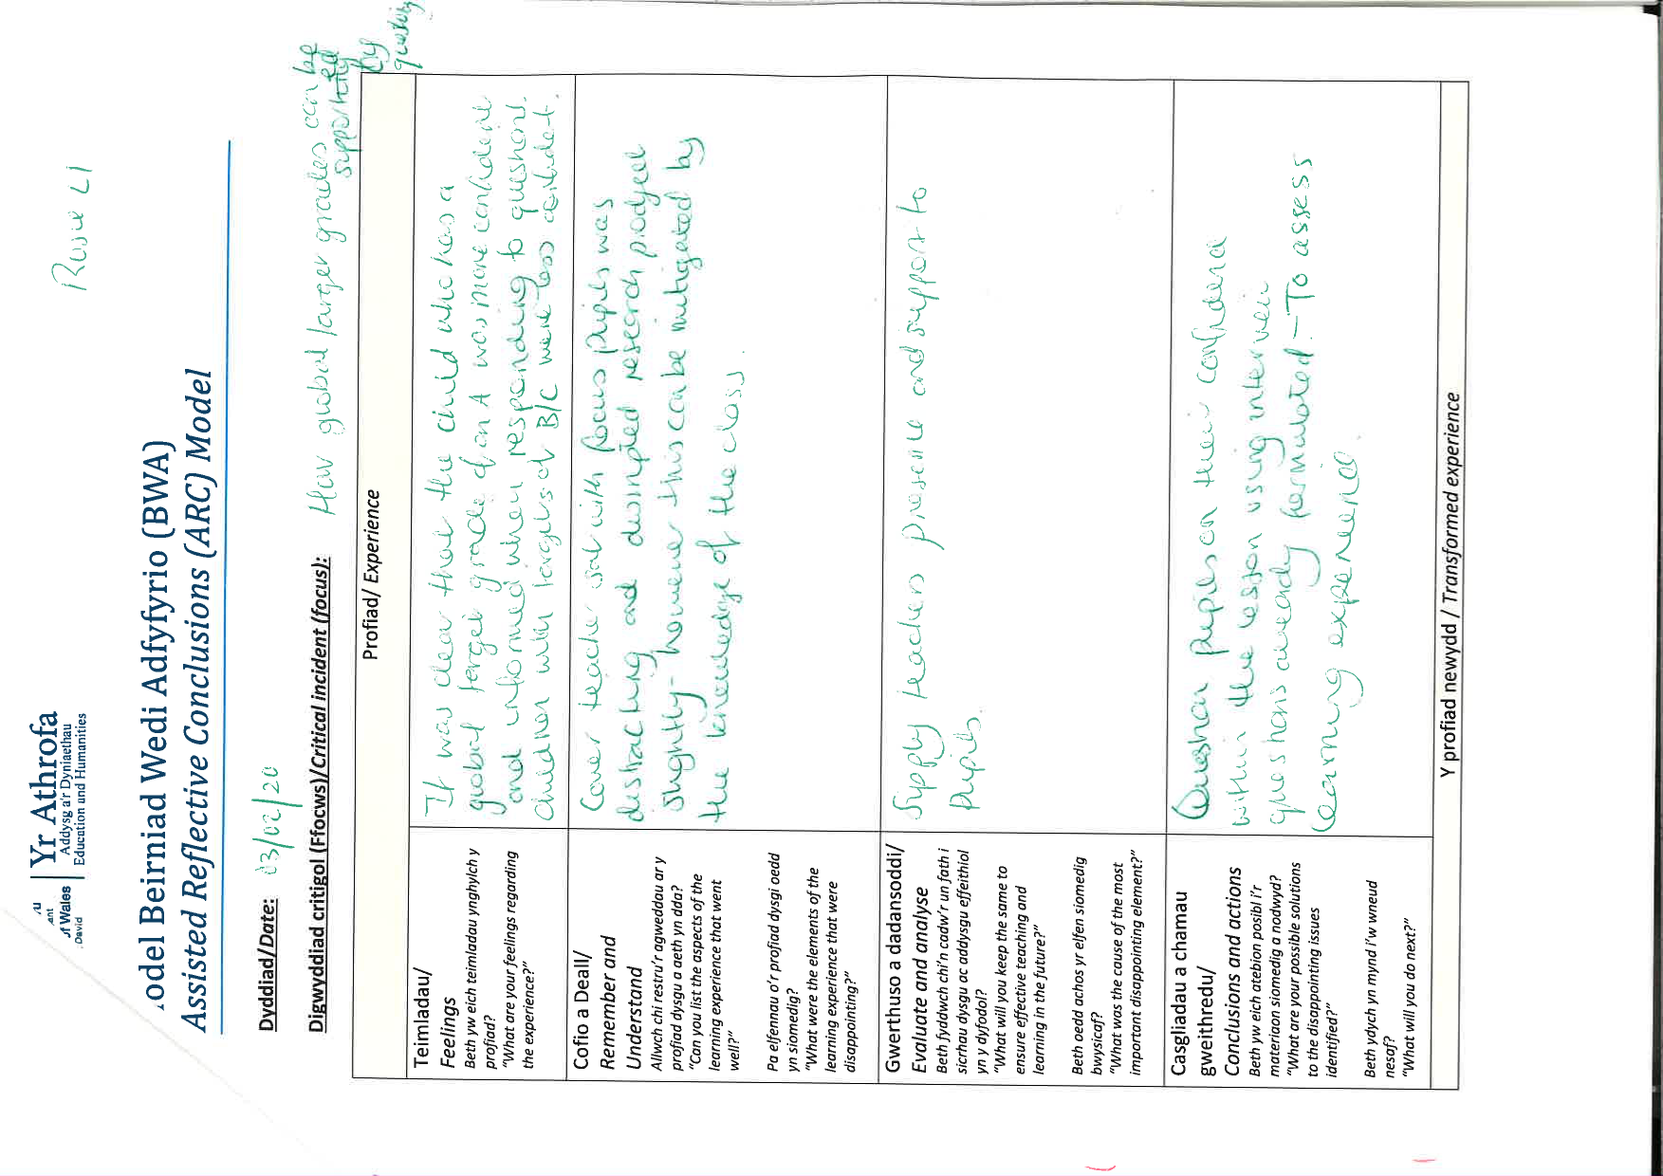
Appendix 4 – Second Lesson reflection.

Appendix 5 – Focus group interview 1.

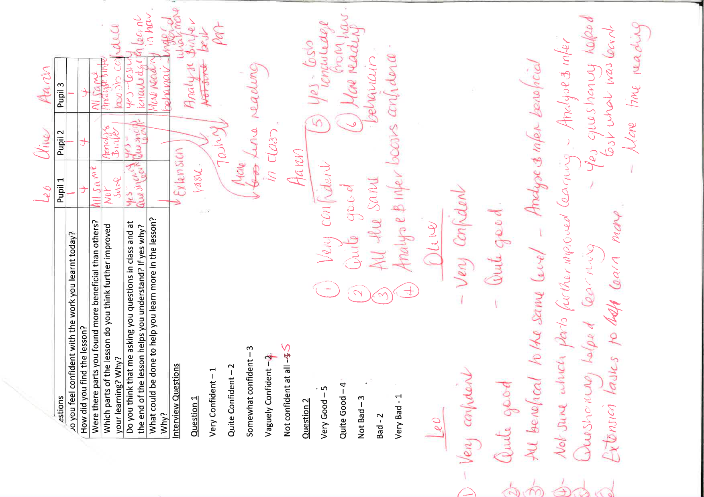

Appendix 6

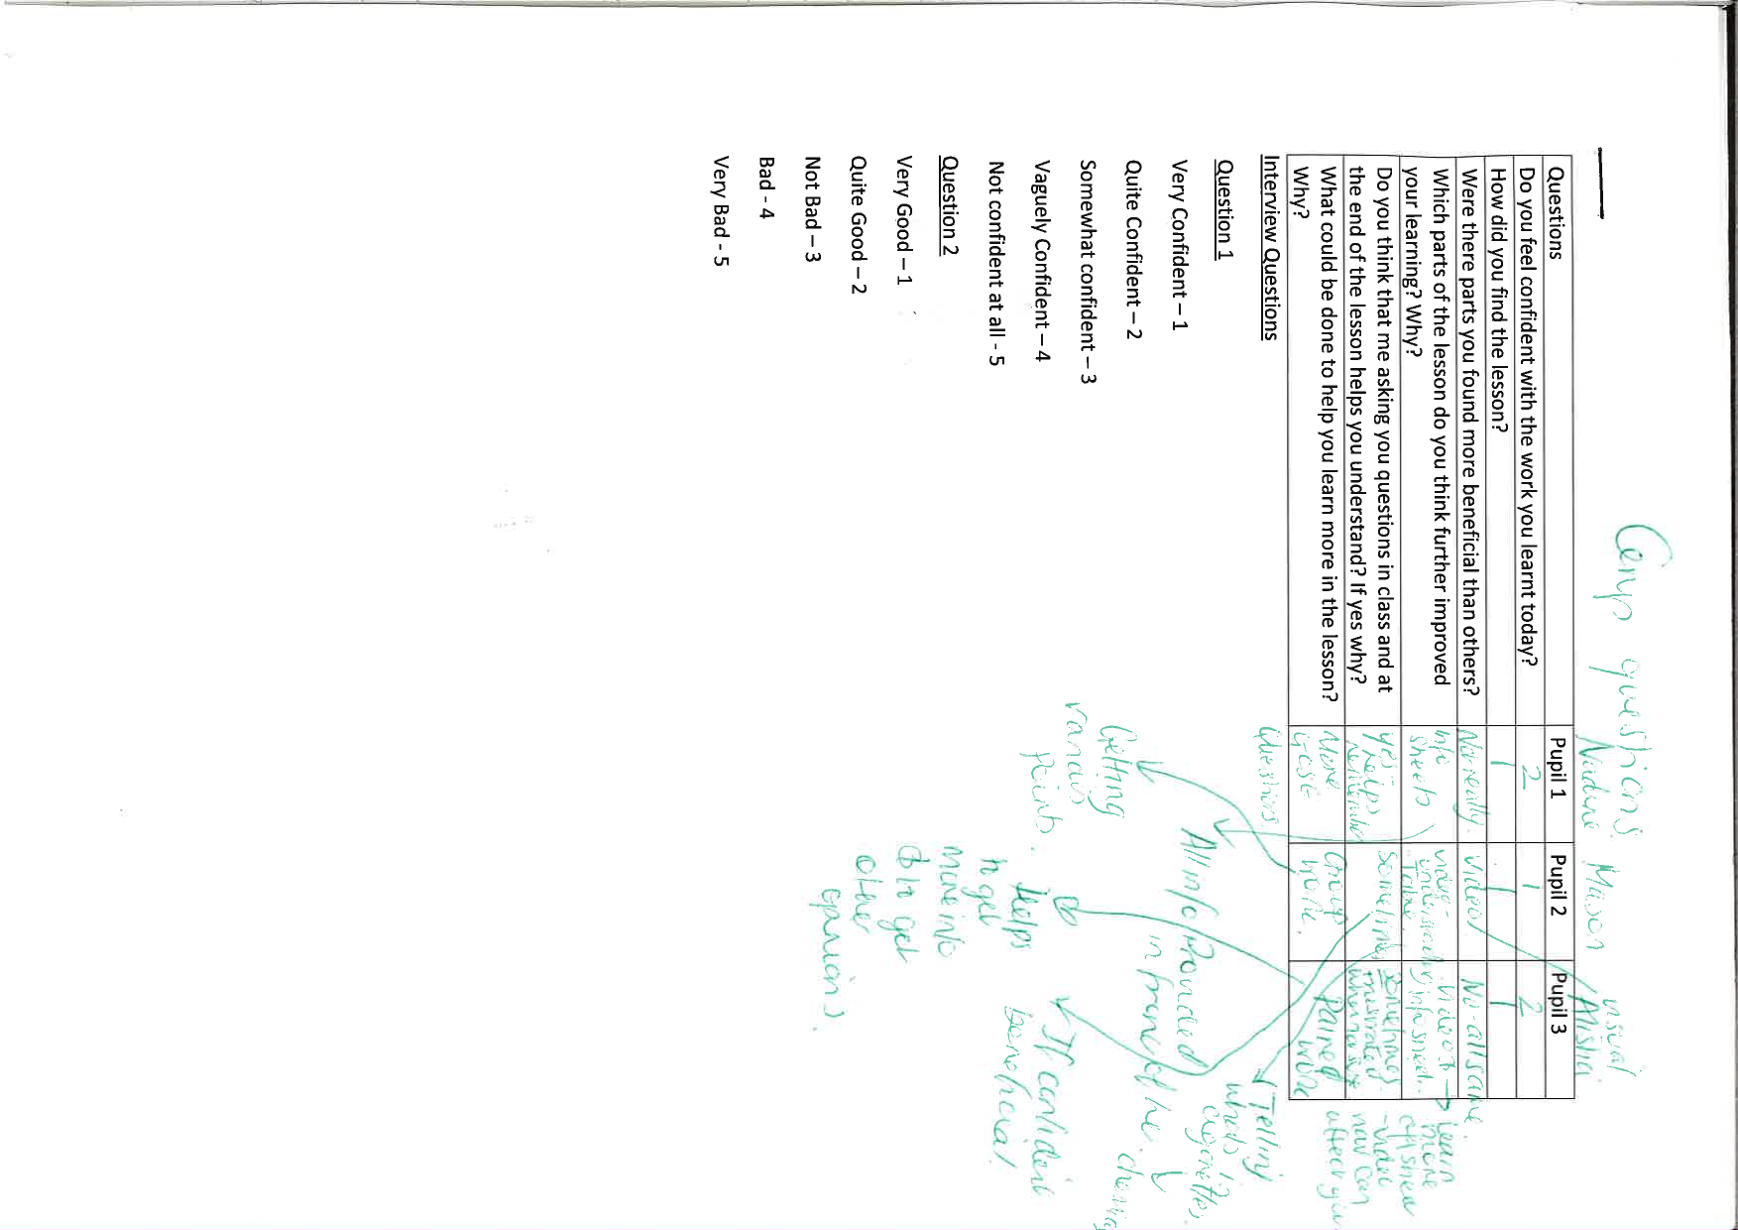
Appendix 6 – Focus group interview 2.

Appendix 7 – Consent form.



