MSc Digital Skills for Health and Care Professionals
BMDS7006

Programme improvement project

Table of contents

Page number | Content
2 | Introduction
3 | Justification
5 | Purpose statement & Method
6 | FITT Framework diagram
8 | Discussion
9 | Data collection & analysis
10 | Project plan table
16 | User feedback charts/tables
19 | Conclusion
21 | Future improvement project
22 | Reference list
22 | Appendix

Programme Improvement Project
Introduction
Welsh Ambulance Service NHS Trust (WAST) employees are supported by a small Occupational Health and Wellbeing (OH&W) service established in 2012 (Wellbeing) and 2013 (OH). In response to a review of sickness absence levels carried out by WAST in 2013 a bid was submitted to fund an Occupational Health service with the aim of reducing long term sickness absence within the trust. A Wellbeing service had already been set up to provide telephone support for any staff member reporting sick, however, ultimately this did not reduce long term sickness absence levels. The Trust’s aim was to have an Occupational Health service that was of high quality, equitable, standardised, affordable and easily accessible within a reasonable timeframe for all.
The Trust wide sickness target for 2013/14 was at 5.62% The Service Delivery Directorate, which manages the majority of staff, was identified as having the highest cumulative sickness absence rate for the period October 2012 to September 2013 and for the month of September 2013. The table below identifies the % absence rate for the different staff groups within the directorate. This is an overall level of just below 7%.
 | 12-month Cumulative | September 2013
Paramedics | 8.35% | 7.94%
Paramedic Practitioner | 3.54% | 2.43%
EMT | 9.65% | 7.18%
UCA | 7.57% | 8.03%
PCS | 9.22% | 8.88%

The estimated cost of sickness absence for service delivery for the 12-month period ending Sept 2013 was £ 5,324,383 [ Data from Strat Plan Report – November 2013]
WAST's internal service went live on November 4th 2013 with the addition of telephone-based consultations for sick leave. To handle sick leave, though, this was a reactive strategy. Adopting purely reactive approaches to address the problem was insufficient given the high rates of sickness absence across the Trust. The direct costs and resulting effect on service delivery provided a strong argument for taking action to enhance our employees' health and wellbeing.
While spending on worker health is sometimes viewed as a poor use of limited resources, there is evidence to suggest that services will more than pay for themselves through reduced absenteeism and other costs, according to Dame Black (2008) and Dr S Boorman (2009).
Everyone agrees that as our workforce ages, there is a chance that some of our workers may not be in good enough condition to carry out their jobs safely. It is acknowledged that those over 45 have a higher chance of developing chronic diseases and musculoskeletal conditions. It might be argued that providing preventative health care throughout employment can lessen the possibility of workers leaving their jobs early due to illness (Vaughan-Jones and Barham 2009).
The purpose of the service was to
- Promote early intervention to address the reasons for employee absences and aid in the recovery of employees returning to work following illness Conduct health evaluations and interventions to assist maintaining work-related fitness and to encourage healthy lifestyle choices.
- Use compiled data to identify health hazards and focus on activities to stop illnesses brought on or made worse by work.
- By lowering sick leave and helping an ageing staff to remain fit enough to work longer.
Achievement will assist to protect and sustain the delivery of front-line services.
Provided within this service are sickness absence consultations, immunisations, pre-employment checks and wellbeing support amongst other things. In order for the service to record information electronically, any contacts or results of medical checks and to maintain confidentiality in accordance with GDPR and WAST’s own information governance policies, a new updated software programme was required.
Justification
A business case submission was made which outlined the needs of the service and the requirements of a digital software package. The business case provided a number of recommendations for the OH&W service one of which was the procurement of a digital solution for electronically storing and maintaining staff health records.
Option 1: Do nothing.
The previous system of record keeping and data analysis required significant administration including setting up employee folders and sub folders on a computer desktop. The data held in an employee’s folders was not readily accessible and there were difficulties cross referencing different episodes of activity.
There was a risk that employee records might be misplaced in another employee’s folder
The system had limited capacity to store too large a number of files and would be totally unwieldy once this number escalated.
Recommendation:
A fit for purpose database was required to enable the efficient, effective and safe management of employee health records.

Option 2: Develop a database in house
This was a time and resource intensive process and the end result would require suitable and sufficient piloting to ensure that it was fit for purpose and user friendly.
The system would not be compatible with the one used in the LHBs, thereby creating unnecessary difficulties with the transfer of staff health information, interoperability would not be achieved. It is estimated that the cost of this work would exceed £6K
Recommendation:
The development of an in-house database was discounted due to the immediacy of the requirements for a robust OH database and record management system.

Option 3: Purchase COHORT Occupational Health Software
The software’s core modules enabled the following employee information to be managed:
- Pre-employment
- Management referrals and sickness absence
- Health surveillance
- Immunisation and recall
- Sharps injuries
The software:
- enabled appointment management and generation of standard letters.
- provided health surveillance questionnaires that had been designed in conjunction with the Faculty of Occupational Medicine and the HSE so there was no requirement to design questionnaires in-house
- allowed data to be uploaded from occupational health tests performed on regulation screening equipment (such as spirometry and audiometry)
- analysed data to provide reports to assist in monitoring the performance of the service and health trends.
- supported the requirements for accreditation of the Occupational Health Service.
An optional module provided support for voluntary health screening assessment and stress risk management.
COHORT (Cority) provides software ongoing support as part of its package and would undertake the training for users.
As all Local Health Boards (LHBs) were using COHORT it would make it possible to transfer our employees’ health records from the LHBs to WAST, with the appropriate consent and WASPI agreements.
Recommendation: To meet the essential requirement of the occupational health service for a safe, secure and effective information management system, the purchase of COHORT (v9) software was recommended.
Following the recommendations of the business case and with approval from the Executive Team and Regional Director.

Purpose statement
The purpose of this paper was to analyse the advantages and disadvantages of implementing a new software programme for management and sharing of OH&W employee medical records. Contributing to improving interoperability between WAST and LHB’s and also to reduce the workload of the OH&W staff saving time and money in the long term. It was important to consider the appropriate approach to implementing change and any barriers or opportunities that may arise during the project.
Methods
There are two well-known theories that offer various ways to examine the idea of fit between technology and work practises these are the Task Technology Fit (TTF) model and the Technology Acceptance Model (TAM). Utilizing the notions of perceived utility and perceived ease of use as drivers of attitudes toward using technology, intentions to use technology, and actual usage of technology, TAM is frequently employed in the health care industry (Mirela Prgomet, 2019)The importance of TAM as a theoretical framework to evaluate the connection between users and technology was highlighted by findings from Holden and Karsh's foundational review of TAM and its use in health care literature The analysis did, however, also emphasise the need for other structures to enable the investigation of additional linkages. Similar to Dishaw and Strong, they point out that TAM may fall short in assisting comprehension of the usage of technology due to the lack of a clear construct examining tasks (Dishaw and Strong, 1999). They suggest that, in contrast to TAM, the TTF model explicitly includes a task-technology concept.
The task-technology fit is determined by the combination of task qualities and technology attributes, which in turn affect how technology is used. The model's basic tenet is that technology will be applied when it can meet the requirements of a given activity. Lepanto et al. came to the conclusion that "TTF is a valid technique to analyse perceived benefits, but it is crucial to take into account the characteristics of users" after using it to evaluate the fit of a picture archiving and communications system (PACS). Other people have stated in a similar manner that TTF's drawback is that it does not explicitly include a component that looks at user characteristics.
The FITT Framework was introduced to better understand the adoption of IT and is built on the premise that effective IT adoption in a clinical setting depends on the interaction or best possible fit of three fit dimensions: the human users, the technology, and the clinical activities and processes. A person represents a specific user or user group. Technology includes different tools and how they work together to complete a task. All necessary working procedures and tasks are included in the task. Either the task dimension or the individual dimension both involve organisational elements. The FITT Framework’s emphasis on the user and task interaction is one of its distinctive features, as problems with IT support for professionals’ workflows are among the most commonly mentioned reasons for eHealth failure (Ammenwerth et al,2006)
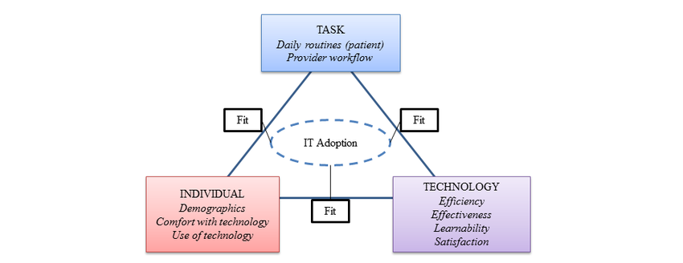

The above diagram represents the relationships between Task, Technology and Individual (User) in the adoption of IT software.

The FITT framework was developed for the healthcare sector following analysis of literature regarding the adoption of technology. It is largely based on the notion that technology is dependent on its fit between user (individual) and the task. The individual is classified as either a single user or a user group. User qualities could include, technical expertise, teamwork, motivation to undertake the task, receptivity to different working methods and organisational context. Tasks are made up of complete tasks or processes and may include characteristics such as activity interdependence or task complexity. Any tool needed to complete the task is referred to as technology which includes paper-based and computer-based equipment.
The purpose of the initial project in 2013 was to ensure the team approached usability from the perspective of OH&W staff and external organisations. Using the fit between individual, task and technology framework the project team were able to identify areas that required improvement in terms of the way in which the software worked and was used.
In 2019 the software package was due for an upgrade to an updated version (COHORT v10). Short user surveys were performed collecting user experiences of the previous version and in the form of ‘good news’ stories from a number of organisations with OH services who used COHORT (v10). Cost analysis was carried out to show any anticipated savings and to ensure affordability.
Evidence was taken from case studies of organisations with geographically diverse workforces such as Essex police force, Great Western Hospitals and Anglian Water which provide OH services.
Essex Police reported that “Cohort has enabled our admin team to work smarter, not harder. It has enabled the admin team to improve turnaround times for referrals, and call back times. They now use their time more efficiently, rather than just pumping around great piles of paper”. (Vince Lungley, Clinical Lead and Local Service Manager, Essex Police).
Sarah Barton – Occupational Health & Systems Manager at Anglian water spoke of her team’s experience using Cohort software – “we saved approximately 40% of our OH Advisor’s time by using Cohort Software.”
The Great Western Hospitals NHS Foundation Trust offers other medical treatments at several sites in addition to acute hospital services at the Great Western Hospital in Swindon. The Great Western Hospitals NHS Foundation Trust, which had previously relied on paper-based systems (like many other NHS institutions), made the switch to a paperless system, which has significantly improved their capacity to deliver a more effective and high-quality service. According to Tania Foggoa, Office Manager – “The number of appointments in our clinics is up by 60%. Our nurses are saving approximately 50% of their time in regards to what they used to be doing, because they used to have to handwrite notes, handwrite reports or type them up or dictate them. Now it’s all centralised on templates, checkboxes, it’s just a quicker process.” (Cohort software.com)
WAST OH advisors work differed to that of OH administrative staff and wellbeing practitioners. 75% of the work carried out by OH advisors could be completed at home and 25% would need to be based in a clinical setting. Due to the switch to hybrid working during the pandemic and since, there was a requirement for portable plus desk top technology to ensure staff could perform their duties effectively and efficiently. 80% of the OH advisors’ role was digital and 20% of the role still required a paper-based approach. The OH advisors also undertook mobile immunisations clinics from a vehicle which needed to have the capability to access Wi-Fi hotspots and keep information secure.
Using the same premise as the initial project plan made it easier to set up the project team and to agree deadlines. Due to lessons learnt from the 2013 project deadlines set were more achievable and realistic reducing the risk of the project failing. The team had changed considerably with team members leaving and new staff arriving but having the initial project plan to work from and utilising the skills of those new staff members would be instrumental in ensuring the project hit the ground running.
Discussion
The future Configuration of NHS Occupational Health Services report 2010 (nhshealthatwork) outlined the need for the “remodelling of Occupational Health Services”. The report raised a number of concerns including the financial and other pressures to improve efficiency and cost effectiveness of services. In his review Dr Steve Boorman states “the fragmentation is compounded by persistent difficulties with diverse information systems and the sharing of patient information between providers”. (Boorman S, 2009)
The second report of the Sir Mansel Aylward-led One Wales Occupational Health Task and Finish Group was delivered to the Minister of Health and Social Services in 2010. The paper promoted an integrated strategy for workplace health. A standardised system for gathering employee occupational health data across all LHBs was advised in the report. This approach was intended to make information sharing easier when staff members switched between Trusts.
All local health boards were utilising COHORT Occupational Health Software by October 2013 and work then began with WAST to enable COHORT to interface with ESR. This enabled interoperability between software programmes and the information shared reduced recruitment times and support long term sickness absentees more effectively. The system was able to generate a broad range of reports that enabled WAST to understand the health profile of its employees and target its Occupational health and wellbeing resources to maximum effect.
The purpose of the software product is to maintain electronic health records for all WAST employees. The service was looking for a programme that could offer interoperability between Human Resources software and the OH software to allow for a more streamlined approach to information sharing across Local Health Boards (LHB’s) and WAST.
Without a doubt, health information technologies (HITs) have the potential to improve the effectiveness and efficiency of healthcare delivery. HITs, however, can potentially have unforeseen effects, a shift in work habits (such as adjusting the pace and sequencing of clinical tasks), unfavourable workflow challenges, paper persistence, and only limited support for clinicians' information needs and work practises (Steele Gray et al., 2016)
According to research, HITs are either used and incorporated into routine, avoided, or rejected depending on how well they "fit" with clinical practise. The intended benefits of the HIT might not be realised when work practises and technology are incompatible.
Data collection and analysis
Data was collected using various methods, qualitive data was collected in the form of user feedback via short Microsoft forms surveys (see appendix). Literature was reviewed and Cohort ‘customer success’ stories were obtained from a number of organisations already using the software. The goal was to use a variety of different experiences to obtain a broader understanding of the advantages and disadvantages of adoption and implementation of the updated software (COHORT v10).
It was important that the upgraded software provided much needed interoperability with more than one interface as WAST OH&W services had now expanded and were providing services for external organisations. The updated software was required to easily transfer information between LHB’s but also Public Health Wales (PHW) and Health Courier Services (HCS) as part of the Service Level Agreements (SLA). It was also vital that any software upgrade adhered to all stakeholder confidentiality polices and met the GDPR legislation.
The contract went out to tender, all interested parties submitted their bids and after a robust selection process the successful provider was nominated. In an initial consultation between the provider (COHORT Occupational Health Software), WAST and Occupational Health Service took place a project plan was established for the implementation of the new software. Following analysis of qualitative and quantitative data collected the Trust approved the procurement of a new software package and a project team was established and a project plan initiated.
The implementation of the upgraded IT software provided many challenges – user engagement/acceptance, technical issues, initial cost implications, demographic issues when training users, motivation of users to adopt the upgraded system. It was important for the project team to understand the reasons for these challenges and to identify opportunities to overcome them. These opportunities were supported by the use of the FITT framework. Using the FITT framework for this project enabled the team to identify design and functionality issues with the software along with usability issues. The FITT framework was utilised in this project to characterise and analyse the fit between individual, task, and technology, which can be used to find ways to improve how those factors interact.
Project Plan
Whilst the project plan was proposed and timelines for completion agreed, consideration of adequate resource to progress the project was insufficient. Limited resource, new OH administration and Covid-19 were all contributing factors in determining the completion of each stage on time.

Migration Project Proposal  Welsh Ambulance Service  CSP18025  Target: Cohort Version 10 |  | Ownership | Proposed Date(s) |  | Achieved
 |  | Ownership | START DATE  (start of business) | DUE DATE  (close of business) | Achieved
 | - Initial consultation meeting: | OH Team  Cohort Software |  | Wed 28/08/2019 | Y
 | - Acceptance of proposed dates to be agreed no later than: | OH Team |  | Mon  02/09/20219 | Y
 | - Pre-Requisites to be acknowledged by local IT department and returned to Cohort Software by no later than: | OH Team  Local IT Team |  | Mon  16/09/2019 | Y
Installation & Connectivity Testing – V10 Testing
 | - Both Test & Production environments to be built and issued by no later than: | Cohort Software |  | Thu 29/08/2019 | Y
 | - Connectivity Testing to take place between: | OH Team | Thu 28/08/2019 | Fri 18/10/2019 | Y
 | - Connectivity Test sign off to be received by no later than: | OH Team |  | Fri 18/10/2019 | Y
Configuration & consultation
 | - Report Migration from v9 to V10 to be gathered and defined no later than: | OH Team  Cohort Software |  | Wed 13/11/2019 | Y
 | - Letters templates to be received by no later than: | OH Team |  | Wed 13/11/2019 | Y
 | - V9 reports to be migrated to be received no later than: | OH Team |  | Wed 13/11/2019 | Y
 | - Electronic Signatures (if applicable) to be received by no later than: | OH Team |  | Wed 13/11/2019 | Y
 | - User List to be agreed by no later than: | OH Team |  | Wed 13/11/2019 | Y
 | - Company Logo & Letterheads to be received by no later than: | OH Team |  | Wed 13/11/2019 | Y
 | - Copy of ‘Additional dropdown lists’ to be received by no later than: | OH Team |  | Wed 13/11/2019 | Y
 | - Confirmation of current dropdown lists have been addressed by: | OH Team |  | Wed 13/11/2019 | Y
 | - Management Referral Forms & Response forms to be received by no later than: | OH Team |  | Wed 13/11/2019 | Y
Training & Set Up
 | - System Admin Training: Following the analysis of the system, a full training session to be delivered to understand the set-up of the system, and what is required. To take place on: | OH Team  Cohort Software | Wed 13/11/2019 | Thu 14/11/2019 | Y
Data Migration - Initial
 | - Production Cohort V10 Environment to be configured with letter templates, and any additional requirements between: | Cohort Software | Wed 13/11/2019 | Fri 06/12/2019 | Y
 | - Production Cohort V10 Database backup taken on: | Cohort Software |  | Fri 06/12/2019 | Y
 | - Initial copy of Cohort V9 database to be supplied on:  This is to include:  - Letter Template Folder  - Electronic Signatures (If applicable)  - Pre-Placement Document Folder  - Any externally referenced Documents | Local IT  Cohort Software |  | Fri 06/12/2019 | Y
Data Migration – Dry Run #1
 | - DRY RUN#1 - Data Migration Solution including the migration of reports, to be executed between: | Cohort Software | Mon 08/12/2019 | Fri 20/12/2019 | Y
 | - DRY RUN#1 – Migrated Database presented through the V10 Test environment on: | Cohort Software |  | Fri 20/12/2019 | Y
 | - Training: General User Training to be carried out with the team in order for a thorough testing phase and an idea of the system functionality on: | OH Team  Cohort Software | Wed 11/12/2019 | Thu 12/12/2019 | Y
 | - DRY RUN #1 – Migrated Data and Reports testing to take place between: | OH Team | Mon 23/12/2019 | Fri 10/01/2019 | Y
 | - Dry Run Issue log, including any issues with reports, to be received by no later than: | OH Team |  | Fri 10/01/2019 | Y
Process Testing
 | - Additional set up changes to be made to ‘Start Point’ database no later than: | OH Team  Cohort Software |  | Fri 17/01/2019 | Y
Data Migration – Dry Run #2
 | - DRY RUN #2 - Data migration scripts\Reports to be addressed following any issues raised in UAT#1 between: | Cohort Software | Mon 13/01/2019 | Fri 17/01/2019 | Y
 | - DRY RUN #2 - Migrated Database presented through the V10 Test environment by cob on: | Cohort Software |  | Fri 17/01/2019 | Y
 | - DRY RUN #2 - Migration testing to take place, including converted reports, between: | OH Team | Mon 20/01/2019 | Fri 24/01/2019 | Y
 | - Issue log to be received by no later than:  OR  Sign off document returned to Cohort Software by no later than: | OH Team |  | Fri 24/01/2019 | Y
Please note: If any issues are remaining following DRY RUN #2, the project will need to be reviewed by all parties, and therefore and further dates beyond this point may then change accordingly.

Final Migration & Go Live
 | - DOWNTIME | ALL | COB Fri  02/08/2019 | Fri  09/08/2019
 | - Final copy of the V9 DB to be Supplied at COB on: | Local IT  Cohort Software |  | Fri 24/01/2019 | Y
 | - Final Copy of the Cohort V10 production DB to be taken on: | Cohort Software |  | Fri 24/01/2019 | Y
 | - Final Migration conversion to take place between: | Cohort Software | Mon 27/01/2019 | Wed 29/01/2019 | Y
Please note: anything added to Cohort 9.2 / 9.3 beyond this point will not transfer to the new system. Provisions should be made operationally to accommodate this. However, it may be possible for Cohort 9.2 / 9.3 to be made available in ‘Read Only’ mode.

 | Training
 | - General User Training Days | OH Team  Cohort Software | Tue 28/01/2019 | Wed 29/01/2019 | Y
 | - System Admin Training Day | OH Team  Cohort Software | Thu 30/01/2019 | Fri 31/01/2019 | Y
 | - Go Live & Support | OH Team  Cohort Software |  | Mon 03/02/2019 | Y

Implementing change
When implementing any change, it is important to remember that everyone deals with change differently. The process of perpetually updating an organization's objectives, organisational design, and resource capacity to accommodate the varying needs of both internal and external customers is known as change management. Organizational existence is characterised by constant change, both at the tactical and strategic levels. “There should be no question about how crucial it is for any organisation to be able to see where it needs to go and how to manage the changes necessary to get there. As a result, organisational change and organisational strategy are inextricably linked. Organizational change is important, thus managing it is becoming a crucial managerial competency” (Senior, Citation2002). Few would dispute that the main responsibility of management today is the leadership of organisational change. "Against a backdrop of increasing globalisation, deregulation, the rapid pace of technological innovation, a growing knowledge workforce, and shifting social and demographic trends," (Graetz, 2000)
Lewin (Bamford, 2003) a theorist, researcher, and practitioner in interpersonal, group, intergroup, and community connections, launched the planned method to change in 1946. (Eldrod II, 2002) Before change and new behaviour may be successfully embraced, Lewin (1946 in Burnes, Citation2004) stated that the “old behaviour must be abandoned”. A successful change project must therefore include the three processes of “unfreezing the current level, migrating to the new level, and refreezing this new level”, according to Lewin (Eldrod II, 2002) This change model understands that in order to successfully implement new strategies, “it is necessary to get rid of outdated behaviour, structures, procedures, and cultures” (Bamford, 2003)
The introduction of an organisations project management method involves changing the way in which people work so that projects succeed and business/performance improves. As shown in Prince2 Project management, gaining the support of the people who are required to change the way in which they work is at the heart of most change models. This involves but isn’t limited to, understanding the resilience of those impacted by the change and engaging those affected by the change in order to keep their support throughout the project (Axelos,2017). It is important to consider the ‘people’ element whenever a change is being considered. Many change initiatives are destined to failure from the very beginning due to the poor management, issues of resistance can sometimes be attributed to poor management and communication of the change process.
When considering implementing the updated software programme, moving from Cohort v9 to Cohort v10 OH&W management invited OH&W team members along with other system users to provide experiences, concerns and ideas to help gauge possible causes for failure. It was important for the service to involve all stakeholders as their input would prove invaluable. By involving software users and those who have personal experience of the system it would ensure the project team were aware of any barriers or obstacles they may encounter during the project. It also allowed those users to have a say in the type of system they felt would be beneficial and make their work more streamlined, efficient and effective. Project management is not just about achieving the end goal, project management also allows for information sharing and collaboration with others.
User feedback
User feedback was obtained using Microsoft (MS) Forms questionnaires and user interviews – verbal consent was obtained to share individual stories and experiences. A disclaimer was added to the MS form advising of the sharing of feedback provided but all providers would remain confidential unless explicit consent given to use personal information.

Examples of feedback forms can be found in the Appendix.

- There seems to be an emerging theme that the OH administration staff and management were unaware of the level of involvement required in terms of ‘building the system’
- OH&W staff and managers felt the training provided was inadequate and too brief meaning a lot of time was spent asking for further support from those who were confident in use of the system.
- Managers found the process of submitting referrals extremely time consuming and the system was not user-friendly.
- COHORT and ESR, whilst bi-directional, did not always support two-way communication meaning recruitment services were regularly chasing pre-employment clearances.
- Once staff were confident in using the system it did free up time for other administrative tasks.
- Cohort allowed the service to store lots more information digitally and negated the use of folders on desktops which was in line with information governance policies.

Results and user feedback following survey – 100 staff in various roles within WAST, PHW and HCS were sent links to the survey – 56 staff responded and the results are below.

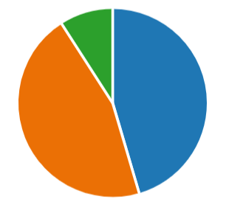
45% found the training package sufficient
45% found the training package insufficient
10% we unsure

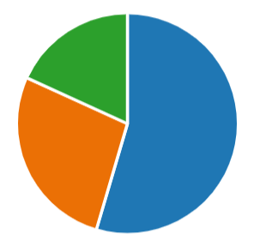
55% of staff required ongoing support from the OH&W admin team.
18% said they often required support
27% did not require ongoing support

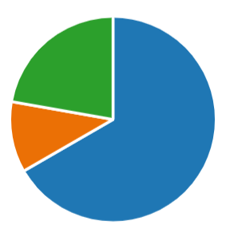
11% said they would be happy to continue with Cohort
67% said they would prefer not to continue with Cohort
22% were unsure
Figure 1 Snapshot of user feedback
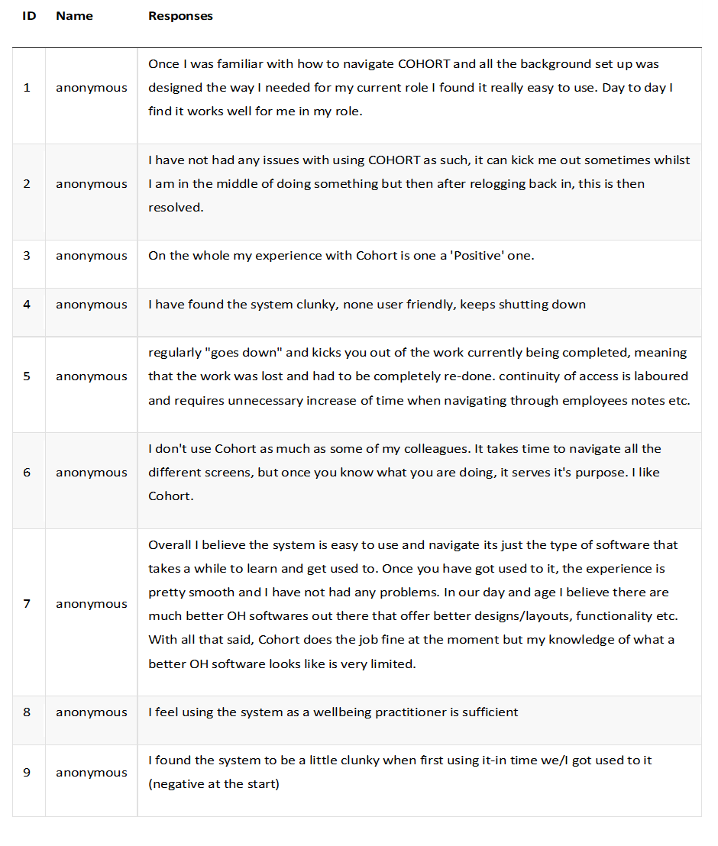
Figure 2 Snapshot of OH&W user experience

Fit between the individual and technology
The overall staff experience of the technology on a whole was relatively positive. An important aspect of the COHORT software was that the system was a ‘one-stop shop’ providing everything the service required at the click of a button. The rigid nature of the software, password protection and the layout of the interface meant that some found the usability poor. A good fit between the patient and technology, with an emphasis on personalization and autonomous functioning, may encourage staff to use the software rather than revert to the old system. On the other hand, as autonomy increases, there are more alternatives to manage and a greater need for staff to be more digitally literate. It is important to manage expectation – lack of confidence or digital competence may discourage users and this may result in increased workload for OH admin or important referrals not being submitted by managers.
Fit between technology and the task
To ensure a good fit between Cohort and the tasks and processes it is important to manager the expectations of users. The technology needs to be fit for purpose, have adequate functionality and be able to sufficiently support the tasks required. It became clear during this study that some staff found the technology difficult to navigate and therefore completion of tasks was seen as a chore. A regular issue with the technology was that it would ‘crash’ causing work to be lost increasing the work of those using the system. The technology needs to be inviting, user-friendly and it needs to be attractive in order to encourage users to change their behaviours. Staff’s experiences of the upgraded software varied with differing levels of motivation to use it. It is important that staff understand why certain tasks need to be completed in a certain way and how to incorporate their new way of working into their everyday work tasks.
Fit between the individual and the task
It is important to engage users in tasks from the outset, staff who are not engaged will lack motivation. It is important to understand what motivates an individual and embrace that to achieve goals. When implementing a new way of working it is vital that all tasks are accompanied by easy-to-follow instructions for staff to refer back to. This will encourage them to learn autonomously, thereby reducing the burden on the OH&W administrative team. it was clear from the feedback that the majority of staff felt supported which could be a reason for the project succeeding. It is not always possible to motivate everyone as motivation
Limitations
The feedback for this paper should be carefully interpreted. The sample of staff responding was small and could be perceived as biased. However, as suggested by (B Albert, 2013) ‘smaller samples of 8 or 10 participants can still be meaningful’ The user experiences may not be a true representation of the wider organisation and therefore it is important to keep communication channels open. Continually look to improve and most definitely listen to those who use the software most.
Conclusion
It has been difficult to gauge whether the project to upgrade from v9 to v10 was a complete success. Whilst the project brief and deadlines were met, suggesting the project was a success, user experience has been varied and therefore does not conclusively suggest success or failure. In terms of the implementation of COHORT (v10) the project was a success. Targets were met at each stage of the project and even through the pandemic the software implementation progressed relatively smoothly. However, some OH staff struggled to use the new technology and found the training quite difficult to follow whilst others coped with the change more easily and found the process less complex or stressful. Some managers struggled with the upgraded software when needing to submit more than one referral at a time due to time constraints and the usability of the system, with them often electing to revert to the previous route of submitting referral requests via email. This created more work for the OH administrative team and ran the risk of referrals being missed, lost or misinterpreted. Changing the behaviours of those struggling with the updated software proved to be one of the biggest challenges for the project team. OH administrative staff were pivotal in ensuring the project stayed on target as essentially it was this team that built the software to meet the requirements of the service and communicated the changes to all staff and stakeholders.
A number of WAST staff members were happy to provide their personal experience of the transition from Cohort v9 to v10 with many sharing the same concerns, the training package provided was insufficient and pace at which the change occurred was too fast and did not allow time for them to adjust to the new way of working. Whilst the software looked similar in some areas the usability of the system changed considerably and some found this quite challenging. It wasn’t only the software that changed but processes were also scrutinised and due to data protection and GDPR managers were no longer able to ask administrative staff to submit referrals on their behalf but instead had to find time in their already busy schedules to submit referrals personally. This was a common frustration amongst management within WAST, PHW and HCS.
Further issues were found with the functionality from a recruitment process perspective. Medicals and clearances carried out and issued by OH for new recruits were to be linked with the ESR/TRAC system used by the recruitment team thus removing the need for emails to be sent notifying the team of any updates. However, the system regularly failed meaning TRAC were continuously having to contact OH to chase clearances and this resulted in delays for new starters to begin their new roles. This often had a significant impact on already overstretched services as staff were having to defer training amongst other issues until their clearance had been received by TRAC.

For the OH&W team the change was slightly more straightforward as most of the team were more accustomed to the software. This does not mean there weren’t challenges along the way. During the transition period Covid19 enforced changes to the service, including no face-to-face meetings or training. Whilst some team members were unphased by online learning others struggled and found it difficult to understand the software without being able to physically access the software and without having a physical support mechanism available. Increased fast track recruitment of staff recruited due to the pandemic meant that the workload of the small admin team increased in turn reducing the amount of time that could be spent completing each stage of the project plan. Staff were pushed to their limits to meet the deadlines of each project stage so that financial penalties were not incurred. This impacted on some of the team negatively with some staff having to take time off work with stress related concerns and staff morale was low. Whilst it is difficult to blame the implementation of the new software directly, it would be fair to suggest it would have had some influence on the decisions of those staff members to not remain in work and the issues caused by these staff absences would have impacted on the remaining staff negatively.

Future programme improvement project
In 2022 the contract between WAST and COHORT was due for renewal, this gave the OH&W service the perfect opportunity to analyse the effectiveness, value and limitations of the software. Again, short surveys were used but also personal experience of OH&W staff alongside a number of WAST managers collected in the form of informal interviews. The key findings from the feedback were that whilst the software had served its purpose for a number of years it was no longer fit for purpose, it was ‘clunky’ and no longer user-friendly. Many users had struggled to navigate the software and found it to be time consuming and cumbersome with very little offered in return. Although COHORT (v10) was bi-directional there were continuous issues with data transfer and regularly technical glitches would occur, causing unnecessary delays in sharing of information.
Using the lessons learnt from the COHORT project, WAST, along with all Health Boards across Wales have set up a joint Task & Finish group to ensure collaborative working. This will ensure all services are using the same software and that all processes are aligned. The aim of the Task & Finish group is to share good working practice and knowledge in order to reach the agreed goal of the improved programme project. Working collaboratively will allow workloads to be shared and deadlines to be achievable. The business case has been put forward, project terms and deadlines agreed with the implementation and roll out date set to November 2023.
As technology improves and user requirements change it is important to ensure the organisation moves and develops at the same time.

Reference list
- Albert, B. and Tullis, T., 2013. Measuring the user experience: collecting, analyzing, and presenting usability metrics. Newnes.
- AXELOS Limited. (2017) ‘Managing Successful Projects with PRINCE2.’, p. 281-285
- Bamford, D. R. and Forrester, P. L. (2003) ‘Managing planned and emergent change within an operations management environment’, International Journal of Operations & Production Management, 23(5), pp. 546 –564.
- Cohort software internet source available at www.cohort-software.com
- Dishaw M, Strong DInformation & Management (1999) 36(1) 9-21 Extending the technology acceptance model with task–technology fit constructs.
- Eldrod II, P. D. and Tippett, D. D. (2002) ‘The “death valley” of change’, Journal of Organizational Change Management, 15(3), pp. 273–291
- Graetz, F. (2000) ‘Strategic change leadership’, Management Decision, 38(8), pp. 550–562
- NHS health at work report (2010) internet source– available at www.nhshealthatwork.co.uk
- Nilsson, L., Hellström, A., Wennerberg, C., Ekstedt, M. and Schildmeijer, K., 2020. Patients’ experiences of using an e-Health tool for self-management support after prostate cancer surgery: a deductive interview study explained through the FITT framework. Bmj Open, 10(6), p.e035024.
- Prgomet M, Georgiou A, Callen J, Westbrook J. Fit Between Individuals, Tasks, Technology, and Environment (FITTE) Framework: A Proposed Extension of FITT to Evaluate and Optimise Health Information Technology Use. Stud Health Technol Inform. 2019 Aug 21;264:744-748. doi: 10.3233/SHTI190322. PMID: 31438023
- R.T., 2005. Organisational change management: A critical review. Journal of change management, 5(4), pp.369-380.

Appendix
https://forms.office.com/Pages/ResponsePage.aspx?id=uChWuyjjgkCoVkM8ntyPrjI_U-HpQMNOobQzzkaZwe5UMVYzRjE0U1cxNzE4Vk9CT0tOVVA2OFdWTi4u
https://forms.office.com/Pages/ResponsePage.aspx?id=uChWuyjjgkCoVkM8ntyPrjI_U-HpQMNOobQzzkaZwe5UNVNMT0xDSFFYUU85RVJKM1FTVzY0Tks5NC4u

