Video Link:
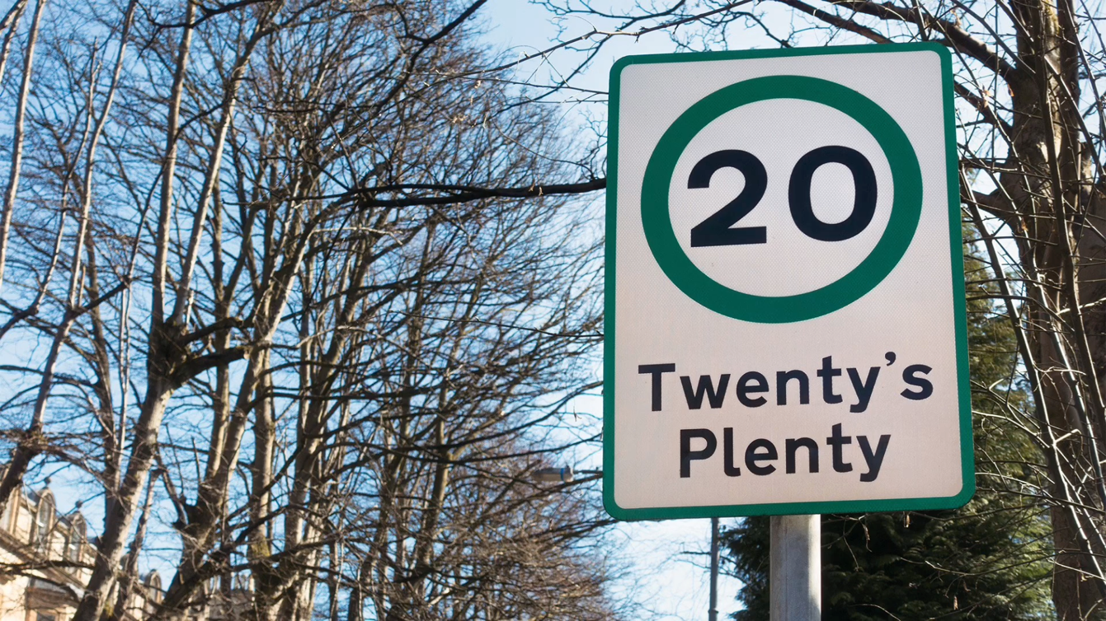

Notes for video:

Introduction:
-Introduce yourself
-Introduce the new 20 mph limit within Wales (Welsh Government, 2022)
-Highlight big potential implications for the tourism and leisure sector
- Why these speed limits were implicated, Community health and wellbeing (Welsh Government, 2022) (Cairns J, 2014)
-Address the communities concerns (Welsh Government, 2024)
* Remember this is a news story, act like you're on the news*

Investigate:
-how the new speed limit is affecting tourism and leisure BE SPECIFIC TO SWANSEA
-Talk about how you have researched local businesses, Residents and event organisers
- UK Cabinet Minister Penny Mordaunt opinion on the matter. She calls it “Insane” and predicts economic setbacks (BBC News, 2023)
-Address controversies and debates around this policy (Cairns J, 2014)
Analysis:
-40% decrease in collisions (Welsh Government, 2024)
-NHS savings of £92 million (BBC News, 2023)

Main Findings:
-Introduce the advantages and disadvantages section. Mention they are specific to local community and tourism sector of Swansea.
Advantages:
-Enhances Safety (Welsh Government, 2024)
-Pedestrian friendly zone (Welsh Government, 2024)
-Reduced accidents, fewer accidents in populated areas (Welsh Government, 2024) (Cleland, C.L 2020)
-Adapting for success, adjustment creating chances for businesses
Disadvantages:
-Economic strain, delivery Services (BBC News, 2023)
-Public dissatisfaction, residents and tourists (BBC News, 2023)

-Impact on tourism appeal, Mention sources e.g. Journalist and travellers (Express News, 2023) (BBC News, 2023)
- Traffic congestion, commuters and tourists (BBC News, 2023)

...........................................................................

-Provide a balance view on the situation (Welsh Government, 2024)
-Focus on tourism and discuss the response from businesses and tourists
-Mention both sides of argument and why they are both valid
- Lower speeds reduce severity of accidents (Welsh Government, 2022) (Cleland, C.L 2020)
- discuss pedestrian friendly (Welsh Government, 2024)
-Negatives are stronger than positive – Wales being the first country to implement this policy (Welsh Government, 2022)
-Local businesses, affecting their delivery services – May lead to job loss (BBC News, 2023) (Express News, 2023)

Conclusion:
-Summarize the main points
-Propose adjustments to the policy balancing safety and the needs of the community and tourism/ leisure industry
-Talk about the importance of finding a balance between safety and the needs for local businesses
-Tailoring speed limits to different areas
- Finish up, .... I'm Calypso Manfield and thank you for joining me in this insightful exploration of ‘Navigating the slow lane’.

References :
Ad van visits Swansea to highlight ‘damage’ 20mph scheme is causing drivers (2023) Swansea Bay News. Available at: https://swanseabaynews.com/2023/10/12/ad-van-visits-swansea-to-highlight-damage-20mph-scheme-is-causing-drivers/ (Accessed: 18 January 2024).
Belli , E. (2023) Wales’ 20mph speed limit destroying companies, claims boss, BBC News. Available at: https://www.bbc.co.uk/news/uk-wales-66867280 (Accessed: 15 January 2024).
Birt , E. (2023) Gorslas, Llandybie and cross hands 20mph signs vandalised, Gorslas, Llandybie and Cross Hands 20mph signs vandalised. Available at: https://www.southwalesguardian.co.uk/news/23829799.gorslas-llandybie-cross-hands-20mph-signs-vandalised/ (Accessed: 18 January 2024).
Browne, A. (2023) Wales’ 20mph limit absolutely insane, says Penny Mordaunt, BBC News. Available at: https://www.bbc.co.uk/news/uk-wales-politics-66802351 (Accessed: 14 January 2024).
Cairns, J. et al. (2014) ‘Go slow: An umbrella review of the effects of 20 mph zones and limits on health and Health Inequalities’, Journal of Public Health, 37(3), pp. 515–520. doi:10.1093/pubmed/fdu067.
Cleland, C.L. et al. (2020) ‘Effects of 20 MPH interventions on a range of public health outcomes: A meta-narrative evidence synthesis’, Journal of Transport &amp; Health, 17, p. 100633. doi:10.1016/j.jth.2019.100633.
Evans, T. (2023) 20mph default speed limit ‘putting tourists off visiting Wales’, Tories claim, Sky News. Available at: https://news.sky.com/story/20mph-default-speed-limit-putting-tourists-off-visiting-wales-tories-claim-13017451#:~:text=The%20Welsh%20Conservatives%20say%20the,getting%20used%20to%22%20the%20change.&text=The%2020mph%20default%20speed%20limit,according%20to%20the%20Welsh%20Conservatives. (Accessed: 13 January 2024).
Evitts, J. (2023) Wales’ 20mph speed limit: Petition against breaks records, BBC News. Available at: https://www.bbc.co.uk/news/uk-wales-66853445 (Accessed: 15 January 2024).
Forgrave, A. (2023) Multiple ‘go-slow’ protests planned over Wales’ 20mph speed limit, Wales Online. Available at: https://www.walesonline.co.uk/news/wales-news/multiple-go-slow-protests-planned-27994283 (Accessed: 18 January 2024).
Forgrave , A. (2023) Police action warning as 20mph road signs torn down and defaced, North Wales Live. Available at: https://www.dailypost.co.uk/news/north-wales-news/police-action-warning-20mph-road-27754661 (Accessed: 18 January 2024).
Gwenda (2023) Active travel – devolution makes a difference, Cycling UK. Available at: https://www.cyclinguk.org/blog/active-travel-devolution-makes-difference (Accessed: 18 January 2024).
Hodgson, A. (2023) Swansea Stock drone footage, YouTube. Available at: https://youtu.be/zvl1wjM-2qg?si=TbOkN-IPrbkizmA1 (Accessed: 18 January 2024).
Wales 20mph limit: Cardiff Protest March as petition tops 400K, BBC News. Available at: https://www.bbc.co.uk/news/uk-wales-66902150 (Accessed: 18 January 2024).
Introducing default 20mph speed limits (2023) GOV.WALES. Available at: https://www.gov.wales/introducing-default-20mph-speed-limits (Accessed: 12 January 2024).
Introducing 20mph speed limits: Frequently asked questions (2024) GOV.WALES. Available at: https://www.gov.wales/introducing-20mph-speed-limits-frequently-asked-questions (Accessed: 12 January 2024).
ITV News (2023) Tourist says ‘never again’ to visiting Wales due to 20mph limit, ITV News. Available at: https://www.itv.com/news/wales/2023-11-27/tourist-says-never-again-to-visiting-wales-due-to-20mph-limit (Accessed: 15 January 2024).
Mortimer, J. (2023) ‘I’m a car expert - the 20mph speed limit in Wales is going to destroy tourism’, Express.co.uk. Available at: https://www.express.co.uk/life-style/cars/1817867/wales-speed-limit-safety-tourism (Accessed: 15 January 2024).
Ready for 20mph (2023). Welsh government . 18 September. Available at: https://youtu.be/cJN2V5kcgFE?si=Xg7O9rwQ4T4_IkPK (Accessed: 18 January 2024).
Roberts, H. (2023) Safer at 20mph: Let’s look out for each other, Wales Safer Communities. Available at: https://safercommunities.wales/safer-at-20mph-lets-look-out-for-each-other/ (Accessed: 18 January 2024).
Russell, L. (2022) Reducing speed limits to 20mph has little impact on road safety, new report finds, Sky News. Available at: https://news.sky.com/story/reducing-speed-limits-to-20mph-has-little-impact-on-road-safety-new-report-finds-12748218 (Accessed: 18 January 2024).
Swansea city centre panorama (2022). 10 April. Available at: https://youtu.be/Gty2r15A-g0?si=Wjs1bAW7udXIyrh2 (Accessed: 18 January 2024).
Walton, S. (2023) Record number of welsh motorists sign petition in protest at New 20mph Speed Limits, CAR Magazine. Available at: https://www.carmagazine.co.uk/car-news/motoring-issues/20mph-speed-limit/ (Accessed: 18 January 2024).
20mph by default – could new speed limits reduce collisions on welsh roads? (2022) Ymwchil y Senedd | Senedd Research. Available at: https://research.senedd.wales/research-articles/20mph-by-default-could-new-speed-limits-reduce-collisions-on-welsh-roads/ (Accessed: 18 January 2024).

