Chapter 3 – Methodology

3.1 Introduction

This chapter explores the researchers’ methods to collect data in this research and strives to achieve the second objective of this research project.
The definition of research varies widely, with shared elements present, yet a definitive, universally agreed-upon description has yet to be established among experts. Walliman (2022) succinctly describes research as an endeavour aimed at systematically uncovering unknowns. Furthermore, Walliman (2022) asserts that research, within an academic context, ought to extend the boundaries of understanding.
There are two fundamental components of research: Primary and Secondary (Bryman, 2016). Influenced by an academic gap in relevant data pertinent to DFT, primary research was chosen to answer the question posed by the research. Although secondary data has not been excluded outright, its exploration has proved vital to enhancing the scope of the research, through a comprehensive literature review at its foundation.

3.2 The Research Strategy

The research onion created by Saunders et al will provide an insight into the chosen research methods, providing a clear understanding of the importance of research and how it should be completed (Saunders et al, 2009). Figure 3.1 outlines the research methods available to the researcher.
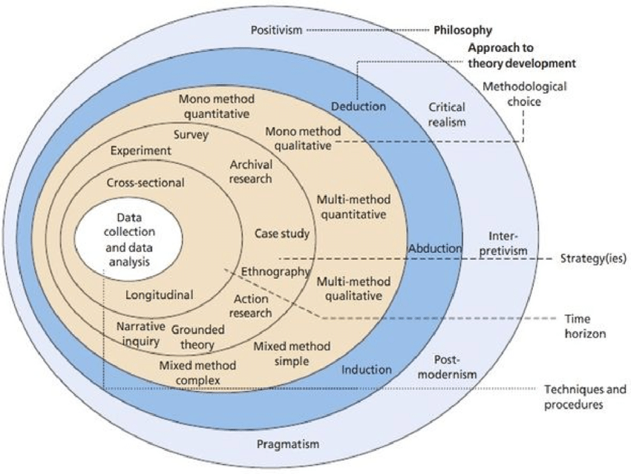
Figure 3.1 – The Research Onion. (Source: Saunders, Lews and Thornhill, 2016).
The Research Onion proposed by Saunders et all (2009), is a theoretical model for constructing research methodology. It illustrates the various layers or stages involved in formulating an effective methodology, starting with the core philosophy guiding the research, followed by the selection of approaches, methods, strategies, and the definition of time horizons. These aspects together shape the study design, determining the primary methods and procedures for collecting and analysing data, and assuring alignment between the selected tools and the fundamental philosophical beliefs. The overall model aids the researcher to systematically develop a research strategy and ensures its coherence and alignment throughout the research process. It is for this reason it is the chosen framework for this research project.

3.1.1 Research Philosophy

The outer layer of the research onion offers philosophical considerations for the researcher who has embraced the interpretivism approach in this study. Interpretive research utilises qualitative methods to thoroughly explore the participants' perspectives and uncover the underlying meanings and significance of their actions, interactions, and interpretations within their social environments (Tshabangu, 2021). Participants' subjective viewpoints were crucial for examining how individuals and groups interpret and attribute significance to their daily experiences and interactions (Atkinson, 2012). Interpretivism's emphasis on depth and context is well-suited for examining the application of DFT in Dyfed Powys Police.
Interviews offer researchers an enhanced opportunity to delve into individual experiences and gain a deeper understanding from various perspectives, thereby adding more depth and context to research (Willis, 2007). Tshabangu (2021) also notes the advancement of understanding by comparing and contrasting the differences and similarities between individual viewpoints and experiences.
Despite the obvious strengths, interpretivism is not without its challenges. An inherent limitation of interpretivism is its susceptibility to participant bias from those in a position of influence, who may potentially compromise the objectivity and broader applicability of any research outcomes (Fellows and Liu, 2015). By acknowledging this, the researcher has critically evaluated alternative philosophical paradigms, yet reaffirmed the suitability of interpretivism for its emphasis on the contextual and subjective dimensions of knowledge, aspects somewhat constrained within the positivist framework (Atkinson, 2012).
This approach is designed to capture a broad spectrum of experiences and viewpoints within the Dyfed Powys Police, thereby enriching the study's findings and supporting the development of well-grounded policies and procedures concerning the use of DFT.

3.1.2 Research Approach

The next layer of the research onion outlines the different approaches available to the researcher. Three approaches are widely discussed in academic literature, more recently Saunders, Lewis and Thornhill (2019) identify these approaches as deduction, abduction, and induction.
Inductivism, as outlined by Adams, Khan, and Raeside (2007), relies on the premise that specific observations can lead to the formulation of general theories, with the repeated occurrence of events laying the groundwork for universal laws, a principle that has been central to scientific inquiry since the 19th century. In contrast, Bryman (2016) highlights the deductive approach, which starts with a theoretical framework, challenging the researcher to either substantiate or refute the proposed theory.
Bridging the gap between these methodologies, the abductive approach emerges as a versatile alternative, which offers researchers the flexibility to switch between the inductive and deductive paradigms, as described by Hammond and Wellington (2021).
The inductive approach was selected for this study, due to its emphasis on leveraging participants' experiences as the primary driver of research analysis (Azungha, 2018). This preference was dictated by the characteristics of the collected data, enabling the formulation of theories directly from research outcomes. This approach can be instrumental in informing subsequent studies, policies, or recommendations in the application of Digital Forensic Triage (DFT) within Dyfed Powys Police.

3.1.3 Research Strategy and Choice

The adoption of a ‘Mixed-Method’ approach by the researcher, consisted of data collected from participants through their voluntary engagement in questionnaires and interviews. The questionnaire was distributed to a variety of departments engaging in criminal investigations with exposure to digital forensics. These departments included the Criminal Investigation Department (CID), Management of Serious Sexual & Violent Offenders (MOSAVO), Priority Policing Team (PPT), Digital Investigation Unit (DIU) and Digital Forensic Unit (DFU).

3.1.4 Time Horizon

The 'Time Horizons' layer is a crucial aspect of the research onion model, guiding the research design selection (Saunders, Lewis, and Thornhill, 2016). Given the limited timeframe for this project, a cross-sectional study was deemed more appropriate than a longitudinal survey. Although the later provides more detailed data by observing changes over time, they are often costly and time-intensive (Cohen, Manion, and Morrison, 2018; Walliman, 2006). A cross-sectional study is not only cost-effective and quicker but also lays the groundwork for subsequent future research. However, it's important to note that the brevity of the study period might compromise the depth and comprehensiveness of the findings (Levin, 2006).

3.3 Techniques: Data Collection and Analysis

3.3.1 Data Collection

A structured data collection process is crucial to ensure the data acquired is well-defined and accurate, which then supports the validity of subsequent decisions based on the findings (Sapsford and Jupp, 2006). Therefore, questionnaires and interviews are the preferred research tools for data collection in this study.
Through the use of interviews the researcher aimed to capture the depth of insights provided by face-to-face interviews, which include both verbal and nonverbal elements, as noted by Elswick (2017). However, the complexity of accurately recording and utilising this detailed information can present challenges, as noted by Elswick (2017) who suggests that interviewers should personally transcribe the sessions promptly to effectively manage the multifaceted data produced.

3.3.2 Survey Design

Participants were provided a single questionnaire, consisting of 15 questions, capturing both qualitative and quantitative data. Microsoft forms provided a platform to create and distribute the questionnaires.
Appendix A provides a copy of the questionnaire and the results from all 43 participants.

3.3.3 Interview Design

The researcher conducted two interviews for the study, selecting both participants based on their expertise and experience in Digital Forensics, as well as their managerial roles within the organisation.
Appendix B provides a copy of the interview questions and a transcript of the responses from both participants.

3.3.4 Data Analysis

Data acquired through the questionnaires was analysed using Microsoft analysis tools built into Microsoft Forms. Microsoft Excel was also utilised in order to provide analytical visual aids in the form of graphs, tables and pie charts further enhancing the understanding of the data acquired.
Interviews were completed with the aid of Microsoft Teams, which allowed for the recording and transcription of responses from the participants.

3.4 Reliability and Validity

This study emphasises that reliability and validity is fundamental to its methodology, aligning with Cohen, Manion, and Morrison's (2018) definitions of these terms as consistency and accuracy in research findings, respectively. Acknowledging Adams, Khan, and Raeside's (2007) caution on the limits of generalisation in scientific theories, a mixed-method approach combining interviews and questionnaires was adopted to enhance data quality and breadth. Questionnaires were designed for clarity and comprehensiveness, following Cohen, Manion, and Morrison's (2018) guidelines, while interviews, as recommended by Bickman and Rog (2009), offered flexibility in data collection, allowing for both qualitative and quantitative insights. Measures such as pilot testing of questionnaires and semi-structured interviews ensured the reliability and validity of the data. In addition, triangulation enhanced the study's validity by ensuring findings were consistent across various methods and disciplines in the organisation, thereby reinforcing the credibility of the results (Gibson, 2017).
The researcher has aimed to build the methodology on a strong theoretical base, so that it may yield findings that are reliable, valid, and broadly applicable. They have actively tackled potential limitations to offer meaningful contributions to the field of DFT.

3.5 Limitations

Consistent with the nature of scholarly inquiry, this study encompasses inherent limitations. Denscombe (2014) emphasises the importance of a researcher's recognition and critical evaluation of these constraints. This involves an acknowledgment of the methodological limitations, the effects of resource constraints, the reliability of participant responses, the conceivable benefits of alternative methodologies, and the impact of unexpected variables on our results. Such a reflective approach ensures a comprehensive and balanced assessment of the research's scope and findings.
The first limitation with this study is the sample size and selection. This study is specific ally targeted at the effectiveness of DFT in Dyfed Powys Police. Lambert (2019) notes that the likelihood of obtaining statistically significant outcomes, increases with larger sample sizes. To overcome this the researcher has complemented quantitative data with qualitative insights to add depth to the findings.
A further limitation of confirmation bias could be introduced into the study due to the researcher’s affiliation with the organisation, the digital forensic arena and their overall experience in digital investigations. Such bias can significantly impact a research study, resulting in a skewed interpretation of data, where researchers may selectively gather, interpret, or use evidence in a way that confirms their preconceptions (Bos, 2020).
In contrast, McNeill and Chapman (2005) note that the strong feeling of a researcher doesn’t automatically result in findings slanted towards the researchers’ beliefs or values. The researcher has overcome this by taking an openminded and balanced approach to the study, considering both sides of any argument presented in the findings (Bos, 2020).

3.6 Ethical Considerations

Prioritising ethical considerations in any research project is paramount. It sets the standards that guides the conduct of the researcher and ensures the protection of the rights of those who are subject of the research (Saunders, Lewis and Thornhill 2016). Consequently, a comprehensive ethics form was diligently filled out and approved before the project began, covering all aspects to ensure full compliance with ethical standards.
Prior to engaging in any data collection, participants were thoroughly briefed on the research project's aims and objectives, which also outlined the intended use of their contributions in the analysis phase. In line with the ethics approval from the University of Wales Trinity Saint David (UWTSD), the researcher emphasised that participation was entirely voluntary, with participants free to opt out or decline at any point.
Despite the open nature of qualitative interviews fostering a more engaging interaction between the researcher and participants, the study strictly protected participants' anonymity to safeguard their privacy. To prevent the opportunity for the misuse of data, all personal data was treated with the utmost confidentiality, anonymised, and secured on a password protected device.

3.7 Conclusion

In this chapter, the researcher has effectively pinpointed and illustrated the most fitting and pertinent research methodology for the dissertation. The ensuing chapter will be dedicated to the presentation and thorough analysis of the data gathered during the data collection phase of the research project.

