Student Name/no | Dapaah Tweneboah (1916217)
Module Code | BMSW 4003_LON
Assignment Title | Digital Skills and Research Methods
Lecturer Name | Modak Koushik

Table of Contents
1.Introduction 3
2.Rationale 3
3.Research Objective 4
4.Literature Review/Review of the existing Literature 4
5.Methodology 5
5.1Data collection 6
5.2 Ethic in data collection 6
5.3Findings and Analysis 6
5.4 Summary of Finding 12
5.5 Recommendation 12
6.Conclusion 13
7.References 13
Appendices 1 15
Appendices2 18

1.Introduction
The purpose of this research is to find out how virtual learning environment has impacted students at the University of Wales Trinity Saint David and their experience. “Virtual Learning is defined as a learning experience that is enhanced utilizing computer and/or the internet both outside and inside the facilities of the educational organization. The instruction most commonly take place in an online environment. The teaching activities are carried out online whereby the teacher and learner are physically separated(in terms of place, time, or both”. (Racheva, 2017)
In this research I will be considering primary and secondary data whereby questionnaire will be prepared and sent to sixteen students in my class and I will use the result to plot Bar-graph and pie charts. I will analyse the graph and give summary of the findings. This will help to understand how virtual learning has impacted student at UWTSD.

2.Rationale
As virtual learning environment has become and playing important role about the way people are studying now especially at this covid-19 era, it has become imperative that a research is done to find out how students are adjusting themselves to this learning method, especially students at university of wales trinity saint David to find out how it is impacting their studies compare to face to face studies.

3.Research Objective
The objective of this study is to find out how student at university of wale trinity saint David feel about virtual learning environment, is it helping them or not helping them? is it making positive impact or negative impact on their education, if student are not happy with it, what can be done to improve it, and base upon this research information can be gathered to improve virtual learning environment at the UWTSD.

4.Literature Review/Review of the existing Literature
University of Waikato Institute of Technology, New Zealand,
In 2014, Waikato institute of technology conducted a research about student’s views on their understandings of learning with the synchronous adobe connect virtual classroom in fully online university course.
The method applied in this research was qualitative approach, six students plus their lecturers were involved in this research. They collected data through interviews, observation of online activity over the period of one semester. Data collection was all about online learning activity. The interviews they conducted took place from the start and end of semester, people who took part where asked semi-structured question about their experiences with online learning classroom. Their findings were that student had a challenges with time zone as many learners were from different time zone, so it was difficult planning activities that will be suitable for all participant, majority of student also favoured to have more virtual classroom activities, but the positive part of the research was that students expressed their overall satisfaction with virtual learning because virtual learning provide flexibility, interaction and collaboration. There was a recommendation that there should be a further Adobe connect virtual classroom research that will focus on everyday practice and uses of this virtual tool to establish it best use.
(Gedera,2014)
This research and my research can relate to each other because both focused on virtual learning environment but this one specifically focussed on synchronous adobe connect virtual classroom and mine focussed-on impact of virtual learning environment at UWTSD. In summary of this report majority of the students are satisfy with adobe connect virtual learning but with improvement to having more virtual classroom activities the student would have been more satisfied.
United State Department of Education.
In 2010, Global for the policy and course studies service of the U.S Department of Education conducted a research about “In What Way does the usefulness of online learning compare to the traditional face-to-face teaching. What they intended to achieve about this research was to provide policymakers, administrated and educators with research- based support about the way to introduce virtual education for k-12 and teachers training. The method they used for this research was Meta-Analysis, it is a procedure of blending the result of many experiment or quasi-experiments to acquire a combined assessment of the size of the effect. This research involved 50 study effect.
Peterson, C. L., and N. Bond. (2004)
Findings
Out of the 50-study effect 43 study effect were involved with older learners, and they found that students doing virtual learning functioned better on average than those doing face-to-face. The study also proved that the outcome of student doing online learning surpassed those doing traditional class based. They also came up with an interesting finding that students doing blended learning, that is both online learning and face to face are also more effective than those doing only class based. The research also proved that online learning gives more flexibility and make way for increase of education time than is for face-to-face.
This research is somehow relate to my one because it was focused on how effective online learning could be for k-12 students, and my one was basically how online learning has impacted students at University of Wales Trinity Saint David.

5.Methodology
Creswell describes methodology as a clear group of methods that go with one another and that have the ability to fit to provide data and findings that will reveal the research question and suit the researcher’s objective.
(Creswell, 2003)
With this research I will be using both qualitative and quantitative method because I will be preparing questionnaire which will be sent to sixteen student and the responds I get from them will be analysis. It will involve words and numbers.
Population
Population is defined as a whole group of people whereby some individuals are chosen to take part in a study.
Ali, S (2012)
The entire population at the University of Wales Trinity Saint David is about 2,300 which are from different faculties in London Campus, but for this research purposes not all of them can be used, so it will be narrow down to Sample.
Sample is defined as a small section of people chosen for a particular study; the sample should clearly portray the specific intended group. Sampling it down to students doing DSR Term 2 at UWTSD London campus will be about 350 students and it is still going to be difficult, so I have narrowed it down to sample size. Sample size will be based on the students in my class which will be up to 19 students.
(McLeod, 2018)

5.1Data collection
According to Bhart, “data collection is defined as the procedure of collecting, measuring and analysis accurate insights for research using standard validated techniques”. (Bhart, 2019)
With this research I will consider both Primary and Secondary data. Primary data is a data which the researcher himself collect by using methods like surveys, interviews, or experiments for the purpose of research project, and Secondary data is a data which other people have collected and used for a research which is readily available on a public domain.
(Glen, 2018)
I used books, journal, and website for the secondary data collection and for the primary data because of the corvid 19 it was done online, I conducted a survey by preparing questionnaire and I emailed it to my class mates. They sent their responds back to me by email, I used their responds to plot a graph and bar chart.

5.2 Ethic in data collection
Data collection protection act.
During my data collection of this research I did not acquire data through unfair means, I did not manipulate data, I did not do anything unethical, I have been honest and never alter my result, I took permission from all people involved, all people involved identity kept confidential, I did not influence any result, and finally I did not share any information of the participant to any third party.

5.3Findings and Analysis
Nine questionnaires were sent to sixteen people, the questions were multiple, close ended and open-ended questions. The students were asked, question 1, how do they find virtual learning compare to face to face? nine students responded it was good, five student said it was fair, one student said it was very good, none of the student said it was either poor nor excellent. Question 2, was how easy can they access module? Six students said it was EASY, five said it was VERY EASY, four said it was neither EASY nor Difficult, two said it was Difficult. Question 3. Was form scale 1-10 how likely are they to recommend virtual learning to their friend, five responded likely, 11 said very likely. Question 4, participant were asked if virtual learning has helped them with their studies, fifteen students responded YES, while one student said NO, Question 5, they were asked if virtual learning has made it easy for them to achieved their academic goal, ten student said yes and six students said NO. Question 6, students were asked if they have the choice will they prefer virtual learning studies in the future? ten students said YES and six student said NO. Question 7, students were asked how they agree with the following statement, “virtual learning allows them to study without stress and at the comfort of their home”, eleven of the students agree, three neither agree nor disagree, one disagree and one strongly agree. Question 8, participants were asked from scale 1-10 how satisfied are they with virtual learning? (10 being highly satisfied) eight said satisfied, eight responded highly satisfied. The last question was an open-ended, students were asked how virtual learning has helped them, twelve students responded that it has helped them to improved their virtual learning experience while four said they would have preferred face to face learning.

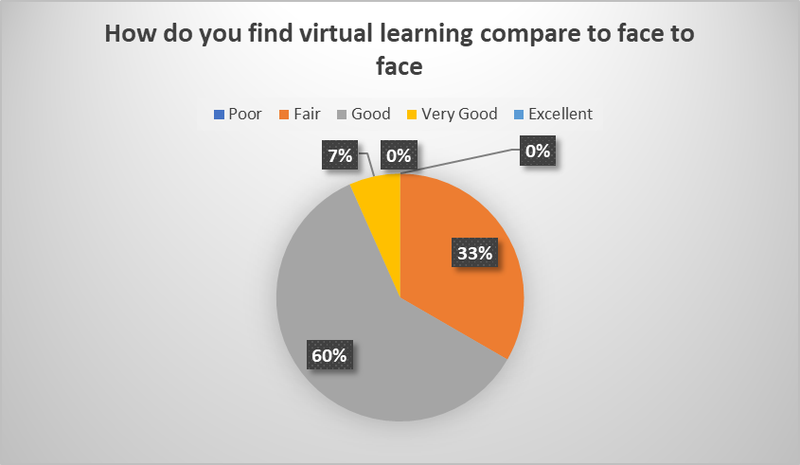
According to the chart when sixteen students were asked how they compare virtual learning to face to face, nine students said it was good which represent 60%, five student said it was fair which represent 33%, one student said it was very good representing 7%, neither of the students saw it as poor nor excellent.

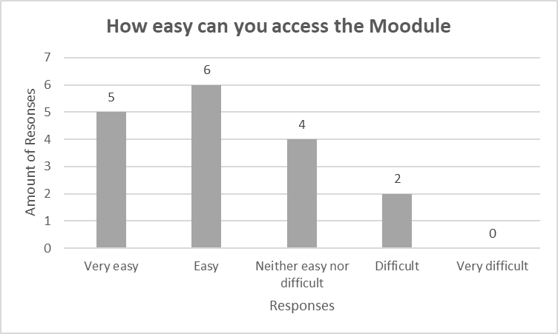
When students were asked how easy it was for them to access module, six student said it was easy, five students said it was very easy, four said it was neither easy nor difficult, two said students said it was difficult and no student said it was very difficult.

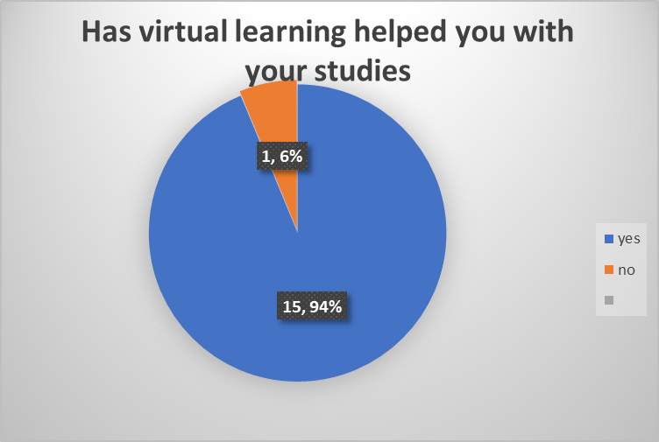
Based upon this chart result when student were asked how virtual learning has helped them with their studies, 15 students said it has helped them which represent 94% and only 1 student said it has not help him which also represent 6%.

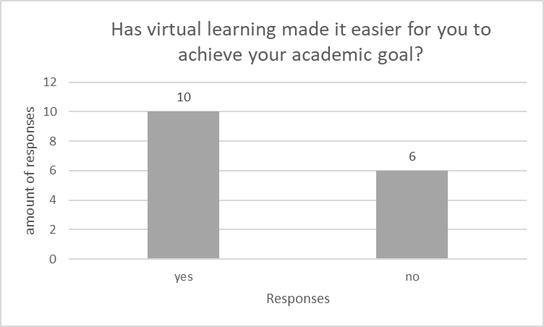
When student were asked if virtual learning has made it easier for them to achieve their academic goal, 10 students responded that it has helped them to achieved their academic goal, and 6 students also responded that it has not help them.

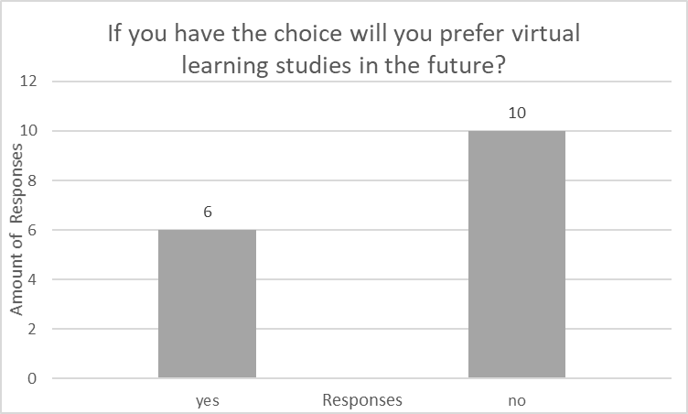
When students were asked if they will prefer to use virtual learning in the future, 10 people responded that they will rather prefer face to face learning, and 6 people also responded they will prefer virtual learning.

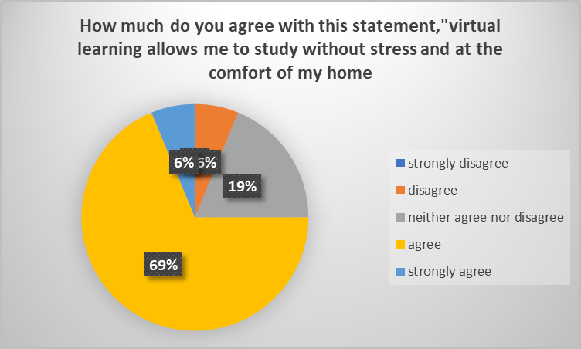

When students were asked if virtual learning has allowed then to study without stress and at the comfort of their home, 11 students agree to the statement representing 69%, three student neither agree nor disagree representing 19%, one student strongly agree representing 6% and one student disagree which also represent 6%.

5.4 Summary of Finding
Based upon the responds I had from the sixteen students whom I sent the questionnaire to, it has been established that majority of the student believed that computer-generated learning has impacted them positively at the University of Wales Trinity Saint David, only a few students think they have not benefited from it and has impacted them negatively.

5.5 Recommendation
As not all student think they have benefited from virtual learning environment at the University of Wales Trinity Saint David and has had negative impact on them, it is important that their concerns are address and improvement are made to virtual learning environment so that all students at the University will have positive impact on their studies, future research on virtual learning environment needs to be conducted so that the University will be able to know if virtual learning is impacting positively or negatively on the students at the University.

6.Conclusion
After conducting this research I can conclude that majority of students at University of Wales Trinity Saint David has had positive impact with virtual learning environment, but still there could be room for improvement like students having easy access to Moodle, better internet connection, and improvement to Microsoft team.

7.References
Gedera, D. S. 2014." An Activity Theory analysis of moodle in facilitating asynchronous activity in a fully online university course". International journal of Science and Applied Information Technology, 10(4), pp. 93-101.
Racheva, v.( 2017). virtual learning. [Online]
Available at: http://www.vedamo.com
[Accessed: 10 august 2020].

Cresswell, J. W. (2003) . Qualitative Inquiry & Research Design, London,
Sage Publications Ltd. (3 rd edn)
Ali, S. (2012), Questionnaire design & admin, [Online:
https://www.slideshare.net/ludymae/chapter-9methods-of-data-collection]

Glen, S. 2018. Statistics How TO. [Online]
Available at: http://statisticshowto.com/primary-data-secondary/
[Accessed: 23 August 2020].

Peterson, C. L., and N. Bond. 2004. Online compared to face-to-face teacher preparation for
learning standards-based planning skills. Journal of Research on Technology in Education 36
(4):345–61

Appendices 1

Appendices2 

