Name: Razvan Olaru
Student number: 1921597
Module code: BMSW4002
Module title: Effective Team Working & Communication
Module Lectures name:
Saqib Shamim
Assignment title: Effective Team Working & Communication Report
1980 words

Table of Contents
1. Introduction 3
2. Models of Communication 3
2.1 Shannon and Weaver (1948) 3
Figure 1 4
2.2 Schramm (1954) …………………………………………………………………………………… 4
Figure 2 ……………………………………………………………………………………………….. 4
2.3 Berlo (1960) ………………………………………………………………………………………… 4
Figure 3 ………………………………………………………………………………………………… 5
3. Communication Skills …………………………………………………………………………… 5
3.1 Verbal Communication …………………………………………………………………….. 5
3.2 Non-Verbal ………………………………………………………………………………………… 6

3.3 Active Listening …………………………………………………………………………………. 6
4. Case Studies ………………………………………………………………………………………… 7
5. Examples of poor communication from my workplace, and how communication could be improved …………………………………………………. 7
6. Conclusion ………………………………………………………………………………………….. 8
Reference list …………………………………………………………………………………………. 9

Effective Team Working & Communication Report

1. Introduction
Communication is the method of getting and transferring information, including many different methods. Also, according to Nordquist (2019), communication is "the creation and exchange of meaning." This report will explain the models of communication and communication skills.
2. Models of Communication
Are many types of communication methods, and this report will explain the three main models of communication studied: Shannon and Weaver (1948), Schramm (1954) and Berlo (1960).
2.1 Shannon and Weaver (1948)
According to Businesstopia (2018), Shannon and Weaver model of communication is a statistical and scientific theory produced in 1948. This model to use:
- the sender, the individual that gives the information
- encoder, the machine that transfers the information
- the channel utilized to transfer the information
- the decoder is the receiver device of the information
- the receiver is the target address of the information
- noise is the interference that not let the receiver to get the right information.
For example, somebody transmits a message through a telephone, or a telegraph, where the information is forward with a system device. Because of possible interference between the sender and receiver message, it is possible to be received a different message. For example, when a person thinks of something, and later say that idea but differently, some information is lost and is different understand. Aso, when someone is having a phone conversation, because of interference, some words are lost, and the receiver interprets the whole idea of information because the message was incomplete. Because of noise and interference through the messages, the receiver is more concerned when receiving the information to be acquired. This model applied in everyday communication, when people use messages, phone conversation, even in general talking. (Businesstopia 2018)
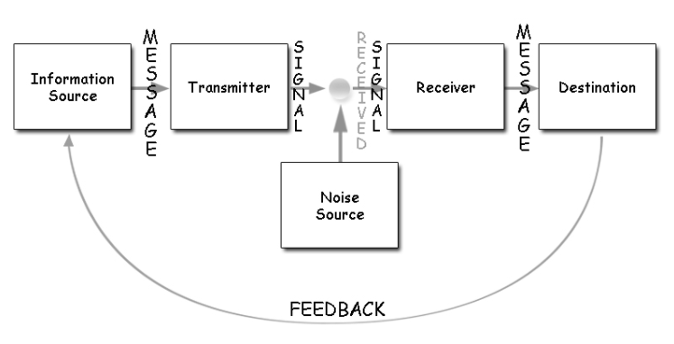
Figure 1

2.2 Schramm (1954)
"According to the Schramm’s model, coding and decoding are the two essential processes of an effective communication"(Juneja n.d.). Schramm thinks that to improve communication must having clear feedback from both sides, receiver and sender. If the communication is not accurate, it is interpreted and understood with errors by both sides. If the sender provides a message or information, and the receiver is interpreting the information because it is not clear, then he must give feedback of clarification back of the sender information. If the receiver does not send feedback, then the information can be fragmentary and misinterpreted. (Juneja n.d.)
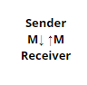
Figure 2

2.3 Berlo (1960)
In the Berlo’s model are several components of communication (Communication Theory n.d.):
- Source: must hold the strength to communicate, attitudes toward the public, experience to tell right the message, and the right material, knowing the social method, knowledge of community culture
- Message: the capability to produce, manage and send the complete information with all the details involved, like gesticulation, body expression, description and precise information
- Channel: It refers to the five human functions: vocal communications, visible information, touching, smelling and tasting.
- Receiver: customer needs to understand all the components and details of the specialist, to replies to the sender efficiently.
For example, if the communication ability of the specialist is accurate, then the customer should have exceptional listening abilities. For communication, the personage should acknowledge the customer, address equally and deliver them whatever they demand to understand the information. (Communication Theory n.d.)
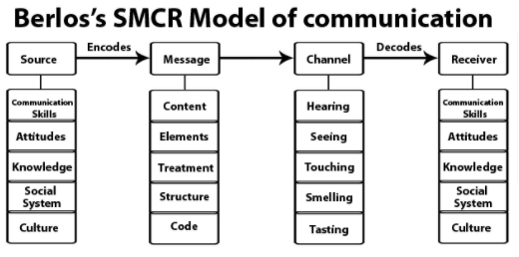
Figure 3

3. Communication Skills

The communication skills are Verbal, Nonverbal (Lumen n.d.) and active listening (Mind Tools n.d.). Verbal communication is the most common and known method of communication, and it is the spread of knowledge within two people speaking. Nonverbal communication is the body communication skills responding with facial and physical showed emotions. Active Listening is an essential communication skill that has a significant influence on connections with others (Mind Tools n.d.).

3.1 Verbal Communication
Verbal communication can be formal or casual conversation; for example, talking with a colleague is casual communication, when a discussion with a lecturer is a formal discussion. Spoken conversation is when an individual is part of a discussion, a lecture or a conference with a public. Written communication can be when an individual is addressing by correspondence, letter, or a written message. Verbal conversations are easy to understand because individuals can modify the information as is talking to the public to provide understandable information. (Lumen n.d.)

3.2 Non-Verbal

According to Lumen(n.d.) "There’s a myth that says that when you speak, only 35 percent of your communication is verbal and 65 percent of it is nonverbal." Additionally, depending on the circumstances, nonverbal communication can modify or damage the information. Nonverbal communication is the body communication skills responding with gesticulations, facial appearances, position, attitude and all the actual emotions displayed. (Lumen n.d.)
Models of nonverbal expression (Lumen n.d.):
- Facial appearance can determine if a character is happy, anxious, irritated, involved or not in the discussions.
- Gesture can produce information more reliable, deliver an understanding message, also can display frustration or excitement to the public.
- Proximity is the distance within the speaker, and the public, where can distract the public if the speaker is too close to them, even be a little intimidating.
- Touch, by hugs, shaking hands, can display affection, compassion, dominance.
- Speakers that keep eye contact with the public indicate that the individual is involved, prepared and engaged in the discussion.
- Appearance is also a non-verbal communication where is exposed to what type of person is speaking. Appearance is telling a lot about the individual where it can maximize the influence the information given.

3.3 Active Listening

3.3 Active Listening is an essential communication skill that has a significant influence on connections with others (Mind Tools n.d.).
For example, people are listening to know, discover, collect knowledge, even for entertainment. Active listening is when people are locus to learn the full information given. To become an active listener, people must (Mind Tools n.d.):
- give attention, being focused on the spokesman, avoiding distress
- confirming that they are listening, by applying facial emotions, looking involved and supporting the spokesman with oral observation
- contribute with feedback, by examining topics, by reviewing the spokesman remarks regularly
- defer judgement, by not interfere with analyses
- answer correctly, being transparent, precise and politely in conclusions.

4. Case Studies
In the case study "Max the multitasker" (Wahl et al.), Max had a lack of honest and empathetic listening. Max was very great at preparation and coordination events, so he begins a company from his house, that it starts with a big success. Unfortunately, he does not afford to hire somebody because his mother was very sick, and he needs to pay for her nursing house and her costly medicine. One customer, Tamara needed to reschedule her party, and she calls Max, that was very busy with other parties. Max having a lack of experience in the field and being busier in every day, he confirmed the reschedule, but he forgets to reschedule the venue. Unfortunately, Tamara does not call back later to confirm the revenue reschedule, and on the day that was the party, the venue was not available for their party, because Max forgets to reschedule the venue. The customer becoming angry, which threatened Max's company, could be viewed as lacking empathy. Regrettably, Max was not a good listener, and he fails to satisfy his clients, as he was not able to keep a schedule of his duties and to complete them because was too busy to work alone, and needed help, that he does not afford to get.
5. Examples of poor communication from my workplace, and how communication could be improved
In my workplace is poor communication in different field as:
- Most of the times, we take our breaks at the end of the shift. However, the breaks are supposed to be taken in the middle on shift. Unfortunately, because of poor communication between the employees, it is not created a shift breaks schedule, and all the employees are more tired during their shifts. This way, all the employees use non-verbal communication, hoping to be better in future, by being sad and extremely tired. If a part of the staff was using verbal communication, by talking with the management team, explaining the situation, all issues regarding the breaks were possible to be fixed. Then the staff more satisfied in the workplace with a smile on their faces all the times. When the staff enjoy their job, then the customers are happier and satisfied with a warm and welcoming place to be, increasing the productivity.
- Another poor communication in my workplace is when we get a new supervisor that he tried to input himself as a new boss. He tried to force everyone to listen to him, he started to control the staff even, and the minutes that they spend on the toilets, he push everyone on not very busy period to over clean all the place over and over, to do not see anyone that was staying for second to take a breath. Regrettably, this new supervisor is not caring to the employee's health, and he tried to be above the manager, unfortunately, the most of staff dislike him, and if he is not going to listen to the staff, the company will lose many good employees, as most of them are very stressed, sad and tired from when was employed the new supervisor. The new supervisor must learn how to be an active listener, to understand that is working with different background people and to make a better atmosphere in the workplace where everyone will enjoy their jobs again and to grow the productivity again.
- Another poor communication in the workplace is when all the staff talk between them in different languages and other who do not talk their language in the workplace can misinterpret their conversation. For example, in my workplace, we have staff from different countries, like Greece, Italy, Romania and England because the company do not require to the staff to talk just in English, because we live and work in London, all the staff talk in their mother languages. Unfortunately, some employees feel offended, even some of them feeling discriminated because they believe that staff that talk in their language ( Greek, Romanian, or Italian), can talk bad staffs about them and they cannot understand to defend themself. Having good verbal communication in the workplace, all employees must talk only English, to not be any misunderstanding and different perception in the workplace that can advance to discrimination. This way, all employees will feel equal in the workplace, and then they can have as a team an excellent verbal communication.
- Also, another poor communication in the workplace is when the management team talk wrong and rude with their team members. For example, in my previous workplace, the manager says to most of the staff that they are selfish because their request their day off in a specific week to be Sunday and Monday because they have some personal problem to fix. Also, the manager listens to the team conversation, and when the employee requests something like specific holidays or days off, they are rude because they heard what their plans in their holidays or their days off are. Also, when the staff is working for many hours with no break, and require having ten minutes break, the management team is rude and do not leave them to have some minutes rest. The management team must be more active listening, and to care about their team member and to talk more formal, as they must to be an example to their staff.

6. Conclusion
This report has explained the models of communication and communication skills. Also, it has explained in many examples of many events from the workplace. Learning the models of communication Shannon and Weaver (1948), Schramm (1954) and Berlo (1960), and having the communication skills like verbal, nonverbal and active listening will improve the individual life in a team, in the workplace, even is improving the everyday communication with the people around, like family, friend, and co-workers.

Reference list

“Active Listening”. Mind Tools.https://www.mindtools.com/CommSkll/ActiveListening.htm. Accessed 25 August 2020

“BERLO’S SMCR MODEL OF COMMUNICATION “. Communication Theory.
https://www.communicationtheory.org/berlos-smcr-model-of-communication/. Accessed 25 August 2020
Case study. MAX the MULTITASKER: A Case Study adapted from Quintanilla, K. M. & Wahl, S.T in Maund, A,. Shriek, M and Tinkler, A, Certificate in Higher Education:Skills for the Workplace. London. Sage . Available in moodle

Figure 1. “Shannon and Weaver Model Of Communication “2018. Businesstopia.
https://www.businesstopia.net/communication/shannon-and-weaver-model-communication. Accessed 25 August 2020

Figure 2. Prachi Juneja “Schramm’s Model of Communication”. MSG.
https://www.managementstudyguide.com/schramm-model-of-communication.htm. Accessed 25 August 2020

Figure 3. “BERLO’S SMCR MODEL OF COMMUNICATION “. Communication Theory.
https://www.communicationtheory.org/berlos-smcr-model-of-communication/. Accessed 25 August 2020

Prachi Juneja “Schramm’s Model of Communication”. MSG.
https://www.managementstudyguide.com/schramm-model-of-communication.htm. Accessed 25 August 2020
Richard Nordquist 2019. “What Is Communication?”. ThoughtCo. https://www.thoughtco.com/what-is-communication-1689877. Accessed 25 August 2020

“Shannon and Weaver Model Of Communication “2018. Businesstopia.
https://www.businesstopia.net/communication/shannon-and-weaver-model-communication. Accessed 25 August 2020
Student example of poor communication in own workplace

“Verbal and Nonverbal Communication “. Lumen.
https://courses.lumenlearning.com/wm-businesscommunicationmgrs/chapter/verbal-and-nonverbal-communication/. Accessed 25 August 2020

