Hot roll dry coil decoupling – MAde LEaner
Module Title – Manufacturing Systems and Simulation Module Code - ACMA6002 Student Name - Rhys James Davies Student ID - 2114983

July 21, 2023
University of Wales Trinity Saint David

\

Table of Contents
Introduction 2
Waste, Value added & Necessary non-value added 3
Waste in the Hot Rolled Coil Decoupling solution. 4
Achieving an Increase Customer Value 5
Making the Solution Leaner 6
Concerns with the changes 7
Works Cited 8

Introduction
The principles of the Lean Manufacturing model have been worked into manufacturing business models throughout history from Henry Ford’s assembly line manufacturing model to Deming’s PDCA to Taichi Ohno’s Toyota production model (Iuga, M.V. and Kifor, C.V., 2013). The key goal of Lean manufacturing is the elimination of waste within a given businesses manufacturing processes or services and the increase of value to the customer (Čiarnienė, R. and Vienažindienė, M., 2012). A range of activities and actions can be classified as waste and often is not straight-forward to identify the waste in the given process. Additionally, the activities that result in improved value to the customer can often be difficult to identify (Johansson, P.E. and Osterman, C., 2017). Additionally, Lean looks at what adds value from the customers perspective and how the process can be improved to increase this preserved value (Hildebrandt, M.G., Et al 2022).

The process that is going to be reviewed and made leaner is the hot rolled coil decoupling solution. This is a service solution and stock management design that allows Tata steel to maintain a level off stock for repeated intermediate hot rolled coils to improve lead times and delivery dates to customers by simply finishing the orders at the point of customer demand. The solution relies on the splitting of the end-to-end production of an order into two separate fulfilment strategies, Make to Availability (MTA) and Finish to Order (FTO). A level of stock of the HR coil will be maintained to ensure that the fulfilment of scheduled orders can be managed accordingly. As well as looking at the solution and highlighting waste to be reduced this report looks to determine what is valuable from the customers perspective and then working to increase that metric through processes improvements.

Waste, Value added & Necessary non-value added
There are seven main types of waste that can be found in lean manufacturing literature these are:
- Excess production
- Excess processing
- Delays
- Transportation
- Inventory
- Defects
- Movement
(Anvari, A., Ismail, Y. and Hojjati, S.M.H., 2011)

Within lean literature the above are classified as ‘Muda’ waste. However, there are additional wastes within the lean literature these being ‘Muri’ and ‘Mura’. Muri classified waste is in relation to overburdening and non-standardised tasks. Finally Mura is inconsistency or unevenness often suggested through inconsistency of demand management (Smith, S., 2014).

Activities and actions that actively plays a role in achiving the preserved value of the customer can be classified as ‘Value added’

Not all activities can be neatly classified as value added or waste and some actions are required i.e not waste but do not provide any value to the customer. These actions are classified as necessary non-value added actions (Melton, T., 2005). This report looks exclusively at the activities classified as waste and value added.

Waste in the Hot Rolled Coil Decoupling solution.
When reviewing the end-to-end process, the first waste identified was within the part of the process where orders were identified as suitable to be supplied through the solution. Within The current IT solution an algorithm predicts what the Hot rolled parameters will be ahead of their determination. This is done to ensure that the route of the order starts from the hot mill and does not result in any caster demand. However, the algorithm cannot accurately predict the routed characteristics and as such the range of orders identified as appropriate to pull from the solution is conservative. This means that the viable orders that the solution fails to identify are unnecessary processing relative to the possibility of pulling from the more streamline decoupled solution. Rewers, P., Trojanowska, J. and Chabowski, P. (2016) highlights one of the key goals of Lean manufacturing as a decrease in the end to end production time while not violating principles such as quality supporting the waste in this process supporting the waste classification in this instance.

The second form of waste identified was over checking. As a consequence of the algorithm solution a four-eyes check is in place to ensure that there has been no change to the routed hot rolled parameters. The volume of this checking causes an increase strain on resource and a bottle neck in the end to end process of creating orders for customer demand. Additionally, the checking is extremely data intensive and mistakes have been made resulting in concessions being raised for out of dimension coils at manufacturing units post hot mill. This results in increasing waste in the form of defect coils that have to be offered to customer on concession reducing the profit margins for the company and hurting customer relations. Furthermore, this additional processing waste directly contradicts the goal of the process to decrease the time it takes to supply demand to the customer. Four eyes checking if unnecessary is considered a waste from a lean manufacturing perspective (Kavanagh, S. and Krings, D., 2011). However, this is not always the case and can be consider valued added if it plays a role in ensuring accuracy and quality and therefore value to the customer. This particular checking process step is unnecessary and is only a required action due to the nature of the solution chosen and can therefore be declared as waste.

Another waste in the process in the process is one of excess production by not fully streamlining the decoupled coil solutions themselves. The review found that there are areas of the decoupling solution where the solution could be streamlined to use a single hot rolled coil. Most notably through the consideration of width trimming and crowning limits. This would further increase the value that the solution provides to the customer. As stated in a previously identified waste, failure to maximise the use of the decoupled results in overproduction as the end to end production of the material could have been streamlined through the decoupled solution.

Achieving an Increase Customer Value
The goal of the decoupling solution and the reason that customers pay a premium on their steel order is from improved delivery times. This makes the primary value consideration for the process the impact that the solution has on the overall delivery timescale for the customer. Within the Lean literature the end goal of decreasing delivery timescales is consistently perceived as a value to customers further supporting this (Gupta, S. and Jain, S.K., 2013). Therefore, any step within the process that plays a role in deliverying an improved timescale to the customer can be considered value added. However, the persuit of improved delivery timescales must not negatively impact the quality of product that the customer receives.

Further to this, the implementation of new decoupled offering ties in with the value to the customer. If a solution is agreed with the customer but it takes a year to implement the solution the customer receives a preserved lower value service for that year. It is therefore value added to streamline the implementation time of the decoupled solutions after inception.

L Wilson (2010). discusses synchronising supply to the customer as a key stage in implementing Lean manufacturing with specific mention to cycle, buffer, and safety stocks. The decoupling solution looks to manage these stock levels while maintaining as little internal stock to more effectively not tie up the company’s cash in stock levels.

Making the Solution Leaner

In order to make the process leaner an action plan was initiated to eliminate the waste identified.
Firstly, the optimisation of the use of grids was targeted. For example, there decoupling solutions to supply Shotton with cold rolled unannealed coil from the V stand in Llanwern. These solutions were originally mapped by Cold rolled percentage reduction only. This meant that no width alterations were pursued in order to maximise coverage of the relative decoupled solutions. Additionally, crown routing was not optimised to minimise the number of grids. Crown is not a requested aspect of the final steel product and is alternatively a consequence of the manufacturing process. The only external factor impacting value to the customer is that some customers may request and pay for a low crown in order for them to gain a flatter coil which for example allows them to more accurately control their processes for punching their products out of the steel.
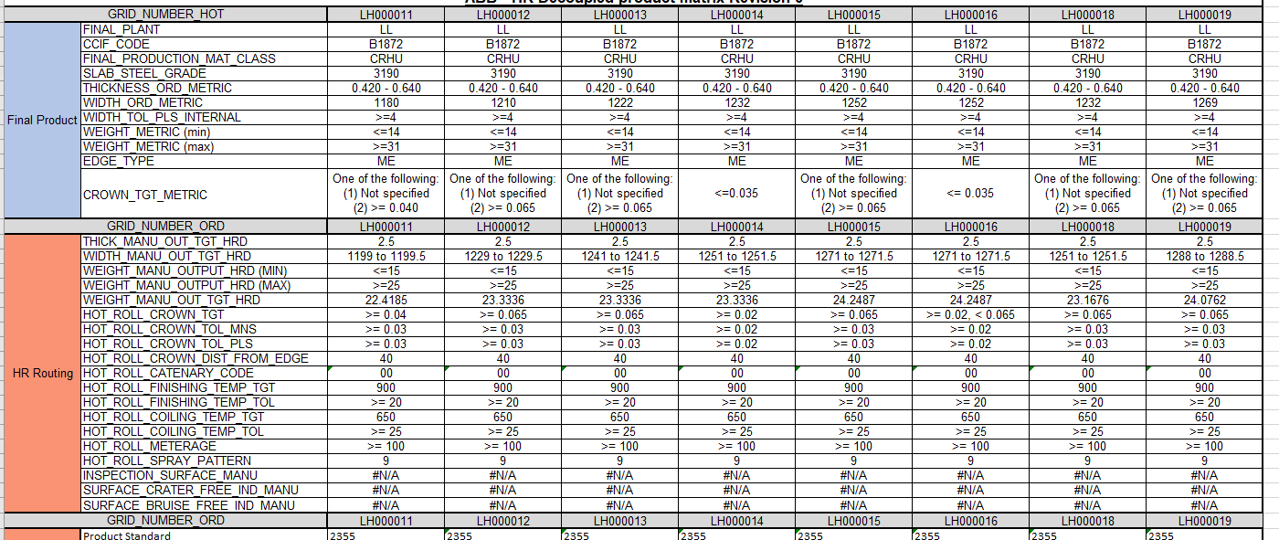

Through discussions with the pickle line it was declared that these formable grades could receive an additional trim of 30mm total increasing the total trim to 50mm. This meant that a HR coil of 1271 could now supply finished hard iron coils of width down to 1222mm. Additionally, discussions were held with the end customer who declared they had no issues with receiving lower crown material.

This resulted in the above grids being streamlined to a single hot roll coil. Eliminating waste in the form of overprocessing as well as standardising the Hot mill schedule process set up greatly by simply needing to produce larger qualities of the same coil with no variation in set up.

Furthermore, the need for the four eyes check was removed through a re-design of the inference solution of the hot rolled decoupled grid removing the need for the alogirthim. By mapping the end to end solution it was highlighted that at the point of creating the order the order entry team were often aware of the desire to pull from decoupled coil through input from the customer technical service team. This meant that a simple indication of the desire to pull from hot rolled coil could completely eliminate the need to predict the HR characteristics and the true inferred values could be used instead. This change also removed the waste that the conservativeness of the algorithm caused as the decoupling solution can now use full coverage. Lastly this change is far more accurate that the previous as the manufacturing characteristics are what are used to determine if the order is viable to be pulled from the HR coil greatly reducing the defects waste in the form of concessions. L Wilson (2010) discusses synchronising internally through creating flow in the process by decreasing variation and defects as a process for implementation lean manufacturing. Supporting the changes made to make the process leaner.

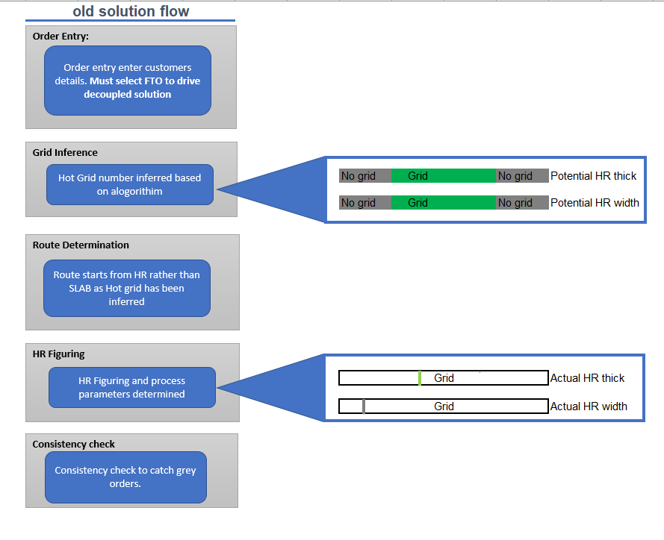

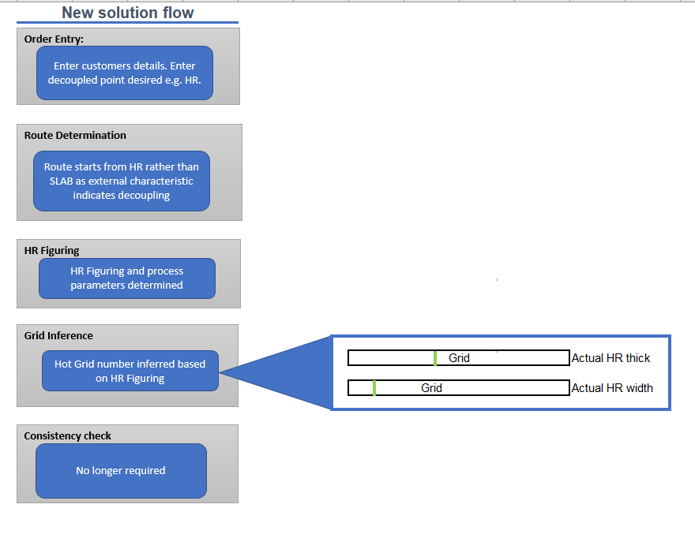

Concerns with the changes
The main concern with the implementation of the changes relates the management of change process. The success of streamlining of the multiple decoupling solutions down to one relies heavily on the stock management of the current grids and an accurately executed cross over process to the new design. There is a risk that if the cross over is not managed accordingly it may result in excess waste stock. In order to mitigate this risk an MoC and cross over process was put in place to manage the stock of the decoupling solutions that are to be made redundant. The hold stock level for the solutions was removed as to not re-stock coils as we reduce the stock. The remaining stock was then phased out and the new deocupled solutions stock phased in. This was done to ensure there was no impact to the supply of material to the customer.

Additionally, with the re-design of the solution there is a risk of confidence in maintaining the solution dropping across the team. Additionally, the implementation of the changes and reasons for doing so must be clear so that colleagues can understand the reason to change and buy into the continuous improvement of the change. To manage this training packs and walkthroughs have been provided in order to limit the confusion. Furthermore, the risk of implementation without appropriate buy in from the hot mill manufacturing shifts can lead to confusion and a sense of being left out as concluded by Bhamu, J. and Singh Sangwan, K., (2014). To avoid this, walkthroughs with each shift on the hotmill were co-ordinated to provide insight on what changes to expect and how to manage.

Works Cited
Anvari, A., Ismail, Y. and Hojjati, S.M.H., 2011. A study on total quality management and lean manufacturing: through lean thinking approach. World applied sciences journal, 12(9), pp.1585-1596.

Bhamu, J. and Singh Sangwan, K., 2014. Lean manufacturing: literature review and research issues. International Journal of Operations & Production Management, 34(7), pp.876-940.

Čiarnienė, R. and Vienažindienė, M., 2012. Lean manufacturing: theory and practice. Economics and management, 17(2), pp.726-732.

Gupta, S. and Jain, S.K., 2013. A literature review of lean manufacturing. International Journal of Management Science and Engineering Management, 8(4), pp.241-249.

Hildebrandt, M.G., Kidholm, K., Pedersen, J.E., Naghavi-Behzad, M., Knudsen, T., Krag, A., Ryg, J., Gerke, O., Lassen, A.T., Ellingsen, T. and Ditzel, H.J., 2022. How to increase value and reduce waste in research: initial experiences of applying Lean thinking and visual management in research leadership. BMJ Open, 12(6), p.e058179.

Iuga, M.V. and Kifor, C.V., 2013. Lean manufacturing: The when, the where, the who. Revista Academiei Fortelor Terestre, 18(4), pp.404-410.

L Wilson. (2010). How to implement Lean manufacturing. .: McGraw-Hill Education. pp.111-115.

Melton, T., 2005. The benefits of lean manufacturing: what lean thinking has to offer the process industries. Chemical engineering research and design, 83(6), pp.662-673.

Johansson, P.E. and Osterman, C., 2017. Conceptions and operational use of value and waste in lean manufacturing–an interpretivist approach. International Journal of Production Research, 55(23), pp.6903-6915.

Kavanagh, S. and Krings, D., 2011. The 8 Sources of Waste and How to Eliminate Them. Government Finance Review, 27(6 s 18).

Rewers, P., Trojanowska, J. and Chabowski, P., 2016, June. Tools and methods of Lean Manufacturing-a literature review. In Proceedings of 7th international technical conference technological forum (pp. 28-30).

Smith, S., 2014. Muda, muri and mura. Lean & Six Sigma Review, 13(2), p.36.

