Modul Code: BMSW4002
Module Name:
Effective Team Working and Communication

Assignment task:
Understanding of the models of communication and the communication skills and refer to any case studies done to show how these helped students’ understanding.

Student ID: _2010699______

Word count: 2,003
UWTSD, 2021

Contents

1. Introduction 3
2. Three Models of Communication 4
2.1. First model of communication: Shannon – Weaver 4
2.2. Second model of communication: Schramm 5
2.3. Third model of communication: Berlo 6
3. Communication Skills 8
3.1. Verbal communication skills – spoken and written 8
3.2. Non-verbal communication skills – body language 8
3.3. Active listening 9
4. Conclusion 10
References 11

Introduction

Communication is one of the main and most important driving forces of the human community. It is also a companion of all human activity and behavior. In the course of each joint activity, people exchange different ideas, ideas, interests, moods, feelings and states. Communication is the exchange of facts, ideas, views or emotions between people.
Communication takes place through certain signs and symbols to which some content is ascribed. Communication in this case could take place only if certain conditions exist (Harris, 2015).
Effective communication in the workplace is essential for good organizational functioning. Predetermines the building of effective teams and fruitful interactions with customers and partners of the company (Harris, 2015). It is a key factor for the professional development and career growth of employees.
This report investigates several communication models: Shannon - Weaver, Schramm, Berlo - described technically, backed by observations from real-world office experience, and visualised with schemes to provide a more complete interpretation of the model.
Participants must have excellent verbal and nonverbal communication abilities, as well as the capacity to effectively listen to and comprehend the speaker, in order for communication to be successful. These abilities are described in the report's second section and are illustrated with examples.

Three Models of Communication

First model of communication: Shannon – Weaver

There are several linear models of communication. One, developed by Claude Shannon and Warren Weaver, was created to make the transmission of an electrical signal more efficient (Shannon and Weaver, 1999). The Shannon-Weaver mathematical model includes an original source of information that sends a message to a transmitter, which then sends a signal to a channel. Noise within the channel can drown out the message. The recipient, who then decodes the message to the destination, receives the signal (Shannon and Weaver, 1999).
The Shannon-Weaver model is a one-way contact model established by Claude Shannon and Warren Weaver in 1948. Before we get through what the paradigm is, we need to break it down into the core terms.
Sender is the one who makes and delivers the post.
Encoder converts the message into signals.
Decoder receives the signals and converts them into a letter.
Receiver, the message's actual destination is the recipient.
Noise refers to unrelated distractions in the channel that can interfere with message receipt.
Now that we've established certain characteristics, let's take a look at the steps in the Shannon-Weaver contact model (Shannon and Weaver, 1999).

Graphic 1. Shannon and Weaver’s model of communication
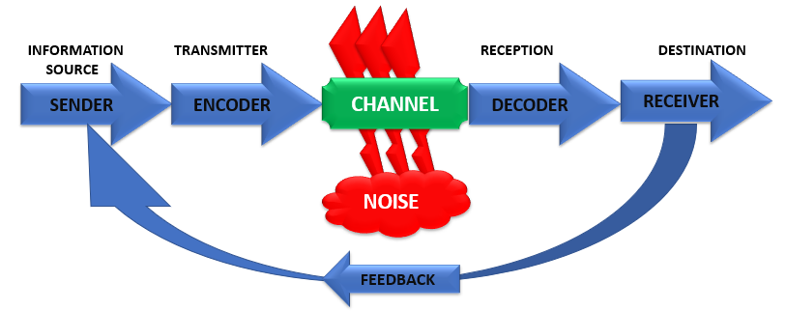
(Student, 2021)
Example: Two colleagues are talking on the phone; the relationship is unstable. One gives his subordinate a list of tasks to be done. The subordinate keeps notes during the conversation, which suddenly fades away. Performs 6 tasks that he has recorded. The manager is calm that he has dictated all the tasks, not realizing that the last 20 seconds the connection has been lost. When checking what was done at the end of the day, it was established that the tasks were 7, and only 6 of them were completed. The subordinate decided that the manager had stopped because he dictated everything. The manager did not realize that the connection was broken and continues to dictate the last 7th task.

Second model of communication: Schramm

Wilbur Schramm, on the other hand, categorizes the concept of communication as any content that reduces uncertainty or the number of alternative options in a given situation (Schramm, 2010). The Schramm contact paradigm is less conventional than the others.
Here are the various pieces you should be aware of:
Encoder: The encoder encodes the letter and delivers it.
Decoder: The message is sent by the decoder.
Interpreter: The individual attempting to translate the message is known as an interpreter (Schramm, 2010).
It is important to understand that sending a message is not the same as reading a message. You may be the intended receiver of a communication and yet receive it without having to translate and comprehend it. Even though we usually read messages when they come through, it is always an extra phase.
The Schramm communication paradigm depicts the continuous movement of regular communication. Since this paradigm focuses on the letter more than transmitting and receiving it, the sender and recipient aren't both named. This is mostly due to Schramm's recognition of the probability of transmitting and receiving messages to and from oneself. The Schramm contact paradigm differs from standard models in that it focuses on the letter rather than the sender and recipient (Schramm, 2010).

Graphic 2. Schramm’s model of communication
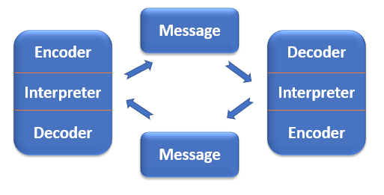
(Student, 2021)

Example: An entertaining TV show shows how a presenter has invited a politician as a guest to comment on the upcoming elections. There is a dialogue in which at one point the presenter asks questions and the guest answers, and the next moment the guest makes a joke that the presenter laughs at. Thus, both participants in the conversation have two-way communication and are both sender and recipient of messages.

Third model of communication: Berlo

Berlo's model of communication comes from the Shannon-Weaver model. This model was considered both the simplest and the most influential model at the time, according to C. David Mortensen (2005). The source of information has communication skills, attitudes, knowledge, and a specific cultural background that influences the message. The source encodes the message, which contains content, elements, structure, code, and processing. This message then goes to a channel that relies on the senses such as hearing, seeing, touch, smell and taste. The recipient then decodes the message and interprets it based on communication skills, attitudes, knowledge, and culture (C David Mortensen, 2005).
Sender generates the message that is meant for the recipient.
Receiver. The message received by the source is collected by the Receiver. Since the source and recipient may be interchanged, the factors that affect them remain the same.
Message. The material that is being received is referred to as a message. There are many approaches to crafting a post.
Channel is the way by which the message is sent. When breaking down the channel, it is particularly necessary to remember how the message is interpreted. A message's aim is to be answered, and hopefully well. If the sender selects the incorrect contact medium, the notification will not be sent.
We view a message sent via a medium using one or more of our five senses: voice, sight, touch, smell, and taste. Therefore, the medium by which a message is sent is important. We cannot detect or taste a photograph or a handshake. We might, but we would look stupid and get no details out of it (C David Mortensen, 2005).

Graphic 3. Berlo’s model of communication
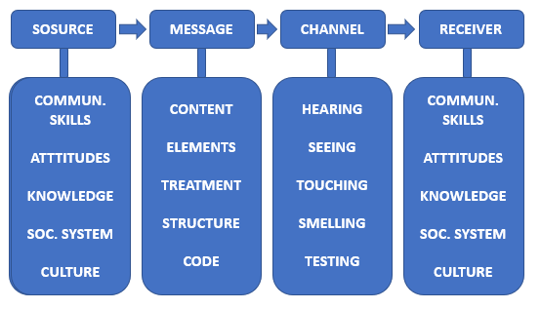
(Student, 2021)

Example: A child, looking out the window, tells his mother how the children play outside on the road and is angry that his mother does not allow him to play on the road, and the other children are allowed. In fact, the child, looking out the window, does not see the whole situation realistically, because outside the window there are signs for temporarily stopping the movement of cars on this section of the roadway. That's why children play undisturbed on the road.

Communication Skills

Verbal communication skills – spoken and written

Verbal contact involves using words to convey the desired meaning. Written and oral communication are the two main types of verbal communication. Traditional pen and paper letters and papers, typed electronic documents, e-mails, text chats, SMS, and everything else communicated by written symbols such as language are all examples of written communication. This type of communication is needed for formal business correspondence and the distribution of legal instructions (Hofert et al., 2015).
Whether face-to-face or by phone, voice chat, video conferencing, or some other means, the spoken word is the other type of verbal communication. Types of oral communication include informal communications such as the grapevine or informal gossip mill and structured communications such as lectures and conferences. Oral communication is used in discussions, causal and casual conversations. The quality of speech, voice modulation, rhythm, volume, tempo, and even nonverbal communications such as body language and visual cues all contribute to conversations' effectiveness.
Example: Teacher who has the verbal skill to present knowledge in an interesting and practical manner so the students are lead to pay attention, remember and therefore, effectively learn in this class (Hofert et al., 2015).

Non-verbal communication skills – body language

Nonverbal contact is communicated using non-linguistic means. These are the behaviours or characteristics of people with socially shared significance and stimulate the meaning of others, such as their presence, use of objects, sound, time, smell, and space (Buck, 2002). This includes visual/kinesics signals like facial expressions, eye motions, gestures, and body orientation; vocal/paralinguistic cues like tone, pitch, speed, and flexion; proxemic remarks like space and distance; olfactory or odours; replicas produced by objects communication and appearance; colour signals; and chronemic or temporal signals.
Nonverbal messages may be sent deliberately or unintentionally, and their context is determined by how they are perceived. As a result, they perform metacommunicative roles and interact for the sake of communication, clarifying the essence of our relationships and the meaning of our verbal messages. The researchers conclude that nonverbal cues bear roughly two-thirds of the message's communicative meaning. Nonverbal messages speak volumes even when used independently of words, if the observer draws meaning from them. Of course, the amount of information transmitted varies depending on its clarity and the receiver's acceptability and receptivity (Buck, 2002).
Example: While performing Zoom session it is noticed that a classmate is not in a good health condition while there is a task that needs to be done in a group. Another colleague proposes to do the task instead and the reason is the body language and the communication skill of recognizing someone’s condition.

Active listening

Active or “reflective” listening has initially been developed and refined by psychologist Carl Rogers for personal counselling use. Rogers wrote extensively about his very successful approach and gave seminars teaching others how to use it to help their patients. The technique can be beneficial in settings outside counselling, including everyday conversations, formal discussions, teaching, managing, and marriage—in virtually every situation where people interact (Buck, 2002). Active listening is instrumental when the speaker has a problem or is animated about some topic. The listener either wants to help the person with that problem or learn more about the speaker’s perspective. Active listening consists of two major components; first, seeking genuinely to understand the other person at two levels, and second, communicating or reflecting that understanding to the speaker. This latter characteristic has caused the approach to be referred to often as “reflective listening”. (Buck, 2002) The reflection is essential because it reassures the speaker and the listener that what is being communicated is understood. Without that connection, neither the speaker nor the listener is sure whether clear communication is taking place. Active listening is a learnable skill. This mindset is the desire to see and understand how another person sees and experiences the world. Having grown up as we have within our own experience set, most of us tend to think that the rest of the world sees the world as we do. We are surprised when we see people behaving in ways that seem irrational to us. To develop active listening skills is to have a genuine interest in seeing the world as others do. Given that desire, one must develop some, perhaps unnatural skills to become effective at the technique (Hofert, 2015).
Example: Reacting on the questions of a teacher with enthusiasm and the fact that a student answers fast is showing active listening throughout the session. This has a positive impact on the communication and learning process in a classroom.

Conclusion

After covering the analysis of the three most prominent communication methods presented by The Shannon-Weaver model, Schramm model, and Berlo model, there is an interaction between the components in the models. The main goal is effectively creating communication by explaining what a reason can be disrupted or the establishment of such chains. The effectiveness of communication methods and skill are crucial to a study and working environment because it affects students learning process and creates an understanding of share. Verbal and nonverbal skill is necessary for establishing communication in every aspect of life and developing such skills a mandatory for a student. Active listening is a skill that shows the ability of e person to interact on a higher level of communication. This skill can be learned, and it is highly appreciated in every institution. The transfer of information is a complex process; however, communication depends on it. It is essentially essential for the personal and professional development and understanding of an individual in every aspect.

References

- Buck, R. (2002). Verbal and Nonverbal Communication: Distinguishing Symbolic, Spontaneous, and Pseudo-Spontaneous Nonverbal Behavior. Journal of Communication, 52(3), pp.522–541.
- C David Mortensen (2005). Problematic communication: the construction of invisible walls. Westport, Conn.: Praeger.
- Harris, R. (2015). Editorial: Communication about communication. Language & Communication, 1(1), pp.1–2.
- Hofert, S., Burke, M., Balighian, E. and Serwint, J. (2015). Improving Provider-Patient Communication: A Verbal and Non-Verbal Communication Skills Curriculum. MedEdPORTAL Publications.
- Schramm, W. (2010). Mass media and national development: the role of information in the developing countries. Stanford: Stanford University Press.
- Shannon, C.E. and Weaver, W. (1999). The mathematical theory of communication. Urbana: University of Illinois Press.

