BMSW4002
Module: Effective Team Work and Communication

Lecturer name: Ejiro Esohwode

Assessment 2: Report of 2000 words demonstrating my understanding of the models of communication and the communication skills

Student ID: 2018709

Name: Georgel Marian David

Executive summary
In this report, various aspects of communication concepts and communication skills in workplace have been discussed. In terms of doing this, various journals and articles have been analyzed and understood. Personal understanding and experience have been mentioned. Theories and models related to communication are also specified here. The major concepts of these theories are stated here. Journals that have been collected to support the report and qualitative and quantitative evidence have been taken from it. Knowledge skills and cognitive skills have been addressed here. Some case studies have been analyzed to identify outcome of poor communication.
Table of Contents
Assignment 2: Report 4
Introduction 4
Engagement with literature skills 4
Concept of effective communication in workplace 4
Good communication skills important in workplace 4
Communication skills 5
Critical 21st century skills framework 6
Ways to deliver better communication in workplace 6
Feedback system 6
Knowledge and understanding skills 7
Models of communication 7
Communication theories 8
Cognitive and intellectual skills 9
Practical skills 10
Conclusion 10
References 12

Introduction
Communication skills refer to involvement of listening, observing, speaking, and understanding of conversations. In case of workplace, a communication skill is important as it helps in boosting the quality of teamwork and can lead towards “better project collaboration”. In case of every industry, this communication skill is applied and so it is important in terms of streamlining “internal communication”. Maintenance of effective communication helps in ensuring entire management and team below them remains on the same page. In this report, various aspects of communication skills and communication models have been discussed. Perspectives of communication in workplace and some case studies have been analyzed here.

Engagement with literature skills
Communication in case of workplace does not refer to the good quality of teamwork, rather than it refers to building relationships, minimization of errors, and productive working. Within workplace, good communication habits can help in resolving various crucial things within an workplace.

Concept of effective communication in workplace
“Effective communication” occurs if a message is sent as well as received accurately. Maintaining communication within workplace does not refer to effective communication. Workplace communication plays an important role for streamlining the entire internal procedure. Maintenance of effective communication helps in increasing the quality of productivity. If communication is maintained effectively, it can increase the confidence level among employees and correct undertaking of works is important here. However, business communication and workplace communication are different.

Good communication skills important in workplace
Establishing good communication within entire organization is important. Understanding of information by every parties involved can be termed as good communication skills. In present days, majority of the organizations are incorporating technologies to maintain the workplace communication effectively. As opined by Suarta et al. (2017), In terms of referring to employability skills, various technologies are being used within the community. With changing nature of working, employability skills are getting more important. Employability is being used along with other skills such as “generic skills”, “non technical skills”, “core skills”, “key skills” and “essential skills”. Hence, employability skills contain a set of “personal qualities”, “core skills” and “process skills”.
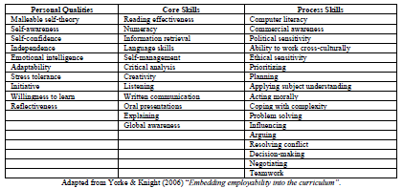
Figure : various communication skills
(Source: Suarta et al. 2017)

Communication skills
Communication skills refers to the process that occurs between more than two parties and people within which, messages are delivered as well as received by another party. In workplace, communication occurs each day. In case, managers give direction to employees for a project, team members communicate with each other regarding project all are done through effective communication. As stated by Mishra (2020), Communication skill is one of the most important employability skills that helps in working out a project effectively and maintaining a good interaction with customers. In terms of recruiting employees, communication skills are examined as it is very much beneficial for organization as well as employees. In addition,this communication also helps in establishing harmonious relation between customers and employees. Apart from that, communication skills can be termed as critical factors for success and can contribute towards organizational success significantly.
Communication skills can relate with ability of speaking, listening, reading, and writing. In terms of enabling effective communication, each employee should have a gainful insight in all “domains of communication skills' '. As stated by Naseem, Nausheen and Mirza (2018), “Communicating accurately and concisely”, “effective oral communication”, “listening effectively”, “and communicating pleasantly and professionally” are some of the factors that can help in developing effective communication skills.

Critical 21st century skills framework
In terms of 21st century, various frameworks have been organized that have been drawn from various perspectives of education, psychology and other fields. As stated by Rios et al. (2020), The “theory driven approach” includes incorporation of feedback from various substantive experts and other workforce specialists that can be determined based on learning outcomes of 21st century. This theory driven framework differs from synthesizing of skills and conceptualization of such skills.

Ways to deliver better communication in workplace
There are some ways following, which communication can be maintained effectively throughout the organization. These factors are “arrangement of meetings” which can help in developing collaborative culture, which further helps in improving employee engagement. Another factor is “brevity for effective workplace communication” which helps in speaking with managers which is important. As opined by Naseem, Nausheen and Mirza, (2018), this skill helps in managing “to the point” and brief communication. Clarification is another important way that plays a key role in managing good and effective communication. Communication style helps in refining the communication aspects. During maintaining communication, “open mindedness” plays an important role. This skill helps in entering to a conversation, which is completely free of judgment and other preconceived ideas. It provides a confidence to the speaker.

Feedback system
Feedback is also helpful in maintaining good communication. Feedback and communication are related to each other as ineffective communication can degrade the feedback system.
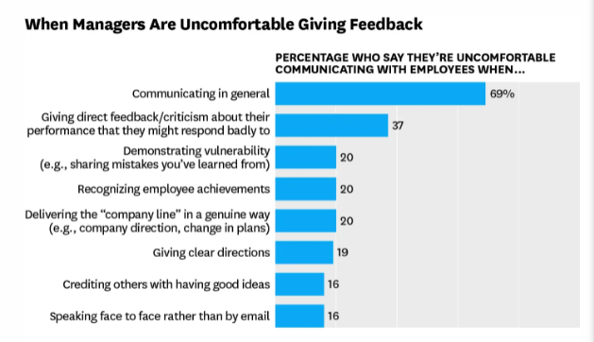
Figure: Feedback and communication
(Source: Naseem, Nausheen and Mirza, 2018)

Knowledge and understanding skills
In terms of understanding various aspects of concept of communication, some models, techniques, and theories are necessary to be understood. Throughout this lesson, I have gained the concept of communication and various insights related to it. The fundamental understanding of me in this aspect has been presented here.

Models of communication
Linear model of communication: this model has been developed by “Shannon and Weaver” in the year 1948 and this model is related to the linear process of communication. Raba (2017) stated that the process in which, sender, speaker transmits messages to other parties have been discussed here completely. Behavior within communication interaction can be defined by this model.
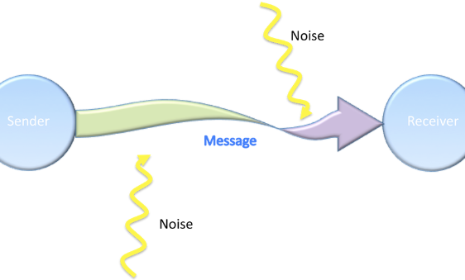
Figure: Linear model of communication
(Source: Raba, 2017)
Interaction model: this model is related to dynamic views of communication. It follows two channels such as communication flow between receiver and sender. Feedback is referred to as indicative comprehension; this model shows communication as an “ongoing process”.
Transactional model: this is also a dynamic model of communication. Fundamentally, this model helps in viewing communication as a “transaction”. In addition, communication refers to a “cooperative action” in which communicators can help in co-creation of processes. Raba (2017) opined that Outcome as well as effectiveness of such interactions can be identified from this. In contrast with interaction models, understanding is not achieved through feedback, in this case people share meaning in a dynamic process.

Communication theories
In terms of understanding various communication theories, I found that there are various theories associated with communication concepts. Major theories associated with communication are “actor network theory”, “adaptive structuration theory”, “agenda setting theory”, “cognitive dissonance theory”, “social exchange theory”, “social learning theory” and many more (mvorganizing.org, 2021). I have acquired the core concept of these theories and the major importances of such theories are also discussed here. I found that communication helps in understanding a process clearly and concisely. Some other concepts of communication such as verbal communication, non verbal communication, interpersonal communication are important in this aspect.

Cognitive and intellectual skills
I have gone through various research journals and articles based on communication and its related concepts. I found that various researchers have provided their individual review and realization throughout these journals. In the journal “Communication Skills for Workplace Success” (Doyle, 2018), top most important communication skills have been presented. These skills are mentioned as “listening”, “non verbal communication”, “clarity and concision”, friendliness”, “confidence”, “empathy”, “open mindedness”, “respect”, feedback and “picking the right medium”. An in depth understanding of these skills have been identified from this journal. This journal has entirely focused on discussing communication skill and in what ways these skills can be developed. Various examples are also given here.
In “Employers’ Perspectives on Workplace Communication Skills: The Meaning of Communication Skills” (Coffelt, Grauman and Smith, 2019) journals, perspectives of employers related communication skills have been discussed. The specific types of communication skills have been addressed that are relevant with employment perspectives. Communication skills that are necessary in workplace are addressed here. This journal is completely focused on “closing the gap studies” and “genre theories”. Unlike the previous journal, this journal does not discussed regarding communication skills but emphasized on theoretical approaches. Some alternative approaches also have been mentioned here which can help in effective communication establishment.
In the journal “Communication Models in Internet of Things: A Survey” developed by (Kulkarni and Kulkarni, 2017), the relation between communication and “internet of things (IoT)” has been addressed. The basic concept of IoT has been stated. Relation between IoT and various communication models have been represented to have an in depth insight about the topic.
In “Communicating quantitative evidence of policy effectiveness and support for the policy: Three experimental studies” (Reynolds, Pilling, Marteau, 2018), this journals has unmodified communicating evidence regarding effectiveness. These journals stated that communicating evidence did not “change support” for policy. However, the info graphic used here reveals that it has increased support for tax return from 45% to 49%. This effect was mediated by “perceived effectiveness”.

Practical skills
In this section, my understanding and realization from some real life case studies based on communications issues have been stated. The way in which poor communication can result in big failure have been addressed here. In the first case study, a chemist shop has been analyzed. Bruce was a research chemist in a large petrochemical company. He innovated some new compounds from some “oil refining by products”. These compounds were environment friendly, safe and economical insecticide (communicationtheory.org, 2021). However, this discovery of Bruce has not been recognized by the company and so he left that company. This has been resulted due to improper and ineffective communication. The company lost an efficient employee due to lack of proper communication.
In another case, a software company named Sagatec Software Inc., a new kind of automation has been initiated for having high quality and user-friendly accounting programs for the business and industries. An effective and versatile program has been developed; however, proper training on using the software has not been provided (communicationtheory.org, 2021). This resulted in leading confusion among users and the manual they developed was not effective enough to clarify the idea of ways to use it. Hence, this also happened due to lack of effective communication.
In my workplace, some issues related to communication have been felt. I found that there is a lack of free and open relationships among project managers and project team members. This resulted in various confusion among employees and degraded the quality of their productivity.

Conclusion
Throughout this report, various aspects of communication have been described. The major importance of communication in workplace has been described here. Various information has been drawn from relevant literature on communication skills and communication in workplace. This information and understanding have been developed in some themes and have been discussed thoroughly. Theories and models related to communication are also specified here. The major concepts of these theories are stated here. Journals that have been collected to support the report and qualitative and quantitative evidence have been taken from it. Apart from that, some case studies have been referred to identify poor communication and its effect on workplace productivity.

References
Journals
Coffelt, T.A., Grauman, D. and Smith, F.L., 2019. Employers’ perspectives on workplace communication skills: The meaning of communication skills. Business and Professional Communication Quarterly, 82(4), pp.418-439.
Doyle, A., 2018. Communication skills for workplace success. Retrieved November, 19, p.2018.
J.P. Reynolds, M. Pilling, T.M. Marteau, 2018. Communicating quantitative evidence of policy effectiveness and support for the policy: Three experimental studies, Social Science & Medicine, Volume 218
Kulkarni, S. and Kulkarni, S., 2017. Communication models in internet of things: a survey. International Journal of Science Technology & Engineering, 3, p.3.
Mishra, P., 2020. EFFECTIVE COMMUNICATION SKILLS: INVESTIGATING THE POLITENESS STRATEGIES USED BY WOMEN AS WORKPLACE DISCOURSE. Journal of Critical Reviews, 7(13), pp.1183-1187.
Naseem, Z., Nausheen, I. and Mirza, Z., 2018. Propagation models for wireless communication system. signal, 5(01).
Rios, J.A., Ling, G., Pugh, R., Becker, D. and Bacall, A., 2020. Identifying critical 21st-century skills for workplace success: A content analysis of job advertisements. Educational Researcher, 49(2), pp.80-89.
Suarta, I.M., Suwintana, I.K., Sudhana, I.F.P. and Hariyanti, N.K.D., 2017. Employability skills required by the 21st-century workplace: A literature review of labour market demand. Advances in Social Science, Education and Humanities Research, 102(58), pp.337-342.
Online articles
Raba, A.A.A., 2017. The influence of think-pair-share (TPS) on improving students’ oral communication skills in EFL classrooms. Creative Education, 8(1), pp.12-23. Available at: https://www.scirp.org/journal/paperinformation.aspx?paperid=73454 [Accessed on 24th aug, 2021]
Websites
communicationtheory.org, 2021. Shannon and Weaver Model of Communication. Available at: https://www.communicationtheory.org/shannon-and-weaver-model-of-communication/ [Accessed on 24th aug, 2021]
mvorganizing.org, 2021. What is the 4 models of communication? Available at: https://www.mvorganizing.org/what-is-the-4-models-of-communication-2/ [Accessed on 24th aug, 2021]

