Module Code and Name: - LCLM5001: Understanding and Engaging Stakeholders
Assignment: Report
Company: BUPA private insurance company

Student Name: Malgorzata Dhouib
Student ID: 2412522

1. Executive Summary
The plan described in this report is the stakeholder involvement strategy of the wearable health device project that will be implemented by Bupa in the future. This gadget, which is meant to monitor the heart rate, the oxygenation and the sleeping patterns, is expected. It empowers the individuals such that they can be empowered to be in control of their health. The report outlines the advantages of Bupa, such as a high reputation on the market and a large number of customers. However, other hurdles such as regulatory barriers, rivalry and consumer acceptance remain.
Identification and analysis of the stakeholders are considered to come up with important and key internal stakeholders like the Product Development, Marketing and Sales Teams as well as the external stakeholders like the regulatory bodies, suppliers, healthcare providers, and consumers. The report mentions the roles, responsibilities, benefits, and challenges that all the stakeholders face and offers an engagement strategy that addresses the needs of the stakeholders.
The report insists on the necessity to ensure good communication, coordination, cooperation and collaboration between the stakeholders that are necessary to instil the success of a project. It also covers the techniques of conflict management, including the application of negotiation and mediation to resolve potential conflicts. The report focuses on assessing the intention of stakeholder involvement on the performance of the business.
Finally, recommendations on the improvement of stakeholder engagement and building long-term relations at the post-launch stage are given. Bupa stakeholder management is decisive in the introduction and eventual success of its wearable health device in the competitive health technology market.

Table of Contents
Introduction 4
Situational Analysis 5
SWOT Analysis: 5
PESTLE Analysis: 6
SMART Objectives 6
Stakeholder Identification and Analysis 6
Internal Stakeholders 6
External Stakeholders 7
Roles, Responsibilities, Benefits, and Challenges of Stakeholders 8
Roles and Responsibilities 8
Benefits 9
Challenges 9
Stakeholder Engagement Frameworks 10
Stakeholder Matrix: 10
RACI Matrix: 11
Engagement Plan: 12
Communication Plan: 12
Process for Engaging Stakeholders 13
The Engagement Process 13
Conflict Management 14
Impact of Stakeholder Engagement on Business Performance 15
Impact on Project Outcomes 15
Business Performance 15
Evaluation 16
Recommendations for Improvement: 16
Long-term Engagement Strategies: 16
Conclusion 17
References: 19

Introduction
Bupa, which is one of the significant providers of health insurance in the UK (and more), and it provides several services connected with health to people and companies (Murray, 2024). Bupa employs over 16 million consumers and operates in over 190 countries, dealing with health insurance, medical and private healthcare. Bupa has a significant role to play within the health insurance industry since it provides the necessary health cover, health and fitness, and general health services. The company is committed to the improvement of the health outcomes, and Bupa has always targeted innovation and the evolving needs of its customers.
Bupa is looking forward to launching a brand new wearable health device, which would help monitor the key health parameters such as the rate of monitoring the heart rate, oxygen level, and sleep patterns. This device will aid in empowering the human being to monitor his or her health in real time and be proactive in order to take preventive measures. With the rising number of customers demanding personalized health technology, Bupa will launch the product in six months.
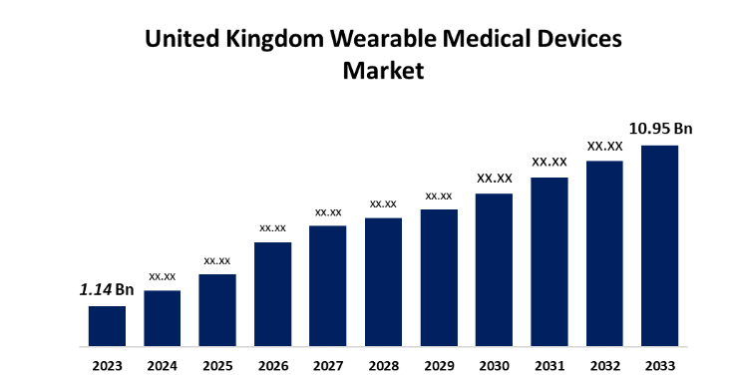
Figure: UK’s Wearable Medical Devices Market
Source: Spherical Insights (2024)
As can be observed, the picture shows a steady increase in the sale of wearable medical equipment in the United Kingdom, where the value of the market will be as low as 1.14 billion GBP in 2023 and grow to 10.95 billion GBP in 2033. The growth is in connection to increased popularity of health-related wearables. The expansion is associated with the recent launch of a wearable health device by Bupa, which is capable of tracking the heart rate, oxygen levels, and sleep habits.

Situational Analysis

SWOT Analysis:
Strengths | Weaknesses
Good reputation in the market in the healthcare industry.. | Product development issues.
High level of established customers. | Poor experience with wearable tech.
Massive resources and investments. | Expensive research and development.
Opportunities | Threats
Diversification into wearable health tech. | Rigorous competition among other brands.
Increasing health consciousness in the world. | Healthcare technology regulatory issues.
Growing consumer needs for health tracking. | Possible consumer resistance toward new technology.
Bupa has the advantage of having a good reputation in the market and a considerable number of customers, which makes the company a trusted healthcare service (Bupa, 2025). However, it might not be able to fast-track innovations because of the problems in product development and the allocation of resources. The opportunities are the rising number of health-sensitive consumers and the rising demand for wearable health technology. The utilisation of these trends can be taken advantage of by expanding into this sector. Nevertheless, risks including stiff competition in the market, regulations, and lack of acceptance of new technology may have an effect on the success of Bupa launching this device.

PESTLE Analysis:
Political: According to the healthcare devices and wearable tech, regulatory issues could occur, such as adherence to health regulations and data protection legislation (Bouderhem, 2023).
Economic: It will need a serious financial outlay in product development, testing, and marketing which affects the resources of Bupa.
Social: The increased preference of consumers to health and fitness technologies, people turn more health-conscious, and demand individual health monitoring technology (Rahaman et al. 2023).
Technological: Bupa has a chance due to the rapid development of wearable technology, including more precise sensors and longer battery life.
Legal: Information privacy laws, Health care laws: privacy of personal health care information regarding its collection, storage, and use.
Environmental: Growing interest in sustainable and eco-friendly processes in manufacturing, and hence supply chain and product design.

SMART Objectives
Objective | Description
Specific | Introduce a health gadget in the form of a wearable that monitors the heart rate, oxygen level, and the sleeping cycle.
Measurable | Within the first 12 months of launch, a 25 per cent market share will be achieved.
Achievable | In 6 months, create the device's existing interest and capabilities.
Relevant | Fits the mission of Bupa to innovate and branch out into wearable technology.
Time-bound | The product launch should be done within 6 months

Stakeholder Identification and Analysis

Internal Stakeholders
The wearable device project would not be as solid without the Product Development Team (Minogue et al. 2024). This team would be in charge of design, prototyping and testing of the product in order to ensure that the device is designed and meets technical requirements, including monitoring of heart rate, oxygen levels, and tracking sleep. They have the experience of developing hardware and software, which is important in the effective delivery of the product in time and in an efficient manner. The Consumer Technology Association states that the market of wearables is rapidly increasing, with more than 130 million products sold worldwide in 2020, which indicates the relevance of efficient product development (Pérez Rico et al. 2022).
The Marketing Team is very important in making the product visible and attractive. They have their work in developing a strong marketing strategy which would involve branding, advertising and market research (Ahmed, 2025). With the devices matching the needs of the consumers, there is an aspect of marketing that will facilitate the demand. The marketing team of Bupa must use evidence-based thinking to reach the right group of people, and this can be illustrated through effective campaigns in neighbouring markets. This group of stakeholders is important because the application of digital marketing platforms like social media networks has paid off in terms of more engagement on health tech products.
The Sales Teams are used to take the product to the market and generate revenue. They are in control of distribution, customer relations and channels. They focus on the partners and making sure they receive partnerships with retailers and become a source of direct revenue. Effective sales strategies in the wearable tech industry can be seen through successful product launches, including Fitbit remaining at the top of the market.

External Stakeholders
On the outside, there must be Regulatory Bodies that help in the verification of the device as per the health and safety standards. In the UK, wearable health devices are one of the products that have to be regulated by specific bodies such as the Medicines and Healthcare products Regulatory Agency (GOV.UK, 2024). The approval by such bodies is important in helping consumers to trust products.
The material needed to view devices production is given by the suppliers. Precise timing of the supply of quality materials such as batteries and sensors is very important towards achieving deadlines during development. Alliances with major suppliers, such as Qualcomm, who provide the technology behind wearable devices, can be considered one of the examples of how the relationships with suppliers can have a direct impact on the product's success (Qualcomm, 2021).
Healthcare Providers have an opportunity to collaborate with Bupa towards the implementation of the wearable device in health services. They might be embraced by the consumers, which is likely in the case of Apple in its cooperation with medical institutions to track chronic health conditions (Apple Healthcare, 2022).

Roles, Responsibilities, Benefits, and Challenges of Stakeholders

Roles and Responsibilities
The Product Development Team is expected to design, develop, and test the wearable device (Arandia et al. 2023). Their responsibility covers making sure that the device is correct in monitoring the heart rate, oxygen levels and sleep patterns and hardware and software integration. Being the central team in the development of the product, their contributions would be crucial in determining the features of the product and its ability to meet market expectations. The wearable health tech market reached 84 billion in the world in 2024 and is anticipated to reach 186 billion in 2030, indicating the significance of being innovative in the field (Grand View Research, 2025).
The Marketing Team has a responsibility to develop a powerful go-to-market strategy. Their actions include branding, positioning the device in the market and adoption of advertising campaigns to attract interest and awareness. As the need for health and fitness wearables continues to increase, a good marketing strategy can result in a high number of consumers. Reports point to the fact that the wearable tech market is developing at a very high pace, and the market will reach USD 176 billion by 2023(Market and Markets, 2025).
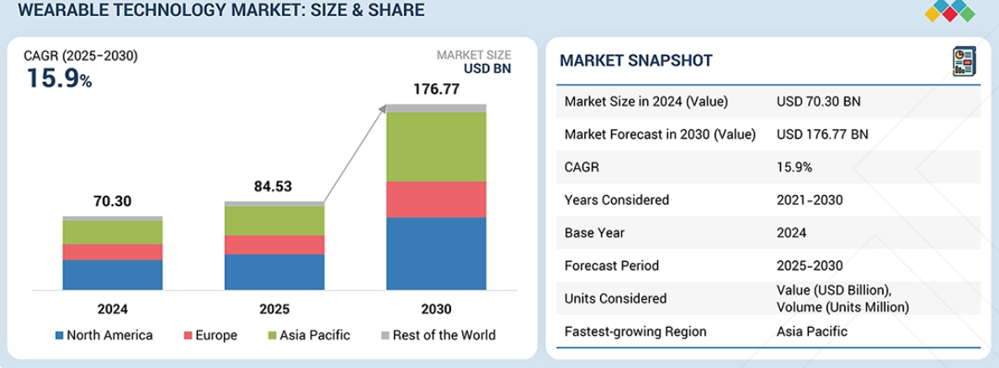
Figure: Wearable Technology Market
Source: Market and Markets (2025)
Sales Teams deal with the distribution, retail relationships, and online sales. They are charged with the responsibility of engaging retail clients, customers, and product adoption. To illustrate this point, Fitbit has been successful, and this can be attributed to the adoption of an efficient sales strategy that saw the product being sold in retail stores and online stores, thereby giving it as much exposure as possible (Jang and Kim, 2025). The Finance Team makes sure that the project is viable. They are also required to control the project budget, find funds to develop their products and make a profit.

Benefits
The respective stakeholders have different advantages for the project. The Product Development Team brings in the technical excellence, making sure that the device can work, can be correct and innovative (Asad et al. 2025). They must play a vital role in the production of a great quality product to enable acceptance in the market. The Marketing Team can offer market intelligence, determining the needs and trends of the market to be used in positioning the product. They have an aptitude to produce forceful marketing messages, and hence the product will be well received among the target audiences.
The Sales Team will be equipped with the understanding of consumer behaviour and market demand, and through this, the product will be passed to the right customers using the right distribution channels. The Finance Team will make independent contributions in the form of budgets, making the project economically viable and profitable.

Challenges
Although they contribute, there are some challenges that each of the stakeholders may encounter. The Product Development Team can even face technical challenges, including the need to make sure that the device passes high health requirements and incorporates high-quality sensors to do precise tracking. Such regulatory authorities as Medicines and Healthcare products Regulatory Agency (MHRA) might make draining requirements, and this might slow down the development process (Makrani et al, 2025). Another issue that the Marketing Team has to deal with is consumer scepticism about the accuracy and reliability of wearable health technology. Discussing the issue of the privacy of data and product effectiveness is an important step towards building trust.

Stakeholder Engagement Frameworks

Stakeholder Matrix:
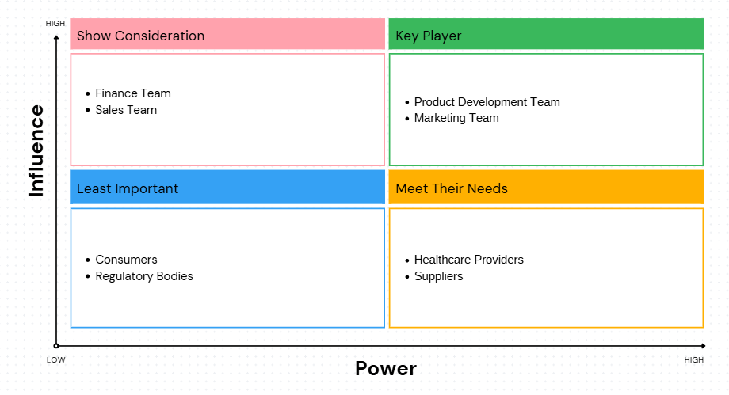
Figure: Stakeholder Matrix
Source: Self-created
The Bupa Wearable Health Device Stakeholder Matrix groups the stakeholders in levels of the degree of influence and interest in the project. The Product Development and Marketing Teams are some of the key players, as they have great influence and interest in the product and shape the success of the product. The Show Consideration category comprises the Finance and Sales Teams, which, though not heavily engaged in the technicalities of the products, play critical roles in resource distribution and the penetration of the market. Meet Their Needs, such as Healthcare Providers and Suppliers, are high-interest-low-involvement, and the least important stakeholders, such as Consumers and Regulatory Bodies, have a more passive role.

RACI Matrix:
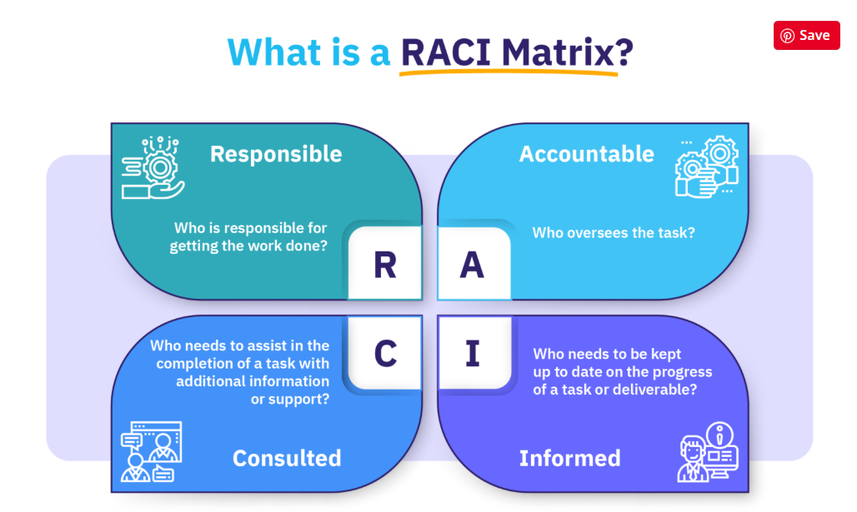
Figure: RACI Matrix
Source: Moltke (2026)
Task | Product Development Team | Marketing Team | Sales Team | Finance Team | Healthcare Providers | Suppliers | Consumers | Regulatory Bodies
Product Design and Development | Responsible | Consulted | Informed | Informed | Consulted | Consulted | Informed | Informed
Marketing Strategy & Campaign | Consulted | Responsible | Consulted | Informed | Informed | Informed | Informed | Informed
Sales Strategy & Distribution | Informed | Consulted | Responsible | Informed | Informed | Consulted | Informed | Informed
Budget & Financial Management | Informed | Informed | Informed | Responsible | Informed | Informed | Informed | Informed
Product Launch & Consumer Adoption | Informed | Consulted | Responsible | Informed | Consulted | Informed | Accountable | Informed
Compliance & Regulatory Approval | Informed | Informed | Informed | Informed | Informed | Informed | Informed | Responsible
Supply Chain Management | Informed | Informed | Informed | Informed | Informed | Responsible | Informed | Informed
The RACI Matrix is a table that specifies the roles and roles of the key stakeholders in the wearable health device project of Bupa. The Product Development Team is where the major responsibility lies in terms of product design and development, whereas the Marketing Team is the one that takes the responsibility for the marketing strategies. Distribution strategies are being addressed by Sales Teams, whose main task is to be devoted to consumer adoption and revenue. Budgeting is taken care of by the Finance Teams, with Accountable taking the responsibility of Finance. The Accountable role is due to the Regulatory Bodies, to ensure compliance, and the Responsible role is due to Suppliers to deliver components in time. The matrix explains the role played by every stakeholder towards project success.

Engagement Plan:
Bupa needs to implement strategies that are tailored to several stakeholders to best mirror their needs and roles. In the case of the Product Development Team, innovation and the ability to make a decision in time should be promoted with the help of regular meetings and collaborative tools (Swart et al. 2022). The Marketing Team must also undergo brainstorming exercises and market feedback mechanisms, while ensuring that they are kept up to date with consumer preferences. Sales Teams should be regularly trained and informed about the features of the product so that they can be able to sell the device. In the case of the Regulatory Bodies, it will be beneficial to involve them early as part of developing the product so that things are not compromised by violation of health and safety rules.

Communication Plan:
Effective communication is essential to ensure that the stakeholders are updated (Chukwurah et al. 2024). The Product Development and Sales Teams will be informed about any changes and progress regularly through email, video conferences, and internal platforms. As a company, reports and compliance should be provided to the Regulatory Bodies and Healthcare Providers as an external party. The immediate feedback (surveys and consumer test results) will be of great assistance to the Marketing Team.

Process for Engaging Stakeholders

The Engagement Process
Clear communication, coordination, cooperation, and collaboration are needed to ensure effective stakeholder engagement (Koilakonda, 2023). Through the application of The Four Cs, which are Communication, Coordination, Cooperation, and Collaboration, Bupa will be able to ensure optimal stakeholder participation and stakeholder commitment to the project.
The key to effective stakeholder engagement is communication. Informing the stakeholders timely manner on the forces behind the wearable device, addressing their concerns, and sending important updates will build trust and transparency (Igwe-Nmaju and Anadozie, 2022). As an example, the Product Development Team must be constantly informed with the help of team meetings, project management software and real-time collaborative tools such as GROVE (Thomas, 2024).
Coordination entails bringing together all the stakeholders that are involved and going in one direction, which is towards shared goals. In that manner, the Sales Team must coordinate closely with the Marketing Team to guarantee that the promotional campaign is aligned with sales and that the distribution channels of the products are prepared (Shaffer and Okundaye, 2025). It will be ensured that the coordination meetings are conducted frequently to prevent stalling and lack of congruence so that the team can focus on addressing any arising problem effectively before it runs out of control.
Cooperation is something necessary to establish healthy relationships between the stakeholders. To illustrate, such parts as the Product Development Team and the Regulatory Bodies should liaise to guarantee that the device adheres to health and safety standards (Daryanani et al. 2025). This entails clear and consistent feedback from the regulatory bodies and understanding what they need to be by the development team.
Lastly Collaboration is the ultimate stage of engagement, in which the stakeholders collaborate to co-create solutions and make decisions. The Product Development Team and the Marketing Team will need to work closely to develop the product and ensure that it matches the expectations of the consumers. Healthcare Providers should also work with Bupa in testing the device and offer useful clinical feedback on how to enhance the product.

Conflict Management
Even in cases where the stakeholders have been approached best, a conflict can occur in the project, especially when there is a conflict of interest, objectives or expectations among the stakeholders. As such, there should be efficient conflict management practices that can deal with such problems in a timely and productive manner (Adham, 2023). The process of conflict resolution may be organized by using negotiation, mediation, and collaboration so that the project is not condemned to fail because of personal problems or misunderstandings among colleagues.
One of the major conflict resolution techniques is negotiation. During negotiations, stakeholders openly agree to negotiate on their differences and arrive at mutually acceptable resolutions and make efforts to settle the conflict without overemphasizing their interests at too high a cost (Lin and Cheung, 2023). As an illustration, when there is a disagreement between the Sales Team and Marketing Team on the strategy to position the product, then a negotiation process can be taken to bring the two parties on board. Other tools are helpful in conflict management, such as mediation (Mundane et al. 2022). A neutral third party can be used where the stakeholders fail to solve a conflict on their own because the third party is capable of introducing communication to both parties and assisting them in reaching a compromise. As one more example, when the Regulatory Bodies raise some issues related to the privacy of data viewed by the device, and the Product Development and Marketing Teams are at a crossroads in perceiving how such issues may be resolved, an external mediator would enable them to learn what the regulatory stipulations demand and propose a compromise solution.
Collaboration is a form of conflict resolution which is aimed at involving stakeholders to find a creative solution that would satisfy all stakeholders (ALSHURIDEH et al. 2024). When there is a conflicting priority, i.e. variance in project schedule or resource distribution, then collaborative effort enables stakeholders to unite and agree with one another to find a solution to the source of the conflict and come up with a solution that would benefit all parties. To put it in another way, when there is conflict between the Suppliers and Product Development Team on the issue of delivery times, the two parties can work together to seek a more probable alternative, like modification of the schedules or streamlining of the supply chain activities.

Impact of Stakeholder Engagement on Business Performance

Impact on Project Outcomes
The involvement of the stakeholders directly influences the effectiveness of the wearable health device project of Bupa because all the parties involved in it can play a significant role in its development. The Product Development Team, as an example, does not want to face delays but collaborates with the Regulatory Bodies to meet the standards of health (Shah, 2024). The ongoing interaction with Healthcare Providers will enhance the refinement of the device to suit healthcare requirements, and this will make it more probable to adopt the device. Marketing/ Sales Teams play a vital role in product placement within the market so that it can be distributed to the correct consumers. Good product success in consumer acceptance is higher when its products have a high level of stakeholder collaboration (Durco et al. 2025). Moreover, dynamic Supplier relations will provide components in time and minimize possible production delays.

Business Performance
The strong work with the stakeholders, in turn, helps to reinforce the market position of Bupa, as well as its consumer confidence and sales data (Kockaya, 2024). Through the active participation of the Marketing Team, Bupa will be able to design specific campaigns that resonate with the trends and likes of consumers, making the brand more visible and consumer-trustworthy. Incorporation of Healthcare Providers increases the credibility of the product since healthcare providers can recommend the device, which creates trust. A survey has revealed that one-third of the 2000 participants would like to receive personalized healthcare through the technology (Verily, 2025). Furthermore, the cooperation with Sales Teams provides the distribution strategies in accordance with the market needs to achieve the efficiency of sales channels. Based on the high stakeholder engagement, not only are the market penetration and customer satisfaction usually improved, but also the long-term profitability and competitive advantage are directly improved. Bupa can secure its place in the wearable tech by these strategic partnerships.

Evaluation
It is necessary to measure the stakeholder engagement effectiveness to determine the level of project success. Important milestones on product development, regulatory approvals, and adoption rates into the market are the important Key Performance Indicators (KPIs) to assess engagement (Kerzner, 2023). In the case of the Product Development Team, such KPIs as meeting deadlines and the level of prototype quality may be applied, whereas Marketing Teams can be judged by the customer acquisition rates and brand awareness rates. A recurring consumer survey or focus group will assist in determining the level of satisfaction and areas where improvement can be made.

Recommendations for Improvement:
To involve stakeholders better next time a product is launched, Bupa must lay more emphasis on establishing early and uninterrupted interaction between the Product Development Team, the Marketing and the Regulatory Bodies. It is possible to consult regulatory agencies at an early stage of design and simplify the process of approval, which helps to minimize delays and be able to comply with them, as well as avoid obstacles in the end (Kalu et al. 2024). Also, Bupa ought to use cross-functional workshops, whereby knowledge-sharing is done among teams to ensure all stakeholders are in touch with the product objectives as well as the market demands. There should be enhanced feedback loops with the Healthcare Providers and Consumers by real-time user testing and clinical trials, which would enable Bupa to get valuable insights in the process of the development cycle. Being more dynamic and data-oriented in the stakeholder engagement, Bupa will be able to minimise risks, enhance product relevance, and enhance the efficiency of the entire project. The incorporation of direct input from the consumer at the beginning of the process leads to a subsequent increase in the level of adoption after the launch.

Long-term Engagement Strategies:
Bupa must develop long-term engagement strategies after launching the product to ensure that the relationship with the key stakeholders remains positive. To Healthcare Providers, Bupa will be in a position to provide follow-up clinical feedback programs and training to incorporate the wearable device in the health management services. To Consumers, Bupa will be able to provide post-launch customer service or devise customer loyalty schemes where the customers remain loyal to the products. Constant involvement in the form of updates, improvements, and the personalization feature will also assist in maintaining consumer interest. In addition, Suppliers are to be included in the updating of the product to predict the needs in the future and support the smooth production cycles. Frequent conferences and consultations with Regulatory Bodies will ensure that the product is based on the changing standards. As is the case with such brands as Apple, the active stakeholder involvement after the product is released leads to long-term relevance of the product and expansion in the market (Podolny and Hansen, 2020). By creating continuous relationships, Bupa will be able to innovate and solidify its position in the market.

Conclusion
Lastly, stakeholder involvement is among the critical concerns that define whether or not the Bupa wearable health device project will succeed. Bupa can ensure that every stakeholder of major significance or interest, like the Product Development Team, Marketing, Sales, and Healthcare Providers. The Regulatory Bodies can play their roles with minimal issues to the project's success through effective communication, coordination, cooperation and collaboration. The stakeholder groups also have their parts to play, like ensuring compliance of their products, or even the sale promotion of their products and the creation of trust among consumers.
The effectiveness with which Bupa attracted and managed its stakeholders in the process is immensely associated with the success of the project. The early and continuous interaction of the stakeholders facilitates early and successful product development, penetration in the market and more acceptance by the consumers. Besides, effective communication channels should be established to allow Bupa to address potential conflicts and challenges in order to ensure that the project is on schedule. The assumption behind the involvement in the work of Healthcare Providers and Consumers further highlights the need to amend the product in line with the market need and gain the confidence of the healthcare society.
The interest of the firm in innovation and customer-centric solutions is evident in the stakeholder engagement strategy that the company has chosen, or rather adopted, which is the health tech engagement strategy adopted at Bupa. By ensuring that the proper relationship is in place with the overall stakeholders, including internal and external, Bupa can be able to build a product that would help to meet the needs of the consumer. It includes accuracy, reliability, and usability that would also meet the set regulatory and technical criteria and needs of the consumers.

References:
Adham, T.K.I., 2023. Conflict resolution in team: Analyzing the of conflicts and best skills for resolution. Scholars Journal of Engineering and Technology, 11(08), pp.152-162. Available at: https://d1wqtxts1xzle7.cloudfront.net/104982291/Conflict_Resolution_in_Team_Analyzing_the_Cauuse_of_Conflicts_and_Best_Skills_for_Resolution-libre.pdf?1691989158=&response-content-disposition=inline%3B+filename%3DConflict_Resolution_in_Team_Analyzing_th.pdf&Expires=1770118072&Signature=deR9pgf5boZCYTi09fB-9ErLcfyI7X8oXNWBaVaTfStt6ZpNVb28ieossxbLJAAgFoD~F3M8dv4tASynErwQPtGAPZ8W5ES3T5aXNKFC0Qhsk08pXApS68JdoSSv4Zh25sc8nCY3mmG988e0RhN8y2Fo1nKYuV5ko5lAsZe70etGejYPafqQ~CEYXWeEoc1Nc-kzI530DHNPW-dmZQtmlbiPxIJNXU2eAJcf3O~5~97T0qZVtsc~cDPZ-lblM8M77kth4hZM~2EHUH5PwCMAFvMIu8iBHLe6cnGsD6OAvpFiGYFb48N~3silYIXYj43KnhdeH8ym4Ec~cd9qlrEKfQ__&Key-Pair-Id=APKAJLOHF5GGSLRBV4ZA (Accessed: 03 February 2026).
Ahmed, U., 2025. Integration of Marketing Functions: Theory and Practice. Copyright© 2025 Eurasian Research Institute, p.55. Available at: https://www.gbppublications.com/_files/ugd/5e526c_d512b35bd3f04b9eac3a95ed47ef78ea.pdf#page=68 (Accessed: 03 February 2026).
ALSHURIDEH, M., AlHamad, A. and Al Kurdi, B., 2024. Synergizing Conflict Management Strategies for Enhanced Project Excellence: A Comparative Analysis of Dynamics Across Organizational Sectors. International Journal of Theory of Organization and Practice (IJTOP), 4(2), pp.122-134. Available at: https://journals.gaftim.com/index.php/ijtop/article/view/404 (Accessed: 03 February 2026).
Apple Healthcare (2022) Healthcare, Apple (India). Available at: https://www.apple.com/in/healthcare/ (Accessed: 03 February 2026).
Arandia, N., Garate, J.I. and Mabe, J., 2023. Medical devices with embedded sensor systems: design and development methodology for start-ups. Sensors, 23(5), p.2578. Available at: https://www.mdpi.com/1424-8220/23/5/2578 (Accessed: 03 February 2026).
Asad, M., Hafeez, M.H., Saleem, I., Asif, M.U., Sulaiman, M.A.B.A. and Awain, A.M.B., 2025. Product innovation: a mediator between entrepreneurial orientation, knowledge management, and performance of SMEs. Journal of the Knowledge Economy, 16(4), pp.15381-15403. Available at: https://link.springer.com/article/10.1007/s13132-024-02465-z (Accessed: 03 February 2026).
Bouderhem, R., 2023. Privacy and regulatory issues in wearable health technology. Engineering Proceedings, 58(1), p.87. Available at: https://www.mdpi.com/2673-4591/58/1/87 (Accessed: 03 February 2026).
Bupa (2025) Helping people live longer, healthier, happier lives and making a Better World. Available at: https://www.bupa.com/~/media/files/b/bupa-v5/documents/annual-report-2024/bupa-group-2024-annual-report-and-accounts.pdf (Accessed: 03 February 2026).
Chukwurah, N., Ige, A.B., Idemudia, C. and Adebayo, V.I., 2024. Strategies for engaging stakeholders in data governance: Building effective communication and collaboration. Open Access Res J Multidiscip Stud, 8(1), pp.057-67. Available at: https://www.researchgate.net/profile/Naomi-Chukwurah-3/publication/388386674_Strategies_for_Engaging_Stakeholders_in_Data_Governance_Building_Effective_Communication_and_Collaboration/links/6795c855207c0c20fa5b289c/Strategies-for-Engaging-Stakeholders-in-Data-Governance-Building-Effective-Communication-and-Collaboration.pdf (Accessed: 03 February 2026).
Daryanani, A.E., Maduekwe, U.N., Baird, P. and Ehrenfeld, J.M., 2025. Ensuring medical device safety: The role of standards organizations and regulatory bodies. Journal of Medical Systems, 49(1), p.16. Available at: https://link.springer.com/article/10.1007/s10916-025-02150-x (Accessed: 03 February 2026).
Durco, B.B., Farias, C.O., Pimentel, T.C., Tavares Filho, E.R., Gambaro, A., Cruz, A.G., Duarte, M.C.K. and Esmerino, E.A., 2025. Redefining innovation: the role of co-creation in collaborative new food product strategies. Current Opinion in Food Science, 63, p.101298. Available at: https://www.sciencedirect.com/science/article/abs/pii/S2214799325000281 (Accessed: 03 February 2026).
GOV.UK (2024) Regulating medical devices in the UK, GOV.UK. Available at: https://www.gov.uk/guidance/regulating-medical-devices-in-the-uk (Accessed: 03 February 2026). Qualcomm (2021) Developers: Building intelligent health and fitness wearables, Wireless Technology & Innovation. Available at: https://www.qualcomm.com/news/onq/2021/04/building-intelligent-health-and-fitness-wearables (Accessed: 03 February 2026).
Grand View Research (2025) Wearable Technology Market Size: Industry Report, 2030, Wearable Technology Market Size | Industry Report, 2030. Available at: https://www.grandviewresearch.com/industry-analysis/wearable-technology-market (Accessed: 03 February 2026).
Igwe-Nmaju, C. and Anadozie, C., 2022. Commanding digital trust in high-stakes sectors: communication strategies for sustaining stakeholder confidence amid technological risk. World Journal of Advanced Research and Reviews, 15(3), pp.609-630. Available at: https://www.researchgate.net/profile/Chibogwu-Igwe-Nmaju/publication/392474457_Commanding_Digital_Trust_in_High-Stakes_Sectors_Communication_Strategies_for_Sustaining_Stakeholder_Confidence_Amid_Technological_Risk/links/684c337326f43051a5807069/Commanding-Digital-Trust-in-High-Stakes-Sectors-Communication-Strategies-for-Sustaining-Stakeholder-Confidence-Amid-Technological-Risk.pdf (Accessed: 03 February 2026).
Jang, S.-B. and Kim, M. (2025) Digital Fitness Revolution: User Perspectives on Fitbit’s role in Health Management, Behavioral sciences (Basel, Switzerland). Available at: https://pmc.ncbi.nlm.nih.gov/articles/PMC11851486/ (Accessed: 03 February 2026).
Kalu, A., Ochuba, N.A., Eyeregba, M.E., Onifade, O. and Ezeh, F.S., 2024. Advances in Regulatory Compliance and Grant Reporting Using Agile Tools in Mission-Focused Organizations. International Journal of Advanced Multidisciplinary Research Studies, 4(6), pp.1935-1941. Available at: https://www.multiresearchjournal.com/admin/uploads/archives/archive-1745832839.pdf (Accessed: 03 February 2026).
Kerzner, H., 2023. Project management metrics, KPIs, and dashboards: a guide to measuring and monitoring project performance. John wiley & sons. Available at: https://www.google.co.in/books/edition/Project_Management_Metrics_KPIs_and_Dash/xXKnEAAAQBAJ?hl=en&gbpv=1&dq=Key+Performance+Indicators+(KPIs)+such+as+product+development+milestones,+regulatory+approvals,+and+market+adoption+rates+are+critical+metrics+for+evaluating+engagement.+&pg=PR9&printsec=frontcover (Accessed: 03 February 2026).
Kockaya, G., 2024. Collaborative approaches to market access: Working with stakeholders. Health Policy. Available at: https://marketaccesstoday.com/collaborative-approaches-to-market-access-working-with-stakeholders/?doing_wp_cron=1770115916.1222710609436035156250 (Accessed: 03 February 2026).
Koilakonda, R.R., 2023. Effective communication strategies for stakeholder engagement. International Journal of Core Engineering & Management, 7(8), pp.2348-9510. Available at: https://www.researchgate.net/profile/Raghunath-Reddy-Koilakonda/publication/385319028_EFFECTIVE_COMMUNICATION_STRATEGIES_FOR_STAKEHOLDER_ENGAGEMENT/links/672056a9edbc012ea14567b8/EFFECTIVE-COMMUNICATION-STRATEGIES-FOR-STAKEHOLDER-ENGAGEMENT.pdf (Accessed: 03 February 2026).
Lin, S., Li, K. and Cheung, S., 2023. Managing disputes for a sustainable construction: A perspective of settlement facilitating elements in negotiations. Buildings, 13(10), p.2578. Available at: https://www.mdpi.com/2075-5309/13/10/2578 (Accessed: 03 February 2026).
Makrani, M.F., Goyal, A. and Sayeed, S.Y., 2025. A comparative overview of global regulatory authorities: Ensuring quality, safety, and efficacy in medicines. International Research Journal of Pharmacy and Medical Sciences, 8(2), pp.93-99. Available at: https://irjpms.com/wp-content/uploads/2025/03/IRJPMS-V8N2P150Y25.pdf (Accessed: 03 February 2026).
Market and Markets (2025) Wearable technology market 2025- 2030 [300 pages & 251 tables], MarketsandMarkets. Available at: https://www.marketsandmarkets.com/Market-Reports/wearable-electronics-market-983.html (Accessed: 03 February 2026).
Minaoglou, P., Efkolidis, N., Manavis, A. and Kyratsis, P., 2024. A review on wearable product design and applications. Machines, 12(1), p.62. Available at: https://www.mdpi.com/2075-1702/12/1/62 (Accessed: 03 February 2026).
Moltke, N. (2026) Raci Template & Ultimate 2026 Guide to the RACI matrix [+free download], AIHR. Available at: https://www.aihr.com/blog/raci-template/ (Accessed: 03 February 2026).
Munduate, L., Medina, F.J. and Euwema, M.C., 2022. Mediation: Understanding a constructive conflict management tool in the workplace. Journal of Work and Organizational Psychology, 38(3), pp.165-173. Available at: https://journals.copmadrid.org/jwop/art/jwop2022a20 (Accessed: 03 February 2026).
Murray, S.F., 2024. The Problem of Private Health Insurance: Insights from Middle-income Countries. Cambridge University Press. Available at: https://www.cambridge.org/core/elements/abs/problem-of-private-health-insurance/3249807116F0C6B0BDC520B1F7FF243D (Accessed: 03 February 2026)
Pérez Rico, J.E. and Pineda Rodríguez, S.A., 2022. Mapping the commercial potential of wearable devices and their applications for their market launch. Available at: https://bdigital.uexternado.edu.co/challenge (Accessed: 03 February 2026).
Podolny, J.M. and Hansen, M.T. (2020) How Apple is organized for Innovation, Harvard Business Review. Available at: https://hbr.org/2020/11/how-apple-is-organized-for-innovation (Accessed: 03 February 2026).
Rahaman, M.A., Taru, R.D., Prajapat, V. and Emran, A., 2023. Determinants of health-conscious consumers’ intention to adopt fitness apps. Innovative Marketing, 19(3), p.1. Available at: https://www.proquest.com/openview/21a10d5606192c16f25f50235ad85340/1?pq-origsite=gscholar&cbl=5240902 (Accessed: 03 February 2026).
Shaffer, M. and Okundaye, I.O., 2025. Marketing, Sales, and Distribution. In Innovation in Nephrology (pp. 381-397). Academic Press. Available at: https://www.sciencedirect.com/science/chapter/edited-volume/abs/pii/B9780323956802000351 (Accessed: 03 February 2026).
Shah, N.P., 2024. Navigating challenges in new product development: Strategies for reducing failure rates in the medical device industry. World Journal of Advanced Research and Reviews, 22(03), pp.786-795. Available at: https://www.researchgate.net/profile/Nirali-Shah-27/publication/381845318_Navigating_challenges_in_new_product_development_Strategies_for_reducing_failure_rates_in_the_medical_device_industry/links/67f3ddf876d4923a1afd2927/Navigating-challenges-in-new-product-development-Strategies-for-reducing-failure-rates-in-the-medical-device-industry.pdf (Accessed: 03 February 2026).
Spherical Insights (2024) United Kingdom wearable medical devices market size, 2033, Spherical Insights. Available at: https://www.sphericalinsights.com/reports/united-kingdom-wearable-medical-devices-market (Accessed: 03 February 2026).
Swart, K., Bond-Barnard, T. and Chugh, R., 2022. Challenges and critical success factors of digital communication, collaboration and knowledge sharing in project management virtual teams: a review. International Journal of Information Systems and Project Management, 10(4), pp.84-103. Available at: https://aisel.aisnet.org/ijispm/vol10/iss4/5/ (Accessed: 03 February 2026).
Thomas, R.K., 2024. Marketing health services. ACHE Learn. Available at: https://www.google.co.in/books/edition/Marketing_Health_Services_Fifth_Edition/0-FkEQAAQBAJ?hl=en&gbpv=1&dq=the+Marketing+Team+requires+clear+communication+regarding+consumer+preferences,+competitive+analysis,+and+feedback+from+healthcare+providers+to+align+their+strategies+with+market+demands&pg=PP15&printsec=frontcover (Accessed: 03 February 2026).
Verily (2025) Survey: What do consumers want from their health technology?: Verily: Alphabet Precision Health Company, Verily. Available at: https://verily.com/perspectives/consumer-health-tech-survey (Accessed: 03 February 2026).

