02 Aug 2019
Jomir Ullah
1708855
Developing Workplace Critical Thinking
BMSK5001

Contents

Introduction 2
Barclays Bank-Core Value 3
Main Analysis 4
The concept of Belief 4
What are values and their types? 6
Attitude and its Function 9
Management Theory 13
Conclusion 17
References 18

Introduction

In this report we will attempt to differentiate and scrutinise the definitions of beliefs, values and attitudes in a workplace environment. We will look at how the relationship between these systems can affect the behaviour of an individual and also how these play a role in the formation of culture and norm setting. This report will also consider the personal beliefs attitudes and values held by the researcher and explain how these can also affect the researchers attitudes in the workplace.
In understanding these issues we will look at Barclays Bank which the researcher is familiar with. Barclays bank is a very large UK based bank which has an employee base of approximately 85,000 across the globe and has been trading for over 325 years.(Barclays, 2018)
We will look at their core values and organisational culture. We will determine how their organisational values and culture will affect an employee’s performance, engagement and work ethics. It is important to note that Barclays recruit new employees based on these organisational values which govern how they operate as a company. A prospective employee will need to demonstrate these values to get maximum chance of being selected for their chosen role.
We will need to decipher what management style or theory is adopted within this organisation to fully understand how employees and managers attitude might alter their perception and work input.
It is also significant to understand how emotions can play a substantial role in a character’s behaviour. Having a negative attitude to work or an emotional inclination towards a task will affect rational discourse. When emotions are evident, critical thinking is lost. In the workplace deductive reasoning will always give support to employees to maintain professional conduct and meet their objectives. (Stephens, Dunn and Hayes, 2019)
Critical thinking in the workplace is fundamental to not only a meaningful role, but also to be an active and engaged global citizen and a prospective employee.

Barclays Bank-Core Value
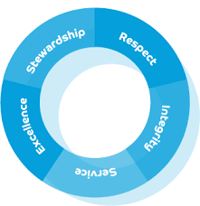
Barclays, like any other company have created these professional values, so that your personal values don’t affect the rapport you build with customers and colleagues in the workplace. What you seem is appropriate may not be the opinion of others.
Below is a diagram to highlight the sources of where beliefs, values and attitudes may arise.
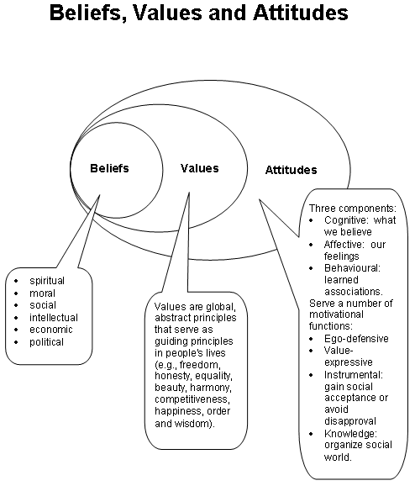

Main Analysis



The concept of Belief
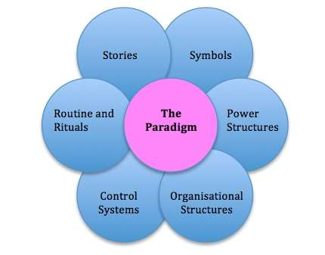
According to Sartwell (1992) The smallest unit of knowledge is considered a belief. The beliefs can be terminal and lack flexibility, or they can be fluid and change dependent on exposure to external stimuli, exposure to different cultures. (Seitz, Paloutzian and Angel, 2018)
In essence a belief is a paradigm a way of thinking, a thought process, which over time an individual claims to be true and factful, this then becomes a part of their belief system. Stimulus from own experience, cultural settings, religious gathering or even education can have a major impact on peoples belief system. They will constantly try to reinforce their own belief system to be true unless proven otherwise.
As a bank employee, stereotypical beliefs that you have may have developed through your personal experiences may impact on how you relate to your colleagues and team and how you advise customers to meet their needs, this will affect the quality of your work and relationships in the workplace. This will also have a negative impact on team performance.
Prejudices you hold regarding sexuality, disability and age will hinder your judgments as you will make assumption based on your beliefs. As already stated these beliefs may be unproven. e.g. disabled people are not able to perform to their full potential
e.g. People who identify with LGBT are not normal.
We are all intuitive and like to know more about colleagues we are working with. This is what makes everyone unique and at the same time versatile. As we all perceive our surrounding in different ways based on our upbringing, childhood fears, social circle and level of personal communication in the household all pay a part in forming our beliefs. In the workplace how we make decisions, either for personal gain or for the gain of group will also challenge our beliefs and values. (McCarty and Shrum, 2001)

Beliefs are like a traffic control system; they are signals giving direction, meaning, and a sense of purpose to our daily lives and control how we make our decision at work and how we conduct ourselves in the team.
To understand better the relationship between belief, values and attitudes we can use the betari box model.

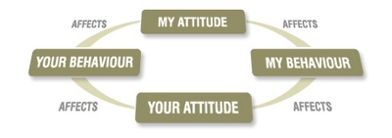betari box model

Although the box is easy to understand as it goes in a loop. It can help you to understand better when there is negative aspect of attitude and behaviour displayed in the workplace. It provides a simple way to stop and address the issues that may cause conflict. And realising that changing these thoughts or actions will eventually have a positive knock on effect to improve/adapt behaviour and overall attitude.



What are values and their types?

When we begin to define value it is to quantify or measure the worthiness of an object or thought. Values can be enduring or salient in nature. They are what the individual considers to be an organised system of personal thought’s and opinions and hold a special importance in their cognitive process. (Schminke, Arnaud and Taylor, 2014) The level of significance of the value is idiosyncratic and will differ depending on exposure to certain beliefs and immediate social background and culture. Values are mostly portrayed in the way we live our lives such as moral and democratic values.

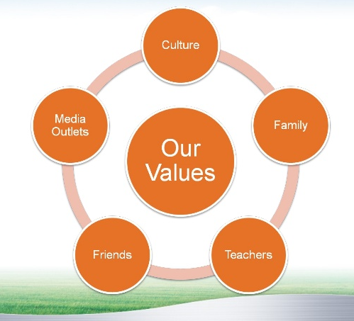
Our values stem from our beliefs. We use them as a guidance to make decision in our lives and in the workplace. Values arise from many different sources and experiences we are exposed to. Furthermore, music, technology, social media all create an impact on the behaviour values and attitudes we adopt in the workplace.
The employee needs to be aware of this fact as whilst in employment, we are too busy with meeting objectives, that we often forget how others may perceive our behaviour. We also need to be aware of what attitudes are being observed by our team members.
It is significant to understand that belief reinforces value and vice versa. With this knowledge it will help us to understand the values of customers and colleagues.
e.g. a customer of the bank wishes to take out a high interest mortgage. Although the employee may feel this is outrageous. As this goes against their own beliefs and judgment (they really want to help the customer). The employee is strongly against offering a high interest mortgage. It is against their values. The attitude they adopt will be clearly projected in how they communicate to the customer. As they feel this is not the correct way. The ownership of a home is most valuable to the client. At any cost. To maintain professionalism, it is imperative that one does not impose one own beliefs and values on a customer and allow them to decide by supporting and guiding them.
By imposing personal values on the customer the employee is going against the core values of the bank of stewardship. They are also denying the right to the customer to make their own decision and not taking the consideration of the customer. The customer may lose confidence in the employee and the bank and may not wish to do business with them.
In the workplace people who have shared values seem to get on better and create an atmosphere conducive to work. This is why most major organisation have core values which helps to align behaviour in the workplace.

Shared values at work produce better results as it is easier to get on with people who hold similar values as yourself, this in turn improves teamwork, decision making, helps to meet deadlines, better productivity and growth for the business. In the workplace to hold a high personality characters ; shared values such as honesty, respect and trustworthiness are highly desirable.
Vedel (2016) review of John Holland (1997) study shows that employers choose among these traits to fit into organisational culture. Barclays realises this and has set these attitudes within their core value statements.
Employees who display these traits behave positively in the workplace:
- Have emotional Intelligence and stability related to job satisfaction
- People who are agreeable are better in social environments
- Extroverts are deemed more content in their role and have god social skills.
All the above suggest a strong correlation to positive organisational behaviour.

There are two types of values:
- Instrumental: everyday values (Abbarno, 2015)
- Terminal : Long term aims and goals to succeed in the workplace or life.

It is the instrumental values which will have an impact on a daily basis. Emotions in the workplace are difficult to understand and one needs to be very careful not to judge or cause hurt to others feeling.
e.g. employee is crying as her dog died over the weekend. The dog may have had a personal value to the employee. However, others may not feel the same way about dogs. If this employee is mocked by others for crying, she would get sentimental. This would have an impact on her work and personal life. She may even resign as she feels no-one cares about her. If people are sympathetic towards her predicament then this enhances good relations, which in turn improves communication in the team.
e.g. an employee of the bank does not value diversity. As a result he is subtly refusing to communicate with another colleague of ethnic origin. By not talking he is displaying a negative attitude towards his colleagues and his work. The team has noticed this behaviour and moral is low in the team. Work is not completed on time. Other colleagues are not comfortable working in this environment.
Barclays has a diverse and inclusive workforce. Managers need to give feedback based on the observed behaviour and allow the employee to change their perception and behaviour before taking further action. We see how a person’s behaviour can affect other employees as well as the overall success of the team.
Why does organisation have values? The organisation benefits by having core value as this sets out their mission, it also benefits them by attracting prospective employee and new business. A strong set of values will enable the workforce to be engaged and motivated to achieve.
Most organisation today advertise their core values as a means to improve their company status in the markets. These values attract the attention of employees who want to grow and learn to improve their skills and knowledge. This leads to greater loyalty and staff retention.
When an organisation is noticed and has happy employees delivering the service. This has a positive impact on customers and clients. Customer will do further business as they see value in the company’s progress and staff.
Today’s modern day corporate social responsibility is a value which stands out. This is where business demonstrate their responsibility to the environment and follow ethical business processes. This establishes a competitive edge and gives leverage over other business rival for new projects.

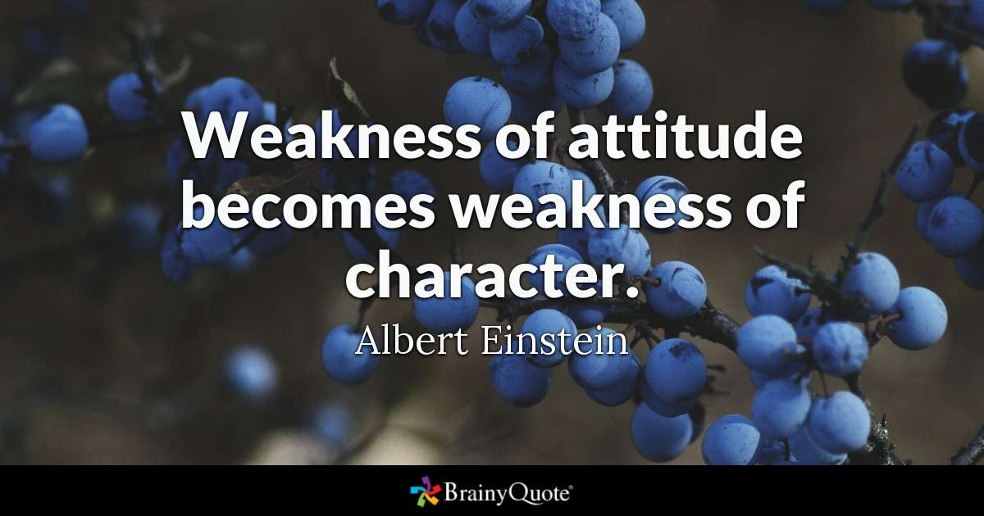

Attitude and its Function

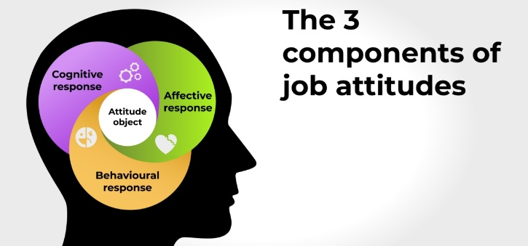
Attitude and behaviour are used commonly to mean the same. In fact, there is a difference. Attitude always has a referent, (Beshai et al., 2014) it is always directed at an object. We might describe work colleagues with a positive or negative attitude and inherently assume that they are underperforming. We must not assume attitude equates behaviour based on observed behaviour.eg it has been known that some employees display fake behaviour in order to gain trust of managers and other employees for their personal gain.
When we link these three concept we can state that attitude refers to the beliefs and values a person holds, they are evaluative statement which can be favourable or unfavourable towards people or an event. Whereas, behaviour describes how the individual conduct themselves in the workplace or outwardly displays their thoughts and feelings through their actions and body language.
To breakdown this term further we need to understand the fundamental characteristics of attitude. Noble Prize winner Max Karl Ernst Ludwig Planck (1948) stated that “when you change the way you look at things, the things look at change. The perception that thinking can succeed shows a good attitude and will be manifested in your behaviour.
Individual in the workplace who show a good attitude know their personal capabilities and will take on a board a poor result and make changes to succeed. They don’t become negative and are realistic about the future prospects.
Functions of attitude: Katz (1960) provides function of attitudes
- Knowledge: attitude provides meaning and familiarity, knowledge for life. Purpose refers to our need for a reliable and constant world that we live in.
- Self/Ego expressive: the attitude we direct in the workplace help connect who we are and may make one feel positive as we have emphasised our identity.
- Adaptive: if a person holds and expresses a socially acceptable attitude then that person is seen as adaptive and flexible. Other colleges will reward them with approval and social acceptance and welcome them into the team. They will be seen as a person whom can be entrusted with different tasks and responsibilities.
There are various studies which analyse the psychology of behaviours and actions. In their study Maio and Haddock, (2019) describe the three components of attitude:
1. Cognitive: Which refers to how the mind interprets knowledge and understanding of the issue at hand.
2. Affective: The feeling one perceives as regards to the issue.
3. Conative: Behavioural response to the issue i.e. action.
e.g. An employee with the belief that their line manager promoted another employee who did not deserve this promotion. (Cognitive), as a result they now dislike the line manager (Affective), they now are looking for another job with another company (behavioural). With this thought process we see that the employee will more than likely have a negative attitude towards their manager. This is against the Respect values of Barclays as they claim that one should take ownership of their work and not blame others. The employee should challenge what they feel is wrong in a polite way and see what they can do to improve their own performance at work. Sadly, this situation may arise in your work life. A strong value mismatch may create conflict in the workplace this will affect their work performance and relationship with other members. This can lead to a hostile working environment, where there is no respect. This will impact on the service provided to customers.
Vogel and Wänke (2016); Casnici et al. (2016) all describe how attitudes over time can be changed. How these behaviours can be changed is best described by the Cognitive Dissonance Theory.
Theory of Cognitive Dissonance

Aronson and Festinger, (1997) assert that dissonance occurs when our beliefs and behaviour don’t add and the mind is in conflict with a thought or expression. To alleviate cognitive dissonance (inconsistency) you have to change your belief and actions.
e.g. an employee of the bank is always late for work and clearly not organised to meet the service level expectations of the customers. This observed behaviour will have a negative impact on other members of staff. However, it transpires that this person has caring responsibilities which prevents them from coming into work on time. By changing our paradigm, we can improve our attitude, overtime this attitude will hold value and be cemented in our belief. That is not to judge a person too quickly.

Requisite types of attitude:
- Job satisfaction: A person with a high-level of job satisfaction will project a positive attitude towards their role. An unhappy employee will display negative attitude towards their role.
- Organisational commitment: A person who shows commitment will produce high level work and integrate into the work environment more quickly. Otherwise they may become disruptive and cause conflict with their behaviour and attitude.
In the workplace the individual is aiming for self-efficacy so that everyone will perform to best of the skills and knowledge that they have gained to meet the expectation of the immediate department and the organisation as a whole. For this to happen they need to have a high self-efficacy. The diagram below shows another external stimulus that can affect the self-efficacy of the individual.

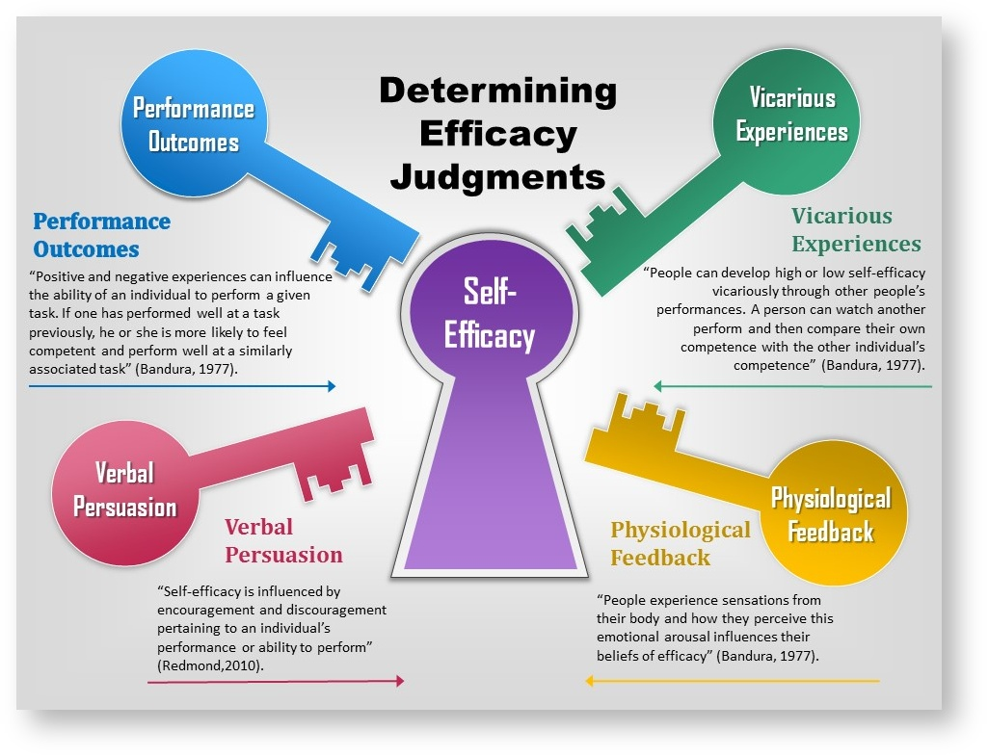

when employees all display positive behaviour and truly embrace the organisational values, they will fit into the culture of working environment. Work will be interesting and rewarding, the customers will feel the benefit of this as the workforce will be motivated and dedicated to providing the best service for the benefit of the organisation.
Efficient workers are always eager to progress and learn new skills. This is possible as they have tailored their beliefs and values to match the organisation core values. This in fact makes them a better person. As positive attitude to work is rewarded through performance appraisal and bonuses.

Management Theory

There is an abundance of management theories. (Morden, 2017) These protocols help by motivating employees, adapting to various leadership style to bring change within the organisation to make it a success for everyone.
Amongst the founders fathers of management theory Frederick Taylor, McGregor and Henry Foyal. Unlike the other theorist Maslow completely changed the way employees were looked upon by employers. In the industrial revolution there was rapid change in the working environment. The introduction of large companies meant more people in employment to feed the family. They had requisite needs for survival.
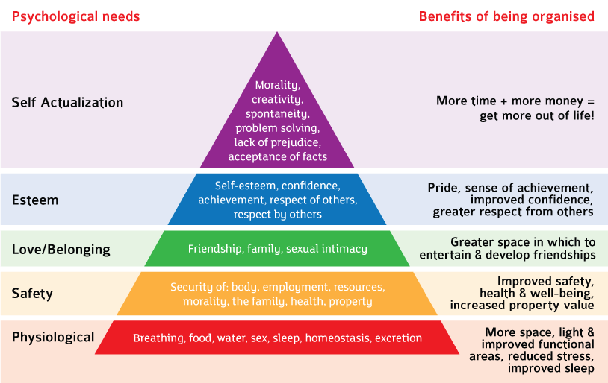
McGregor saw them as being lazy, Taylor saw employees as machine, who would produce volumes of work and be rewarded accordingly. Maslow gave them appreciation and enlightened business owners to see their employees as an asset and gave them ways to motivate the employees to make them more productive.
Organisation since then have put the employees first rather than production of goods and services. They now ask the question “How can we cater for the needs of our employees?”.

Maslow’s hierarchy of needs is presented in the form of a pyramid in most text books, with specific physiological and psychological needs at each level. Although there a criticisms that Maslow did not represent his work in the form of a pyramid. (Cummings and Bridgman, 2011; Schaller et al., 2010) His research allowed organisation to focus on employee performance, gave them much more rights of the task they were doing and what the likely result would be. This in turn improved attitude and loyalty. As a result this increased the motivation levels of employees at all levels.
Maslow purported that once a level was satisfied the employee would move to the next level up and their motivation and loyalty might change if the needs of the employee were not met. E.g. career development opportunities, further training on different skills set. The end goal is to reach the top and to achieve self-actualisation. When one is content in work and life.
Although this is a psychological theory it has been used in the workplace and other sectors such as education. Maslow asserted that if the needs of the lower levels are not met through motivation then the individual will not able to move to the next phase as they will be pre-occupied with lower basic needs. An example of this would be if the working environment was not safe or the temperature was too hot. The employees will not be able to focus on their work. The organisation needs to adapt their employee development process to ensure that employee orientated processes takes place as this will inevitably improve the culture at work and improve productivity and growth.
Although the researcher has found awareness in Maslow approach in the working environment. Other researchers Fallatah and Syed (2017) have found his evidence to be lacking as they feel it was observed behaviour in the western world and did not cover other parts of the world.
There is deficiency in the hierarchy as there is cultural bias. Hofstede (1984) proclaims the basic needs of the individual may differ. E.g. In the west some have put internet connection as a basic necessity, this is different to other parts of the world where food, security and sleep have more value attached to them.
Zvavahera and Tandi (2019) have further critiqued Maslow work as they feel that it does not account for the needs of different societies and cultures. E.g. Through periods of recession, famine and war. Also further studies by Tay and Diener (2015) have stated that the ranking used by Maslow may vary by age of the individual. So the ranking does not necessarily apply as shown in the pyramid.

The researcher believes that Abraham Maslow theory is best suited to Barclays bank and this is how they approach their business model. A practical example of this is given by Goodlife Ntuli, (2017), the report describes how through the results employee satisfaction surveys, performance appraisal and training opportunities the employees of the bank are very satisfied and motivated by the organisation they work in as they are actively involved in decision making, allowing employees to develop their personal goals and work objectives.
Maslow hierarchy has had a positive impact on the researcher beliefs values and attitudes as it provides for a general framework and guidance to move up the hierarchy and to achieve self-actualisation and be the best. The theory gives a foundational approach to realise your potential. To make improvements in your self-awareness and classify what values are important to you for career progression.
It is the opinion of the researcher that in today’s modern society this theory is still relevant if we compare the needs of the hierarchy and apply it in a work-based scenario. The requirement to be paid for investing your time at work is very desirable. No-one wishes to be unemployed. According to the hierarchy, the need for belonging today is to fit into the company culture as a junior member or management position, and abide by the core values of the organisation. Despite their being bias in his theory, no employee wants to feel left out. This will affect job satisfaction and lead to overall disengagement in the job role. Their own beliefs and values need to match that of the organisation.
The Esteem category can be fulfilled by achieving recognition by immediate colleagues and receiving industry standard qualificaton. Self-actualisation can be achieved by discovery of meaningful work. In the banking sector, finding satisfaction from helping a customer becoming debt free or offering a product which is both beneficial to the customer and the bank would be an example of find meaning in work.
Furthermore, if you disregard Maslow first level which is physiological needs then this will have detrimental effect on your work performance. If you do not get enough sleep or eat properly you will not be able to function at work or produce your best work.
Although in todays modern day society we don’t worry to much about the first level, we do worry about work related stress and the need to have a balance is much greater today. The hierarchy provides a systematic approach that we can work towards to achieve self-actualisation.
This will motivate us to be creative and become our best. We value brands and this is what we buy into. In the workplace organisation hire like-minded individual who share the company values to regulate organisational behaviour and maintain good working relations.
The researcher believes that as a result of Maslow hierarchy organisation have since introduced features such as Paternity Leave for parents amongst other job perks. The organisation values family life so as a result this would positively impact the employee who would remain loyal to the company as they have shared values.

Conclusion

This report identifies that beliefs, values and attitudes displayed in the working environment, highlight whom we really are in reality. It is human nature to respond either positively or negatively to external stimuli. This is portrayed in our behaviour we project and how others in the workplace view our behaviour. Our personal values and attitudes either positive or negative will impact on our work performance and teamwork.
It is important to note that we should not be judgmental and impose our personal beliefs and values on others, undermining them in any way. The beliefs and values we hold make us unique.
The relationship between values belief and attitudes can be explained by the Betari Box Model which clearly shows how this cycle can be continuous dependent on how each component impacts the behaviour of the individual. Each component is intertwined and linked with the each other. We have seen how if we change our perspective on how we value certain things, this may compromise our belief (cognitive dissonance) and provide meaning to our new values and attitudes, ultimately this will change our attitude we display in our job roles. Understanding this will help us to make positive changes to our attitude to work and colleagues and this will help to create a good working environment.
By observing our behaviour or getting regular feedback on our performance one is able to realize what we value and what our beliefs may be as this is portrayed through our actions. If we project negative behaviour then we need to look into our values and beliefs to see where improvements can be made.
One of the major issues people have is not showing interest when a value does not match their own. This hinders progress and disturbs the human interactions that take place in the working environment. Communication is vital for success. Everyone voices should be heard to promote a healthy atmosphere at work and to show respect to each other.
In the absence of self-awareness or critical insight, or the presence of doubt about values, will escalate to irrational attitude to choices, this will eventually lead to undesirable behaviour.
Organisation use core values to govern the behaviour of individual and groups within the working environment. To maintain a level of discipline and healthy organisational culture. They set the norms and protocols. This leads to harmony, good working condition.

References

Abbarno, G. (2015). Inherent and instrumental values. Plymouth, UK: University Press America.
Alderfer, C. P. (1969). An empirical test of a new theory of human needs. Organizational behavior and human performance, 4(2), 142–175.
Aronson, E. and Festinger, L. (1997). Back to the Future: Retrospective Review of Leon Festinger's "A Theory of Cognitive Dissonance." The American Journal of Psychology, 110(1), p.127.
Beshai, S., Prentice, J., Swan, J. and Dobson, K. (2014). The Effects of Dysphoria and Personality on Negative Self-Referent Attitudes and Perceptions of the Attitudes of Others. The Journal of Psychology, 149(5), pp.498-516.
Bono, J., Foldes, H., Vinson, G. and Muros, J. (2007). Workplace emotions: The role of supervision and leadership. Journal of Applied Psychology, 92(5), pp.1357-1367.
Casnici, N., Grimaldo, F., Gilbert, N. and Squazzoni, F. (2016). Attitudes of referees in a multidisciplinary journal: An empirical analysis. Journal of the Association for Information Science and Technology, 68(7), pp.1763-1771.
CUMMINGS, S. and BRIDGMAN, T. (2011). The Relevant Past: Why the History of Management Should Be Critical for Our Future. Academy of Management Learning & Education, 10(1), pp.77-93.
Fallatah, R. and Syed, J. (2017). A Critical Review of Maslow’s Hierarchy of Needs. Employee Motivation in Saudi Arabia, pp.19-59.
Firmin, M. (2010). Commentary: The seminal contribution of Richard LaPiere's attitudes vs actions (1934) research study. International Journal of Epidemiology, 39(1), pp.18-20.
Goodlife Ntuli, M. (2017). An evaluation of bank acquisition using an accounting based measure: a case of Amalgamated Bank of South Africa and Barclays Bank Plc. Banks and Bank Systems, 12(1), pp.160-165.
Hofstede, G. (1984). The Cultural Relativity of the Quality of Life Concept. The Academy of Management Review, 9(3), p.389.
Joinus.barclays. (2019). About us | Barclays Early Careers and Graduates. [online] Available at: https://joinus.barclays/eme/about-us/ [Accessed 28 Jul. 2019].
Katz, D. (1960). The Functional Approach to the Study of Attitudes. Public Opinion Quarterly, 24(2, Special Issue: Attitude Change), p.163.
Locke, E. (1982). The Ideas of Frederick W. Taylor: An Evaluation. Academy of Management Review, 7(1), pp.14-24.
Maio, G. and Haddock, G. (2019). The psychology of attitudes & attitude change. 3rd ed. London: Sage publications ltd, pp.113-196.
Max Karl Ernst Ludwig Planck, 1858-1947. (1948). Obituary Notices of Fellows of the Royal Society, 6(17), pp.161-188.
McCarty, J. and Shrum, L. (2001). The Influence of Individualism, Collectivism, and Locus of Control on Environmental Beliefs and Behavior. Journal of Public Policy & Marketing, 20(1), pp.93-104.
Morden, T. (2017). Principles of management. London: Routledge, chapter 12.
Pettigrew, T.F., Smelser, G.W.A.I.N. and Baltes, P.B., 2015. Allport, Gordon W (1897–1967). International Encyclopedia of the Social and Behavioral Sciences, pp.562-65
Sartwell, C. (1992). Why Knowledge Is Merely True Belief. The Journal of Philosophy, 89(4), p.167.
Schaller, M., Neuberg, S., Griskevicius, V. and Kenrick, D. (2010). Pyramid Power. Perspectives on Psychological Science, 5(3), pp.335-337.
Schminke, M., Arnaud, A. and Taylor, R. (2014). Ethics, Values, and Organizational Justice: Individuals, Organizations, and Beyond. Journal of Business Ethics, 130(3), pp.727-736.
Seitz, R., Paloutzian, R. and Angel, H. (2018). From Believing to Belief: A General Theoretical Model. Journal of Cognitive Neuroscience, 30(9), pp.1254-1264.
Stephens, R., Dunn, J. and Hayes, B. (2019). Are there two processes in reasoning? The dimensionality of inductive and deductive inferences.. [online] Available at: http://dx.doi.org/10.1037/rev0000088 [Accessed 27 Jul. 2019].
Tay, L. and Diener, E. (2015). Subjective Well-Being, Psychological Well-Being, and Islamic Religiosity. International Journal of Science and Research (IJSR), 4(12), pp.1168-1173.
Vedel, A. (2016). Big Five group differences between academic majors: a systematic review. Personality and Individual Differences, 101, p.523.
Vogel, T. and Wänke, M. (2016). Attitudes and attitude change. 2nd ed. London: Routledge Taylor & Francis Group.

