What is criminal profiling, and would nature v nurture play an important part in this?
By Melenie Jane Box.
Independent project – (BMPS6012).

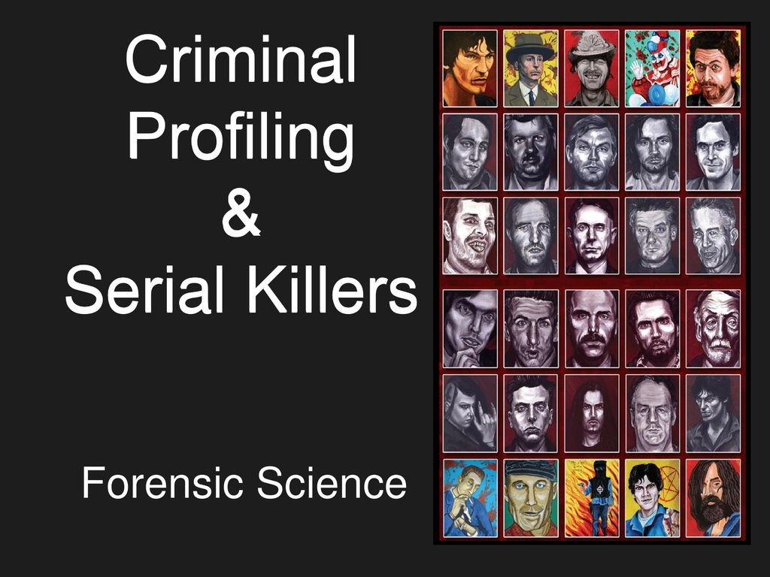
The process for profiling a criminal can be defined with a technique that would be used to identify a perpetrator of many a violent crime. This will identify their behavioural characteristics and personality based upon the analysis of the crime which has been committed.
This process goes on to involve an evaluation of the criminal act, with a very comprehensive evaluation of the specifics of the scene, victim and also the preliminary reports made by the police themselves. There are to be additional steps to these evaluations too, like the post – mortem protocol made by the medical examiner as well as the profile of offender characteristics. Plus there would also be an investigative suggestion which is predicted upon the construction of the criminals profile.
Criminal profiling is rather useful when used in situations like being held hostage, sexual murders, rapists and arsonists to name a few. Criminal profiling is not very suitable for detective work, but is more of a tool that they use to try and help solve forms of violent crimes. (Douglas, J.E & Burgess, M. 1986).
Since time began, criminals have been unwelcomed within our society. For most of the time, research was only directed towards the identity of the physical characteristics of criminals. This approach had very little value of any investigation or the prevention of any crimes. As times have moved on, interest was formed about the workings of the human mind, then all attention turned to either ways of identifying the thought process of these criminals or looking towards any possibilities of the criminals’ subsequent reform.
Within the last century, law enforcements have begun to now realise that the analysis of the behaviour of any subject that is identified can give out clues as to their age, social status, education, physical appearance and so on. These factors would then help the authorities to narrow down their inquiries.
With present day usage of computers, it has now made it more possible to handle masses of data on which the analysis can be based.
Originally it was named psychological profiling, but now better known as offender profiling. The first systemised usage of this technique came about when the Federal Bureau of Investigation or FBI for short, Behavioural Sciences Unit in 1972 and also the Department of Violent Criminal Apprehension programme in 1984. (Innes, B 2003).
The Italian physician born Ezechia Marco Lombroso (Cesare Lombroso) was born on the 6th of November 1835, Verona, Austrian Empire (now in Italy) was known to be the godfather of criminology. Cesare was to state that all criminals can be identified by physical characteristics and that their behaviour was known to be hereditary. Criminal psychologists have since disagreed that Lombroso’s theory, but the fact that you can still construct a physical, plus psychological profile of a criminal has now struck today. Most law enforcements around the globe would rely upon these detailed profiles to help them with their investigations.
Criminal profiling has brought to justice the likes of devious and dangerous criminals. These would range from rapists, kidnappers, serial killers and assassins too. (Innes, B 2003).
Why I chose to do my dissertation on criminal profiling is not just down to the fascination of psychology, or criminals but the facts for me are simple. It would be great to be able to look upon someone and state that as they get older they would change and become a homicidal maniac, or a thief for example. These philosophers and so-called psychologists of the past had great ideas, but now it is time to reassess their works and try to focus upon whether it is nature or nurture or just pure driven evilness within these people. In some twisted sort of way, it could well be a cry for help.
Psychopaths are not the same as sociopaths. For example a psychopath would more than likely end up being in trouble with the law, where as a sociopath tries to blend in with society. They may share some traits like antisocial personality disorder, but this is known to be less severe within a sociopath. The question I would like to find answers to is would the brain structure of a psychopath be the same or different to the average person, if so how and why?
Is it true that all psychopaths are killers or is this just a reflection of how today’s media have portrayed them?
Do the public perceive this to be true, should we believe in everything that the media throws at us?
Should there be actual evidence which can be backed up by the media, or are we fast becoming mushrooms, kept in the dark and fed on crap.
We as a nation are fast becoming gullible and too reliant to be able to think for ourselves. We need to try and stamp this out, look at it from every angle and have the correct evidence before we can determine that someone is a psychopath or a sociopath, as having been labelled this for life could have far reaching devastation’s for this person. Great reform is needed to tackle the amount of criminals within the justice system, make sure we get to the ROOT cause of why these people are frequently offending and also to make sure that justice is served correctly and that the wrong people are not imprisoned for a crime which they did not commit.

Ian Brady and Myra Hindley. (The Moors Murders).
A serial killer is usually a loner, one person who will murder their victims over time, with gaps in-between each of their killings. The majority of these killers would kidnap and torture their victims just like a wild animal would do prior to killing their pray. It is not always evident as to what motivates a killer to commit such horrendous acts, maybe an abnormal psychological process or even anti-social behaviours could be to blame.
Within our society killers have the fear and the fascination for murder. A prime example of this would be Ian Brady and Myra Hindley. Myra was so infatuated with Brady that she was in fear of losing him so did as he asked. Ian Brady was fascinated with murder. He started his murderous spree by killing small animals and then progressed by joining the Nazi Youth group, but wanted bigger and better. Brady was the brains behind these killings, but needed an accomplice, so decided to enlist the help of Myra. This was to be known as a Crime of Passion, and together they were to be known throughout the land as the “Moors Murderers”. (Psychology Today,2023).

