

Student name: Asha Kaphle Rana
Student ID:252776
Module name: Introduction to Health and Social care
Module code:(LCHS4003-LON)
Lecturer name MS Ping Wu

Content page

Pharmacy services …………………………………………. 3
Residential care home ……………………………………... 4
References …………………………………………………… 5


Pharmacy
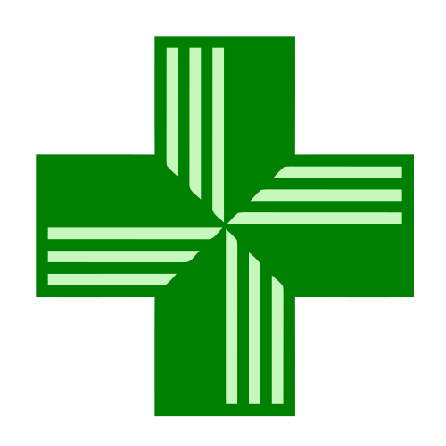
Pharmacy services
Pharmacy services are highly integrated into the NHS, offering walk-in consultations and treatments without a GP appointment. Key offerings include the pharmacy first scheme (prescribing for seven common conditions), blood pressure checks, contraception, vaccinations, and support for new medicine. UK pharmacies provide free NHS and private healthcare without a GP appointment. Pharmacists can offer advice on a range of illness. They can also give advice about medicines. (NHS, England)
Two most challenges currently facing Pharmacy: The two most critical challenges currently facing UK pharmacies are severe medicine shortages and chronic financial strain leading to closures.
- Medicine shortages: Up to 87% of pharmacy teams report daily supply chain disruptions and out-of-stock items. These shortages force staff to spend hour sourcing alternatives and cause significant distress and delays for patients requiring vital medications.
- Financial pressure: Despite expanded clinical services (like the NHS Pharmacy First Services), core funding has struggled to keep pace with rising wages and utility cost. This under funding has resulted in hundreds of community pharmacy closures, straining local access to healthcare and pushing staff morale to critical lows. (Community Pharmacy, England), (BBC)

History of pharmacy
Pharmacy services evolved from traditional apothecaries in 1917 to today’s modern clinical hubs. A timeline of key historical milestones highlights this transformation.
Pre-1948(Apothecaries): Historically, pharmacists compounded medicines and advised the public. Commercial pharmacies, like Boots the chemists, steadily grew as retail and material health care providers.
1948(NHS Era): The creation of National Health Service significantly expanded the role of community pharmacies, focusing primarily on dispensing high volume of free prescription.
1968:(Medicine Act): Standardised the safety, quality, and licensing of medicines, introduced pharmacy only(p) medications.
2003-2006(prescribing Rights): Pharmacists were granted non-medical prescribing rights, evolving into independent prescribers able to manage compressive medication needs.
2024-2026(clinical Services integration): Programs like the pharmacy first scheme expended access to treatments for seven common conditions including sore throats and sinusitis) without a GP appointment, easing pressure on surgeries. (NHS, England)

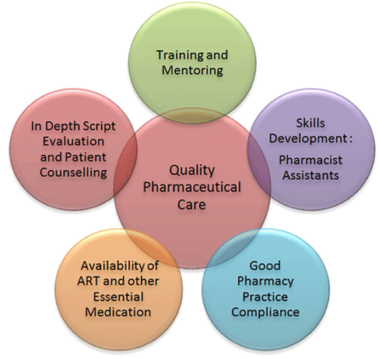 Responsibilities of Pharmacy (Community pharmacy, England)
Current functioning of UK pharmacies:
- New Medicine Service (NMS): An advanced service to support patients newly prescribed medications for long-term conditions to improve adherence.
- Discharge Medicine Service (DMS): Essential tracking and review of medications when a patient is discharged from the hospital ensure continuity of care.
- Independent Prescribing: A structural shift is underway where all newly qualifying pharmacists train as independent prescribers, further removing the need for GP referral.
- NHS Pharmacy First Service: Allows pharmacists to assess, complete episodes of care, and supply prescription-only medicine for 7 common conditions.
(The king’s Fund)
Text

Pharmacy services
Student Name: Asha Kaphle Rana, ID:2527746, Email: ashakafle99@gmail.com
Course Name: Introduction to Health and Social Care

Residential Care Home
Origin of the Residential Care Home
Residential care homes evolved from punitive Victorian workhouses and religious alms-houses. Post- WWI, UK’s National Assistance Act of 1948 abolished workhouses, establishing local authority homes instead. Since the 1980s, the sector has shifted from state-run institutions to predominantly privatised, regulated systems. The history of care homes in the UK begins in 936, when the first-known alms-house was built in York. The story goes that the King Aethelstan, at that time king of the English, provided funding for it after seeing clergymen of an older incarnation of York Minister using their own money to care for the elderly. ‘Alms’ means to give other, through virtue or compassion. Also known as bed houses, from the Anglo-Saxon word for prayer, these houses were funded by wealthy people hoping that their funding would increase their funding would increase their chances of being accepted. In the 1980s under the new conservative Government, residential care homes become big business. Prior to this, local authority homes had been the majority, but self-funded care homes increased and the number of places in them tripled over the course of the decade. while some were against privatisation, this did free up more places in local-authority funded homes for those that really needed them. The registered Homes Act 1984 ensured that all private homes were still regulated. The 1990 NHS and Community Care Act Reform, implemented in 1993, brought in the idea of care centring on individual needs and the care needs assessment was introduced. In 2000, the Care Standards Acts, though not enforced until 2002, replaced the Registered Homes to be a form of care homes for the elderly. The legislation also established care councils in England and Wales, regulated the training of care workers and introduced a new set of minimum standards that all forms of care home were legally obliged to comply with. The landscape for care homes is still changing. According to an IPPR thinktank report, 84% of care home beds occupied by older residents are in for-profit homes, while 13% provided by the voluntary sector with just 3% offered by local council. (carehome.co.uk, Cambridge University Press and Assessment) In recent years there has been a push from developers for more luxury care homes, with the number of small care homes, with the number of small care homes falling. These large builds offer luxury living with the fine dining at every meal, facilities like salons, spas and cinemas and services like chauffeur-driven cars. (carehome.co.uk, Cambridge University Press and Assessment)
Service function today Residential care homes function as supportive, community-based housing option for individuals who can no longer live independently do not require 24-hour medical nursing. They deliver vital services that include assistance with daily living (like bathing and dressing), medication management, freshly prepare meal, and structured social engagement. Beyond physical health, residential care homes serve a crucial social and emotional function. Older adults and vulnerable individuals living alone are highly susceptible to isolation and loneliness. Care homes counteract this by cultivating a vibrant, community-oriented environment where residents can participate in tailored recreational activities, arts, crafts, and group outing. This continuous companionship and emotional support by trained staff significantly enhance the mental health, belonging, and overall quality of life for residents. (care.uk)
Enhancing quality of life for residents Enhancing the quality of life for residents is significant because it directly determines their physical health, emotional well-being, and overall life satisfaction. Providing meaningful life enrichment ensures individuals, maintain their independence, social connections, and dignity, which actively reduces loneliness and biographical disruption. All care homes be connected to the Enhanced Health in Care Homes Services including those who support working age adults, not just older people. (NHS England)
References

NHS England » Launch of NHS Pharmacy First advanced service
Community pharmacy and public health in Great Britain, 1936 to 2006: how a phoenix rose from the ashes - PMC

https://www.carehome.co.uk/advice/a-history-of-care-homes

http://www.ageing.ox.ac.uk/files/Ageing%20Horizons%206%20%20-Jones.pdf
NHS England » Enhanced health in care homes

