

An Academic Report on

“Game Dev Tycoon”

Course title: Game Design and History
Word Count:2325

Student name: Connor Johnson
Student ID: 2517511
Table of Contents
Introduction: 3
Game overview: 3
Visual style & audio design: 4
Gameplay Mechanics: 5
Game structure: 6
Challenges & difficulty: 7
Game flow: 8
Intended audience: 9
Positive and negative aspects: 9
Conclusion: 10

Introduction:
“Game Dev Tycoon was created by Greenheart Games, which was founded in July 2012 by brothers Patrick and Daniel Klug, with an agenda to develop games that are "fun to play instead of mind-numbing money grabbers. Less social, less ville, more game is our motto”[1]. The game places the player in the role of a video game developer tasked with managing a studio from its early beginnings to potential industry success through careful planning and resource management. “In Game Dev Tycoon, you replay the history of the gaming industry by starting your own video game development company in the 80s. Create bestselling games. Research new technologies and invent new game types. Become the leader of the market and gain worldwide fans.”[2].
This report aims to analyse “Game Dev Tycoon”, focusing on its design choices and how they shape the player experience. The report will investigate the game's genre and visual style, as well as its use of audio and visual feedback. In addition, it will explore core game mechanics, structure, challenges, and overall flow. Attention is given to how these elements contribute to player engagement and replay value. This report will also provide an evaluation of the game by identifying both its positive and negative aspects by analysing “Game Dev Tycoon” through an academic lens, which seeks to demonstrate how simulation games can represent complex real-world systems while balancing accessibility and depth.

Game overview:
“Game Dev Tycoon” is a single-player simulation-style game developed by Greenheart Games. It's available on many platforms, including PC via Steam and the “Greenheart Games website”[3]Mobile app stores and the Nintendo Switch, enabling it to reach a broad, varied audience.
The premise of “Game Dev Tycoon” is that the player manages a video game development studio operating out of a garage during the early days of the video game industry. Over time, with the right choices along the way, the player can grow the company into an industry-leading studio with dedicated staff, advanced technology, and larger office spaces.
At its core, the game revolves around designing and releasing video games, with players choosing the genre, themes, target platforms, and development priorities for each project. These decisions affect how well the game performs during media tests, which, in turn, depending on its rating, will affect how well it sells. Alongside this, players must manage their studio's finances, research new technologies, hire employees, and maintain the long-term health of their studio.

Visual style & audio design:
“Game Dev Tycoon” uses a stylised and straightforward approach to visuals that prioritise a clear and accessible playing experience using a cartoon-inspired art style with exaggerated character animations and minimalistic environment details. Office spaces, equipment, and user interfaces are clearly defined. This allows players to quickly understand their functions. This minimalist approach supports the game's management-focused gameplay by reducing distractions and keeping players' attention on decision-making. While the visual simplicity can make the game feel more approachable for new players, the art style may become repetitive over long sessions, especially for more experienced players.
The user interface plays a critical and central role in the visual design. Information is displayed clearly and consistently in the game through pop-up notifications, progress bars, sliders, and icons. These visual elements help communicate the development process, staff performance, review scores and financial outcomes in a direct manner. As a result, players can easily interpret feedback and respond to changes in the game.
The audio design of “Game Dev Tycoon” is subtle yet functional. The background music is calm and repetitive, creating a relaxing atmosphere suitable for extended play sessions. Sound effects are used sparingly to signal important events, such as the completion of a game, the release of reviews, or financial changes. These audio cues reinforce visual feedback and help guide the players' responses to success or failure.
To summarise, the combination of simple visuals and subtle audio enhances usability and reinforces the game's focus on strategic planning.

Gameplay Mechanics:
The primary mechanic of “Game Dev Tycoon” involves the creation of video games where the player selects a genre, theme, platform and target audience. During the game's development, players can allocate resources using sliders that prioritise gameplay, graphics, sound, and story. Resource management is another key mechanic. Players must manage finances, ensuring they can afford the development costs, staff wages and research investments.
Poor financial choices will result in losses, eventually leading to bankruptcy, strengthening the importance of planning and budgeting. Time management plays a significant role as development happens in real time, requiring players to balance speed and quality. Research allows the players to unlock new technologies, genres and features within the game. By spending research points, the players can expand their creative and technical options, enabling more complex and successful games.
Staff management is introduced as the player progresses, adding another layer to the game that requires players to hire and fire employees, assign tasks, and train staff to improve their skills and output. Feedback systems are tightly woven into the game's mechanics. Review scores, sales data, and fan growth provide immediate feedback on players' decisions by clearly reflecting how development choices impact a game's reception and commercial success.
After each release, the review scores indicate overall quality, the sales figures show market success, and changes in fan numbers reflect the studio's long-term reputation. Together, these allow the player to identify successful strategies and recognise poor decisions, supporting learning through trial and error and future adjustments.

Game structure:
Rather than using traditional levels or life systems, “Game Dev Tycoon” uses a time and progression-driven structure. Progression is determined by the growth and success of the players' studio. The game begins with the player sitting at a desk in their garage, representing the early stages of the company. As the player earns money and gains fans, they can move into larger office spaces and hire extra staff, allowing for more in-depth games to be developed. This style of progression reflects the company’s expansion rather than a more traditional, level-based approach to completion. Therefore, advancement is tied to in-game economic performance and strategic decision-making.
Rather than using traditional levels, the game is structured around development projects, each acting as a distinct phase within the player's progression. Each project follows a cycle of planning, development, release and evaluation. During the planning stage, the player can select variables such as the genre, theme, platform and target audience. The development phase then involves allocating time and resources whilst also managing staff performance and project priorities. Once the project is released, the evaluation stage provides feedback through review scores, sales performance and fan growth. This structure repeats throughout the game, creating a continuous sense of progression. As the player advances, the complexity of projects increases through access to new technologies, larger teams and additional development options, helping support the feeling of growth, progression and studio expansion.
Failure is also integrated into the game's structure. If the player runs out of money, the game ends, supporting the need for effective financial management. However, failure does not entirely reset player progress. Knowledge gained from previous playthroughs, such as successful genre combinations, can be applied in the following attempts. This allows the player to leverage these insights and progress more efficiently in future playthroughs.

Challenges & difficulty:
Challenges are presented throughout the game in various ways, mostly requiring strategic decision-making rather than mechanical skill. The difficulty of the game comes from the player's ability to manage limited resources while responding to the evolving market conditions. Early in the game, players face financial restrictions and limited development options. This creates a steep learning curve and can require careful planning to avoid going out of business from a run of bad games.
One of the main challenges is understanding the relationships among the project's genres, themes, and target audiences. The game does not initially provide clear information about which combinations are successful, requiring players to learn through experimentation and the following feedback. I found this to be the case during a personal playthrough. I noticed that specific themes or genres e.g. racing/simulation would work well on specific platforms like the handheld Vena Gear and generate high income and fan growth; however, the same themes and genres would then be terrible on platforms like the play system 2 with the first version generating a 9.75 rating and reaching number 1 on the top sales rank whereas the second iteration didn’t even pass a 6.0 rating and peaked at 20th on the sales ranks.
As the game progresses, the difficulty increases through greater complexity rather than faster pacing. Players must learn to manage larger teams, higher development costs and more advanced technology. Staff management adds its own level of complexity, including balancing workloads, training employees, and maintaining productivity. Time pressure also contributes to the game's difficulty, as development occurs almost continuously, so players must decide when to release a game to increase income and fan growth, and when to invest in the studio to improve overall effectiveness. This becomes more apparent when players scale up and start creating their own game engines to make the projects more individual or purposeful. Players will be stuck between releasing a project to pull in fans and finances, and developing better in-game systems to, in turn, create better projects, whilst sacrificing time and income.
In conclusion, “Game Dev Tycoon” is a game that requires adaptation to perform well; this forces players to mix it up and keep things fresh when developing new projects. As players gain experience and better understand the game's systems, challenges become more manageable, encouraging learning and strategic improvement rather than punishing failure.

Game flow:
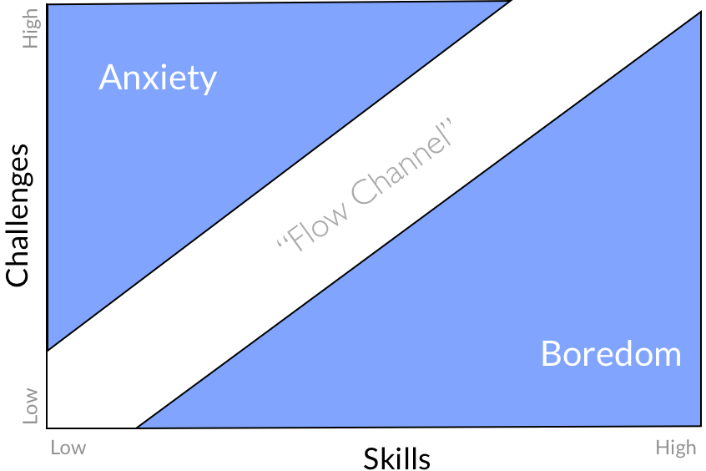
The game flow in “Game Dev Tycoon” is driven by a continuous, repetitive game loop focused on developing new projects. Players circle through stages of planning, development, release and evaluation, creating a steady rhythm that supports extended play sessions. Feedback is delivered to the player after each release to help the player quickly reflect on their decision, either good or bad, and apply the appropriate changes to future projects. The lack of downtime or rigid levels keeps momentum high while increasing complexity over time, ensuring the game stays engaging. “Game flow is the experience of being consistently immersed in that focused mixture of challenge, intrigue, focus and victory. When you look up and realise you’ve snapped out of it and hours have passed—that was a state of game flow.”[4]
Figure 1.
Figure 1[5], supports Csikszentmihalyi’s research on the psychology of flow through challenge and skill. This shows the sweet spot between anxiety caused by increased difficulty and a lack of skill, and the opposite: increased skill but a lack of difficulty, in turn causing high levels of boredom.

Intended audience:
The intended audience for “Game Dev Tycoon” spans from casual players to enthusiasts of simulation/tycoon games. Because the game uses a minimalist user interface with cartoon-inspired graphics, it is highly accessible to newcomers who may feel intimidated by more complex simulation titles like “Software Inc”, a simulation/tycoon game in which players can create office spaces from scratch and even interact with a simulated stock market. Additional layers like these can make new players feel swamped with too much to learn. This is where “Game Dev Tycoon” has blended the simplistic aspect well; this lower barrier can attract a casual audience who would enjoy the fantasy of running a game studio without the frustration of micromanaging.
However, this game can also attract gaming history enthusiasts as the player begins in his garage in the 1980’s moving through various eras of game history and encountering many parodied versions of real-world consoles. This can make the game feel almost nostalgic at times, as players can unlock versions of consoles they remember from their past, i.e. the playsystem 2 (Sony’s PlayStation 2) or even the dreamvast (Sega’s Dreamcast), to name just a few.
Ultimately, “Game Dev Tycoon” targets a large demographic of players, as people who want an easy-going, relaxing experience will feel satisfied, yet people who want to master the game's every detail and learn the best combinations within the deeper mechanics.

Positive and negative aspects:
Evaluating the positive and negative aspects of “Game Dev Tycoon” reveals a successful balance between accessibility and sometimes-unassuming depth. Its greatest strengths lie in its progression loop and educational value, effectively representing the history of the games industry through parody hardware and somewhat realistic era themes.
To expand on those points, the transition from a lone developer working in their garage to heading a team in a fully-fledged game studio provides a clear and rewarding sense of growth. This helps satisfy the game flow mentioned earlier by balancing increasing complexity with player skill growth. The minimalist user interface does a great job of not being overwhelming; it simulates systems like engine research, staff training, and marketing using simple buttons and sliders.
Unfortunately, the game isn’t perfect and does have some limitations. The audio and visual design, while functional, can lack variety, leading some players to lose immersion during longer playthroughs. Personally, I found this to be the case after a few hours of play; I ended up muting the background music because it started to feel monotonous. Certain time-lined events can get a bit predictable on subsequent playthroughs, as things like console releases or contract job offers can start to feel repetitive.

Conclusion:
In conclusion, “Game Dev Tycoon” is a successful simulation that blends accessible design with an educational narrative. By streamlining complex management systems into easy-to-use user interfaces, Greenheart Games has successfully created an experience that appeals to both casual players and gaming history enthusiasts. The game's main strengths lie in its ability to maintain a constant flow state through rewarding progression and immediate feedback. Whilst the audio and visuals can become stale during extended playthroughs, the inclusion of parody hardware, such as the Dreamvast, and industry milestones, adds a layer of depth that keeps players engaged. Ultimately, the game is more than just a business management simulator; it is an interactive exploration of the history of game development through a minimalist lens. All this adds to “Game Dev Tycoon” being a significant and highly replayable simulation title.

References
[1] "Game Dev Tycoon Wiki." https://gamedevtycoon.fandom.com/wiki/Main_Page. Accessed: Jan 12 2026. [Online]. Available: https://gamedevtycoon.fandom.com/wiki/Main_Page
[2] Greenheart Games. "Game Dev Tycoon." Steam,. Accessed: January 12 2026. [Online]. Available: https://store.steampowered.com/app/239820/Game_Dev_Tycoon/
[3] "Game Dev Tycoon." https://www.greenheartgames.com/app/game-dev-tycoon/. Accessed: Jan 12 2026. [Online]. Available: https://www.greenheartgames.com/app/game-dev-tycoon/
[4] Alexander Brazie."Designing a Game's Flow" game design skills. (-06-282024). Accessed: Jan 12, 20262026, [Blog]. Available at: https://gamedesignskills.com/game-design/game-flow/#:~:text=Game%20flow%20is%20the%20experience,%2C%20intrigue%2C%20focus%20and%20victory.
[5] C. Bailey."How to 'Flow': Here’s the most magical chart you’ll come across today", Chris Bailey. (-09-122013). Accessed: Jan 12, 20262026, [Blog]. Available at: https://chrisbailey.com/how-to-experience-flow-magical-chart/

