Assignment 1 Web
Jordan Soroko, 1805357, BSc Computing, Internet Technology & Security, 05/12/19
Table of Contents
- Introduction
- Requirements
- Implementation
- Evaluation
4.1 Usefulness
4.2 Search Engine Optimisation
4.3 Accessibility
- References

Introduction
This Document shows off the site, outlining how it was done, analysis of the work and what was learned in general.

Requirements
The web page was designed to be a multi-page, reactive website in HTML. The topic of choice was Swansea where the viewer is informed on many areas of the city in the web pages in an educative and entertaining way.

Its purpose is to present key areas and information of Swansea, showing the reader: Swansea’s History and present day, where they may visit and also the various activities, they can partake in.
The target audience is of any age and gender but with the common interest of seeking more information on the city, anyone living currently in Swansea and anybody close wanting to visit.
The subject choice was thought to be relevant and appropriate to both the viewer and the author because we are studying in Swansea and as I am also new to the city, I thought it would be exciting to learn what’s about.
Implementation
Here is the completed website with the created pages:

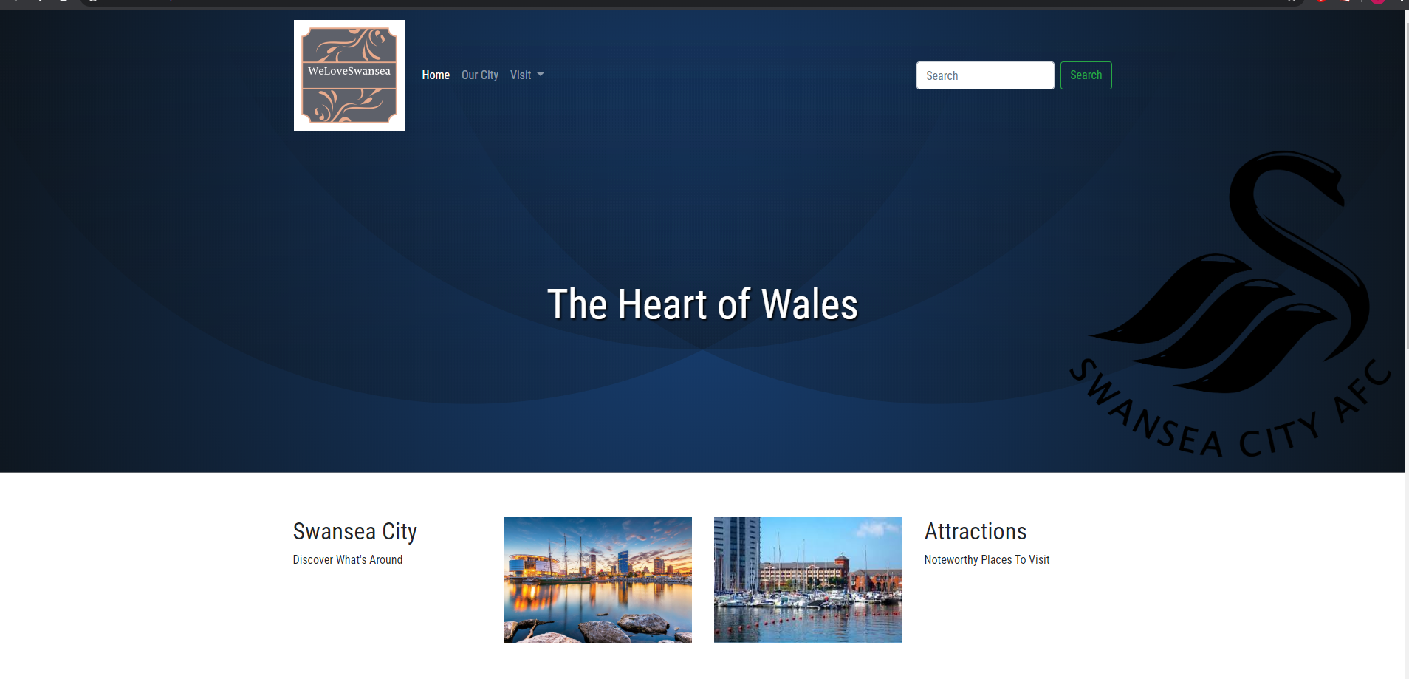

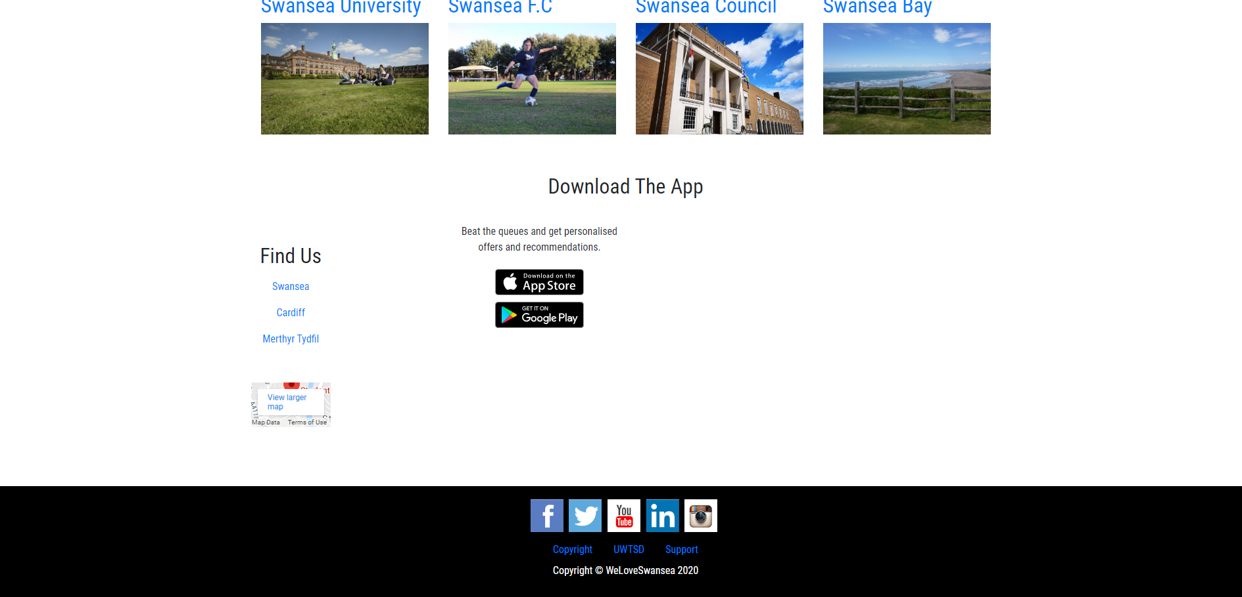

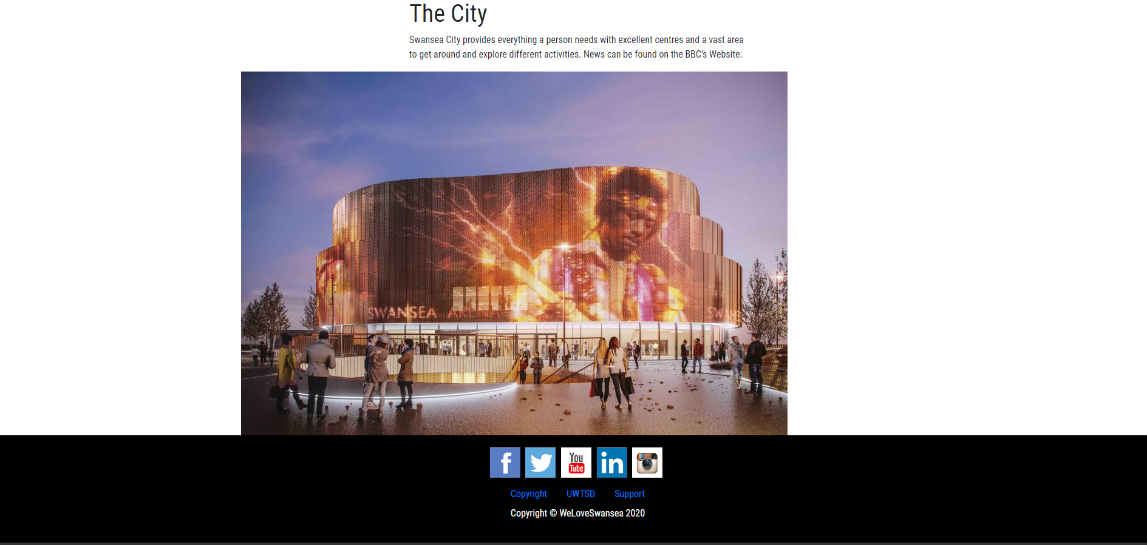

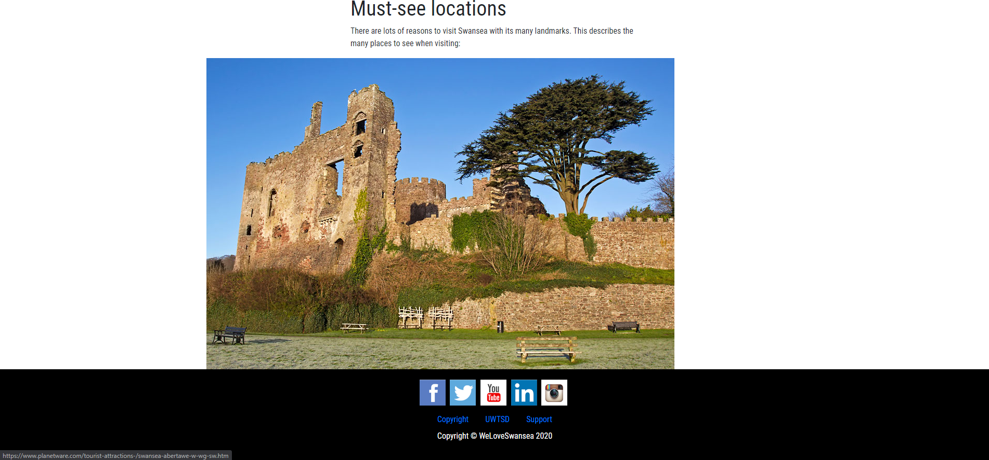

The page was fairly difficult and time consuming with a lot more research in future endeavours with HTML 5.
Validation
The website’s HTML and CSS has been validated through validation sites. It shows any errors that appear with the code. The website came up with a lot of problems to fix:

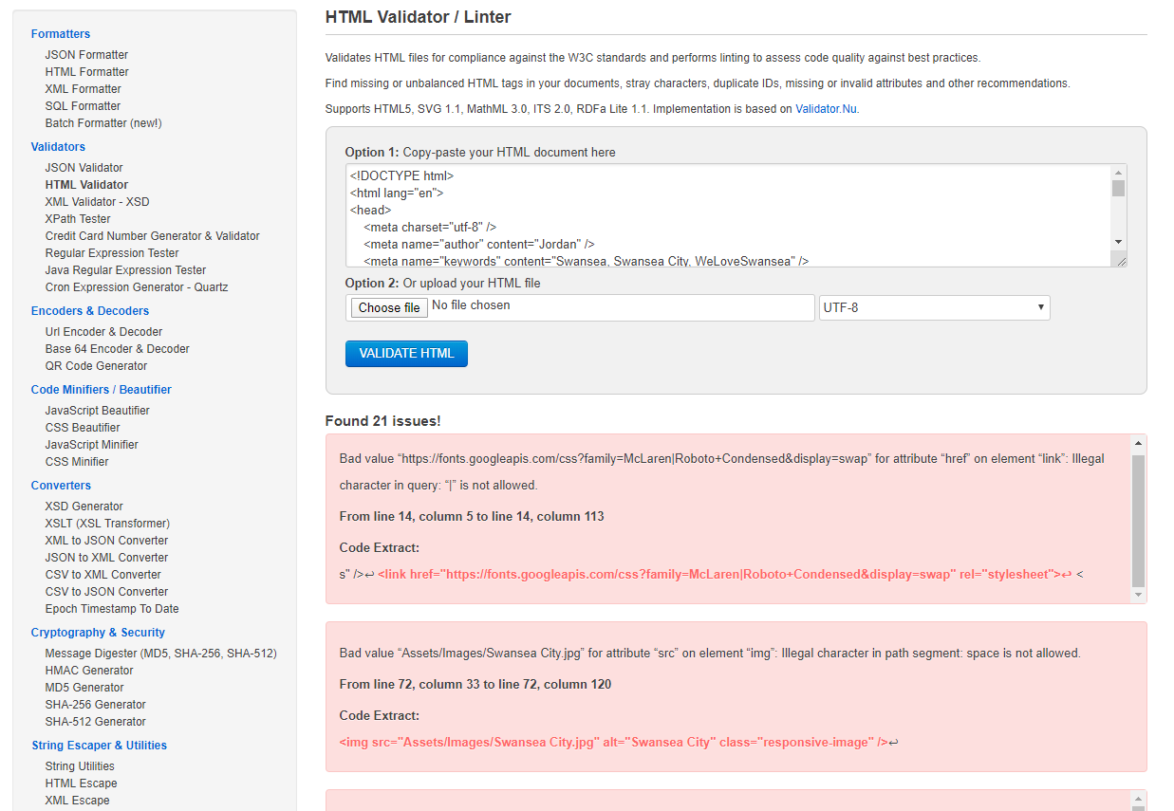
Evaluation
In this section, we will look at important terms and features of web design and my page.
Usefulness
Overall, this is a good starting website, an introduction to HTML that shows off some of the advanced features that make any webpage look smart. The created website conforms to the guidelines created to have a fully functional website.

Search Engine Optimisation
HTML allows their user to apply SEO techniques to a website with the end goal of increasing more traffic online. This is done by a number of techniques, the website created for this report for example includes a few keywords to appear when people may search similar words to them online. This is important because appearing in the first or near first few search results a website is able to promote its values whether it be for financial purposes or to just raise awareness. [1]

Accessibility
The created website is well accessed with each feature used and could be shared and explored by any intended viewers.
An important subject to touch on is WCAG 2.1. This refers to Web Content Accessibility Guidelines being a standard and 2.1 being the most updated version. A helpful source in explaining this set of rules was made by Lucas Chen. [2] Here Lucas goes into detail on tips for making your website accessible, as an example he explains why it is important to focus on one issue at a time and fix all of them until the project is complete. Throughout the coding of these webpages there were many errors which may could sway a person into being frustrated because it looked like a large mess, this technique promotes patience being calm in fixing the many issues one will have when making webpages in their beginning stages.
Conforming to the guidelines, allows the maximum amount of attention to your website by making it readable, navigable, understandable etcetera. They make the created piece of HTML the best it can be for the average viewer but also takes into account extra oddities such as “designing To avoid seizures and physical reactions - refraining from designing content in a way that is known to cause seizures or physical reactions” and also for example being keyboard accessible. [2]
The pages were made up from the Visual Studio package using HTML. Visual Studio supports a multitude of programming languages and similar to create anything the user can from a calculator in C# to a fully functional website in HTML with CSS etc. It is a popular piece of software used around the globe that therefore makes the navigation surrounding the HTML page accessible. This is a great package to utilise all types of programming and for a student to begin to learn in.
A beneficial tool to use online when designing webpages is contrast checker. This simply analyses your site and checks the colours used with colour combination and so on and informs the creator on if the pages are suited towards people with colour blindness and all types of colour diagnosis’s.
Another set of tools to use in web design are browser extensions. Using these extensions will increase the user’s productivity and can also increase the effectiveness of the site. These can be used across multiple platforms such as Firefox and Edge but the most commonly used will be with Google Chrome because it is easy to use, safe and fast. An example of a great extension found is the ‘Web Developer’ which lets you disable features of simple notifications, popups, JavaScript etcetera. [3]

References

[1] | Money Today, [Online]. Available: https://web-a-ebscohost-com.ezproxy.uwtsd.ac.uk/ehost/detail/detail?vid=0&sid=48d2fa49-64b3-49fa-a342-7bbf094fc86e%40sdc-v-sessmgr03&bdata=JnNpdGU9ZWhvc3QtbGl2ZQ%3d%3d#AN=70345088&db=bth.
[2] | L. Chen, "The Beginner's Guide to Accessibility on the Web," 21 November 2019. [Online]. Available: https://dev.to/bettercodingacademy/the-beginner-s-guide-to-accessibility-on-the-web-4fi7.
[3] | T. Phem, "15 Chrome extensions for developers," [Online]. Available: https://usersnap.com/blog/chrome-extensions-for-developers/.

Links used:
https://tinyurl.com/u4vekc7
https://www.template.net/design-templates/logo/swan-logo/
https://www.swansea.ac.uk/
https://www.swanseacity.com/
https://en.wikipedia.org/wiki/Swansea
https://www.swansea.gov.uk/residents
https://www.visitswanseabay.com/
https://www.britannica.com/place/Swansea-county-Wales
http://contrastchecker.com/
https://usersnap.com/blog/chrome-extensions-for-developers/
https://en.wikipedia.org/wiki/Swansea
https://www.walesonline.co.uk/all-about/swansea
http://tourismswanseabay.co.uk/
https://www.wipo.int/copyright/en/
https://www.swansea.gov.uk/mentalhealthinfo
https://www.bbc.co.uk/news/localnews/2636432-Swansea/0
https://www.planetware.com/tourist-attractions-/swansea-abertawe-w-wg-sw.htm
https://walescoastpath.co.uk/carmarthen-bay-gower/
http://www.psam.uk.com/afl-lands-swansea-arena-delivery-role
https://www.freeformatter.com/html-validator.html

marking criteria and Student FEEDBACK

This section details the extent to which the assessment criteria are demonstrated by you, which in turn determines your mark. The marks available for each category of skill are shown. Lecturers will use the space provided to comment on the achievement of the task(s), including those areas in which you have performed well and areas that would benefit from development/improvement.

Common Assessment Criteria Applied (Assignment 1) | Marks available | Marks  awarded
1. Engagement with Literature Skills

Unfortunately the submitted work does not really address the research elements of the assignment brief and generally, demonstrates poor engagement with essential reading and little evidence of wider reading of literature sources. Please ensure that you read the assignment brief carefully in future and verify anything that is unclear with your lecturer. Expand the scope of references to further improve your research work. (Grade mark: 12.00%) | 25 | 3
2. Knowledge and Understanding Skills

Demonstrates a very basic understanding of the standards used to design and implement a website. Some attempt has been made to discuss the validation errors, but these are not really satisfactory. As mentioned below, aim to improve your understanding of the basic CSS and HTML concepts. As you have not completed the research exercise properly, this has had an impact on your ability to properly evaluate the website against the requirements of the assignment brief. (Grade mark: 25.00%) | 20 | 5
3. Cognitive and Intellectual Skills

4. Practical Application Skills

A basic attempt. The main area for improvement is improving your understanding of some of the basics first and how to make your page layouts responsive, learn how to use CSS and the grid system properly. The website also only had 3 pages, one of which was not linked. It was supposed to have 5 pages. Some other things to note: Ensure all tags are properly closed and nested. The website is based on the class tutorial exercise and while it is acceptable to use tutorial exercises, you must ensure that you are applying the exercise appropriately. There was some content from the tutorial exercise that was not relevant for your website and this should have been removed. Make sure all images have alternative text descriptions for accessibility and open external links in a new tab. Generally, I would have liked to see some more variation of the content and concepts used. (Grade mark: 34.00%) | 50 | 17
5. Transferable Skills for Life and Professional Practice

The report is satisfactory, but is missing required elements. See your report for other suggested improvements. (Grade mark: 40.00%) | 5 | 2

Assignment Mark (Assessment marks are subject to ratification at the Exam Board. These comments and marks are to give feedback on module work and are for guidance only until they are confirmed. ) | Late Submission Penalties (tick if appropriate) |  | 27%
 | Up to 1 week late (40% Max) |  | 27%
 | Over 1 week late (0%) |  | 27%

