My future profession
Keti Veselinova (2030287)

Keti
Veselinova
´
One of the
dreams of many
people,specilly
the smaller part
of the
population,is
to
make a career.
´Like every young person, I have my own ideas about my future,goals i want to achieve,ideas to realize to be a successful manager
.

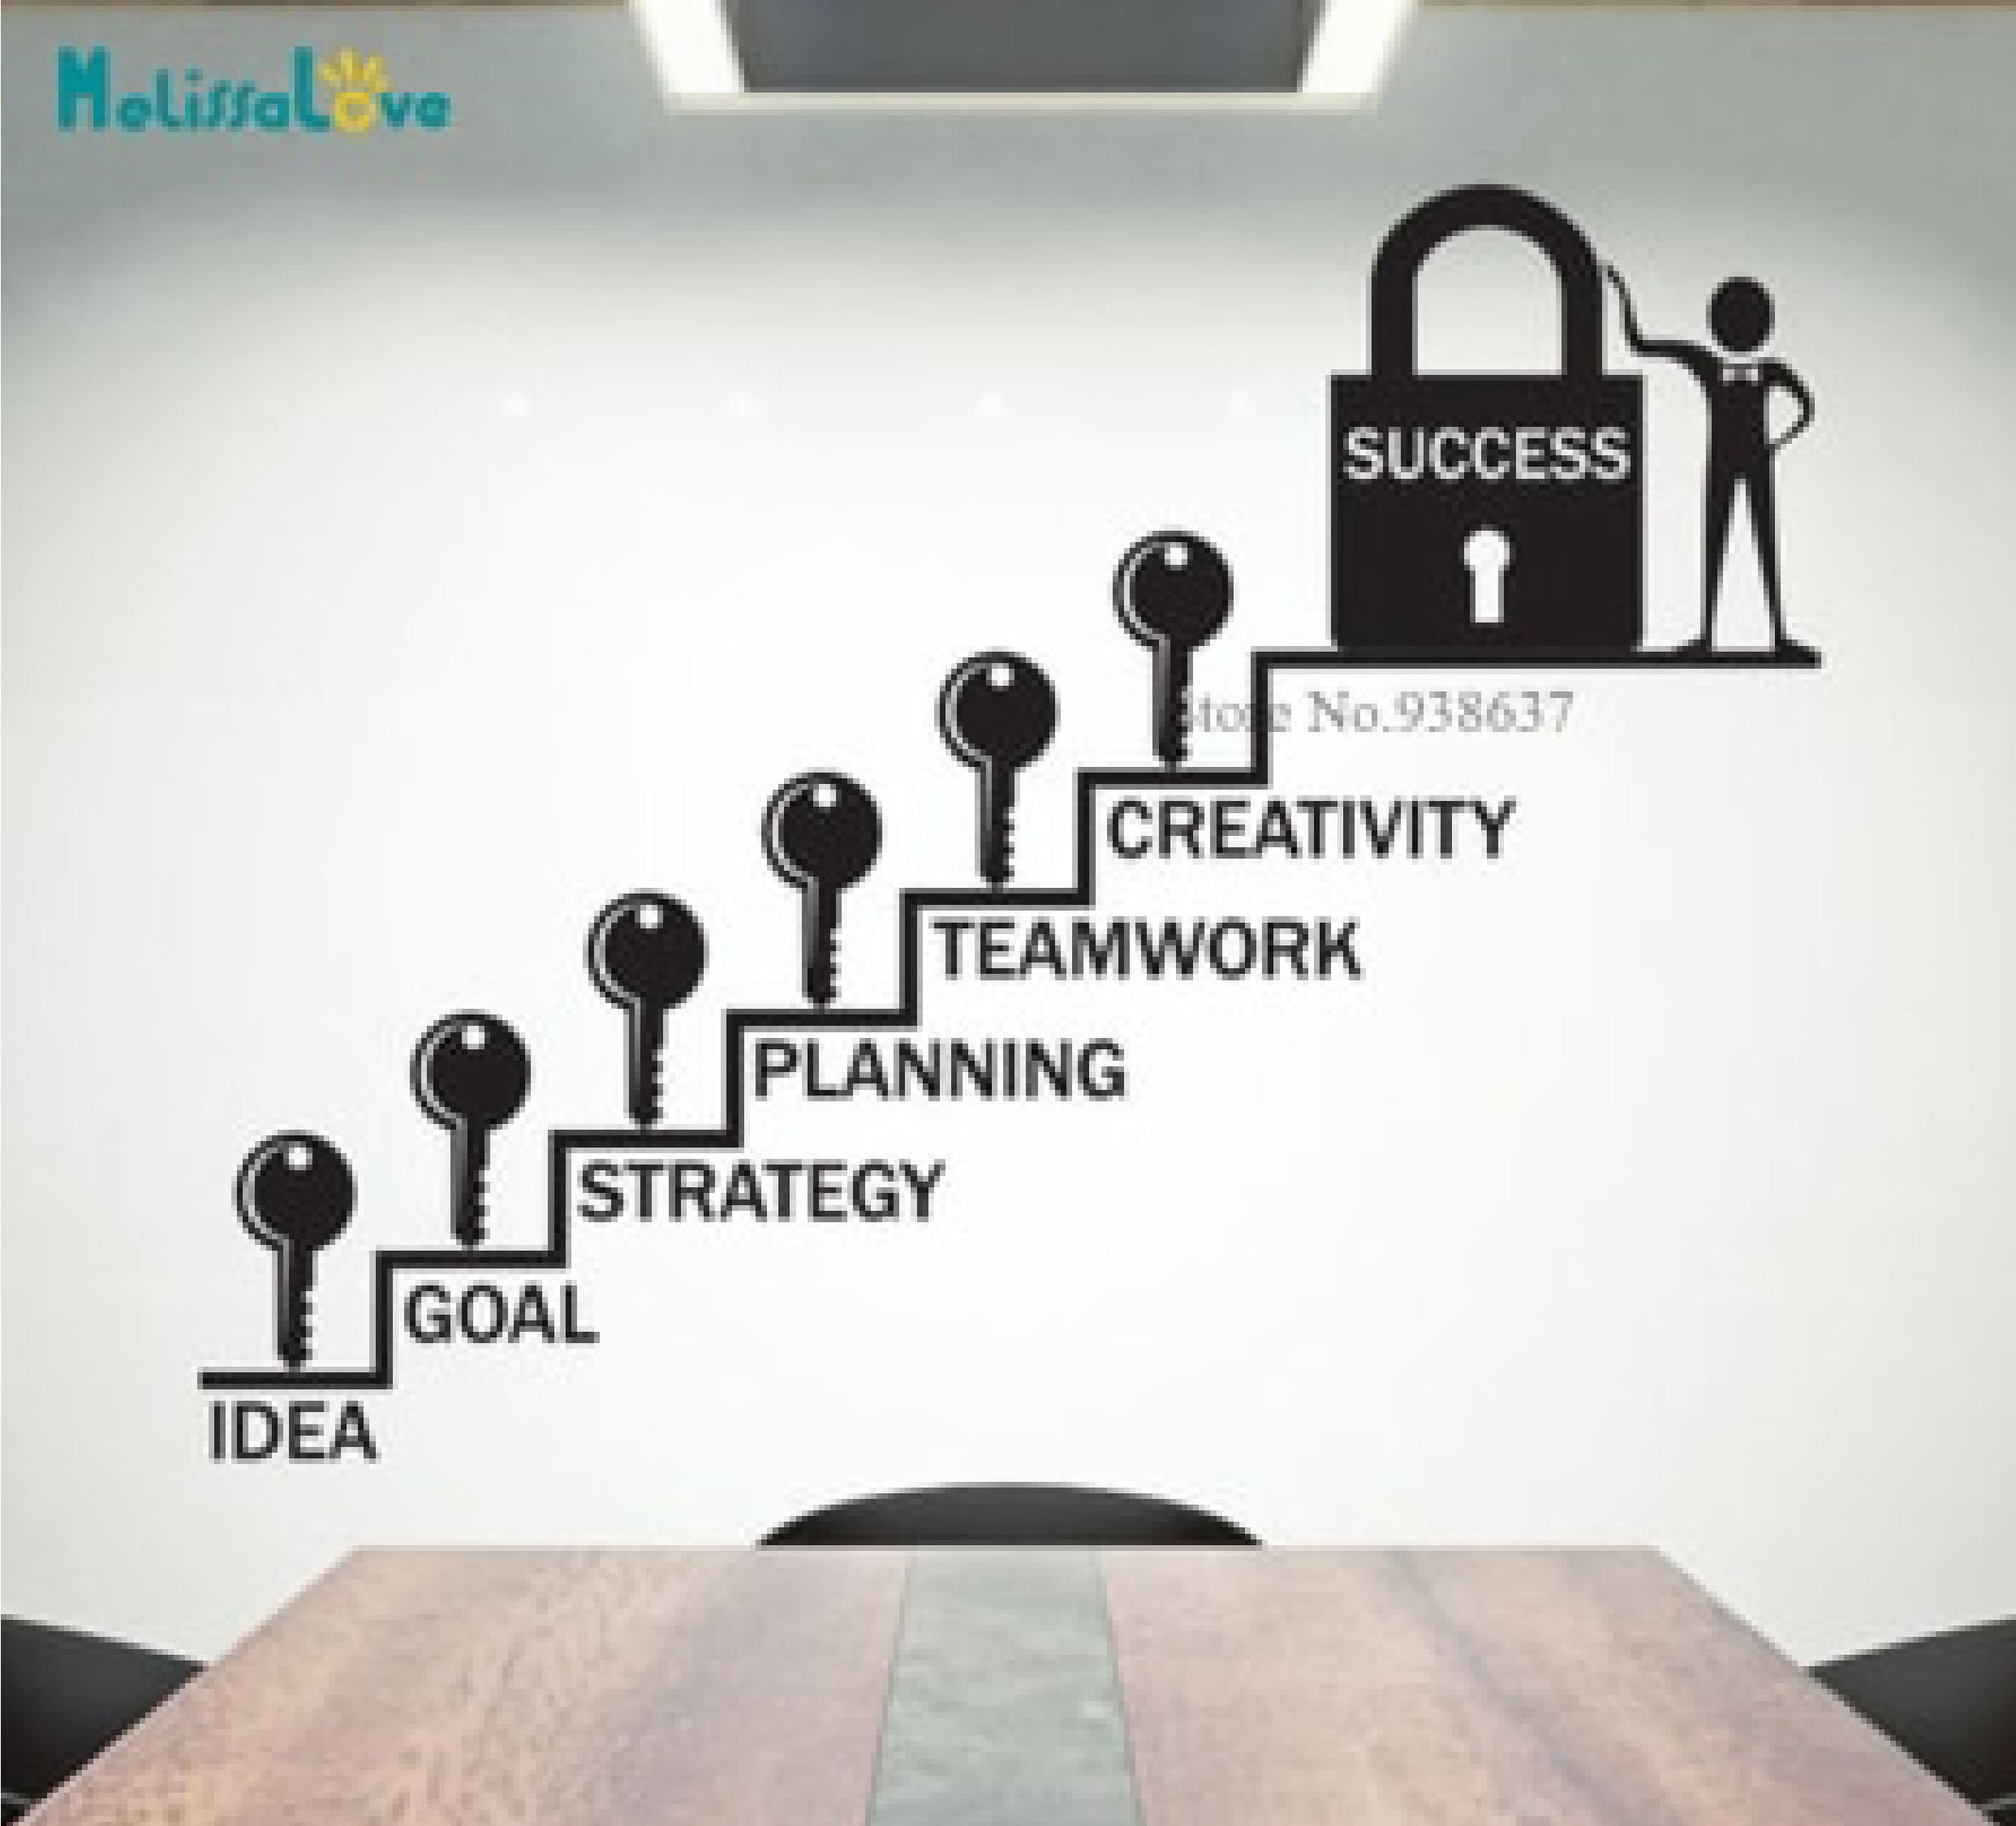
This is my
steps to
success
I am motivated
´ I will work hard and learn hard to be a successful and good student this is a plus for me and my career, in the future to realize a dream that will change my life .
My future profession

What is it
the profession I
chose, I chose manager.
Way I chose this profession
In general,this profession has good prospects and realization. Gives a lot good results and paid is very well .
What I will have the possibility learn while studying it

There is few things I can introduce
1-People management
2-Professional career development 3-Problem Sloving and Decision making and much more .
I hope, you like getting to know my future profession thank you for watching .
It was from me Keti Veselinova 2030287 modul code: (BMSW4001)

