Digital Strategy Development

Name: James Goddard
Student Number: 2111623
Word Count for Core Document Between Contents List, Tables and References: 3850

Contents
Digital Strategy Development 1
Introduction 3
Medication Reconciliation 4
Medication Discrepancies 5
Strategic Requirements 5
Methods 7
Gap Analysis Method 7
Option Appraisal Method 7
Results 9
Gap Analysis Results 9
The current situation 9
Goals and Objectives 13
Analysis of Gaps 14
Plan to close the gaps – options appraisal 14
Options Appraisal – Results 15
Options Appraisal Criteria - Outcome 18
Options Appraisal Recommendation 18
Requirements 18
Functional and Non-Functional Requirements 18
Data collection and analysis 19
Technical standards (data structures, terminology, interoperability). 20
Discussion 20
Conclusion 22
References 23

Introduction

In 2017 the World Health Organization presented a Third Global Patient Safety Challenge: Medication Without Harm (World Health Organization, 2017) challenging countries, health care leaders, regulators, subject matter experts, pharmaceutical companies, researchers and professional organisations to commit to globally reducing avoidable harm that is associated with medicines over the 5 years by 50%. The challenge realises that errors can take place at every step of the medication process, prescribing, dispensing, administering the medication and monitoring. Three categories of action within the challenge include the following high priority areas: elevated risk situations, polypharmacy and transitions of care.
Discrepancies in prescribing and history taking of medications can have a notable effect on patient safety and according to the WHO’s technical report on medication safety in transitions of care (World Health Organization, 2019), effect virtually every patient when they transition between care, such as when a patient is admitted to, or discharged from secondary care.
The report highlights crucial actions for confirming medication safety (Figure 1):
- Appropriate Prescribing and risk assessment
- Medication Review
- Dispensing, preparation, and administration
- Communication and patient engagement
- Medication Reconciliation at care transitions

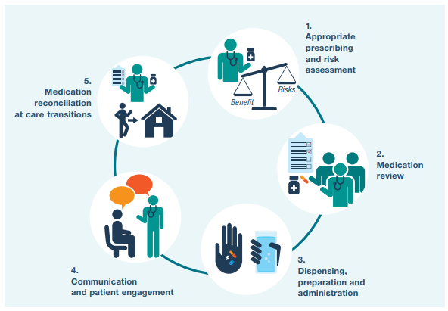
Figure 1 Key Steps for ensuring medication safety (WHO, 2019)
Welsh Government supports the approaches defined in the WHO challenge and indeed recognizes safer medicines management as one of the clinical spaces for improvement action (Welsh Government, 2018). Each of the WHO priorities areas are equally important however this paper will focus on the transitions of care and very specifically on how medicines reconciliation between care settings and locations can be improved.

Medication Reconciliation

During medication reconciliation a patient’s current medications (which can include medicines brought by the patient, and complementary products) are accurately identified and compared with those on their current prescription or list of medicines being used in their current care. It is important that discrepancies are recognised, and any changes documented at the interfaces of care. This is undertaken in partnership between health professionals and patients. It is equally important that any changes to medicines that may have happened during a move between care settings is communicated. For example, a patient may have attended hospital through an emergency that their medication may have contributed to e.g., gastrointestinal bleeding, which some medications can provoke. It is highly likely such a medication would be stopped and it is important that as the patient moves from acute, e.g., casualty to an inpatient ward and is then finally discharged, that this change is communicated otherwise the patient could suffer further harm. As such key changes should be highlighted. Figure 2. Helps to demonstrate this journey.
Precise medicines reconciliation avoids medication errors and offers a footing for evaluating the suitability of a patient’s current medicines. It also helps problems such as weak adherence or non-adherence to be identified.
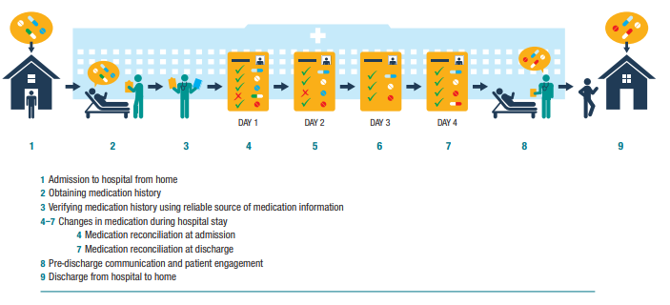
Figure 2. Changes in medication during transitions of care between home and hospital (WHO, 2019)

Medication Discrepancies
A discrepancy is considered any difference that might occur between the medication history, prior to an admission or transition, and the prescribed medication that might occur at the time of admission. These can be deliberate changes or unintentional and they may or may not be documented. WHO, (2019) describes these as intentional and unintentional.

Strategic Requirements
The WHO report identifies some key approaches for improving medication safety where a number consider the reconciliation aspect of the medicines process which should be considered at the transition of care (World Health Organization, 2019). These include:
- Employing formal structured processes for medication reconciliation that seeks to building the “best possible medication history” (BPMH) by talking to the patient or their carer and confirming this with at least one reliable source of information. This is then reconciled, and the medication list updated ensuring that communication happens between the patient and current/future health care providers about alterations to their medications. Roles and responsibilities should be established and clear, utilising appropriate support, training and use of tools and technology.

- Patients that present a higher risk of medication-related harm should be prioritised for medication reconciliation and support at key points like before and after discharge. E.g., an example of a post discharge prioritisation might be a community pharmacy medication usage review referral. (This might be supported digitally)

- The availability and quality of information accessible at care transitions needs to be improved with a focus on recognising the most reliable sources of information for confirming medication histories. Such examples may consist of patient’s own held medication records, digital solutions that help enable and support the reconciliation processes and the use of electronic health records to support transitions that are smoother.

The above strategies highlight a number of key focus areas in terms of understanding requirements that might support the WHO challenge and therefore it is clear that the availability of the following in any requirements would support and allow this particular action area of improving medication safety, realised through better reconciliation:
- Accessible sources of patient medication information (e.g., Those easy to get hold of or be able to view easily)
- Reliable and reputable sources (e.g., GP medication record)
- Previous records
- Ability to communicate changes (to HCPs and patient)
To help highlight information sources used, the Medicines Ethics and Practice guide outlines several sources of medicines information that are used when undertaking a reconciliation (RPSGB, 2021):
- Patient or a representative of the patient
- Patient’s own medications (ones they have bought with them)
- Repeat prescriptions
- GP referral letters
- The patient’s GP medicine records – i.e., from the GP surgery
- Existing hospital discharge summaries (discharge advice letters) or outpatient notes.
- Community pharmacy patient medication records.
- Care home records
- Drug treatment centre records
- Other Healthcare Professionals and specialist clinic records.
- Patient Medication Records – such as Summary Care Record, Welsh GP Record, etc.
Wherever there are digital elements to the information sources there is the potential to link information and utilise it in a better way and consider mechanisms for digitising records that may not already be digitised. This paper will consider how digital technology might be used to improve medicines reconciliation and meet the WHO objective more specifically at the transitions of care.

Methods
To achieve improvements in the medicine’s reconciliation processes, undertaken during transitions, it is necessary to understand what processes and technology are used currently and whether there are mechanisms for identifying and incorporating up to date, accessible and reliable sources of patient medication information and then undertake analysis to understand what is in place now and what will be needed to support this improvement and examine the options available. Therefore, a gap analysis and options appraisal will be undertaken.

Gap Analysis Method
The approach to the gap analysis follows similar principles outlined by Leonard and Bottorff (2022). This included understanding the current situation and that of the future situation, seeing the importance of improved medicines reconciliation. This analysis includes gaining knowledge of the processes of how medicines reconciliation is undertaken, who does it and where does the data that supports it currently come from, whether this is digital or not.
The future state and goals will then be defined, following the principles of “SMART” – Specific, measurable, achievable, relevant and time-sensitive. It is then necessary to analyse the gaps between the current state and the future state. Understanding what is “missing” and why things are not in the aspirational state.
Once the gaps are understood it is possible to formulate a plan and decide on actions and options that might be available to close them.
To support the gap analysis in terms of understanding the current and future states and derive technology requirements a simple literature search will be undertaken to confirm the situation with regards to the number of medication errors or discrepancies related to when medicines reconciliation might take place around the primary care to secondary care to primary care transition. This will not be a detailed analysis as the WHO report itself identifies that this type of medication error is a well-known and reported phenomenon (World Health Organization, 2019) and the RPSGB Medicines, Ethics and Practice (2021), details reputable sources of medicines reconciliation information.
Discussions with colleagues from secondary care in NHS Wales and Digital Health and Care Wales in combination with the personal experience of the author will be used to identify the current state of play in terms of what processes and tools are applied to undertake medicines reconciliation and to determine what is presently available in a digitally accessible format.

Option Appraisal Method
The options appraisal will use the key goals from the gap analysis to define the objectives and then outline the feasible options for achieving these. It will then examine the advantages and disadvantages of each option and assesses these against achieving the goals (as outcomes) and provide a recommendation. This will follow the basic principles outlined in the Local Partnerships (2012) options appraisal workbook which outlines a five phase approach described in Figure 3. For the purposes of this paper and the constraints on the word count the options appraisal will be limited to a high level, taking a hybrid approach from the work of the gap analysis to inform it. Evaluation criteria (described in Table 5) will be based on perceived feasibility and likely perceived benefits to patient safety. No financial exploration was undertaken, and no risks were analysed at this level. It is recognised that these two aspects would otherwise be a fundamental part of an options appraisal.
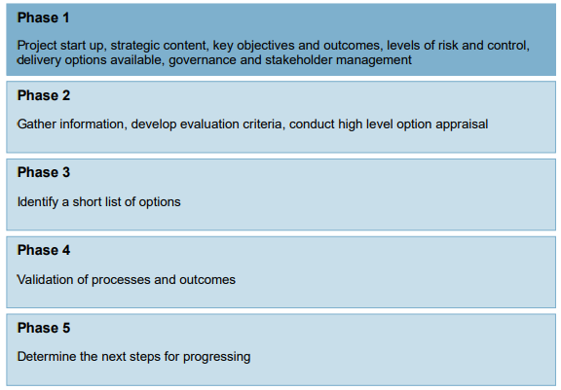
Figure 3. Five Phase Approach (Local Partnerships, 2012)

Results

Gap Analysis Results
The gap analysis is outlined below.

The current situation
Medication reconciliation in secondary care in NHS Wales is undertaken by the hospital pharmacy teams, utilising pharmacists and supported by pharmacy technicians. Patients can be admitted to hospital via several different routes, which may include both planned (which could include an outpatient clinic or a planned surgical procedure or something similar which may result in an “inpatient” stay) and unplanned (such as an accident and emergency admission). Both may lead to an inpatient stay. Unplanned care tends to lead to more work in terms of reconciling a patients medication list as planned admissions allow information to be prepared in advance. Nonetheless any transition of care requires checks and validations to be completed.
Checks will be made against medication that has been written up to be administered to the patient as part of their hospital stay and medicines that the patient was on prior to arrival (medicines on admission), and discrepancies are investigated and corrected or confirmed and the reasons for any changes recorded.
When reconciling medicines, the team will seek to use the most complete, reliable and up-to-date sources of information. These will be checked with the patient to understand if the patient is physically taking (adhering to) the medications in their history. The medications they are taking may differ from that in the documentation.
It is also important for health care professionals to find out about any recently amended or stopped medications.
Who does the medicines history and reconciliation?
Doctors, nurses, pharmacists and pharmacy technicians – at all the transitions of care.
Where does the data currently come from and what tools are used?
The healthcare professionals will obtain medications history from several sources such as those stated in the introduction outlined by the RPSGB (2021).
Some examples of the tools and sources used commonly include:
- Welsh GP Care Record
Digital access to the medication list is available to NHS staff in Wales who have the correct level of access to the Welsh Clinical Portal.
- Patient Repeat Prescription
Patient may bring their repeat prescription list.
- Discharge Advice Letters (DALs)
These contain information about the medicines the patient was discharged from hospital on when they were last admitted. These are the source information primarily used to communicate changes to a patient’s GP and or community pharmacist. It currently relies on an electronic document that must be communicated digitally and acknowledged and acted upon by the receiver. It does not automatically integrate to populate the GP medicine record.
- Patient has their own list
The patient may have written up their own list of medicines – this may be subject to the patient’s own interpretation and may not reflect what they are “supposed” to be taking but will be useful in terms of safety. For example, a patient may only be taking one tablet instead of two tablets and may well be stabilised on this regime. The official history may inform the prescriber that they are on two tablets which could lead to potential adverse effects. This helps to highlight some of the complexities involved.
- Pharmacy dispensing records
These may be available if the patient has had medication dispensed from the hospital previously but may not be the full record and may only serve to confirm a query. The same would be the case for community pharmacy based dispensing records, however they may be helpful to confirm a patient has indeed received a community prescription. Community pharmacy dispensing records are not readily accessible and generally require a telephone call.
- Hospital Patient Records
May be a mix of digital and paper – as such the accessibility and indeed readability of the information is less reliable. Paper records may also not be available straight away, particularly for unplanned care.
The availability and reliability of some of these sources can differ, however the GP record is generally one of the more reliable sources and is more readily available digitally.
A number of systems and sources that utilise medicines information have been identified (see Table 1). However, there is variation in the information that may be available via paper records and that which might be available digitally and variation in the consistency of data and standards used in these systems which can affect the ability to interoperate, interface and integrate data between systems.

Table 1. Health and Social Systems that use medicines data in NHS Wales
Actors  (Note: Patient is an implicit actor in all systems) | System (Application) | Care Setting | Information Currently Used By
GP | GP Systems  - EMIS  - InPractice - VISION | Primary | Primary/Secondary Care/Tertiary/Acute
Community Pharmacy | Community Pharmacy Systems  - Dispensing and Stock Systems (many providers)  - Choose Pharmacy (utilises National Reference Data Service - NRDS tables) | Primary | Primary Care and NWSSP
Care Home | Community Care Homes | Primary | Primary/Secondary Care/Tertiary/Acute
Community Care Schemes | Welsh Community Care Information System  (WCCIS) | Primary | Primary/Secondary Care/Tertiary/Acute
Community Care Schemes | Community Mental Health Teams | Primary | Primary/Secondary Care/Tertiary/Acute
Community Care Schemes | Community Drug Addiction Clinics/Settings (e.g., MDAT) Systems | Primary | Primary/Secondary Care/Tertiary/Acute
NHS Wales (Administration) | NHS Wales Shared Services Partnership (NWSSP)  - Community Pharmacy Prescription Pricing (PCS) System  - Contracts  - TRAMS project?
Ambulance | Ambulance System | Acute | Secondary Care/Tertiary/Acute
NHS111 | NHS111 Systems  - Adastra  - (CAS – Clinical assessment Service)  - 111 Integrated Information System (IIS) |  | Primary
Hospital Clinics  - Emergency Dept  - Out-patient  - In-patient | Hospital Systems  - Welsh Clinical Portal (WCP)  - Outpatient Continuation Sheets  - Medicines Transcribing and Electronic Discharge (MTED)  - WISDM  - Electronic Prescribing and Medicines Administration (EPMA)  - Computerised Outpatient Prescription Printing System (COPPS)  - Chemotherapy prescribing systems  - Critical Care Information System (CCIS)  - Other Bespoke Systems | Secondary Care | Primary/Secondary Care/Tertiary/Acute
Hospital Pharmacy  (Actors that use include:  Health Boards  DHCW  Public Health Wales (PHW)  MI Pharmacists  All Wales Therapeutic and Toxicology Centre (AWTTC)  RxInfo | Hospital Pharmacy Systems  - WellSky (Pharmacy Dispensing and stock control)  - Prescription Tracking Systems  - Dispensing Robots  - Automated Stock Cabinets  - Pharmacy Technical Services (PTS)  - Manufacturing  - CYTO/CIVAS  - INFORM (Formulary)  - Welsh Medicines Service (WMeDS)  - All Wales Intervention Database (AWID)  - Baxter (ward ordering)  - Falsified Medicines Directive (FMD) + Tracelink  - Medecator  - Ward Order Requisitioning (WOROQ) | Secondary Care | Primary/Secondary Care/Tertiary/Acute

Goals and Objectives
It is necessary to consider this context when analysing the gap between the current situation and the aspirational and determine which of the systems to prioritise in order of reliability and importance when reconciling medicines histories. There are some key objectives to enable a state where patient medicines records are readily available in a digitised and consolidated form. Therefore, to support this state, an overall strategic key goal would be to seek a reduction in medicines prescribing errors due to transitions of care that has the SMART aspects described in Table 2:
Table 2. SMART aspects transferrable to objectives
Specific | Achieve at least a 50% reduction in prescribing errors related to transitions of care from admission through to discharge from hospital and in primary care afterwards.
Measurable | This can be measured using medication error intervention data from before and after service improvements or changes.
Achievable | There are a number of existing data standards and interoperability resources that allow interoperability of medicines data. (e.g., GP connect)(NHS Digital, 2021)
Realistic | There are existing digitised medicines data records already in other countries and being developed in the UK. (Andersen et al., 2022, Group, 2022)
Time-Bound | It is realistic to expect implementation with the next two years. The expectation for services of this kind within England is by March 2023. (NHS Digital, 2021)

This goal could be achieved through consolidating and digitising medicines records and making them readily accessible.
More refined goals can be identified by understanding more precisely where discrepancies occur. Examining the evidence it is clear that the majority of patients encounter a minimum of one medication discrepancy when admitted to hospital (Tam, 2005, Lehnbom et al., 2014, Huynh et al., 2013, Becerra-Camargo et al., 2013, Zarif-Yeganeh et al., 2017, Salanitro et al., 2013) and that this also occurs with transfers within hospital (Lee et al., 2010), at discharge (Lehnbom et al., 2014, Riordan et al., 2016, Shah et al., 2020) and within the community where intentional changes that took place within hospital were not actioned in primary care (Lehnbom et al., 2014, Shah et al., 2020).
The literature and gap analysis helps to identify and derive some key areas where it would be pertinent to understand whether improvements can be made and whether there is one solution or many that may help to achieve them. The resulting objectives can be seen in Table 3 (the smart objectives for the strategic goal above (Table 2) could be emulated into each of these transitions of care):
Table 3. Key Objectives from gap analysis and phase 1 of options appraisal
Key Objectives |  | Measure
Objective 1 | Reduce Medication Discrepancies at Admission to Hospital. | See Table 2.  Measure error reduction at Admission
Objective 2 | Reduce Medication Discrepancies at Transfers within Hospital. | See Table 2.  Measure error reduction at Transfers within hospital.
Objective 3 | Reduce Medication Discrepancies at Discharge. | See Table 2.  Measure error reduction at Discharge
Objective 4 | Reduce Medication Discrepancies at Transfer back to community (primary) care. | See Table 2.  Measure error reduction at transfers back to community.

Analysis of Gaps
At the moment key areas where the process of medicines reconciliation is more difficult is in the accessing medicines information from sources that are not digital or support by a digital process. These sources of information are also not consistently available, for example a patient may or may not provide their own composed list of medications. At the same time when viewing medicines information in digital systems it is not always apparent where the source of the information came from.

Plan to close the gaps – options appraisal
To close the gap, it is key that mechanisms to support digitising and increasing availability of sources of patient’s medicines information, in a bidirectional manner, are explored. There are areas where a digital solution along with the appropriate collaboration, engagement and training may help to improve reconciliation. For instance, it may be possible to introduce functionality into a patient app that allows them to confirm medicines that they are adhering to and communicate digitally when necessary. It may also help to consider and explore mechanisms that allow third party solutions to store and use the same repository of information in a persistent and open manner, an open platform (Aperta Foundation, 2018), for instance.
These options are supported by the options reviewed in the options appraisal below.

Options Appraisal – Results
An overview of how the five phases of the options appraisal was approached is described in Table 4.
Table 4. Options Appraisal Phases - Outcomes
Phase 1 | Strategic Context and Goals Identified Using Gap Analysis (Table 2). The options considered available (constrained for the purpose of this paper) were to do nothing, to build “in-house” or to procure a system. Stake holder identification, power and interest assessment and engagement and SWOT analysis would take place at this level but has not been covered in detail for this paper.
Phase 2 | Evaluation criteria assessed against ability to achieve goals and objectives – options should be aligned with meeting the aims of the WHO goals for reducing medication errors at transitions of care by 50%.
Phase 3 | Options Identified:  Option 1 – Do Nothing  Option 2 - Design and build our own system – e.g., a standardised shared medication record (SMR).  Option 3 – Procure a Commercial Off The Shelf (COTS) SMR system.
Phase 4 | Process and Outcomes – Validation (not covered in the scope of this paper)
Phase 5 | The next steps for progressing the preferred options include working with stakeholders to understand and develop the following:  - Analysis and clear understanding of current context  - An understanding of the requirements and functions.  - Study of Feasibility  - Early stake holder engagement, understanding of context  - Analysis  - Stakeholder analysis  - Gap analysis  - Defining requirements  - Design  - Development  - Testing  - User Acceptance

To support medicines reconciliation and the objectives above many pieces of information from many different sources of data need to come together in a standardised format that allows integration and interoperability.
There are many different systems in NHS Wales that process medicines data (see Table 1). However, although the process of medicines reconciliation should happen at all transitions of care, the most common and frequent location where this happens is on a patient admission to hospital. As the secondary care environment for prescribing and administering medicines in Wales moves to a digital solution (electronic prescribing and medicines administration (ePMA)) it will be key that the medicines reconciliation process is able to be fully supported. Whilst the complexity of an ePMA solution means that these solutions will most likely be procured solutions it is important that the medicines record and what it contains remains in a vendor neutral state that is able to persist and make data available in an open manner to the corresponding system, enabling re-purposing and re-use of data and opening up the ability to build applications based on the standards for integrating into this platform. An example of such use of open data and defining an open platform is described by the Aperta Foundation (2018).
Given the vendor neutral and application agnostic aspects that would be required of data persistence platform it lends itself to being a developed system by the strategic NHS digital leadership body in Wales, Digital Health and Care Wales (DHCW).
In Considering the criteria above and that listed in Table 6, The following options were considered (outcomes) Table 5:
Table 5. Outcomes - Options Advantages and Disadvantages
Options | Advantages | Disadvantages
Option 1. Do Nothing | No change management, low upfront costs, resilient. | No effect on reducing patient safety, no benefits gained, risk remains.
Option 2. In-house - Design and build our own system – e.g., a standardised shared medication record (SMR). | Allows greater control and flexibility over the design, implementation and integration. This approach also accounts for vendor neutrality and national ownership and continuing user and stakeholder engagement. A SMR can act as a platform to persist patient medication data that other systems can utilise or even build their own products around. This would standardise the approach to medicines data and use interoperable messaging standards such as HL7 FHIR V4 (Health Level Seven International, 2019) to communicate to other systems if necessary. The SMR should also include medication terminologies such as the dictionary of medicines and devices (dm+d) and the relevant SNOMED CT codes (See key in Table 9) | Requires significant time, resources and ongoing funding. It may not immediately address any areas that still use paper records but may provide a basis to allow this development.
Option 3. Procure/Outsource a SMR system. | There may be ready built SMR systems available on the market which may allow faster implementation. | Risks being less bespoke and could increase the chances of vendor lock in. The requirements specification work would still need to be undertaken to ensure that the system meets the intended functionality. Governance of third party systems may be difficult to have influence on standardisation and interoperability of data. Less control over costs and timelines for independent systems.

Options Appraisal Criteria - Outcome

The following appraisal criteria was established and considered before making a recommendation Table 6:
Table 6. Appraisal Criteria
Appraisal Criteria | Description | Ability/Evidence
Criteria 1. | Vendor Neutrality | Ability to persist data independent of vendor
Criteria 2. | Continuing Stakeholder/User Engagement | Ability to keep stakeholders engaged in continuing development and change.
Criteria 3. | Potential to support future Innovation | Ability to allow innovation and products to be built around it.

Options Appraisal Recommendation
Based on the above criteria, the recommended option would be Option 2, due to the balance towards vendor neutrality, maintaining user engagement and allowing future innovation weighted more towards the in-house option. This option would make significant steps towards closing the gap and enabling future developments to be built upon an agnostic platform utilising interoperability standards and terminology such as HL7 FHIR, SNOMED-CT and dm+d (Health Level Seven International, 2019, Spiers et al., 2017). It will mean that there is a far more accessible source of consolidated information at transfers of care.

Requirements
To support the design and build, more detailed requirements would be necessary, however, considering the objectives in the appraisal and the gap analysis the following key high-level requirements would need to be met and serve as a starting point. These requirements were developed as a result of the gap analysis. Further stake holder engagement would refine these.

Functional and Non-Functional Requirements
These requirements are unique to medicines reconciliation functionality and displayed in Table 7 and 8:
Table 7. Features (High Level Functional Requirements)
Feature | Benefit | Acceptance Criteria
Must be able to view and record the provenance of patient medication | This gives a user the ability to understand the ownership and journey | Can see an information source and owner of each record entry.
Must be able to see and record the reason for a medication | A patient may no longer need the medication and without the reasons for being on a particular medicine being understood it may continue unintentionally which can lead to overprescribing. | Can see the indication and reason for the medication
Must be able to see and record the reason for medication changes | Understanding why a medication has been changed is fundamental to ensuring it is not reverted, re-prescribed, or stopped in error. | Can see a reason why a change has been made.

Table 8. Non-Functional Requirements
Non-Functional Requirement | Benefit | Acceptance Criteria
High Availability | Allows near real time access to relevant clinical data | Data available within 1 minute of request being made. 99.9% system uptime.
Security - Authentication | Access controlled – making sure data is secure | Users can only access with the appropriate authentication method e.g., username, password and smart card.

Data collection and analysis
An example of the data and data types that would be required within the SMR system (Table 9):
Table 9. Data Elements required
Data Name | Type
Medicine Name | SNOMED-CT dm+d extension
Medication Strength | SNOMED CT dm+d extension
Medication Formulation | SNOMED CT dm+d extension
Medicine Coding | SNOMED CT dm+d extension
Indications | SNOMED CT
Dosing Syntax | HL7 FHIR v4
Patient Identifiers | NHS Number
Episode Identifiers | UI
Date | DD/MMM/YEAR
User Identifiers | UI
Key:
UI | Unique Identifier
dm+d | Dictionary of Medicines and Devices (NHSBSA, 2022)  Ensures medications can be correctly identified and are consistent across systems. Supporting interoperability.
SNOMED CT | Systematized Nomenclature of Medicine – Clinical Terms (SNOMED International., 2022)  Ensures standardised terms, synonyms and consistent coding is used – supports interoperability by ensuring meanings are the same and consistent across different systems. Supporting interoperability.
HL7 FHIR v4 | Health Level Seven International, Fast Healthcare Interoperability Resources, version 4. (Health Level Seven International, 2022)  Supports interoperability by standardising messaging and interfaces.

Technical standards (data structures, terminology, interoperability).
The system would require the use of all dm+d concept levels to describe drug entities. It would require, at minimum, SNOMED CT terminology to describe indications, dosing, and any links to sensitives. In terms of interoperability, whilst this is supported with the use of dm+d and SNOMED CT, it is expected that the system should comply with the medicines interoperability standard defined by NHS digital that utilises the HL7 FHIR. (NHS Digital, 2021)

Discussion
There will be a series of steps between present and future implementation, namely:
- Study of Feasibility
  - Early stake holder engagement, understanding of context
- Analysis
  - Stakeholder analysis
  - Gap analysis
  - Defining requirements
- Design
- Development
- Testing
- User Acceptance
Whilst at the same time communicating and raising awareness and making sure the appropriate stakeholders are engaged at the right level.
The acquisition and implementation will require dedicated funding and project management using project management methodologies such as PRINCE2 (Hedeman and Seegers, 2009). Therefore, a project initiation document and business case will be developed to seek funding for the resources required (not covered by the scope of this report).

The steps required to develop, implement and evaluate the system would follow a model similar to the extended V model (Figure 4), reflecting the link to the business needs and scope, the V shows how the deliverables from the initial stages are used in testing the solution. These further steps would also need to be considered:
- Interoperability – Agree standards
- Awareness - Communication
- Training
- Process and Business Analysis
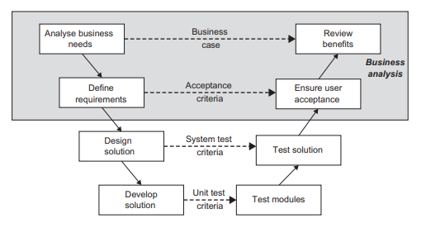
Figure 4. Extended V model (Paul et al., 2010)
The main acceptance criteria and goals will need to be fully evaluated against baselined data collected on medication errors related to transfers of care checked back against the reduction target of 50% described in the WHO report (World Health Organization, 2019).

It is fundamental that suitable training and analysis of the sociotechnical factors and business processes themselves is undertaken. It is key that technology is not implemented alone but is supported with the business change and engagement. To support this an initial step would be to undertake a stakeholder analysis utilising a power and interest grid to help identify the most optimal approach to engaging users (an example can be seen in Figure 5.)

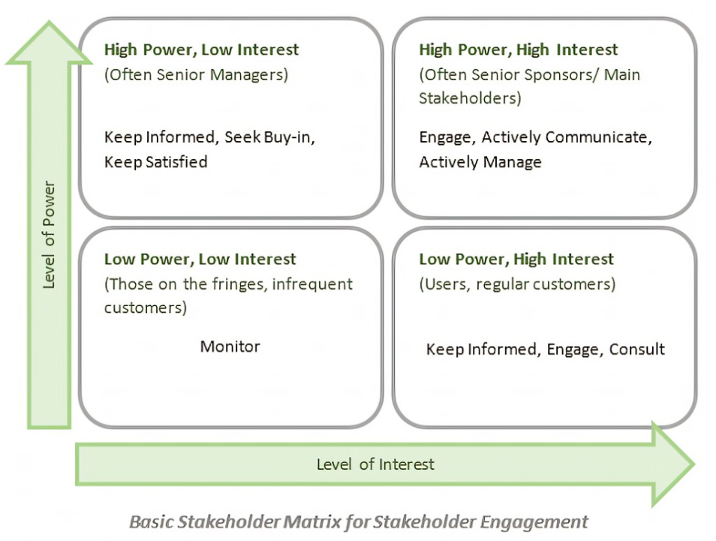
Figure 5. Basic Stakeholder Power and Interest stakeholder management grid (Cadle et al., 2014)

Conclusion
By utilising a solution that allows the consolidation and digitisation of as many sources of a patient’s medicines history and records as possible into a shared medicines record, it will improve the accessibility of information to inform and improve the accuracy of the medicine’s reconciliation processes at transfers of care and help to achieve the aims of the WHO report to reduce medication errors by 50%. This can be directly compared against base line medicines errors rates at transfers of care vs the errors rates following implementation. It is important that such an evaluation considers any bedding in time and as such should be repeated within a few years.
Such a solution would also allow for the provision of a persistent vendor neutral data platform that could allow future developments and improvements to be developed utilising a consistent once for Wales open data source that is also supported by the Welsh Government Digital Architecture Review (Channel 3 Consulting, 2019).

References

Andersen, T. S., Gemmer, M. N., Sejberg, H. R. C., Jørgensen, L. M., Kallemose, T., Andersen, O., Iversen, E. and Houlind, M. B. (2022), 'Medicines Reconciliation in the Emergency Department: Important Prescribing Discrepancies between the Shared Medication Record and Patients’ Actual Use of Medication', Pharmaceuticals, Vol. 15 No. 2, p. 142.10.3390/ph15020142,Available at:https://dx.doi.org/10.3390/ph15020142
Aperta Foundation (2018), Apperta Defining an Open Platform, Available at:https://apperta.org/assets/Apperta_Defining_an_Open_Platform.pdf (Accessed:04/07/2020)
Becerra-Camargo, J., Martinez-Martinez, F. and Garcia-Jimenez, E. (2013), 'A multicentre, double-blind, randomised, controlled, parallel-group study of the effectiveness of a pharmacist-acquired medication history in an emergency department', BMC Health Services Research, Vol. 13 No. 1, p. 337.10.1186/1472-6963-13-337,Available at:https://dx.doi.org/10.1186/1472-6963-13-337
Cadle, J., Paul, D. and Turner, P. (2014), Business analysis techniques, Chartered Institute for IT.
Channel 3 Consulting (2019), 'WG Digital Architecture Review', Available at:https://digitalhealth.wales/sites/default/files/2020-04/WG%20Digital%20Architecture%20Review%202019.pdf (Accessed:29/04/2022)
Group, N. S. C. C. (2022), Somerset Integrated Digital e-Record (SIDeR), Available at:https://www.somersetccg.nhs.uk/about-us/digital-projects/sider/
Health Level Seven International (2019), HL7 FHIR Release 4, Available at:https://www.hl7.org/fhir/ (Accessed:29/04/2022)
Health Level Seven International (2022), FHIR v4.0.1, Available at:https://www.hl7.org/fhir/ (Accessed:12/05/2022)
Hedeman, B. and Seegers, R. (2009), PRINCE2 2009 Edition-A Pocket Guide, Van Haren.
Huynh, C., Wong, I. C. K., Tomlin, S., Terry, D., Sinclair, A., Wilson, K. and Jani, Y. (2013), 'Medication Discrepancies at Transitions in Pediatrics: A Review of the Literature', Pediatric Drugs, Vol. 15 No. 3, pp. 203-215.10.1007/s40272-013-0030-8,Available at:https://dx.doi.org/10.1007/s40272-013-0030-8
Lee, J. Y., Leblanc, K., Fernandes, O. A., Huh, J.-H., Wong, G. G., Hamandi, B., Lazar, N. M., Morra, D., Bajcar, J. M. and Harrison, J. (2010), 'Medication Reconciliation During Internal Hospital Transfer and Impact of Computerized Prescriber Order Entry', Annals of Pharmacotherapy, Vol. 44 No. 12, pp. 1887-1895.10.1345/aph.1p314,Available at:https://dx.doi.org/10.1345/aph.1p314
Lehnbom, E. C., Stewart, M. J., Manias, E. and Westbrook, J. I. (2014), 'Impact of Medication Reconciliation and Review on Clinical Outcomes', Annals of Pharmacotherapy, Vol. 48 No. 10, pp. 1298-1312.10.1177/1060028014543485,Available at:https://dx.doi.org/10.1177/1060028014543485
Leonard, K. and Bottorff, C. (2022), Conducting A Gap Analysis: A Four-Step Template., Available at:https://www.forbes.com/advisor/business/gap-analysis-template/ (Accessed:08/04/2022)
Local Partnerships (2012), 'Options Appraisal Workbook - Planning Advisory Service Pilot Projects', Available at:https://www.local.gov.uk/sites/default/files/documents/pas-options-appraisal-wor-7f5.pdf (Accessed:29/04/2022)
NHS Digital (2021), DAPB4013: Medicine and Allergy/Intolerance Data Transfer, Available at:https://digital.nhs.uk/data-and-information/information-standards/information-standards-and-data-collections-including-extractions/publications-and-notifications/standards-and-collections/dapb4013-medicine-and-allergy-intolerance-data-transfer. (Accessed:25/04/2022)
NHSBSA (2022), Dictionary of Medicines and Devices, Available at:https://www.nhsbsa.nhs.uk/pharmacies-gp-practices-and-appliance-contractors/dictionary-medicines-and-devices-dmd (Accessed:15/05/2022)
Paul, D., Cadle, J. and Yeates, D. (2010), Business analysis, BCS, The Chartered Institute for IT.
Riordan, C. O., Delaney, T. and Grimes, T. (2016), 'Exploring discharge prescribing errors and their propagation post-discharge: an observational study', International Journal of Clinical Pharmacy, Vol. 38 No. 5, pp. 1172-1181.10.1007/s11096-016-0349-7,Available at:https://dx.doi.org/10.1007/s11096-016-0349-7
RPSGB (2021), Medicines, ethics and practice 44: the professional guide for pharmacists, Pharmaceutical Press.
Salanitro, A. H., Kripalani, S., Resnic, J., Mueller, S. K., Wetterneck, T. B., Haynes, K. T., Stein, J., Kaboli, P. J., Labonville, S., Etchells, E., Cobaugh, D. J., Hanson, D., Greenwald, J. L., Williams, M. V. and Schnipper, J. L. (2013), 'Rationale and design of the Multicenter Medication Reconciliation Quality Improvement Study (MARQUIS)', BMC Health Services Research, Vol. 13 No. 1, p. 230.10.1186/1472-6963-13-230,Available at:https://dx.doi.org/10.1186/1472-6963-13-230
Shah, C., Hough, J. and Jani, Y. (2020), 'Medicines reconciliation in primary care: a study evaluating the quality of medication-related information provided on discharge from secondary care', European Journal of Hospital Pharmacy, Vol. 27 No. 3, pp. 137-142
SNOMED International. (2022), SNOMED International's Confluence, Available at:https://confluence.ihtsdotools.org/ (Accessed:12/05/2022)
Spiers, I., Goulding, J. and Arrowsmith, I. (2017), 'Clinical terminologies in the NHS: SNOMED CT and dm+ d', British Journal of Pharmacy, Vol. 2 No. 1, pp. 80-87
Tam, V. C. (2005), 'Frequency, type and clinical importance of medication history errors at admission to hospital: a systematic review', Canadian Medical Association Journal, Vol. 173 No. 5, pp. 510-515.10.1503/cmaj.045311,Available at:https://dx.doi.org/10.1503/cmaj.045311
Welsh Government (2018), 'A Healthier Wales: Long term plan for health and social care', Available at:https://gov.wales/sites/default/files/publications/2019-10/a-healthier-wales-action-plan.pdf
World Health Organization (2017), 'Medication without harm', Available at:https://www.who.int/initiatives/medication-without-harm (Accessed:04/04/2022)
World Health Organization (2019), 'Medication safety in transitions of care: technical report', Available at:https://www.who.int/initiatives/medication-without-harm (Accessed:04/04/2022)
Zarif-Yeganeh, M., Rastegarpanah, M., Garmaroudi, G., Hadjibabaie, M. and Vahedi, H. S. M. (2017), 'Incidence of medication discrepancies and its predicting factors in emergency department', Iranian Journal of Public Health, Vol. 46 No. 8, p. 1086

