

TOPIC: FINANCIAL RISK MANAGEMENT STRATEGIES IN MULTINATIONAL CORPORATION: A CASE STUDY OF BRITISH AIRWAYS
Student Name: Sapnaben Jayesh Desai
Student Id: 2244134
Subject: Dissertation
Submission Date: 17/06/2024
Supervisor: Amare Desta

Declaration
All sources of information, including those for the text, information, pictures, and ideas, have been properly acknowledged and cited. No portion of this work has been plagiarized or used without permission. This research was conducted and reported by all scholarly and ethical standards. My original research is being presented as a partial fulfilment of the requirements for my degree.

Acknowledgement
This study project would not have been possible without the constant support and guidance of my teachers, classmates, and parents. The value of my employment goes well beyond simply aiding me with my studies and offering relevant articles and other resources. Additionally, I got clarification from my classmates, and my family encouraged and supported me as I worked on my research report. I wish to honour, revere, and thank each of these people for their contributions.
Abstract
In the Introduction, the research objectives are developed as per the research topic such as “The financial risk management and the strategies in the multinational corporation undertaking the case study of British Airways.” There are also provided problem statement and rationale which help to understand the main reason for selecting the topic and lastly provide a theoretical framework which emphasises different theories for better understanding the topic. The literature review of the research emphasises the research objectives that help to understand every aspect and also provide accurate information related to the topic. In this chapter, there are also literature gaps that provide information regarding the issues the researcher faces. In the methodology part, the researcher utilised secondary research methodology that helped to collect data from several sources and also helped to understand the overall research procedure lastly provided limitations which emphasise issues that impact future research. In the findings and discussion session, the researcher utilised several statistics data that help to understand every aspect of the research topic. This chapter also discusses the connection between research objectives as well as research topics.
Effective risk management involves adopting adverse actions to mitigate the impact of volatile external elements on the operational chain. This helps the business detect, appraise, and proactively reduce financial risk. Furthermore, it improves long-term financial performance by strengthening the resistance to market instability. Examining British Airways' approach to financial risk management, the study also advances knowledge of industry best practices and lessons discovered in MNC financial risk management. Airways operates in the global marketplace, which is distinguished by a varied economy and a regulatory environment that takes market conditions into account. BA is exposed to a range of financial risks associated with its global operations, such as foreign exchange, geopolitical risk, and regulatory compliance. The study also searches for best practices and lessons learned from other global corporations that operate in similar industries and environments. It also highlighted how changes in oil prices impact operating costs and profitability, keeping in mind the fuel price for utilities, which highlighted the significant financial risk for airlines such as British Airways.

Table of Contents
Chapter 1: Introduction 1
1.1: Background 2
1.2: Research Problem 3
1.3: Research Rationale 4
1.4 Aims & Objectives 5
1.5: Research Questions 5
1.6: Theoretical Framework 6
1.7: Structure of Dissertation 7
Chapter 2: Literature Review 8
2.1 Overview 8
2.2 Role of Financial Risk Management in the MNC, British Airways 8
2.3 Different discrepancies in the financial performance of British Airways 12
2.4 Weaknesses of British Airways on a financial and operational scale 13
2.5 Strategies helpful for British Airways in undertaking financial risk management 15
2.6 Gaps in Literature 18
2.7 Summary 19
2.8 Conceptual framework 20
Chapter 3: Methodology 21
3.1 Overview 21
3.2 Research Philosophy 21
3.3 Research approach 22
3.4 Research Design 22
3.5 Data Collection 23
3.6 Data Analysis 23
3.7 Ethical Consideration 23
3.8 Limitation 24
3.9 Timeline 24
3.10 Summary 26
Chapter 4: Findings 27
4.1 Overview 27
4.2 Findings 1: The significance of financial risk management in British Airways 27
4.3 Findings 2: Strength of financial risk management in British Airways 29
4.4 Findings 2: Weakness of financial risk management in British Airways 30
4.5 Findings 4: Recommended approach for improving the financial risk management of British Airways 32
4.6 Summary 33
Chapter 5: Discussion 34
5.1 Overview 34
5.2 Role of Financial Risk Management in the British Airways 34
5.3 Loopholes of Financial Risk Management in British Airways 37
5.4 Mitigating measures that are helpful for British Airways in undertaking financial risk management 40
5.5 Discrepancies in the financial performance of British Airways 42
5.6 Summary 44
Chapter 5: Conclusion and recommendations 45
5.1 Conclusion 45
5.2 Linking with Objectives 46
5.3 Recommendations 46
5.4 Future Scope and Limitations 47
Reference List 49
Appendices 63
Appendix 1: Ethics Form 63

List of Figures/Tables
Figure 1: Theoretical Framework 6
Figure 2: Structure of Dissertation 7
Figure 3: Monitoring the Modern Experience of Financial Risk 9
Figure 4: Financial risk management 11
Figure 5: Determinants of effective risk management 12
Figure 6: Travel disruption puts British Airways at risk 14
Figure 7: Conceptual Framework 20
Figure 8: Research onion 21
Table 1: Gantt Chart 26
Figure 9: British Airways revenue in 2023 28
Figure 10: Rank of British Airlines in the Global Market 29
Figure 11: Weakness of financial risk management in British Airways 31
Figure 12: Modern technologies in British Airways 32
Figure 13: British Airways annual profit growth 36
Figure 14: Profit reduction due to British Airways' weakness in financial risk management 38

Chapter 1: Introduction

1.1: Background
The current globalised economy and multinational corporations face various financial risks arising from currency fluctuations as well as interest rates, changes and geopolitical instability. It is also affected by the different variables of the effectiveness of financial risk management that is imperative for corporations in safeguarding profitability and ensuring financial stability as well as maintaining the competitive edge (Mazur et al. 2021). The research focuses on exploring the financial risk management strategy of British Airways which is a multinational organisation operating within the aviation sector. British Airways, which is commonly referred to as BA, is the flag carrier for the United Kingdom, which is headquartered in London. The company was established way back in 1974 and has grown into the largest airline.
As per Voss (2021), the multinational corporation British Airways is also facing numerous financial risks due to its global operation, including exposure to foreign exchange and fluctuations. The volatility of fuel prices is an interest rate risk as well as geopolitical. Uncertainties are also one of the major variables that are affecting the company. However, according to Shen, (2022), British Airways is also to be included in the identification and assessment as well as mitigation of the different types of risk that are affecting the financial performance of the company units Furthermore more for corporations such as British Airways, of risk management is important for committing the impact of the volatile external factors upon the operation operations and the financial position. The company would also have to undertake the fluctuation in the exchange rate significantly impacting the multinational corporation's revenue and expenses with the cash flow.
Further, the company is also globalised within the operation with the exposure to the foreign exchange risk arising from the fluctuations in the currencies of the British pound and the US dollar as well as the Euro. As opined by Jackson and Tozer (2020), British Airways, like any other corporation, is exposed to the risk arising from the dynamics in the market segment. The company would also have to undertake political instability with the variables of regulatory changes and trade disputes with the geopolitical tension in the different regions. Furthermore, the significant risk within multinational corporations such as British Airways affects the operational chain with the revenues as well as profitability due the similar factors. According to Chaidir et al. (2023), currency hedging can be one of the profitable ways that can be used by the British Airway for undertaking financial risks such as the forward contract option and the swapping for managing the exposure to foreign exchange risk. Hedging against the adverse currency moment, the company would aim and stabilise the cash flow and protect its profitability. As per Nguyen (2024), British Airways can also undertake the volatility within oil prices by fuel hedging strategies that would help reduce the exposure to the fuel price risk. The company can penetrate within the derivative contract, such as the future and the options for locking in the fuel prices at the predetermined levels, thereby reducing the uncertainty and managing the fuel cost on an effective scale. It can also undertake diversification of the revenue stream and operational activity across multiple geographic regions and market segmentation for reducing the overall risk exposure. By diversifying the operation, the country can offset the impact of the adverse event within a specific region or market with positive performance in others (Syadali et al. 2023). Risk assessment, as well as monitoring, can also be implied by the company for regularly assessing and monitoring the exposure to the various financial risks.
As opined by Suarni and Amelia (2023), Airways can make use of sophisticated risk management, tools and techniques in closely monitoring the market development and the risk indicator closely monitoring the market development and the risk indicator. It can also proactively identify emerging risks and take timely action to mitigate them. Henceforth, it can be said that effective financial risk management is essential for multinational corporations, such as British Airways, to navigate the complexities of the global business environment on a successful scale (Shen, 2022). Implementation of a robust risk management strategy, inclusive of currency and fuel, hedging as well as diversification. British Airways can reduce the impact of financial risk on the operation and the financial performance.

1.2: Research Problem
In the global economy, the multinational corporation is facing the area of initial ramming from the different currencies, fluctuation and interest rate volatility as well as political uncertainty with the market dynamics. The effectiveness of financial risk management is vital for MNCs in safeguarding financial stability, protecting profitability as well as sustaining competitive advantage (Chaidir et al. 2023). The research is also ending by diving in the financial risk management strategy that is employed by British Airways, which is a prominent multinational corporation within the aviation sector. The main problem that is being addressed is the complexity of global operations with foreign exchange risk management. British Airways is in a complex, but dynamic global environment with the presence of multiple countries and exposure to diversified currencies. It also has to undertake the regulatory framework with the market conditions and the complexity that is amplifying the financial risk faced by the organisation.
On the additional scale, it is also elected with the different implementations that can be tailored to the financial strategy for reducing the impact of the global uncertainty within financial performance (Salamah, 2023). Multinational Corporation British Airways is acceptable to the foreign exchange risk that is arising from the fluctuation within the exchange race affecting the revenues. Furthermore, the research is also seeking to identify the best practices and the lessons learned from other multinational corporations in similar industries and contexts. Considering the fuel price for a utility that highlighted the significant financial risk for the airlines such as British Airways, it highlighted the changes within oil prices impacting upon the operating cost and the profitability. The research is also investigating British Airways' strategy in managing the fuel price risk inclusive of fuel, hugging technique, and the future contract as well as options.
Further, it can be mentioned that analysing the effectiveness of future practises and the implications for the financial performance is also assessed in this study. The research also aims to provide insight into the mitigation of fuel price volatility for the airlines. British Airways is also facing regulatory risk as well as geopolitical uncertainties within the different regions where it is operating. This assessment highlighted relationships with the government authorities and the industry stakeholders, examining the risk mitigation strategy of the company and responses to the geopolitical event. The research also highlights the importance of geopolitical risk punishment for the MNC and the implications of the same upon the financial performance

1.3: Research Rationale
Financial risk management is important for operating within the current interconnected global economy. Multinational corporations such as British Airways are facing different risks, inclusive of currency fluctuation uncertainties in the market significantly impacting upon the financial performance as well as company stability (Hu et al. 2020). It also highlights the focus on exploring the financial risk management strategy employed by British Airways, which is one of the leading multinational organisations within the aviation sector. The study highlights the significance of financial risk management.

1.4 Aims & Objectives
Aim
The main aim of the study is to analyse the financial risk management and the strategies in the multinational corporation undertaking the case study of British Airways.
Objectives
- To identify the different discrepancies in the financial performance of British Airways
- To formulate the weaknesses of British Airways on a financial and operational scale
- To recommend strategies helpful for British Airways in undertaking financial risk management.

1.5: Research Questions
- What are the different discrepancies within the financial performance of British Airways?
- What are the weaknesses of British Airways on the financial and operational scale?
- What are the recommended strategies helpful propositions under the financial risk management?

1.6: Theoretical Framework
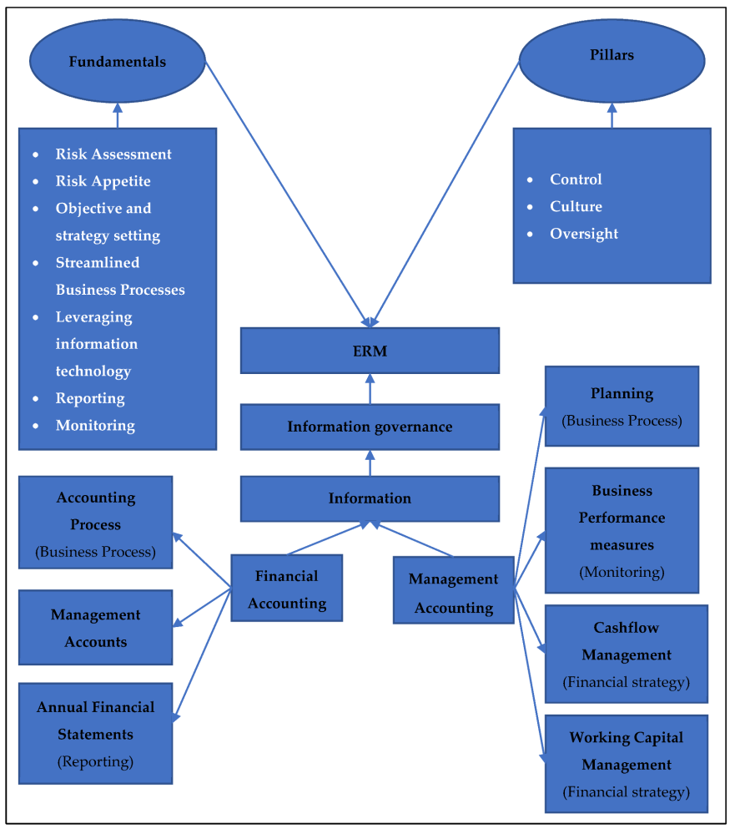
Figure 1: Theoretical Framework
(Source: Self Developed)

1.7: Structure of Dissertation
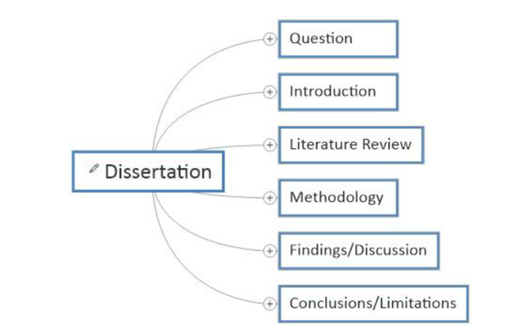
Figure 2: Structure of Dissertation
(Source: Self Developed)

Chapter 2: Literature Review

2.1 Overview
This chapter highlights the literature that has been collected for the investigation process and helps in understanding the existing body of knowledge within the specific field. It also identifies the product contest of the literature that has been collected with the inconsistencies and the areas where further development is needed. It also helps in defining research questions and objectives in a clearer state. The thorough literature review of the investigation avoids the duplication of previous studies (Akomea-Frimpong et al. 2024). It also highlights the understanding that has already been done with the investigation, ensuring that the work is contributing something new to the relevant field. The literature review provides insight into the methodology and the technique that is used within the previous research and the successful elimination of any biases or discrimination. The study highlights the literature on roles in financial risk management within the MNC, British Airways and the different discrepancies within the financial performance of British Airways. It also highlights the weaknesses of British Airways on the financial and operational scale with the strategies that might be helpful for the upcoming market dynamics.

2.2 Role of Financial Risk Management in the MNC, British Airways
Financial management within a multinational corporation (MNC) is associated due to the different inherent complexities as well as operation operations across the various countries with the different risks that are to be included. Additionally, the currencies regulations and the economic conditions are one of the major variables in financial management, ethos of fluctuation and the interest rate change with political instability as well as economic downturn. The effective management of the risk is vital for ensuring stability as well as profitability of the long-term sustainability for key enterprises (Hu et al. 2020). The currency management of MNCs is engaged within the foreign exchange to help in mediating the impact of the currency fluctuation upon the cash flow and the profit statement. This is also inclusive of involving the financial derivative, such as the forward of the future options with the courtesy source for locking in the exchange rates for the future transaction. To do so, the protection against the adverse moments in the exchange rate is also eroding the savings. Diversification of operation is also highlighted by spreading the operation across multiple countries in the regions that can help the MNC in reducing the exposure to country-specific risk. This also highlights the minimising of the local downs in the economic frame and the political instability that may be associated.
Given their wide worldwide reach and exposure to a variety of foreign exchange risks, multinational corporations (MNCs) like British Airways place a high priority on financial risk management. British Airways is a multinational airline that operates in several nations. As such, it is subject to considerable fiscal hazards that could affect both its profitability and fundamental economic health (Xiaoli and Nong, 2021). As opined by Enríquez-Díaz et al. (2021) techniques for managing financial risks adequately serve as essential for reducing these risks and guaranteeing the long-term viability of the corporation. Foreign exchange exposure represents one of the main financial dangers that British Airways faces.
The airline is prone to currency rate swings, operations in multiple countries, and handles payments in various currencies. Effective compliance is also reflected within the management strategy requiring a stronger governance structure of the internal control as well as compliance with the different requirements in the multiple jurisdictions. It was also highlighted for evaluating the external auditors in overseeing the valuation of risk management practice with an MNC and the impact of the regulatory reforms (Finkler et al. 2022). Integration of technology as well as analytics is also offering opportunities for enhancing the efficiency accuracy as well as timelines of the financial risk management process. Sustainability as well as residence in the area or increasing interconnectedness and systematic risk is highlighted by the growing recognition and importance of the integration of sustainable practices.
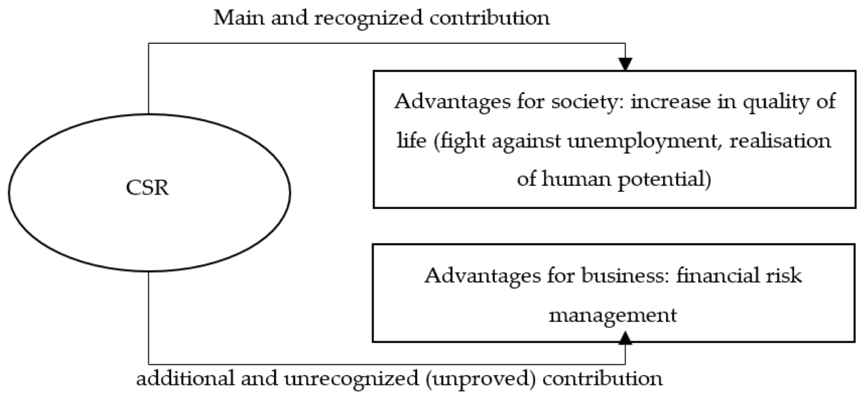
Figure 3: Monitoring the Modern Experience of Financial Risk
(Source: Murugan, 2023)
As per the findings of Murugan (2023), the contemporary globalised economy and multinational enterprises encounter a range of financial hazards stemming from variations in interest rates, currency fluctuations, and geopolitical unrest. It is also impacted by the various factors that determine how effective financial risk management is, which is crucial for businesses to preserve their competitive advantage, provide financial stability, and protect profitability. In addition to this, the flag carrier of the United Kingdom is British Airways, or BA as it is more often known. Its headquarters are located in London (Berry et al. 2023). Since its founding in 1974, the business has expanded to become the biggest airline. The income, expenses, and competitiveness of the airline can all be impacted by fluctuating exchange rates.
British Airways uses hedging techniques to guard against unfavourable changes in exchange rates to control this risk. Through the utilisation of monetary instruments like options and forward contracts, the corporation can lessen the effect that currency fluctuations have on its profit margins. As highlighted by Achim et al. (2022) concerning its worldwide operations, British Airways is exposed to transactions. This particular type of risk results from how changes in exchange rates affect the business's cash flows from transactions involving foreign currencies. Developments in exchange rates, for instance, may have an impact on British Airways' income when tickets sold in foreign currencies are converted into the corporation's accounting currency. As stated by ATMADJA et al. (2021) the airline can implement hedging strategies to control transactional risk and lessen the effect of fluctuating currencies on its cash flows. The effect that currency exchange rate swings have on the future revenue and investment worth of a corporation is known as economic vulnerability.
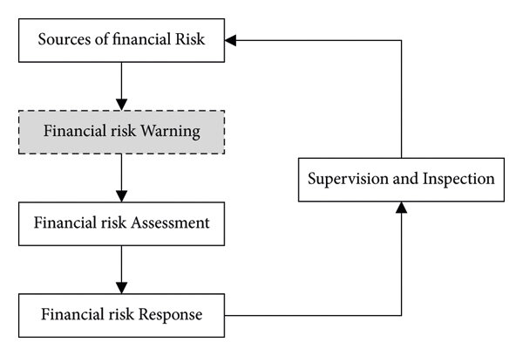
Figure 4: Financial risk management
(Source: Finkler et al. 2022)
In addition to this, it can be mentioned that because of its international activities and investments across multiple nations, British Airways is susceptible to monetary risk. The pricing effectiveness of the airline, how much demand for its services, and its overall earnings are all susceptible to impact by fluctuations in foreign exchange rates (Mihajlović et al. 2020). British Airways might take deliberate steps, which include spreading its income streams across several areas or modifying its pricing procedures in response to changes in the currency, to mitigate its economic vulnerabilities. As highlighted by Chornovolet al. (2020) exchange rate variations that impact the transformation of overseas companies' accounts payable into British Airways' reporting currency give an increase in translation vulnerability. On the other hand, as opined by Finkler et al. (2022) adjustments in exchange rates may have an effect on the airline's earnings estimates along with aggregated accounts of operations since it is a multinational corporation with subsidiaries and assets overseas. Therefore, it can be mentioned that British Airways can utilise accounting strategies that involve balance sheet hedging or natural hedging—that is, matching assets and liabilities represented in the same currency—to mitigate translation risk.

2.3 Different discrepancies in the financial performance of British Airways
With time, British Airways business performance has shown notable oscillations. The difference between profitable and losing times in British Airways' history amounts to one of the most noteworthy monetary disparities (Bustani et al. 2022). For instance, the airline declared a $37 million profit in 1980, but only one year later, in 1981, it sustained an impressive $254 million loss. This unforeseen shift brings to light the airline industry's instability and vulnerabilities. Variations in the number of passengers and earnings have additionally led to differences in revenue for British Airways (Kembauw et al. 2020). The number of passengers travelling with the airline can be greatly affected by factors including fierce competition, modifications to travel patterns and economic circumstances. This can have a substantial effect on the airline's sources of revenue.
According to Hamawandy et al. (2021), British Airways, a worldwide organisation, is also exposed to several financial risks as a result of its global operations, including swings in foreign exchange. In addition to interest rate risk, gasoline price volatility also has geopolitical implications. Another important factor that has an impact on the firm is uncertainty. However, according to YILMAZ (2022), British Airways should also be taken into account when identifying, evaluating, and mitigating the many risks that are influencing the company units' financial performance. Additionally, risk management is crucial for reducing the impact of variable external events upon operations and financial conditions, especially for firms like British Airways.
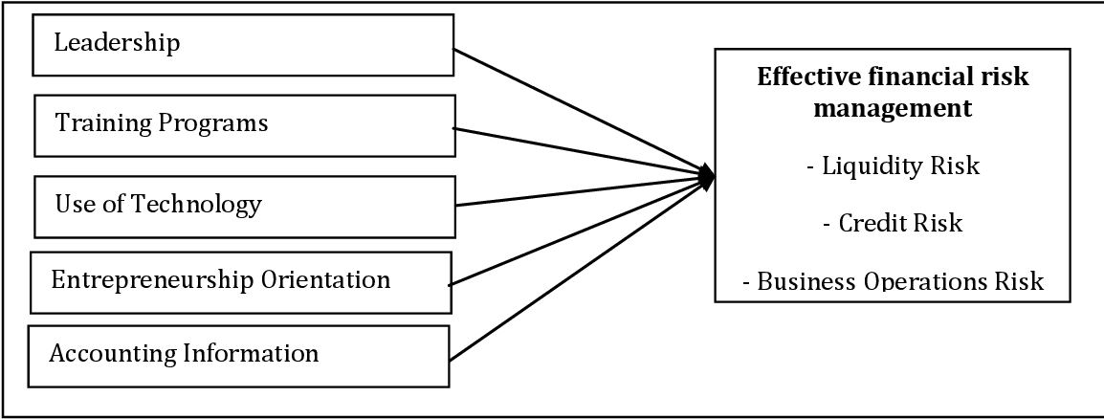
Figure 5: Determinants of effective risk management
(Source: Hamawandyet al. 2021)
Service interruptions or strikes are examples of operational difficulties that can have a big effect on an airline's bottom line. For instance, British Airways lost $108 million overall that fiscal year as a result of the air traffic controllers' walkout at London's Heathrow Airport in 1981 (Petrescu, 2020). In addition to this, it can be mentioned that adjustments in British Airways' economic results have also been attributed to tactical decisions taken by the airline's administration. The financial standing of the airline can be affected through a variety of initiatives, including staff changes, fleet additions or reductions, pricing tactics, and route expansions or contractions (Kharlanov et al. 2022). In the aviation sector, outside factors such as market circumstances and competitiveness can lead to financial disparities for airlines. A company's bottom line is affected by a variety of factors, including modifications to regulations, changes in customer habits, technological improvements, and the cost of fuel.
The commercial success of an airline can also be impacted by government backing or lack thereof. In the circumstance of British Airways, government ownership first offered stability but also presented difficulties when moving toward privatisation because of budgetary and regulatory restrictions (Chang et al. 2020). As highlighted by Ferineet al. (2023) long-term sustainability and a comprehensive strategy are needed to solve persistent financial disparities. To improve overall financial health, this might entail cost-cutting initiatives, optimised routes, fleet upgrades, personnel reorganisation, improvements to the consumer experience, and collaborative efforts.

2.4 Weaknesses of British Airways on a financial and operational scale
With time, British Airways has experienced several financial setbacks that have affected its operations. The amount of debt the business has is one major problem. The airline has had challenges with finances due to a significant debt load, which has impacted its profitability and restricted its ability to devote funds to expansion prospects. As opined by Hochrainer-Stigler et al. (2021) excessive interest payments brought on by high debt levels might lower a company's performance and monetary freedom. As highlighted by Woods (2022) an additional financial fragility of British Airways is its susceptibility to variations in fuel prices. In addition, because of similar considerations, the operational chain with sales and profitability is impacted by the enormous risk that international firms like British Airways face. Therefore, it can be mentioned that being a large airline, British Airways is extremely vulnerable to fluctuations in fuel prices.
The company's expenses for operations climb in response to rising gasoline prices, straining its profit margins. In light of its susceptibility to fluctuations in fuel prices, British Airways may find it difficult to continue achieving steady financial results (Nguyen, 2024). In addition, British Airways has had to contend with fierce rivalry within the airline sector. British Airways' pricing strategy and market share are under strain due to the emergence of low-cost carriers and other competitors. Strong rivalry may result in reduced costs and less earnings for the airline, which would be detrimental to its general economic condition. As opined by Onsongo et al. (2020) British Airways has faced operational problems that have impacted its effectiveness and ratings with consumers in addition to its financial situation. The frequency of employee strikes at the airline is one practical issue. Therefore, it can be stated that a flight schedule may be affected by labour strikes, which may result in cancellations or postponements that annoy customers and harm the airline's brand.
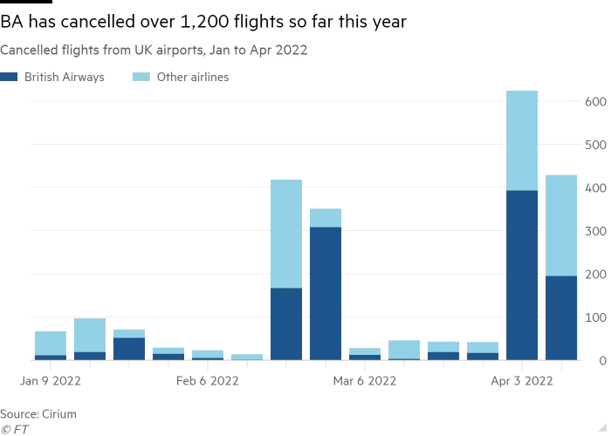
Figure 6: Travel disruption puts British Airways at risk
(Source: Woods, 2022)
British Airways' aged fleet of planes is another operational problem. The airline has come under fire for using older aircraft, which may use less fuel and be more susceptible to maintenance problems. As opined by Al-Hashimyet al. (2022) an ageing fleet can affect consumer trust and efficiency of operation by increasing operating costs, decreasing dependability, and sometimes compromising safety requirements. In addition, Woods (2022), opines that British Airways has had system malfunctions and IT outages that have severely disrupted business operations. Therefore, it has been analysed that an airline has had several high-profile instances in the past few years wherein technological issues resulted in aircraft cancellations as well as airport mayhem. In addition to causing large monetary losses, frequent IT malfunctions harm British Airways' standing as a dependable and customer-focused airline.
Centralised treasury management also allows the MNC to streamline cash management and optimise liquidity. Leveraging economies of scale and better monitoring, as well as control of the exposure to the various risks, are also associated with the same. The scenario analysis as well as stress testing is to be conducted by MNC to assess the potential impact of the adverse event upon the financial performance and the solvency by stimulating the various scenarios such as the currency crisis and the geopolitical conflict or the economic downturn (Ito, 2022). Compliance with the regulatory requirement is essential for the MNC to avoid legal or financial penalties. This is inclusive of adopting the accounting standard tax regulation as well as foreign exchange control. The study also highlighted the continuous monitoring and staying ahead of emerging risks by informing the risk management strategies in prompt addressing the resolving of threats (Zakaria, 2023). Compliance with the regulatory requirement is also inclusive of the different insurance and the risk transferred by certain insurance companies through the purchase of the insurance policies such as property and casualty insurance with the business interruption as well as political risk. This also helps in protecting against the losses arising from the event, such as natural disasters or the accidents of the expropriation by foreign governments (Andrushchenko et al.2020). Continuous adaptation as monitoring is required of the market conditions for the job, practical development and the macroeconomic print. It is essential for the MNC insta ahead of the curve. It also highlights the adjusting of the employees by evolving the threats and capitalising opportunities in the dynamic global market.

2.5 Strategies helpful for British Airways in undertaking financial risk management
Being a major international airline, British Airways (BA) is subject to several financial risks that could have a big effect on its business and profitability. To reduce these risks and guarantee long-term prosperity, BA must practise effective control of financial risks. As opined by Chaidir et al. (2023) diversification is one of the best tactics for controlling financial risk. Further, it can be stated that BA can lessen its exposure to any one risk factor by distributing its revenue streams over several products, markets, and client segments. For example, if BA has a diversified portfolio of routes and services, its impact on its overall earnings would be negligible if consumer demand for flights to a single destination declines owing to financial or political uncertainty.
An additional important strategy for controlling financial risks is hedging, especially when it comes to risks associated with fuel costs and currency fluctuations. As highlighted by PLC, (2020) BA can secure investments in future fuel and currency prices by using a variety of hedging tools, including forward contracts, alternatives, and swaps. By using this procedure, Güngör Göksu (2023) opinions that BA is better able to guard against unforeseen spikes in fuel prices or currency depreciation that can have a detrimental effect on its bottom line. British Airways, like any other firm, needs to take care of its cash flow well. BA can satisfy its short-term obligations and engage in long-term growth prospects by carefully controlling its cash inflows and outflows and by preserving adequate liquidity. Furthermore, BA might benefit from early-payment reductions from suppliers or discounts on inventory purchases when it has a solid working capital position (Salamah, 2023). Additionally, the company would have to deal with exchange rate fluctuations, which have a big influence on the cash flow of the global corporation and its revenue and expenses.
Further, it can be mentioned that the business's operations are globalised, exposing it to foreign exchange risk brought on by changes in the value of the US dollar, the British pound, and the euro. According to Zaytsev et al. (2021), British Airways is susceptible to the risk associated with the characteristics of the market segment, just like any other firm. Along with the elements of trade conflicts and geopolitical tension in other locations, the corporation would also have to deal with political instability. A sound financial risk management strategy must include regular risk identification and analysis as inferred from the article by Zada et al. (2021). In addition to this, early risk identification allows BA to assess possible hazards' impact and likelihood on the company and create backup plans to help reduce them before they become real. This proactive strategy not only lowers the probability of unfavourable results but also shows stakeholders that sensible fiscal oversight is being practised.
Currency hedging, according to Voss (2021), may represent one of the beneficial strategies that British Airways can utilise to undertake financial risks such as forward contracts, contract options, and swaps to manage its exposure to foreign exchange risk. protecting oneself against a bad money moment. The company's goals would be to safeguard competitiveness and stabilise cash flow. According to Cozmuta (2024), British Airways can also manage the fluctuations in oil prices by implementing fuel hedging techniques that would lessen its dependence on the risk associated with fuel prices. An additional crucial component of British Airways' financial risk management is insurance coverage. An airline can be shielded against a variety of losses by having the right insurance plans, including injury to property, liability lawsuits, business disruption, and cargo damage.
By guaranteeing sufficient insurance coverage for every possible risk, BA can reduce its vulnerability to unanticipated losses that can hurt its financial results. When risk management becomes more difficult, such as in times of financial instability or crisis, successful interaction with stakeholders is essential. In addition to exhibiting strong leadership qualities within the company, open communication regarding the character of hazards presented to British Airways and the actions being taken to minimise them helps foster trust with shareholders, clients, staff, and other stakeholders (Pujiharto et al. 2023). Finally, to help British Airways navigate through uncertain economic conditions and ensure sustainable growth for the company, the airline can use a variety of strategies to manage financial risks. These include "diversification, hedges, cash flow management, risk assessment and analysis, coverage from insurance, and dialogue with stakeholders.
To reduce uncertainty and effectively manage fuel costs, the corporation might enter into derivative contracts about prospective and option pricing locking in fuel prices at established levels (Güngör Göksu, 2023). It can also partition the market to lower overall risk exposure and diversify the income stream and operational operations over several geographical areas. broadening the scope of the business. The nation might use the success in other markets to counterbalance the negative effects of an unfavourable incident that occurs in one particular market or region (Cozmuta, 2024). The corporation may also imply that risk evaluation and oversight are necessary for routinely evaluating and tracking the exposure to different financial risks. Airways can employ advanced risk management strategies, instruments, and methods to closely monitor market trends and risk indicators, according to Kuljanin et al. (2021), keeping a close eye on the risk indicator and the market's progress. Additionally, it is capable of anticipating risks and acting quickly to mitigate them. Therefore, it can be concluded that comprehensive financial risk management is necessary for multinational companies like British Airways to successfully traverse the intricacies of the global business environment (Hamawandyet al. 2021). application of a comprehensive risk management plan that includes diversification, hedging, and provisions for fuel and currency. British Airways can mitigate the effects of financial risk on its operations and financial results. British Airways operates in a dynamic and multifaceted global context, involving various countries and varying currencies. In addition, the regulatory structure must be implemented in light of the complicated market conditions that are increasing the financial risk that the organisation is exposed to. In addition, it is chosen with a variable deployment that can be adjusted to the financial plan to lessen the influence of worldwide uncertainty on financial results. The foreign exchange risk coming from fluctuations in the exchange rate that impact revenues is acceptable to the multinational firm British Airways (Salamah, 2023). Additionally, the research looks for best practices and lessons discovered from other multinational companies operating in a comparable sector and environment. Taking into account the fuel price for utilities, which brought attention to the substantial financial risk for airlines like British Airways, it also brought attention to how fluctuations in oil prices affect operational costs and profitability.

2.6 Gaps in Literature
The literature review serves as the backbone of the academic work providing a comprehensive review of the existing research that is relevant to the study. It also highlights the landscape, identifying and addressing the gaps which are paramount for advancing knowledge and contributing meaningfulness to the field (Mintah and Gulko, 2023). The notable gap is found in the literature revolving around the method's logical approach. Numerous studies are exploring the particular topic that employs disparate methodologies leading to inconsistencies or limitations within the generality of the findings. Addressing the gap involves advocating a unified approach and highlighting the need for additional research that employs alternative methods for corroborating the existing findings (Kugel, 2023). The common gap lying within the theoretical framework within the investigation process is diving, deep within theoretical underpinning that lacks the robust theoretical foundation. Further, it also addresses the fragment inside and the oversight in understanding the same.
Bridging the gap also highlights the involvement of synthesising the diversified theoretical perspective and proposing a novel framework that better encapsulates complexities for the phenomena under investigation. Furthermore, the literature cap is also highlighting the underrepresented context of the irrelevant review article. Highlighting the gap which is necessary for the concerned effort to diversify the research sample and extend the investigation within the unexplored context. On an additional scale, technological advancement and societal challenges are also outpacing academic injury, leaving a gap within emerging areas of the study. Rapid development within fields such as artificial intelligence with biotechnology and global governance are also outstripping scholarly scrutiny. Technological advancement with societal challenges is also outpacing academic injury, leaving a gap within the emerging areas of study. The gaps are also highlighted in the literature review chapter for synthesising the existing research but also critically evaluating the limitations.

2.7 Summary
This chapter aids in understanding the body of knowledge currently in existence within the particular field by highlighting the literature that has been gathered for the investigation process. It also indicates the areas that require more research and improvement as well as the product contest of the gathered material with the contradictions. It also aids in the clearer definition of study objectives and queries. By conducting a thorough literature analysis, the investigation can avoid repeating earlier findings. To guarantee that the work is adding anything new to the pertinent sector, it also emphasises the understanding that has already been achieved with the inquiry. The literature study sheds light on the approach and strategy employed in earlier studies, as well as how any biases or discrimination were successfully eliminated. The study draws attention to the literature on British Airways financial performance disparities as well as the roles played by the MNC in financial risk management. Along with highlighting British Airways' operational and financial shortcomings, it also offers some strategies that could be useful for the future dynamics of the market.

2.8 Conceptual framework
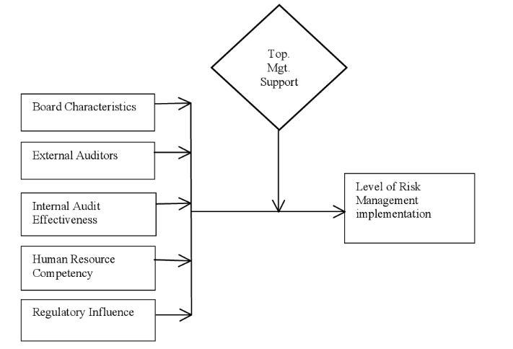
Figure 7: Conceptual framework
(Source: Self Developed)

Chapter 3: Methodology

3.1 Overview
The research methodology helps to understand the proper data-gathering procedure in a particular manner. This chapter of the research emphasises the data collection procedure of the relevant topic such as ‘Financial risk management strategies in British Airways’ case study, with the help of secondary research methodology. This chapter explores the research philosophy, approach, design, data collection, and data analysis procedure. This chapter also explores ethical considerations as well as limitations that help in future research. This research also utilised research onion that helped researchers to complete the overall research procedure without any complexity.
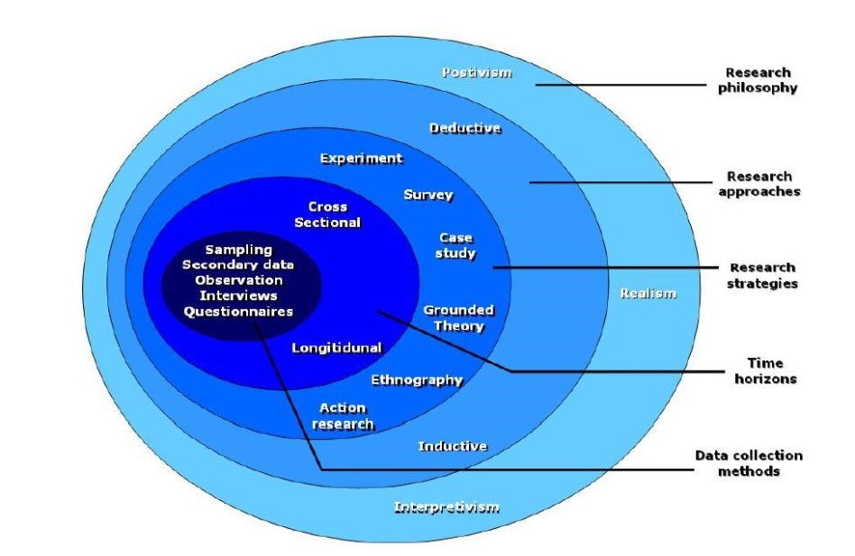
Figure 8: Research onion
(Source: Abdelhakim, 2021)

3.2 Research Philosophy
Research philosophy is one of the key elements that help the researcher by providing proper data-gathering principles that ease the process. There are various research philosophies but for this secondary research, the interpretivism research philosophy was utilised to collect the information from various sources. This interpretivism research philosophy helps the researcher to provide the research with an effective way and method to collect the information that increases the accuracy rate in their research (Alharahsheh et al., 2020). The interpretivism research philosophy emphasises a wider range of data where it is easier to identify the appropriate information. On the other side, positivism and pragmatism research philosophy emphasise the individual's personal experience that is utilised in primary research (Junjie et al., 2022). Since this research follows secondary, that is why interpretivism research philosophy is the correct choice for this research.

3.3 Research approach
The research approach provides the researcher an overall data collection plan to complete the research. There are various types of research approaches, but for this secondary research deductive research approach is utilised. The deductive research approach helps the researcher to understand every aspect of the research topic. This approach focuses on the research objective as well as the relevant theories which enhances the accuracy rate of the information for this research (Casula et al., 2021). There is another research approach such as the inductive research approach which is mainly utilised in primary research methodology. This induction approach helps the researcher to analyse the respondent and based on that data will be identified (Grinchenko et al., 2020). Since this study follows a secondary research methodology, a deductive research approach is appropriate for this research.

3.4 Research Design
Research design is another significant phase that helps the researcher to develop an effective method that helps to identify the right information from sources. In this particular secondary research, explanatory research designs are utilised to complete the research. The explanatory research approach is focused on the initial observations, research objectives, and their analysis (Young et al., 2020). Explanatory research design mainly emphasises several theories linked with the relevant topic. This design helps the researcher to understand every aspect of this topic and their importance in the research. Another research approach such as the experimental research approach is mainly utilised in the primary research methodology because it emphasises the individual personal experiences (Proudfoot et al., 2023). Since the study does not conduct any survey or interview, the explanatory research approach is quite appropriate for this secondary research.

3.5 Data Collection
The data collection procedure is one of the significant stages that help the researcher complete the overall research procedure. In this study, the research utilised secondary research methodology for collecting information from various articles, journals, and online sources. The main reason for selecting a secondary research methodology is to collect a wider range of data that help to improve the overall research procedure and enhance the chance of truthfulness. This secondary research methodology helps the researcher to find satisfactory information that helps to improve the research quality (Young et al., 2020). The research utilised some online platforms including MDPI, PubMed, Google Scholar, and others. To collect the appropriate information, the research utilised various keywords such as ‘British Airlines’, ‘risk management’, ‘yearly revenue’, and others. The researcher only utilised the information which was published after 2019. The secondary research helps the research to provide a wider range of information that increases the chance of accurate information. This research methodology also emphasises statistical information that helps to maintain transparency as well as effectiveness. The primary research mainly emphasises the individual personal experiences that are limited sources. Since this research utilised secondary research methodology, there was wider information that helped to understand every aspect of

3.6 Data Analysis
Since this research methodology utilised secondary research techniques it helped to easier to collect the information from various sources. For analysing the data, the researcher utilised thematic analysis that helped to understand the connection of every aspect with the objectives. With the help of thematic analysis, the researcher can highlight the past record which helps to understand the initial observations and also helps to do the research findings with various statistical data of this research (Braun et al., 2023). This thematic analysis also helps the research to maintain openness as well as flexibility which helps to improve the overall research procedure. In the thematic analysis, the research compares every piece of information that helps to identify the right pieces of information.

3.7 Ethical Consideration
There are various ethical considerations that the researcher follows during this research. In the research, the researcher only selects the information that is relevant and connects with the research objectives. To maintain data privacy, utilised the Data Protection Law 2018 which helped to make this research more effective (Dave et al., 2023). The research also gives credit to every source which helps transparency and effectiveness. The researcher also emphasises the data quality as well as data quantity to enhance the accuracy rate.

3.8 Limitation
Various limitations impact the research's effectiveness. In secondary research, there is a smaller range of information which creates difficulties in identifying The appropriate information. Since there is a wider range of information, sometimes it impacts the data quality and sometimes the information is biased creating confiscation and decreasing the research procedure's effectiveness.

3.9 Timeline

Activity | 1st  week | 2nd  week | 3rd  week | 4th  week | 5th  week | 6th  week | 7th week | 8th week | 9th  week | 10th week | 11th week | 12th week | 13th week | 14th week | 15th week
“Selection of research topic”
“Aim and objective formation”
“Literature Review Preparation”
“Selection of research methods”
“Data collection”
“Data analysis”
“Writing total project”
“Submission”

Table 1: Gantt chart
(Source: Gantt chart)

3.10 Summary
In summary, this research utilised secondary research methodology to collect information related to the topic such as the impact of risk management strategies on the organisation with the British Airline case study. This study utilised interpretivism research philosophy, deductive approach, explanatory research design, and most significant thematic analysis to complete the overall research procedure (Naik et al., 2022). This secondary research methodology helps the researcher to maintain the research transparency as well as effectiveness.

Chapter 4: Findings

4.1 Overview
Financial risk management is one of the significant tools that help to identify financial loss and issues. This financial risk management has an impact on British Airways' overall business as well as their work productivity (Berrada et al., 2023). Since this research follows the secondary research methodology, the research utilised information from various online articles, journals, and others to complete the overall research. To prove the information the research utilised statistical data that help to provide current information about the relevant topic such as ‘Financial risk management strategies in the multinational corporation with the help of British Airways.’ This chapter discusses the impact of financial Risk management in British Airways and the strengths and weaknesses of financial risk management with numeric data. This chapter also explores various recommendation approaches that help the organisation to improve its business growth.

4.2 Findings 1: The significance of financial risk management in British Airways
Financial risk management is to help multinational corporations such as British Airways to identify their financial loss and the current issues that impact their overall business growth as well as their work productivity (Akowe et al., 2023). The currency exchange rate is one of the key significant variables that impact the British Airways business. As per Cozmuta et al., (2024), in the 2022 financial year, the US currency rate has a huge currency fluctuation which is approx. 9% which impacts the British Airway business including ticket prices, fuel prices, and other expenses. In this critical situation, their revenue was 678 million dollars (Savchenko et al., 2023). To address these issues, they emphasise various risk management tools such as forward contracts and most significant currency exchanges to manage the currency fluctuation circumstances by storing sufficient amounts of fuel and other materials. Niv et al., (2024) mention that operational risk management is another important key variable of financial risk management that helps British Airways improve its business and enhance its work productivity. With this operational risk management, British Airways spend 890 million dollars on their technology as well as their employee's training, and other activities to improve their performance and the brand reputation in the global competitive market (Erdem et al., 2024). British Airways emphasise regular tracking of their work pattern and other activities to identify the issues. This risk management helps the organisation to enhance their business by up to 10% in 2023 (Shin et al., 2023). Financial risk management emphasises improving the decision-making process as well as improving problem-solving ability.
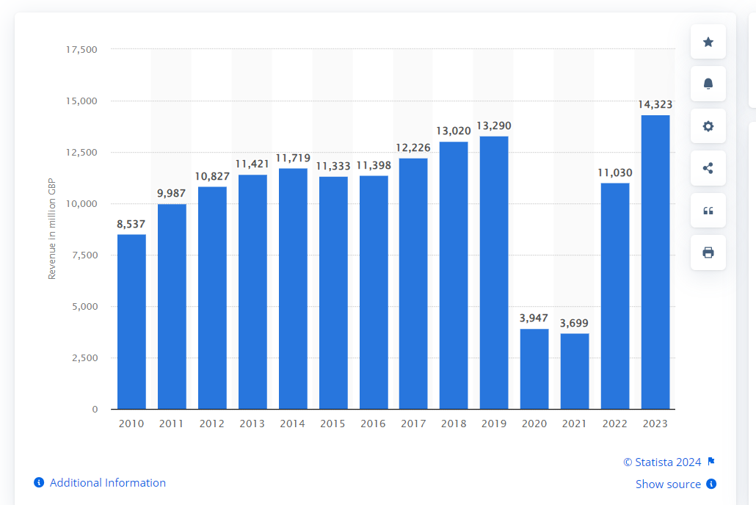
Figure 9: British Airways revenue in 2023
(Source: Statista, 2023)
These financial risk management strategies help British Airways achieve its long-term objectives and enhance its yearly revenue by up to 8% (Gupta et al., 2023). With the help of risk management strategies, they can make sure that sustainable activities help them to establish a loyal base of customers. Financial risk management strategies have a significant impact on British Airways' business growth in the COVID-19 pandemic situation. In the COVID situation, British Airways emphasise their employee's well-being, safety, and customer experience which helps to maintain their position in the competitive market (Tariq et al., 2024). These strategies help to maintain the overall management practices and enhance the business in a crisis. Financial risk management allows British Airways to improve its financial performance as well as improve its relationship with various stakeholders (Li et al., 2023). Stakeholder collaboration helps the organisation to improve its creative innovation, investment, and other activities. This stakeholder value helps British Airways boost its revenue by up to 5% in 2023 which helps to maintain its financial performance (Xue et al., 2023). Economic uncertainty directly impacts the demands of airlines. In this critical situation, financial risk management strategies provide various approaches including managing extra cost, diversity income, and most significantly reserving the money for future critical situations.

4.3 Findings 2: Strength of financial risk management in British Airways
Financial risk management is helping British Airways to implement its business in various effective ways. Financial risk management provides an effective full protection approach that helps them to increase their revenue (Horwell et al., 2023). With the help of this approach, British Airways locks the fuel price by storing huge amounts of fuel for their future usage. The approach helped them to generate 234 million dollars in 2021 (Esmaeeli et al., 2024). British Airways manages the fuel prices by emphasising the market demands that help them to improve their financial stability. In British Airways, there is a wider range of customers, to manage the currency exchange risk they utilise various financial management tools (Tyagi et al., 2023). Financial risk management also helps to reduce operational risk. In this risk management, they can improve their overall organisation infrastructure by providing training employees training and spending 120 million dollars on their organisation infrastructure program (Adler et al., 2024). They utilised various modern technologies to improve their work productivity, market analysis, and most significantly improve the employee's well-being.
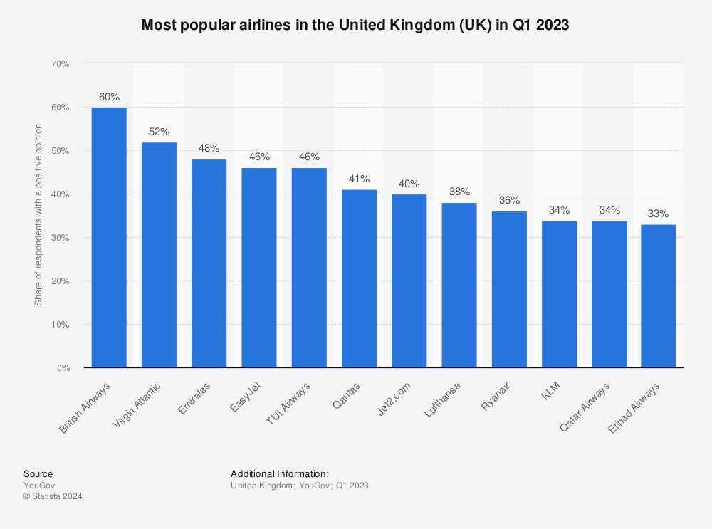
Figure 10: Rank of British Airline in the global market
(Source: Statista, 2023)

As per Bailey et al., (2024), they invested 234 million dollars in their technology integration which helps them to improve their business activities. This risk management helps British Airways prevent the risk related to cyber security. They collaborate with government agencies, cyber experts, and other professionals to mitigate the risks (Yaşar et al., 2023). With the help of financial risk management, British Airways promotes its sustainable activities via various events, seminars, and others to establish an effective loyal customer. As per Nthenya et al., (2023), financial risk management strategies also help to improve the effective communication towards various stakeholders, investors, and employees that help to improve the business (Kelman et al., 2021). These management strategies help to maintain the transparency that improves the business. British Airways collaborates with various stakeholders that provide effective strategies for their creative innovation, and other activities. This stakeholder collaboration helped British Airways achieve 456 million dollars in revenue in 2023 (Delcea et al., 2023). These strategies help British Airways to track ongoing improvement, identify the financial issues and develop mitigation strategies to enhance the business and build trust toward the stakeholders, investors, and others.

4.4 Findings 2: Weakness of financial risk management in British Airways
Financial risk management strategies are important elements that help British Airways improve its overall work performance and brand reputation. This risk management allows British Airways to track their daily activities to enhance their performance and identify their problems (Delcea et al., 2023). This risk management helps British Airways to develop its strategies to achieve its long-term objectives. Various disadvantages impact their business including their yearly revenue, employee performance, and others. Instability of currency exchange rate is one of the significant weaknesses of financial risk management that impacts British Airways business. This currency exchange rate is effective on their financial stability and they lose 230 million dollars in 2021 (Kelman et al., 2021). They utilised modern technology and spent 140 million dollars on their creative innovation as well as their marketing to prove their brand reputation (Bellandi et al., 2023). In the pandemic situation, British Airways faces difficulties in market trends and customer preferences. In this critical situation, the customer reduces their travel expenses by up to 6% which impacts on overall airline sales (Vincent et al., 2023). Economic and political fluctuation is one of the key weaknesses that highly impact the British Airways business. As per Akowe et al., (2023), in 2022, the US GDP decreased by up to 7% which had a high impact on the British Airways Business. According to Tanrıverdi et al., (2023), the ongoing currency exchange rate, government regulation regarding travel taxes which increased by 12%, and others reduced the yearly revenue of British Airways. In 2023, the British Airways yearly revenue was 14 billion dollars (Yanginlar et al., 2023). Due to the COVID-19 pandemic, there is a lack of skilled employees and the financial risk management strategies do not work effectively in that particular situation to maintain their business.
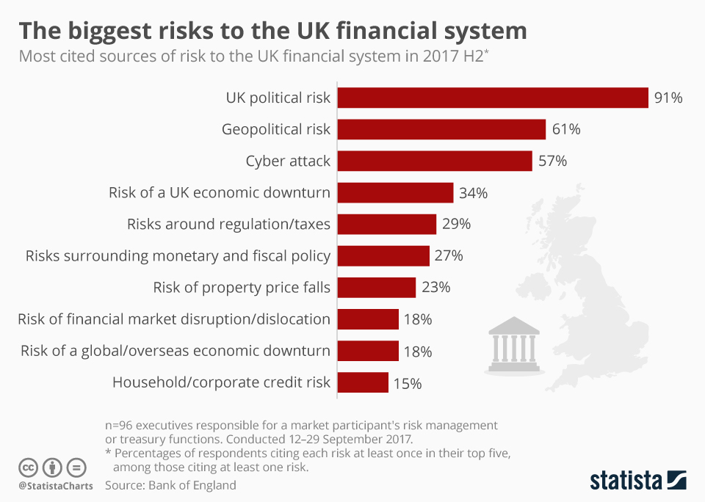
Figure 11: Weakness of financial risk management in British Airways
(source: Armstrong, 2019)
To enhance work productivity British Airways utilised several modern technologies but it has various risks including cybersecurity threats. Niv et al., (2024) mention that because of this cyber-attack they lose various significant data and get 567 million losses in 2022 impacting on their overall business. Cyber security also impacts their overall system creating various problems regarding operating the business. In the Financial risk management of British Airways, several human factors including judgement, monitoring, and other factors can be significantly impacted (Shin et al., 2023). For this risk management, British Airways emphasise skilled employees and stakeholders who provide strategic ideas that help them to improve their overall business as well as enhance their work productivity (Gupta et al., 2023). Financial risk management also impacts the organisational infrastructure which reduces work efficiency. In this organisational infrastructure, various key elements such as management, work environment, and most significant services help to improve the business (Erdem et al., 2024). In the end, there are various weaknesses including fluctuation of fuel price, currency exchange rate, organisational infrastructure, and most significant operational difficulties that impact British Airways' overall business.

4.5 Findings 4: A recommended approach for improving the financial risk management of British Airways
Developing the financial risk management in British Airways is significant for improving the overall business growth, financial stability, and most significant employees' well-being. This financial risk management also helps British Airways to achieve short-term and long-term goals with the help of technological advances, and other strategies (Mavrouli et al., 2023). British Airways needs to emphasise technological utilisation in every department which helps to improve work efficiency. In 2023, British Airways spent 89 million dollars on various technologies such as data analytics and AI to enhance work productivity (Louw et al., 2023). These techniques help British Airlines to understand the current market trend and develop its strategies as per market demands. They also hire cyber experts and professionals to reduce the cybersecurity threat by spending 67 million dollars (Shi et al., 2024). With the help of financial risk management strategies, British Airways emphasise their employee’s well-being as well as their skill improvement.
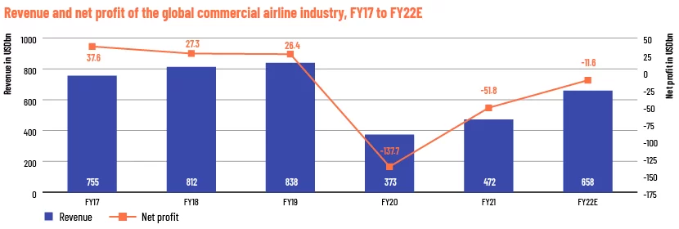
Figure 12: Modern technologies in British Airways
(Source: Statista, 2021)
As per Arias et al., (2023), they spent 160 million dollars to provide effective training, educational sessions, and other facilities to improve their skills. They also emphasise on effective communication with employees to understand their problems and provide solutions to establish an effective work environment (Keller et al., 2024). They provide their employees with rewards, incentives, and other facilities to encourage them to enhance their work performance. Strategic collaboration with stakeholders and other partners to improve their work activities. British Airlines invest 60 million dollars in their strategic partnership to enhance their work effectiveness (Omidi et al., 2023). British Airways's emphasis utilised various financial reporting tools that help them to regularly monitor their activities and details to identify the issues. This tool helps them to provide regular updates to their partners which allows to establish transparency and most significant credibility (Horwell et al., 2023). British Airways needs to emphasise improving regulatory compliance and effective relationships with governance. This regulatory compliance helps the organisation to understand current market trends and other significant information that impacts business growth. According to Adler et al., (2024), they also spend 40 million dollars on improving corporate governance which helps to improve risk oversights. This company needs to emphasise their board of directors and other team members to identify the current issue. This corporate governance helps British Airways to financial stability. They need to develop an effective compliance management team that tracks the changes in laws, financial reports, and other important details of the market.

4.6 Summary
In summary, this chapter of this research utilised various statistical information to the relevant topic such as, ‘Financial risk management strategies in the multinational corporations with British Airways case study.’ Financial risk management strategies are helping British Airways to enhance their work productivity as well as maintain their brand reputation in the global competition market. Financial risk management strategies include technological implications, improving effective communication, enhancing regulatory compliance, and most significantly managing the currency exchange rate issue. British Airways emphasises the employees' well-being, and creative innovation that helps them to improve their business, and financial stability and most significantly establish a loyal base of customers.

Chapter 5: Discussion

5.1 Overview
Financial risk management is one of the important key elements that help the organisation to address several risks that reduce the company's financial status. In financial risk, there are several key elements including market risk, credit risk, and most operational risk (Li et al., 2023). This risk impacts the organisation's infrastructure, work productivity as well as employees' well-being. In the British Airway, financial risk management plays an important role in improving their overall business activities. As per Cozmuta et al., (2024), British Airways faces several challenges: fuel price risk, currency exchange rate, and credit risk that reduce the overall work productivity and financial stability. To reduce the financial management risks, British Airways emphasises several approaches including operational risk management, regulation compliance, and most importantly hedging.
This approach helps the organisation to improve its organisational infrastructure, work productivity, and most importantly maintain brand reputation in the global competitive market (Mintah et al., 2023). The organisation needs to emphasise following government regulations to operate the business smoothly and reduce the risk of financial instability (Berrada et al., 2023). This chapter emphasises analysis of every aspect of the research topic and understanding the connection between the literature review and findings with the help of several articles, journals, and other sources. This chapter also emphasises analysing the importance of financial risk management in several MNCs including British Airways and helps to provide significant information regarding financial risk management activities and their mitigation strategies.

5.2 Role of Financial Risk Management in the British Airways
Financial risk management is an important key element that impacts the organisational infrastructure, work productivity, employees' well-being, and most importantly, economic status. Due to financial risk management, British Airways faces several challenges in its financial status (Berrada et al., 2023). This financial risk management impacts British Airways’ overall business activities and it also affects their brand reputations. There are several key elements including operational activities, managing the extra expenses, improving the partner's confidence, and most importantly government regulations that help to operate their business smoothly in the global competitive market (Cozmuta et al., 2024). British Airways emphasises its operational stability which helps them to improve their work patterns and provide an effective work environment that increases work activities. Effective risk management practices help British Airways to reduce the extra cost from several departments which also helps them to maintain their financial status. In 2023, British Airways reduced 345 million dollars in cost by utilising cost management practices (Mintah et al., 2023). British Airways maintains their collaboration relationships by providing important information regarding business, profits, and others to maintain their transparency helps to increase confidence, and is also helpful for their business practices. As per Alıcı et al., (2024), British Airways also emphasises following government regulations to understand current market changes, taxes, and other important information and help to operate the business in a competitive market.
As per Shi et al., (2024), several types of financial risks impact British Airways' business growth. Fuel price risk is one of the important risks that reduce profitability and enhance the cost that impacts their financial stability. In 2022, the British spent 300 million dollars to purchase fuel which impacted their economic status (Colak et al., 2023). They emphasise collecting less costly fuel but due to regulation compliance, they are unable to purchase less costly fuel. From 2021, they operate their business globally which increases the extra cost including taxes, currency rate, customer preferences, and other important elements that increase the cost (Akowe et al., 2023). Changes in currency rates influence ticket prices to reduce sales as well as reduce portability. In 2021, British Airways faced a 1 billion loss that impacted their brand reputation. Liquidity risk is another important factor that impacts British Airways (Kassem et al., 2023). British emphasis on managing their stock and achieving short-term objectives. This Liquidity risk has various key elements including reserve cash, credit lines, and most importantly effective cash flow that reduce the issues regarding lack of liquidity. British Airways always emphasises its organisational infrastructure and employee’s well-being (Shin et al., 2023). To improve their employee's well-being, they spend 500 million dollars on their training activities, educational sessions, seminars, and other activities (Savchenko et al., 2023). They provide several facilities including bonuses, incentives, flexible work hours, remote work facilities, and others to encourage them to improve their work performance.
As per Niv et al., (2024), to address the financial risk management issues, British Airways utilised several approaches that helped them to improve their overall work productivity, enhance brand reputation, and most importantly improve organisation infrastructure. According to Tariq et al., (2024), British Airways utilised a Hedging approach to address the issue regarding fuel price, currency rate, taxes, and others to reduce the extra cost. With the help of the hedging method, British Airways will reduce extra by up to 9% in 2022 (Xue et al., 2023). British Airways also utilised diversification methods to manage their networks which helped them to operate their business smoothly. This diversification approach helps British Airways to understand its market trends and develop its strategies as per their understanding (Colak et al., 2023). To address the financial risk management issues, British collaborates with several partners including stakeholders, investors, distributors, and suppliers to improve their strategic planning and other activities that help to improve their overall business productivity. Berrada et al., (2023) mention that British Airways’ emphasis is on utilising modern technologies including AI, IoT, ML, block chain, and other advanced technologies to enhance their business activities as well as improve their brand reputation. In 2023, British Airways spent 600 million dollars on their technology integration which helped to improve their business growth (Savchenko et al., 2023). This organisation also emphasises communication with their partners with advanced technology that helps to simplify the communication process (Tariq et al., 2024). That communication helps the organisation to achieve long-term success and maintain its financial stability.
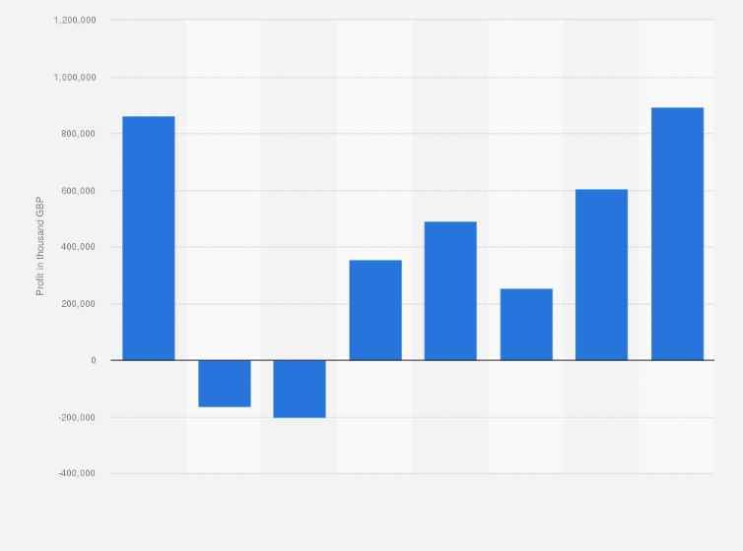
Figure 13: British Airways annual profit growth
(Source: Statista, 2023)
British Airways collaborates with several online platforms, and influencers to promote their business and provide important information regarding services, offers, and most importantly company data that help them to build trust and it helps to reduce financial risk (Niv et al., 2024). To collaborate with several platforms and influencers, they spend 250 million dollars every year to enhance their business reach and visibility (Kassem et al., 2023). British Airways’ emphasis on sustained profitability with the help of advanced technology, collaboration with several partners, and others to maintain the competitive edge. To enhance the brand reputation, British Airways’ emphasis on customer services, providing attractive offers, improving employees' skills, and others to establish trust towards the customer helps to build a loyal base of customers as well as improve the financial status (Delcea et al., 2023). During covid-19 pandemic, British Airways emphasised cost management, hedging, situation analysis, and most importantly reducing ticket prices which helped to enhance the overall sales and business activities (Li et al., 2023). During a pandemic, they follow government regulations that help them to operate their business in the global competitive market.

5.3 Loopholes of Financial Risk Management in British Airways
Financial risk management is one of the important key variables that impact British Airways’ overall business practices and reduce financial stability. As per Pemberton et al., (2024), to improve its financial stability and work activities British Airways focuses on its operational activities that help to improve its work performance and also help them to enhance their brand value in the global competitive market. British Airways utilised several risk management approaches that helped them maintain their profitability as well as help them achieve long-term success (Tirado et al., 2023). There are several weaknesses including over-reliance on hedging, external sources, operational activities, regulatory compliance, and most importantly limited resources that reduce the effectiveness of British Airways’ work productivity (Jang et al., 2023). Over-reliance on Hedging is an important element that reduces British Airways' overall work performance. As per Xue et al., (2023), in this over-reliance on hedging, the fuel cost, currency rate, taxes, and the country's economic status play an important role in increasing the extra cost that impacts the business. Fuel cost increases the rate of ticket prices and reduces profitability and the currency exchange rate also impacts customer behaviour because increasing ticket pricing influences customer buying behaviours (El Haddad et al., 2023). In 2022, due to the changes in currency rate, this company faced a 200-million-dollar loss that impacted on their brand reputation (Othman et al., 2023). To improve their brand reputation, they emphasise their creative innovation with the help of modern technology.
According to Tanrıverdi et al., (2023), to utilise modern technology, they spend 560 million dollars to adapt and advance technology in several departments. This advanced technology helps them to improve their work performance as well as help the organisation to communicate with their global partners to understand their emotions as well as requirements (Tariq et al., 2024). This technology also helps in developing strategies and their marketing department. British Airways’ emphasis on utilising Data analytics to understand current market trends helps them to understand the current market and customers (Hashmi et al., 2023). This approach helps them to develop effective relationships with their customers as well as build loyal-based customers. Several external shocks including financial instability, geopolitical risks, and changes in government regulation impacted British Airways' business activities (Baji-Irshad et al., 2024). The country's economic instability increases the rate of tickets and other facilities impacts British Airways sales and decreases work productivity (Popova et al., 2023). During the pandemic in the UK, they face financial issues and the customers do not use the Airline services due to their financial status and others that also reduce the business.
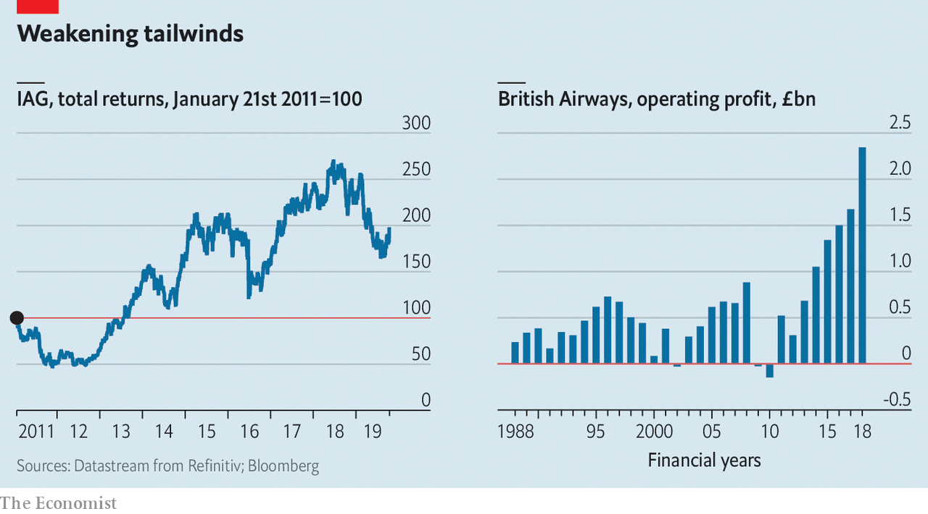
Figure 14: Profit reduction due to British Airways weakness in financial risk management
(source: The Economist, 2019)
To address the problem, British Airways’ emphasis on providing various offers, and facilities to attract the customer which helps to increase the business. During the pandemic, British Airways spent 300 million dollars to improve their services and they also reduced the ticket rate by up to 12% to increase sales (Tyagi et al., 2023). British Airways strictly follows government regulations and policies to operate their business. This regulation helps them to understand market changes and as per this can develop their strategies. As per Borghei et al., (2024), British Airways follows ‘stricter environmental regulation’ to reduce the rate of operation costs, help to increase ticket prices, and also help to invest the remaining money on their fuel extension. According to Le Thanh et al., (2023), British Airways collaborates with several government agencies, and non-profitable businesses to understand customer preferences as well as get knowledgeable about the changes in the country earlier that help to manage the complex situations. British Airways gives 100 million dollars to government agencies to operate their business without any risk (Kaituko et al., 2023). British Airways has fewer records regarding the country's economy and other important data that help them to analyse their work activities.
To avoid these difficulties, British needs to emphasise collecting information regarding their competitor's information, market trends, country information, and other information that help them to improve their business activities and provide them with an effective approach to resolve their weaknesses that help to achieve long-term success in the global competitive market (Zhu et al., 2023). British Airways emphasises risk assessment practices that help to understand complex situations including external and internal events to improve the risk and provide effective business opportunities to increase success (Tirado et al., 2023). British Airways emphasises developing an effective relationship with its customers, partners, and others. To develop effective relationships, they utilised several online platforms and conducted campaigns, events, and other activities where they collected feedback from them which helped to understand their requirements and their problems (Kaituko et al., 2023). British Airways spends 200 million dollars on campaigns, events, and other activities that help to improve their effective communication (Hashmi et al., 2023). During the pandemic, British Airways emphasised employee wellbeing, which helped them to encourage them to improve their business activities. As per Tanrıverdi et al., (2023), this company also emphasises customer economic status, for that reason they reduce the ticket price as well as provide several offers to improve their sales. According to Le Thanh et al., (2023), British Airways invested 450 million in cyber security because, in financial risk management, cyber Threats are one of the significant key elements that reduce business effectiveness. Cybersecurity creates several problems regarding cyberbullying and other crimes that impact their business activities.

5.4 Mitigating measures that are helpful for British Airways in undertaking financial risk management
British Airways is using financial risk management to implement its operations in a number of efficient methods. According to Horwell et al. (2023), financial risk management offers an efficient full protection strategy that enables them to boost income. British Airways uses this strategy to lock in gasoline prices by stockpiling large amounts of fuel for later use. They were able to make $234 million in 2021 because of the strategy (Esmaeeli et al., 2024). British Airways controls gasoline prices by focusing on what the market will bear, which will help them become more financially stable. In order to build a strong base of devoted customers, British Airways uses seminars, events, and other means to advertise its sustainable operations with the aid of financial risk management.
Nthenya et al. (2023) state that financial risk management techniques also aid in enhancing effective communication with a variety of stakeholders, investors, and staff members, all of whom contribute to the growth of the company (Kelman et al., 2021). These managerial techniques support preserving the openness that enhances the company. British Airways works with a range of partners who offer efficient approaches to support their innovative and creative endeavours, among other things. British Airways was able to generate $456 million in income in 2023 thanks to the cooperation of several stakeholders. A broader range of clients use British Airways, and they use a variety of financial management instruments to control the currency exchange risk.
The focus of British Airways was on using a variety of financial reporting tools to help them track and detect concerns by routinely monitoring their actions and details. They can build transparency and, most importantly, credibility by using this tool to assist them in giving their partners regular updates (Horwell et al., 2023). British Airways should prioritise strengthening its connections with governance and complying with regulations. The organisation benefits from this regulatory compliance by having a better understanding of current market trends and other important data that affect business growth. Adler et al. (2024) claim that they also invest $40 million in enhancing corporate governance, which enhances risk oversight. The company's board of directors and other team members need to be emphasised to pinpoint the existing problem.
One of the crucial components that assist the organisation in addressing various risks that jeopardise the company's financial standing is financial risk management. It can be imperative to state that market risk, credit risk, and operational risk comprise the majority of financial risk. This risk affects the well-being of the workforce, work productivity, and organisational infrastructure (Hashmi et al., 2023). Financial risk management is a key component of British Airways' overall business activity improvement strategy. British Airways is confronted with multiple issues that lower overall work productivity and financial stability, including fuel price risk, currency exchange rate risk, and credit risk.
Operational risk can be decreased through financial risk management as well. By investing 120 million dollars in their organisation infrastructure program and offering staff training, they can enhance their total organisational infrastructure in this risk management (Adler et al., 2024). They made use of a variety of contemporary technology to increase worker productivity, conduct market research, and—above all—improve employee wellbeing. These tactics assist British Airways in monitoring continuous progress, identifying financial problems, and creating mitigation plans to improve the company and foster confidence among stakeholders, investors, and other parties (Bellandi, 2023). Business travel demand appears to be shrinking, which is a process that began far back in 1999 and has been continued as the result of the current financial crisis.
Dominant companies such as British Airways are searching for alternative forms of communication with economy class tickets by encouraging the business passengers to move on the front through the cabin and maintain the frequency where it is reasonable. British Airways also has been attracting the consumer times namely the business passenger interested in the consumers not appearing viable (Adler et al., 2024). British Airways also works upon the serving of the pure pleasure market appearing to be the disrupting business model with the low-cost carrier. Taking in place the maturing airline market strategies of the company is also in dire need for matching the life-cycle of the market that it is existing in. British Airways also need to highlight the maintenance of profit with the saturation of the market and analyse the plan then be long run profit maximise, which case reasonably is substantially fixed cost and would be covered with the normal return on the capital that is to be achieved (). it also acts upon the low-cost carriers requiring the flights to fully cover the allocated cost. Thus, ignoring the issue of the transfer passengers and the legacy carriers separates the decision-making of an operator such as in the first stage. The company also needs to demonstrate the new carriers with the limited frequency flyer programmes, providing the substantially low air phase of the security level of service for competing effectively with the incumbent.

5.5 Discrepancies in the financial performance of British Airways
British Airways has been the titan of the skies, boasting a rich history but also the financial performance has been marked by the birth of soaring profits and plumbing losses. The company acts upon the understanding of the different factors behind the descriptions required having deep within the complex interplay of the external influences with the strategic decision and the internal challenges
External factor
- Fuel price fluctuation is one of the main factors influencing British Airways with the cost significantly impacting the profitability (Niv and Tal, 2024). It also highlights the airlines being susceptible to global oil price fluctuation. When the prices are spiking, the operating cost or rising proportionately, squeezing the margins. Conversely, periods of lower prices can result in temporary relief at the potential higher profits.
- In cases of economic decline, the consumers' spending habits are highly sensitive to the variable economic conditions. During periods of recession, the travel demand is often dipped leading to lower passenger numbers and the reduction of revenue from British Airways (Statista, 2023). The company has also been particularly detrimental on the long-haul routes with the airways typically commanding the premium fares.
- In terms of political instability, the political and rest with the security threat can destruct the travel and the tourism patterns. Act of terrorism or the regional conflict as well as pandemic such as Covid-19 also have caused a significant disruption for the British Airways (Tariq, 2024). Consumers have reflected the feelings of demean for fights and the rerouted journeys as well as travel restrictions contributing to the different financial losses.
- In terms of currency fluctuation, the exchange rate plays a crucial role in the financial picture of British Airways (Xue et al., 2023). The fluctuations are also impacting the revenue and the cost as the stronger British pound can make the airways fearless competitive within the market with other currencies have been weakened.
Internal decision
- The fleet management strategy of British Airways is significantly affecting the finances. Modern and fuel-efficient planes are also offering significant cost savings whereas the older planes are more expensive to operate (Kassem and Santamaria, 2023). The airline is also to balance the fleet modernisation cost with the long-term benefits of fuel efficiency
- In terms of network strategy, the profitability of the route depends upon the factors of passenger volume competition and the operating cost. This also works upon the decision and Airways focuses on the long haul premium route that has yielded the high yield passengers (YILMAZ, 2022). However, the strategy also leaves the airline most exposed to different and unpredictable economic terms compared to the low-cost carrier focusing upon the short-haul routes.
- In terms of labour disputes, it can incredibly disrupt costly strikes and union agreements leading to flight cancellations with passenger frustration and reputational damage maintaining the positive labour relation is crucial for British Airways in the operation and the financial well-being (Woods, 2022).
- In terms of marketing and branding strategies, the labour dispute can be increasingly disruptive as well as costly, striking the marketing and branding strategies (Güngör Göksu, 2023). It also ensures the British Airway commanding the premium fares for attracting the loyal consumer base. However, the marketing budget needs to be carefully managed in order to ensure the positive return upon the investment.
Infrastructural challenges
- In terms of cost structure, British Airways has the legacy airline facing the challenges in managing the cost structure (Chaidir et al. 2023). The airline has historically had the higher fixed cost such as the staff salaries of the airport fees as compared to the budget carriers. It also ensures the streamlining of operations, finding that correct cost efficiency is crucial for financial stability.
- The airline industry is fairly competitive with established travel and low-cost carriers for market share. It needs to constantly innovate and adapt to the offering to stay competitive within the terms of price and the service offered.
- In terms of passenger experience, delivering a consistently high-quality passenger experience is essential for consumer retention and loyalty (Kharlanov et al. 2022). However, operational issues such as delays and cancellations due to the package problem can damage the reputation British shares and deter passengers from choosing the airline in the upcoming future course of action.
British Airways has been highly participated in navigating through the smoother skies in the future of financial health, depending upon the ability to address the mentioned discrepancies (Statista, 2023). The airline also needs to develop a comprehensive strategy that would tackle the external factors and the internal challenges. This also is inclusive of filling the hedging strategies with the diversification of revenue streams and the focus on cost efficiency as well as continuous improvement within passenger experience. In addition to the same fouling of positive labour, relation and adaptation to the evolve in competitive landscape it is also crucial for the ensuring of long-term stability. This helps in understanding the factors contributing to the financial performance and the proactive management of the same. British Airways can also navigate the terminal skies in the industry by achieving sustainable financial success.

5.6 Summary
British Airways emphasises several strategies, including operational risk management, regulatory compliance, and—most importantly—hedging, to lower the financial management risks. This strategy aids the company in enhancing its work output, organisational infrastructure, and—above all—maintaining its reputation in the cutthroat international marketplace. To keep corporate operations running smoothly and lower the risk of financial instability, the organisation must prioritise adhering to government rules. With the aid of several articles, journals, and other sources, this chapter focuses on the examination of every facet of the research issue and the comprehension of the relationship between the findings and the literature review. The next section offers important information about financial risk management activities and their mitigation measures, as well as an analysis of the significance of financial risk management in several MNCs, including British Airways.

Chapter 5: Conclusion and recommendations

5.1 Conclusion
Airlines have the ability to employ advanced risk management strategies, instruments, and practices to closely monitor market trends and risk indicators. Additionally, it is capable of anticipatorily spotting new threats and acting quickly to reduce them. Therefore, it can be concluded that successful financial risk management is necessary for multinational companies to successfully navigate the complexity of the global business environment, including British Airways. application of a comprehensive risk management plan that includes diversification, hedging, and provisions for fuel and currency. British Airways has the ability to mitigate the effects of financial risk on its operations and financial results. In order to lessen its exposure to the risk associated with fuel prices, British Airways can also handle the volatility in oil prices using fuel hedging techniques. In order to reduce uncertainty and effectively manage fuel costs, the corporation might enter into derivative contracts pertaining to future and option pricing locking in fuel prices at predetermined levels.
It can also partition the market to lower overall risk exposure and diversify the income stream and operational activity over several geographical areas. The nation can counteract the negative effects of an unfavourable incident in one market or region by diversifying its operations and seeing success in other areas. The corporation may also imply that risk assessment and monitoring are necessary for routinely evaluating and tracking the exposure to different financial risks. It should be noted that this study also evaluates the impact on financial performance and the efficacy of potential future practices. The study also attempts to shed light on how airlines can lessen the volatility of fuel prices. In addition, British Airways must deal with geopolitical unpredictability in the various locations in which it operates and regulatory risk. This study examined the company's risk mitigation plan and its reactions to the geopolitical event, with a focus on relationships with industry players and government authorities.
The study also emphasises how crucial geopolitical risk management is for multinational corporations and how it affects their financial performance. Multinational corporations face a variety of challenges in the global economy, including initial currency shock, interest rate fluctuations, and political unpredictability related to market dynamics. For multinational corporations (MNCs), financial risk management efficacy is essential to maintaining competitive advantage, profitability, and financial stability. The research concludes with an examination of British Airways' financial risk management plan. British Airways is a well-known international airline in the aviation industry. The complexity of managing foreign exchange risk in worldwide businesses is the primary issue being addressed. British Airways is a multinational company that operates globally, exposing it to various financial risks such as swings in foreign exchange. In addition to interest rate risk, gasoline price volatility also has geopolitical implications. Another important factor that has an impact on the firm is uncertainty. British Airways must also be taken into account while identifying, evaluating, and mitigating the many risks that are influencing the company units' financial performance. Furthermore, risk management is crucial for reducing the impact of variable external events upon operations and financial condition, especially for firms like British Airways.

5.2 Linking with objectives
Objective 1: The first objective is to identify the different discrepancies in the financial performance of British Airways.
Objective 2: The first objective is to formulate the weaknesses of British Airways on a financial and operational scale.
Objective 3: The first objective is to recommend strategies helpful for British Airways in undertaking financial risk management.

5.3 Recommendations
- Foreign Exchange Risk Management: British Airways faces significant exposure to currency fluctuation due to the global operation. In order to mediate the risk, the airline is using the hedging strategy such as the contract with the currency options. It also acts as the locking of the exchange rate in advance. British Airways can reduce the uncertainty for future cash flows and the profit margin from the adverse currency movement.
- Fuel Risk Price Management: The major cost component for the airlines. Considering the fluctuation in the process is significantly affecting the profitability of British Airways. Furthermore, the airline is also employing the instrument of hedging such as the futures and the so for managing the fuel price risk. Entering into the hedging contract. British Airways can stabilise the fuel cost over a certain period, thereby minimising the impact of volatile fuel prices on the financial performance.
- Interest Rate Risk Management: Given the substantial that and the financing activities, British Airways is exposed to the interest rate risk. Fluctuation also refers to the usage of interest rates with the derivative instrument that can manage the same on an effective scale. The strategy would help optimise the debt structure and reduce the impact of interest rate change on the financial position.
- Operational Risk Management: Beyond the financial market risk, British Airways is focusing on the managing of operational risk that could impact its financial health. It also includes the risk related to safety and security with regulatory compliance and operational disruption. Implementation of proper stress management framework and the contingency plan share Vaiz is also enhancing the resilience minimising the potential financial risk from the operational incident.
- Strategic Risk Management: Dynamic and competitive airline industry where British Airways functioning faces the strategic risk, such as changes in the consumer preferences, with the complete pressure and the geopolitical uncertainties. The airline also needs to continuously monitor the markets with the conducting of scenario planning or identifying and addressing the potential strategic risk. It puts forward the proactive adjusting of business strategies and diversifying the service offerings of British Airways six in mediating the impact of external uncertainties on the financial performance.

5.4 Future scope and Limitations
Interdisciplinary research in the future is increasingly recognized regarding the approaches for solving the complex problem. In future research work regarding the particular topic it values the intersection between the disciplines, such as psychology and technology as well as economics and environmental science. With the rapid evolution and the application of the fields, the dissertation can contribute in proposing innovative solutions as well as policy recommendations. It also functions upon the challenges and opportunities that are relevant for improvement in the future course of action. Exploring the different cultural safety is also important at the moment for providing valuable insight in understanding the future trajectory.
In terms of limitation, accessibility to the relevant data is important for limiting and depth of the research, especially within the sensitive areas. It also ensures the ethical considerations such as the sensitive data of information regarding human subjects requiring the stringent ethical protocols that can constrain the scope of the study. Limitations in the funding and time with the accessibility to the specialised equipment. Equipment is also expecting impact the feasibility and scale of the dissertation research method, logical constant is also one of the main instances that has to be satisfied in challenging of implementation and the interpretation of the same

Reference List
Abdelhakim, A.S., 2021. Adopted Research Designs by Tourism and Hospitality Postgraduates in The Light‎ of Research Onion. International Journal of Tourism and Hospitality Management, 4(2), pp.98-124.
Achim, M.V., Safta, I.L., Văidean, V.L., Mureșan, G.M. and Borlea, N.S., 2022. The impact of covid-19 on financial management: evidence from Romania. Economic Research-EkonomskaIstraživanja, 35(1), pp.1807-1832.
Adler, N. and Andreana, G., 2024. Aiding airlines for the benefit of whom? An applied game-theoretic approach. European Journal of Operational Research, 314(2), pp.552-564.https://www.sciencedirect.com/science/article/pii/S037722172300718X
Akomea-Frimpong, I., Jin, X. and Osei-Kyei, R., 2024. Fuzzy Analysis of Financial Risk Management Strategies for Sustainable Public–Private Partnership Infrastructure Projects in Ghana. Infrastructures, 9(4), p.76.
Akowe, A., 2023. Risk Management and Financial Performance of Firms in Nigeria: Firm Size as a Moderator. Journal of Public Administration, Policy and Governance Research, 1(4), pp.62-84.https://jpapgr.com/index.php/research/article/view/49
Akowe, A., 2023. Risk Management and Financial Performance of Firms in Nigeria: Firm Size as a Moderator. Journal of Public Administration, Policy and Governance Research, 1(4), pp.62-84.https://jpapgr.com/index.php/research/article/view/49
Alharahsheh, H.H. and Pius, A., 2020. A review of key paradigms: Positivism VS interpretivism. Global Academic Journal of Humanities and Social Sciences, 2(3), pp.39-43.https://gajrc.com/media/articles/GAJHSS_23_39-43_VMGJbOK.pdf
Al-Hashimy, H.H., Alabdullah, T.T.Y., Ries, E., Ahmed, M.A., Nor, M.I. and Jamal, K.A.M., 2022. The Impact of Financial Management Elements and Behavioral Intention on the Financial Performance. International Journal of Scientific and Management Research, 5(12), pp.117-149.
Alıcı, A., 2024. Analysis of Macroeconomic Factors Affecting Airline Stock Prices. ANDULI. Revista Andaluza de Ciencias Sociales, (25), pp.93-137.https://revistascientificas.us.es/index.php/anduli/article/view/22342
Arias, A., Nika, C.E., Vasilaki, V., Feijoo, G., Moreira, M.T. and Katsou, E., 2024. Assessing the future prospects of emerging technologies for shipping and aviation biofuels: A critical review. Renewable and Sustainable Energy Reviews, 197, p.114427.https://www.sciencedirect.com/science/article/pii/S1364032124001503
‌Armstrong, M. (2019). Infographic: The biggest risks to the UK financial system. [online] Statista Infographics. Available at: https://www.statista.com/chart/12031/the-biggest-risks-to-the-uk-financial-system/ .
ATMADJA, A.T., SAPUTRA, K.A.K., MANURUNG, D.T. and WULANDARI, R., 2021. Factors that influence financial management: A case study in Indonesia. The Journal of Asian Finance, Economics and Business, 8(6), pp.1203-1211.
Bailey, D., 2024. ‘Building back better’or sustaining the unsustainable? The climate impacts of Bank of England QE in the Covid-19 pandemic. British politics, 19(1), pp.134-153.https://link.springer.com/article/10.1057/s41293-022-00223-w
Bani-Irshid, A.H., Hamasha, M.M., Al-Nsour, L., Mohammad, L., Al-Dabaibeh, A., Al-Majali, R. and Al-Daajeh, H., 2024. Supply chain risk assessment and mitigation under the global pandemic COVID-19. International Journal of Production Management and Engineering, 12(1), pp.43-63.https://polipapers.upv.es/index.php/IJPME/article/view/19240
Bellandi, F., 2023. Does Accounting Influence Finance? The Case of IFRS 9 and Fuel Hedging. International Journal of Business and Management, 16(12), pp.1-1.https://scholar.archive.org/work/7q4qqfzdhfftxc6k43uwhrgtmy/access/wayback/https://ccsenet.org/journal/index.php/ijbm/article/download/0/0/46282/49356
Berrada, H., El Ghazi El Houssaïni, S. and Boutahar, J., 2023. Implementing information technology risk management: A case study in the African airline industry. J. Organ. Technol. Entrep, 1(1), pp.58-76.https://library.acadlore.com/JOTE/2023/1/1/JOTE_01.01_05.pdf
Berrada, H., El Ghazi El Houssaïni, S. and Boutahar, J., 2023. Implementing information technology risk management: A case study in the African airline industry. J. Organ. Technol. Entrep, 1(1), pp.58-76.https://library.acadlore.com/JOTE/2023/1/1/JOTE_01.01_05.pdf
Berry, M., Salinas, M. and Gundur, R.V., 2023. Financial risk management strategies of small to medium illicit drug enterprises: considering low-level money laundering. Trends in Organized Crime, pp.1-23.
Borghei, Z., Linnenluecke, M. and Bui, B., 2024. The disclosure of climate-related risks and opportunities in financial statements: the UK’s FTSE 100. Meditari Accountancy Research, 32(3), pp.1031-1063.https://www.emerald.com/insight/content/doi/10.1108/MEDAR-05-2023-1998/full/html
Braun, V. and Clarke, V., 2023. Toward good practice in thematic analysis: Avoiding common problems and be (com) ing a knowing researcher. International journal of transgender health, 24(1), pp.1-6.https://www.tandfonline.com/doi/abs/10.1080/26895269.2022.2129597
Bustani, B., Khaddafi, M. and Ilham, R.N., 2022. Regional Financial Management System of Regency/City Regional Original Income In Aceh Province Period Year 2016-2020. International Journal of Educational Review, Law And Social Sciences (IJERLAS), 2(3), pp.459-468.
Casula, M., Rangarajan, N. and Shields, P., 2021. The potential of working hypotheses for deductive exploratory research. Quality & Quantity, 55(5), pp.1703-1725.https://link.springer.com/article/10.1007/s11135-020-01072-9
Chaidir, M., Yulianti, G., Santoso, S. and Kumandang, C., 2023, December. Financial Management Proficiency For MSMEs. In Proceeding of The International Conference on Business and Economics (Vol. 1, No. 2, pp. 285-293).
Chang, C.L., McAleer, M. and Wong, W.K., 2020. Risk and financial management of COVID-19 in business, economics and finance. Journal of Risk and Financial Management, 13(5), p.102.
Chornovol, A., Tabenska, J., Tomniuk, T. and Prostebi, L., 2020. Public finance management system in modern conditions. Investment Management & Financial Innovations, 17(4), p.402.
Colak, O., Enoch, M. and Morton, C., 2023. Airport business models and the COVID-19 pandemic: An exploration of the UK case study. Journal of Air Transport Management, 108, p.102337.https://www.sciencedirect.com/science/article/pii/S0969699722001569
Cozmuta, A., 2024. Selling ‘The World’s Favourite Airline’: British Airways’ privatisation and the motives behind it. Business History, 66(1), pp.181-200.https://www.tandfonline.com/doi/abs/10.1080/00076791.2021.1926991
Cozmuta, A., 2024. Selling ‘The World’s Favourite Airline’: British Airways’ privatisation and the motives behind it. Business History, 66(1), pp.181-200.
Cozmuta, A., 2024. Selling ‘The World’s Favourite Airline’: British Airways’ privatisation and the motives behind it. Business History, 66(1), pp.181-200.https://www.tandfonline.com/doi/abs/10.1080/00076791.2021.1926991
Dave, T., Athaluri, S.A. and Singh, S., 2023. ChatGPT in medicine: an overview of its applications, advantages, limitations, future prospects, and ethical considerations. Frontiers in artificial intelligence, 6, p.1169595. https://www.frontiersin.org/articles/10.3389/frai.2023.1169595/full
Delcea, C. and Cotfas, L.A., 2023. Risk Assessment and Transport Cost Reduction Based on Grey Clustering. In Advancements of Grey Systems Theory in Economics and Social Sciences (pp. 139-178). Singapore: Springer Nature Singapore.https://link.springer.com/chapter/10.1007/978-981-19-9932-1_4
Delcea, C. and Cotfas, L.A., 2023. Risk Assessment and Transport Cost Reduction Based on Grey Clustering. In Advancements of Grey Systems Theory in Economics and Social Sciences (pp. 139-178). Singapore: Springer Nature Singapore.https://link.springer.com/chapter/10.1007/978-981-19-9932-1_4
El Haddad, L., Khan, M., Soufny, R., Mummy, D., Driehuys, B., Mansour, W., Kishnani, P.S. and ElMallah, M.K., 2023. Monitoring and Management of Respiratory Function in Pompe Disease: Current Perspectives. Therapeutics and Clinical Risk Management, pp.713-729.https://www.tandfonline.com/doi/abs/10.2147/TCRM.S362871
Enríquez-Díaz, J., Castro-Santos, L. and Puime-Guillén, F. eds., 2021. Financial management and risk analysis strategies for business sustainability. IGI Global.
Erdem, M. and Özdemir, A., 2024. Sustainability and risk assessment of data center locations under a fuzzy environment. Journal of Cleaner Production, 450, p.141982.https://www.sciencedirect.com/science/article/pii/S0959652624014306
Esmaeeli, N., Sattari, F., Lefsrud, L. and Macciotta, R., 2024. Assessing the risks associated with the Canadian Railway System using a safety risk model approach. Transportation research record, 2678(2), pp.795-808.https://journals.sagepub.com/doi/abs/10.1177/03611981231176549
Ferine, K.F., Saefudin, A., Ariwibowo, P. and Azim, I., 2023. Financial Management in Reaching Product Empowerment Index Standards Related to Science on MSME Performance. JurnalPenelitian Pendidikan IPA, 9(7), pp.5716-5724.
Finkler, S.A., Calabrese, T.D. and Smith, D.L., 2022. Financial management for public, health, and not-for-profit organizations. CQ Press.
Grinchenko, S. and Shchapova, Y.L., 2020. The deductive approach to Big History’s Singularity. The 21st Century Singularity and Global Futures: A Big History Perspective, pp.201-210.https://link.springer.com/chapter/10.1007/978-3-030-33730-8_10
Güngör Göksu, G., 2023. A retrospective overview of the Journal of Public Budgeting, Accounting and Financial Management using bibliometric analysis. Journal of Public Budgeting, Accounting & Financial Management, 35(2), pp.264-295.
Gupta, R., Jain, K. and Gupta, C.C., 2023. Risk analytics for project success. In Research Handbook on Project Performance (pp. 133-157). Edward Elgar Publishing.https://www.elgaronline.com/edcollchap/book/9781802207613/book-part-9781802207613-16.xml
Hamawandy, N.M., Ali, R., Bewani, H.A.W.A., bdulmajeed Jamil, D., Rahman, S.K. and Othman, B.J., 2021. The financial Impacts of (COVID-19) on financial reporting quality Airlines Companies: British Airlines. The journal of contemporary issues in business and government, 27(2), pp.5264-5271.
Hashmi, R., 2023. Disruptive Enterprise Factors and Risk Management in Global Supply Chain. South Asian Journal of Social Review, 2(1), pp.1-14.http://journal.sagpb.com/index.php/SAJSR/article/view/60
Hochrainer-Stigler, S., Schinko, T., Hof, A. and Ward, P.J., 2021. Adaptive risk management strategies for governments under future climate and socioeconomic change: An application to riverine flood risk at the global level. Environmental Science & Policy, 125, pp.10-20.
Horwell, C.J., Elias, T., Covey, J., Bhandari, R. and Truby, J., 2023. Perceptions of volcanic air pollution and exposure reduction practices on the Island of Hawai ‘i: Working towards socially relevant risk communication. International Journal of Disaster Risk Reduction, 95, p.103853.https://www.sciencedirect.com/science/article/pii/S2212420923003333
Hu, W., Shou, Y., Kang, M. and Park, Y., 2020. Risk management of manufacturing multinational corporations: The moderating effects of international asset dispersion and supply chain integration. Supply Chain Management: An International Journal, 25(1), pp.61-76.
Ito, A., 2022. Risk Management Strategies of Japanese Companies in China: Political Crisis and Multinational Firms.
Jackson, S. and Tozer, J., 2020. A vision for data science at British Airways. Impact, 2020(1), pp.15-19.
Jang, H., Mujeeb-Ahmed, M.P., Wang, H., Park, C., Hwang, I., Jeong, B., Zhou, P. and Mickeviciene, R., 2023. Regulatory gap analysis for risk assessment of ammonia-fuelled ships. Ocean Engineering, 287, p.115751.https://www.sciencedirect.com/science/article/pii/S0029801823021352
Junjie, M. and Yingxin, M., 2022. The Discussions of Positivism and Interpretivism. Online Submission, 4(1), pp.10-14.https://eric.ed.gov/?id=ED619359
Kaituko, L.E., Githaiga, P.N. and Chelogoi, S.K., 2023. Board structure and the likelihood of financial statement fraud. Does audit fee matter? Evidence from manufacturing firms in the East Africa community. Cogent Business & Management, 10(2), p.2218175.https://www.tandfonline.com/doi/abs/10.1080/23311975.2023.2218175
Kassem, R. and Santamaria, D., 2023. The impact of tourist perception of fraud risk on tourism planning. In Handbook on Tourism Planning (pp. 242-254). Edward Elgar Publishing.https://www.elgaronline.com/edcollchap/book/9781803923598/b-9781803923598.00020.xml
Keller, I., Eierle, B. and Hartlieb, S., 2024. Auditors’ Carbon Risk Consideration under the EU Emission Trading System. Accounting in Europe, 21(1), pp.14-43.https://www.tandfonline.com/doi/abs/10.1080/17449480.2023.2256059
Kelman, I., Alexander, D., Fearnley, C., Jenkins, S. and Sammonds, P., 2023. Systemic risks perspectives of Eyjafjallajökull volcano's 2010 eruption. Progress in disaster science, 18, p.100282.https://www.sciencedirect.com/science/article/pii/S2590061723000091
Kembauw, E., Munawar, A., Purwanto, M.R., Budiasih, Y. and Utami, Y., 2020. Strategies of financial management quality control in business. TEST Engineering & Management, 82, pp.16256-16266.
Kharlanov, A.S., Bazhdanova, Y.V., Kemkhashvili, T.A. and Sapozhnikova, N.G., 2022. The case experience of integrating the SDGs into corporate strategies for financial risk management based on social responsibility (with the example of Russian TNCs). Risks, 10(1), p.12.
Kugel, S., 2023. Help! It’s Almost 2024 and Travelers Keep Making the Same Mistakes. The New York Times (Digital Edition), pp.NA-NA
Kuljanin, J., Kalić, M., Begović, B., Mijović, N. and Renold, M., 2021. The effect of LCC market entry on dominant FSC's price into long haul sector: A case of Norwegian competition on British Airways' prices on selected transatlantic routes. Journal of Air Transport Management, 91, p.102016.
Le Thanh, X., Minh, T.T. and Le Thai, P., 2023. Road and Air Transport Sectors to a Greener Future in The Uk: Lessons for Vietnam. International Journal of Management Excellence (ISSN: 2292-1648), 17(2), pp.2447-2459.https://techmindresearch.org/index.php/ijme/article/view/1281
Li, L., Gong, Y., Wang, Z. and Liu, S., 2023. Big data and big disaster: a mechanism of supply chain risk management in global logistics industry. International Journal of Operations & Production Management, 43(2), pp.274-307.https://www.emerald.com/insight/content/doi/10.1108/IJOPM-04-2022-0266/full/html
Li, L., Gong, Y., Wang, Z. and Liu, S., 2023. Big data and big disaster: a mechanism of supply chain risk management in global logistics industry. International Journal of Operations & Production Management, 43(2), pp.274-307.https://www.emerald.com/insight/content/doi/10.1108/IJOPM-04-2022-0266/full/html
Louw, L.B., Esterhuyzen, E. and Swart, M.P., 2023. Aligning Event Risk Management with the Sustainable Development Goals. In SDGs in Africa and the Middle East Region (pp. 1-24). Cham: Springer International Publishing.https://link.springer.com/content/pdf/10.1007/978-3-030-91260-4_68-1.pdf
Mavrouli, M., Mavroulis, S., Lekkas, E. and Tsakris, A., 2023. The impact of earthquakes on public health: A narrative review of infectious diseases in the post-disaster period aiming to disaster risk reduction. Microorganisms, 11(2), p.419.https://www.mdpi.com/2076-2607/11/2/419
Mazur, N., Khrystenko, L., Pásztorová, J., Zos-Kior, M., Hnatenko, I., Puzyrova, P. and Rubezhanska, V., 2021. Improvement of controlling in the financial management of enterprises. TEM Journal-Technology, Education, Management, Informatics.
Mihajlović, M.B., Tadin, D.B. and Gordić, B.M., 2020. The role of financial management in the company. Tehnika, 75(4), pp.498-503.
Mintah, E.O. and Gulko, N., 2023. The impact of the COVID-19 pandemic on social and environmental reporting and financial performance of airlines operating in the UK. Journal of Financial Reporting and Accounting.https://www.emerald.com/insight/content/doi/10.1108/JFRA-01-2023-0032/full/html
Mintah, E.O. and Gulko, N., 2023. The impact of the COVID-19 pandemic on social and environmental reporting and financial performance of airlines operating in the UK. Journal of Financial Reporting and Accounting.
Murugan, M.S., 2023. Large-scale data-driven financial risk management & analysis using machine learning strategies. Measurement: Sensors, 27, p.100756.
Naik, N., Hameed, B.M., Shetty, D.K., Swain, D., Shah, M., Paul, R., Aggarwal, K., Ibrahim, S., Patil, V., Smriti, K. and Shetty, S., 2022. Legal and ethical consideration in artificial intelligence in healthcare: who takes responsibility?.Frontiers in surgery, 9, p.266.https://www.frontiersin.org/articles/10.3389/fsurg.2022.862322/full?gclid=Cj0KCQiAjbagBhD3ARIsANRrqEsSbEC-BHyiNltKKBRXm4CkJOwBot_U3M1rDu9zP0GaORA5bEfrypoaAtqFEALw_wcB
Nguyen, Q.K., 2024. How Does Financial Flexibility Strategy Impact on Risk Management Effectiveness?. SAGE Open, 14(2), p.21582440241240842.
Niv, Y. and Tal, Y., 2024. Patient Safety and Risk Management Organizations and Institutions. In Patient Safety and Risk Management in Medicine: From Theory to Practice (pp. 179-193). Cham: Springer Nature Switzerland.https://link.springer.com/chapter/10.1007/978-3-031-49865-7_13
Niv, Y. and Tal, Y., 2024. Patient Safety and Risk Management Organizations and Institutions. In Patient Safety and Risk Management in Medicine: From Theory to Practice (pp. 179-193). Cham: Springer Nature Switzerland.https://link.springer.com/chapter/10.1007/978-3-031-49865-7_13
Nthenya, N.N., 2023. Knowledge Transfer and the Development of Airline business in Africa: Kenya Airways, 1977-2017. Journal of Evolutionary Studies in Business, 8(2), pp.1-31.https://revistes.ub.edu/index.php/JESB/article/view/33989
Omidi, L., Karimi, H. and Moradi, G., 2023, October. Assessment of emergency risk management and resilience engineering at management levels of a high hazard industry. In Safety and Reliability (pp. 1-23). Taylor & Francis.https://www.tandfonline.com/doi/abs/10.1080/09617353.2023.2263728
Onsongo, S.K., Muathe, S.M. and Mwangi, L.W., 2020. Financial risk and financial performance: evidence and insights from commercial and services listed companies in Nairobi securities exchange, Kenya. International Journal of Financial Studies, 8(3), p.51.
Othman, A., Dhouib, A. and Nasser Al Jabor, A., 2023, July. Fostering websites accessibility: A case study on the use of the Large Language Models ChatGPT for automatic remediation. In Proceedings of the 16th International Conference on PErvasive Technologies Related to Assistive Environments (pp. 707-713).https://dl.acm.org/doi/abs/10.1145/3594806.3596542
‌Pemberton, M.A., Arts, J.H. and Kimber, I., 2024. Identification of true chemical respiratory allergens: Current status, limitations and recommendations. Regulatory Toxicology and Pharmacology, p.105568.https://www.sciencedirect.com/science/article/pii/S0273230024000096
Petrescu, R.V.V., 2020. British Airways is Ordering up to 42 Boeing 777-9s Aeronaves to Modernize the UK Flag Carriers Long-Haul Fleet. Journal of Aircraft and Spacecraft Technology.
PLC, J.W., 2020. Annual Report and Financial Statements 2020. Welwyn Garden City: Black Sun Plc. Retrieved May, 18, p.2020.
Popova, P., Marinova, K. and Popov, V., 2023. Internet of Things and Big Data Analytics for Risk Management in Digital Tourism Ecosystems. Risks, 11(10), p.180.https://www.mdpi.com/2227-9091/11/10/180
Proudfoot, K., 2023. Inductive/deductive hybrid thematic analysis in mixed methods research. Journal of Mixed Methods Research, 17(3), pp.308-326.https://journals.sagepub.com/doi/abs/10.1177/15586898221126816
Pujiharto, Y.R.C., Mariyanti, T., Jayaprawira, A.R. and Terah, Y.A., 2023. Financial Management of Indonesian Hajj Against the Yield by Using a Dynamics System Model. APTISI Transactions on Management, 7(1), pp.69-78.
Salamah, S.N., 2023. Financial management strategies to improve business performance. Journal of Contemporary Administration and Management (ADMAN), 1(1), pp.9-12.
Savchenko, L., Ovdiienko, O., Boichenko, M. and Mostenska, T., 2023. Assessment of the relationship between corporate social responsibility environmental goals implementation and financial and operational indicators of airlines. ZeszytyNaukowe. Transport/Politechnika Śląska.https://yadda.icm.edu.pl/baztech/element/bwmeta1.element.baztech-c3a7af55-716e-4c74-9c23-077b6ef21bd1
Savchenko, L., Ovdiyenko, O., Boichenko, M. and Mostenska, T., 2023. Assessment of the relationship between corporate social responsibility environmental goals implementation and financial and operational indicators of airlines. Zeszyty Naukowe. Transport/Politechnika Śląska.https://yadda.icm.edu.pl/baztech/element/bwmeta1.element.baztech-c3a7af55-716e-4c74-9c23-077b6ef21bd1
Shen, Z., 2022, December. Analysis of British Airway's Hedging Strategies. In 2022 2nd International Conference on Economic Development and Business Culture (ICEDBC 2022) (pp. 307-311). Atlantis Press.
Shi, Y. and Li, X., 2024. Bankruptcy prediction for the European aviation industry: An application of the Altman model. Managerial and Decision Economics, 45(1), pp.477-491.https://onlinelibrary.wiley.com/doi/abs/10.1002/mde.4018
Shi, Y. and Li, X., 2024. Bankruptcy prediction for the European aviation industry: An application of the Altman model. Managerial and Decision Economics, 45(1), pp.477-491.https://onlinelibrary.wiley.com/doi/abs/10.1002/mde.4018
Shin, H., Kang, J., Sharma, A. and Nicolau, J.L., 2023. The impact of COVID-19 vaccine passport on air travellers’ booking decision and companies’ financial value. Journal of Hospitality & Tourism Research, 47(5), pp.927-936.https://journals.sagepub.com/doi/abs/10.1177/10963480211058475
Shin, H., Kang, J., Sharma, A. and Nicolau, J.L., 2023. The impact of COVID-19 vaccine passport on air travelers’ booking decision and companies’ financial value. Journal of Hospitality & Tourism Research, 47(5), pp.927-936.https://journals.sagepub.com/doi/abs/10.1177/10963480211058475
Statista (2023). Most popular airlines in the UK 2019 | Statista. [online] Statista. Available at: https://www.statista.com/statistics/951250/most-popular-airlines-uk/.
Statista (2023). Worldwide revenue of British Airways 2018 | Statistic. [online] Statista. Available at: https://www.statista.com/statistics/264296/british-airways-worldwide-revenues-since-2006/ .
Statista. (2021). British Airways’ UK operating profit 2007-2015 Statistic. [online] Available at: https://www.statista.com/statistics/308774/british-airways--uk-operating-profit/.
Statista. (2023). British Airways’ UK operating profit 2017-2023 Statistic. [online] Available at: https://www.statista.com/statistics/308774/british-airways--uk-operating-profit/.
Suarni, A. and Amelia, R., 2023. Analysis of Mosque Financial Management in Ujung Bulu District, Bulukumba Regency, South Sulawesi, Indonesia. Public Sector Management and Accounting Research, 2(2).
Syadali, M.R.A., Segaf, S. and Parmujianto, P., 2023. Risk management strategy for the problem of borrowing money for Islamic commercial banks. Enrichment: Journal of Management, 13(2), pp.1227-1236.
Tanrıverdi, G., Merkert, R., Karamaşa, Ç. and Asker, V., 2023. Using multi-criteria performance measurement models to evaluate the financial, operational and environmental sustainability of airlines. Journal of Air Transport Management, 112, p.102456.https://www.sciencedirect.com/science/article/pii/S0969699723000996
Tariq, M.U., 2024. Enhancing cybersecurity protocols in modern healthcare systems: Strategies and best practices. In Transformative Approaches to Patient Literacy and Healthcare Innovation (pp. 223-241). IGI Global.https://www.igi-global.com/chapter/enhancing-cybersecurity-protocols-in-modern-healthcare-systems/342829
The Economist (2019). British Airways’ profits may not fly high much longer. [online] The Economist. Available at: https://www.economist.com/business/2019/10/19/british-airways-profits-may-not-fly-high-much-longer.
Tirado, J.S. and Mavlutova, I.N.E.S.E., 2023. The Impact of Strategic Management Accounting on The Financial Performance of Low-Cost Airlines. Wseas Transactions on Environment and Development, 19, pp.786-797.https://www.researchgate.net/profile/Inese-Mavlutova/publication/372838247_The_Impact_of_Strategic_Management_Accounting_on_The_Financial_Performance_of_Low-Cost_Airlines/links/64ce7965806a9e4e5cec78cd/The-Impact-of-Strategic-Management-Accounting-on-The-Financial-Performance-of-Low-Cost-Airlines.pdf
Tyagi, A., Tripathi, R. and Bouarfa, S., 2023. Learning from past in the aircraft maintenance industry: An empirical evaluation in the safety management framework. Heliyon, 9(11).https://www.cell.com/heliyon/pdf/S2405-8440(23)08828-X.pdf
Vincent, A., Chu, N.T., Shah, A., Avanthika, C., Jhaveri, S., Singh, K., Limaye, O.M. and Boddu, H., 2023. Sudden infant death syndrome: risk factors and newer risk reduction strategies. Cureus, 15(6).https://www.cureus.com/articles/136695-sudden-infant-death-syndrome-risk-factors-and-newer-risk-reduction-strategies.pdf
Voss, W.G., 2021. Airline Commercial Use of EU Personal Data in the Context of the GDPR, British Airways and Schrems II. Colo. Tech. LJ, 19, p.377.
Woods, M., 2022. Risk Management in Theory and Practice. In Risk Management in Organisations (pp. 40-56). Routledge.
Xiaoli, W. and Nong, N.B., 2021. Evaluating Big Data Strategies for Risk Management in Financial Institutions. Journal of Computational Social Dynamics, 6(3), pp.34-45.
Xue, Y., Le, Y., Zhang, X. and Jiang, K., 2023. Exploring Schedule Risks in Large Airport Operational Readiness: Risk Identification and the Systematic Model. Journal of Construction Engineering and Management, 149(12), p.04023123.https://ascelibrary.org/doi/abs/10.1061/JCEMD4.COENG-13697
Xue, Y., Le, Y., Zhang, X. and Jiang, K., 2023. Exploring Schedule Risks in Large Airport Operational Readiness: Risk Identification and the Systematic Model. Journal of Construction Engineering and Management, 149(12), p.04023123.https://ascelibrary.org/doi/abs/10.1061/JCEMD4.COENG-13697
Xue, Y., Le, Y., Zhang, X. and Jiang, K., 2023. Exploring Schedule Risks in Large Airport Operational Readiness: Risk Identification and the Systematic Model. Journal of Construction Engineering and Management, 149(12), p.04023123.https://ascelibrary.org/doi/abs/10.1061/JCEMD4.COENG-13697
Yanginlar, G., Civelek, M.E. and Gülçür, E., 2023. The effect of supply chain risk management on logistics performance and innovation performance. International Journal of Professional Business Review: Int. J. Prof. Bus. Rev., 8(11), p.6.https://dialnet.unirioja.es/servlet/articulo?codigo=9199188
Yaşar, M. and Gerede, E., 2023. Results of competitive dynamics: Examination of the factors determining the operational and financial performance of airlines: The case of the Turkish international airline market. Journal of Entrepreneurship, Management and Innovation, 19(4), pp.111-145.https://ww.jemi.edu.pl/vol-19-issue-4-2023/results-of-competitive-dynamics-examination-of-the-factors-determining-the-operational-and-financial-performance-of-airlines-the-case-of-the-turkish-international-airline-market
YILMAZ, R., 2022. Evaluation of organizational ethics in terms of businesses: The case of Virgin Atlantic Airways and British Airways. International Journal of Aeronautics and Astronautics, 3(2), pp.98-109.
Young, M., Varpio, L., Uijtdehaage, S. and Paradis, E., 2020. The spectrum of inductive and deductive research approaches using quantitative and qualitative data. Academic Medicine, 95(7), p.1122.https://journals.lww.com/academicmedicine/FullText/2020/07000/The_Spectrum_of_Inductive_and_Deductive_Research.41.aspx
Zada, M., Yukun, C. and Zada, S., 2021. Effect of financial management practices on the development of small-to-medium size forest enterprises: Insight from Pakistan. GeoJournal, 86(3), pp.1073-1088.
Zakaria, S., 2023. Hedging Effectiveness as an International Financial Risk Management Strategy. Golden Ratio of Mapping Idea and Literature Format, 3(1), pp.01-22.
Zaytsev, A.A., Blizkyi, R.S., Rakhmeeva, I.I. and Dmitriev, N.D., 2021. Building a model for financial management of digital technologies in the areas of combinatorial effects. Economies, 9(2), p.52.
Zhu, X., Wen, Z., Regan, D. and Zhu, J., 2023. A systematic analysis of supply chain risk management literature: 2012-2021.https://www.researchsquare.com/article/rs-3613791/latest

