

UWTSD MBA HKBM7009
(UWMBA-30013-2022-1-SS)
HKBM7009 Global Business Challenges

An Analytical Study on Exploring Investment Opportunities in a Global Financial Market: China

An Analytical Report Submitted in Contribution to 100% Module Assessment

Student Name | ： | Leo Kwok Chun Ho
Student ID Number | ： | 2133983
Date of Submission | ： | 27 February 2023
Lecturer | ： | Dr. Che Cheong Poon

UWTSD MBA (May/Nov 2022 intakes)
BMMB7009 Global Business Challenges

Assignment Title:
An Analytical Study on Exploring Investment Opportunities in a Global Financial Market: Australia

“I, Leo Kwok Chun Ho student number: 2133983, certify this work is the result of my own investigations, except where otherwise stated. All references have been duly cited”


Signed: _____________________

Date: 19 February 2023

Table of Contents
1. Introduction 3
2. Company background 4
2.1 Company profile 4
2.2 Current investment portfolio and investment performance 5
2.3 Global business challenges and the rationale for exploring investment opportunities in some global financial markets 6
3. The characteristics of the Shanghai Stock Exchange and the Business environment in China 8
3.1 The Shanghai Stock Exchange 8
3.2 The time movement of the China SSE Composite Index 9
3.3 The Business environment in China 10
3.3.1 Economic & Trade 10
3.3.2 Socio & Political 10
3.3.3 Legal environments 11
4. Analysis and discussion 12
4.1 The relationship between the trend movement of the stock price indexes. 12
4.2 Reduce risks and dependence on the local market in the future 14
4.2.1 Industry rivalry 14
4.2.2 Substitutes & Complements 14
4.2.3 Power of Input Suppliers 15
4.2.4 Power of Buyers 15
4.2.5 Entry 15
4.3 Increase profits and expand the scale of the company and enhance the international reputation 16
5 Conclusion and recommendations 22
5.1 Conclusion 22
5.2 Recommendations 22
References 23

Synopsis

This report aims to urge the company to consider expand in its global stock investment in China. Based on the GDP, CPI, CISI, and stock index data in China, we use some simple descriptive statistics and correlation analysis to conduct the study. Furthermore, we applied Michael Porter's Five Force Model to facilitate the analysis in the microeconomic aspect of the study. The studies strongly support the suggestion.

Introduction
To expand the company’s financial investment in a global stock market, in addition to pay attention to its potential investment return and risk, we must also consider the macroeconomic performance of the country.
In recent years, the global economy has been continuously impacted by the trade war between China and the United States, the war between Russia and Ukraine, and covid-19. The stock market once fell sharply. It has had a huge impact on governments, businessmen, and people around the world, and significantly affected everyone's investment behavior. . Of course, the company is no exception. In addition to the impact on the ability of customers to perform contracts, the quality of assets is also under pressure compared to the previous period. In 2021, it recorded a large loss, and was subsequently suspended by the Hong Kong Stock Exchange. Although the company was able to resume trading later, it has already sounded a warning signal for the company. On the other hand, the asset management industry in Hong Kong has been developing very rapidly, As indicated by Figure 1, a total of 1,914 companies have been licensed by the Securities and Futures Commission or registered with the Securities and Futures Commission to engage in asset management business, which has increased by more than 70% within 5 years. As a consequence, the competition in the local asset management industry has intensified day by day. In order to sustain business, the company needs to expand its stock investment portfolio in overseas markets.

Figure 1 Number of asset management companies registered in Hong Kong (2014 to 2020)
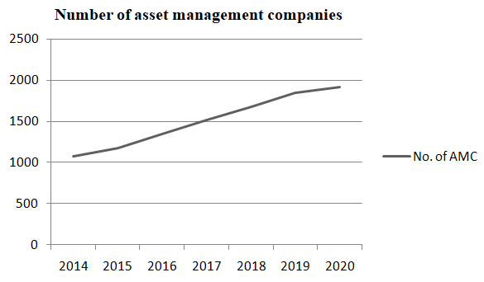
Sources: (Legislative Council Secretariat, 2021) [https://www.legco.gov.hk/research-publications/chinese/2021issh25-asset-management-industry-in-hong-kong-20210430-c.pdf]

First of all, we mainly want to reduce risks and dependence on the local market in the future, and then increase profits, and at the same time expand the scale of the company and enhance international reputation.
To achieve the above-mentioned research objectives, we have collected the major macroeconomic data of China including GDP, CPI, and foreign trade to analyze China's economic environment and its future trends. In addition, we apply Michael Porter's Five Forces Model to discuss the Microeconomic Environment, .After that, we measure and discuss the expected return and risk of the China stock market.
Following the introduction section, section 2 provides a brief and concise description of the background and financial status of the company; section 3 is to deal with the characteristics of the Shanghai Composite Index and compare it with Hong Kong’s Hang Seng Index. Finally, the conclusions and recommendations are presented in section 5.

Company background

ABC Company is an asset management company established on November 1, 1999. The goal of the company at the beginning of its establishment was to deal with the Asian financial crisis and resolve financial risks. It is one of the world's famous financial asset management companies. In 2015, ABC Company was listed on the main board of the Hong Kong Stock Exchange. As of the end of 2021, the total assets of ABC Company reached RMB 1,568.422 billion. In 2021, the total revenue will be RMB 93.067 billion, the net profit will be RMB 1.986 billion(ABC Company, 2022).The main businesses of the company include non-performing asset management business, financial service business, and asset management and investment business. As of the end of 2021, ABC Company has more than 30 branches, and its service network covers many regions around the world. At present, the group employs more than 9,000 people(ABC Company, 2022). The company's mission is to resolve financial risks, enhance corporate value, and achieve employees' dreams. The company's vision is to build an internationally renowned and leading asset management company and financial service brand. The company's core values are integrity, innovation, professionalism, and stability.

2.1 Company profile

Through comprehensive financial services such as the acquisition of non-performing assets, debt restructuring, asset restructuring of distressed enterprises, and bankruptcy reorganization, the company implements major projects such as judicial auctions, listed companies will help the market and revitalize assets by acquiring defaulted bonds, optimize resource allocation, and increase asset value. Prevent and defuse financial risks, serve the development of the real economy, and support supply-side structural reforms. The company adheres to the functional positioning of a financial asset management company, focuses on the overall requirements of "the year of transformation and the year of tackling difficulties", refines and implements the four major business tasks of "minimizing risk, reducing living inventory, optimizing growth, and strengthening the foundation", focusing on the "big non-performing" business field, optimize the business structure, innovate new products and models such as default risk bond acquisitions, wealth management asset management plan acquisitions, etc., and give full play to the role of the main force.

2.2 Current investment portfolio and investment performance

Figure 2a Company portfolio of financial asset Figure 2b Distribution of Listed and Unlisted Shares and Funds
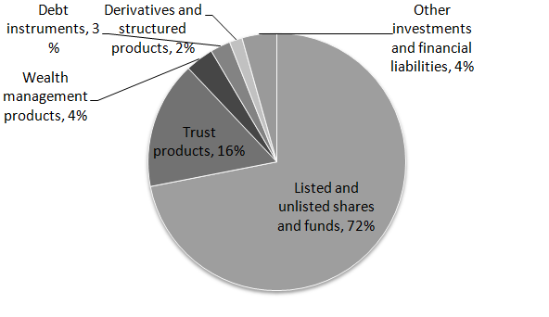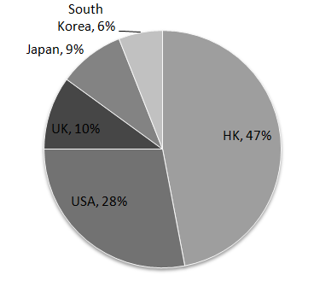
Sources: (ABC Company, 2021) Sources: (ABC Company, 2021)

Figure 2a and Figure 2b demonstrated that more than 70% of the company's main income comes from listed and unlisted stocks and funds. And the distribution of investment is concentrated in Hong Kong and the United States. If it is too concentrated in one or two regions, risk management is prone to crisis. Therefore, we should expand our business to China to share risks, and China's economy will occupy an important position in the world in the future. . The future crisis has sounded the alarm, and the economy continues to be impacted by the Sino-US trade war, the Russia-Ukraine war, and covid-19. And from Figure 1, the number of local asset management companies in Hong Kong is increasing, and everyone has divided up the Hong Kong market.

2.3 Global business challenges and the rationale for exploring investment opportunities in some global financial markets

China's geographical location is very close to Hong Kong, and the cultures of the two places are also relatively close. In addition, the exchange risk of the legal currency system of the two places is at a controllable level, and there will not be too much fluctuation. Moreover, the mainland has successively launched 12 new opening-up policies Measures and cancellation of investment quota restrictions for Qualified Foreign Institutional Investors (QFII) and Renminbi Qualified Foreign Institutional Investors (RQFII), as well as policies such as restrictions on RQFII pilot countries and regions, to attract foreign capital into the mainland capital market and promote foreign capital in the mainland stock and bond markets The proportion continued to increase, further promoting the opening up of the mainland capital market. Obviously, China's financial service industry will enter a new era led by opening up. Hong Kong, as the main channel for China's capital market to connect to the outside world, not only provides a variety of options for the interconnection between the mainland and the international financial market, but also enhances its international influence. In China's financial market opening model, the Shanghai-Hong Kong Stock Connect, Shenzhen-Hong Kong Stock Connect and Bond Connect took the lead in realizing the interconnection between the domestic stock and bond markets and the Hong Kong capital market. As a free port of global capital, Hong Kong has the inherent conditions to radiate other major financial markets. Hong Kong's financial industry has vigorously strengthened its connection with major global financial markets through various types of cross-regional financial cooperation. China's financial industry also gives full play to the overall advantages of Hong Kong's financial market, builds a regional operation and management platform, comprehensively accelerates the accumulation of overseas assets and the manifestation of overseas business results, accelerates the improvement of global investment, financing and financial service capabilities, and enhances international management and operation capabilities(HKTDC, 2020).
The Guangdong-Hong Kong-Macao Greater Bay Area's ability to serve the real economy in financial services continues to improve, which will inject new momentum into regional economic growth and effectively expand the strategic maneuvering space for national development. Against the backdrop of downward pressure on the global economy and major changes in international governance unseen in a century, the Guangdong-Hong Kong-Macao Greater Bay Area keeps pace with world-class bay areas such as Tokyo and San Francisco in terms of population, area, economic scale, and container throughput. It not only provides an important engine for China's economic growth, but also has the conditions to become an important center for global economic development. The financial industry in the Greater Bay Area will present a new development pattern, providing a new historical opportunity for Hong Kong to comprehensively enhance its functional positioning in the financial industry in the Greater Bay Area.

The characteristics of the Shanghai Stock Exchange and the Business environment in China

3.1 The Shanghai Stock Exchange

Shanghai Stock Exchange established on November 26, 1990 and opened on December 19 of the same year, it is supervised and managed by the China Securities Regulatory Commission. It is a member-based legal person that provides venues and facilities for centralized securities trading, organizes and supervises securities transactions, and implements self-discipline management. To create a standardized, transparent, open, dynamic and resilient market environment, its main functions include: providing venues, facilities and services for centralized securities trading; formulating and revising the business rules of the Shanghai Stock Exchange; Issuing and listing applications; reviewing and arranging securities listing transactions, deciding on the termination and re-listing of securities, etc.; providing non-public issuance of securities transfer services; organizing and supervising securities transactions; organizing and implementing innovations in trading varieties and trading methods; supervising members; Supervise listed trading companies and relevant information disclosure obligors, and provide websites for information disclosure obligors to release information disclosed according to law; supervise securities service agencies that provide services for securities issuance, listing, trading, etc.; establish or participate in the establishment of securities registration and settlement Institutions; management and publication of market information; investor education and protection; laws, administrative regulations and other functions permitted, authorized or entrusted by the China Securities Regulatory Commission(Shanghai Stock Exchange, 2023).

3.2 The time movement of the China SSE Composite Index

Figure 3a Figure 3b
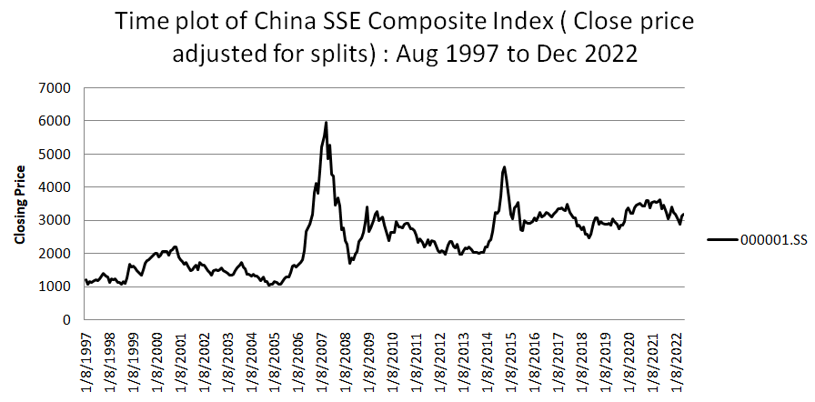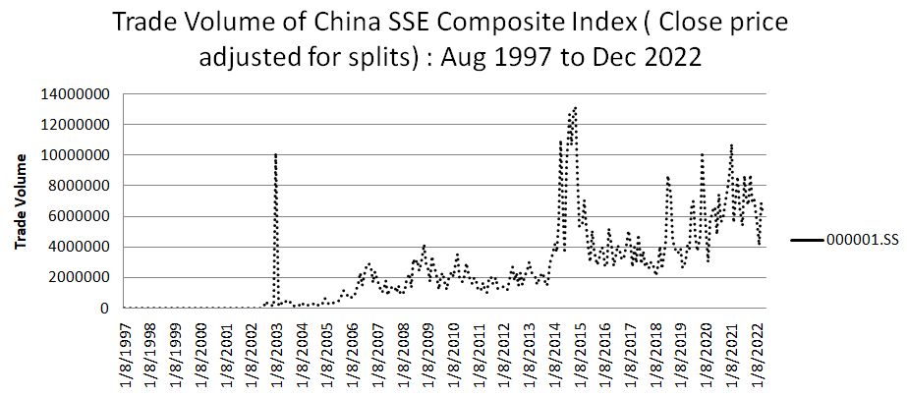
Source: Constructed by the Author Source: Constructed by the Author
Based on Figure 3a and Figure 3b, regardless of the increase in the index and the trading volume all the time, it has always been good.

Table 1 Coefficient of variation and standard deviation of HK vs China and HK vs US
 | Mean | Standard Deviation | CV
000001.SS | 2438 | 909 | 37%
HSI | 19408 | 6063 | 31%
IXIC | 4391 | 3448 | 79%
Source: Constructed by the Author

And we use the coefficient of variation method to calculate the composite index of Hong Kong, China and the United States respectively. Hong Kong is 31%, China is 37%, and the United States is 79%. The markets of China and Hong Kong are relatively close, and through the coefficient of variation, we know the risk is also lower.

3.3 The Business environment in China

3.3.1 Economic & Trade

Since the promotion of "reform and opening up", China has become the fastest growing major economy in the world, with an average annual growth rate of 10% over the past 30 years. The originally dominant state-owned enterprises began to coexist with market capitalism and private enterprises. Today, these various forms of state-owned enterprises stand alongside a large number of private and foreign-owned enterprises. How fast this 10% average growth rate is, we can see from the GDP difference between Taiwan and China in 1994 30 years ago, Taiwan’s GDP at that time was 256.2 billion US dollars (nominal GDP), accounting for China The total GDP is about 45%. However, 30 years later, China's GDP is as high as 18 trillion, making it the second largest economy in the world. The total economic value of Taiwan is not even among the top five provinces in China(OOSGA, 2023).China joined the WTO in November 2001. Through more intense participation in WTO dispute settlement, China is also becoming increasingly vested in the maintenance of WTO norms and rules, and consequently(Harpaz, 2010). And the US-China trade war began in July 2018and has lasted over four years.

3.3.2 Socio & Political

China has canceled epidemic prevention and control measures for nearly three years. However, for Generation Z, born between 1995 and 2010, the struggle did not lead to better outcomes in life. Foreign media reported that in the face of high unemployment and sluggish economic growth, they have become pessimistic and their trust in leaders has declined. The current economic development in China is not optimistic, and the government is actively carrying out risk management and control. The focus of economic work this year is to stabilize growth, expand domestic demand, and boost market confidence. In order to solve the current problems, Mainland China will introduce a proactive fiscal policy and loose monetary policy(Ren, Guo, Zhu, and Ying, 2020).

3.3.3 Legal environments

According to the provisions of the Constitution and the Legislative Law, the National People's Congress and it is Standing Committee exercise state legislative power. The National People's Congress formulates and revises criminal, civil, a state agency, and other basic laws. In terms of opening up to the outside world, provisional regulations or regulations can be formulated. Local regulations can be formulated on the premise that the Constitution, laws, administrative regulations, and local regulations of the province and autonomous region are not in conflict; People's governments may formulate rules and regulations by laws, administrative regulations, and local regulations of their provinces, autonomous regions, and municipalities directly under the Central Government; people's congresses in ethnic autonomous areas have the right to formulate autonomous regulations and separate regulations by the political, economic, and cultural characteristics of the local ethnic groups. The people's congresses and their standing committees of the provinces and cities where the special economic zones are located formulate regulations and implement them within the scope of special economic zones by the authorized decisions of the National People's Congress(HKTDC Research, 2018).

4. Analysis and discussion

4.1 The relationship between the trend movement of the stock price indexes.

Figure 4a
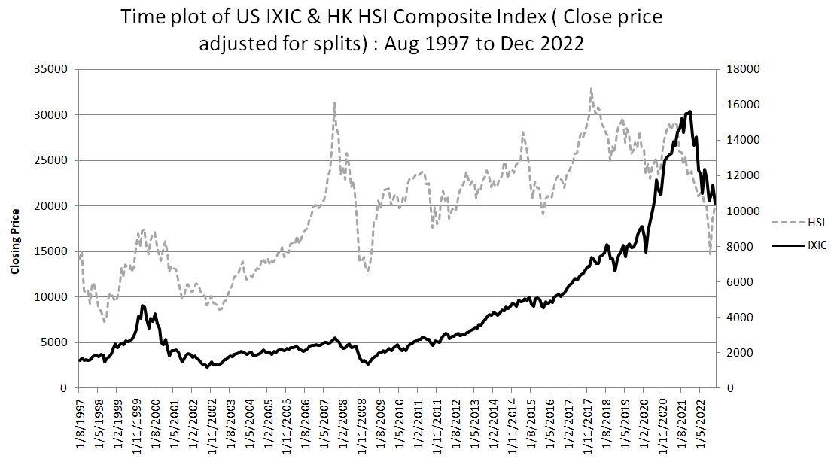
Source: Constructed by the Author
Figure 4b
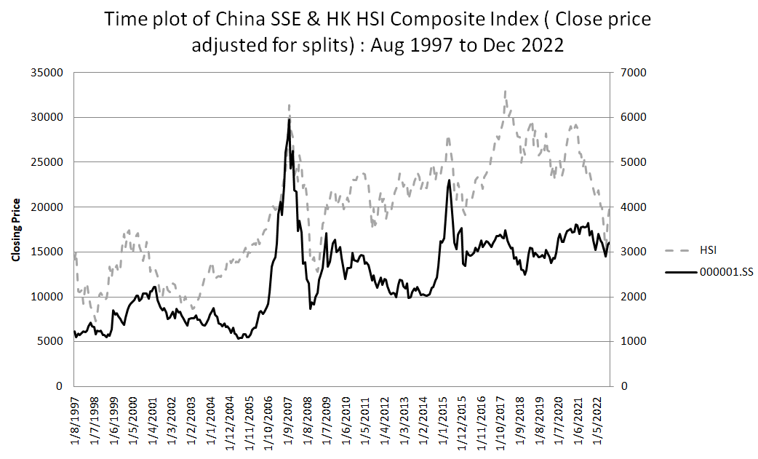
Source: Constructed by the Author
In Figure 4a and Figure 4b, we use the Shanghai Stock Exchange Index to represent China, and the Nasdaq Index to represent the United States. We can compare the Hang Seng Index in Hong Kong by comparing the two graphs. First of all, in Figure 4a, we can see that the relationship between the Nasdaq Index and the Hang Seng Index is often the same. Although the range may not be the same, it is not difficult to see that the relationship between the two is partially linked. On the other hand, in Figure 4b, we concluded that the relationship between the Shanghai Composite Index and the Hang Seng Index has a partially opposite trend. Sometimes when the Hang Seng Index rises, the Shanghai Composite Index will fall, and vice versa. Of course, when there are major global events, the trends of the two will be relatively close, such as the financial turmoil and the global epidemic. In addition to the graph on the left, we also use the correlation matrix to analyze the stock price index of Hong Kong, China, and the United States. Below, we divide the 25 years from Aug 1997 to Dec 2022 into 3 periods.

Table 2 Correlation coefficient of 000001.SS VS HSI and IXIC VS HSI
 | Time Period
 | 1/8/1997 to 31/12/2006 | 1/1/2007 to 31/12/2014 | 1/1/2015 to 31/12/2022
000001.SS VS HSI | 0.35 | 0.54 | 0.17
IXIC VS HSI | 0.65 | 0.52 | 0.02
Source: Calculated from [please provide URL of the ccccc1SS, HIS and TXIC]

Based on Table 2, we can know that China's Shanghai Composite Index is 0.35, 0.54, and 0.17 in three periods, which are close to those of the United States. Therefore, through the correlation matrix, our company can expand its business to China, and in the future, China will gradually replace the United States as the world's largest economy. And within 20 years, China's GDP% will be better than that of the United States, and the research also points out that China's GDP% growth in the future will be higher than that of the United States and the world average. Next, we will briefly introduce China's economic, trade, social, political, and legal environment.
We will use micro-economic and macro-economic to analyze and evaluate the potential profitability and risks that may be faced. Michael Porter's Five Forces Model is a micro-environmental analysis, mainly used to analyze the competitive landscape of the industry, so that we can formulate good corporate strategies and marketing management when we enter the market. Strengthen our own industry share and maintain high corporate profits ability, thus driving the continuous increase of our company's profits. First recognize the market, do a good job of investigation, know yourself and the enemy, and you will be victorious in all battles. And use different macroeconomic indicators and statistics to attract the purchase of stocks on the Shanghai Stock Exchange.

4.2 Reduce risks and dependence on the local market in the future

The following will use Michael Porter’s Five Force to study microeconomic analysis. This model essentially analyses the competitive forces that exist within the industry that the company is a part of. By using this model, the company will effectively be able to assess the various competitions that it faces in its designated industry.

4.2.1 Industry rivalry

There are currently four major asset management companies in China, namely China Huarong Asset Management Corporation, China Great Wall Asset Management Corporation, China Orient Asset Management Corporation and China Cinda Asset Management Corporation. In the past 20 years, the development of the 4 companies has been very rapid, especially in the past 10 years, the annual growth rate of the total assets of each company has reached 30% or more, and one is even close to 50%(Blackboard news, 2021). These asset management companies all own banks, insurance companies, trusts, securities companies and various companies related to financial facts (Dinny 2018).

4.2.2 Substitutes & Complements

The threat of substitution & complement is low. It has become a fact that foreign investors directly apply for AMC licenses. According to the official website of the Beijing Local Financial Supervision Administration on February 18, Oaktree (Beijing) Investment Management Co., Ltd., a wholly owned subsidiary of Oaktree Capital, a world-renowned investment management company, has completed industrial and commercial registration in Beijing. This will be the first foreign-controlled AMC. Liu Yang, an analyst at S&P Global Ratings, said that it is expected that returning to the main business of non-performing asset management will help stabilize the debt levels of the four major AMCs, but profits will be diluted, and asset growth will also slow down(Hexun, 2020). It is estimated that in the next one to two years, including overseas business, the four major AMCs will maintain a high single-digit asset growth rate. With the tightening of regulations, including the introduction of new regulations on capital regulation in 2018, the asset growth rate of non-performing asset management companies has slowed down since 2017. The main factors affecting the competition among AMCs within the industry are the number of non-licensed AMC companies, the degree of product differentiation, and the degree of market concentration. Competition among non-licensed AMCs in China is fierce.

4.2.3 Power of Input Suppliers

The power of the input supplier is extremely high. The establishment of a national asset management company requires the approval of the state, but only one was approved from 1999 to 2021. Therefore, it is difficult to pass the approval, the entry barrier is high, and the monopoly is strong, so the bargaining power is strong. Even though, all of our investment products and the stock market are open. Therefore, it is unlikely that there is a problem of price manipulation by suppliers because manipulation and price control are illegal acts.

4.2.4 Power of Buyers

The bargaining power of the buyer is extremely high. Since the company belongs to the asset management company, it has a vast number of competitors who can provide the same products (Bruijl, 2018). As of February 2021, there are 5 nationwide AMCs in China, 4 of which were approved for establishment in 1999 and 1 newly approved for establishment in 2020, all of which are registered in Beijing. There are 58 local AMCs, one more than by the end of 2020. Hebei, Guangdong, and Fujian each have 1 AMC to be approved, Shaanxi and Liaoning each have 1 AMC under construction, and Jilin has 1 AMC that has been disbanded. There are 2 listed AMCs in China, both of which are national and are listed on the Hong Kong Stock Exchange; there are 15 AMC concept listed companies, of which 8 are listed on the Shenzhen Stock Exchange and 7 are listed on the Shanghai Stock Exchange.

4.2.5 Entry

Licensed national asset management companies have high barriers to entry, but it is not as difficult as before. You can start with a non-licensed asset management company, and then obtain the qualification of a licensed asset management company through the listing status in Hong Kong because the advantage of the company is that it is a listed company on the main board of Hong Kong, while only two of the largest asset companies in China have obtained the listing status in Hong Kong. According to MacroPolo, initially, only five local AMCs were licensed, and by the end of February 2018 there were 47, and finally, six more are awaiting approval from the China Banking Regulatory Commission. Some provinces have only one, while others have as many as three. Given that 16 local AMCs were only granted the qualification in 2017 and 2018(Dinny, 2018), for asset management companies, the barriers to entry mainly include three aspects: industry access control, capital entry barriers, and talent barriers. The market in China is open(The State Council, 2019). It is easy for our company to expand business in China.

4.3 Increase profits and expand the scale of the company and enhance the international reputation

People in the international community need to protect a more integrated global economy. We must admit that there are uncertain risks in the world, some of which are driven by economic logic. We know from COVID-19 and the invasion of Ukraine that cost considerations are not the only factor. Security of supply must also be factored into economic decisions. But that inevitably means higher overall global production costs. So, there is security and stability of supply. Because people's living habits have changed a lot due to COVID-19 in recent years. The popularity of online platforms, the reduction of physical consumption, and the increase in the application of electronic money will bring new shocks to society. In addition, major events in recent years have led to an increase in unemployment and economic decline. Uncertainty factors in people's lives will prompt them to reduce consumption and save their salary or income. When personal wealth increases, they will start to invest in various types of products for asset appreciation. Therefore, China's future investment market prospects are very optimistic, and our company must enter the Chinese market to earn considerable profits.
For the IMF, central banks and monetary and fiscal policy provide sound analysis for debt and provide an institutional approach to addressing debt problems. And the world has pushed and at the highest level the Global Sovereign Debt Roundtable An agreement was reached(Kristalina, 2023).

Figure 5 GDP of China (2018 to 2022)
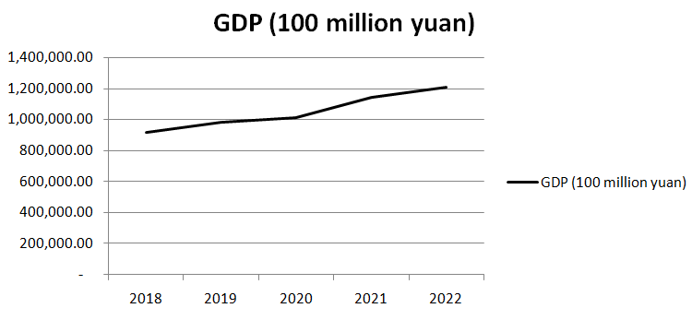
Sources: (National Bureau of Statistics of China, 2023)
Based on Figure 5, China's GDP has grown considerably every year, especially in the context of the global economic crisis and the pandemic. Economic & Trade has pointed out that China's GDP has grown at an average annual rate of 10% in the past 30 years. Has become the world's fastest growing major economy, China's GDP is as high as 18 trillion, becoming the world's second largest economy(OOSGA, 2023).

Table 3 Assets and Liabilities Statistics of Financial Institutions (the end of 2022Q3)
Assets and Liabilities Statistics of Financial Institutions (end of 2022Q3)
 | Outstanding (Trillion Yuan) | YoY Growth Rate (%)
Total Assets of Financial Institutions | 413.46 | 10.1
Of which:
Banking Institutions | 373.88 | 10.2
Securities Institutions | 12.87 | 7.3
Insurance Institutions | 26.71 | 9.8
Liabilities of Financial Institutions | 376.61 | 10.3
Of which:
Banking Institutions | 342.94 | 10.4
Securities Institutions | 9.68 | 6
Insurance Institutions | 23.98 | 11.7
Owner's Equities of Financial Institutions | 36.85 | 7.2
Of which:
Banking Institutions | 30.94 | 8
Securities Institutions | 3.18 | 11.4
Insurance Institutions | 2.73 | -4.5
Sources: (PBC, 2022) [http://www.pbc.gov.cn/goutongjiaoliu/113456/113469/4761016/index.html]

According to Table 3, we can know that the entire financial market has experienced considerable growth, especially investment products. The annual increase in RMB deposits was 26.26 trillion, an increase of 6.59 trillion year-on-year. Among them, household deposits increased by RMB 17.84 trillion, non-financial enterprise deposits increased by RMB 5.09 trillion, fiscal deposits decreased by RMB 58.6 billion, and non-bank financial institution deposits increased by RMB 1.38 trillion. In December 2022, RMB deposits increased by RMB 724.2 billion, a year-on-year decrease of RMB 440.3 billion(PBC, 2023).
Based on the data from the People's Bank of China, the increasing amount of Chinese people's deposits represent an opportunity for investment companies. Because the increase in deposits in a place means that their potential purchasing power exists. As long as the epidemic situation improves and the overall market environment returns to normal, the potential purchasing power will be released, forming a very terrifying purchasing power. When a large amount of hot money flows into the market, the entire investment the product market will usher in a small spring, and even enter a bull market. We need to find these potential customers so that they become our loyal customers and earn a win-win situation.
To strengthen the connection between the stock markets of China and Hong Kong and promote the development of the investment markets of the two places, the China Securities Regulatory Commission and the Hong Kong Securities and Futures Commission both agreed to expand the scope of eligible stocks for Shanghai-Hong Kong Stock Connect(China Securities Regulatory Commission, 2022). Therefore, our company has seized the opportunity to expand its business in China. In addition, the Chinese themselves have confidence in most of the products and services in Hong Kong. This alone is superior to other domestic investment companies. Furthermore, when the investment markets of the two places are increasingly interconnected, the Chinese customer base can also drive the investment products of Hong Kong companies, and Hong Kong customers can also drive the domestic investment products, which is mutually beneficial.

Figure 6 China Consumer Price Index: Jan 2016 to Dec 2022
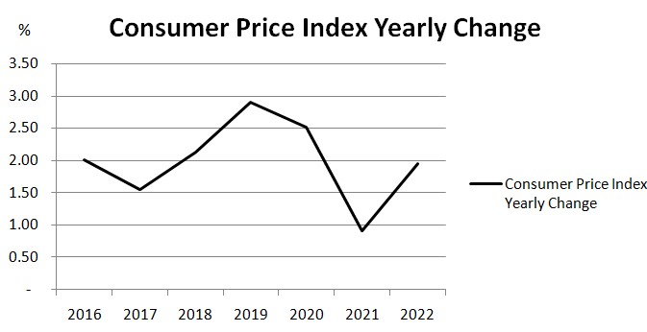
Sources: (National Bureau of Statistics of China, 2023)[http://www.gov.cn/shuju/index.htm]

The consumer price index is an indicator of price changes that reflects the price of goods and services related to residents' lives in a region. It is expressed in percentages and is also one of the main indicators for measuring inflation. The inflation rate refers to the "CPI annual growth rate", and its calculation formula is as follows:

Inflation rate (inflation rate%) = (this year's CPI - last year's CPI) ÷ last year's CPI

When the inflation rate shows negative growth, it usually means a recession. People don’t consume and companies don’t invest, which is commonly known as “deflation.”However, if the inflation rate is too high, it means that prices will soar in a short period of time, and the real purchasing power of people's currency will decline. This will also cause people to dare not consume, and companies will shrink their investment, which will also damage the economy. Therefore, it is generally believed that the inflation rate in a region is maintained at a moderate inflation rate of 2% to 3%, which is a relatively healthy inflation level. If the CPI changes drastically, it will greatly affect the monetary and fiscal policies of a country or region, and the governments of various countries will use more radical means to bring the CPI and inflation back to normal levels, which in turn will affect the financial and stock markets. If inflation is too high, interest rates will be raised to make it difficult to borrow money, thereby inhibiting the flow of excess hot money in the market; on the contrary, when the economy is weak, interest rates will be lowered to make currency circulation easier and promote investment and consumption. Depend on Figure 6; China's CPI trend will be between 1% and 3%, which belongs to a healthy market environment, which will help consumption and investment in various types of products.
Under the rule of the CCP, the corruption and inefficiency of the CCP, as well as various economic crises derived from the CCP system such as the housing market, the stock market, or the debts of enterprises, governments, and residents, will eventually be concentrated in the banking system, reflected in the bad debts of the banks. China's banking system has been able to make a glamorous performance and cover up the huge crisis of the CCP's debt economy, mainly because the four major AMCs have taken over a large number of bad debts. This not only impacts the ability of China's banking industry to quickly deal with bad debts to make room for new loans but also exacerbates financial risks in the banking industry and endangers social stability. Therefore, our company needs to carefully deal with different high-risk investment products to avoid unnecessary losses to the company and customers, affect the company's reputation, and deter potential customers and investors.

Figure 7 China Investor Sentiment Index(Apr 2020 to Mar 2021)
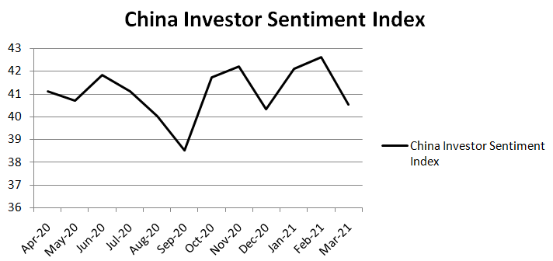
Sources: (Headlines, 2022) [https://min.news/economy/3d0fd7678f5297cdfd71c62464d5e534.html]

China Investors Sentiment Index (CISI) is based on the collection of hundreds of millions of pieces of financial text big data that can reflect investor sentiment on the Internet, and uses deep learning methods to measure text information to reflect the sentiment of Chinese retail investors new tools. The index not only contains past market information, but also reflects investors' willingness to invest and expectations of market trends. Domestic economic data is getting better, but investor sentiment has dropped significantly, but this is only affected by COVID-19. Investors stay on the sidelines and maintain their purchasing power. Now that China has canceled most of the epidemic policies, all aspects of society will be upward. In that time, a certain amount of purchasing power will be released to drive the whole social atmosphere. The investment market will definitely be driven by the enthusiastic investment and trading atmosphere.

5 Conclusion and recommendations

From all the above analysis, we can identify the expansion of business to China to reduce the risk and dependence on the Hong Kong market in the future, and can also expand the company's scale, enhance international reputation and increase income.

5.1 Conclusion

We use standard deviation, coefficient of variation, Michael Porter's Five Force and correlation coefficient to evaluate that China is a suitable place for us to expand our business(Namaki, Shirazi, Raei and Jafari, 2011) and can effectively reduce investment risks(Yunna and Yisheng, 2014). On the other hand, we use China's GDP, CPI, CISI and deposits to increase Based on the measured potential purchasing power, we can increase the considerable income(Pagdin and Hardy, 2017) and expand the company's planning, thereby enhancing the international reputation(Wu and Zhuo, 2015).

5.2 Recommendations

When doing business in China, the standard corporate income tax rate is 25%, while in Hong Kong it is 16.5%. Therefore, when making financial plans, you need to pay special attention to tax rates. China’s stock market is easily affected by policies(Tsai, 2017), so you must pay close attention. And China There is also the control of the entry and exit of funds to prevent the outflow of a large amount of funds in China. However, we can legally transfer funds out of China through overseas acquisitions(Rui and Yip, 2008).

References

Anderlini, J. & Hornby, L. (2014) China overtakes US as world’s largest goods trader. Financial Times, 10, 2014.
ABC Company (2022) Annual Report 2021. (Accessed: 28 January 2023).
BBC News (2020) Top 10 global economies in 2050. Available at: https://www.ettoday.net/news/20200328/1678793.htm (Accessed: 26 January 2023).
Blackboard news (2021) My country's top five AMC. Available at: https://www.sohu.com/a/446567601_660924 (Accessed: 27 January 2023).
Bruijl, G.H.T. (2018). The relevance of Porter's five forces in today's innovative and changing business environment. Available at SSRN 3192207.
China Securities Regulatory Commission (2022) Joint announcement of the China Securities Regulatory Commission and the Hong Kong Securities and Futures Commission. Available at http://www.csrc.gov.cn/csrc_en/c102030/c6917403/content.shtml (Accessed: 28 January 2023).
Dinny, M. (2018) The Big Four AMCs. Available at: https://macropolo.org/analysis/the-big-four-amcs-changing-priorities-and-rankings-in-a-new-era/ (Accessed: 27 January 2023).
Dinny, M. (2018) China’s Local AMCs. Available at: https://macropolo.org/analysis/chinas-local-amcs-making-a-mark-but-bending-the-rules/ (Accessed: 27 January 2023).
HKTDC Research. (2018) China’s Legal SystemAvailableat: https://research.hktdc.com/en/article/MzU2OTI1MDcy (Accessed: 26 January 2023).
HKTDC Research (2020) Rationale Behind the Development of Hong Kong as an International Financial Center and Practical Foundations to Withstand External Shocks. Available at: https://research.hktdc.com/en/article/NDU4ODYzMzA4 (Accessed: 2 February 2020).
Harpaz, M. D. (2010). Sense and sensibilities of China and WTO dispute settlement. Journal of World Trade, 44(6).
Hexun (2020) The first foreign AMC is here. Available at: http://news.hexun.com/2020-02-18/200338622.html (Accessed: 27 January 2023).
Headlines (2023) March 2021 China Investor Sentiment Index: Domestic economic data is improving. Available at: https://min.news/economy/3d0fd7678f5297cdfd71c62464d5e534.html (Accessed 3 February 2023).
Kristalina, G. (2023) Transcript of International Monetary Fund Managing. Available at: https://www.imf.org/en/News/Articles/2023/01/13/tr011223-transcript-of-imf-md-kristalina-georgieva-media-roundtable (Accessed: 28 January 2023).
Li, J., Rim, G. N., & An, C. J. (2022). Comparative Study of Knowledge-Based Economic Strength Between China and the USA. Journal of the Knowledge Economy, 1-37.
Legislative Council Secretariat(2021). Asset Management Industry in Hong Kong. Available at: https://www.legco.gov.hk/research-publications/chinese/2021issh25-asset-management-industry-in-hong-kong-20210430-c.pdf (Accessed: 2 February 2023).
National Bureau of Statistics of China (2023) National Economy Withstood Pressure and Reached a New Level in 2022. Available at: http://english.www.gov.cn/archive/statistics/202301/17/content_WS63c61d81c6d0a757729e592c.html (Accessed: 28 January 2023).
National Bureau of Statistics of China (2023) CPI Data. Available at: http://www.gov.cn/shuju/index.htm (Accessed: 28 January 2023).
Namaki, A., Shirazi, A. H., Raei, R., & Jafari, G. R. (2011). Network analysis of a financial market based on genuine correlation and threshold method. Physica A: Statistical Mechanics and its Applications, 390(21-22), 3835-3841.
OOSGA (2023) 2023 Economic Status, Industry Development, and Overall Market Analysis. Available at: https://zh.oosga.com/economies/chn/ (Accessed: 27 January 2023).
PBC (2022) Assets and Liabilities Statistics of Financial Institutions (the end of 2022Q3). Available at: http://www.pbc.gov.cn/diaochatongjisi/resource/cms/2022/12/2022123016042222986.htm (Accessed: 28 January 2023).
PBC (2023) 2022 Financial Statistics Report. Available at: http://www.pbc.gov.cn/goutongjiaoliu/113456/113469/4761016/index.html (Accessed: 28 January 2023).
Pagdin, I., & Hardy, M. (2017). Investment and Portfolio Management: A Practical Introduction. Kogan Page Publishers.
Ren, Y., Guo, Q., Zhu, H., & Ying, W. (2020). The effects of economic policy uncertainty on China’s economy: evidence from time-varying parameter FAVAR. Applied Economics, 52(29), 3167-3185.
Rui, H., & Yip, G. S. (2008). Foreign acquisitions by Chinese firms: A strategic intent perspective. Journal of world business, 43(2), 213-226.
Shanghai Stock Exchange (2023) About me. Available at: http://english.sse.com.cn/ (Accessed 2 February 2023).
The State Council’s Office of Financial Stability and Development Committee (2019) Measures for Further Opening Up the Financial Sector. Available at: https://english.www.gov.cn/services/investment/202102/24/content_WS6035aa9fc6d0719374af960c.html (Accessed: 28 January 2023).
Tsai, I. C. (2017). The source of global stock market risk: A viewpoint of economic policy uncertainty. Economic Modelling, 60, 122-131.
Wang, C., Tripp, C., Sears, S. F., Xu, L., Tan, Y., Zhou, D. & Ho, R. (2021) The impact of the COVID-19 pandemic on physical and mental health in the two largest economies in the world: a comparison between the United States and China. Journal of behavioral medicine, 44(6), 741-759.
Wu, J., Wu, Z., & Zhuo, S. (2015). The effects of institutional quality and diversity of foreign markets on exporting firms’ innovation. International Business Review, 24(6), 1095-1106.
Yunna, W., & Yisheng, Y. (2014). The competition situation analysis of shale gas industry in China: Applying Porter’s five forces and scenario model. Renewable and Sustainable Energy Reviews, 40, 798-805.

